Additional file
Safeguarding our dentistry heritage: a study of the history and conservation of 19th-20th century dentures
Artur Neves
Department of Conservation and Restoration and LAQV-REQUIMTE, NOVA School of Sciences and Technology, NOVA University Lisbon, Caparica, 2829-516 Portugal
Robert Friedel
Department of History, University of Maryland, College Park, MD, 20742, USA
Maria Elvira Callapez
Centro Interuniversitário de História das Ciências e da Tecnologia, Faculdade de Ciências, Universidade de Lisboa, Campo Grande, Lisbon, 1749-016 Portugal
Scott D. Swank
Department of Dental Public Health, University of Maryland School of Dentistry & National Museum of Dentistry, Baltimore, MD, 21201, USA
Corresponding author: Artur Neves, al.neves@campus.fct.unl.pt

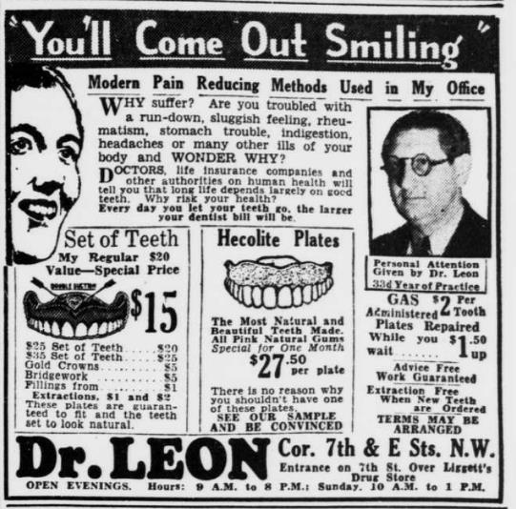
Figure 1. Advertisement for Hecolite in the Evening Star, Washington, D.C, Friday, February 8, 1935.

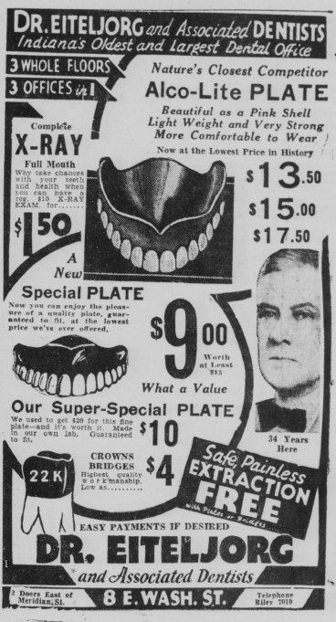
Figure 2. Advertisement for Alcolite in the Indianopolis Times, March 21, 1933

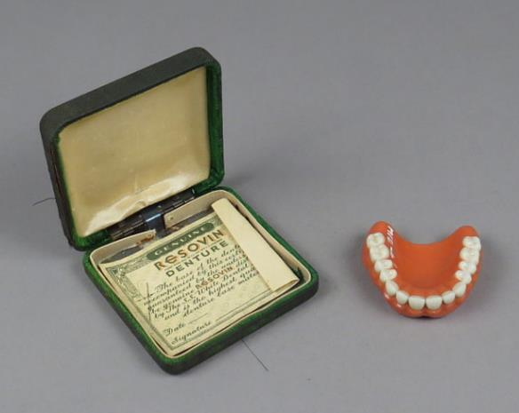
Figure 3. Resovin dental platefrom the Smithsonian Collection, ID number MG.260892.295.

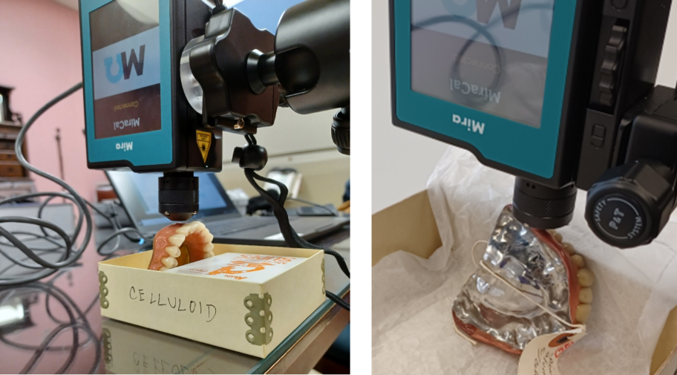

Figure 4. Raman MIRA DS analysis of the swaged gold and celluloid dental plate JUSTI 21 from NMD (left) and of the vulcanized rubber and Vitallium alloy denture MG.291116.0046 from NMAH (right), using the 3mm distance objective set up.

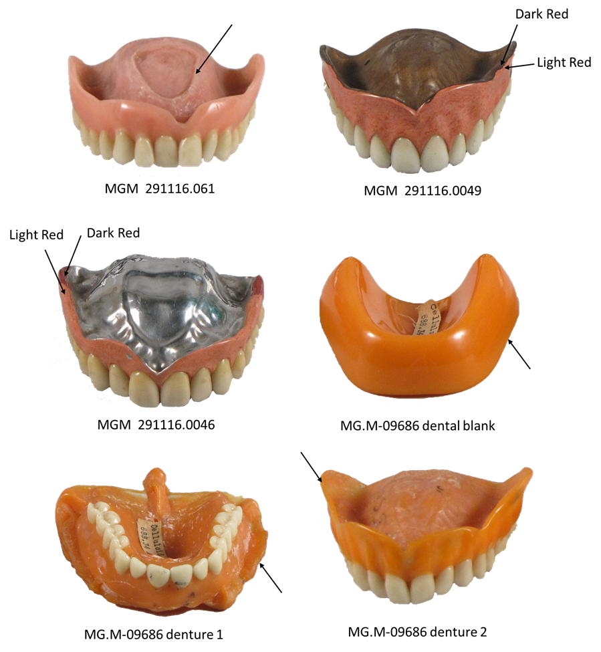

Figure 5. NMAH’s dentures and micro sampling location. Denture photographs source: Smithsonian Institution.

Table 1. NMD’s denture and sampling location. The microscope images were collected with a DINO-LITE digital microscope.
Denture and sampling location | Microscope image of sampling location
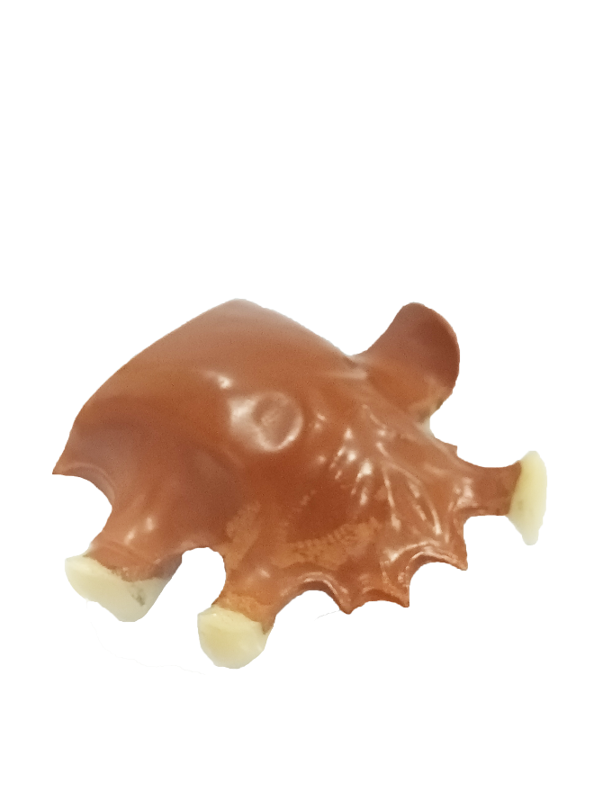Kellmer 95 | 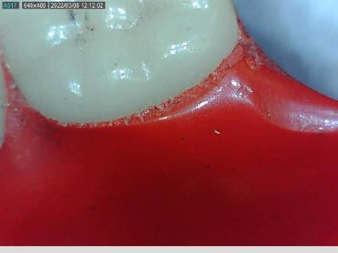
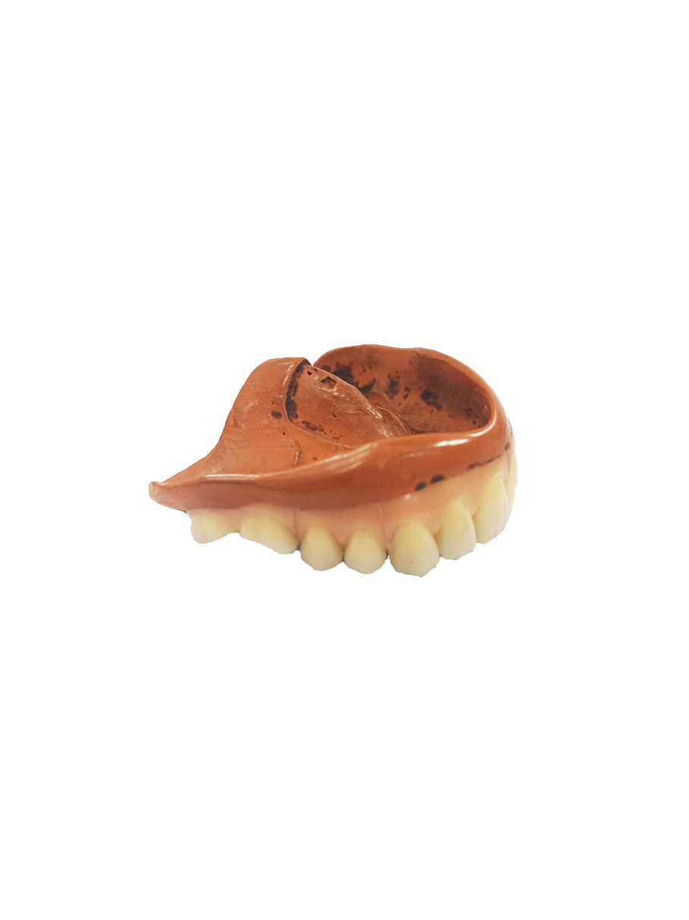  2002.99.4797 | 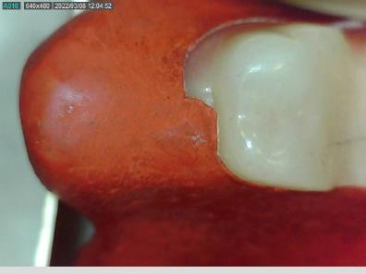
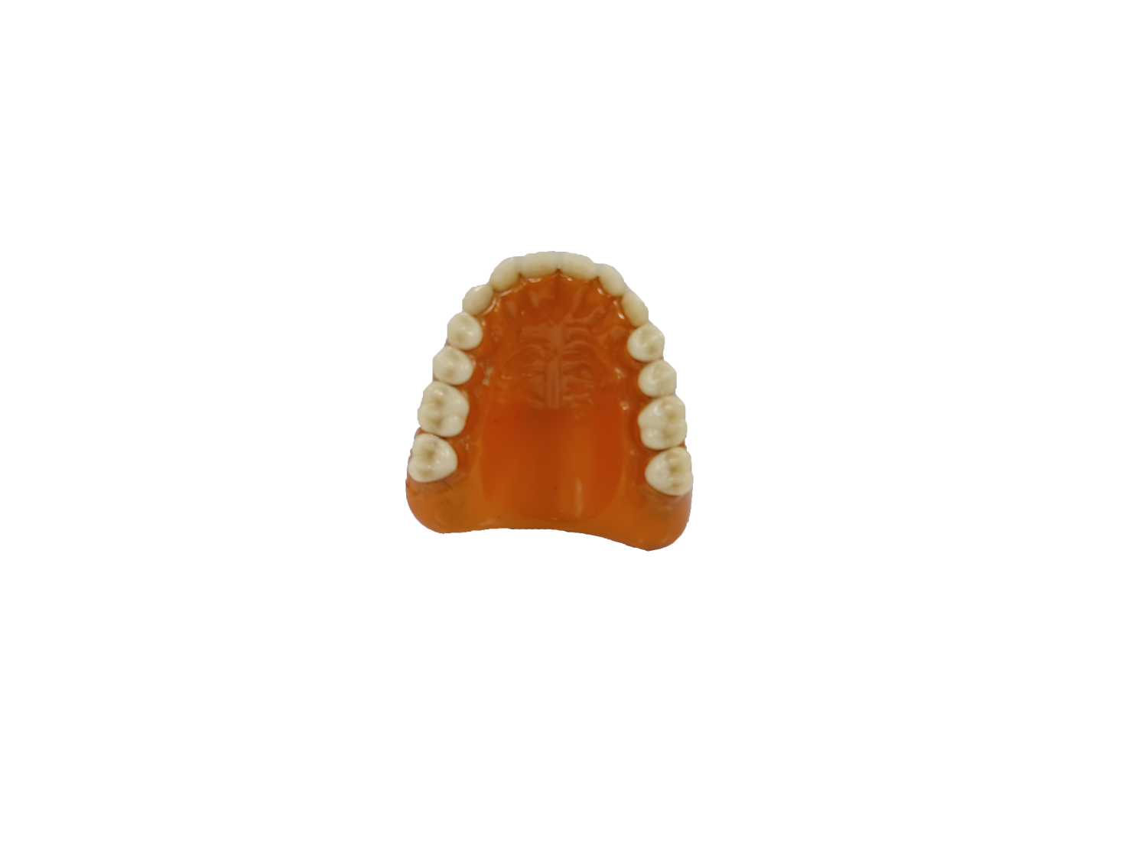  2002.99.5496 | 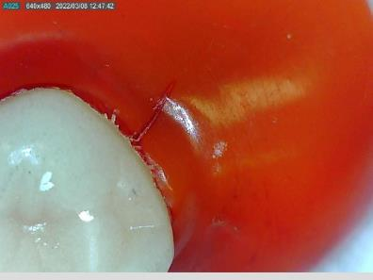
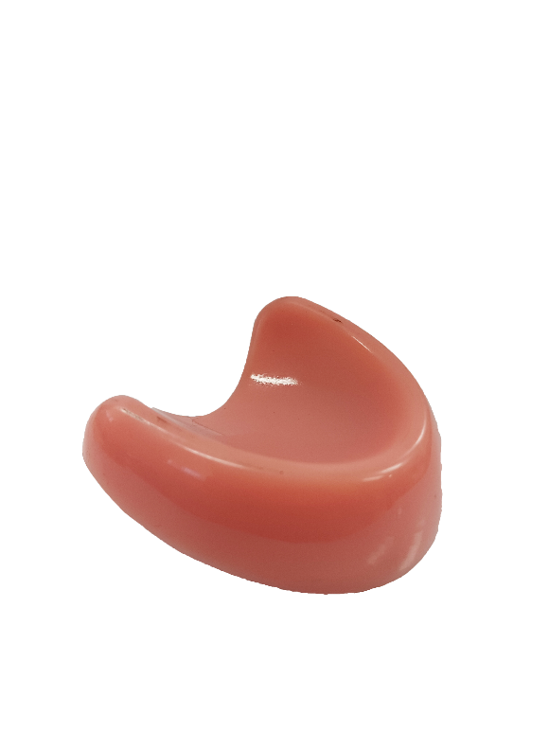  2002.99.5831 | 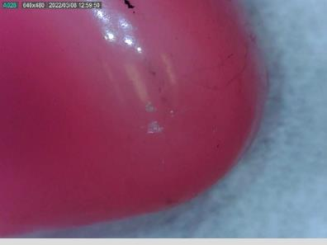
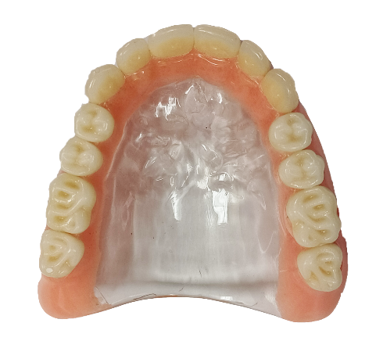  JUSTI 23 | 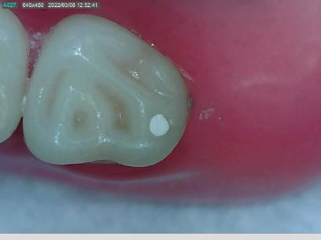
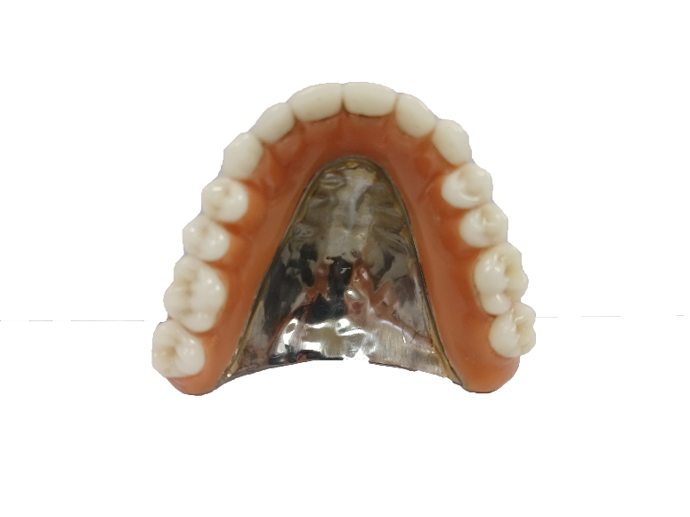  JUSTI 24 | 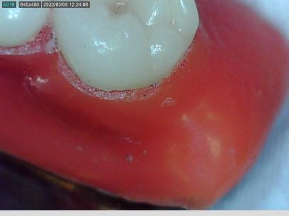
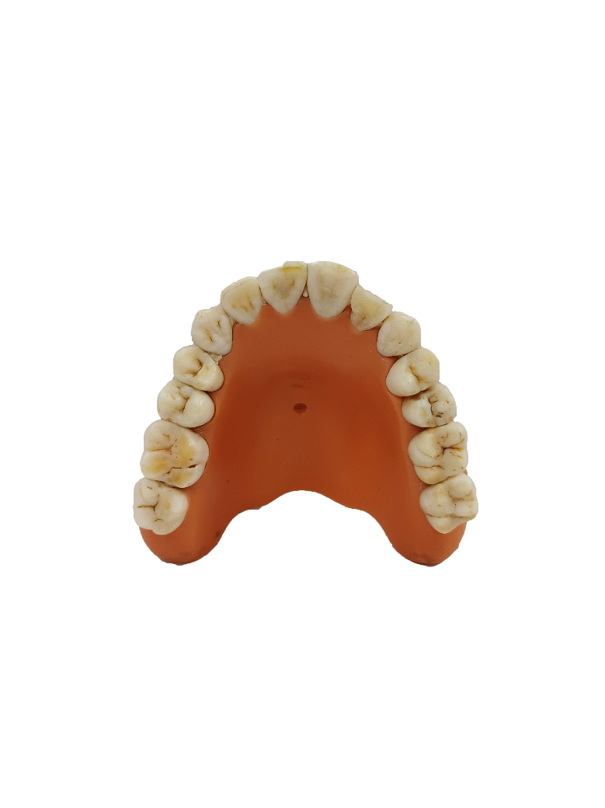  SSW21 | 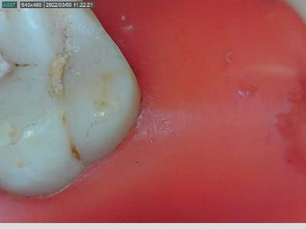
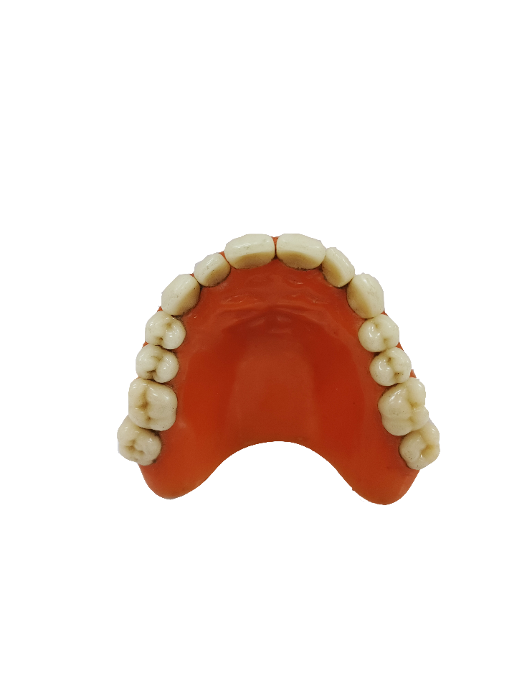  92.2.0924 | 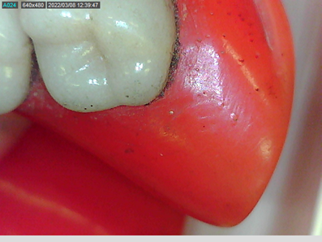
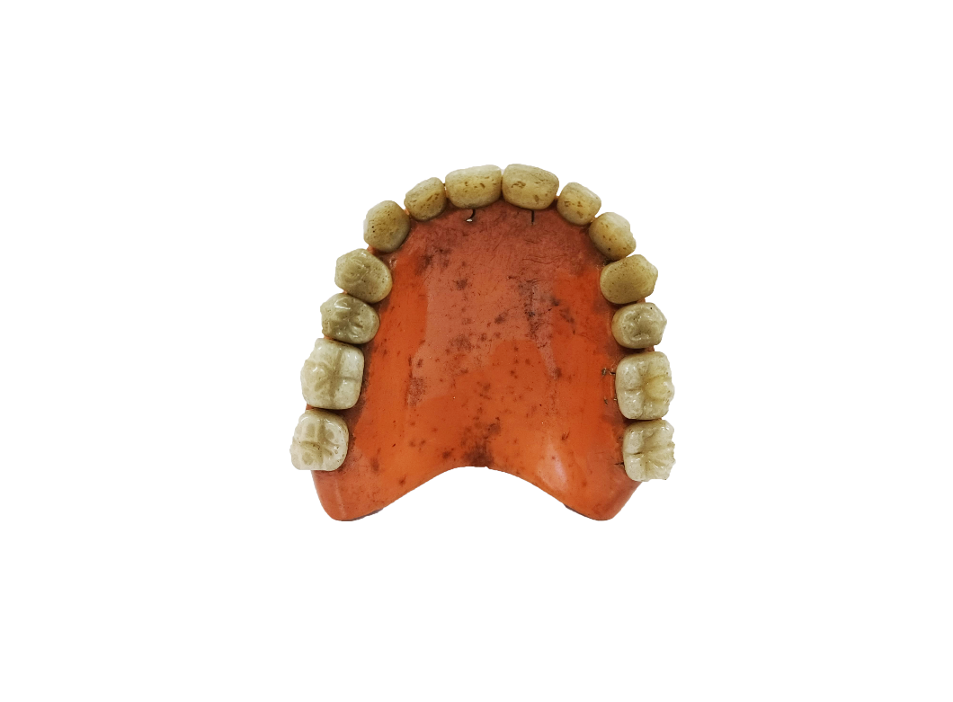  2002.99.5780 | 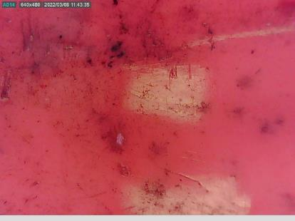

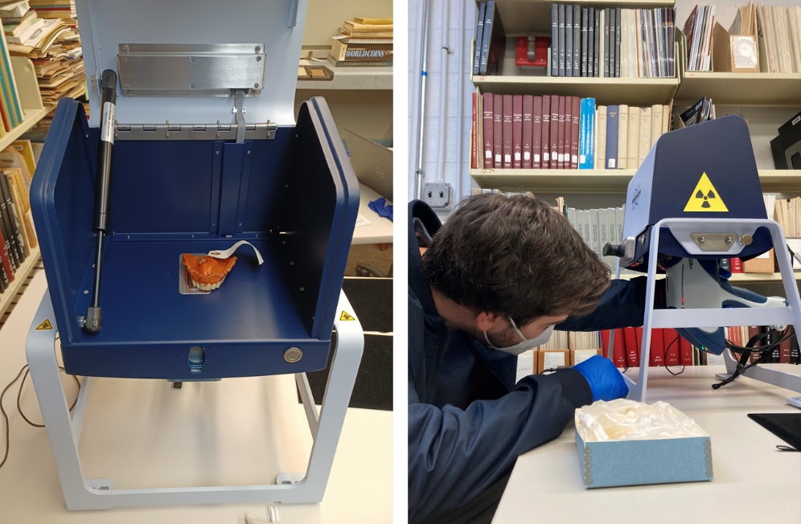Figure 6. Right, celluloid denture inside the X-ray fluorescence spectrometer S1 Titan analysis chamber. The analysis area where the x-ray beam interacted with the object is beneath the denture. The chamber lid was closed for analysis. Left, different view where it is possible to see the X-ray fluorescence spectrometer S1 Titan beneath the analysis chamber. The trigger had to pressed during the analysis; the time corresponding to the acquisition time.

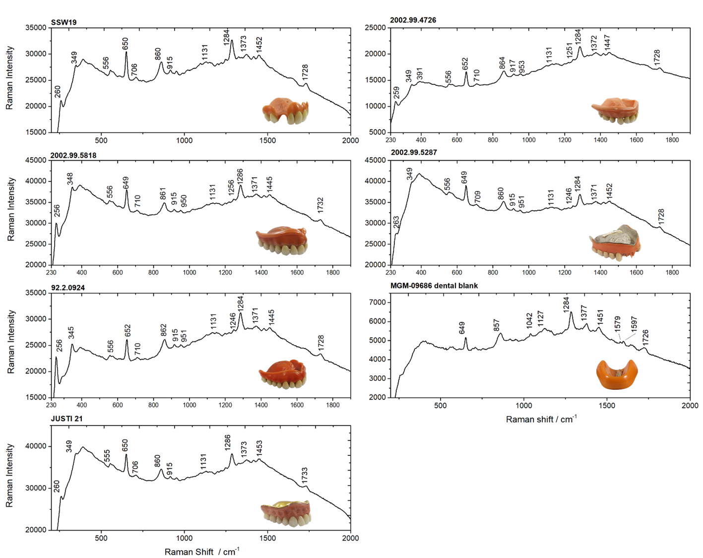

Figure 7. Handheld Raman spectra of the celluloid dentures’ from NMD and NMAH, namely SSW19 (10s), 2002.99.4796 (7s), 2022.99.5818 (8s), 2022.99.5287 (6s), 92.2.0924 (10), MG.M-09686 dental blank (2.6s) and JUSTI 21 (7s)

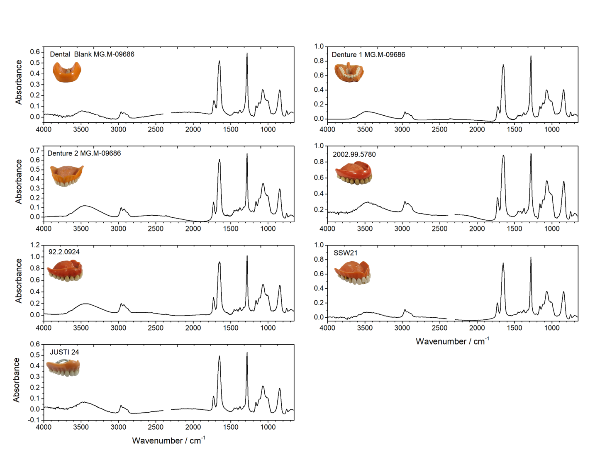

Figure 8. Infrared spectra of the celluloid dentures’ microsamples from NMD and NMAH.

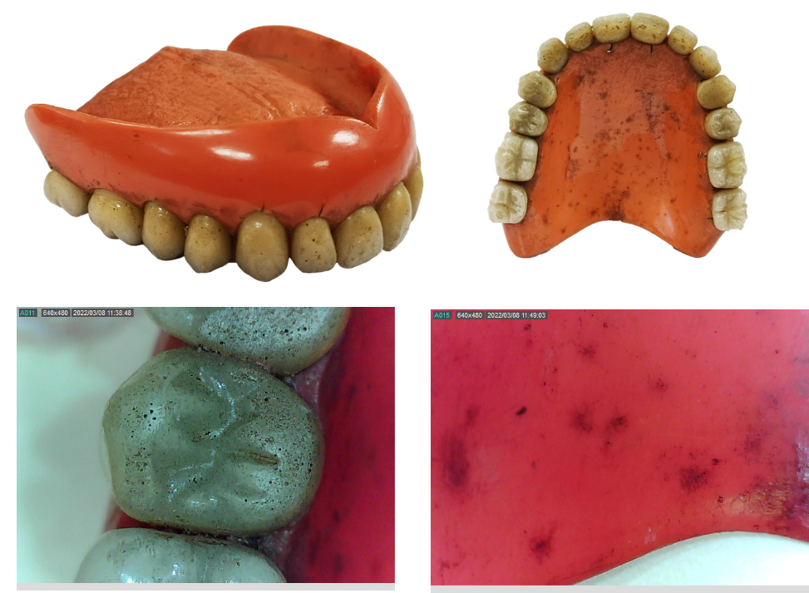

Figure 9. Photographs with a 65MP camera (top) and with a Dinolite USB digital microscope AM2111-0.3MP (bottom) showing the overall conservation condition of 2002.99.5780, showing the brown areas across the red celluloid and yellowed teeth with dark spots.

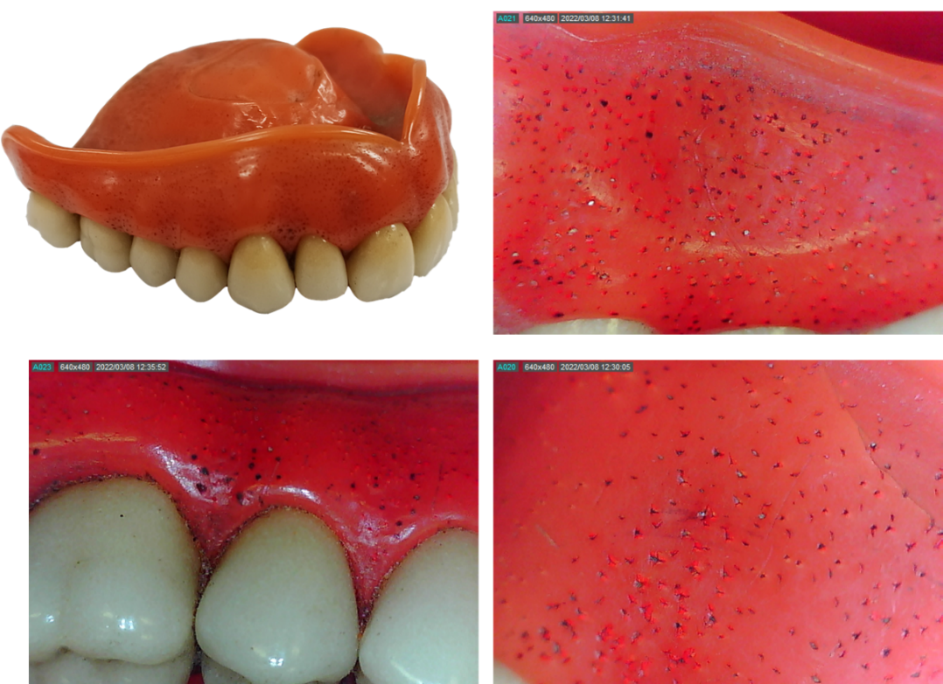

Figure 10. Photographs with a 65MP camera (top) and with a Dinolite USB digital microscope AM2111-0.3MP (bottom) showing the conservation condition of 92.2.0924, namely the pitting effect at the celluloid gums.

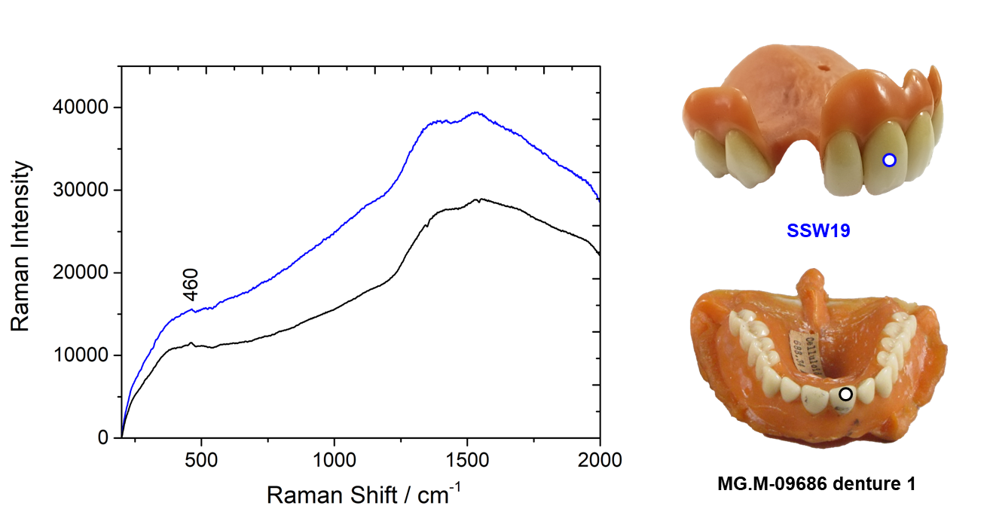Figure 11. Handheld Raman spectra of the teeth of celluloid dentures SSW19 (2s) and MG.M-09686 denture 1 (3.7s). The tooth analyzed for each denture is identified with a circle.

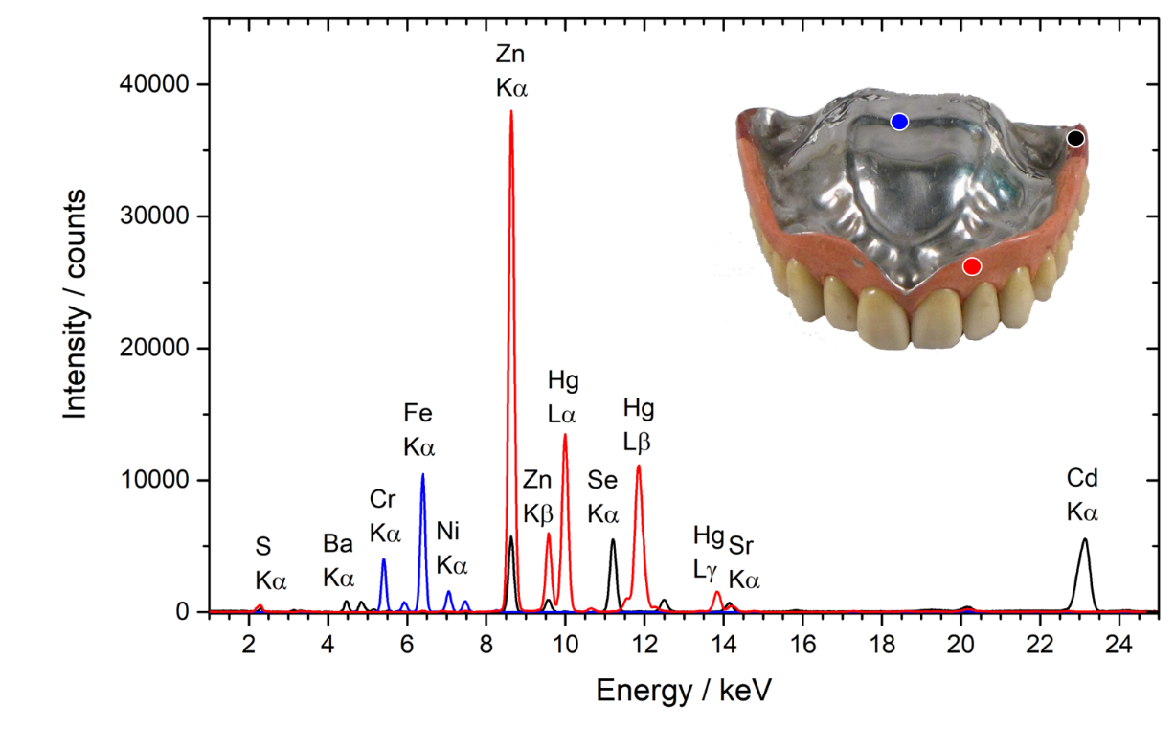
Figure 12. XRF spectrum of NMAH’s vulcanized rubber denture MG.291116.0046 in three different points, marked in the denture’s photograph.
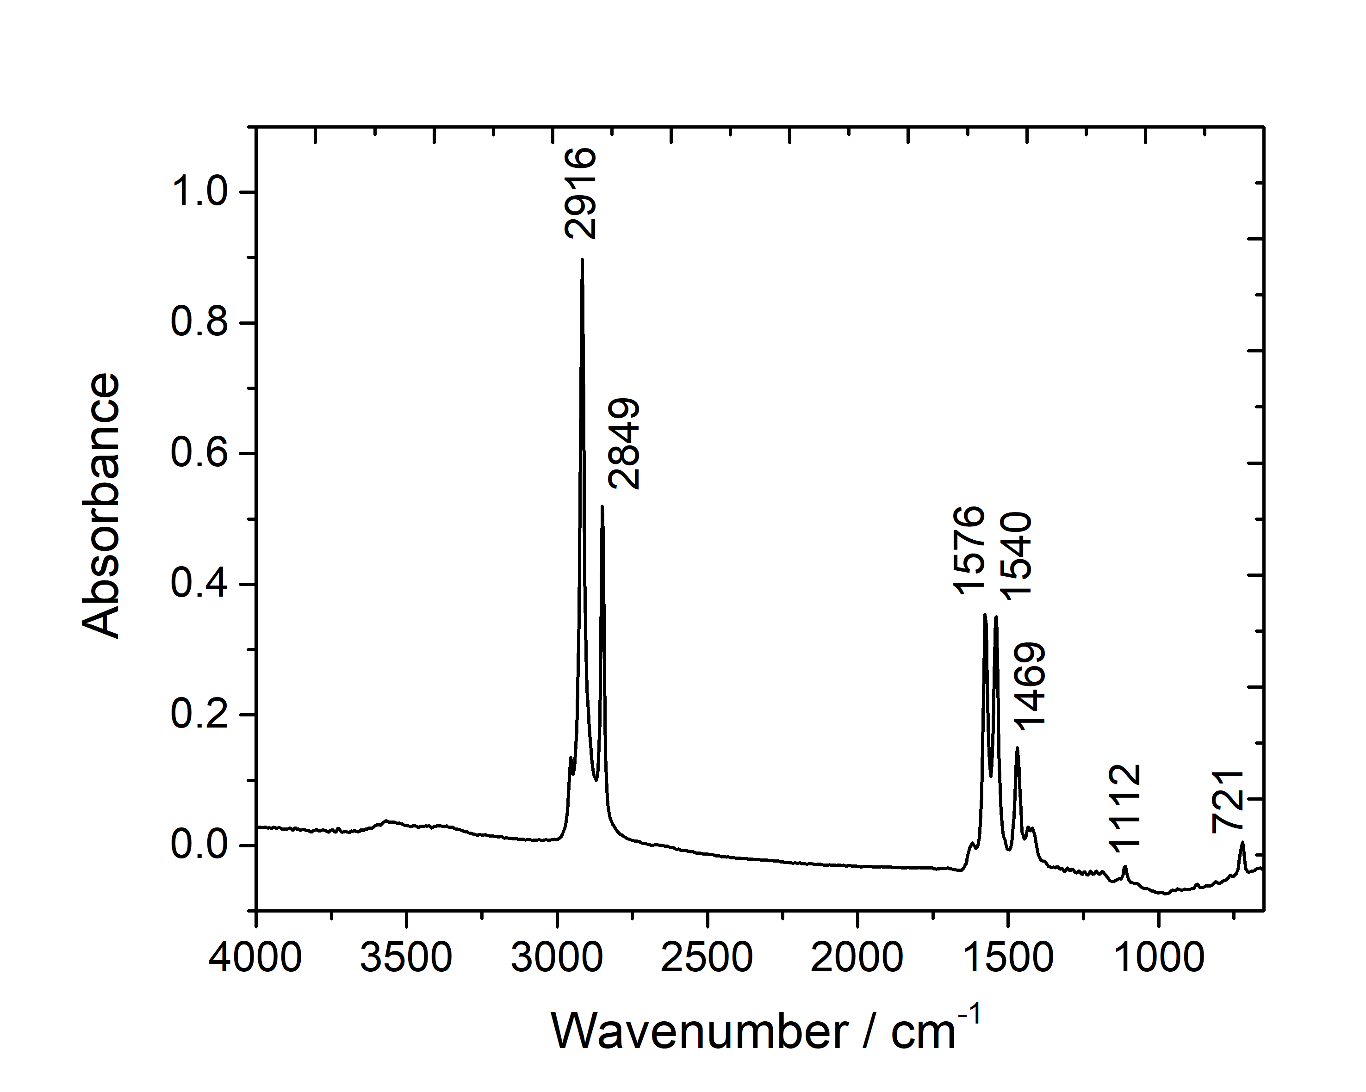
Fig 13. Infrared spectrum of a calcium stearate reference, for more details on this reference preparation and characterization please see Otero et al. (2014).

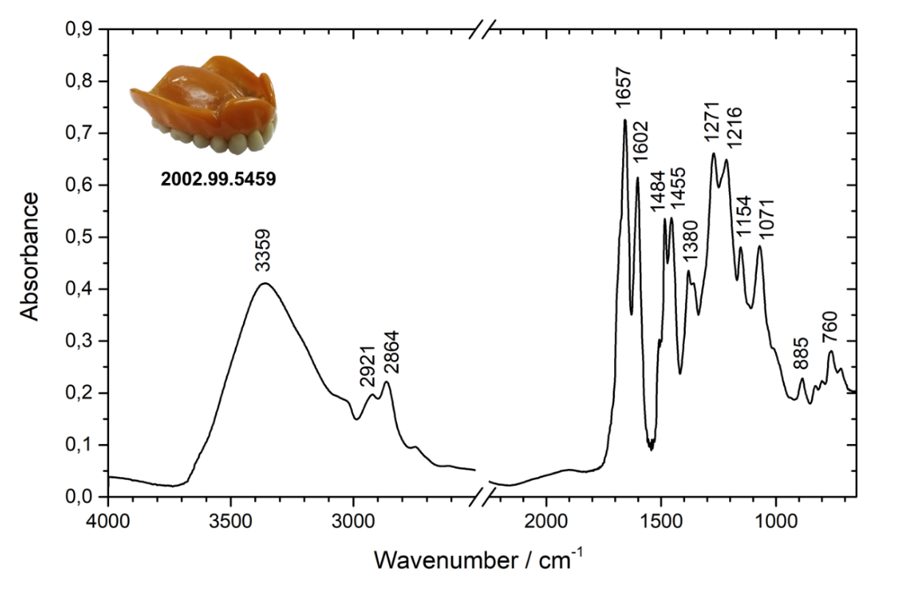

Figure 14. Infrared spectra of NMD dental plate 2002.99.5496 (probably a Luxene dental plate from the Bakelite Corporation).

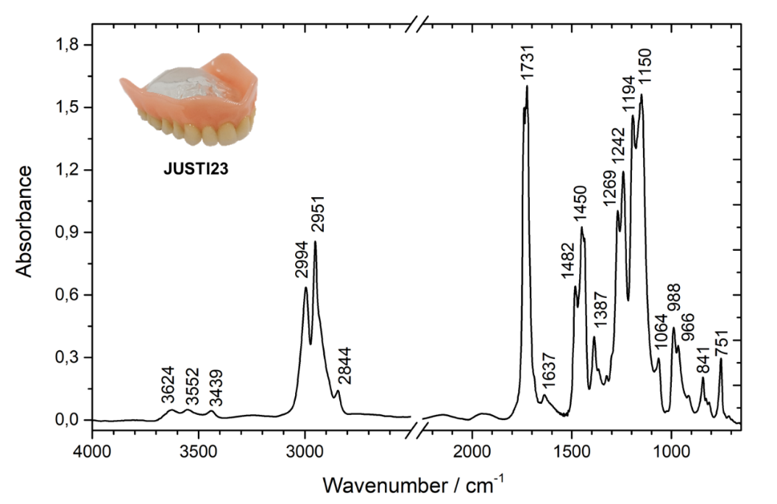

Figure 15. Infrared spectra of NMD dental plate JUSTI 23 identified as PMMA. Bands at 1731 and 1150 cm⁻¹ are saturated.

.

