Additional file 1

Table S1. Artificial ageing converted to years in standard museum conditions
 | 1st light aging | 2nd light aging
Equivalent years in standard museum conditions ª | 5 | 10
Lux hours in chamber | 2,391,727 | 4,947,386
Lux in chamber | 6,649 | 7,114
Hours in chamber | 360 | 695
Days in chamber | 15 | 29
ª Lux hours in chamber / lux hours per year under standard museum conditions (200 lux per hour * 7 hours per day * 361 days per year)

Table S2. Material transparencies from 0–100%. From left to right: dry Evolon (10 x MAG), wet xanthan gum-stabilised emulsion (30 x MAG), dried HWR (10 x magnification), surfactant-free microemulsion (no magnification)
Fully opaque | More opaque | Translucent | Less transparent | Fully transparent
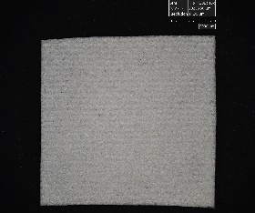 | 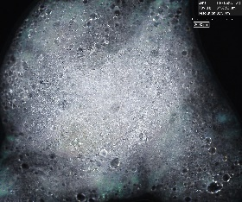 | 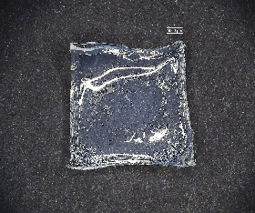 |  | 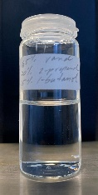
Evolon | Xanthan gum-stabilised emulsion | HWR | No example | Surfactant-free microemulsion

Table S3. Steps needed to test, prepare, apply, clear, and remove cleaning systems and delivery methods
 | Cleaning systems |  |  |  | Delivery methods
 | ME with surfactant | ME without surfactant | XE | OS | HWR | Evolon | Brush | Swab
Experimentation with exposure time ª |  |  | 1 |  | 1 | 1
Formulation ^{b} |  | 1 | 1 |  |  | 1
Pre-washing ^{c} |  |  |  |  | 1 | 1
Pre-loading ^{d} |  |  |  |  | 1 | 1
Cutting ^{e} |  |  |  |  | 1 | 1
Blotting |  |  |  |  | 1
Increasing contact |  |  |  |  | 1 | 1
Covering |  |  |  |  | 1
Gel/cloth removal |  |  |  |  | 1 | 1
Varnish solubilisation |  |  |  |  |  |  | 1 | 1
Varnish removal |  |  | 1 |  | 1 | 1
Cleaning system clearance | 1 |  | 1
Total no. of steps | 1 | 1 | 4 | 0 | 9 | 8 | 1 | 1
ME = microemulsion, XE = xanthan gum-stabilised emulsion, OS = organic solvent

ª Experimentation with exposure time addressed the need for additional experimentation with different exposure times to find a suitable stopping-point (when the varnish is acceptably reduced, or signs of oil paint disruptions, e.g., pigment pickup, are observed) for less transparent materials that cover a significant area of the test site, obstructing observation of the varnish removal process.

^{b} Formulation considered the weighing and mixing of substances but varied in time and effort, depending on the number of substances, and the method of mixing, e.g., by frothier, prolonged mixing using a magnetic stirrer, or a quick shake. These differences, however, were not considered substantial enough to warrant a weighting of this step, which was always counted as one.

^{c} Pre-washing was counted as a step in the preparation of Evolon, as it has been recommended to remove saturated fatty acids (SFAs) from the cloth that might be deposited in the underlying oil paint and induce the formation of crystalline metal soaps (1). On the other hand, this risk was demonstrated in an experimental setup where crystalline metal soaps were detected in an oil paint after a 50-minute exposure to Evolon, saturated with acetone or ethanol (1). Whether the cloth saturated with a microemulsion or a slow-diffusing solvent and applied for considerably less time, would likewise release SFAs into the paint, remains unconfirmed. Possibly the risk is significantly lower, as the transport of water-insoluble species into paint should be inhibited by microemulsions and slow-diffusing solvents (2–5). In addition, the recommended pre-washing protocol would be both costly and environmentally unfriendly, involving sequential washing in ethanol (1), which could lead to the omission of this step.

^{d} Pre-loading, i.e., the process of loading a gel or cloth with a cleaning system, was counted as one step for both HWR and Evolon, even though significantly more time was spent loading the gel compared to the cloth (12 hours versus a few seconds). On the other hand, in art conservation practice, a controlled solvent loading method has been developed for Evolon, involving additional weighing (cloth and cleaning system) and 12-hour containment (6). Despite the additional time spent, this method is recommendable, as it optimises material use and has been shown to reduce interactions between the cleaning system and paint (1). The quicker method used in this study, where the cleaning system was administered dropwise with a pipette, is more suitable for initial testing in varnish removal practice.

^{e} Cutting and handling, in general, was more difficult with HWR than Evolon, as the gel was slippery, which was also noted by Bartoletti (7). The added difficulty was not reflected in this analysis.

Table S4. ‘Initial cost’ calculated for cleaning systems and delivery methods
 | Product | CAS no. | Product no. | Supplier | Amount | Product price in euro | Price per 100 mL
Surfactant-containing ME | Polar Coating B |  | 2090002 | Deffner & Johann | 1 L | 60.00 | 6.00
Surfactant-free ME | Deionised water | 7732-18-5 | 38796 | Merck | 1 L | 15.50 | 1.55
Surfactant-free ME | 2-propanol 99.9% | 67-63-0 | 34863 | Merck | 1 L | 69.60 | 6.96
Surfactant-free ME | 1-butanol 99.9% | 71-36-3 | 537993 | Merck | 1 L | 48.87 | 4.89
Surfactant-free ME |  |  |  |  |  |  | 3.28 ª
XE | Deionised water | 7732-18-5 | 38796 | Merck | 1 L | 15.50 | 1.55
XE | BnOH | 100-51-6 | 8.22259 | Merck | 1 L | 88.60 | 8.86
XE | Xanthan gum | 11138-66-2 | 63450 | Kremer pigmente | 1 Kg | 33.75 | 3.38
XE |  |  |  |  |  |  | 3.04 ^{b}
OS | 2-propanol 99.9% | 67-63-0 | 34863 | Merck | 1 L | 69.60 | 6.96
 |  |  |  |  |  |  | Price per 100 g
Gel | HWR (1 pc) |  | 2092014 | Deffner & Johann | 0.051 Kg | 18.00 | 35.29 ^{c}
Cloth | Evolon (100 pcs) |  | 2219005 | Deffner & Johann | 1.600 Kg | 165.00 | 10.31 ^{d}
Swab | Cotton Wool Wadding (40 pcs) |  | 2201100 | Deffner & Johann | 4.480 Kg | 70.00 | 1.56
 | Wooden Sticks (100 pcs x 10) |  | 2203100 | Deffner & Johann | 0.790 Kg | 25.50 | 3.23
 |  |  |  |  |  |  | 1.98 ^{e}
ME = microemulsion, XE = xanthan gum-stabilised emulsion, OS = organic solvent

ª 65/25/10 wt.% water, 2-propanol, 1-butanol

^{b} 78.5/20/1.5 wt.% water, BnOH, xanthan gum

^{c} HWR can be reused up to five time, but varnish removal efficacy can decrease with each application (8).

^{d} Reusing Evolon has been discouraged based on frayed fibre-edges, observed at 2000x magnification, after seven days immersion either in acetone or ethanol (1).

^{e} 75/25 wt.% cotton wool wadding, wooden sticks

Table S5. Organic solvents used for four cleaning systems with hazard categories and prevention precautionary codes. Hazard categories linked with the organic solvents included in the cleaning systems through the European Parliament, Council of the European Parliament (9). Duplicates and lower hazard categories within one system were disregarded in the assessment (annotated in blue). For example, ‘Flam. Liq. 3’ was disregarded for the surfactant-free microemulsion, as less hazardous than ‘Flam. Liq. 2.’ The prevention precautionary codes highlighted in bold for the surfactant-containing microemulsion were provided by the manufacturer (10). This cleaning system also contains alkyl(C9-11) alcohol, ethoxylated surfactants, which have not been assessed by the European Parliament, Council of the European Parliament.
 | Organic solvents | CAS no. | Hazard categories | P2-- codes
Surfactant-containing ME | Butanone | 78-93-3 | Flam. Liq. 2 | P210, P233, P240, P241, P242, P243, P280
Surfactant-containing ME | Butanone | 78-93-3 | STOT SE 3 | P261, P271
Surfactant-containing ME | Butanone | 78-93-3 | Eye Irrit. 2 | P264, P265, P280
Surfactant-containing ME | 2-butanol | 78-92-2 | Flam. Liq. 3
Surfactant-containing ME | 2-butanol | 78-92-2 | STOT SE 3
Surfactant-containing ME | 2-butanol | 78-92-2 | Eye Irrit. 2
Surfactant-free ME | 2-propanol | 67-63-0 | Flam. Liq. 2 | P210, P233, P240, P241, P242, P243, P280
Surfactant-free ME | 2-propanol | 67-63-0 | STOT SE 3 | P261, P271
Surfactant-free ME | 2-propanol | 67-63-0 | Eye Irrit. 2
Surfactant-free ME | 1-butanol | 71-36-3 | Flam. Liq. 3
Surfactant-free ME | 1-butanol | 71-36-3 | Acute Tox. 4 (oral) | P264, P270
Surfactant-free ME | 1-butanol | 71-36-3 | STOT SE 3
Surfactant-free ME | 1-butanol | 71-36-3 | Skin Irrit. 2 | P264, P280
Surfactant-free ME | 1-butanol | 71-36-3 | Eye Dam. 1 | P264, P265, P280
XE | BnOH | 100-51-6 | Acute Tox. 4 (inhale) | P261, P271
XE | BnOH | 100-51-6 | Acute Tox. 4 (oral) | P264, P270
OS | 2-Propanol | 67-63-0 | Flam. Liq. 2 | P210, P233, P240, P241, P242, P243, P280
OS | 2-Propanol | 67-63-0 | STOT SE 3 | P261, P271
OS | 2-Propanol | 67-63-0 | Eye Irrit. 2 | P264, P265, P280

Table S6. Precautionary categories, codes and phrases linked to the organic solvents in Table 5
Categories | Codes | Phrases
Standard laboratory practice | P264 | Wash hands thoroughly after handling.
Standard laboratory practice | P265 | Do not touch eyes.
Standard laboratory practice | P270 | Do not eat, drink or smoke when using this product.
Ventilation | P261 | Avoid breathing dust/fume/gas/mist/vapours/spray.
Ventilation | P271 | Use only outdoors or in a well-ventilated place.
PPE | P280 | Wear protective gloves/protective clothing/eye protection/face protection/hearing protection/…
Containment | P233 | Keep container tightly closed.
Fire prevention | P240 | Ground and bond container and receiving equipment.
Fire prevention | P210 | Keep away from heat, hot surfaces, sparks, open flames and other ignition sources. No smoking.
Fire prevention | P241 | Use explosive-proof […] equipment
Fire prevention | P242 | Use non-sparking tools.
Fire prevention | P243 | Take action to prevent static discharges.
Table S7. Pigment pickup from five repeated tests with the surfactant-containing microemulsion + HWR on the brown earth oil paint sample
Test no | Swab | Test area | Pigment pickup | Numerical value
6 | dry | bottom | Minor | 2
6 | dry | top | Trace | 1
7 | dry | bottom | Minor | 2
7 | dry | top | Trace | 1
8 | dry | bottom | Minor | 2
8 | dry | top | Minor | 2
9 | dry | bottom | Trace | 1
9 | dry | top | Minor | 2
10 | dry | bottom | Trace | 1
10 | dry | top | Minor | 2
6 | wet | total | None | 0
7 | wet | total | None | 0
8 | wet | total | None | 0
9 | wet | total | None | 0
10 | wet | total | None | 0
 |  |  | SUM | 16
 |  |  | MIN | 0 (= ‘none’)
 |  |  | MAX | 2 (= ‘minor’)

Table S8. Pigment pickup from five repeated tests with the surfactant-free microemulsion + Evolon on the brown earth oil paint sample
Test no | Swab | Test area | Pigment pickup | Numerical value
1 | dry | bottom | Minor | 2
1 | dry | top | Trace | 1
2 | dry | bottom | Trace | 1
2 | dry | top | Trace | 1
3 | dry | bottom | Minor | 2
3 | dry | top | Trace | 1
4 | dry | bottom | Trace | 1
4 | dry | top | Minor | 2
5 | dry | bottom | None | 0
5 | dry | top | Minor | 2
 |  |  | SUM | 13
 |  |  | MIN | 0 (= ‘none’)
 |  |  | MAX | 2 (= ‘minor’)

Table S9. Pigment pickup from five repeated tests with the xanthan gum-stabilised emulsion + brush on the lead white oil paint sample
Test no | Swab | Pigment pickup | Numerical value
1 | dry 1 | None | 0
1 | dry 2 | Trace | 1
2 | dry 1 | None | 0
2 | dry 2 | Minor | 2
3 | dry 1 | None | 0
3 | dry 2 | Trace | 1
4 | dry 1 | None | 0
4 | dry 2 | None | 0
5 | dry 1 | None | 0
5 | dry 2 | Trace | 1
1 | wet | Trace | 1
2 | wet | Trace | 1
3 | wet | Trace | 1
4 | wet | Trace | 1
5 | wet | None | 0
 |  | SUM | 9
 |  | MIN | 0 (= ‘none’)
 |  | MAX | 2 (= ‘minor’)

Table S10. Pigment pickup from five repeated tests with the surfactant-free microemulsion + swab on the lead white oil paint sample
Test no | Swab | Pigment pickup | Numerical value
6 | 1 | None | 0
6 | 2 | None | 0
6 | 3 | None | 0
6 | 4 | Trace | 1
6 | 5 | Trace | 1
7 | 1 | None | 0
7 | 2 | None | 0
7 | 3 | None | 0
7 | 4 | Trace | 1
7 | 5 | Trace | 1
8 | 1 | None | 0
8 | 2 | None | 0
8 | 3 | None | 0
8 | 4 | None | 0
8 | 5 | None | 0
9 | 1 | None | 0
9 | 2 | None | 0
9 | 3 | Trace | 1
9 | 4 | Trace | 1
9 | 5 | Trace | 1
10 | 1 | None | 0
10 | 2 | None | 0
10 | 3 | None | 0
10 | 4 | Trace | 1
10 | 5 | Trace | 1
 |  | SUM | 9
 |  | MIN | 0 (= ‘none’)
 |  | MAX | 1 (= ‘trace’)

Table S11. Pigment pickup from five repeated tests with the organic solvent + swab on the lead white oil paint sample
Test no | Swab | Pigment pickup | Numerical value
11 | 1 | None | 0
11 | 2 | None | 0
11 | 3 | None | 0
11 | 4 | None | 0
11 | 5 | Trace | 1
12 | 1 | None | 0
12 | 2 | None | 0
12 | 3 | None | 0
12 | 4 | None | 0
12 | 5 | None | 0
13 | 1 | None | 0
13 | 2 | Trace | 1
13 | 3 | None | 0
13 | 4 | None | 0
13 | 5 | Trace | 1
14 | 1 | None | 0
14 | 2 | None | 0
14 | 3 | Trace | 1
14 | 4 | None | 0
14 | 5 | None | 0
15 | 1 | None | 0
15 | 2 | None | 0
15 | 3 | None | 0
15 | 4 | None | 0
15 | 5 | None | 0
 |  | SUM | 4
 |  | MIN | 0 (= ‘none’)
 |  | MAX | 1 (= ‘trace’)

Figure S1. Star diagrams for the independent evaluation parameters shown separately for cleaning systems and delivery methods

Cleaning systems (overlapping lines were staggered for visibility)

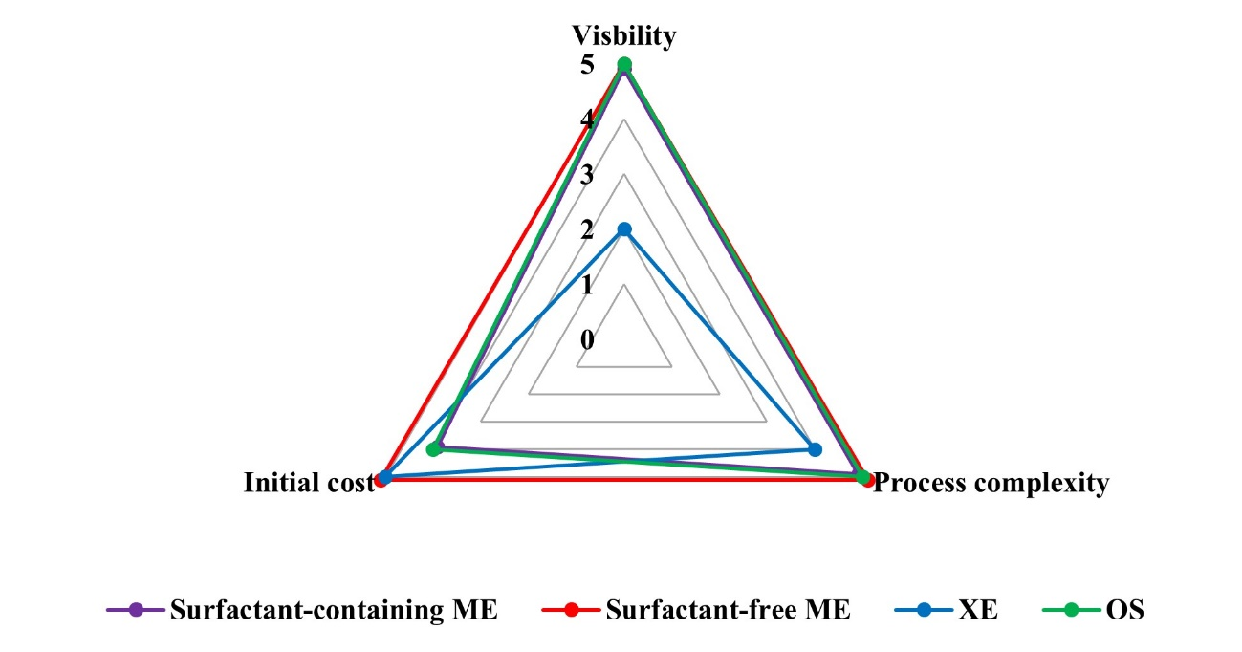

Delivery methods

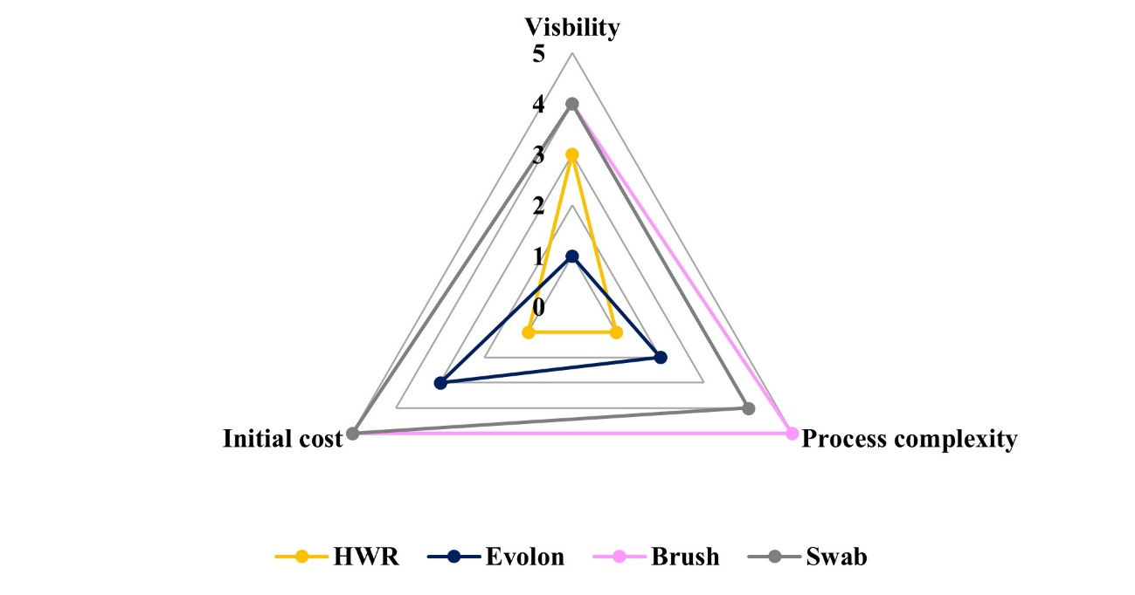

Figure S2. ATR-FTIR spectra of: a. xanthan gum-stabilised emulsions used to remove dammar varnish from the lead white oil paint sample, b. lead white, c. xanthan gum and d. dammar
a. Average of the 5 xanthan gum-stabilised emulsions after treatment (red spectrum). Image of a used gel-emulsion (mock-up D3, test 1) taken in UV light using the Hirox microscopy (HR-1020E lens) at 30 x magnification.
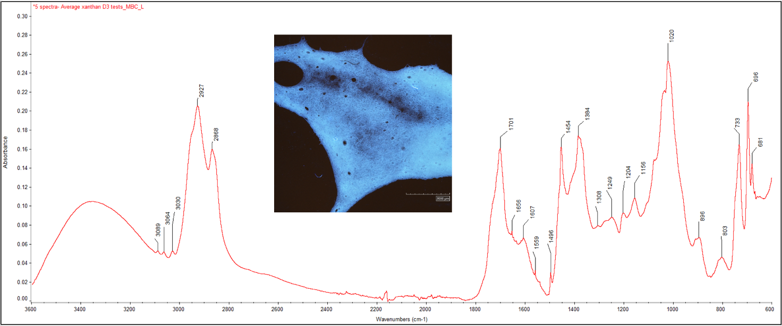
Shoulder on the 1384 IR band and 681 were considered evidence of based lead carbonate in the gel-emulsions. IR bands 1607, 1020, 733, and 696 indicated xanthan gum, and 2927, 2868, 1701, 1454, and 1384 (without shoulder) were associated with dammar varnish. Spectra comparisons provided below.
b. Xanthan gum-stabilised emulsions after treatment (red spectrum) and basic lead carbonate (unknown source) (blue spectrum)
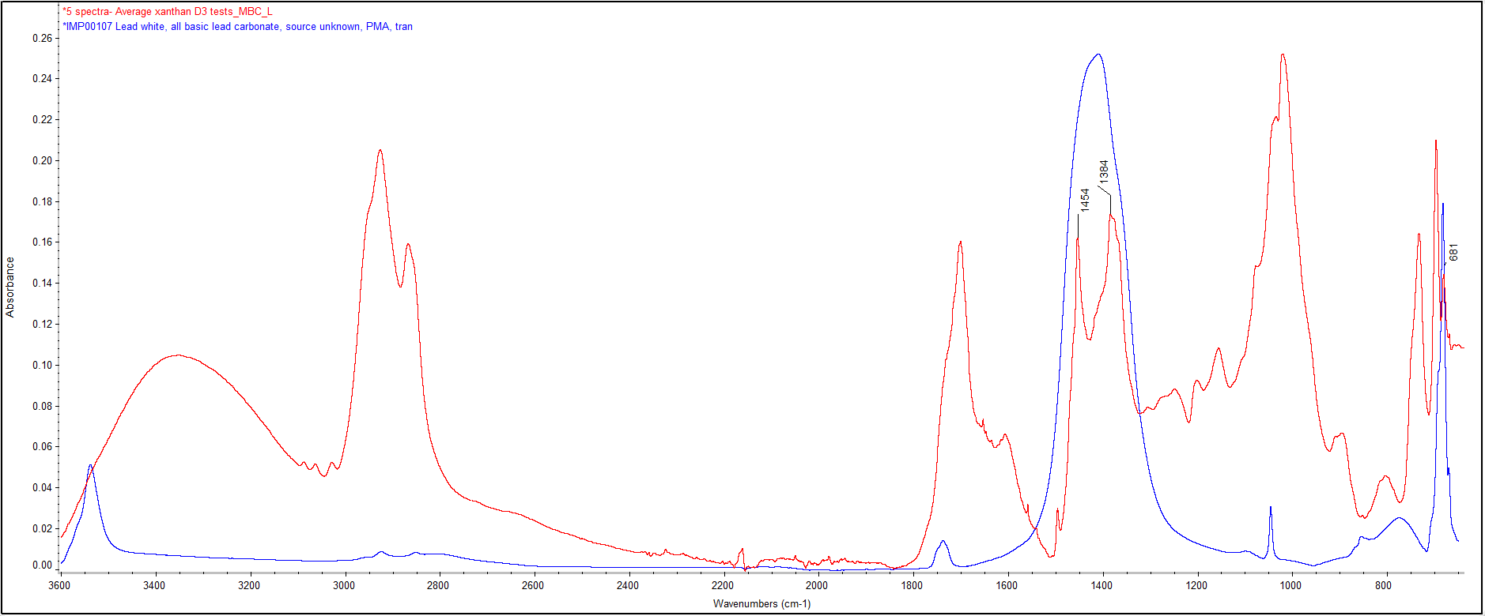

c. Xanthan gum-stabilised emulsions after treatment (red spectrum) and pure xanthan gum (VANZAN® NF-C Xanthan Gum) (blue spectrum):
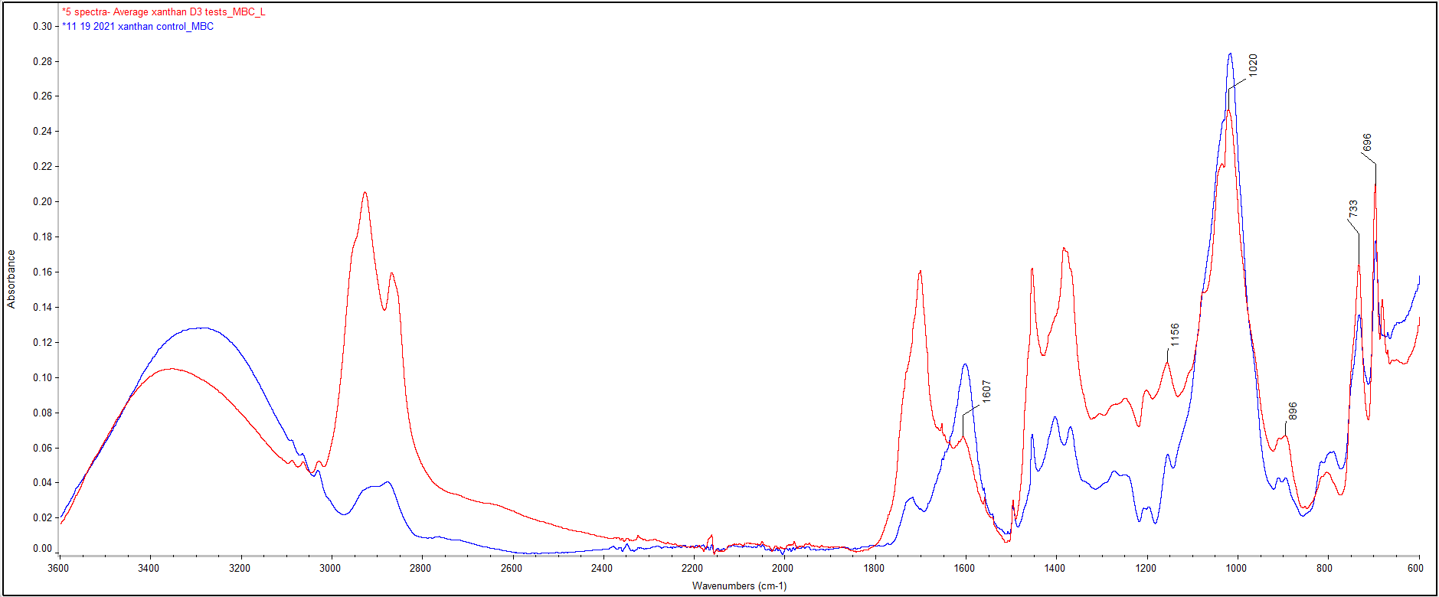
d. Xanthan gum-stabilised emulsions after treatment (red spectrum) and pure dammar (Gum Damar, best quality) (purple spectrum):
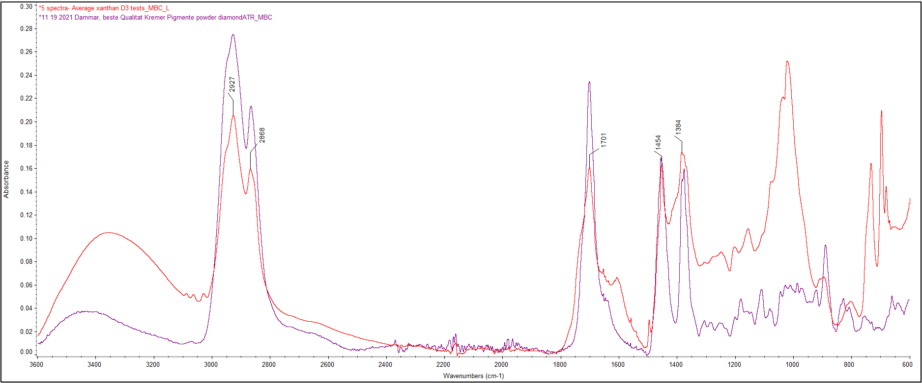

Figure S3. ER-FTIR of a varnished, brown earth oil paint sample (mock-up I3) exposed to Polar Coating B via HWR (tests 7 to 9)
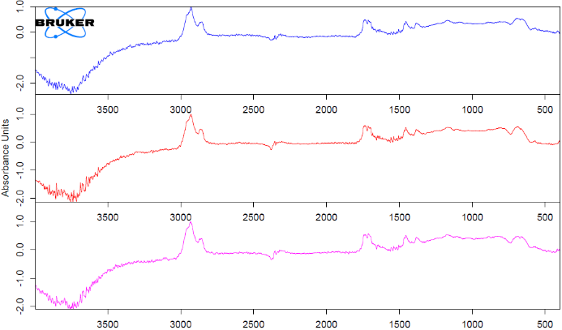

Figure S4. ER-FTIR of a varnished, brown earth oil paint sample (mock-up I3) unexposed to cleaning
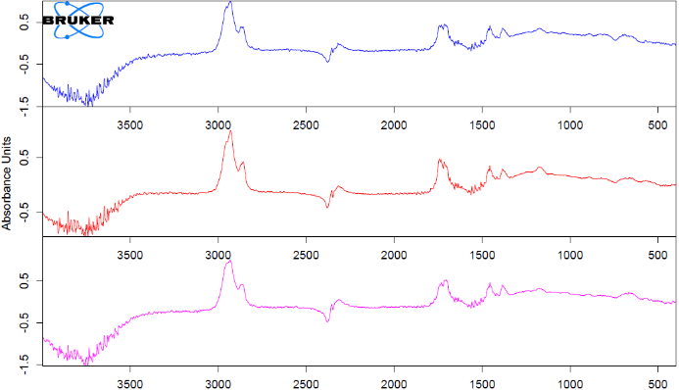

Figure S5. ER-FTIR of a HWR gel after immersion in Polar Coating B
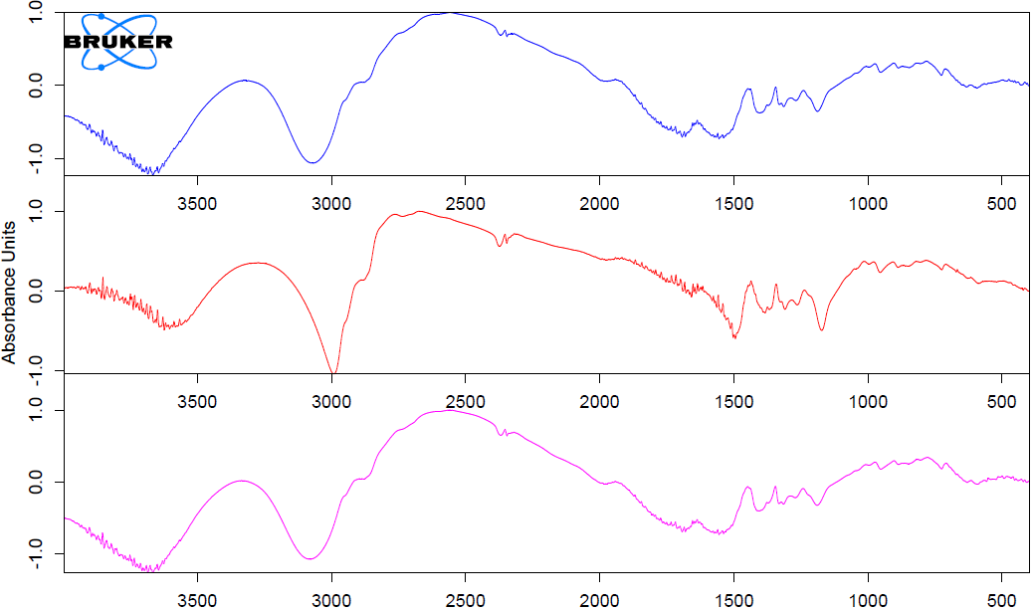

Figure S6. ER-FTIR of a varnished, lead white oil paint sample (mock-up D3) exposed to the xanthan gum-stabilised emulsion with BnOH (tests 3 to 5)
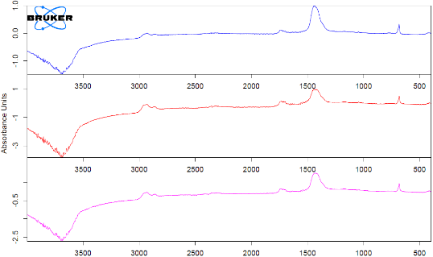

Figure S7. ER-FTIR of a varnished, lead white oil paint sample (mock-up I9) unexposed to cleaning
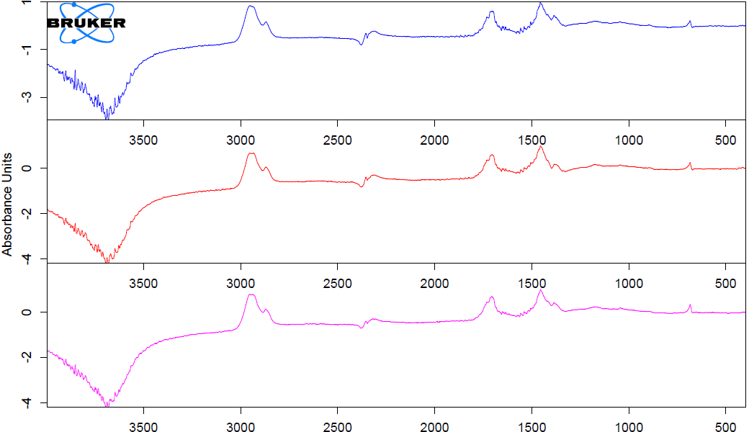

Figure S8. ER-FTIR of the xanthan gum-stabilised emulsion with BnOH
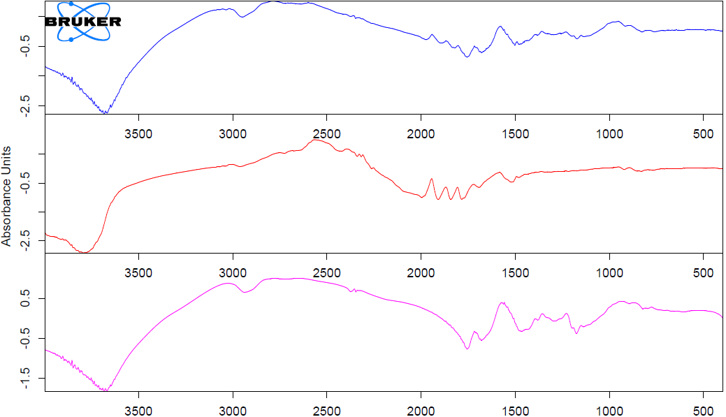

References

1. Baij L, Liu C, Buijs J, Alvarez Martin A, Westert D, Raven L, et al. Understanding and optimizing Evolon® CR for varnish removal from oil paintings. Herit Sci. 2021;9(1):155.
2. Phenix A. The swelling of artists’ paints in organic solvents. Part 2, comparative swelling powers of selected organic solvents and solvent mixtures. J Am Inst Conserv. 2002;41(1):61–90.
3. Baglioni P, Chelazzi D, Giorgi R, Poggi G. Colloid and materials science for the conservation of cultural heritage: cleaning, consolidation, and deacidification. Langmuir. 2013;29(17):5110–22.
4. Baij L, Hermans JJ, Keune K, Iedema PD. Time-dependent ATR-FTIR spectroscopic studies on solvent diffusion and film swelling in oil paint model systems. Macromolecules. 2018;51(18):7134–44.
5. Baij L, Buijs J, Hermans JJ, Raven L, Iedema PD, Keune K, et al. Quantifying solvent action in oil paint using portable laser speckle imaging. Sci Rep. 2020;10(1):10574.
6. Tauber G, Smelt S, Noble P, Kirsch K, Siejek A, Keune K, et al. Evolon CR: Its use from a scientific and practical conservation perspective. In: AIC Paintings Specialty Group Postprints. 2018. p. 45–9.
7. Bartoletti A, Barker R, Chelazzi D, Bonelli N, Baglioni P, Lee J, et al. Reviving WHAAM! a comparative evaluation of cleaning systems for the conservation treatment of Roy Lichtenstein’s iconic painting. Herit Sci. 2020;8(1):9.
8. Nanorestore Gel® Dry [Internet]. Center for Colloid and Surface Science (CSGI); 2019. Available from: https://www.csgi.unifi.it/products/downloads/geldry_ts_eng.pdf
9. Consolidated text: Regulation (EC) No 1272/2008 of the European Parliament and of the Council on classification, labelling and packaging of substances and mixtures, amending and repealing Directives 67/548/EEC and 1999/45/EC, and amending Regulation (EC) No 1907/2006 [Internet]. European Parliament, Council of the European Union; 2023 p. 1550. Available from: https://eur-lex.europa.eu/legal-content/EN/TXT/PDF/?uri=CELEX:02008R1272-20230731
10. Nanorestore Cleaning Polar Coating B [Internet]. Center for Colloid and Surface Science (CSGI); 2015. Available from: https://www.csgi.unifi.it/products/downloads/cleaning_sds.pdf

