GLASS BEADS FROM A SCYTHIAN GRAVE ON THE ISLAND OF KHORTYTSIA (ZAPORIZHZHIA, UKRAINE): INSIGHTS INTO BEAD MAKING THROUGH 3D IMAGING
Dmytro Nykonenko^{1,2}*, Oleh Yatsuk¹, Laura Guidorzi^{3,4}, Alessandro Lo Giudice^{3,4}, Francesca Tansella^{3,4}, Ludovica Pia Cesareo^{3,5}, Giusi Sorrentino³, Patrizia Davit¹, Monica Gulmini¹, Alessandro Re^{3,4}
¹ Department of Chemistry, University of Turin, Via Pietro Giuria, 7, 10125 Turin, Italy
² Khortytsia National Reserve, Vulytsya Starogo Redutu 9, 69017 Zaporizhzhia, Ukraine
³ Department of Physics, University of Turin, Via Pietro Giuria, 1, 10125 Turin, Italy
⁴ Istituto Nazionale di Fisica Nucleare (INFN) Sezione di Torino, Via Pietro Giuria, 1, 10125 Turin, Italy
⁵ Department of Environmental Sciences, Informatics and Statistics, Ca’ Foscari University, via Torino, 155, 30172 Mestre (VE), Italy
* corresponding author: dmytro.nykonenko@unito.it

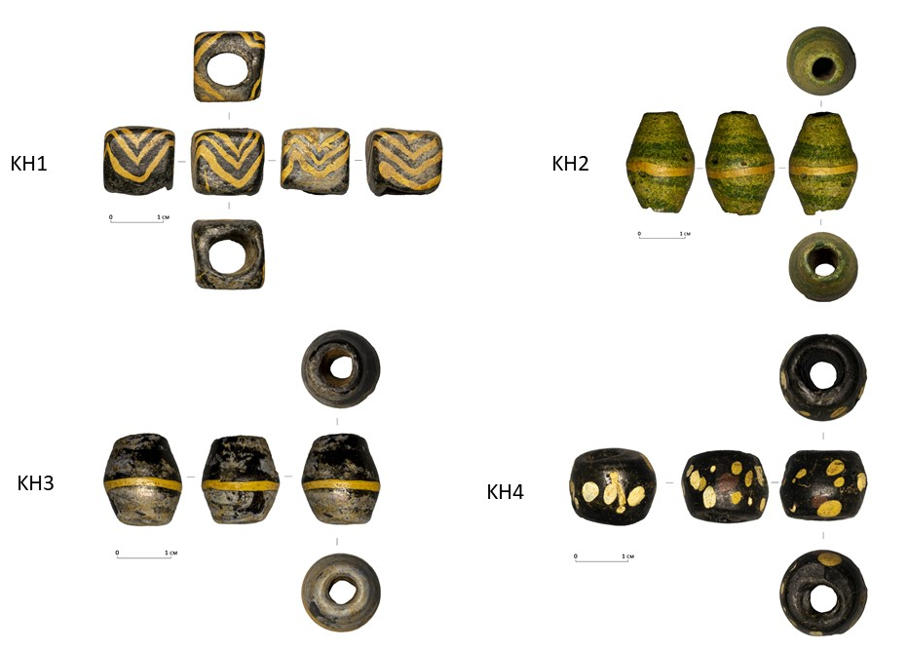
Figure S1. Images of the beads from an archival documentation perspective

