Some considerations about selective damaged induced by pigment-medium interactions in a Neoplasticist oil canvas painting: Composition dans le cône avec couleur orange by G. Vantongerloo (1929)
F.C. Izzo, M. Gnemmi, M.A. Herrero-Cortell, A.M.Garcìa-Castillo, M-Martinez-Lòpez, L.Fuster-Lòpez

SUPPLEMENTARY MATERIALS
Multiband imaging

Figure S.1 UVFC image with detail of pigment checker
Figure S.2 IRFC image with detail of pigment checker
Figure S.3 UVR image with crack detail
Figure S.4 UVL image with repainting and cracks details
Figure S.5 IRT image with repainting and drawings details

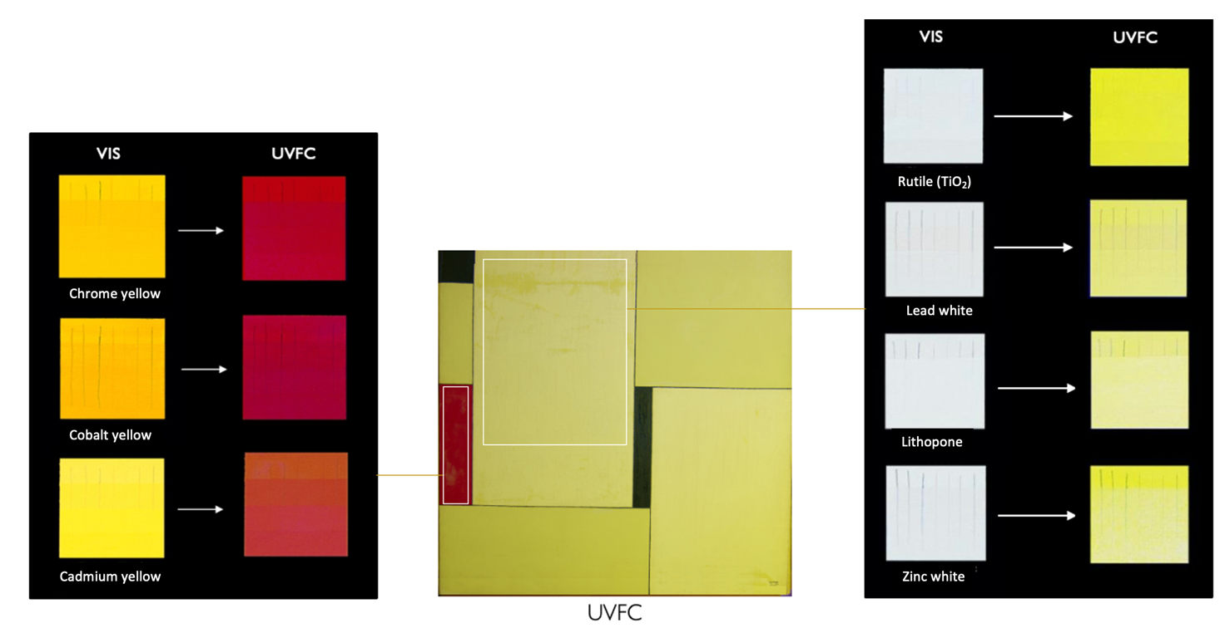
Figure S.1 UVFC image with detail of pigment checker

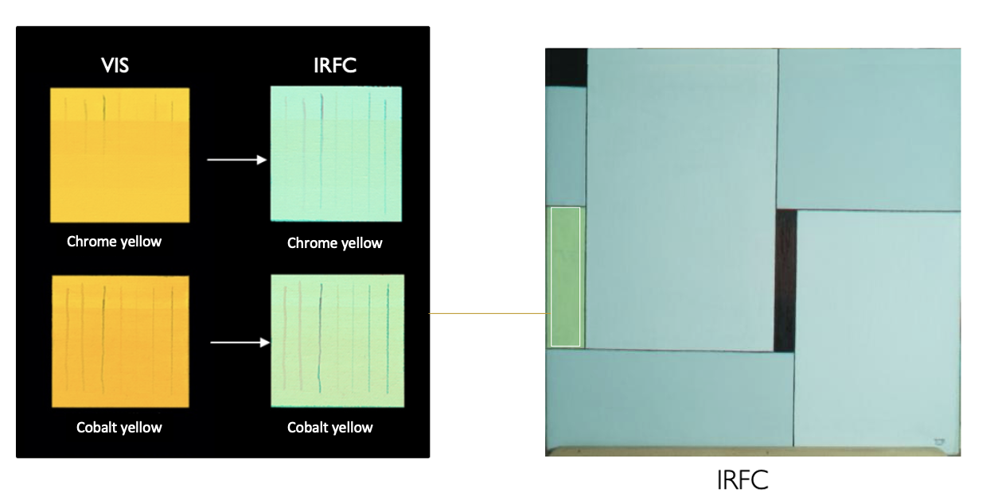
Figure S.2. IRFC image with detail of pigment checker

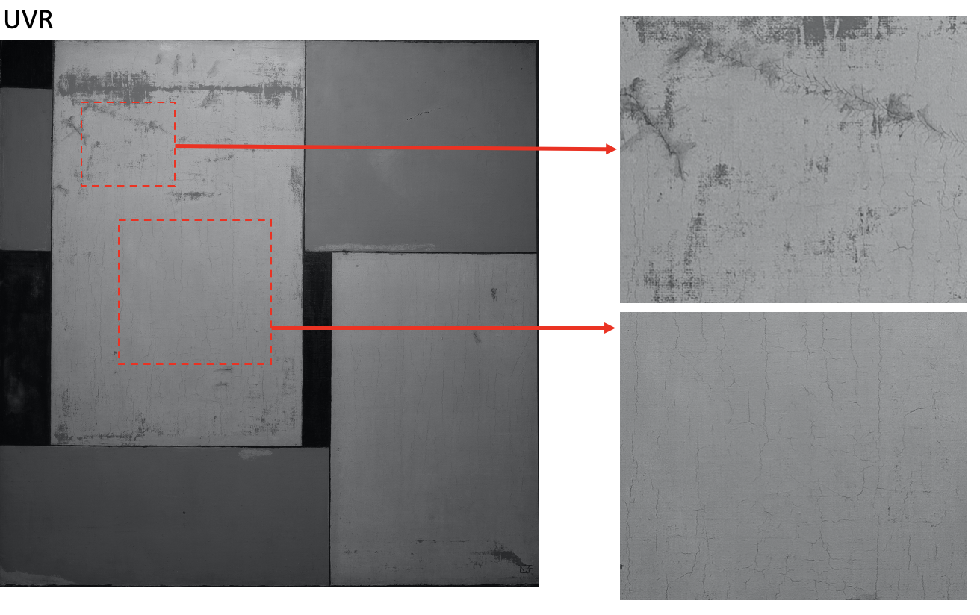
Figure S.3 UVR image with crack detail

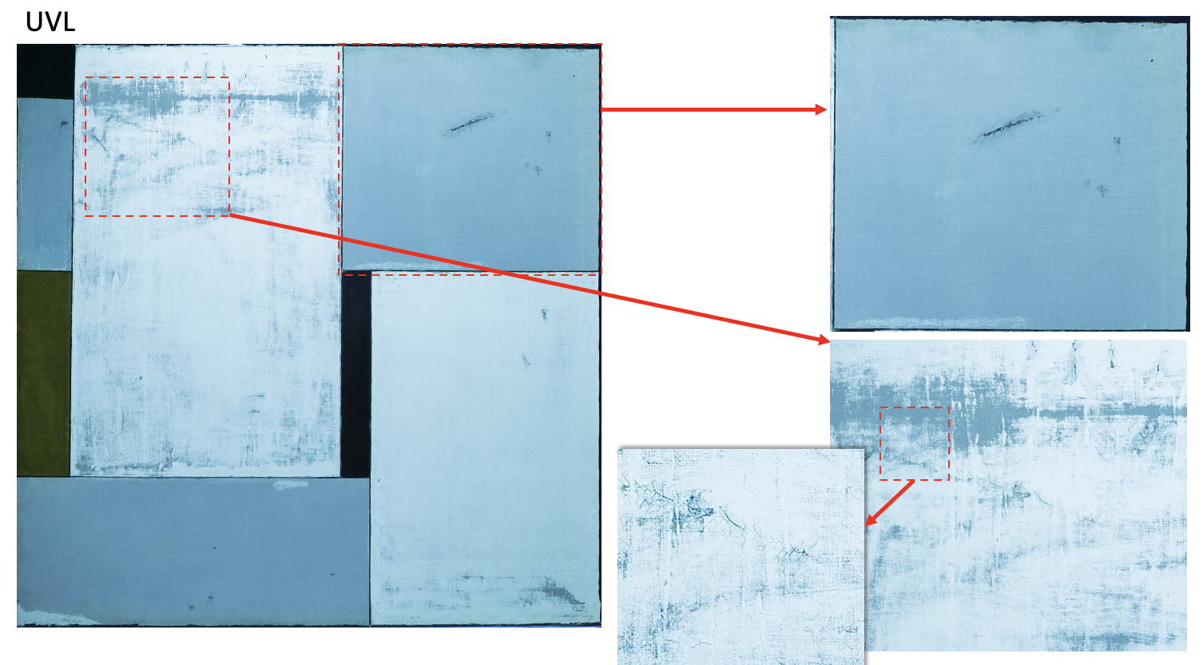

Figure S.4 UVL image with repainting and cracks details

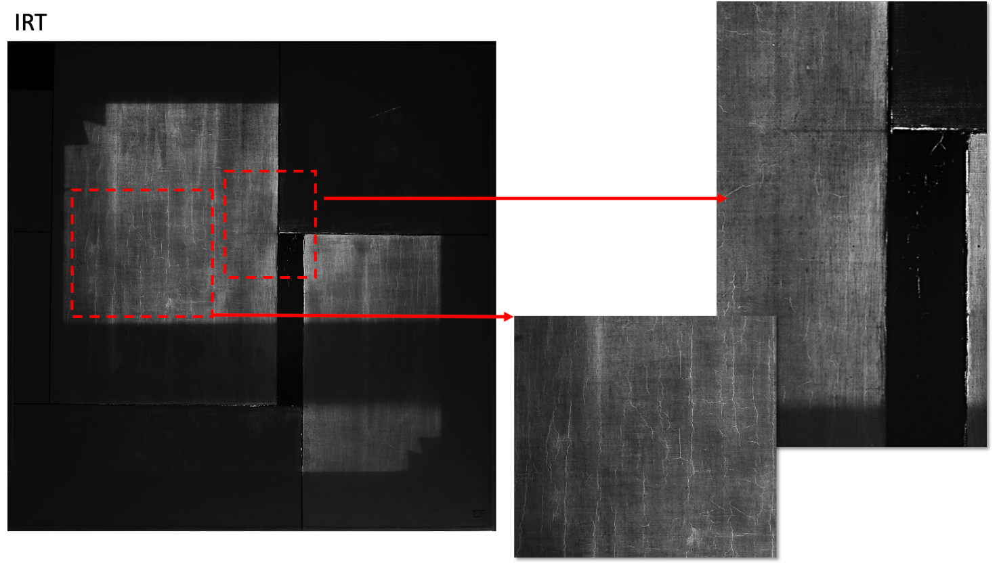

Figure S.5 IRT image with repainting and drawings details

SUPPLEMENTARY MATERIALS
Chemical investigation of artist’s materials

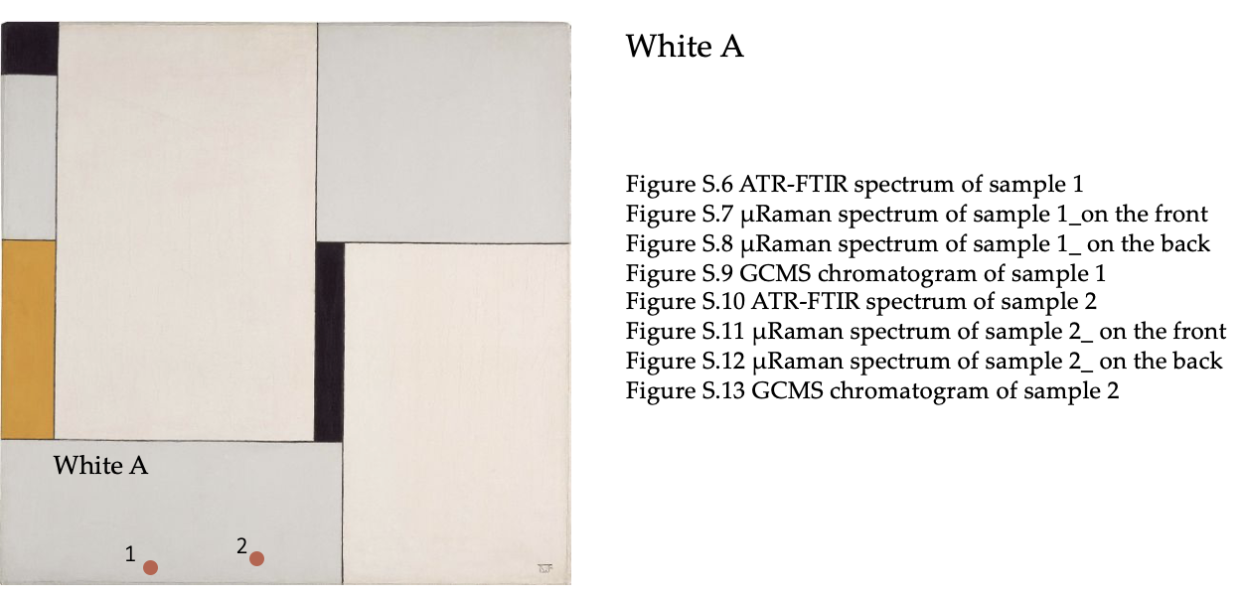

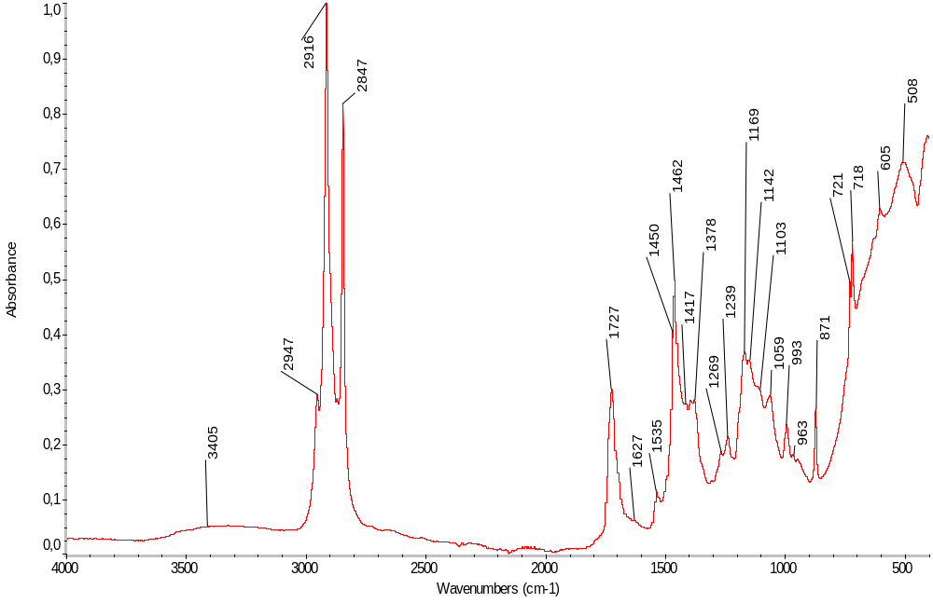
Figure S.6 ATR-FTIR spectrum of sample 1
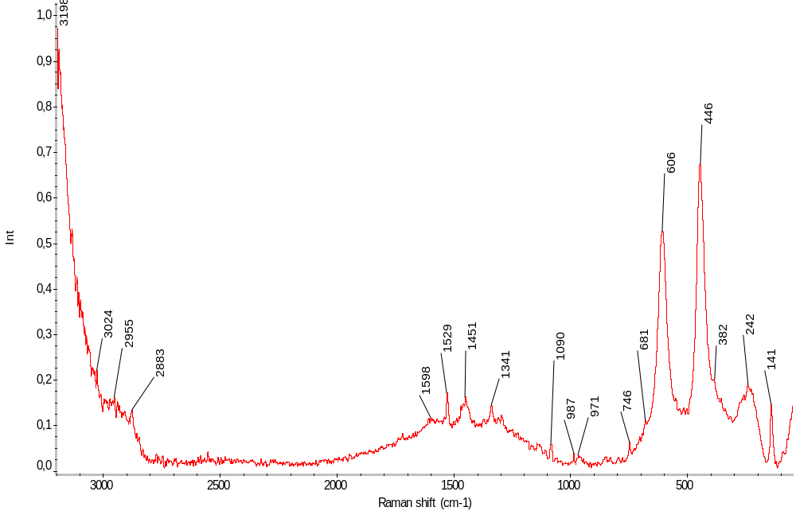
Figure S.7 μRaman spectrum of sample 1_on the front

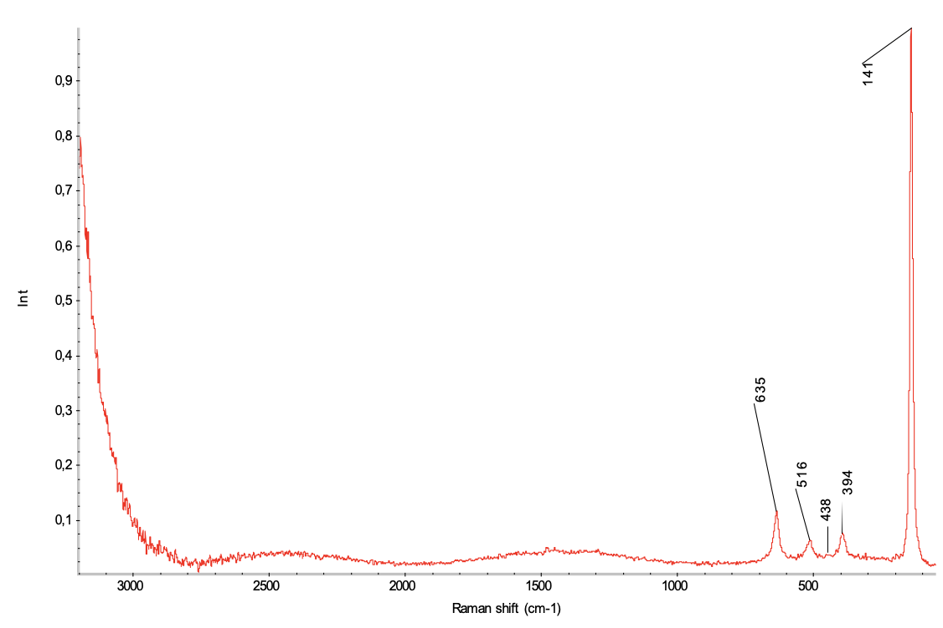
Figure S.8 μRaman spectrum of sample 1_ on the back
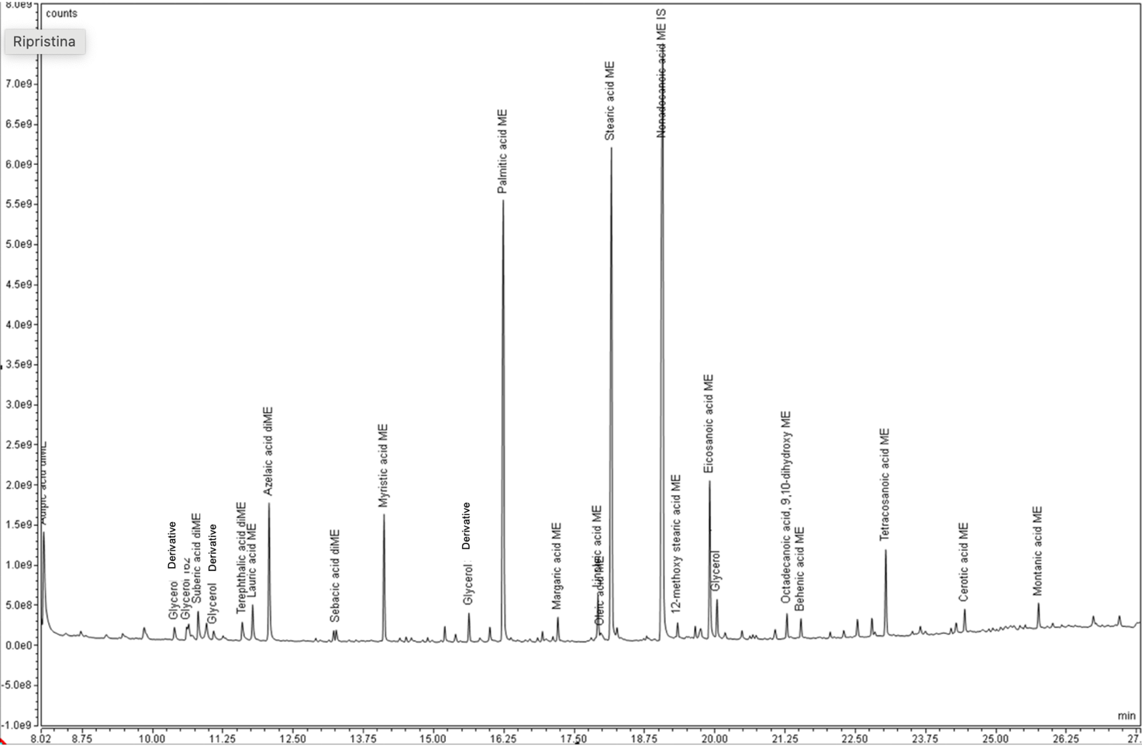

Figure S.9 GCMS chromatogram of sample 1

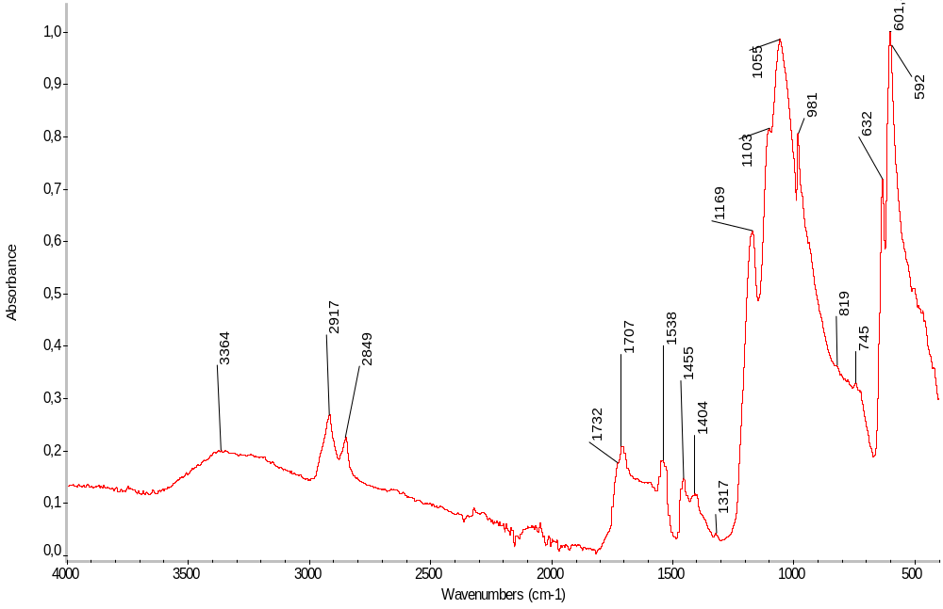
Figure S.10 ATR-FTIR spectrum of sample 2

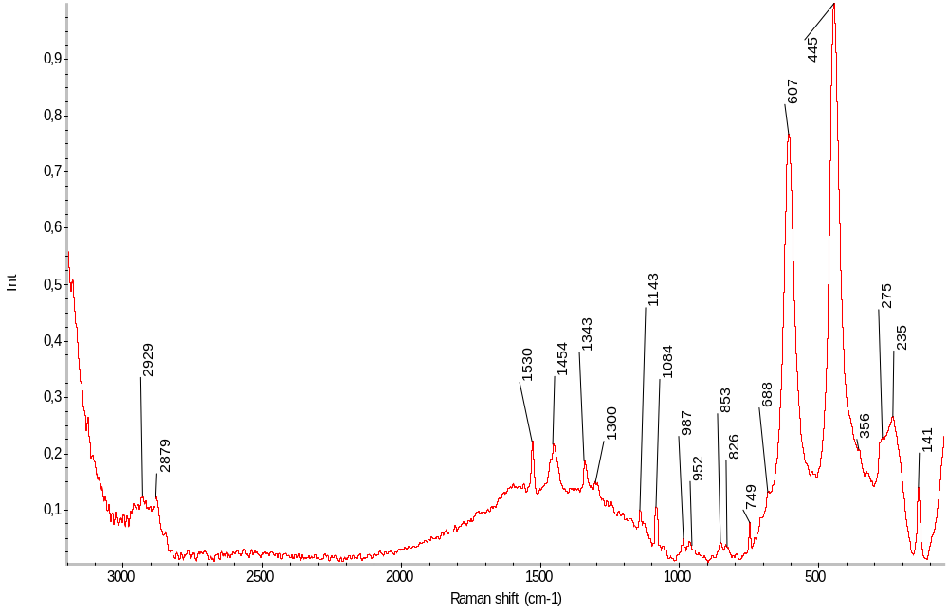
Figure S.11 μRaman spectrum of sample 2_ on the front

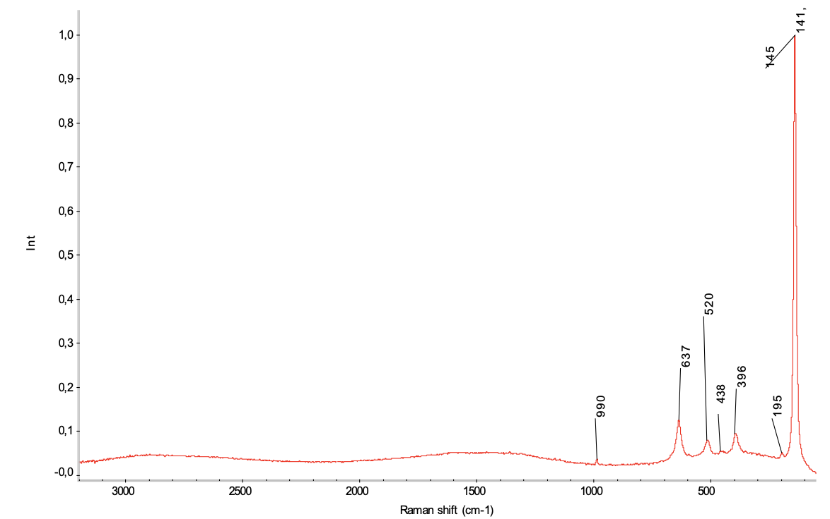
Figure S.12 μRaman spectrum of sample 2_ on the back

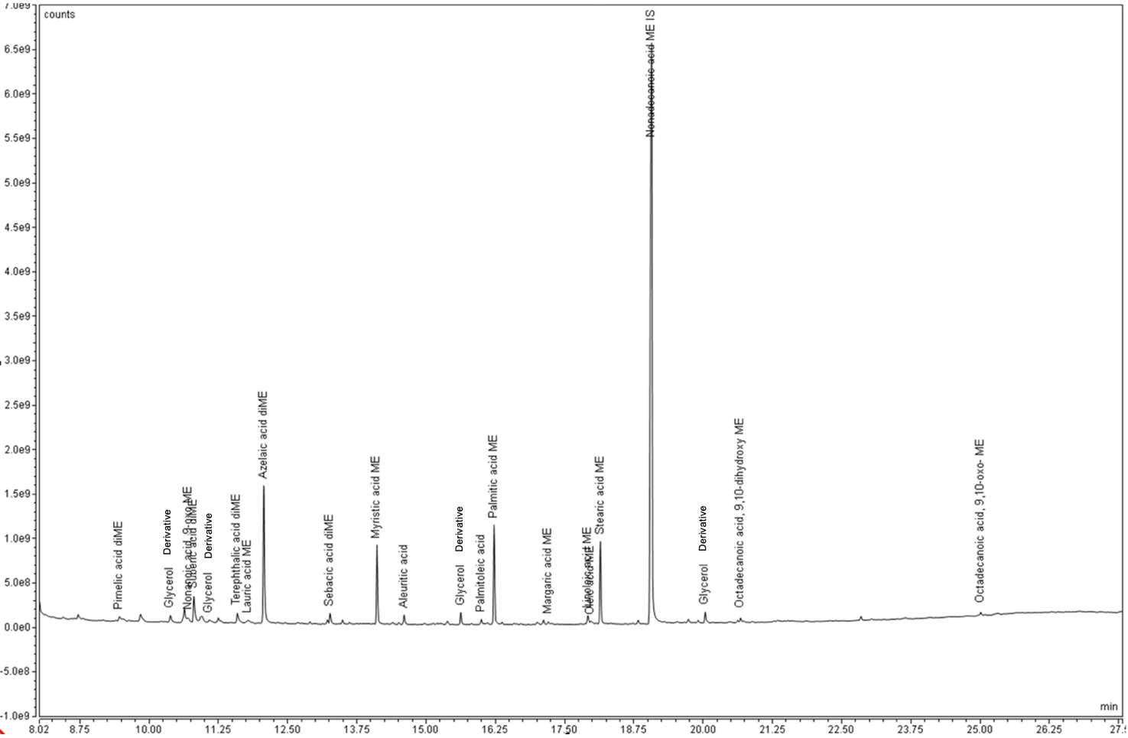
Figure S.13 GCMS chromatogram of sample 2

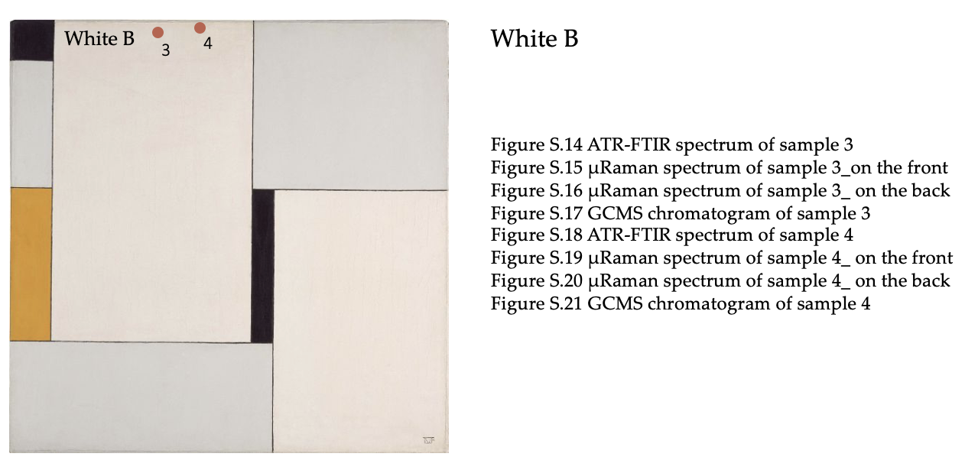

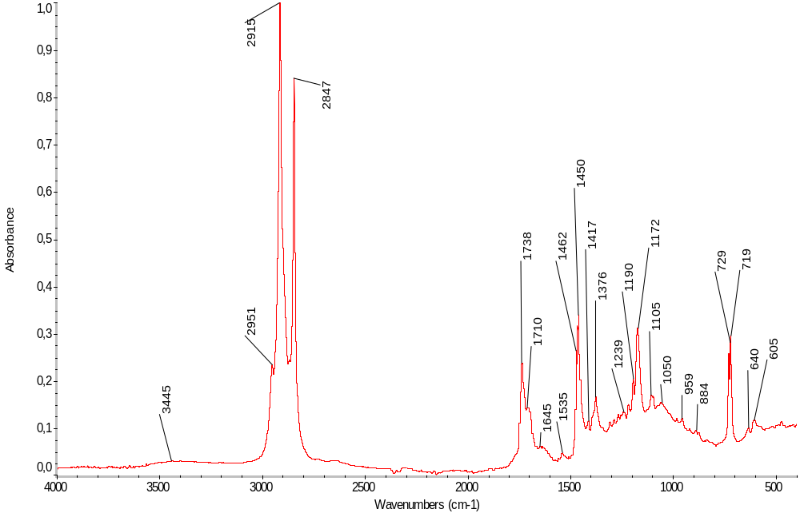
Figure S.14 ATR-FTIR spectrum of sample 3
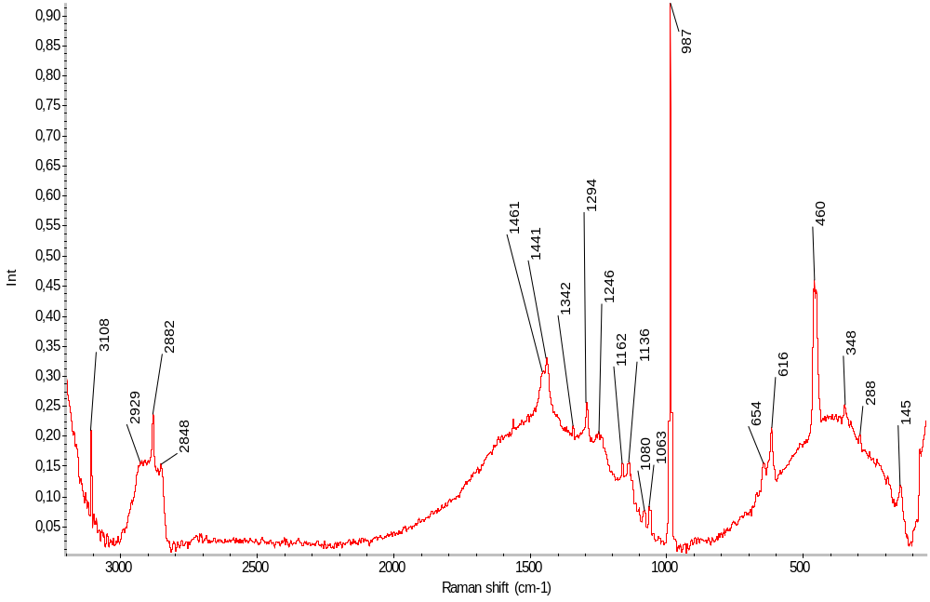

Figure S.15 μRaman spectrum of sample 3_ on the front

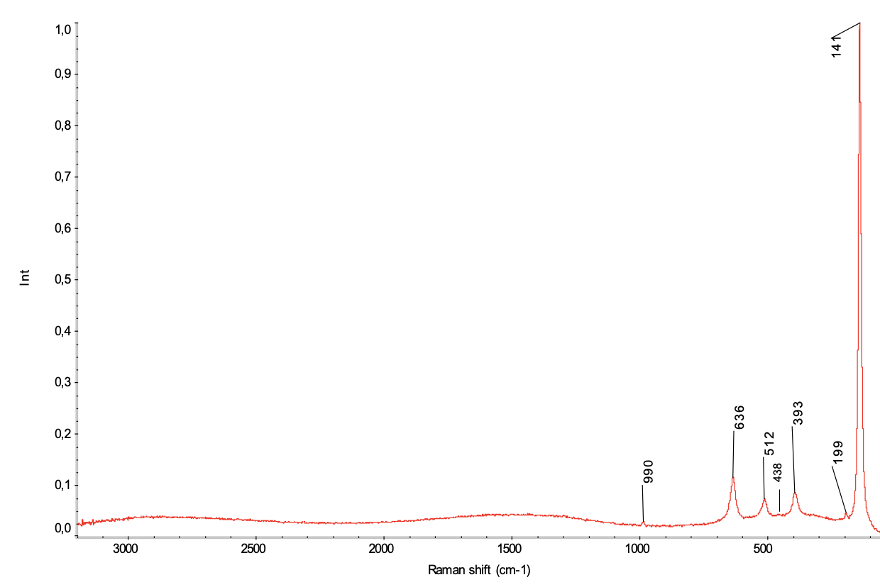
Figure S.16 μRaman spectrum of sample 3_ on the back

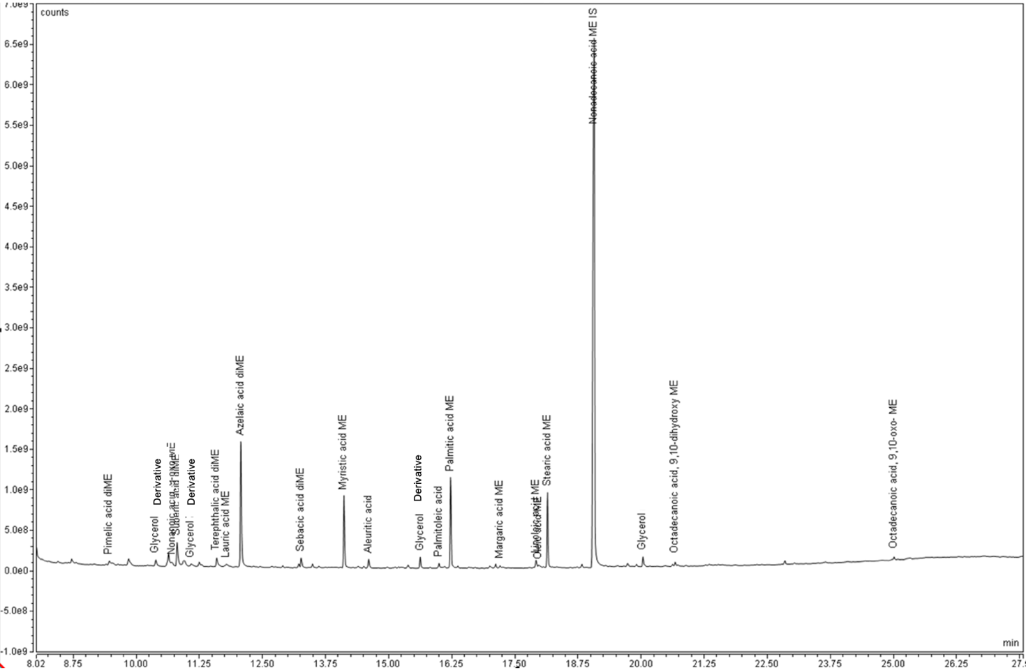
Figure S.17 GCMS chromatogram of sample 3

Figure S.18 ATR-FTIR spectrum of sample 4

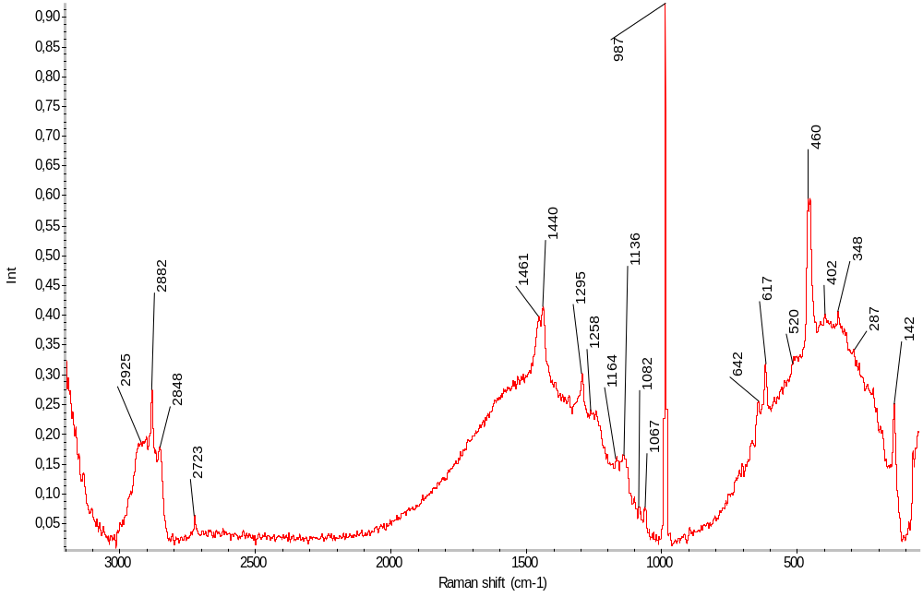
Figure S.19 μRaman spectrum of sample 4_ on the front

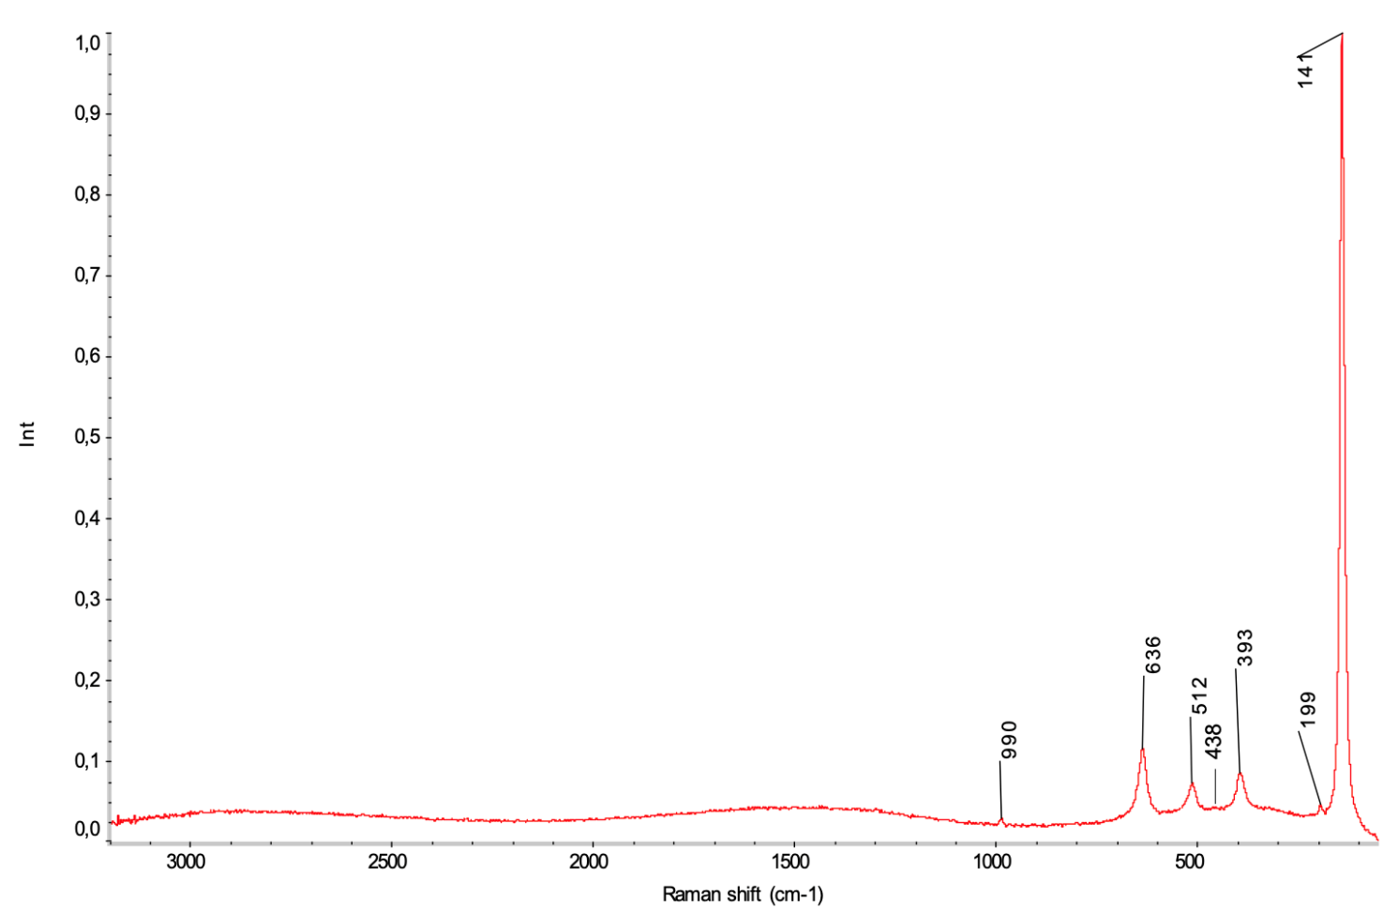

Figure S.20 μRaman spectrum of sample 3_ on the back

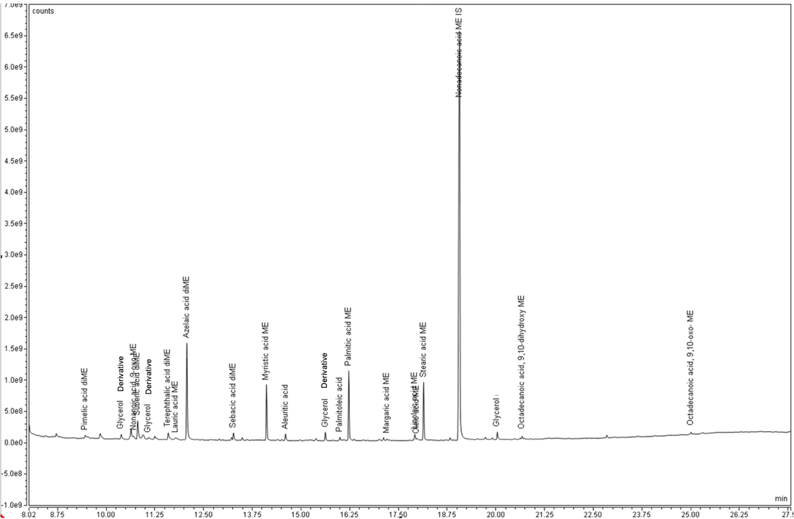

Figure S.21 GCMS chromatogram of sample 4

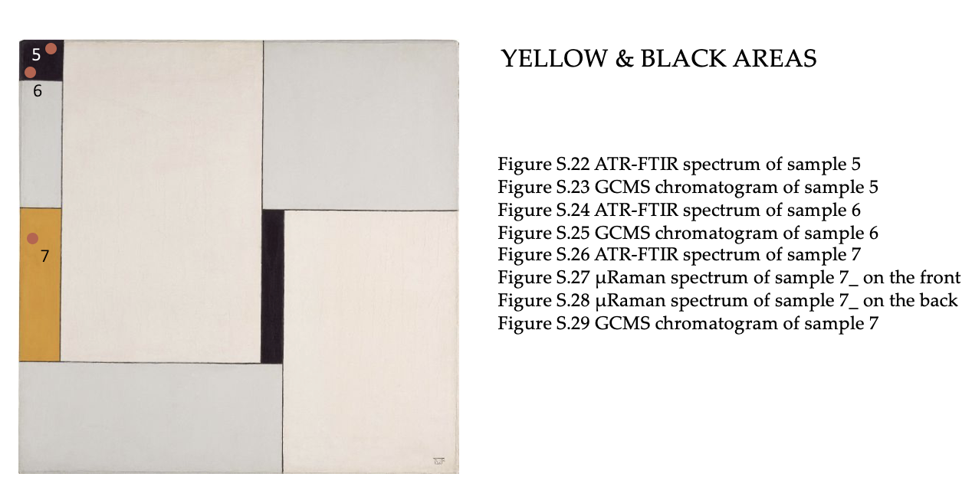

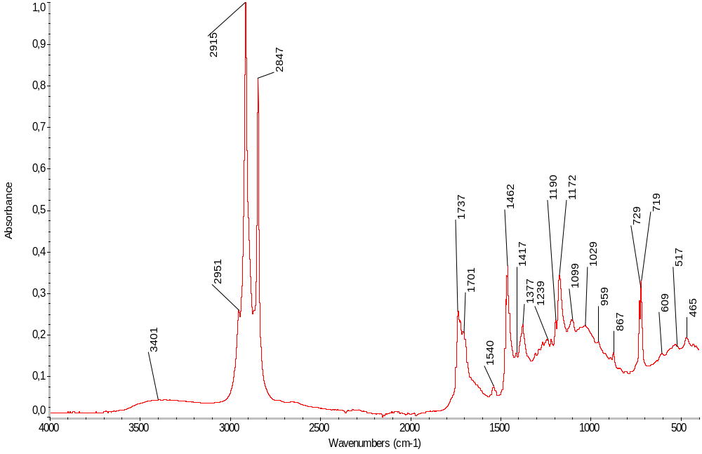Figure S.22 ATR-FTIR spectrum of sample 5

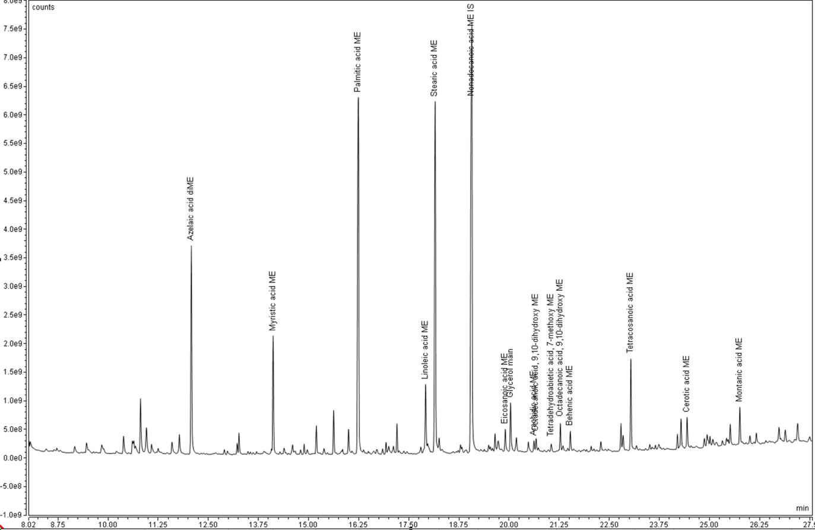
Figure S.23 GCMS chromatogram of sample 5

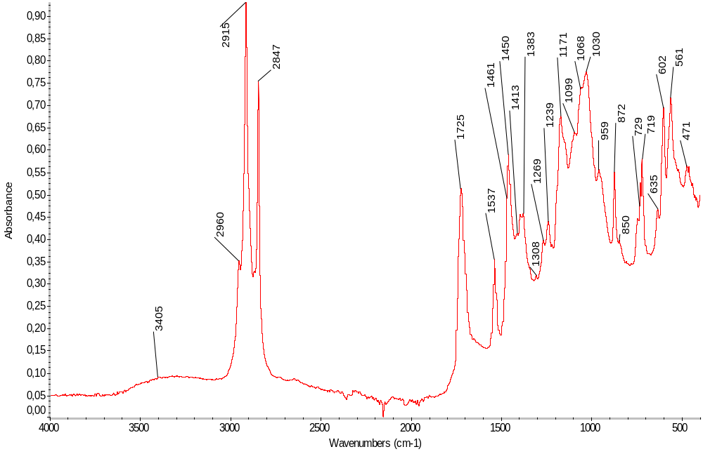
Figure S.24 ATR-FTIR spectrum of sample 6

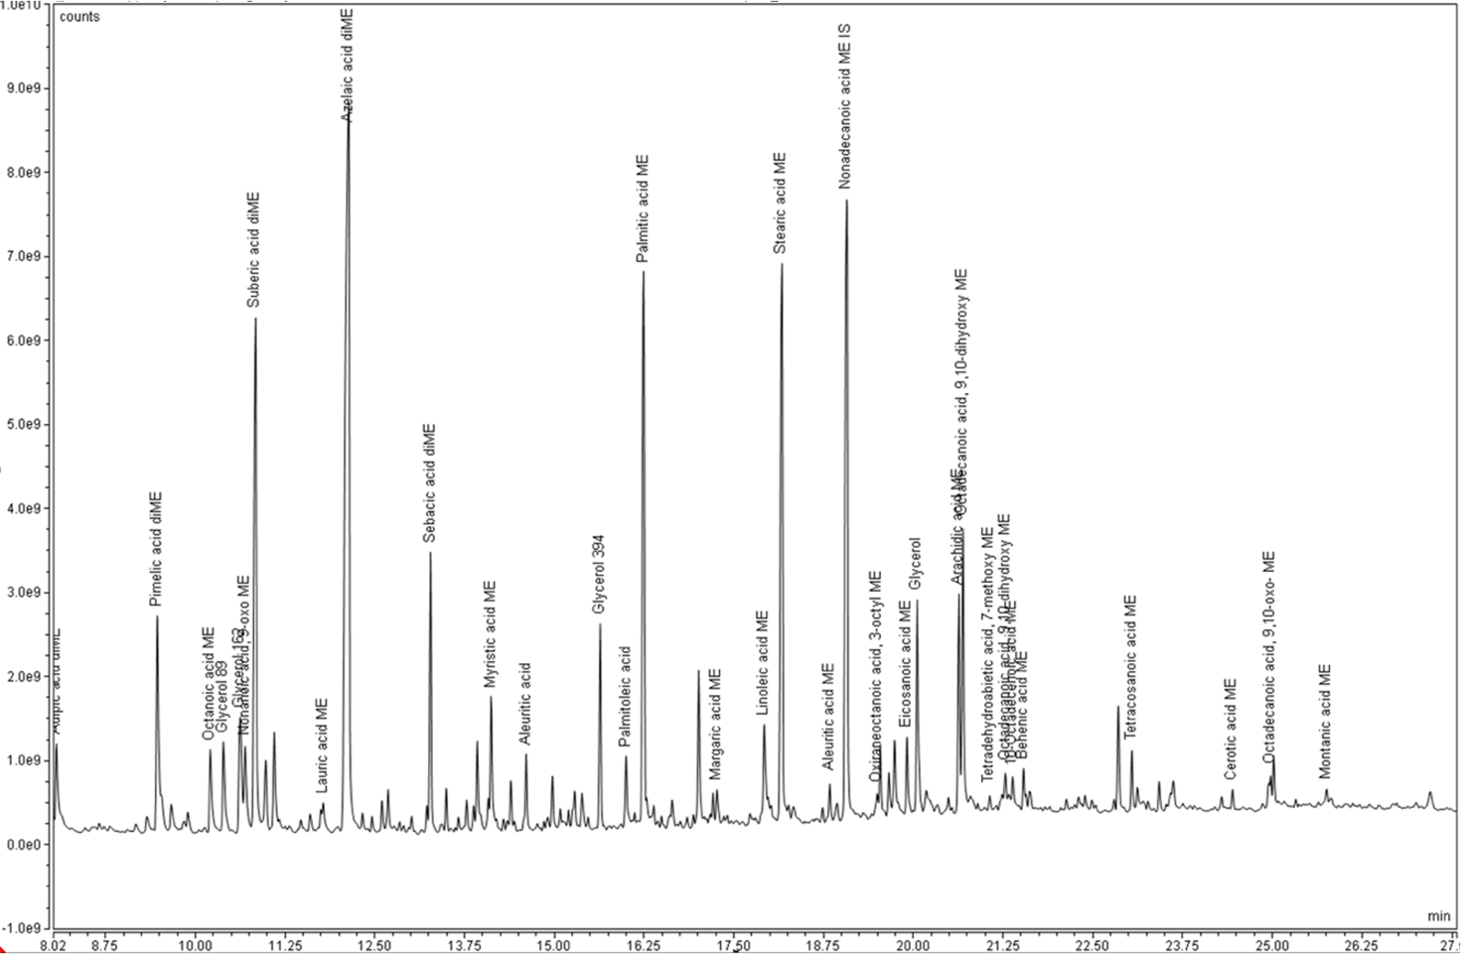
Figure S.25 GCMS chromatogram of sample 6

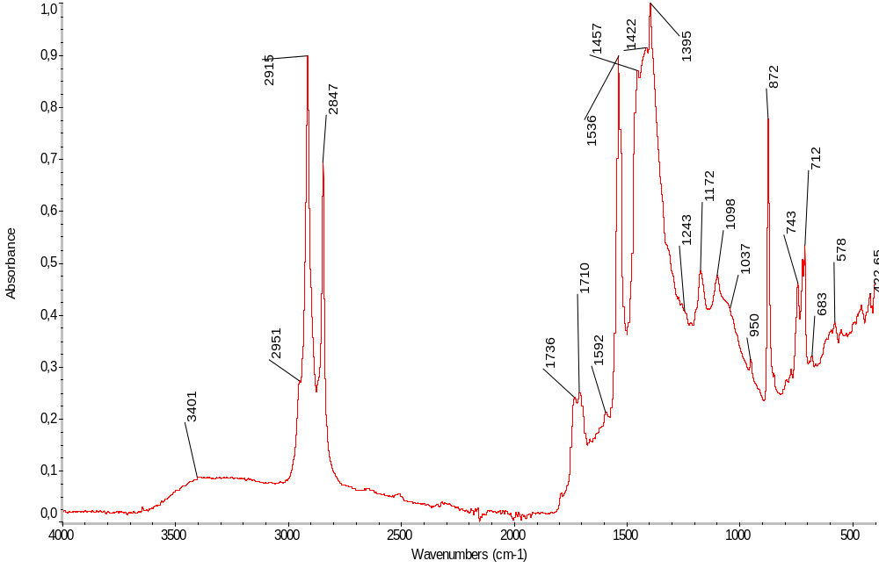
Figure S.26 ATR-FTIR spectrum of sample 7

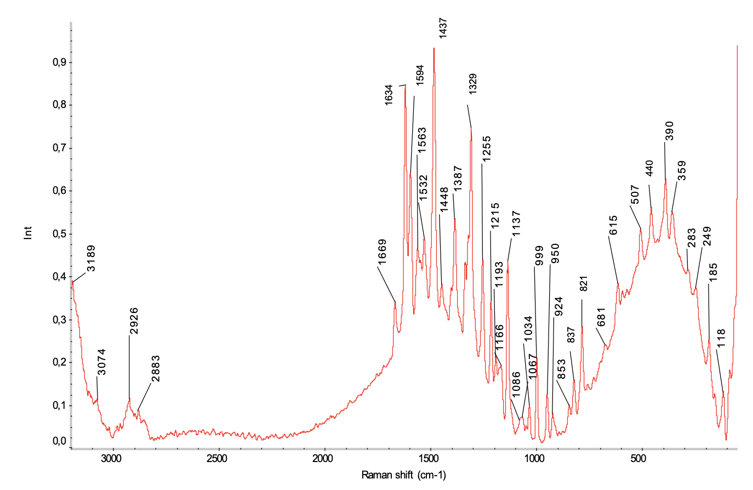
Figure S.27 μRaman spectrum of sample 7_ on the front

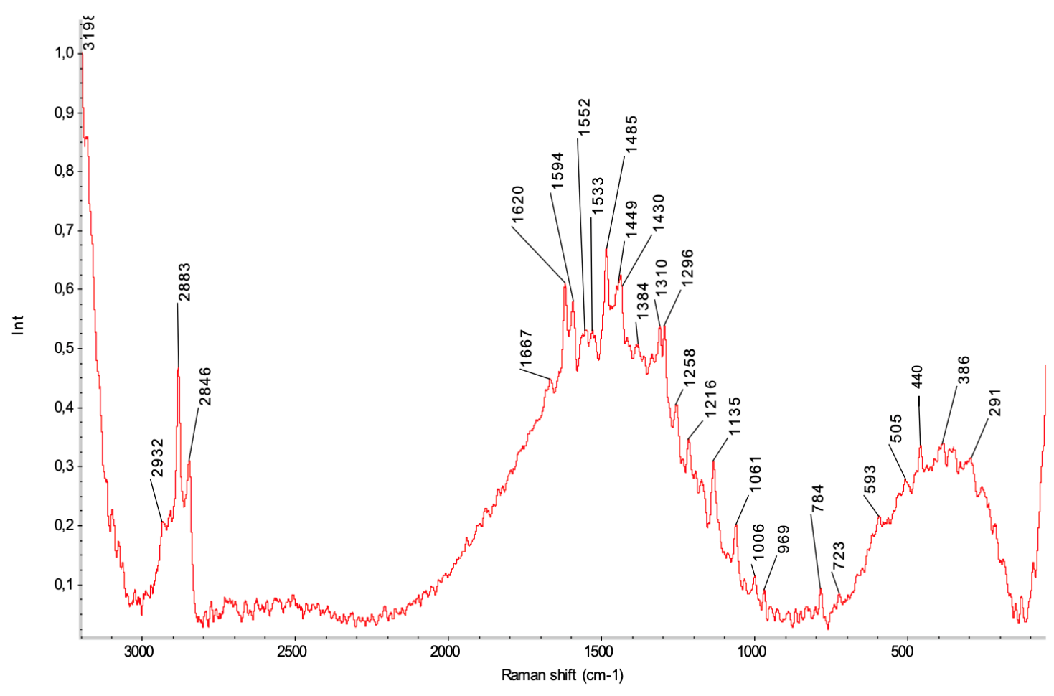
Figure S.28 μRaman spectrum of sample 7_ on the back

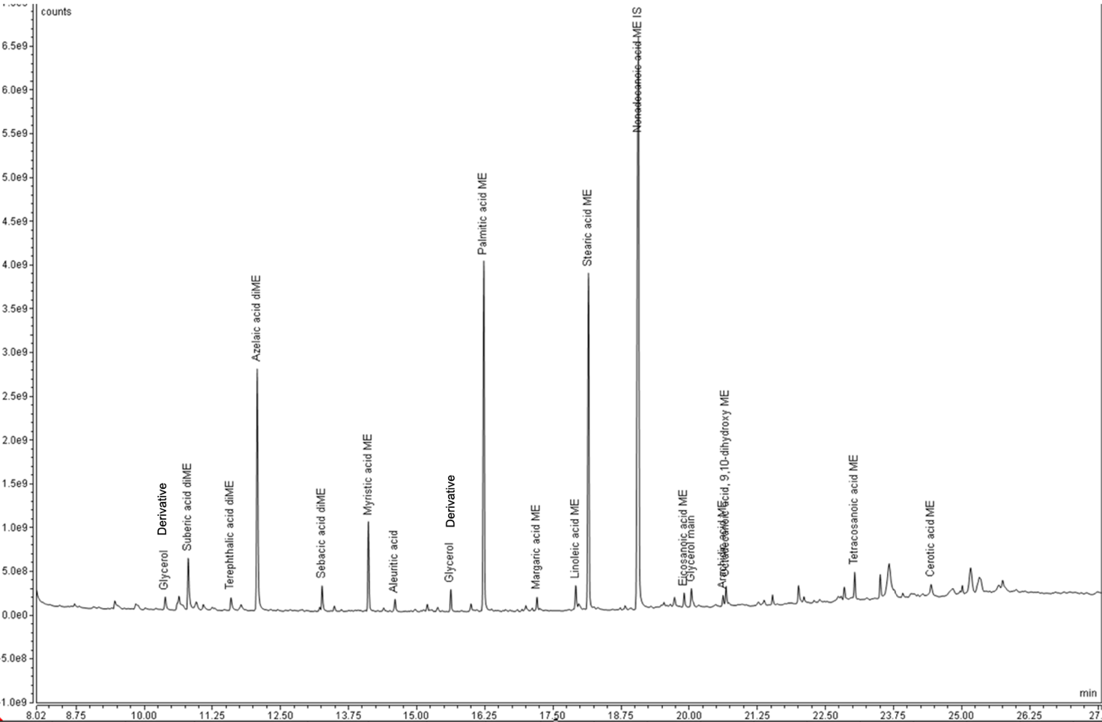
Figure S.29 GCMS chromatogram of sample 7

