Risk of fracture in massive cultural objects made of lime wood: a case study of Veit Stoss’ altarpiece

Magdalena Soboń*¹ and Łukasz Bratasz¹

¹Jerzy Haber Institute of Catalysis and Surface Chemistry, Polish Academy of Sciences, 30-239 Krakow, Poland

*corresponding author, magdalena.sobon@ikifp.edu.pl

Supplementary material
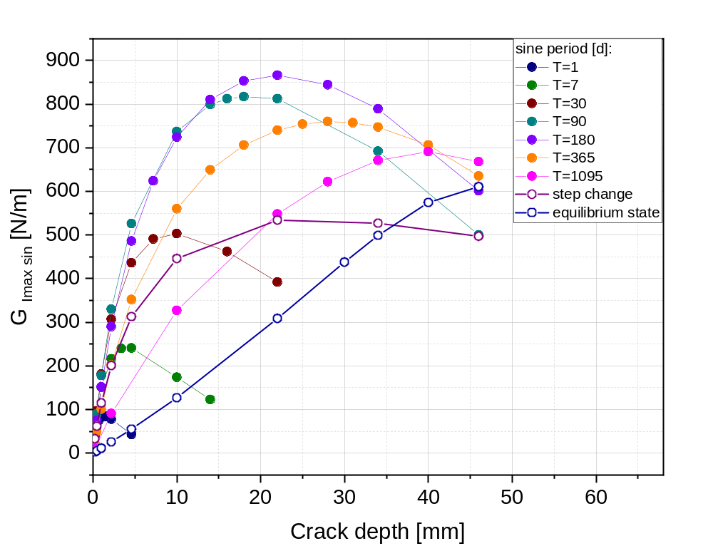
Fig. S1 Maximum value of G_{I} reached in lime wood during the RH sine cycles of 30% amplitude centred at the 50% RH level and varying period. Similar curves for pine were published in [6]

