Title: Spatiotemporal changes and driving factors of ecosystem services between karst and non-karst World Heritage sites in Southwest China
Authors: Yue Chen^{1 #}, Li Rong^{1 #}, Kangning Xiong^{1 *}, Mingjun Feng¹, Cai Cheng²
Affiliations:
¹ School of Karst Science, Guizhou Normal University / State Engineering Technology Institute for Karst Desertification Control, Guiyang 550001, China
² Ministry of Education Key Laboratory for Biodiversity Science and Ecological Engineering, National Observations and Research Station of Wetland Ecosystems of the Yangtze Estuary, Institute of Biodiversity Science and Institute of Eco-Chongming, School of Life Sciences, Fudan University, Shanghai 200438, China
*Corresponding author: Kangning Xiong; Address: School of Karst Science, Guizhou Normal University, Guiyang 550001, China; E-mail: xiongkn@gznu.edu.cn; Tel & Fax: 0086-851-86690478
#The two authors contributed equally to this work.

Table S1 Habitat suitability of each habitat type and sensitivity of habitat types to each threat source.
Habitat type | Habitat suitability | Sensitivity of each habitat type to threat source
Habitat type | Habitat suitability | Cropland | Impervious land | Road
Cropland | 0.3 | 0 | 0.6 | 0.1
Forest | 1 | 0.8 | 1 | 0.4
Shrubland | 0.9 | 0.5 | 0.5 | 0.2
Grassland | 0.8 | 0.5 | 0.6 | 0.3
Water body | 0.7 | 0.6 | 0.8 | 0.5
Impervious land | 0 | 0 | 0 | 0

Table S2 Max impact distance and weights of threat factors.
Threat factor | Max distance (km) | Weight | Decay type
Cropland | 4 | 0.6 | Exponential
Impervious land | 6 | 1 | Exponential
Road | 2 | 0.4 | Linear

Table S3 Biophysical table used in the InVEST model.
Land use type | C_above | C_below | C_soil | C_dead | usle_c | usle_p | lulc_veg | root_depth | Kc
Cropland | 1.31 | 0.76 | 47.22 | 0.00 | 0.23 | 0.4 | 1 | 2100 | 0.7
Forest | 37.62 | 7.38 | 76.01 | 2.62 | 0.01 | 1 | 1 | 5200 | 1
Shrubland | 16.20 | 1.90 | 39.33 | 1.36 | 0.1 | 1 | 1 | 5200 | 0.67
Grassland | 3.40 | 5.80 | 37.26 | 0.85 | 0.15 | 1 | 1 | 2300 | 0.65
Water body | 0.00 | 0.00 | 0.00 | 0.00 | 0 | 0 | 0 | 1 | 1.1
Impervious land | 0.00 | 0.00 | 21.00 | 0.00 | 0 | 0 | 0 | 1 | 0.3

Table S4 Classification of ecosystem service provision for the four World Heritage sites in Southwest China.
Site | Type | Year | Low (1) | Medium (2) | High (3)
Shibing Karst | Habitat quality | 2000 | 0 - 0.557 | 0.557 - 0.843 | 0.843 - 1
Shibing Karst | Habitat quality | 2010 | 0 - 0.522 | 0.522 - 0.801 | 0.801 - 1
Shibing Karst | Habitat quality | 2020 | 0 - 0.482 | 0.482 - 0.753 | 0.753 - 1
Shibing Karst | Carbon storage | 2000 | 0 - 0.169 | 0.169 - 0.475 | 0.475 - 1
Shibing Karst | Carbon storage | 2010 | 0 - 0.169 | 0.169 - 0.475 | 0.475 - 1
Shibing Karst | Carbon storage | 2020 | 0 - 0.169 | 0.169 - 0.475 | 0.475 - 1
Shibing Karst | Soil retention | 2000 | 0 - 0.051 | 0.051 - 0.227 | 0.227 - 1
Shibing Karst | Soil retention | 2010 | 0 - 0.051 | 0.051 - 0.227 | 0.227 - 1
Shibing Karst | Soil retention | 2020 | 0 - 0.051 | 0.051 - 0.227 | 0.227 - 1
Shibing Karst | Water conservation | 2000 | 0 - 0.522 | 0.522 - 0.925 | 0.925 - 1
Shibing Karst | Water conservation | 2010 | 0 - 0.294 | 0.294 - 0.624 | 0.624 - 1
Shibing Karst | Water conservation | 2020 | 0 - 0.306 | 0.306 - 0.914 | 0.914 - 1
Libo-Huanjiang Karst | Habitat quality | 2000 | 0 - 0.553 | 0.553 - 0.835 | 0.835 - 1
Libo-Huanjiang Karst | Habitat quality | 2010 | 0 - 0.545 | 0.545 - 0.824 | 0.824 - 1
Libo-Huanjiang Karst | Habitat quality | 2020 | 0 - 0.529 | 0.529 - 0.804 | 0.804 - 1
Libo-Huanjiang Karst | Carbon storage | 2000 | 0 - 0.170 | 0.170 - 0.476 | 0.476 - 1
Libo-Huanjiang Karst | Carbon storage | 2010 | 0 - 0.170 | 0.170 - 0.476 | 0.476 - 1
Libo-Huanjiang Karst | Carbon storage | 2020 | 0 - 0.170 | 0.170 - 0.476 | 0.476 - 1
Libo-Huanjiang Karst | Soil retention | 2000 | 0 - 0.059 | 0.059 - 0.247 | 0.247 - 1
Libo-Huanjiang Karst | Soil retention | 2010 | 0 - 0.059 | 0.059 - 0.247 | 0.247 - 1
Libo-Huanjiang Karst | Soil retention | 2020 | 0 - 0.059 | 0.059 - 0.247 | 0.247 - 1
Libo-Huanjiang Karst | Water conservation | 2000 | 0 - 0.298 | 0.298 - 0.937 | 0.937 - 1
Libo-Huanjiang Karst | Water conservation | 2010 | 0 - 0.298 | 0.298 - 0.933 | 0.933 - 1
Libo-Huanjiang Karst | Water conservation | 2020 | 0 - 0.298 | 0.298 - 0.894 | 0.894 - 1
Fanjingshan | Habitat quality | 2000 | 0 - 0.635 | 0.635 - 0.910 | 0.910 - 1
Fanjingshan | Habitat quality | 2010 | 0 - 0.588 | 0.588 - 0.859 | 0.859 - 1
Fanjingshan | Habitat quality | 2020 | 0 - 0.561 | 0.561 - 0.835 | 0.835 - 1
Fanjingshan | Carbon storage | 2000 | 0 - 0.170 | 0.170 - 0.476 | 0.476 - 1
Fanjingshan | Carbon storage | 2010 | 0 - 0.170 | 0.170 - 0.476 | 0.476 - 1
Fanjingshan | Carbon storage | 2020 | 0 - 0.170 | 0.170 - 0.476 | 0.476 - 1
Fanjingshan | Soil retention | 2000 | 0 - 0.075 | 0.075 - 0.263 | 0.263 - 1
Fanjingshan | Soil retention | 2010 | 0 - 0.071 | 0.071 - 0.259 | 0.259 - 1
Fanjingshan | Soil retention | 2020 | 0 - 0.071 | 0.071 - 0.251 | 0.251 - 1
Fanjingshan | Water conservation | 2000 | 0 - 0.416 | 0.416 - 0.914 | 0.914 - 1
Fanjingshan | Water conservation | 2010 | 0 - 0.420 | 0.420 - 0.906 | 0.906 - 1
Fanjingshan | Water conservation | 2020 | 0 - 0.427 | 0.427 - 0.902 | 0.902 - 1
Chuishui Danxia | Habitat quality | 2000 | 0 - 0.553 | 0.553 - 0.843 | 0.843 - 1
Chuishui Danxia | Habitat quality | 2010 | 0 - 0.553 | 0.553 - 0.843 | 0.843 - 1
Chuishui Danxia | Habitat quality | 2020 | 0 - 0.541 | 0.541 - 0.831 | 0.831 - 1
Chuishui Danxia | Carbon storage | 2000 | 0 - 0.169 | 0.169 - 0.475 | 0.475 - 1
Chuishui Danxia | Carbon storage | 2010 | 0 - 0.169 | 0.169 - 0.475 | 0.475 - 1
Chuishui Danxia | Carbon storage | 2020 | 0 - 0.169 | 0.169 - 0.475 | 0.475 - 1
Chuishui Danxia | Soil retention | 2000 | 0 - 0.067 | 0.067 - 0.259 | 0.259 - 1
Chuishui Danxia | Soil retention | 2010 | 0 - 0.067 | 0.067 - 0.259 | 0.259 - 1
Chuishui Danxia | Soil retention | 2020 | 0 - 0.067 | 0.067 - 0.259 | 0.259 - 1
Chuishui Danxia | Water conservation | 2000 | 0 - 0.290 | 0.290 - 0.906 | 0.906 - 1
Chuishui Danxia | Water conservation | 2010 | 0 - 0.294 | 0.294 - 0.922 | 0.922 - 1
Chuishui Danxia | Water conservation | 2020 | 0 - 0.298 | 0.298 - 0.906 | 0.906 - 1

Table S5 Classification criteria of trade-offs/synergies among ecosystem services.
Type | Classification | Combination | Examples
Trade-offs | Strong trade-offs | 1H and 3L | 1131, 1311
 |  | 1H,1M and 2L | 1213, 1231, 1312, 1321, 2311, 3211
 |  | 1H,2M and 1L | 1223, 1232, 1322, 2213, 2231, 2312,  2321, 3212, 3221
 | Weak trade-offs | 2H and 2L | 1313, 1331, 3311
 |  | 2H, 1M and 1L | 1323, 1332, 2313, 2331, 3213, 3231,  3312, 3321
 |  | 3H and 1L | 1333, 3313, 3331
Synergies | Strong synergies | 1H and 3M | 2223, 2232, 2322, 3222
 |  | 2H and 2M | 2233, 2323, 2332, 3223, 3232, 3322
 |  | 3H and 1M | 2333, 3233, 3323, 3332
 |  | 4M | 2222
 |  | 4H | 3333
 | Weak synergies | 1M and 3L | 1121, 1211, 2111
 |  | 2M and 2L | 1212, 1221, 2211
 |  | 3M and 1L | 1222, 2212, 2221
 |  | 4L | 1111

Table S6 Land use transfer matrix of the four World Heritage sites in Southwest China from 2000 to 2020.
Site | Land use type (hm²) | Cropland | Forest | Shrubland | Grassland | Water body | Impervious land
Shibing Karst | Cropland | 2222.64 | 169.38 | 2.52 | 32.94 | 0.18 | 10.8
Shibing Karst | Forest | 1744.11 | 23151.96 | 302.13 | 21.51 | 0 | 0.72
 | Shrubland | 217.17 | 216.18 | 223.11 | 4.77 | 0 | 0
 | Grassland | 3.78 | 0.72 | 0.09 | 0.36 | 0 | 0.09
 | Water body | 0.27 | 0.09 | 0 | 0 | 2.52 | 0
 | Impervious land | 0 | 0 | 0 | 0 | 0 | 1.71
Libo-Huanjiang Karst | Cropland | 3197.43 | 863.73 | 21.33 | 7.29 | 22.32 | 84.96
Libo-Huanjiang Karst | Forest | 1338.84 | 69606.54 | 1396.35 | 8.46 | 1.53 | 13.59
Libo-Huanjiang Karst | Shrubland | 419.31 | 2475.99 | 1986.21 | 6.75 | 0 | 0.18
 | Grassland | 23.76 | 14.31 | 8.82 | 3.06 | 1.35 | 0.54
 | Water body | 1.8 | 7.65 | 0 | 0 | 16.2 | 0
 | Impervious land | 0 | 0 | 0 | 0 | 0.27 | 4.05
Fanjingshan | Cropland | 1183.95 | 360.63 | 18.18 | 0.54 | 2.16 | 38.97
 | Forest | 1214.28 | 74350.89 | 134.01 | 0.54 | 1.62 | 12.24
 | Shrubland | 17.91 | 158.58 | 46.98 | 0 | 0 | 0
 | Grassland | 0.72 | 0.54 | 0.09 | 0.18 | 0 | 0.18
 | Water body | 0.27 | 0.09 | 0 | 0 | 3.24 | 0.45
 | Impervious land | 0 | 0 | 0 | 0 | 0 | 3.06
Chishui Danxia | Cropland | 1292.13 | 320.31 | 1.71 | 1.62 | 1.08 | 9.18
Chishui Danxia | Forest | 2093.04 | 68413.5 | 34.47 | 2.88 | 0 | 10.71
 | Shrubland | 31.05 | 104.76 | 13.59 | 0 | 0 | 0
 | Grassland | 1.62 | 1.17 | 0 | 0.99 | 0.09 | 1.35
 | Water body | 8.1 | 0.81 | 0 | 0 | 61.56 | 4.05
 | Impervious land | 0 | 0 | 0 | 0 | 0.36 | 19.98

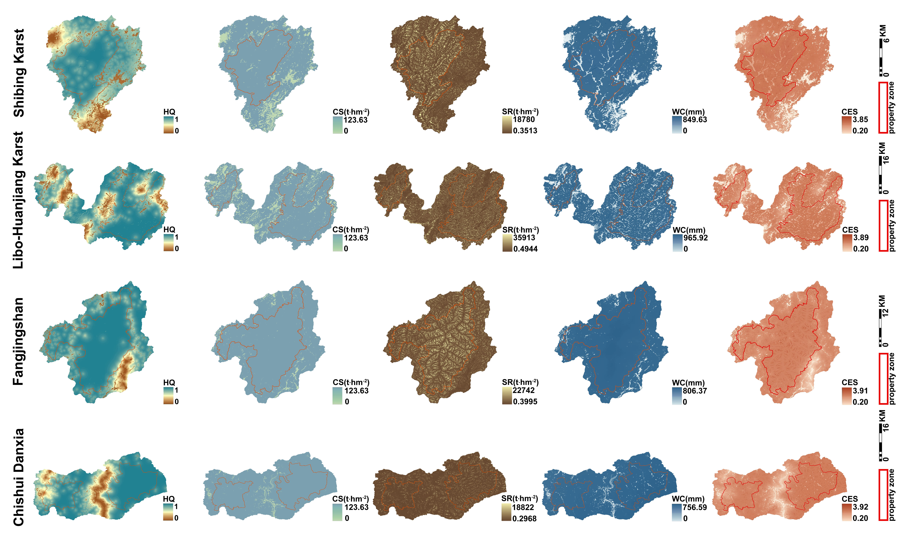
Fig. S1 Spatial differences in ecosystem services of the four World Heritage sites in Southwest China in 2000. HQ: habitat quality; CS: carbon storage; SR: soil retention; WC: water conservation; CES: combined ecosystem service.

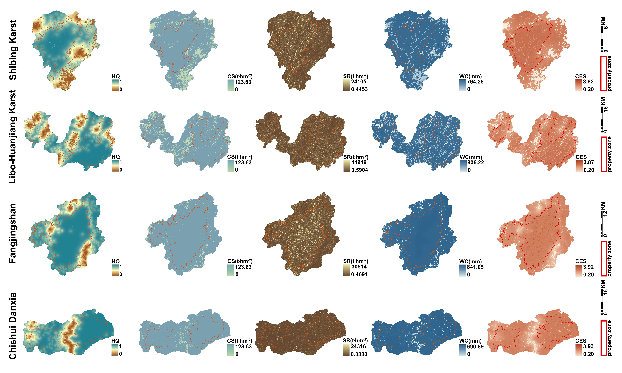
Fig. S2 Spatial differences in ecosystem services of the four World Heritage sites in Southwest China in 2010. HQ: habitat quality; CS: carbon storage; SR: soil retention; WC: water conservation; CES: combined ecosystem service.

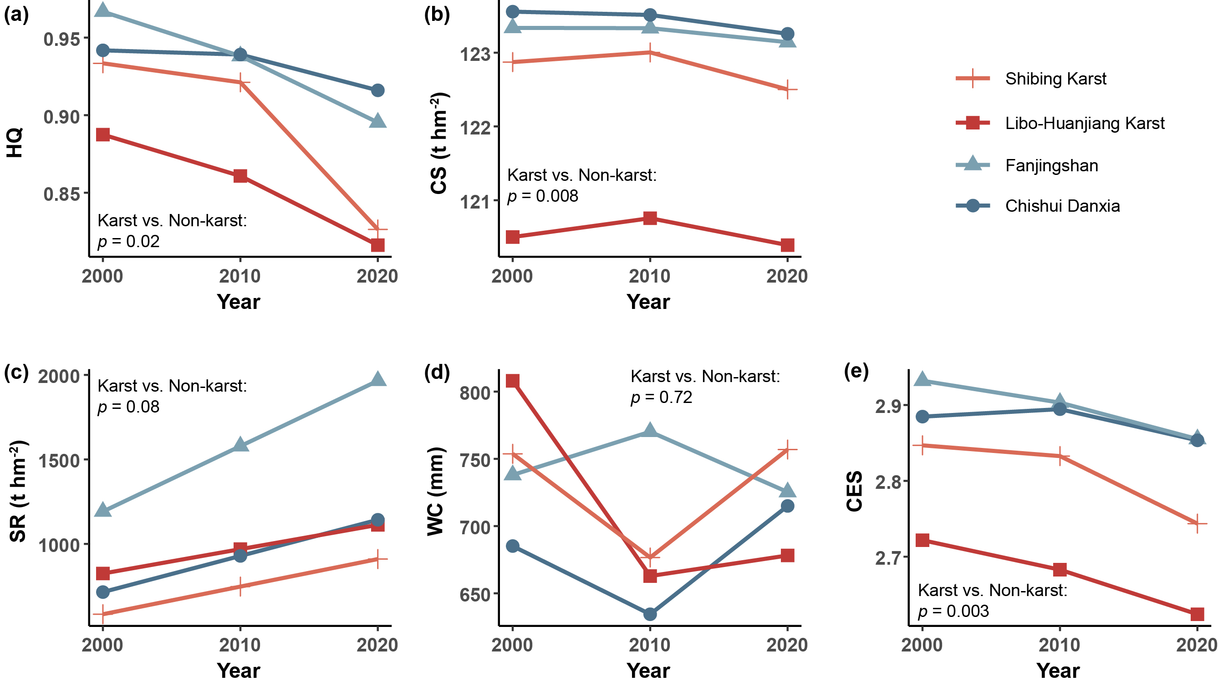
Fig. S3 Temporal variation in the mean value of habitat quality (HQ, a), carbon storage (CS, b), soil retention (SR, c), water conservation (WC, d), and combined ecosystem service (CES, e) in the property zone of the four World Heritage sites in Southwest China. One-way ANOVA was used to test the difference in the mean value of ecosystem services between karst and non-karst World Heritage sites.

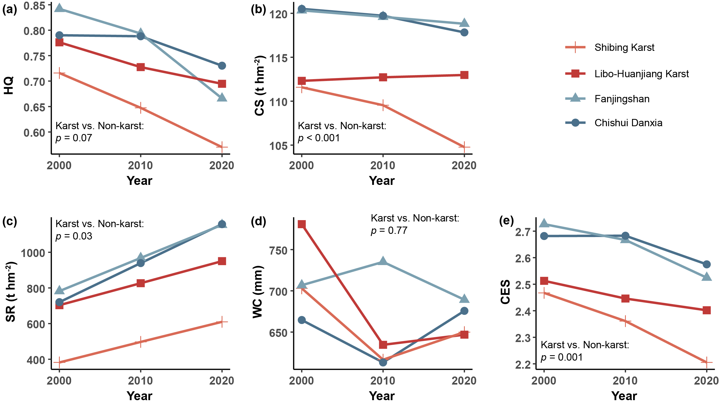
Fig. S4 Temporal variation in the mean value of habitat quality (HQ, a), carbon storage (CS, b), soil retention (SR, c), water conservation (WC, d), and combined ecosystem service (CES, e) in the buffer zone of the four World Heritage sites in Southwest China. One-way ANOVA was used to test the difference in the mean value of ecosystem services between karst and non-karst World Heritage sites.

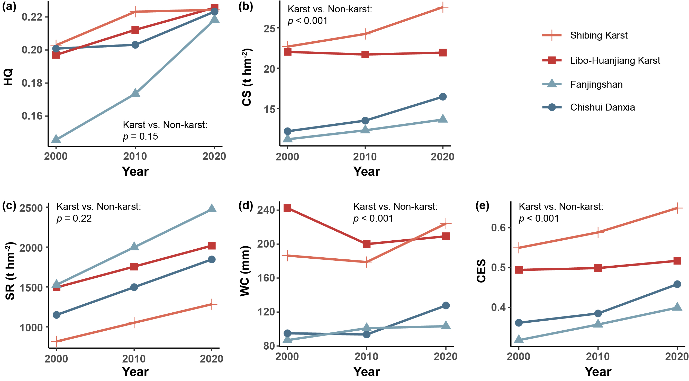
Fig. S5 Temporal variation in the standard deviation of habitat quality (HQ, a), carbon storage (CS, b), soil retention (SR, c), water conservation (WC, d), and combined ecosystem service (CES, e) of the four World Heritage sites in Southwest China. One-way ANOVA was used to test the difference in the standard deviation of ecosystem services between karst and non-karst World Heritage sites.

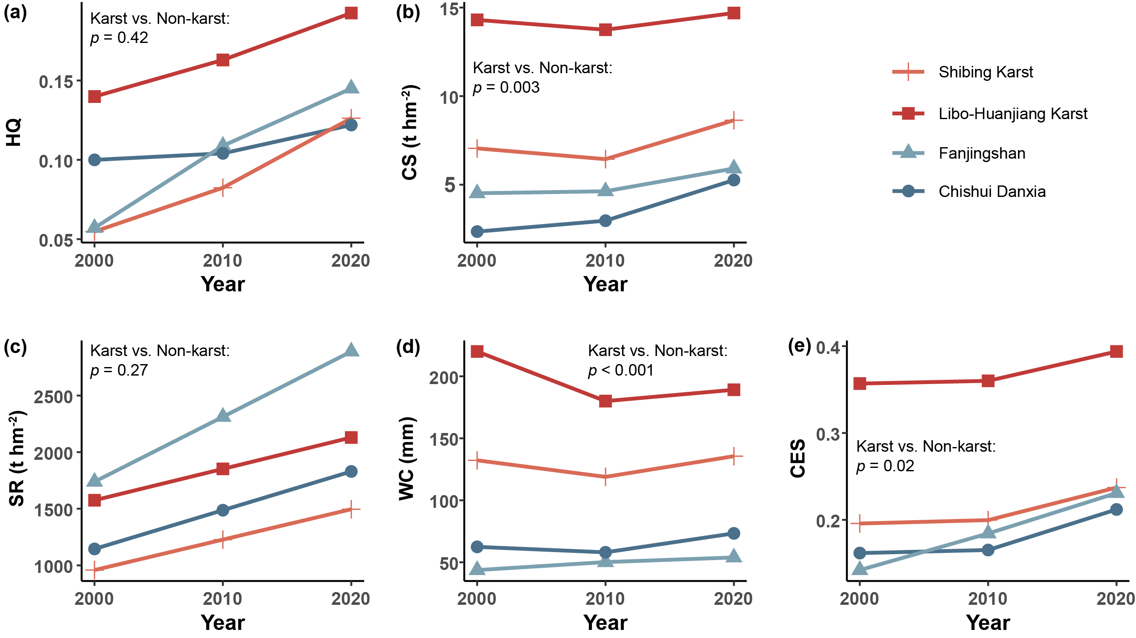
Fig. S6 Temporal variation in the standard deviation of habitat quality (HQ, a), carbon storage (CS, b), soil retention (SR, c), water conservation (WC, d), and combined ecosystem service (CES, e) in the property zone of the four World Heritage sites in Southwest China. One-way ANOVA was used to test the difference in the standard deviation of ecosystem services between karst and non-karst World Heritage sites.

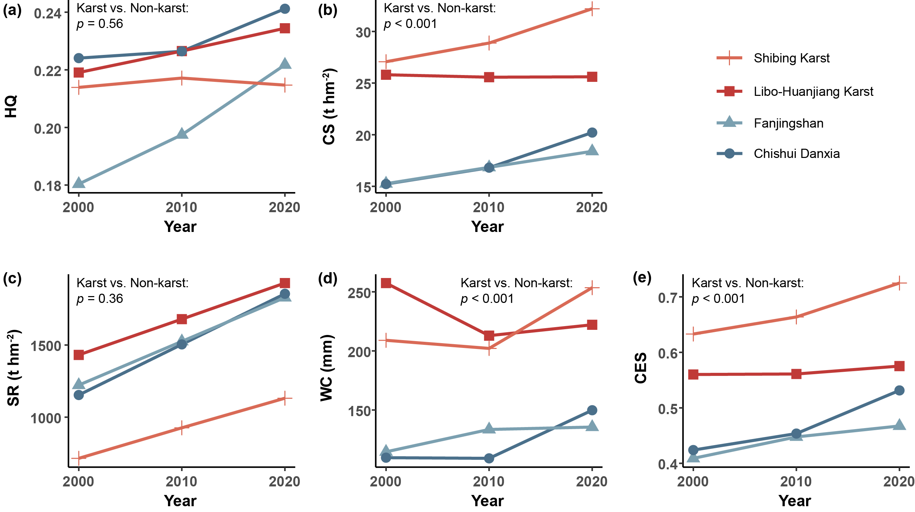
Fig. S7 Temporal variation in the standard deviation of habitat quality (HQ, a), carbon storage (CS, b), soil retention (SR, c), water conservation (WC, d), and combined ecosystem service (CES, e) in the buffer zone of the four World Heritage sites in Southwest China. One-way ANOVA was used to test the difference in the standard deviation of ecosystem services between karst and non-karst World Heritage sites.

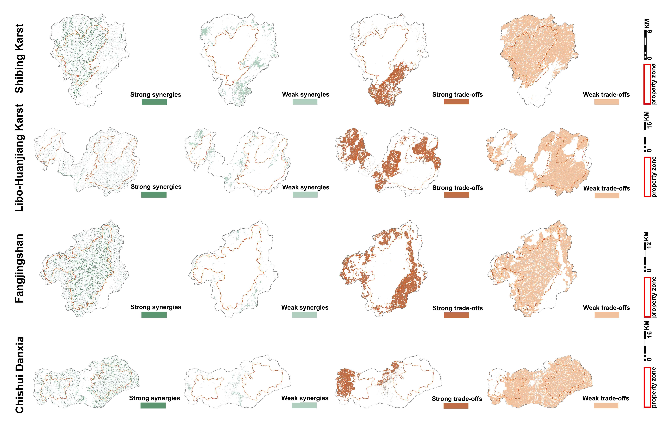
Fig. S8 Spatial differences in trade-offs and synergies among ecosystem services of the four World Heritage sites in Southwest China in 2000.

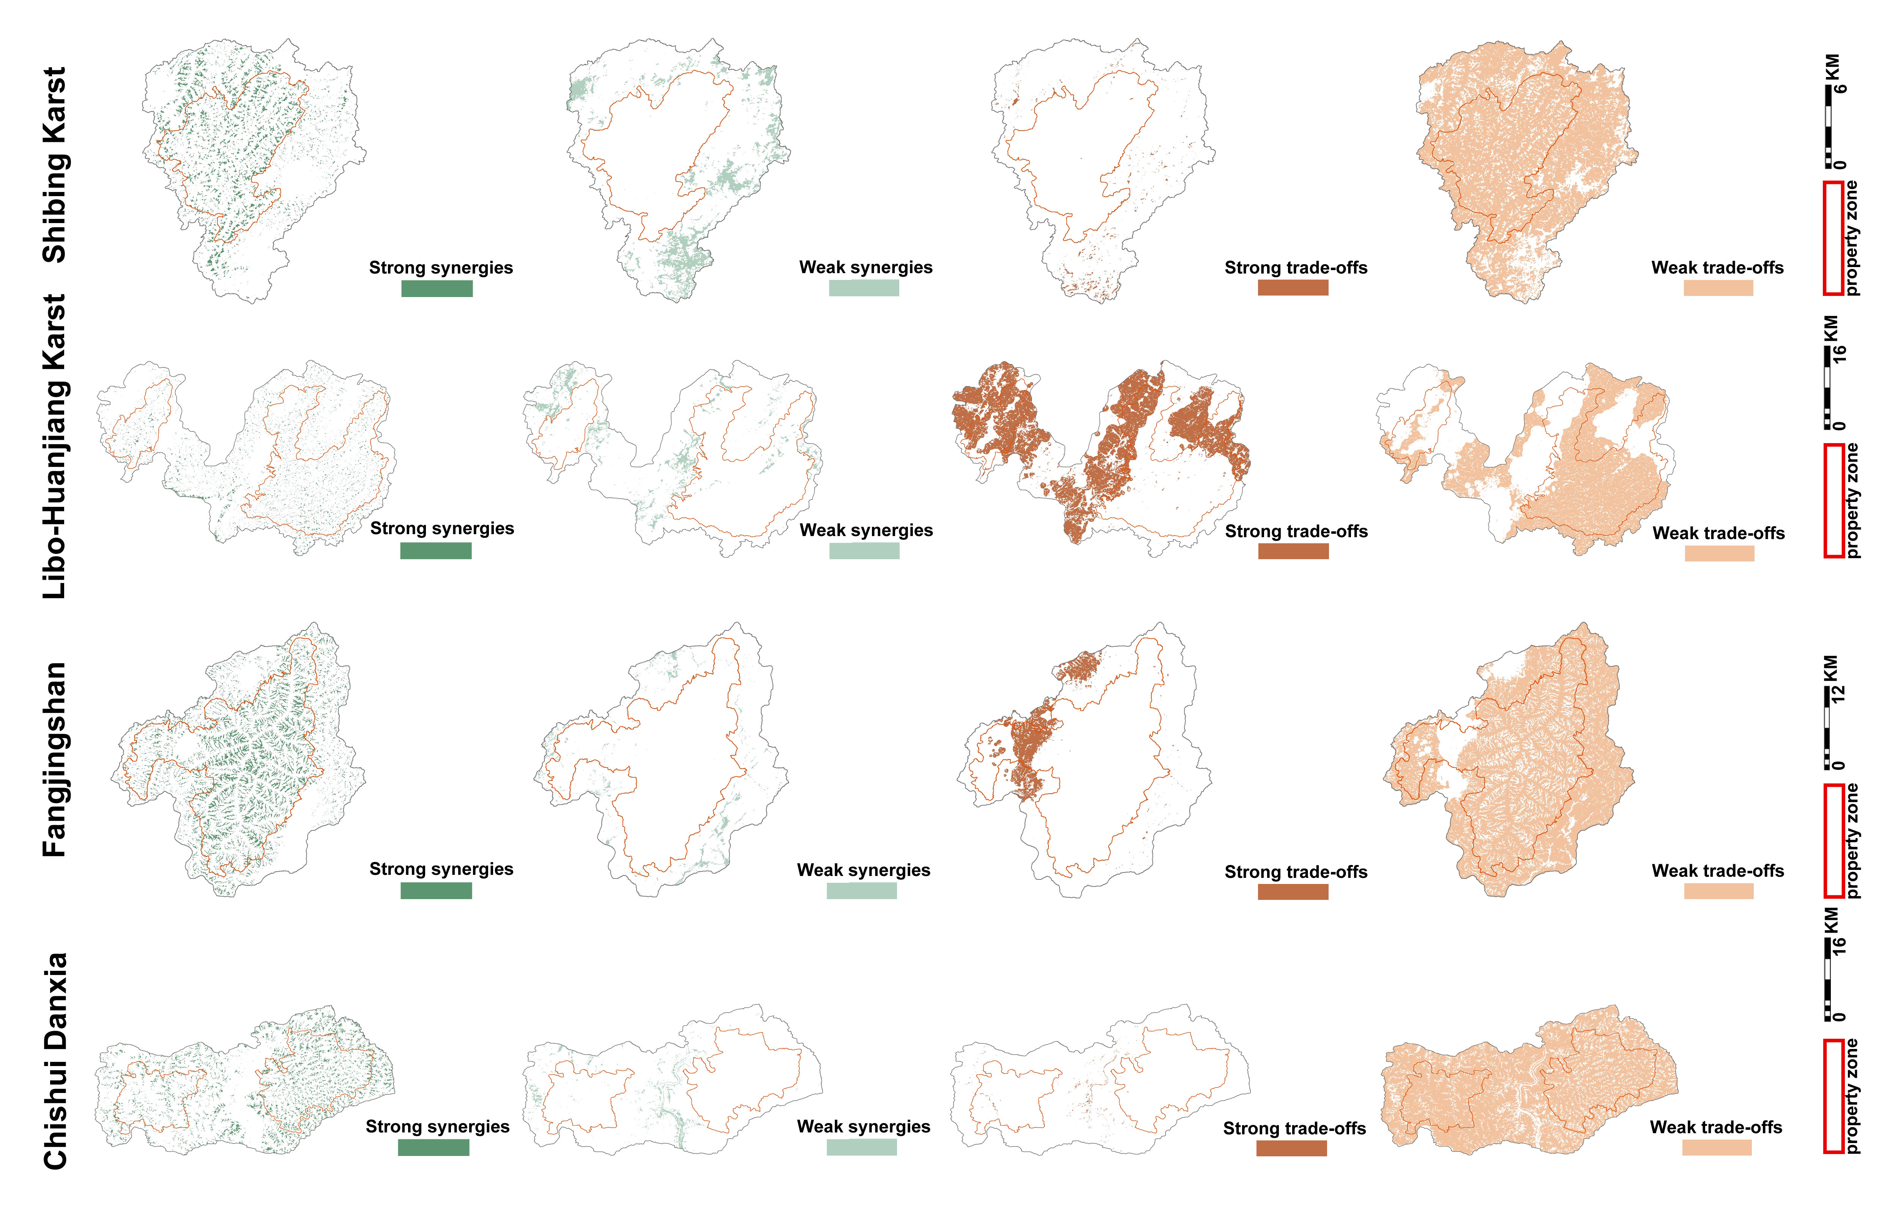
Fig. S9 Spatial differences in trade-offs and synergies among ecosystem services of the four World Heritage sites in Southwest China in 2010.

