Additional file

Butadiene sulfone as ‘volatile’, recyclable dipolar, aprotic solvent for conducting substitution and cycloaddition reactions
Yong Huang,^{a,c,†} Esteban E. Ureña-Benavides,^{a,c,†} Afrah J. Boigny,ª Zachary S. Campbell,ª Fiaz S. Mohammed,ª Pamela Pollet,^{b,c} Jason S. Fisk,^{d} Bruce Holden,^{d} Charles A. Eckert^{a,b,c} and Charles L. Liotta^{a,b,c}
ª School of Chemical and Biomolecular Engineering, Georgia Institute of Technology, Atlanta, 30332, GA, USA
^{b.} School of Chemistry and Biochemistry, Georgia Institute of Technology, Atlanta, GA, 30332, GA, USA
^{c.}Specialty Separations Center, Georgia Institute of Technology, Atlanta, 30332, GA, USA
^{d.} The Dow Chemical Company, Midland, Michigan, 48674, USA
† Yong Huang and Esteban E. Ureña-Benavides are co-first authors contributing to this article.
*E-mail address of the corresponding author: charles.liotta@chemistry.gatech.edu; pamela.pollet@chemistry.gatech.edu.

Preparation of Benzyl Azide (1)
The benzyl azide used for the cycloaddition reactions was synthesized and isolated first in acetonitrile water. Benzyl chloride (6.2 g) and sodium azide (4.4 g) were added to a three neck round bottom flask, followed by addition of 20 mL of water and 80 mL of acetonitrile. The reaction mixture was heated to 60 °C and allowed to react overnight. Benzyl azide (1) was extracted with dichloromethane, dried over MgSO₄ and filtered. Acetonitrile and dichloromethane were evaporated under reduced pressure to yield a clear yellow liquid.
Characterizations
Nuclear magnetic resonance (NMR): ¹H-NMR and ¹³C-NMR spectra were measured on a Bruker Avance III 400 spectrometer, and NMR yield was quantified by internal standard.

Gas chromatography/flame ionization detector (GC-FID): GC-FID was using a Shimadzu GC2010 gas chromatograph fitted with a Supelco PTA-5 (30m x 0.32 mm x 1.00 µm, length x inside diameter x film thickness) capillary column. The injector temperature was held constantly at 300 °C, and column oven was increased from 90 °C to 300 °C at a ramp rate of 15 °C/min. GC-FID detector temperature was held at 320 °C. The used calibration curves are listed as below in Fig.S6.

Triple quadrupole tandem mass spectrometer with ionization via ESI (ESI-MS): experiments were run on a Quattro LC, made by Micromass, which is now part of Waters. The capillary voltage was 3.5kV, and the cone voltage was 20V. The instrument was scanned from 150-1500Da in 3 seconds. Nitrogen was used as both the nebulizing gas, at a flow of 100L/hr, and the desolvation gas, at 600L/hr.

Ion trap/orbitrap tandem mass spectrometer (LTQ Orbitrap XL): made by Thermo Instruments. The source voltage was 5kV, the capillary voltage was 35V, and the tube lens voltage was 110V. The sheath gas was nitrogen, at a flow of 10 arbitrary units, and the auxiliary gas was nitrogen, at a flow of 5 arbitrary units. The mass resolution was 30,000, and the instrument was scanned from 75-2000Da.

Differential scanning calorimeter (DSC): DSC was carried out on a TA DSC Q20, under nitrogen flow, at a scanning rate of 10 ºC min⁻¹.

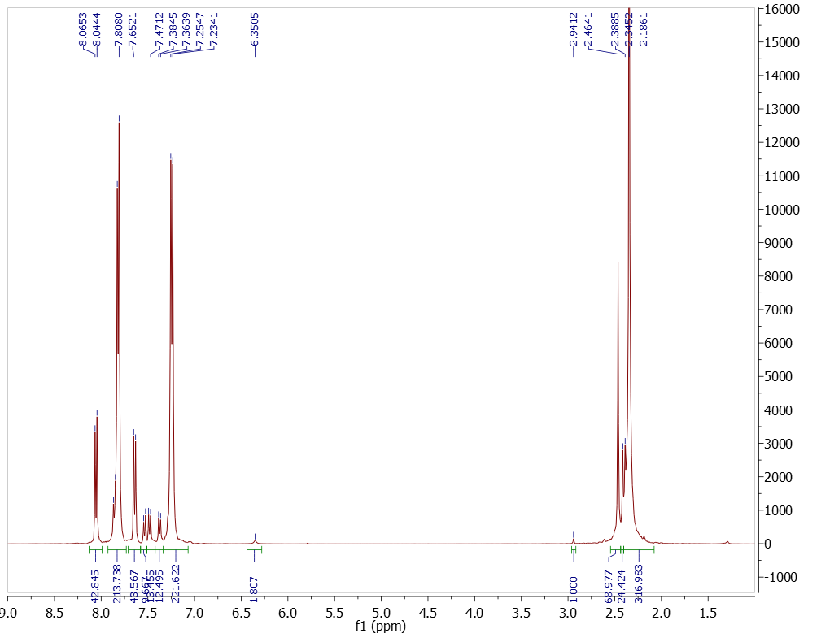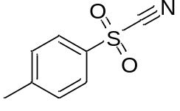
1
2
3
1
2
3

Fig.S1.a ¹H-NMR of p-Toluenesulfonyl Cyanide (3) in DMSO-d6 for 2 days at 50 °C.
p-Toluenesulfonyl Cyanide ¹H NMR (DMSO-d₆, ppm): δ = 2.46 (s, 3H), 7.64 (d, J= 8.6 Hz, 2H), 8.05 (d, J= 8.4 Hz, 2H). The same reaction solution (TsCN and DMSO-d₆) was then spiked with toluenesulfonic acid, and the ¹H-NMR result was shown in Fig.S1.b.
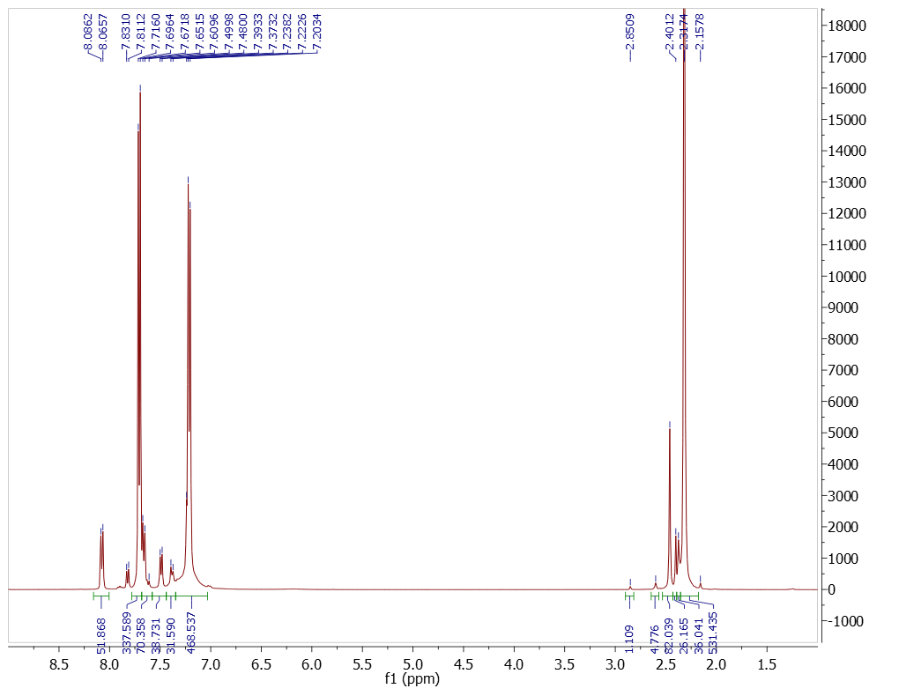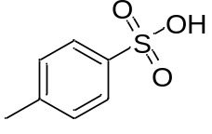
1
2
3
1
2
3
x
y
z
x
y
z
Fig.S1.b ¹H-NMR of p-Toluenesulfonyl Cyanide in DMSO-d6 for 2 days at 50 °C, spiked with toluenesulfonic acid.
The increased peaks x, y, z correspond to the increased amount of p-toluenesulfonate. p-Toluenesulfonate ¹H NMR (DMSO-d₆, ppm): δ = 2.30 (s, 3H), 7.19 (d, J=7.7 Hz, 2H), 7.69 (d, J=7.8 Hz, 2H).

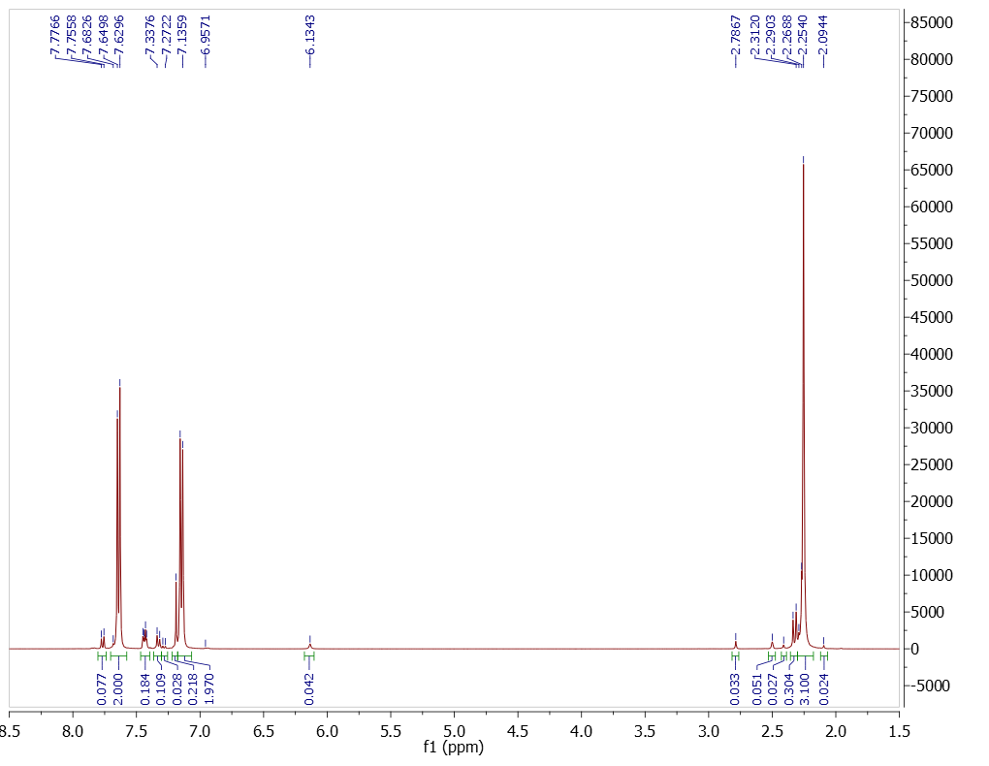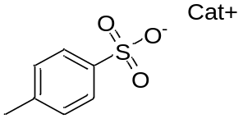
1
2
3
x
y
z
x
y
z
Fig.S1.c ¹H-NMR of p-Toluenesulfonyl Cyanide in DMSO-d6 for 4 days at 50 °C.
Comparing Fig.S1.C (reaction at 4 days) with Fig.S1.a (reaction at 2 days), p-Toluenesulfonyl Cyanide was further consumed and its peaks became much smaller.
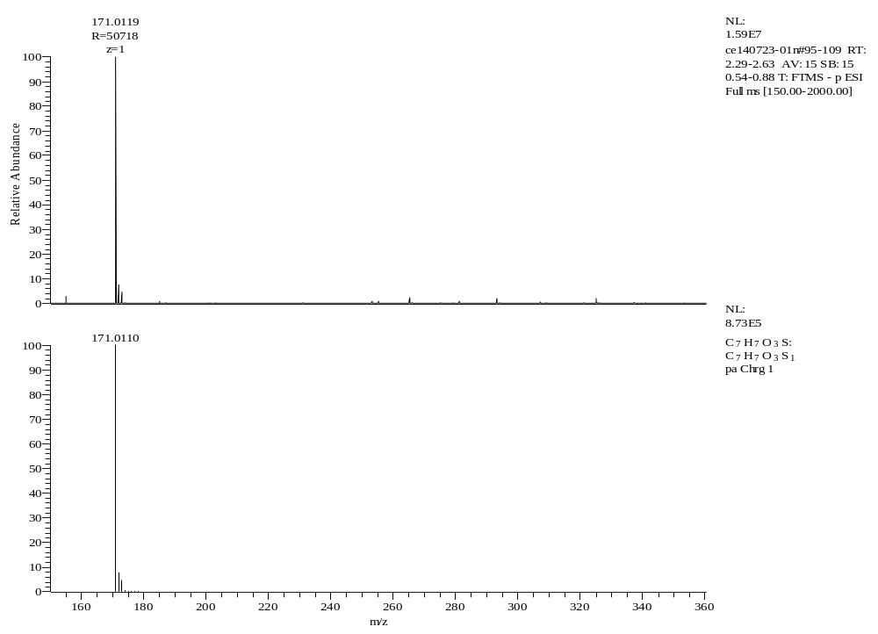
Fig.S2 Negative Ion trap/orbitrap tandem MS of major product obtained upon reaction of DMSO with p-toluenesulfonyl cyanide.
Exact mass analysis was consistent with the p-toluenesulfonate (ESI-FTMS (m/z): calcd. for C₇H₇O₃S 171.0110, found 171.0119 [M]⁻).

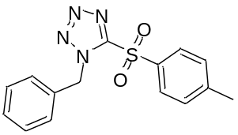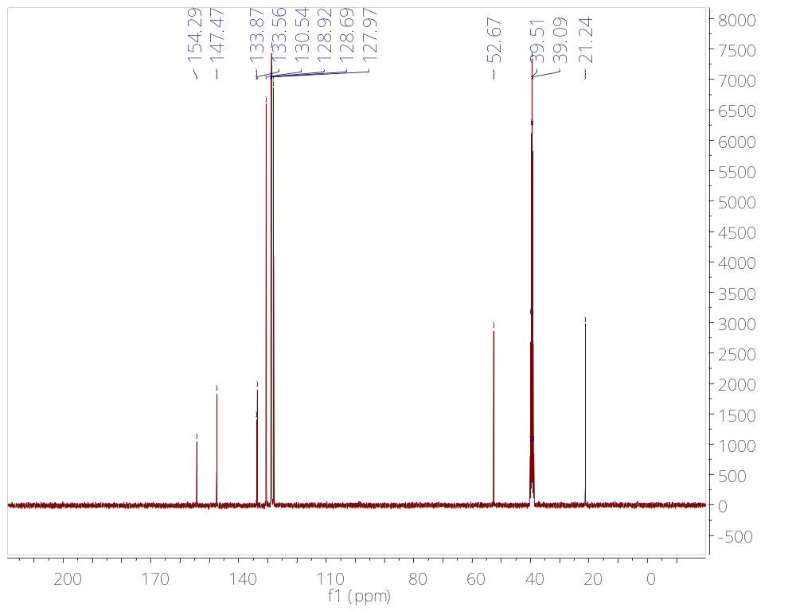
Fig.S3.a ¹³C NMR of 1-benzyl-5-p-toluenesulfonyl tetrazole (2) using cheletropic switch and followed by solvent extraction prior to column chromatographic procedure.
No appreciable differences were observed between Fig.S2.a and Fig.S2.b, which suggests that comparable purities can be obtained without the need for subsequent column chromatography.

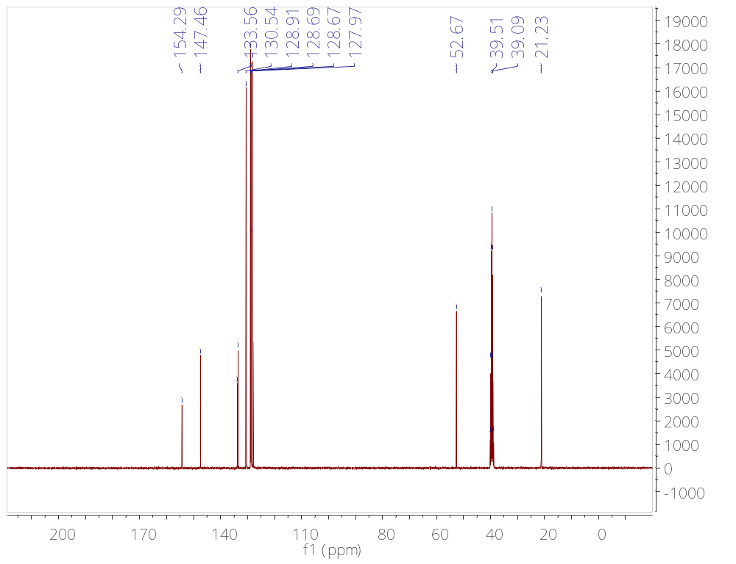

Fig.S3.b ¹³C NMR of 1-benzyl-5-p-toluenesulfonyl tetrazole (2) using cheletropic switch and followed by solvent extraction after the column chromatographic procedure.

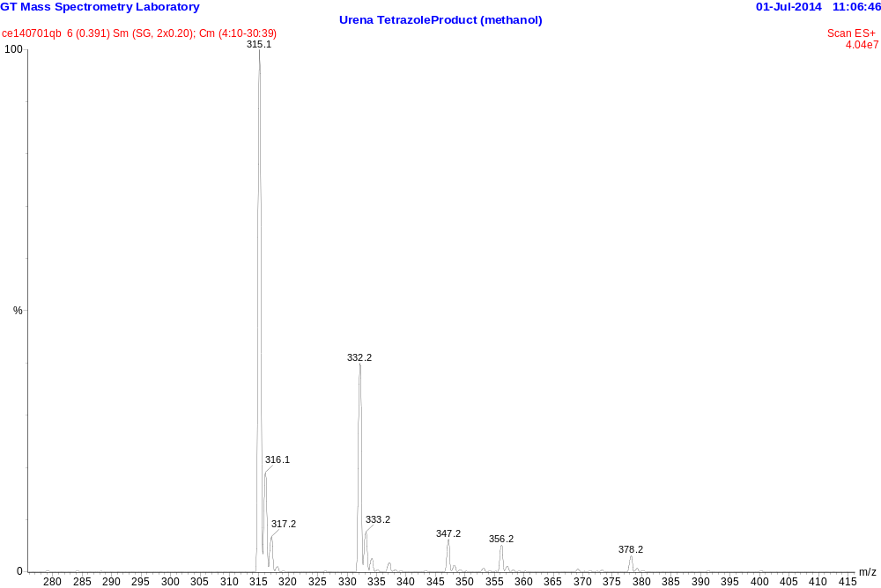
Fig.S4 ESI-MS spectra of 1-Benzyl-5-(p-toluenesulfonyl)tetrazole (2) from cycloaddition chemistry using BS as solvent: 315 [M+H]⁺, 332 [M+H₂O]⁺

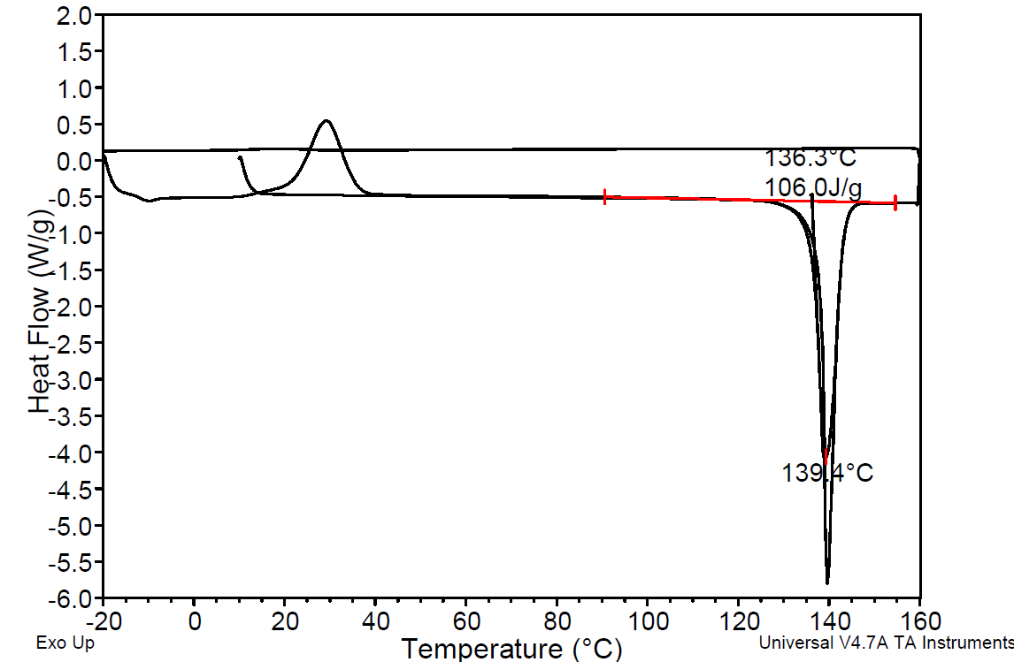
Fig.S5 DSC scan of 1-Benzyl-5-(4-methylphenylsulfonyl)tetrazole (2) product from cycloaddition chemistry reaction using BS as solvent.
DSC scan started at 25 °C, and then temperature was increased to 160 °C at a ramp rate of 10 °C/min. The initial heating process helped to eliminate thermal history of sample. Next, DSC was cooled down to -20 °C for sample to crystallize, and then was heated to 160 °C to determine its melting point and enthalpy of fusion.

Fig.S6.a GC-FID calibration curve for internal standard biphenyl.
This curve was used to calculate the concentration of biphenyl in reaction solution, which was then used to determine the concentration of BnCl before reaction.

Fig.S6.b GC-FID calibration curve for BnAz (1).
This curve kept track of concentration of BnAz in reaction solution. GC yield of BnAz was able to be calculated.

Fig.S6.c GC-FID calibration curve for BnCl.
This curve was used to calculate the concentration of BnCl in reaction solution. Conversion of BnCl at different reaction time was able to be determined.
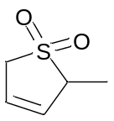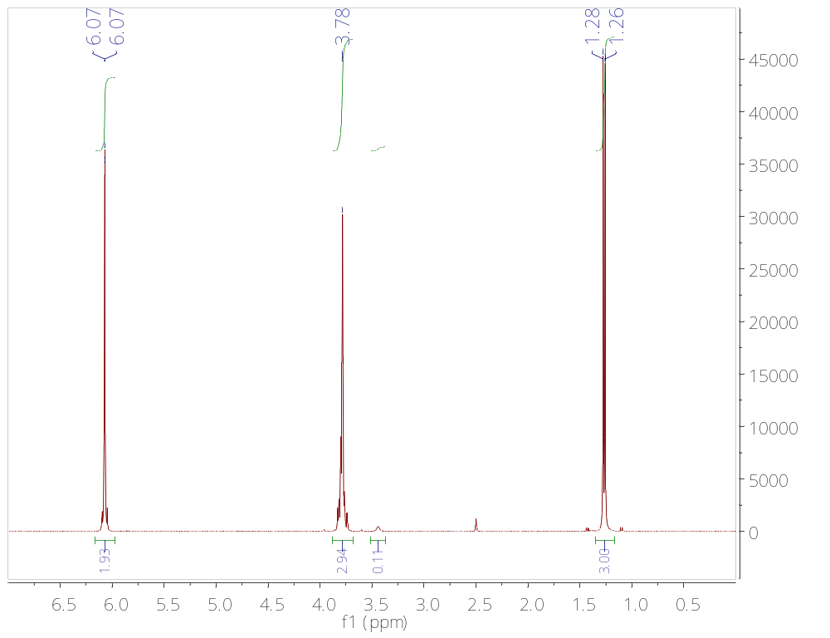
Fig.S7.a Piperylene sulfone ¹H NMR (DMSO-d₆, ppm): δ = 2.27 (s, J=7.2 Hz, 3H), 3.78 (m, 3H), 6.07 (m, 2H).
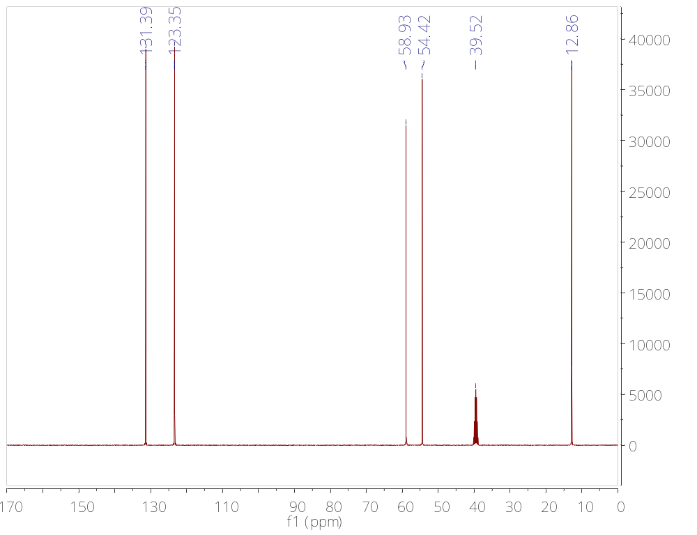
Fig.S7.b Piperylene sulfone 13C NMR (DMSO-d6, ppm): δ = 12.86, 54.42, 58.93, 123.35, 131.39.

