Supplementary material for
Modeling unobserved geothermal structures
using a physics-informed neural network with transfer learning of prior knowledge

Akihiro Shimaª, Kazuya Ishitsukaª*, Weiren Linª, Elvar K. Bjarkason^{b}, Anna Suzuki^{c}

ªKyoto University, Kyoto, Japan.
^{b}Akita University, Akita, Japan
^{c}Tohoku University, Sendai, Japan

*Corresponding author: ishitsuka.kazuya.4w@kyoto-u.ac.jp

Contents of this file
Figures S1–S5

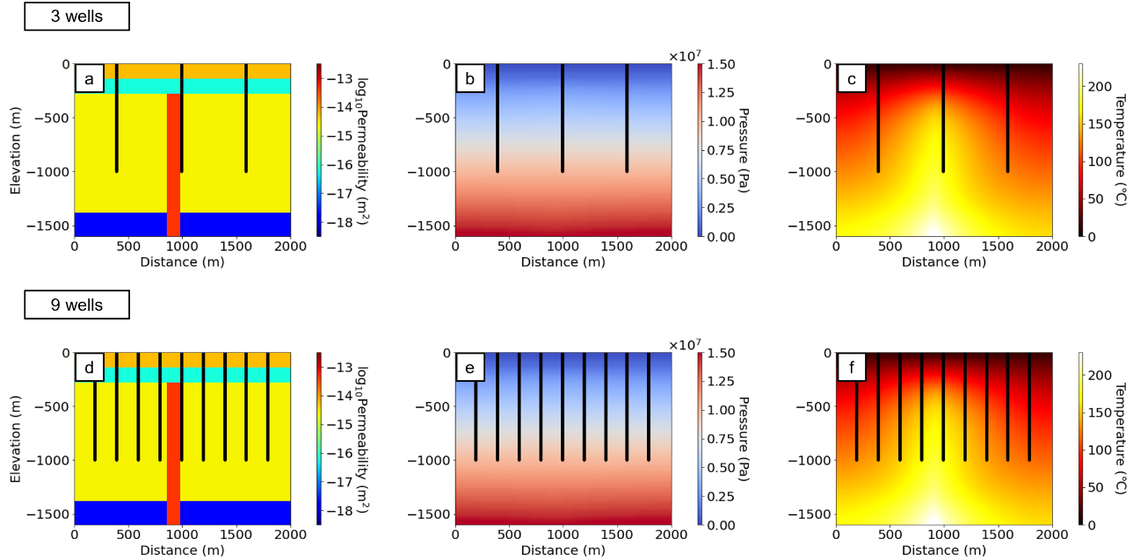
Fig. S1. Well locations for 3 (a), (b), and (c) and 9 (d), (e), and (f) in the simplified setting. (a) and (d) are permeability, (b) and (e) are pressure, and (c) and (f) are temperature distributions.

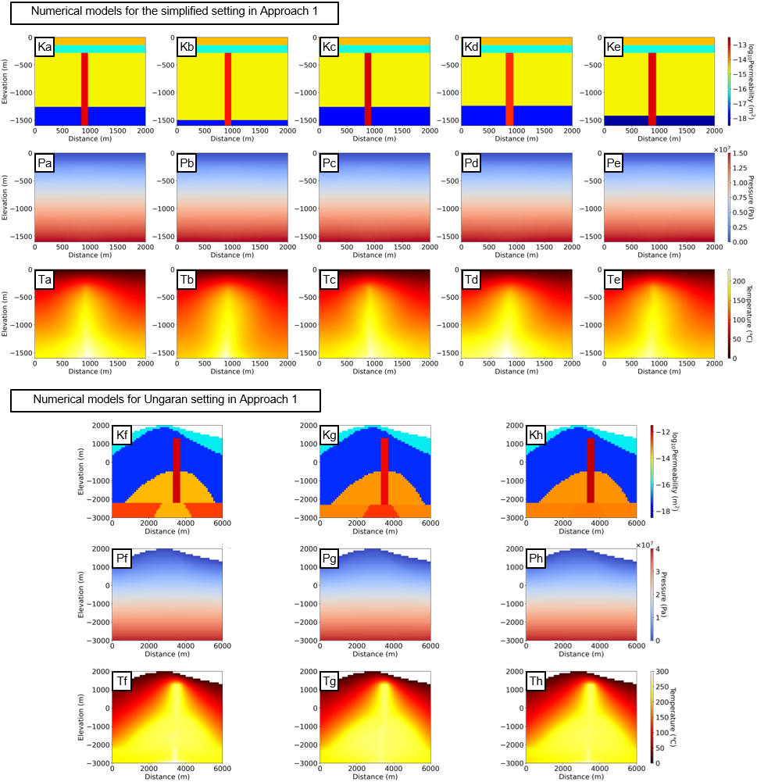
Fig. S2. Selected simulation settings with similar well logs to the reference model (Approach 1): (a)–(e) simplified and (f)–(h) Ungaran settings. Ka–h, Pa–h, and Ta–h show permeability, pressure, and temperature distributions, respectively. (a) shows when one numerical model, (a)–(c) three pre-training models, and (a)–(e) five pre-training models were used for pre-training in the simplified setting.

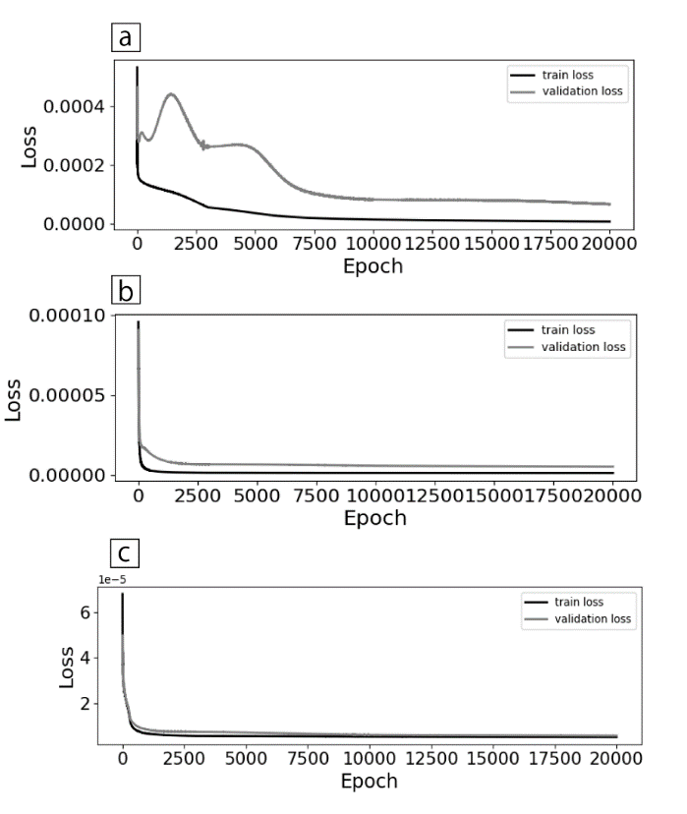
Fig. S3. Loss functions of the training and validation datasets at each epoch in the simplified setting shown in Fig. 6. (a), (b), and (c) are from the Reference PINN, PINN-TL (Approach 1), and PINN-TL (Approach 2), respectively.
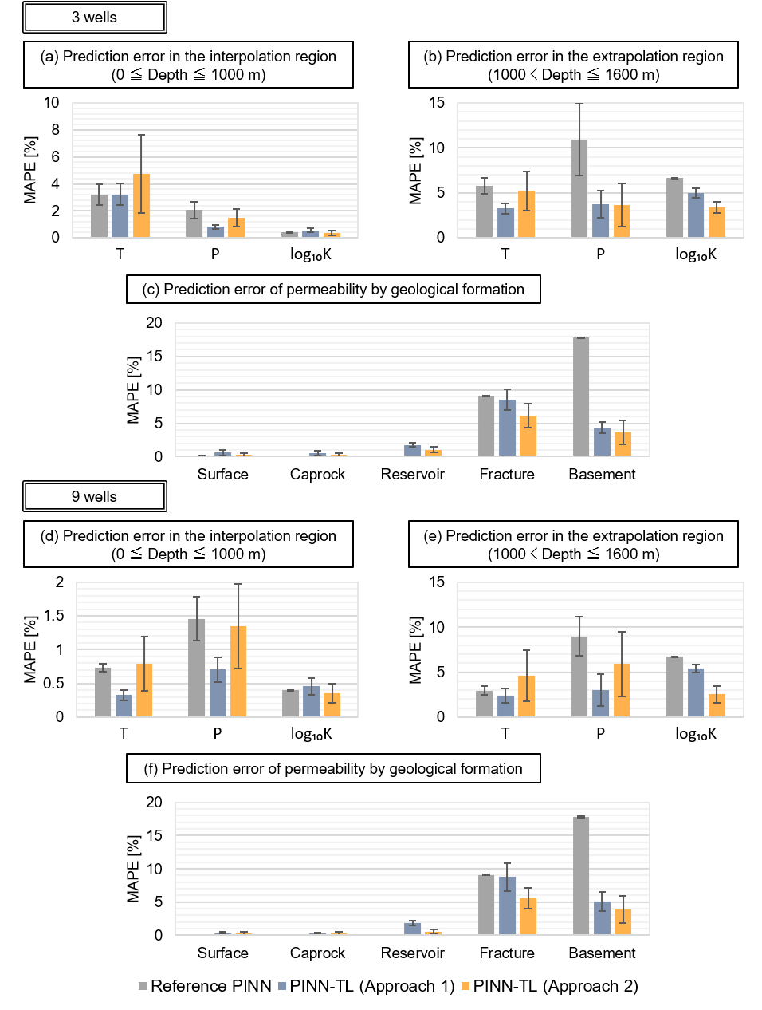
Fig. S4. Prediction error of the simplified setting for interpolated region shallower than 1000 m depth (a) and (d), extrapolated region deeper than 1000 m depth (b) and (e), and permeability by geological formation (c) and (f) for the simplified setting. (a), (b), and (c) show results for three wells, and (d), (e), and (f) show results for nine wells. Vertical and error bars represent the mean and standard deviation of MAPE.

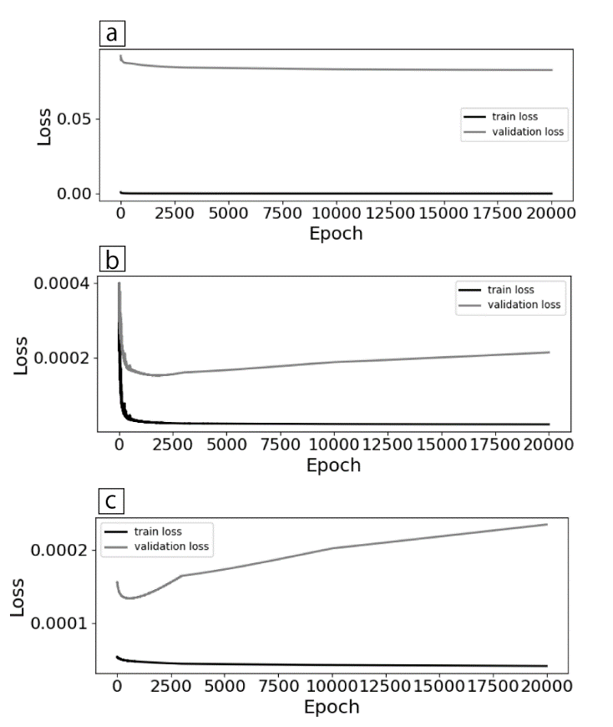
Fig. S5. Loss functions of the training and validation datasets at each epoch in the Ungaran setting shown in Fig. 8, for the (a) Reference PINN, (b) PINN-TL (Approach 1), and (c) PINN-TL (Approach 2).

