Supplementary figure 2.

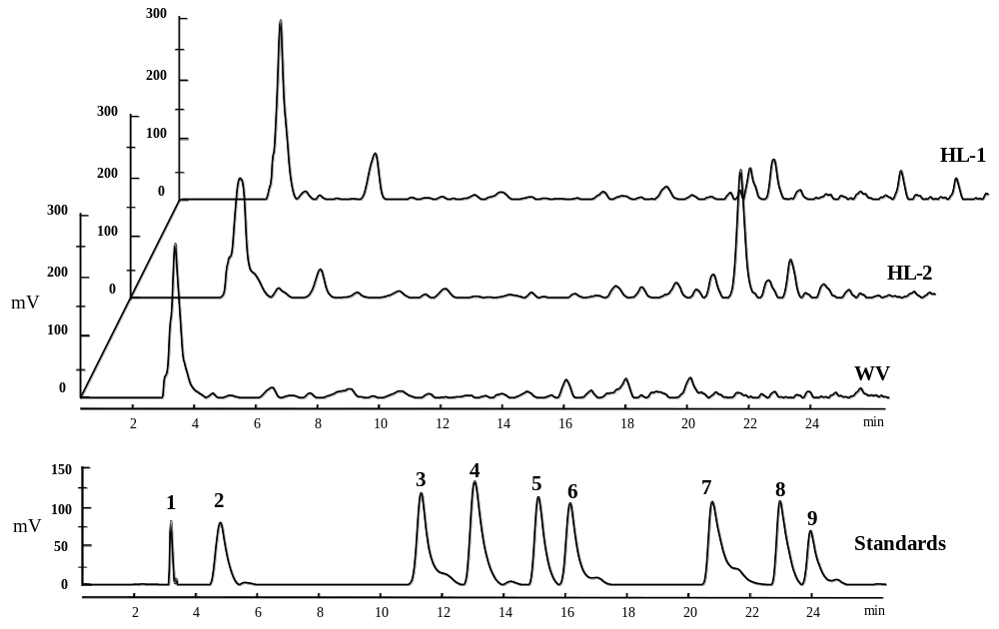

Supplementary figure 2. HPLC profiles of phenolic standards and WBM leaf extracts detected at 280 nm. Peaks: 1, ascorbic acid; 2, gallic acid; 3, salicylic acid; 4, caffeic acid; 5, ferulic acid; 6, cinnamic acid; 7, myricetin; 8, quercetin; 9, luteolin.

