Additional file

Morphology, taxonomy and mating-type loci in natural populations of Volvox carteri in Taiwan

Figures S1-S3.

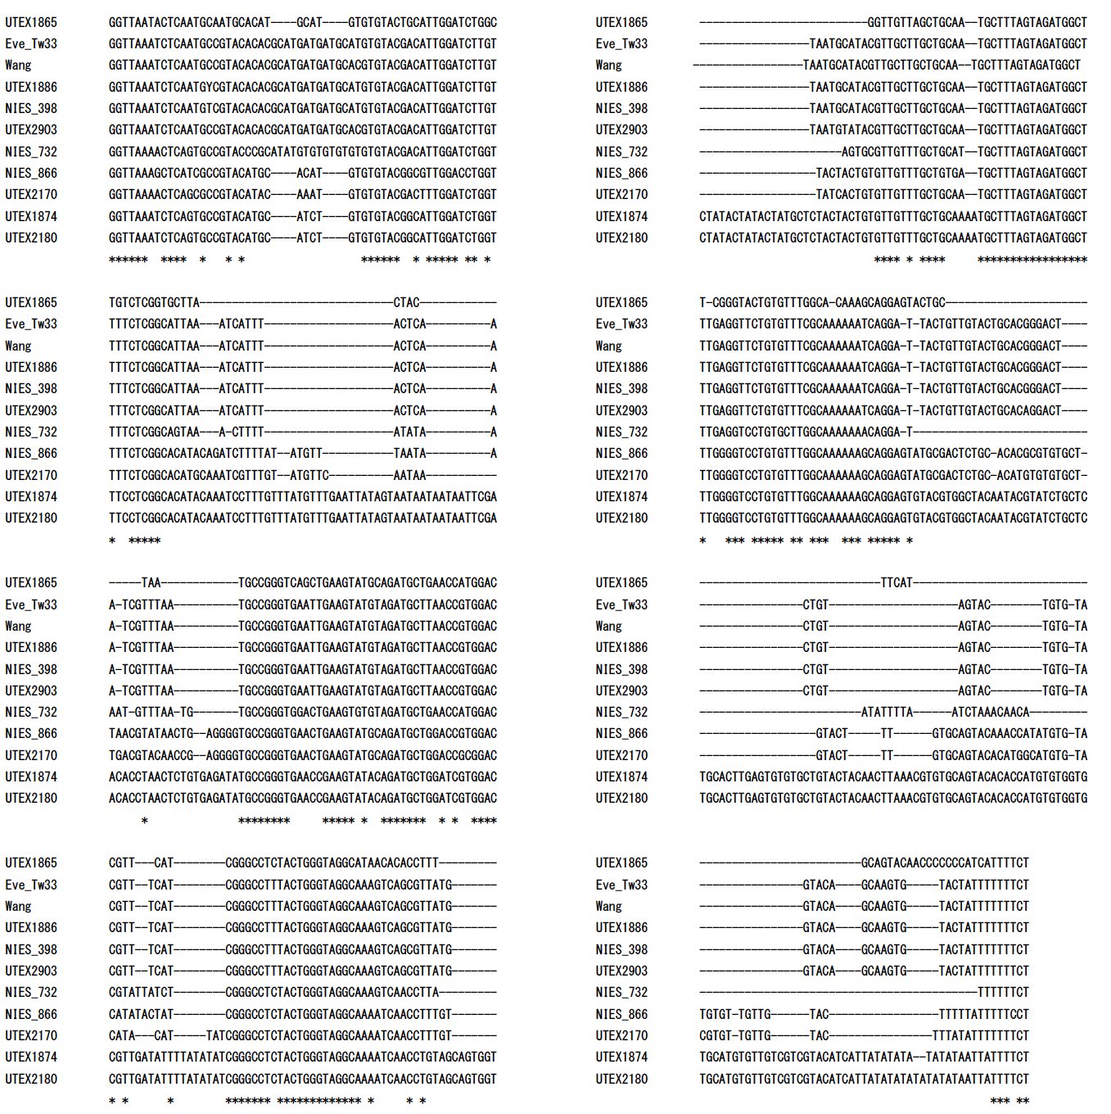
Figure S1. Alignment of nuclear rDNA ITS-2 sequences used for construction of the phylogenetic tree (Fig. 3).
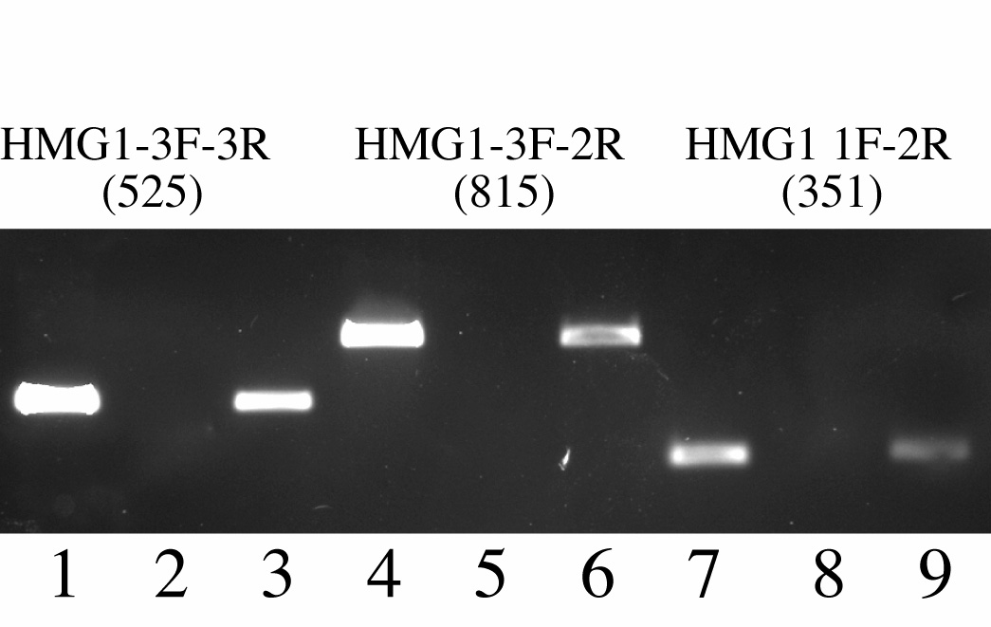
Figure S2. Results of genomic PCR of three strains using three pairs of HMG1f primers (Table 2 and Fig. S3). Numbers below primer pairs represent expected sizes of the PCR products. Lanes 1, 4 and 7: Eve (UTEX 1885). Lanes 2, 5 and 8: 2016-tw-nuk-8-2. Lanes 3, 6 and 9: 2016-0609-v-1.

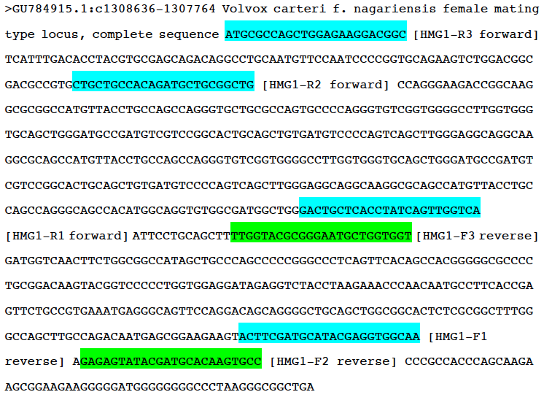
Figure S3. Primer positions of six HMG1f primers used in Figure 3 and Figure S1.

