Supplementary information for
Fungal endophytes of Plumbago zeylanica L. enhances plumbagin content

Namdeo B. Andhale^{1,2} , Mohd. Shahnawaz*^{1,3} and Avinash B. Ade*¹
¹Department of Botany, Savitribai Phule Pune University, Ganeshkhind, Pune Maharashtra-411007, India
²Department of Botany, Fergusson College, FC Road, Shivajinagar, Pune-411004, MS, India
³Present address, Plant Biotechnology Division, CSIR-Indian Institute of Integrative
Medicine, Canal Road Jammu, Jammu-180001, J&K, India
*Corresponding author: Phone: +91-020-25601439. Fax: +91-020-25690498.
Email: mskhakii@unipune.ac.in
avinashade@unipune.ac.in

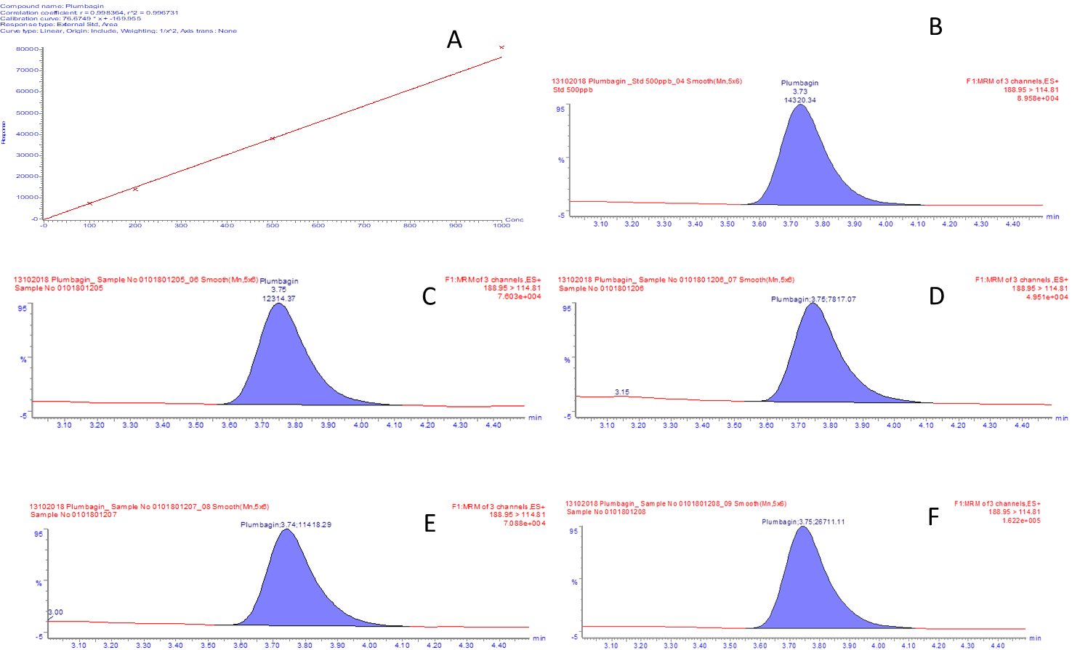

Fig. S1.

Fig. S1. Estimation of the Plumbagin using LCMS-MS analysis, A: Calibration curve of Plumbagin, B: Chromatogram representing the standard Plumbagin, C: Chromatogram representing the mass and peak of the plumbagin in the methanolic root extract of control plants, D: Chromatogram of representing the mass and peak of the plumbagin in the methanolic root extract of the plants treated with Isolate-1, E: Chromatogram representing the mass and peak of the plumbagin in the methanolic root extract of the plants treated with Isolate-2, F: Chromatogram representing the mass and peak of the plumbagin in the methanolic root extract of the plants treated with Isolate-3.

