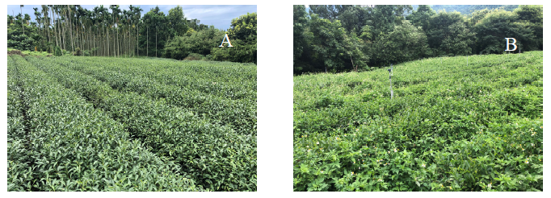

Figure S1. The conventional agriculture (panel A) and sod culture (panel B) farming of 20-25 year-old tea plants (Camellia sinensis) 45-55 cm high.

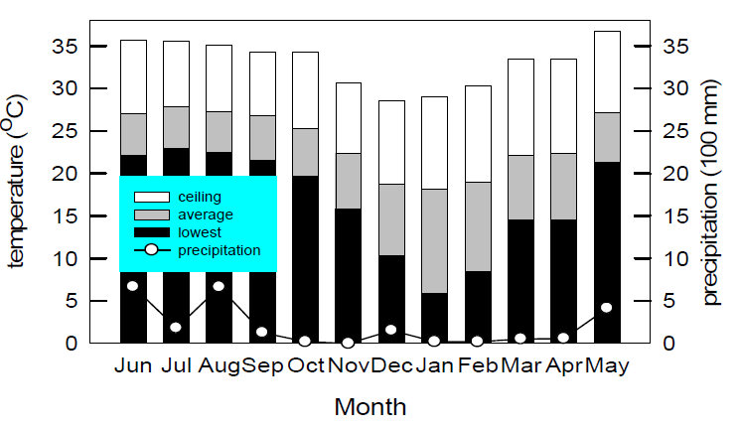

Figure S2. Monthly air temperatures (bar) and precipitation (circle) during the study period from June 2019 to May 2020 at the lower-elevation mountain area of central Taiwan (120°39'12.4"E, 23°38'36.7"N).

