Botanical Studies

Association mapping of important agronomic traits in Mucuna pruriens (L.) DC.

Supplementary Information

All Supplementary Tables are combined in a single Excel file.
The table titles and captions are listed below.

Table S1 Details of M. pruriens accessions used for the association analysis along with collection locations and geographic affiliations before filtration.

Table S2 Details of SSR primer pairs used in the study before filtration.

Table S3 Eigen vector and Eigen values of the first five principal components (PCs) for phenotypic traits.

Table S4 Allelic data for 90 SSR markers.

Table S5 Details of marker attributes based on 66 SSR markers retained after stringent filtration.

Table S6 Marker-trait associations identified at a significance level of P < 0.05 with phenotypic variance explained (PVE) > 10%.

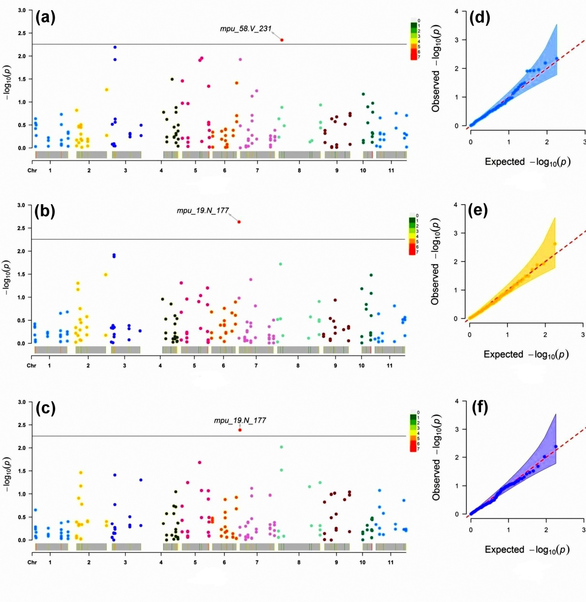
Fig. S1 Manhattan plots (P-value) for MLM depicting significant marker trait association at adjusted threshold P < 5.55 × 10⁻³ (a) Inflorescence length (b) Flower buds per inflorescence (c) Flower length; Quantile-Quantile (Q-Q) plots of MLM (d) Inflorescence length (e) Flower buds per inflorescence (f) Flower length
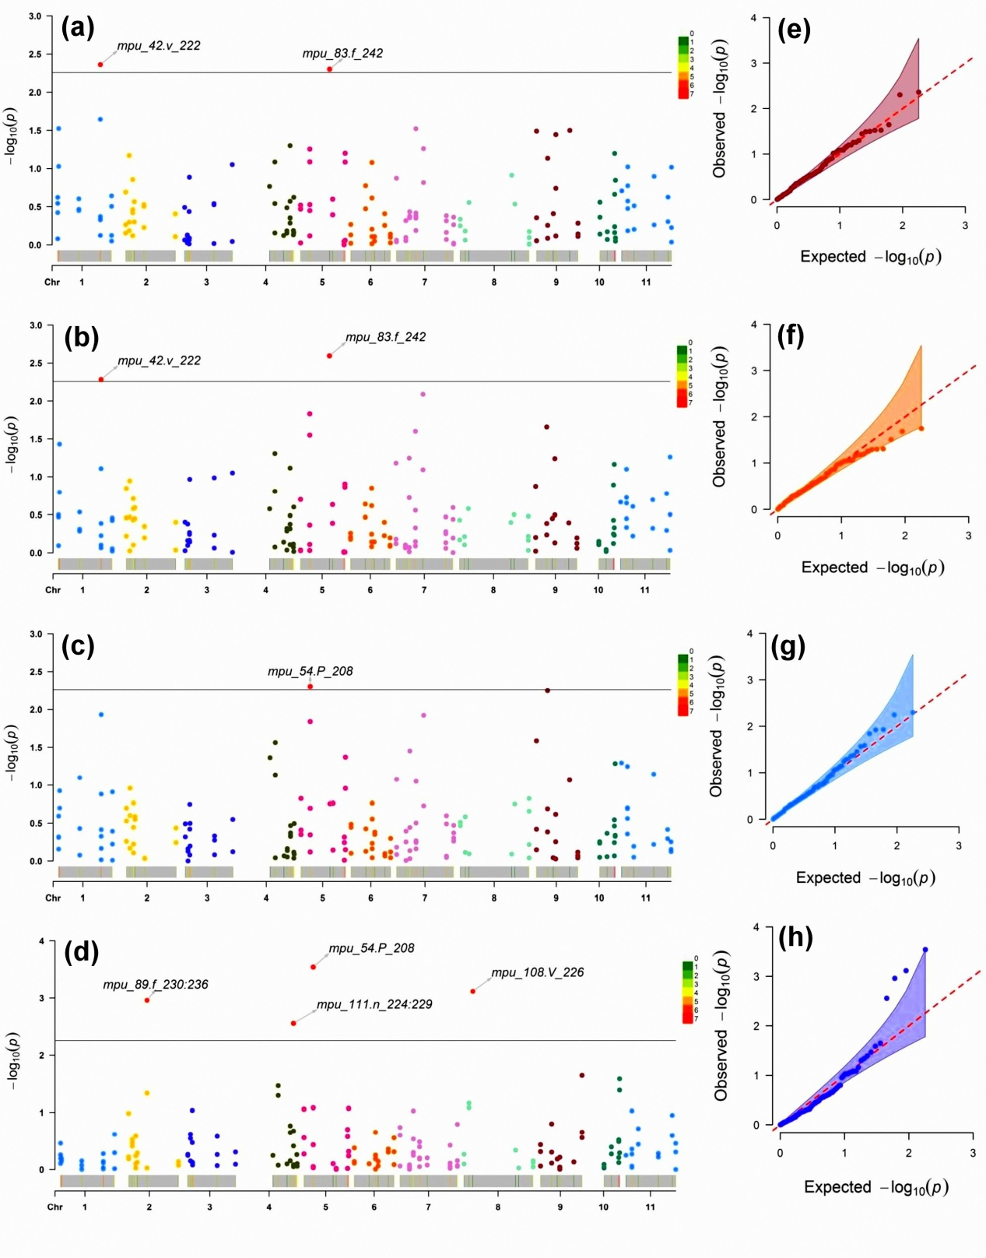
Fig. S2 Manhattan plots (P-value) for MLM depicting significant marker-trait association at adjusted threshold P < 5.55 × 10⁻³ (a) Seed length (b) Seed width (c) Seed thickness (d) Hundred seed weight; Quantile-Quantile (Q-Q) plots of MLM (e) Seed length (f) Seed width (g) Seed thickness (h) hundred seed weight

