Supplementary Material
New acorane-sesequiterpenes and anti-retinoblastoma constituents from the marine algicolous fungus Trichoderma harzianum NTU2180 guided by molecular networking strategy

Andrea Gu ^{a,b}, Fan-Li Lin ^{c,d}, Chung-Kuang Lu ^{e}, Tz-Wei Yeh ^{a,e}, Yih-Fung Chen ^{f}, Ho-Cheng Wu ^{b,g*}, Tzong-Huei Lee ^{a*}

ª Institute of Fisheries Science, College of Life Science, National Taiwan University, Taipei 106319, Taiwan
^{b} School of Pharmacy, College of Pharmacy, Kaohsiung Medical University, Kaohsiung 807378, Taiwan
^{c} Department of Pharmacology, School of Post-Baccalaureate Medicine, College of Medicine, Kaohsiung Medical University, Kaohsiung 807378, Taiwan
^{d} Department of Medical Research, Kaohsiung Medical University Hospital, Kaohsiung 807378, Taiwan
^{e} National Research Institute of Chinese Medicine, Ministry of Health and Welfare, Taipei 112304, Taiwan
^{f} Graduate Institute of Natural Products, College of Pharmacy, Kaohsiung Medical University, Kaohsiung 807378, Taiwan
^{g} Department of Medical Research, Kaohsiung Medical University Hospital, Kaohsiung 807378, Taiwan

*Correspondence:
Dr. Ho-Cheng Wu
School of Pharmacy, College of Pharmacy, Kaohsiung Medical University, Kaohsiung 807378, Taiwan
No. 100, Shiquan 1st Rd., Sanmin Dist., Kaohsiung 807378, Taiwan (R.O.C.)
Phone: +886 7 3121101 ext. 2672
* E-mail: hcwu@kmu.edu.tw

Prof. Tzong-Huei Lee
Institute of Fisheries Science, College of Life Science, National Taiwan University, Taipei 106319, Taiwan
No. 1, Sec. 4, Roosevelt Rd., Da'an Dist., Taipei 106319, Taiwan (R.O.C.)
Phone: +886 2 33661828
* E-mail: dthlee1@ntu.edu.tw
Content
Figure S1. The isolation flow chart of large-scale fermentation of T. harzianum NTU2180 on GBR. 1
Figure S2. Feature-based molecular networking (FBMN) of the EtOAc fractions from T. harzianum NTU2180 fermentation on GBR. 2
Figure S3. ¹H NMR spectrum of compound 1 (CDCl₃, 600 MHz) 3
Figure S4. ¹³C NMR spectrum of compound 1 (CDCl₃, 150 MHz) 3
Figure S5. HSQC spectrum of compound 1 4
Figure S6. COSY spectrum of compound 1 4
Figure S7. HMBC spectrum of compound 1 5
Figure S8. NOESY spectrum of compound 1 5
Figure S9. HRESIMS spectrum of compound 1 6
Figure S10. ¹H NMR spectrum of compound 2 (CDCl₃, 600 MHz) 6
Figure S11. ¹³C NMR spectrum of compound 2 (CDCl₃, 150 MHz) 7
Figure S12. HSQC spectrum of compound 2 7
Figure S13. COSY spectrum of compound 2 8
Figure S14. HMBC spectrum of compound 2 8
Figure S15. NOESY spectrum of compound 2 9
Figure S16. HRESIMS spectrum of compound 2 9

Figure S1. The isolation flow chart of large-scale fermentation of T. harzianum NTU2180 on GBR.

Figure S2. Feature-based molecular networking (FBMN) of the EtOAc fractions from T. harzianum NTU2180 fermentation on GBR.
(A) The three targeted molecular families (MF1, MF2, MF3) containing terpenoids for further isolation and purification were is framed in blue. (B) Painted by the EtOAc fractions of three MF clusters from (A). The isolated pure compounds were denoted by circles inside the MF clusters, and annotated with structure and precursor ion.

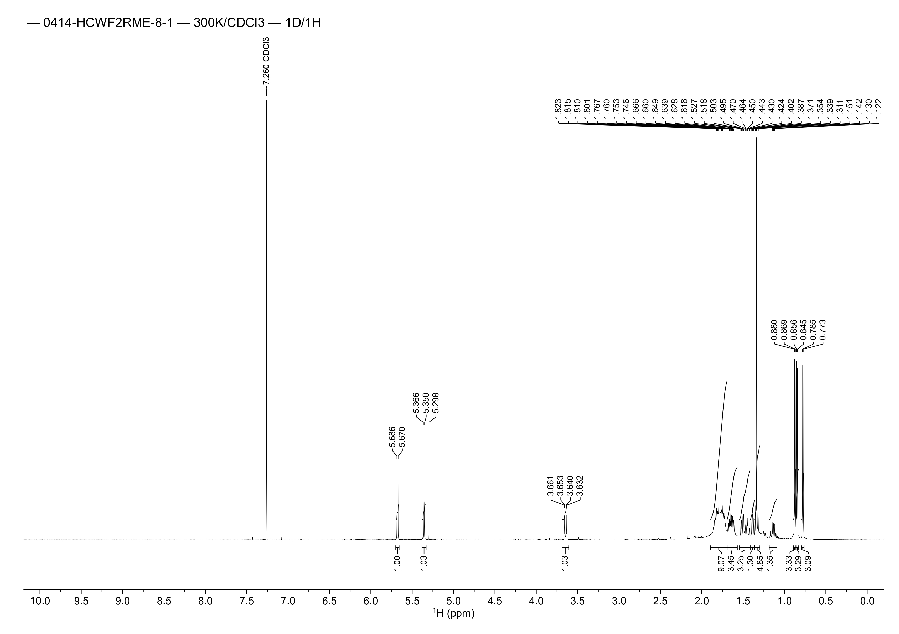

Figure S3. ¹H NMR spectrum of compound 1 (CDCl₃, 600 MHz)
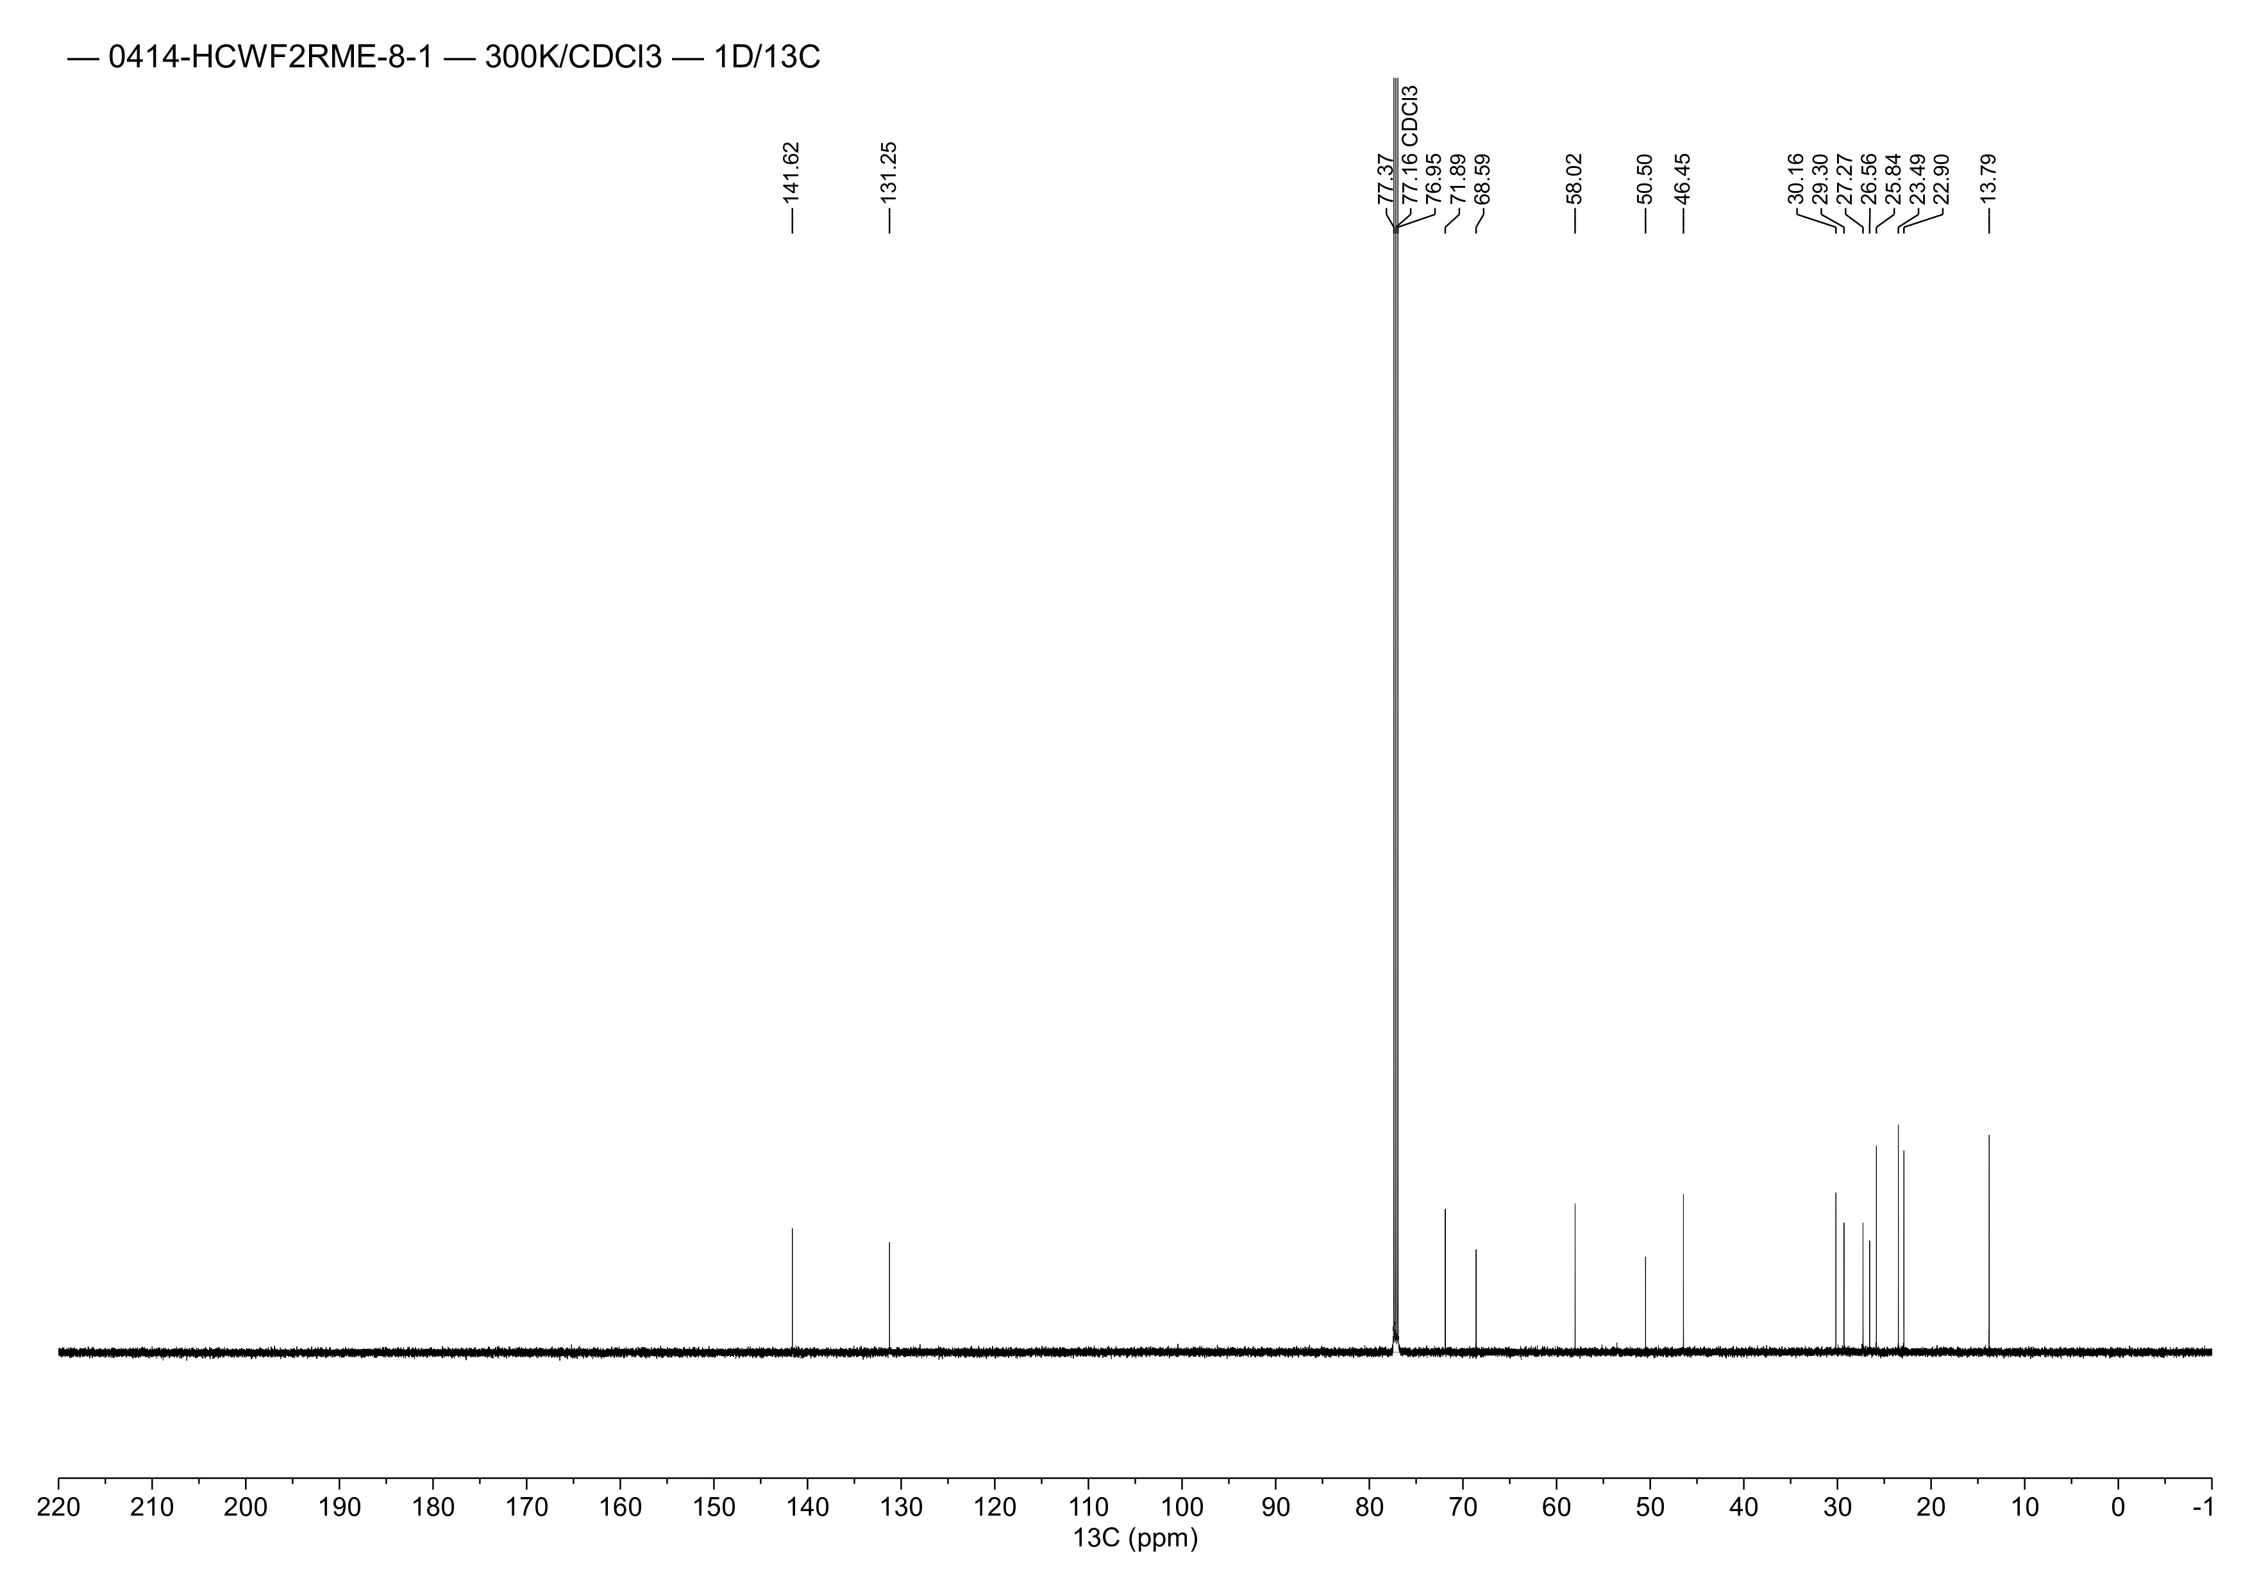

Figure S4. ¹³C NMR spectrum of compound 1 (CDCl₃, 150 MHz)
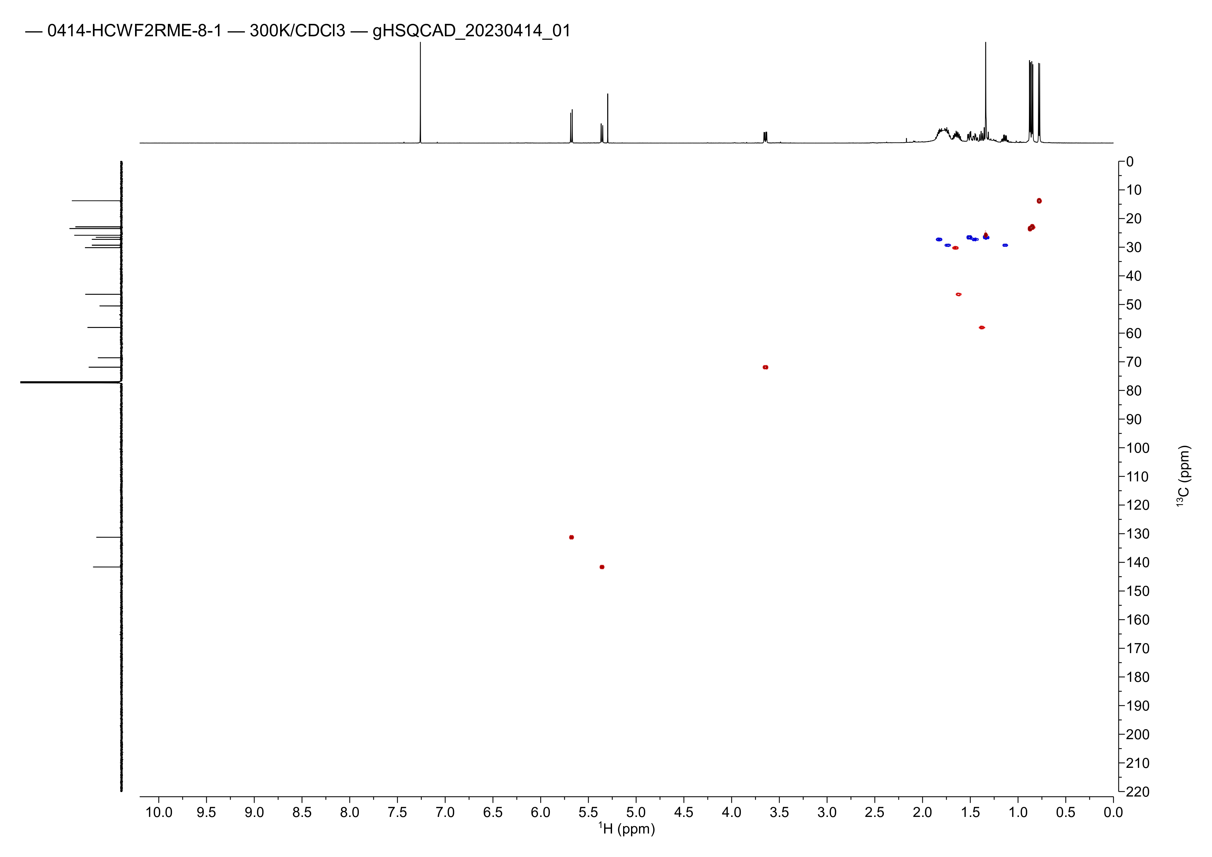

Figure S5. HSQC spectrum of compound 1
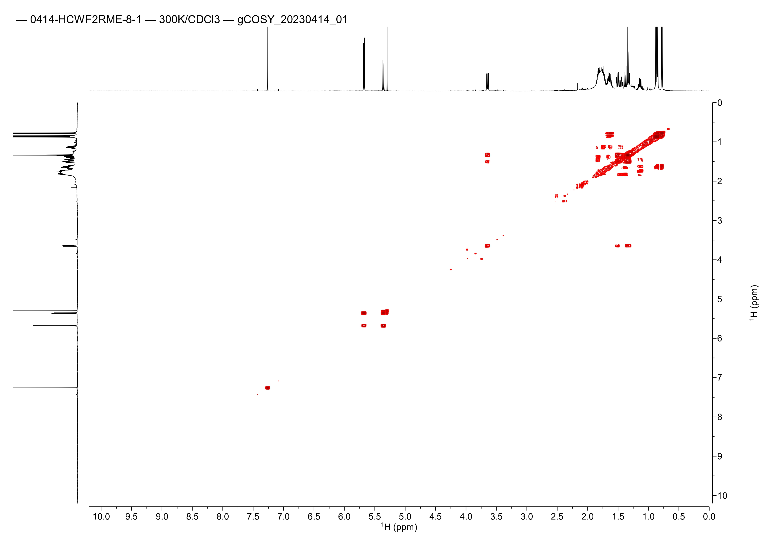

Figure S6. COSY spectrum of compound 1
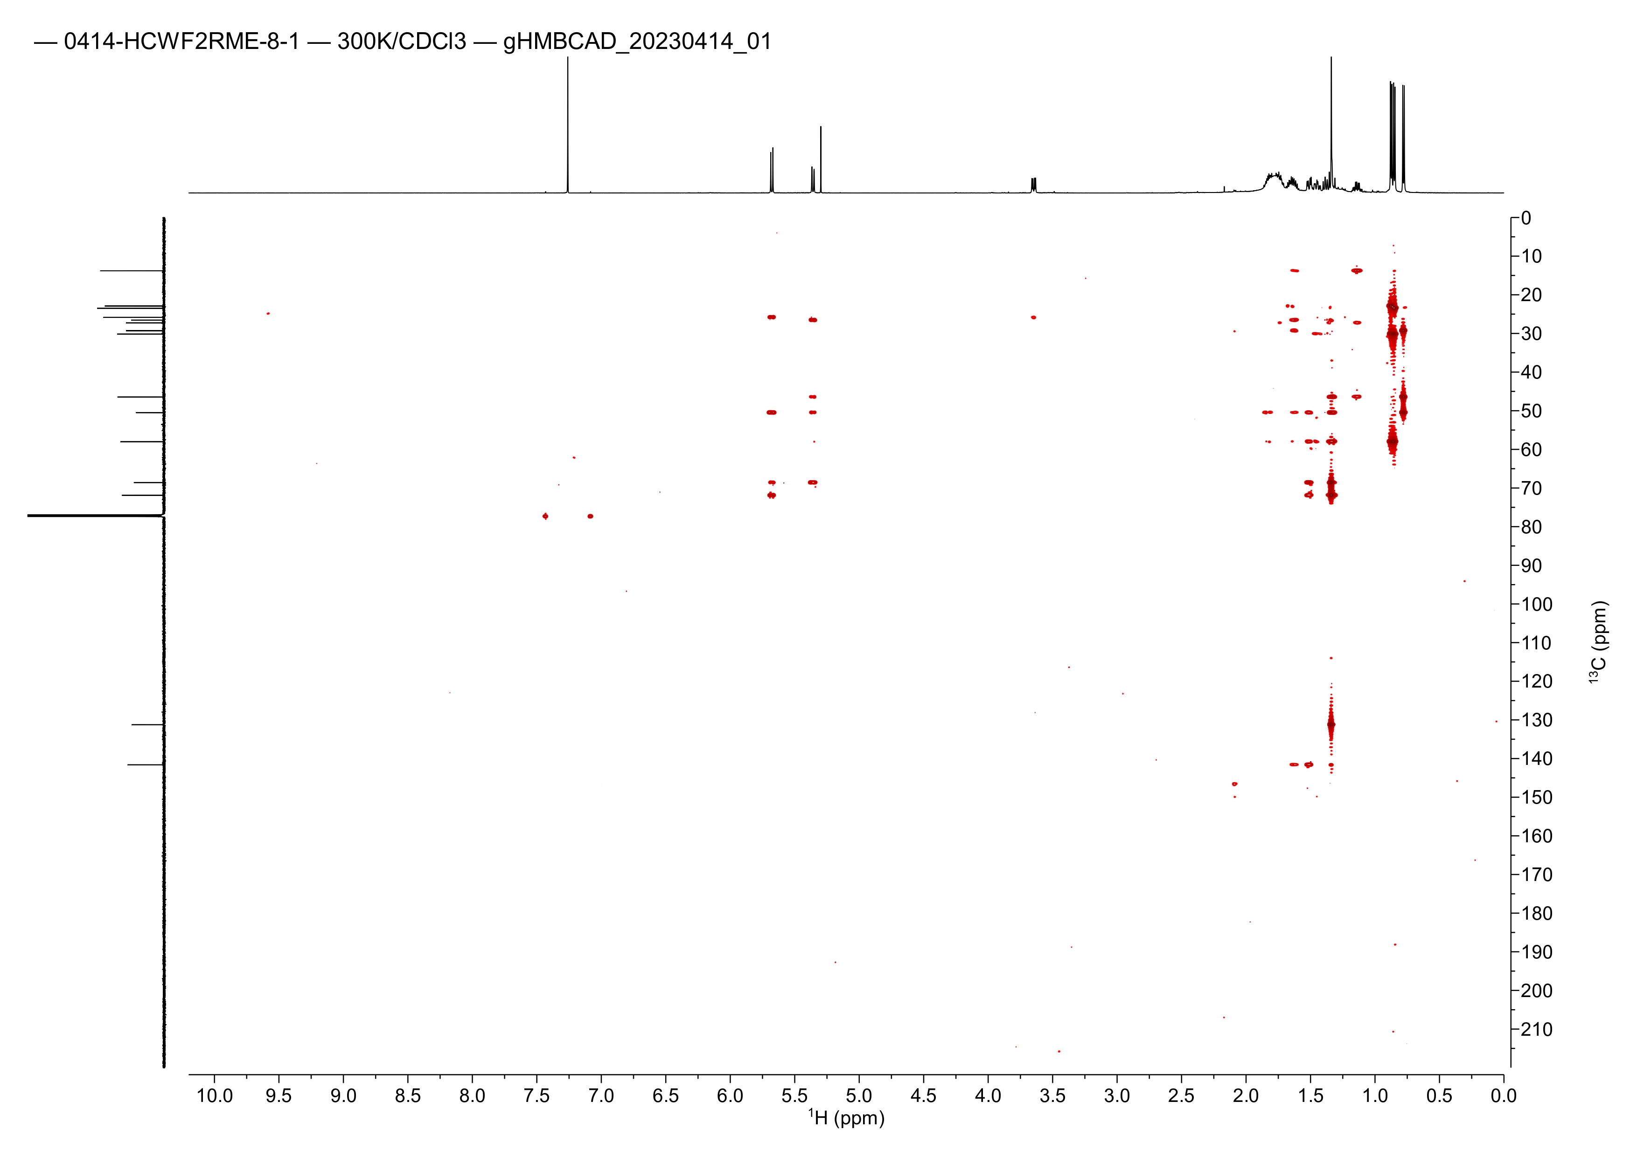

Figure S7. HMBC spectrum of compound 1
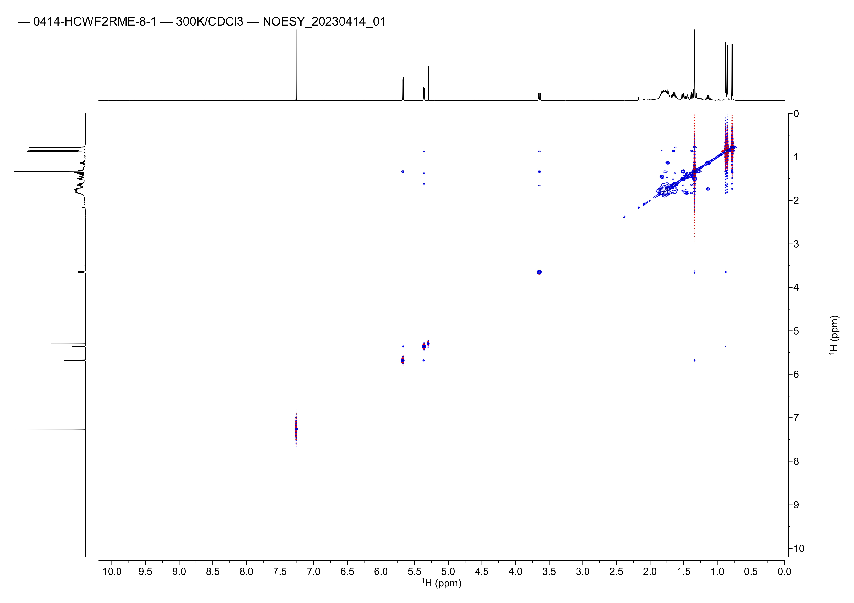

Figure S8. NOESY spectrum of compound 1
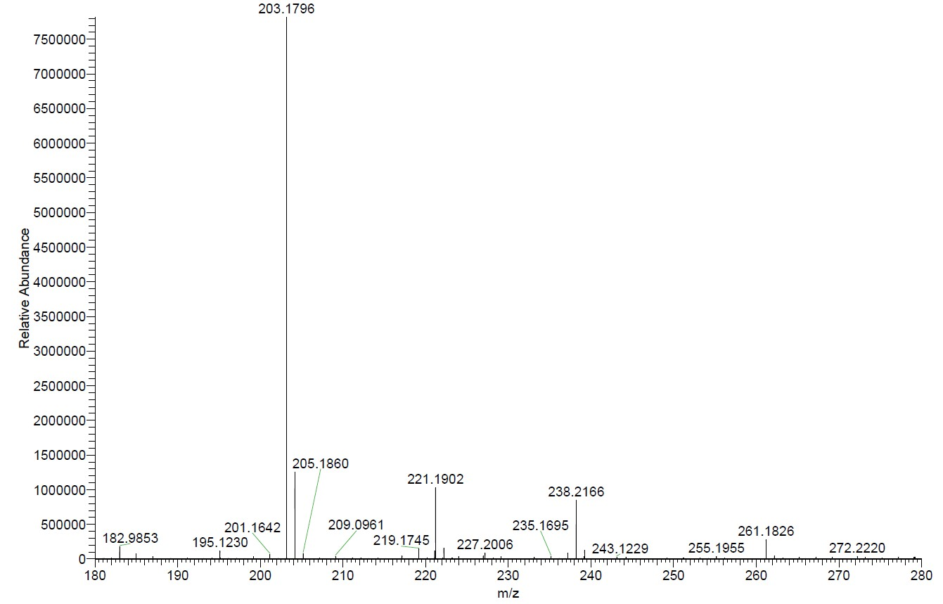

Figure S9. HRESIMS spectrum of compound 1
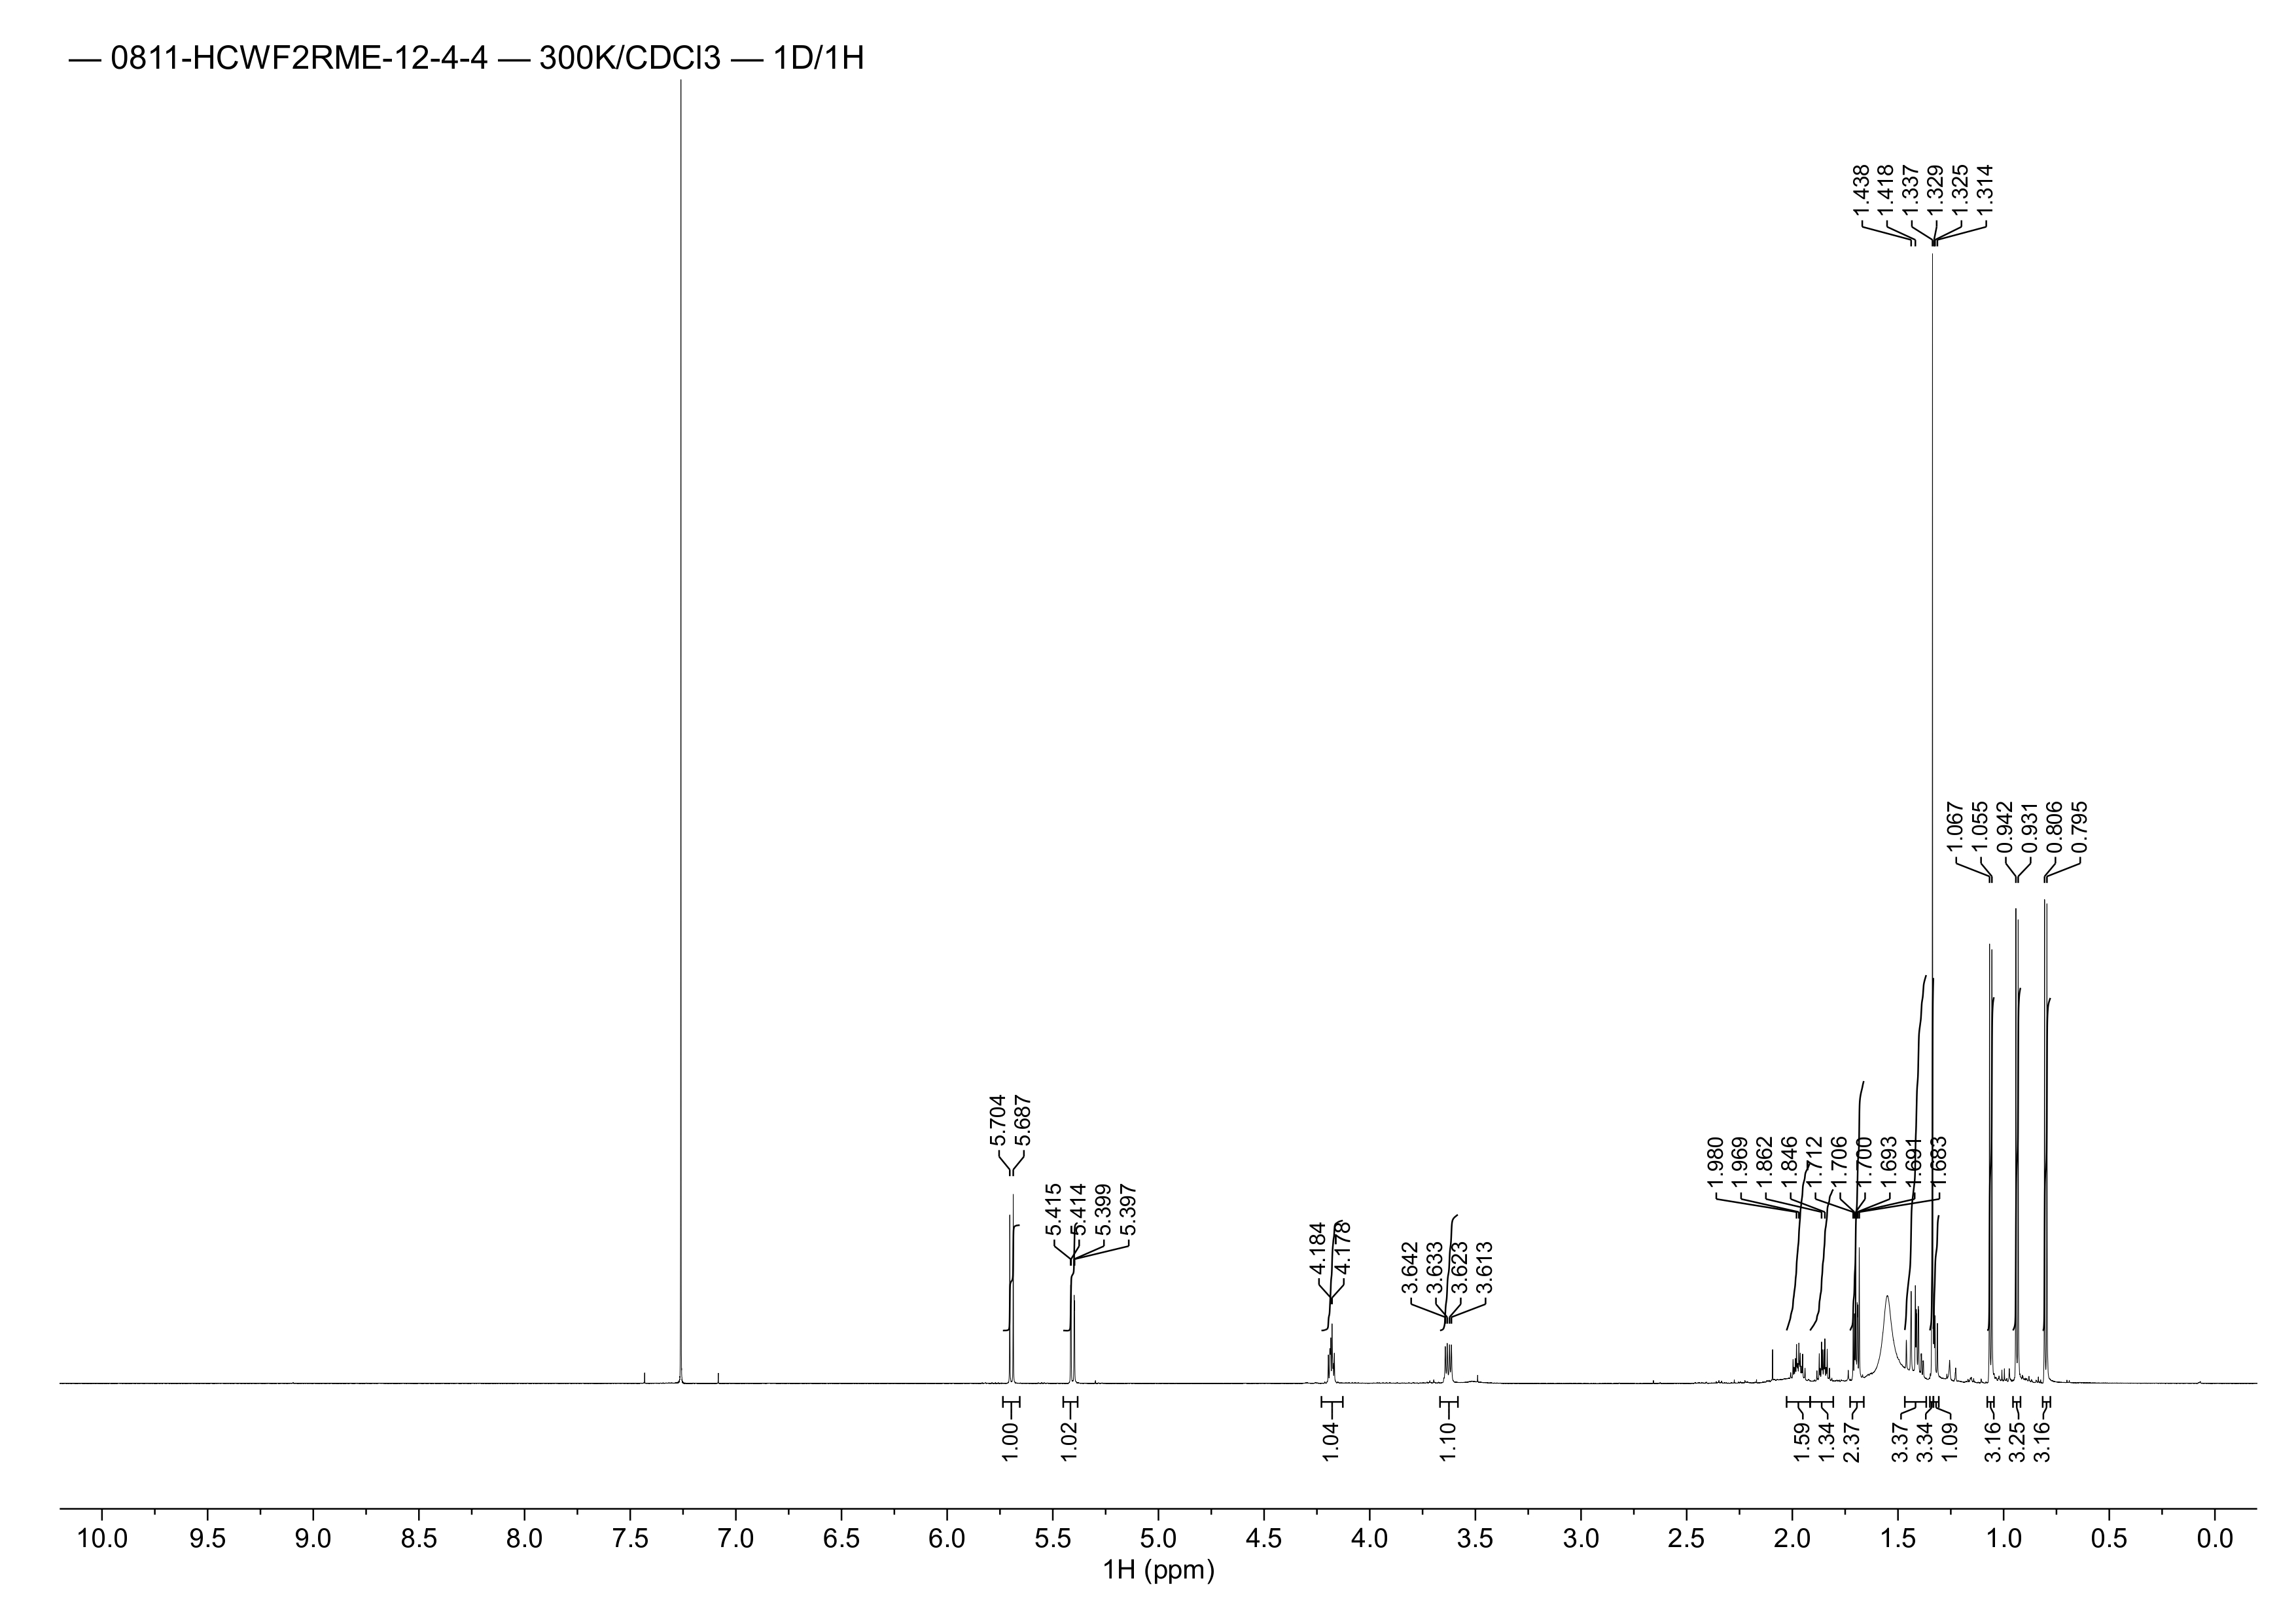

Figure S10. ¹H NMR spectrum of compound 2 (CDCl₃, 600 MHz)
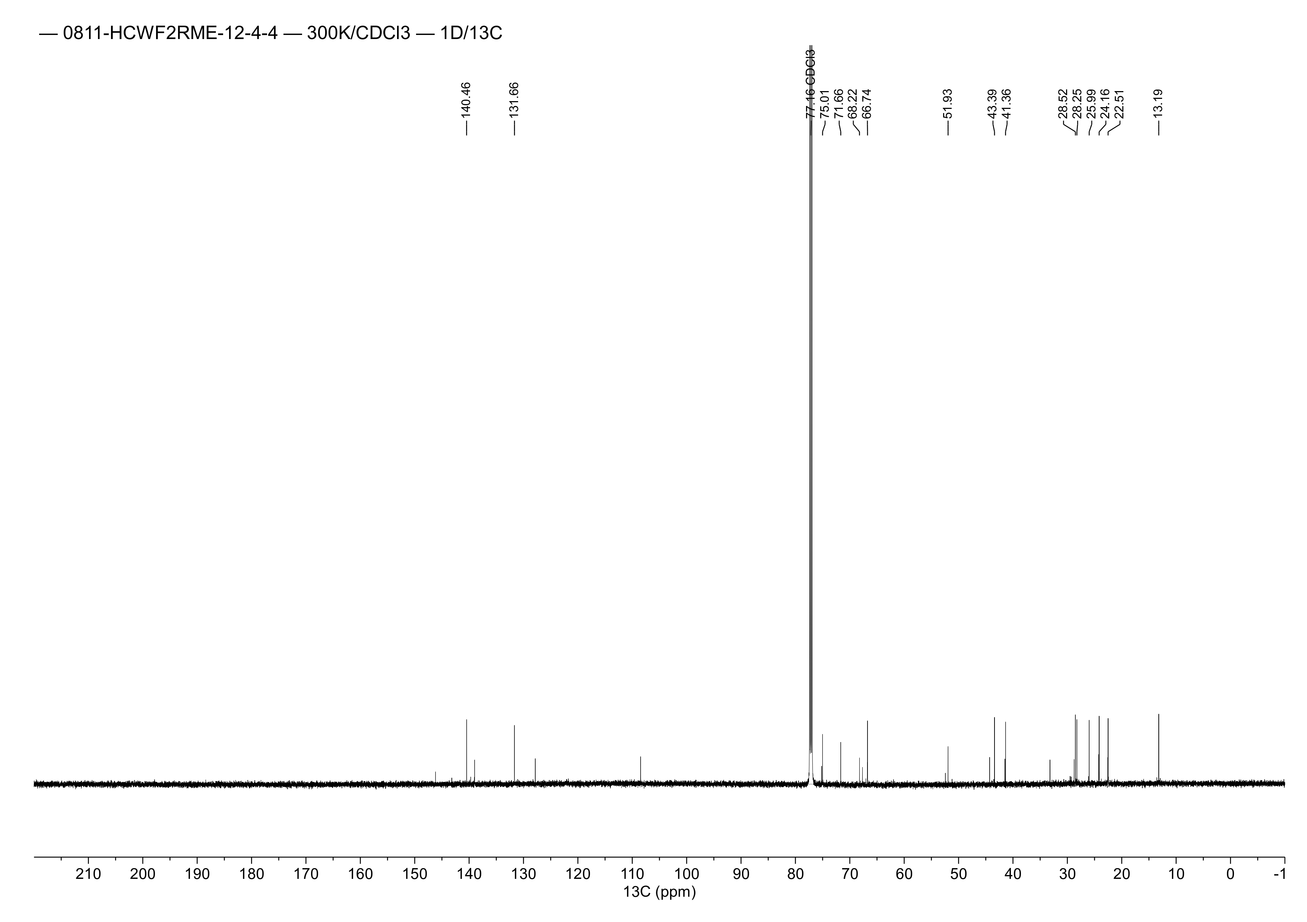

Figure S11. ¹³C NMR spectrum of compound 2 (CDCl₃, 150 MHz)
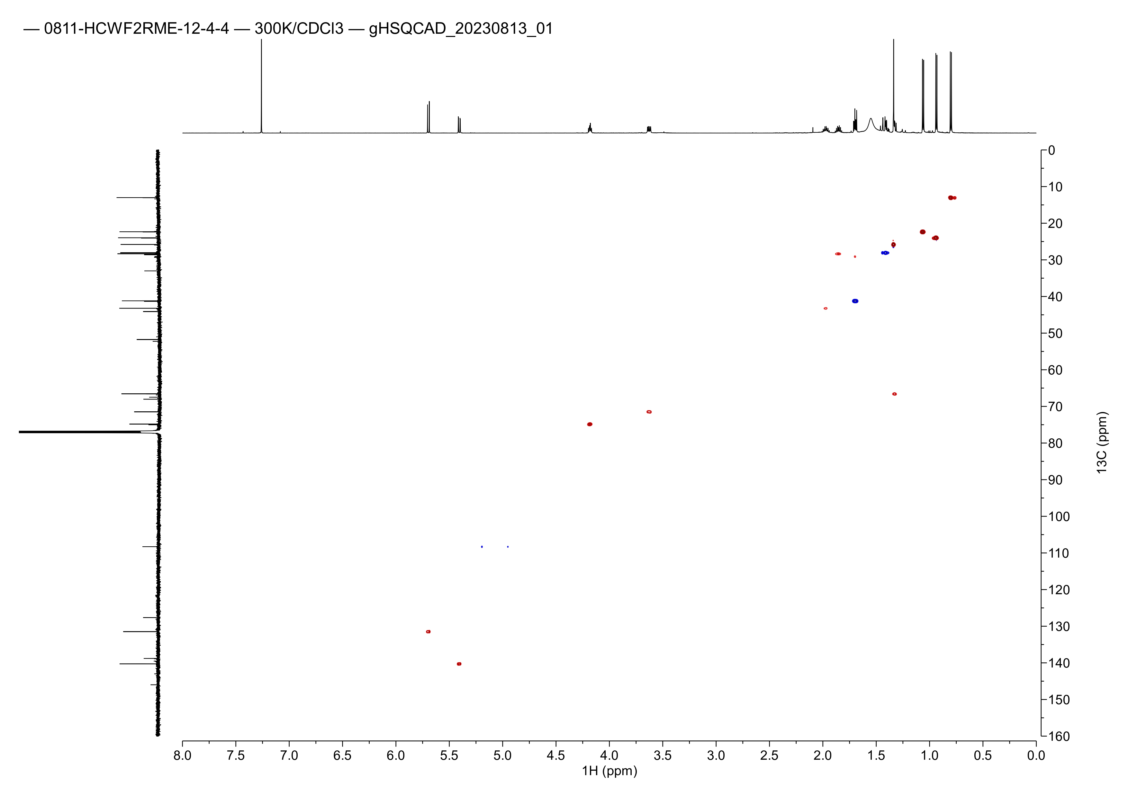

Figure S12. HSQC spectrum of compound 2
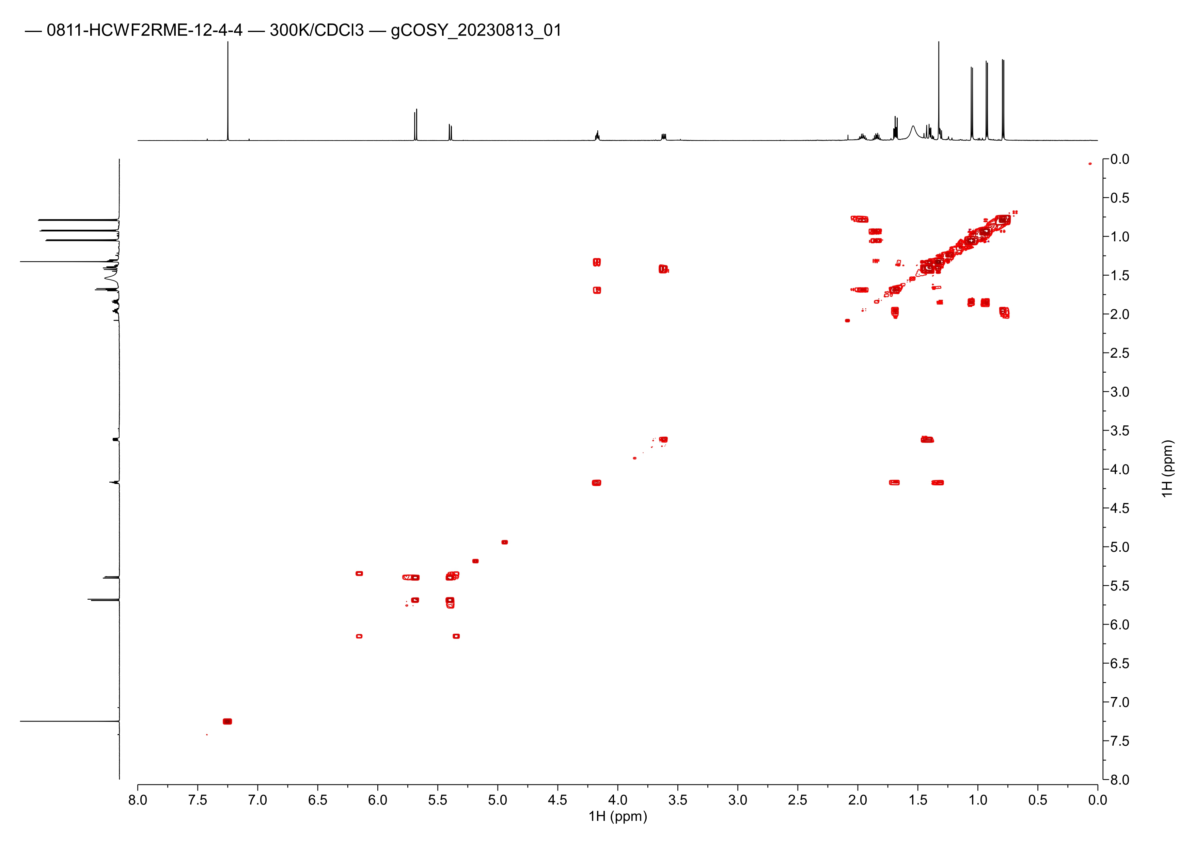

Figure S13. COSY spectrum of compound 2
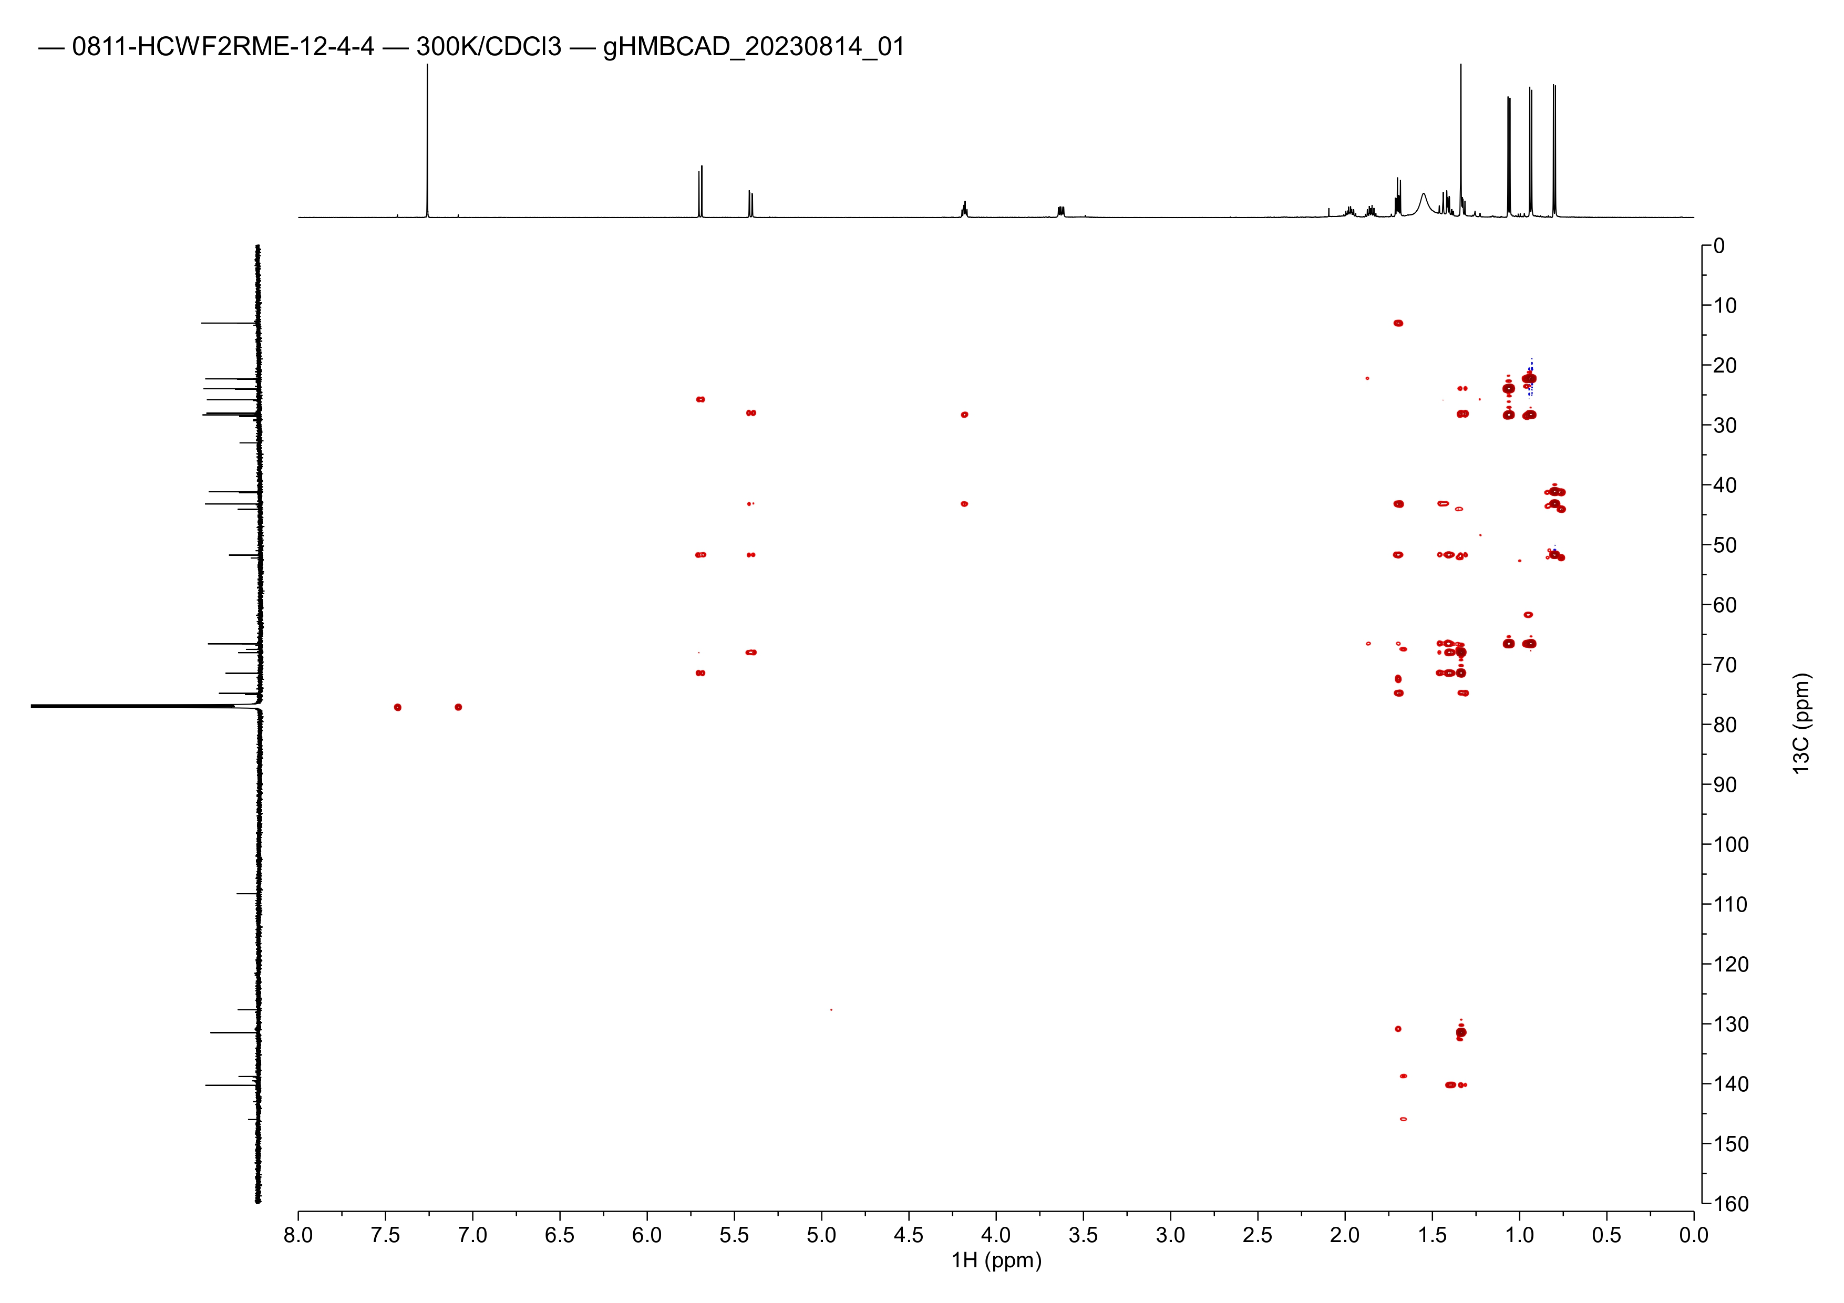

Figure S14. HMBC spectrum of compound 2
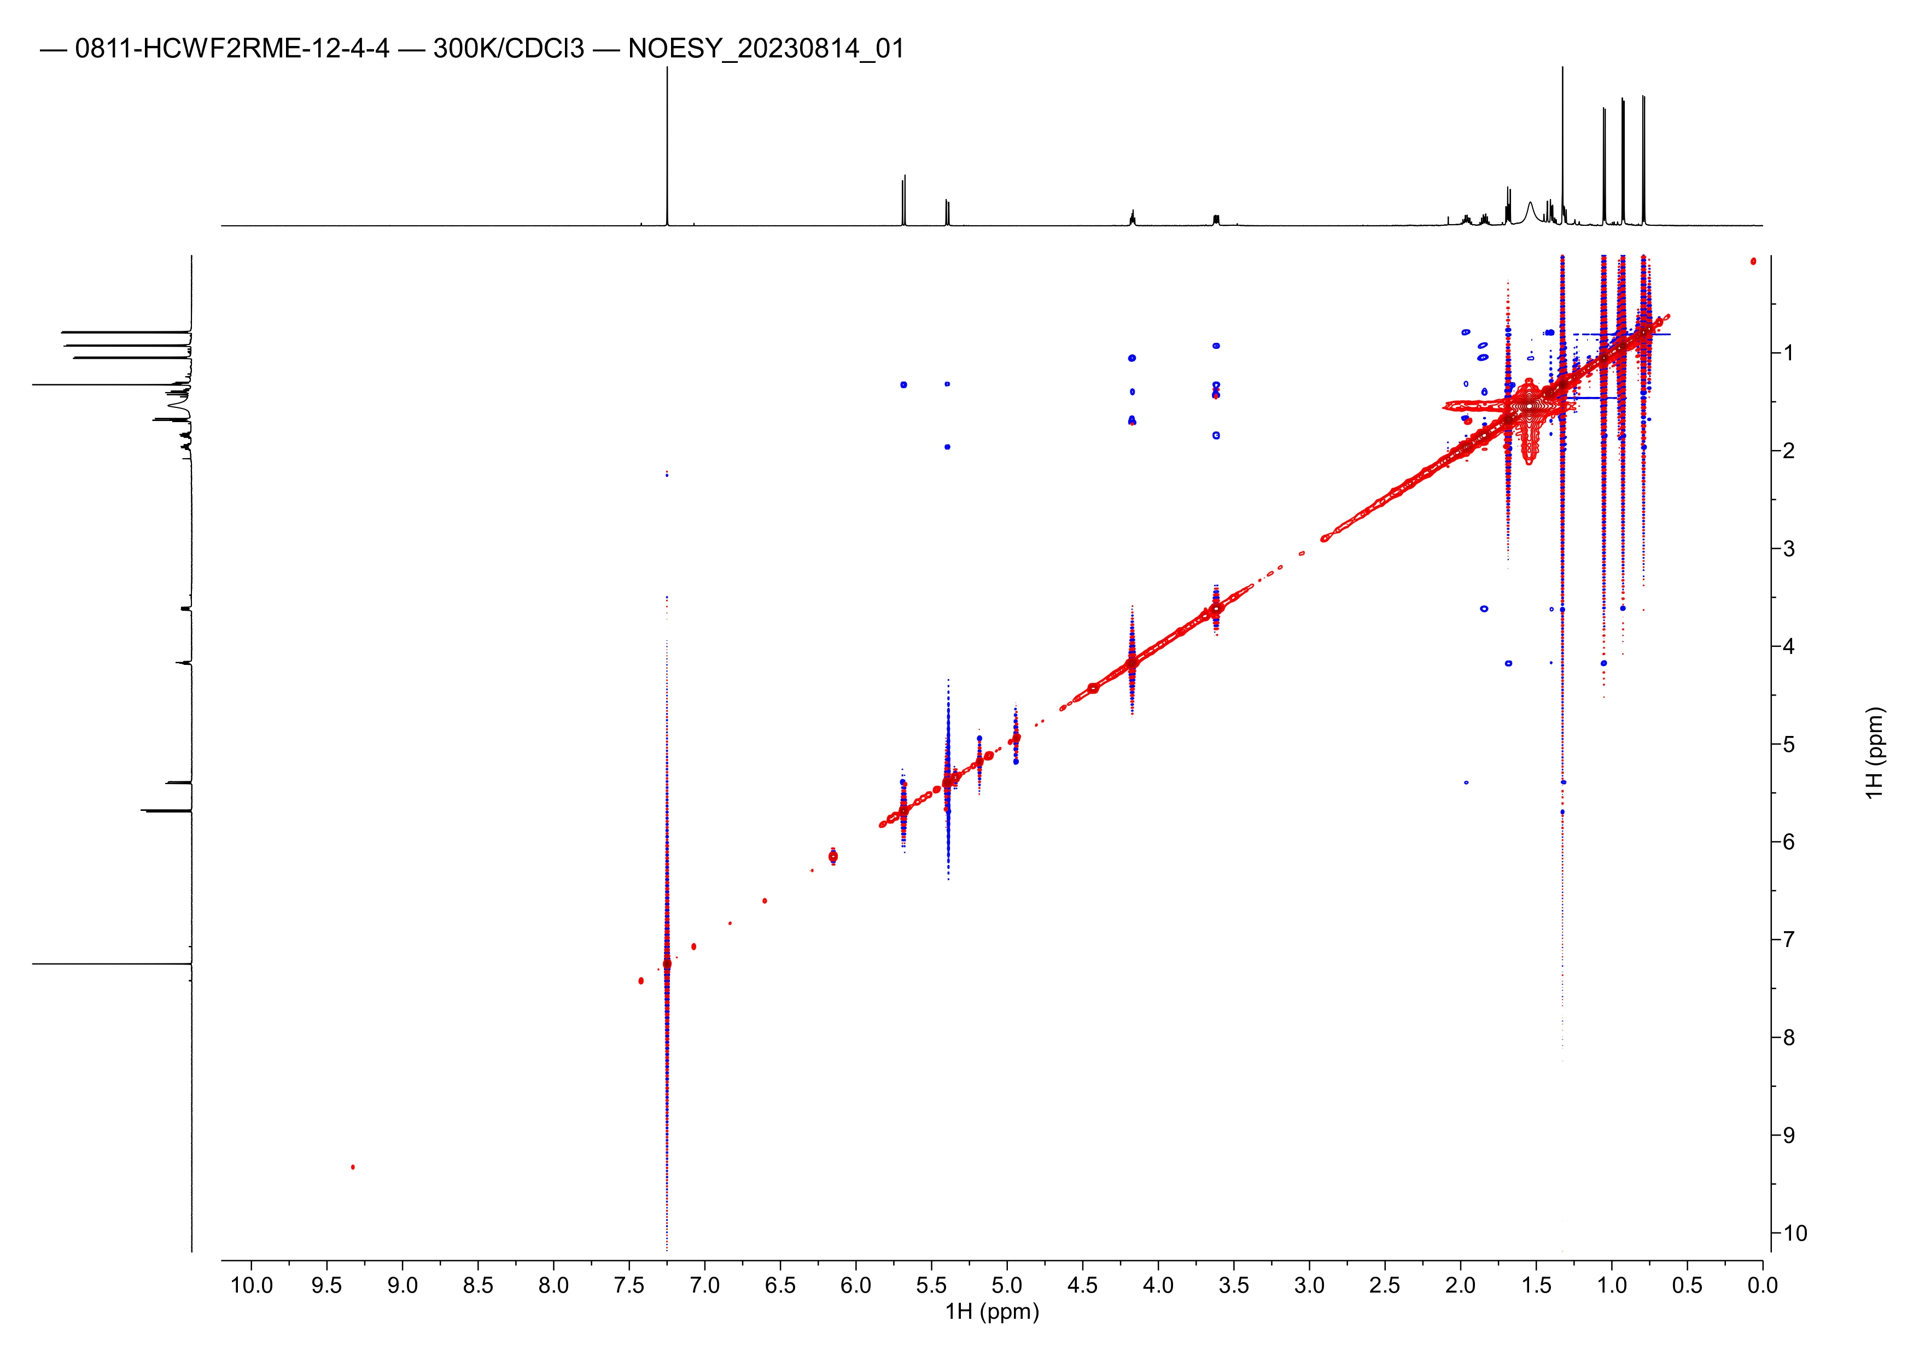

Figure S15. NOESY spectrum of compound 2
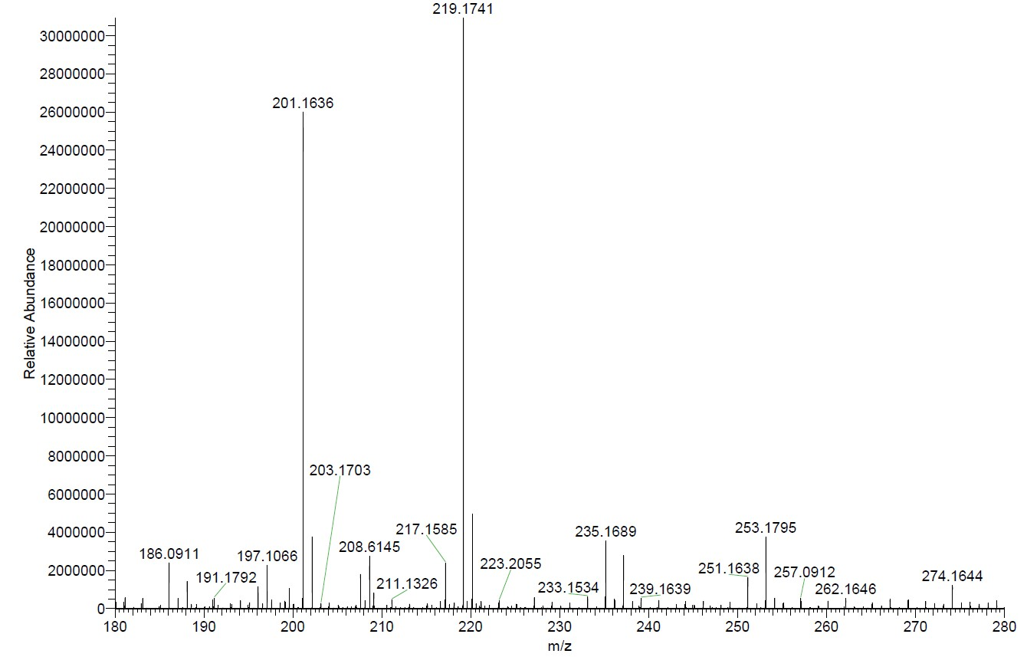

Figure S16. HRESIMS spectrum of compound 2

