Supporting Information

Novel iNOS-Inhibiting Cytochalasins from an Oyster-Derived Fungus Westerdykella dispersa Ca4-13: Structural Insights and Molecular Docking Analysis
Shu-Jung Huang¹, Su-Jung Hsu¹, Shih-Wei Wang^{2,3,4}, Yi-Chien Liu^{5,6}, Cheng-Yan Jiang^{6,7}, George Hsiao^{6,7*}, Tzong-Huei Lee^{1,8*}

¹Institute of Fisheries Science, National Taiwan University, 106319, Taipei, Taiwan
²Department of Medicine, MacKay Medical College, New Taipei City 25245, Taiwan.
³Institute of Biomedical Sciences, Mackay Medical College, New Taipei City 25245, Taiwan.
⁴School of Pharmacy, College of Pharmacy, Kaohsiung 807378, Taiwan
⁵Ph.D. Program in Drug Discovery and Development Industry, College of Pharmacy, Taipei Medical University, Taipei 11031, Taiwan
⁶Department of Pharmacology, School of Medicine, College of Medicine, Taipei Medical University, Taipei 11031, Taiwan.
⁷Graduate Institute of Medical Sciences, College of Medicine, Taipei Medical University, Taipei 11031, Taiwan.
⁸Department of Life Science, College of Life Science, National Taiwan University, 106319, Taipei, Taiwan
*Correspondence: geohsiao@tmu.edu.tw (G.H.); thlee1@ntu.edu.tw (T.-H.L.)
Table of Contents
Fig. S1. HRESIMS spectrum of compound 1. 3
Fig. S2. IR (ZnSe) spectrum of compound 1. 4
Fig. S3. ¹H NMR (500 MHz, methanol-d₄) spectrum of compound 1. 5
Fig. S4. ¹³C NMR (125 MHz, methanol-d₄) spectrum of compound 1. 6
Fig. S5. HSQC spectrum of compound 1. 7
Fig. S6. COSY spectrum of compound 1. 8
Fig. S7. HMBC spectrum of compound 1. 9
Fig. S8. NOESY spectrum of compound 1. 10
Fig. S9. HRESIMS spectrum of compound 2. 11
Fig. S10. IR (ZnSe) spectrum of compound 2. 11
Fig. S11. ¹H NMR (500 MHz, methanol-d₄) spectrum of compound 2. 12
Fig. S12. ¹³C NMR (125 MHz, methanol-d₄) spectrum of compound 2. 13
Fig. S13. HSQC spectrum of compound 2. 14
Fig. S14. COSY spectrum of compound 2. 15
Fig. S15. HMBC spectrum of compound 2. 16
Fig. S16. NOESY spectrum of compound 2. 17
Fig. S17. HRESIMS spectrum of compound 3. 18
Fig. S18. IR (ZnSe) spectrum of compound 3. 18
Fig. S19. ¹H NMR (500 MHz, methanol-d₄) spectrum of compound 3. 19
Fig. S20. ¹³C NMR (125 MHz, methanol-d₄) spectrum of compound 3. 20
Fig. S21. HSQC spectrum of compound 3. 21
Fig. S22. COSY spectrum of compound 3. 22
Fig. S23. HMBC spectrum of compound 3. 23
Fig. S24. NOESY spectrum of compound 3. 24
Table S1. Crystal data and experimental details for compound 1. 25
Table S2. Bond lengths [Å] and angles [°] for compound 1. 26
Table S3. CDOCKER energy and interaction pattern of potential inducible nitric oxide synthase (iNOS) inhibitors predicted by molecular docking analysis. 30

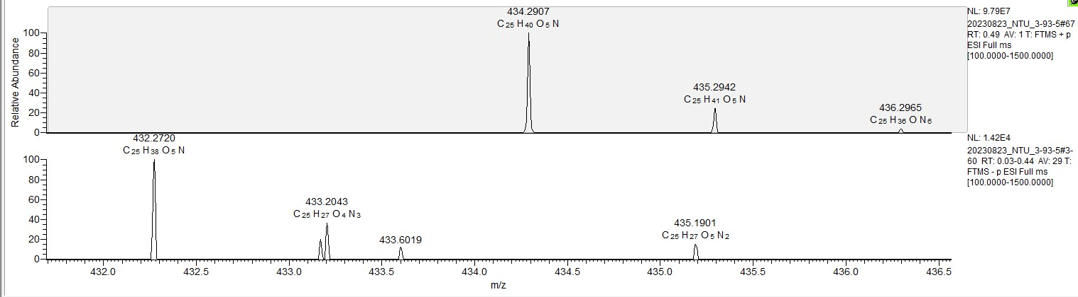

Fig. S1. HRESIMS spectrum of compound 1.

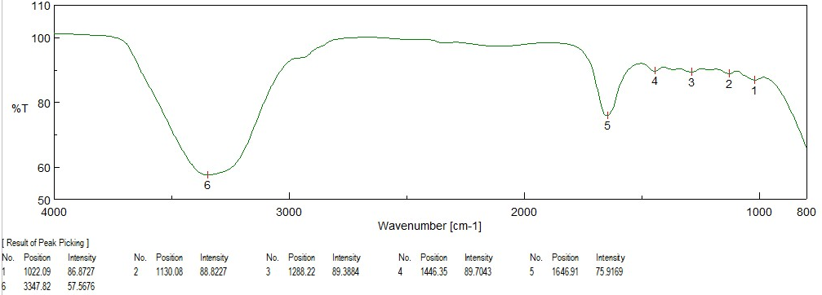

Fig. S2. IR (ZnSe) spectrum of compound 1.

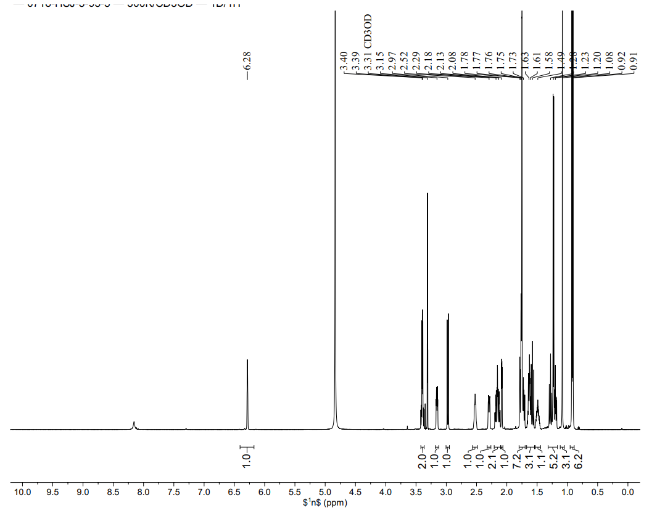
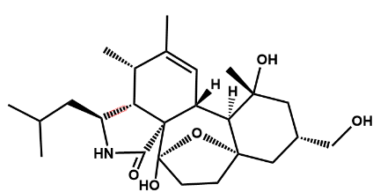

Fig. S3. ¹H NMR (500 MHz, methanol-d₄) spectrum of compound 1.

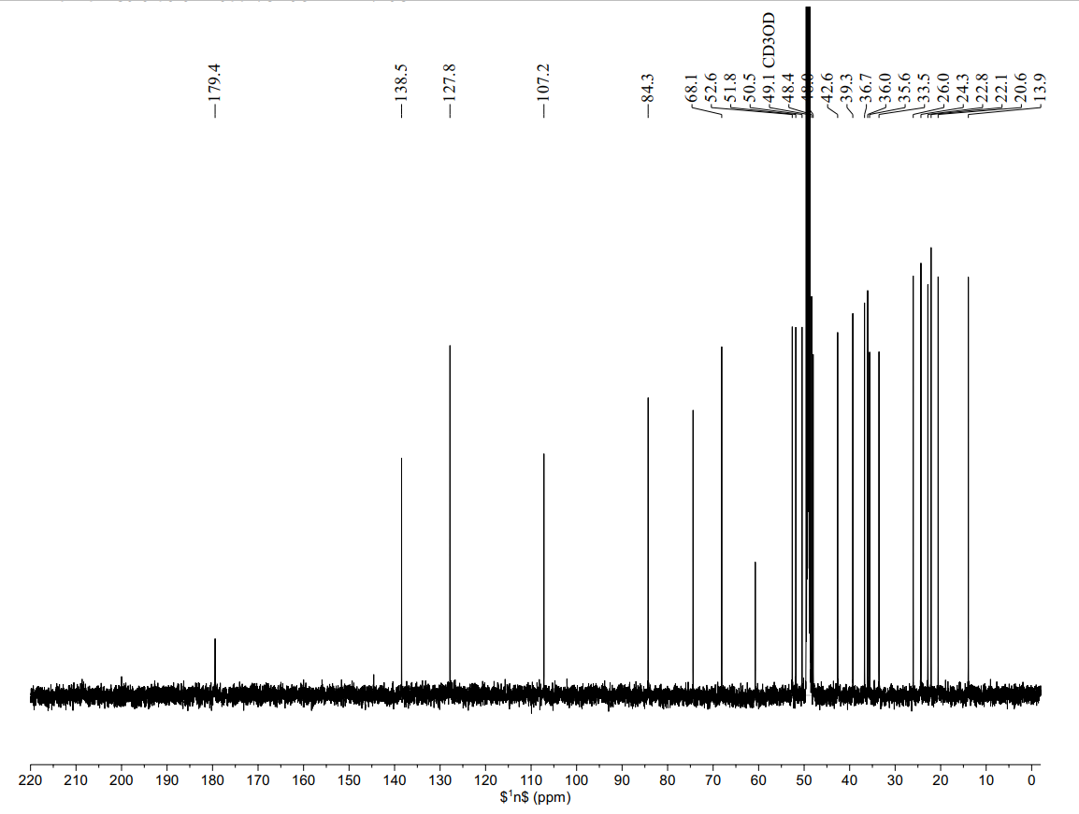
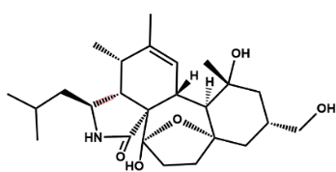

Fig. S4. ¹³C NMR (125 MHz, methanol-d₄) spectrum of compound 1.

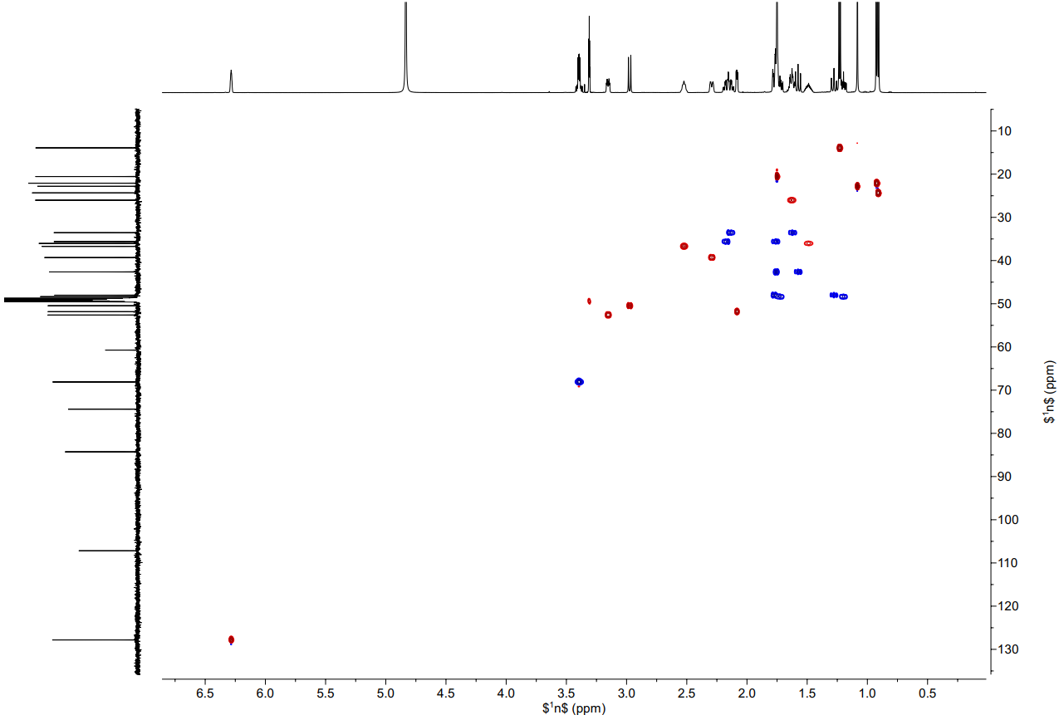

Fig. S5. HSQC spectrum of compound 1.

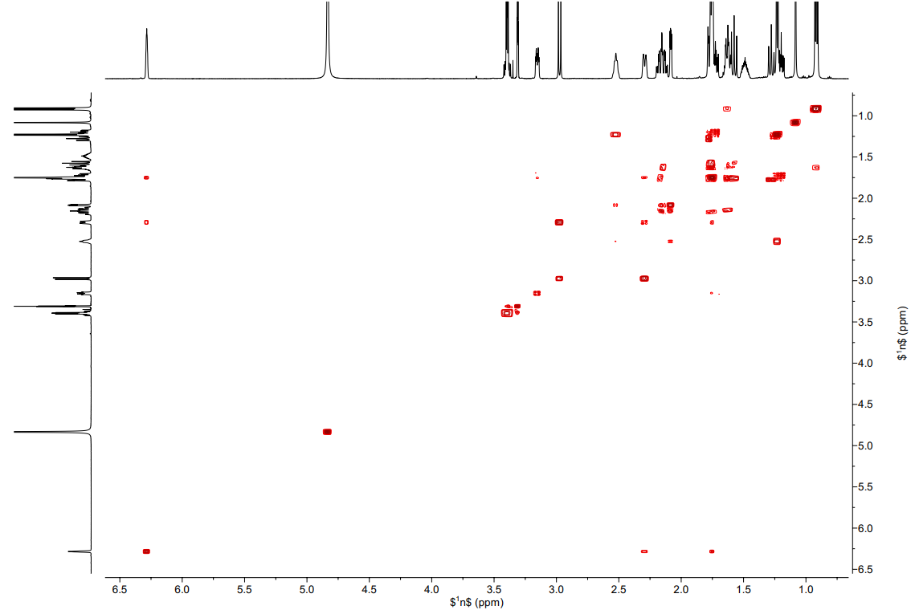

Fig. S6. COSY spectrum of compound 1.

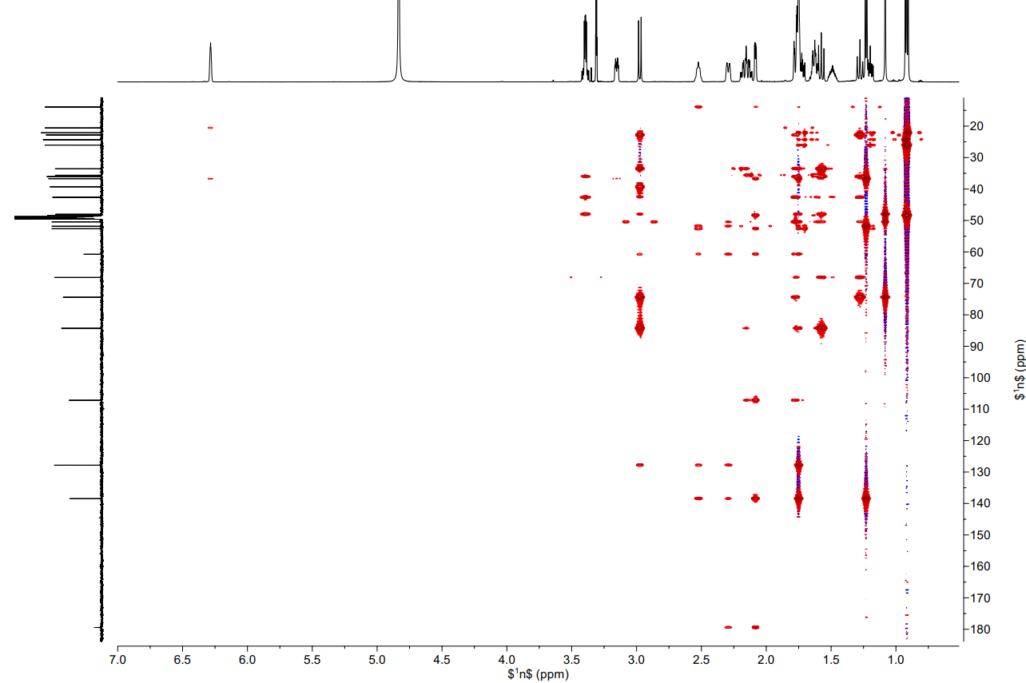

Fig. S7. HMBC spectrum of compound 1.

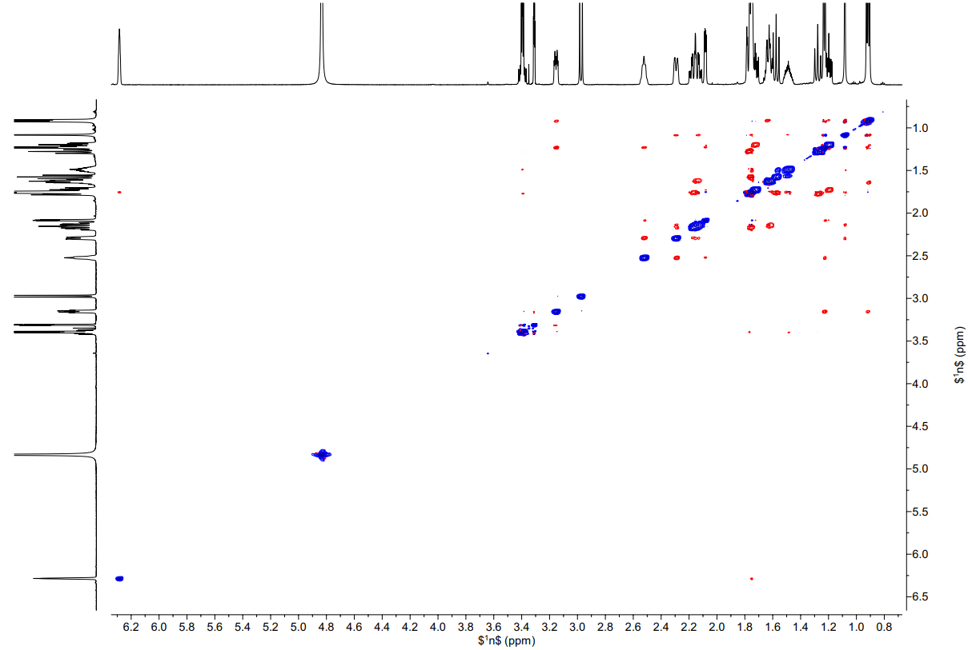

Fig. S8. NOESY spectrum of compound 1.

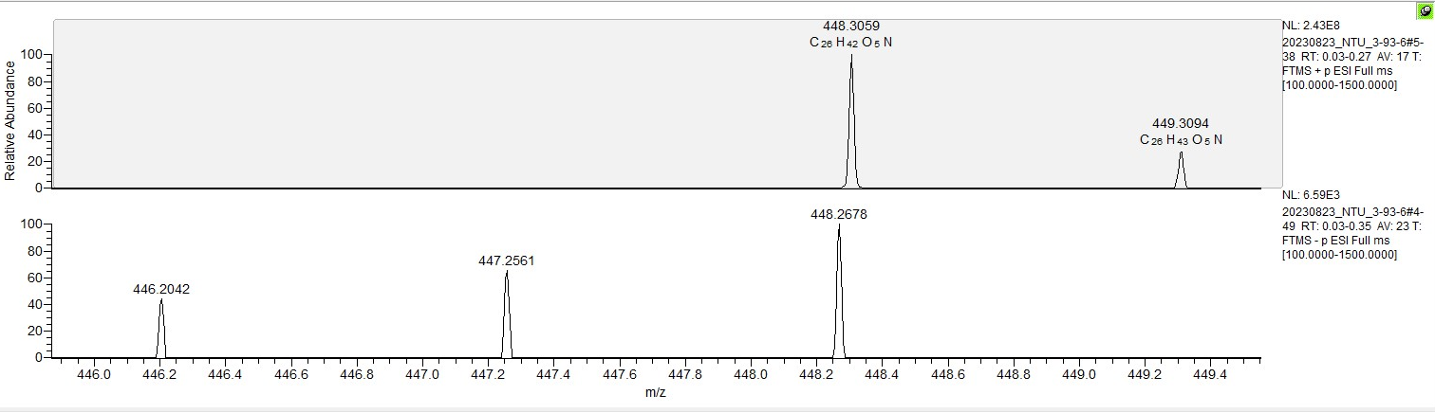

Fig. S9. HRESIMS spectrum of compound 2.

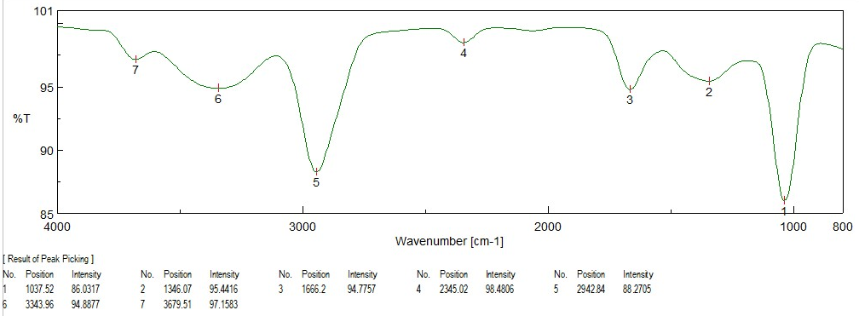

Fig. S10. IR (ZnSe) spectrum of compound 2.

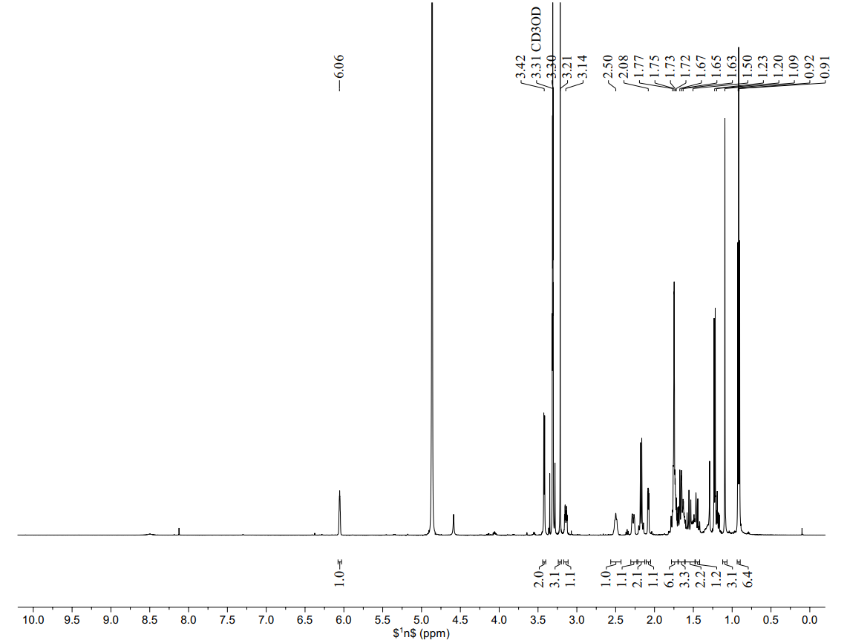
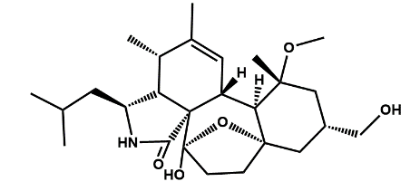

Fig. S11. ¹H NMR (500 MHz, methanol-d₄) spectrum of compound 2.

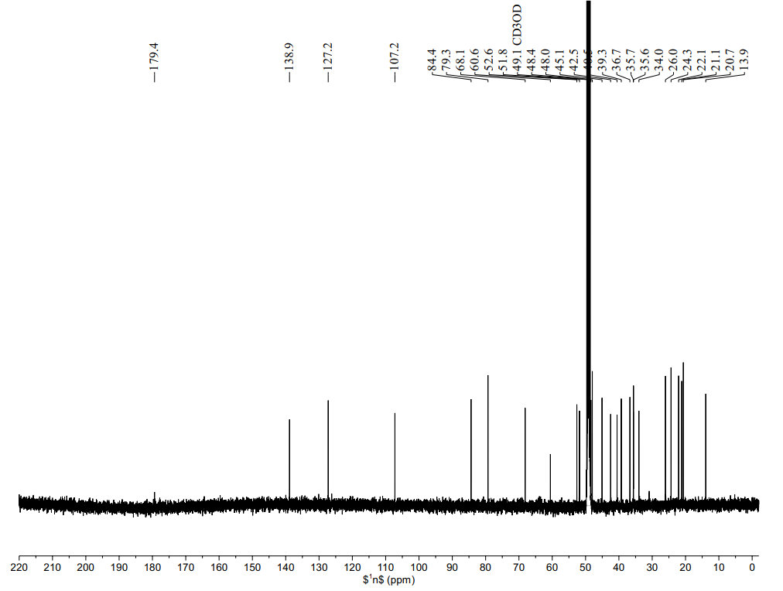

Fig. S12. ¹³C NMR (125 MHz, methanol-d₄) spectrum of compound 2.

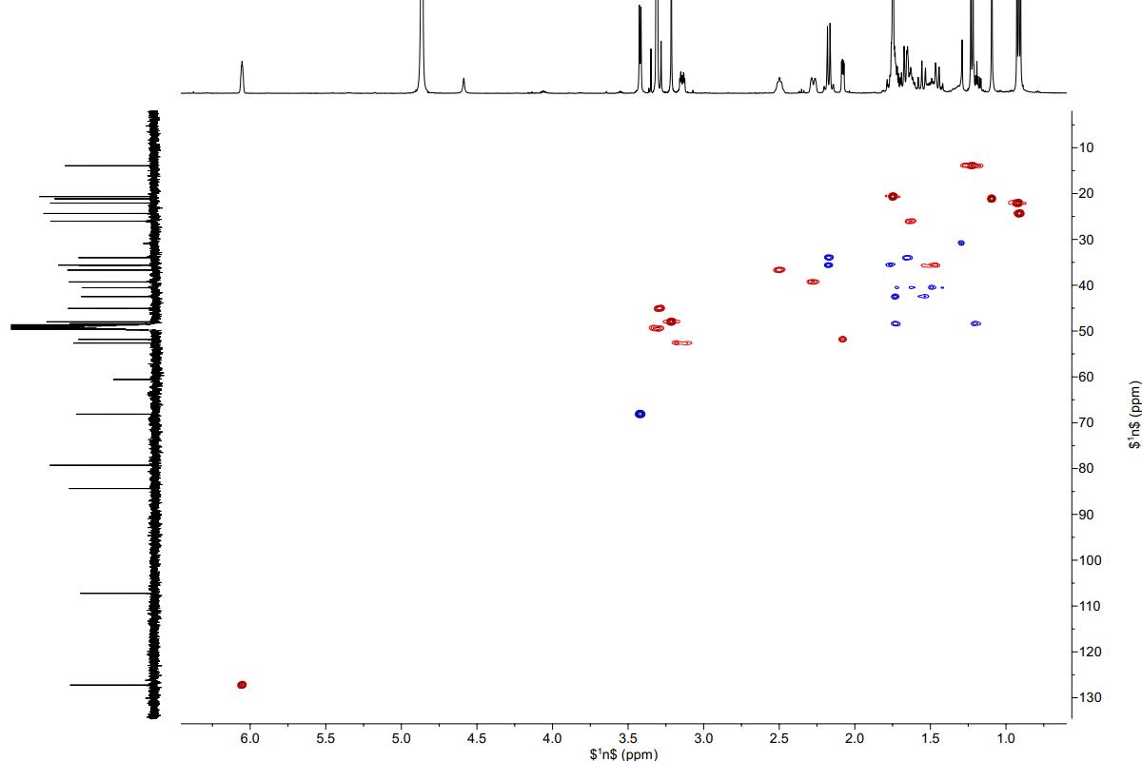

Fig. S13. HSQC spectrum of compound 2.

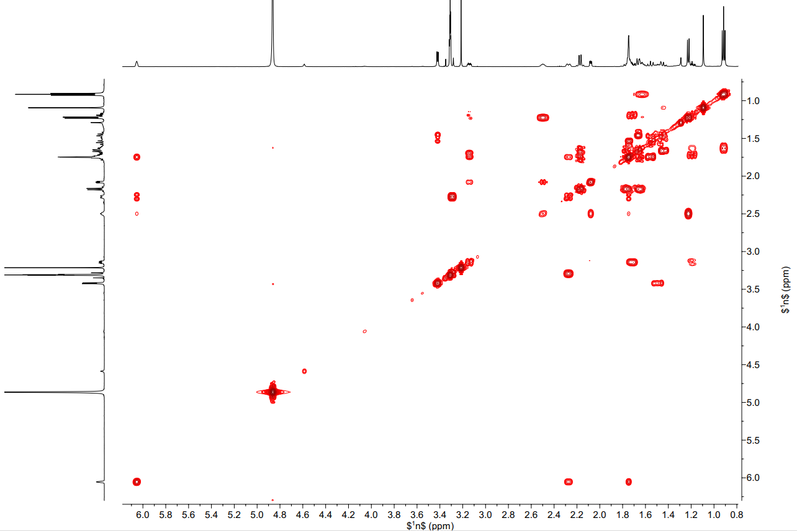

Fig. S14. COSY spectrum of compound 2.

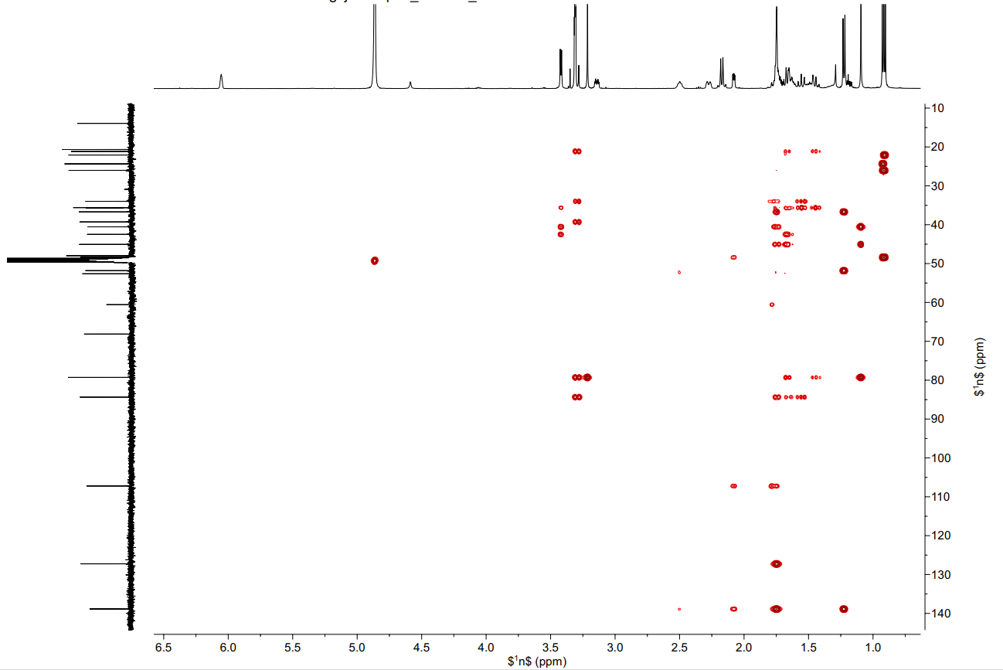

Fig. S15. HMBC spectrum of compound 2.

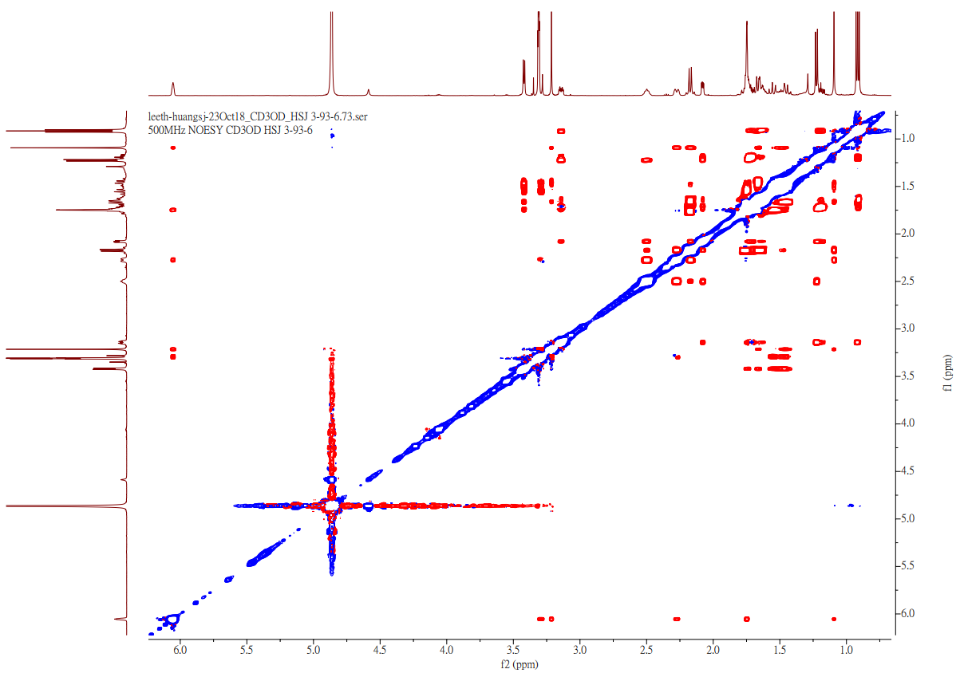

Fig. S16. NOESY spectrum of compound 2.

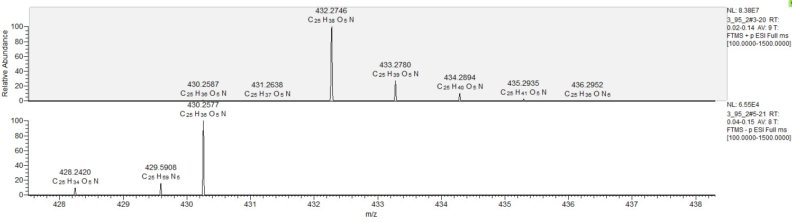

Fig. S17. HRESIMS spectrum of compound 3.

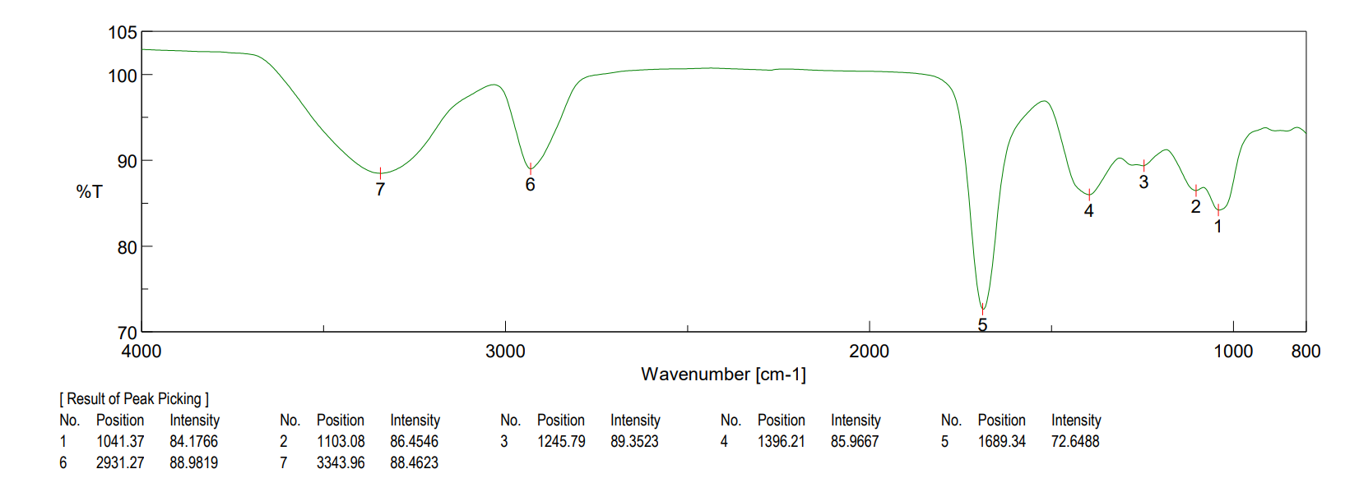

Fig. S18. IR (ZnSe) spectrum of compound 3.

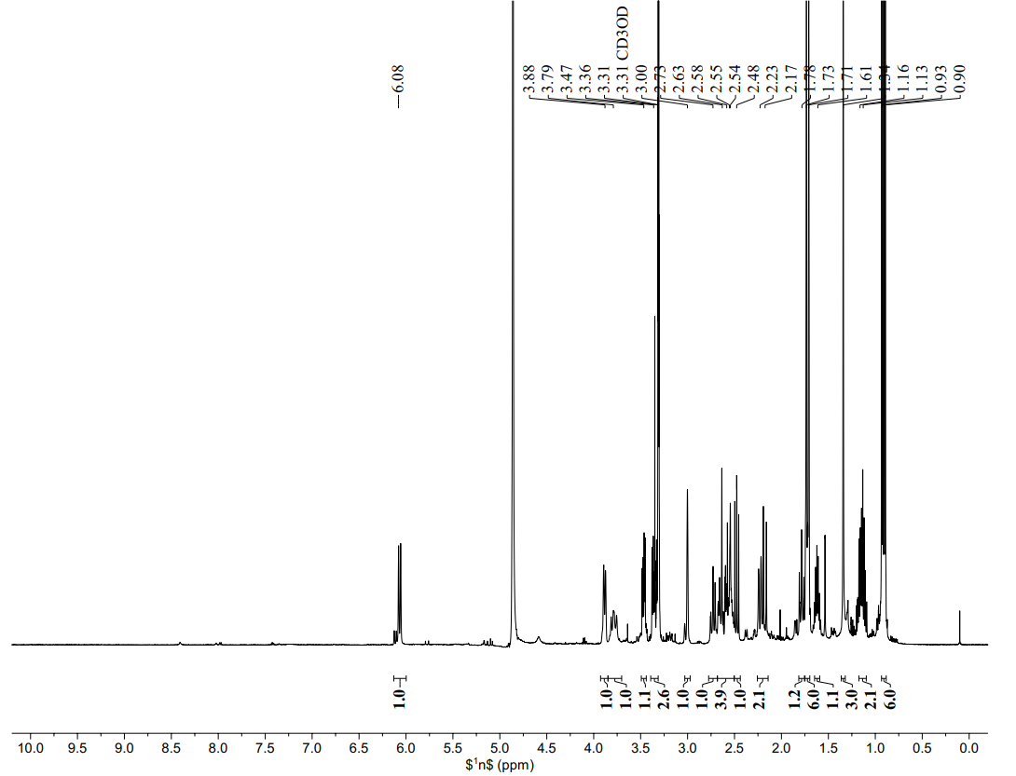
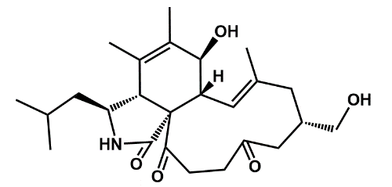

Fig. S19. ¹H NMR (500 MHz, methanol-d₄) spectrum of compound 3.

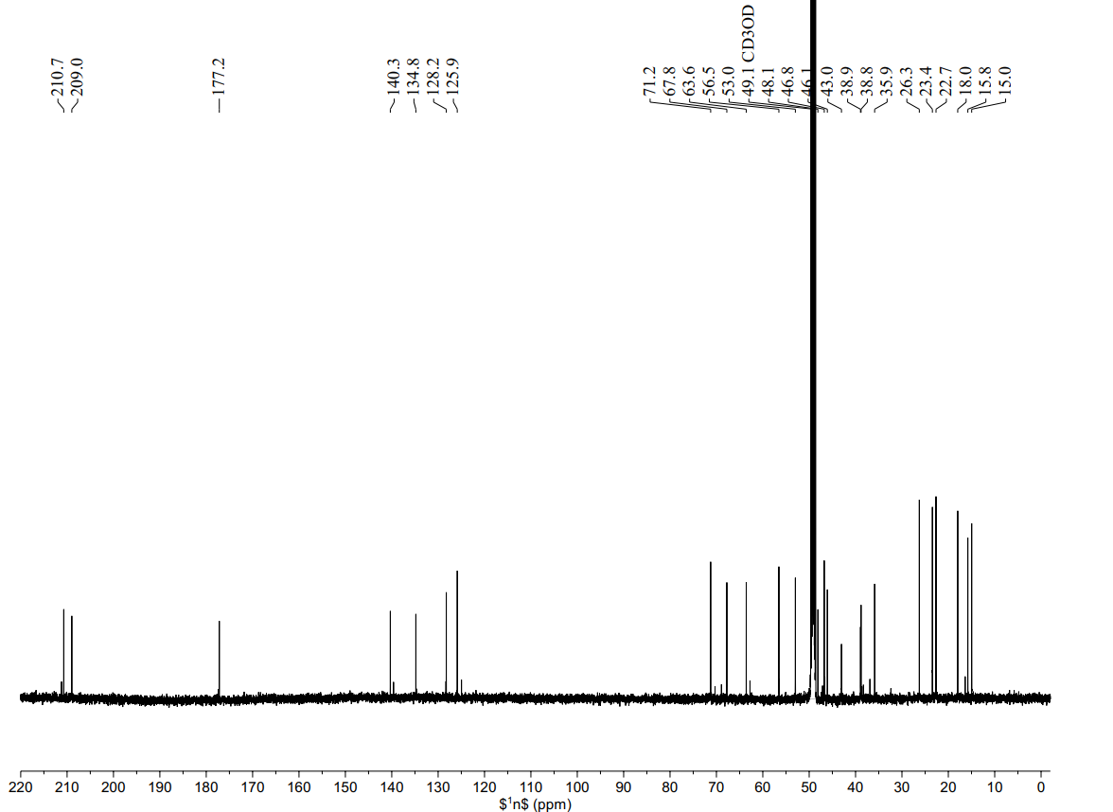

Fig. S20. ¹³C NMR (125 MHz, methanol-d₄) spectrum of compound 3.

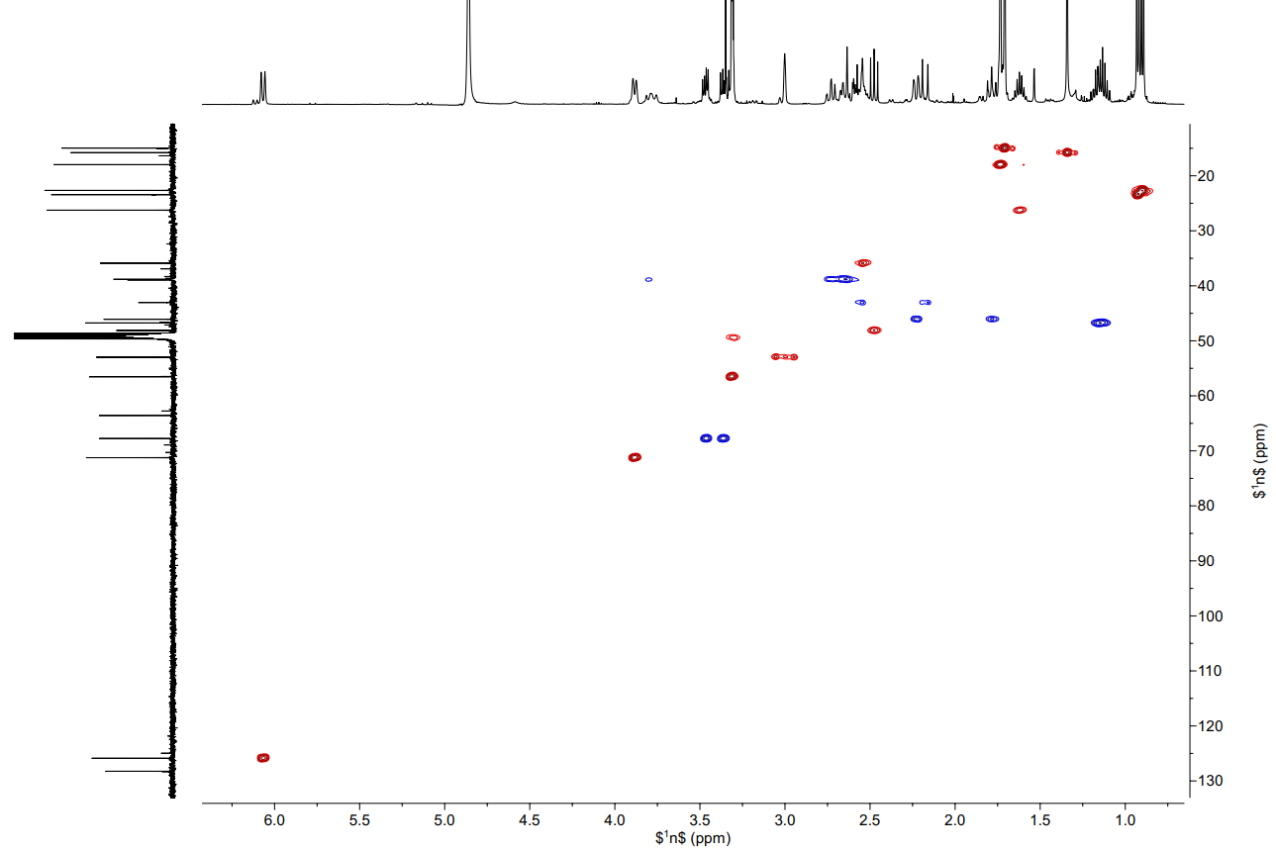

Fig. S21. HSQC spectrum of compound 3.

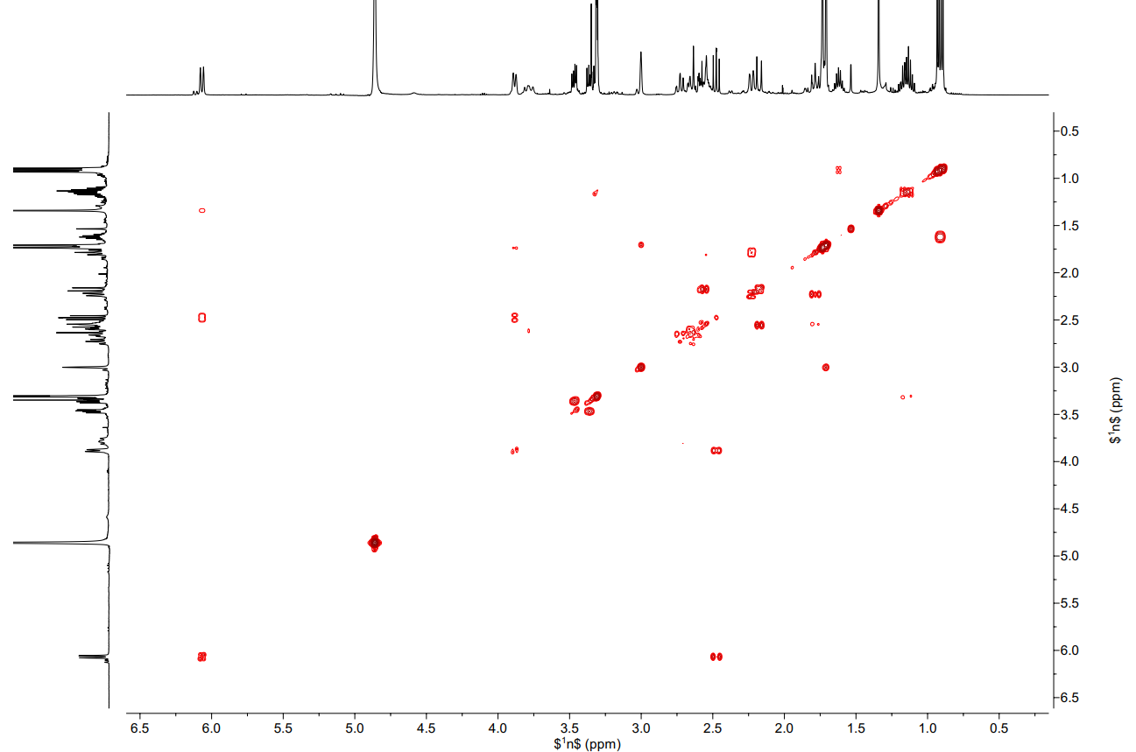

Fig. S22. COSY spectrum of compound 3.

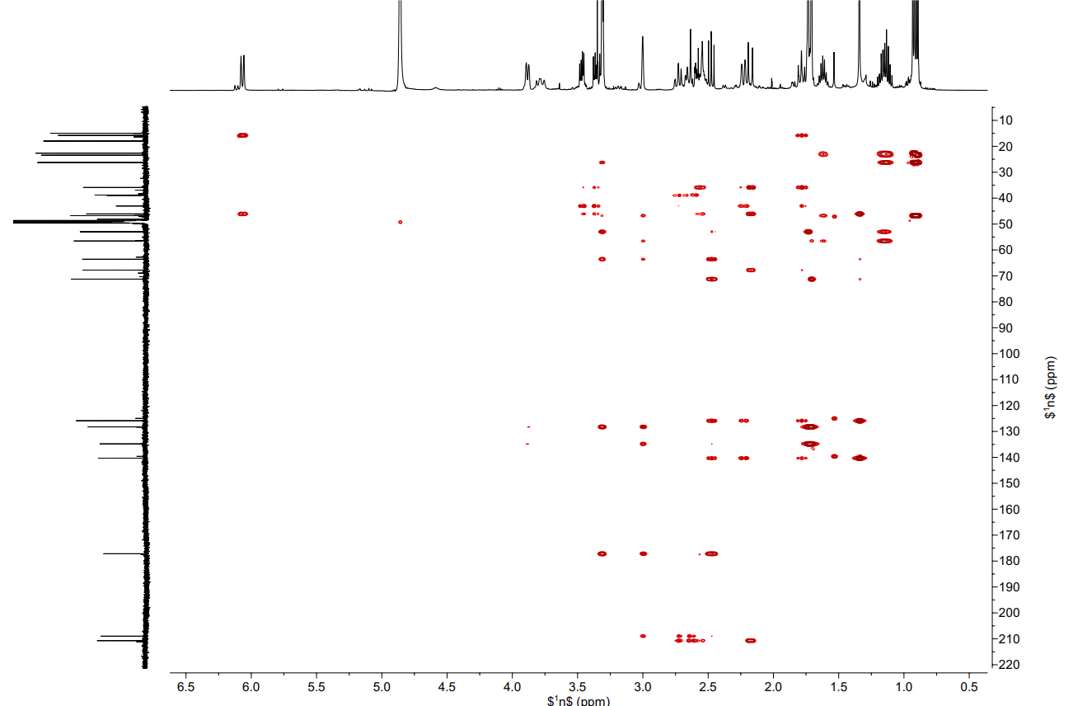

Fig. S23. HMBC spectrum of compound 3.

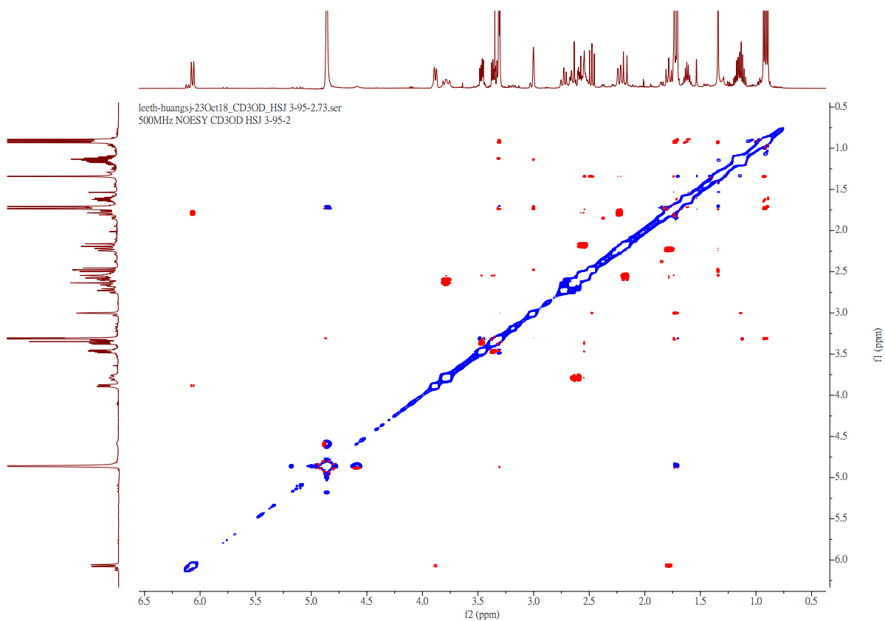

Fig. S24. NOESY spectrum of compound 3.

Table S1. Crystal data and experimental details for compound 1.
Crystal data
Empirical formula C25 H42 N O6.50
Formula weight 460.59
Crystal system Monoclinic
Space group P2₁
Unit cell dimensions a = 9.5486(3) Å α= 90°.
b = 41.4842(15) Å β= 111.0752(19)°.
c = 13.2919(4) Å γ = 90°.
Volume 4912.9(3) Å3
Z 8
F(000) 2008
Density (calculated) 1.245 Mg/m3
Wavelength 1.54178 Å
Cell parameters reflections used 9563
Theta range for Cell parameters 3.20 to 74.82°.
Absorption coefficient 0.720 mm-1
Temperature 100(2) K
Crystal size 0.220 x 0.180 x 0.020 mm3
Data collection
Diffractometer Bruker AXS D8 VENTURE, PhotonIII_C28
Absorption correction Semi-empirical from equivalents
Max. and min. transmission 1.0000 and 0.8118
No. of measured reflections 107015
No. of independent reflections 19508 [R(int) = 0.0675]
No. of observed [I>2_igma(I)] 18170
Completeness to theta = 67.679° 99.1 %
Theta range for data collection 1.065 to 75.048°.
Refinement
Final R indices [I>2sigma(I)] R1 = 0.0557, wR2 = 0.1395
R indices (all data) R1 = 0.0620, wR2 = 0.1462
Goodness-of-fit on F2 0.974
No. of reflections 19508
No. of parameters 1199
No. of restraints 1
Absolute structure parameter 0.08(12)
Largest diff. peak and hole 0.395 and -0.303 e.Å-3
Table S2. Bond lengths [Å] and angles [°] for compound 1.
_____________________________________________________
O(1)-C(21) 1.435(7)
O(1)-C(18) 1.436(7)
O(2)-C(21) 1.394(8)
O(3)-C(1) 1.239(8)
O(4)-C(14) 1.445(6)
O(5)-C(26) 1.427(8)
N(2)-C(1) 1.335(9)
N(2)-C(3) 1.468(8)
C(1)-C(9) 1.529(8)
C(3)-C(10) 1.513(9)
C(3)-C(4) 1.556(9)
C(4)-C(5) 1.542(9)
C(4)-C(9) 1.554(8)
C(5)-C(6) 1.532(9)
C(5)-C(11) 1.541(9)
C(6)-C(7) 1.325(10)
C(6)-C(12) 1.503(9)
C(7)-C(8) 1.497(8)
C(8)-C(13) 1.518(9)
C(8)-C(9) 1.572(9)
C(9)-C(21) 1.552(8)
C(10)-C(22) 1.526(10)
C(13)-C(18) 1.560(8)
C(13)-C(14) 1.567(9)
C(14)-C(15) 1.522(9)
C(14)-C(25) 1.531(9)
C(15)-C(16) 1.530(9)
C(16)-C(17) 1.552(8)
C(17)-C(18) 1.524(9)
C(18)-C(19) 1.552(8)
C(19)-C(20) 1.548(9)
C(20)-C(21) 1.544(9)
C(22)-C(24) 1.529(11)
C(22)-C(23) 1.530(11)

C(21)-O(1)-C(18) 105.9(5)
C(1)-N(2)-C(3) 115.7(5)
O(3)-C(1)-N(2) 125.0(6)
O(3)-C(1)-C(9) 125.2(5)
N(2)-C(1)-C(9) 109.8(5)
N(2)-C(3)-C(10) 112.7(6)
N(2)-C(3)-C(4) 103.5(5)
C(10)-C(3)-C(4) 113.7(5)
C(5)-C(4)-C(9) 112.4(5)
C(5)-C(4)-C(3) 111.7(5)
C(9)-C(4)-C(3) 106.7(5)
C(6)-C(5)-C(11) 115.8(6)
C(6)-C(5)-C(4) 108.4(5)
C(11)-C(5)-C(4) 111.6(6)
C(7)-C(6)-C(12) 123.7(6)
C(7)-C(6)-C(5) 115.7(6)
C(12)-C(6)-C(5) 120.7(6)
C(6)-C(7)-C(8) 118.5(6)
C(7)-C(8)-C(13) 120.6(5)
C(7)-C(8)-C(9) 106.9(5)
C(13)-C(8)-C(9) 111.5(5)
C(1)-C(9)-C(21) 108.1(5)
C(1)-C(9)-C(4) 104.0(5)
C(21)-C(9)-C(4) 113.3(5)
C(1)-C(9)-C(8) 111.4(5)
C(21)-C(9)-C(8) 109.1(5)
C(4)-C(9)-C(8) 110.9(5)
C(3)-C(10)-C(22) 116.3(6)
C(8)-C(13)-C(18) 108.4(5)
C(8)-C(13)-C(14) 116.0(5)
C(18)-C(13)-C(14) 112.9(5)
O(4)-C(14)-C(15) 107.9(5)
O(4)-C(14)-C(25) 104.3(5)
C(15)-C(14)-C(25) 110.7(5)
O(4)-C(14)-C(13) 108.1(5)
C(15)-C(14)-C(13) 109.3(5)
C(25)-C(14)-C(13) 116.1(5)
C(14)-C(15)-C(16) 113.6(5)
C(26)-C(16)-C(15) 111.4(5)
C(26)-C(16)-C(17) 110.2(5)
C(15)-C(16)-C(17) 109.5(5)
C(18)-C(17)-C(16) 113.6(5)
O(1)-C(18)-C(17) 107.0(5)
O(1)-C(18)-C(19) 101.3(4)
C(17)-C(18)-C(19) 113.5(5)
O(1)-C(18)-C(13) 108.7(5)
C(17)-C(18)-C(13) 110.9(5)
C(19)-C(18)-C(13) 114.6(5)
C(20)-C(19)-C(18) 104.0(5)
C(21)-C(20)-C(19) 103.7(5)
O(2)-C(21)-O(1) 110.2(5)
O(2)-C(21)-C(20) 115.6(5)
O(1)-C(21)-C(20) 102.5(5)
O(2)-C(21)-C(9) 107.7(5)
O(1)-C(21)-C(9) 107.3(4)
C(20)-C(21)-C(9) 113.2(5)
C(10)-C(22)-C(24) 114.3(6)
C(10)-C(22)-C(23) 109.8(7)
C(24)-C(22)-C(23) 111.2(7)
_________________________

Table S3. CDOCKER energy and interaction pattern of potential inducible nitric oxide synthase (iNOS) inhibitors predicted by molecular docking analysis.
Interactions | Interaction residues | Compounds
Interactions | Interaction residues | 1 | 2 | 3 | *Curcumin
Cdocker interaction energy (mol /Kcal) |  | -44.0605 | -45.2659 | -46.4667 | -59.3552
H-bond | ARG193 |  |  |  | ✓
 | ARG260 |  |  |  | ✓
 | ARG375 |  |  | ✓
 | ARG382 |  |  |  | ✓
 | ASP376 |  | ✓ | ✓
 | GLN257 |  |  |  | ✓
 | GLU371 | ✓ | ✓ | ✓ | ✓
 | TYR341 |  |  |  | ✓
Pi-Cation | ARG375 |  |  |  | ✓
Pi Alkyl | ARG193 | ✓ | ✓
 | CYS194 | ✓ | ✓
 | PRO344 | ✓ | ✓ | ✓
 | VAL346 | ✓ | ✓
Alkyl | PHE363 | ✓ | ✓
 | TRP188 | ✓ | ✓
 | TRP367 |  |  | ✓
 | TRP457 | ✓ | ✓ | ✓ | ✓
* Reference compound.

