Additional Material A
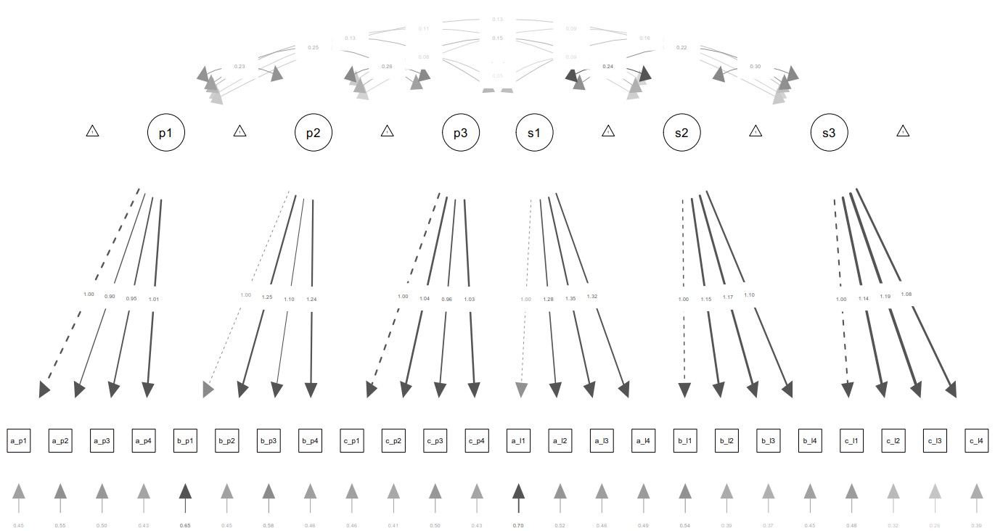

Figure A. Statistical model used in confirmatory analyses in Study 1 and Study 2 (s1, s2, and s3 = academic self-concept at Time 1, Time 2, and Time3; p1, p2, and p3 = perspective-taking at Time 1, Time 2, and Time3)

