Supplemental online materials

How reading comprehension and age at arrival predict achievement among 1st generation immigrant students in Germany: Evidence from PISA 2012-2022

This supplemental material accompanies the article cited above. In this supplemental analysis we focus on comparisons between 1st generation immigrant students (IMMIG = 3; n = 1,248) against all non-1st generation students (n = 22,947) across four PISA cycles (2012–2022) in Germany (OECD, 2023). 1st generation students with missing arrival age (n = 59, n_{all} 1st gen = 1,248) who were excluded in the main analyses (N = 1,189) are retained here. All estimates are weighted by W_FSTUWT and pooled across plausible values using Rubin’s (1987) combining rules as specified in Equations 6 and 7 of the main article. Achievement domains (mathematics, reading, science) are provided as 10 plausible values in 2015–2022 and 5 in 2012; each cycle is pooled with its own M so that between-imputation variance is correctly estimated. SES indicators (HISEI, HOMEPOS, PARED) are available as 10 nationally imputed plausible values in 2015–2022; in 2012 only likelihood squares estimates (WLE) are available—a single point estimate per student—so between-imputation variance is zero for 2012 SES comparisons, and standard errors reflect within-imputation sampling uncertainty only.
Supplement A reports sample sizes and cohort composition. Supplement B presents achievement comparisons. Supplement C examines teacher-rated reading comprehension. Supplement D compares SES indicators. Supplement E reports composite scores. Supplement F presents marginal effects from multilevel models. Supplement G contains R code excerpts of the main analyses.

Supplement A: Sample description
The combined sample contains N = 24,195 students: n = 1,248 1st generation immigrants and n = 22,947 non-1st generation students.
Table S1
1st generation cohort composition by cycle
Cycle | Non-1st Generation | 1st Generation | Total
2012 | 8,110 | 260 | 8,370
2015 | 5,476 | 215 | 5,691
2018 | 4,428 | 299 | 4,727
2022 | 4,933 | 474 | 5,407

A.1 1st generation cohort composition by cycle
A reviewer concern is whether the composition of the 1st generation immigrant population changes meaningfully across cycles, particularly given the Syrian refugee influx post-2015. We document two key composition indicators below: the proportion of 1st generation immigrant students who do not speak German at home (LANG = 1) and the distribution of arrival ages.
Table S2
Proportion of 1st generation students not speaking German at home (LANG), by cycle.
Cycle | n (1st Generation) | % non-German at home (weighted)
2012 | 91 | 57.9%
2015 | 215 | 76.6%
2018 | 296 | 86.0%
2022 | 474 | 87.4%
Note. In 2012, LANG had approximately 65% missingness among 1st generation students (91 of 260 had valid LANG responses); the weighted percentage reflects this subsample only.
Table S3
Arrival-age distribution among 1st generation students, by cycle
Cycle | n | Mean arrival-age | SD | Median | % arrival age  ≥ 10 years
2012 | 238 | 6.09 | 4.34 | 5 | 23.7%
2015 | 196 | 5.85 | 4.62 | 5 | 24.0%
2018 | 289 | 8.83 | 4.90 | 11 | 58.4%
2022 | 466 | 8.53 | 3.37 | 9 | 43.4%
These tables show that the composition of the 1st generation immigrant subsample is not constant across cycles (see also Figure 1 of the main article for the arrival-age distributions by cycle). The proportion of non-German-speaking students rose from 58% (2012) to 87% (2022) and the share arriving at age 10 or later increased from 24% to 43%—as is plausible given the Syrian refugee influx from 2015 onwards. The widening achievement gap documented in Supplement B therefore reflects a combination of compositional change and any genuine instructional or policy effects. Disentangling these two sources is beyond the scope of the present descriptive supplement but is acknowledged as a limitation: cross-cycle mean differences confound compositional and genuine instructional changes.

Supplement B: Achievement comparison
For each cycle × domain combination, weighted group means, SDs, and Cohen’s d (Cohen, 1988) are computed from each of M plausible-value draws, then pooled via Rubin’s (1987) combining rules. Standard errors incorporate both within-imputation sampling variance (Ū) and between-imputation variance (Bₘ). PISA 2012 provides M = 5 PVs per domain; 2015–2022 provide M = 10. Each cycle is pooled with its own M, preserving the correct between-imputation component. The within-imputation variance for weighted means is approximated as Ū_{m}= ${\hat{σ}}_{w}^{2}$/ n_{eff} ; for Cohen’s d, the Hedges and Olkin (1985) large-sample approximation is used. The pooled SD denominator uses the sum of survey weights as the effective sample size in each group, following standard practice for survey-weighted effect sizes.
Table S4
Weighted achievement by domain and cycle (Rubin-pooled).
Cycle | Domain | 1st Gen.  M (SE) | Non-1st Gen.  M (SE) | Gap | Cohens d | n  (1st Gen.) | n  (Non-1st Gen.
2012 | MATH | 466.0 (6.0) | 511.8 (1.1) | -45.8 | -0.532 | 260 | 8110
 | READ | 454.8 (6.2) | 507.3 (1.1) | -52.5 | -0.625 | 260 | 8110
 | SCIE | 462.7 (6.0) | 521.5 (1.1) | -58.8 | -0.672 | 260 | 8110
2015 | MATH | 446.0 (8.6) | 512.7 (1.9) | -66.8 | -0.748 | 215 | 5476
 | READ | 430.8 (9.4) | 519.1 (1.6) | -88.3 | -0.893 | 215 | 5476
 | SCIE | 434.2 (7.6) | 518.1 (1.5) | -84.0 | -0.854 | 215 | 5476
2018 | MATH | 434.8 (6.7) | 510.6 (1.8) | -75.8 | -0.803 | 299 | 4428
 | READ | 404.5 (7.2) | 511.9 (1.7) | -107.4 | -1.048 | 299 | 4428
 | SCIE | 419.7 (8.4) | 514.9 (1.8) | -95.2 | -0.938 | 299 | 4428
2022 | MATH | 398.4 (4.7) | 488.1 (1.4) | -89.7 | -0.971 | 474 | 4933
 | READ | 381.9 (5.2) | 495.4 (2.1) | -113.5 | -1.104 | 474 | 4933
 | SCIE | 395.0 (5.3) | 507.8 (1.7) | -112.9 | -1.090 | 474 | 4933
Effect sizes range from d = −0.53 (2012 mathematics) to d = −1.10 (2022 reading), all exceeding Kraft’s (2020) threshold for large effects in education (|d| ≥ 0.20). Because our effect sizes are descriptive group differences rather than causal treatment effects, they are expected to exceed the Kraft benchmarks (Kraft, 2020, Guideline 1), but the comparison underscores the practical magnitude of the immigrant–non-immigrant gap. The gap widens monotonically across all domains.
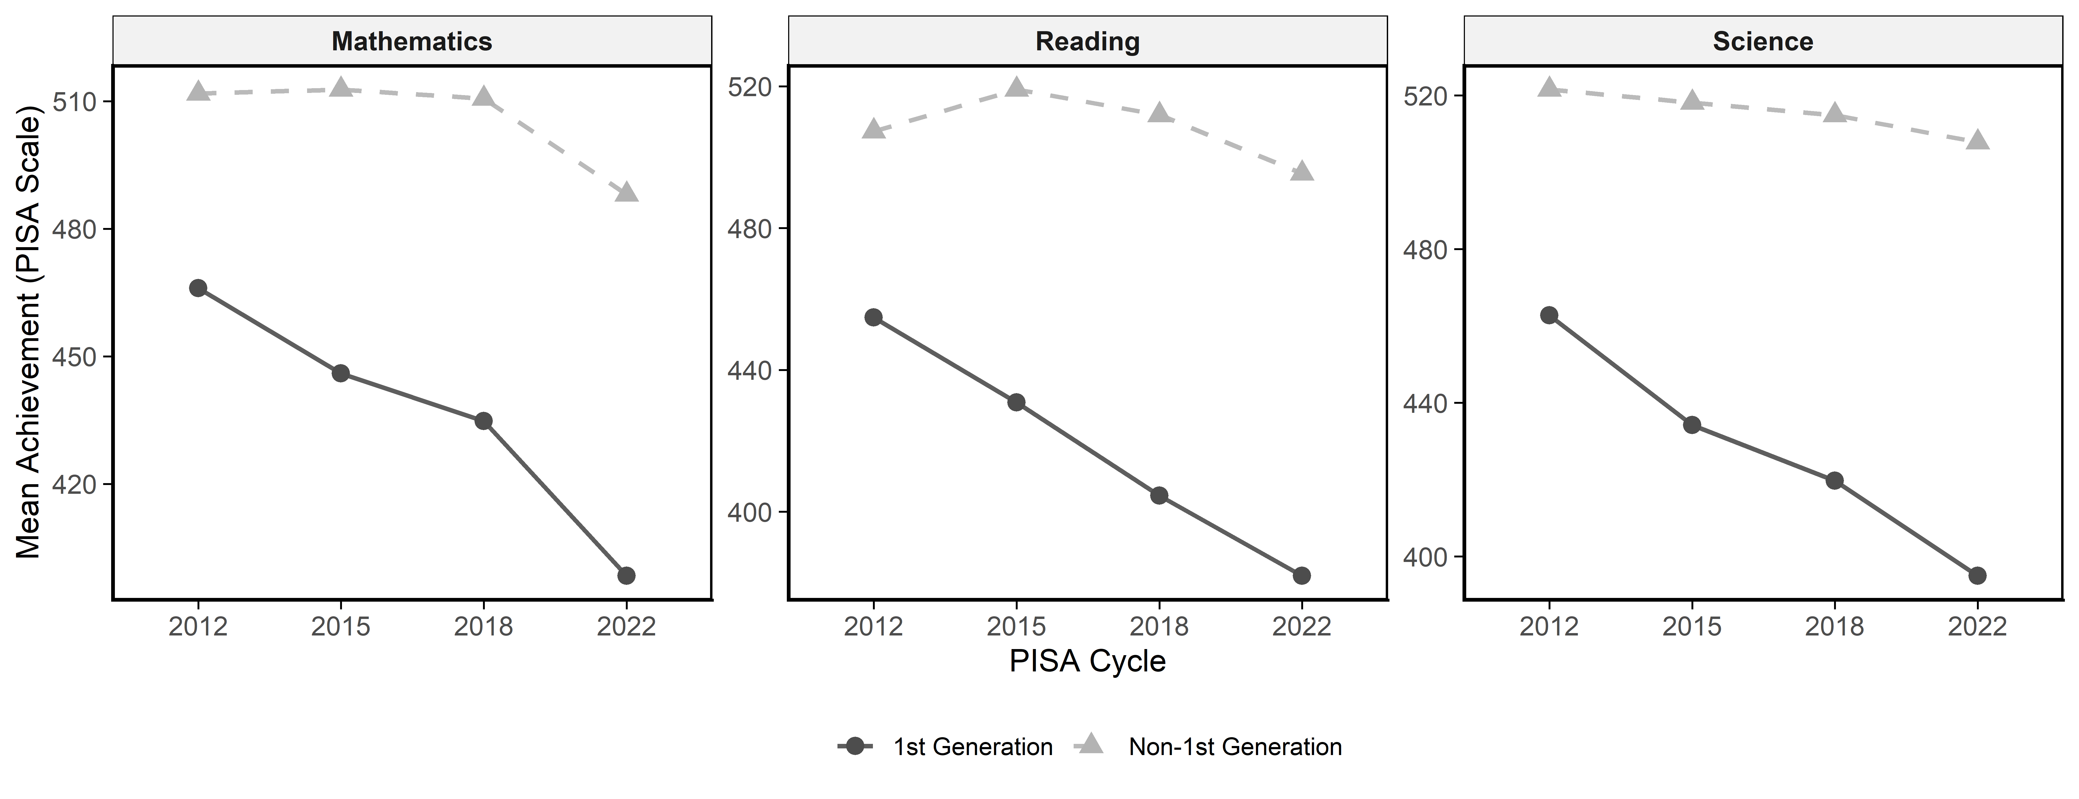
Figure S1. Achievement trends
Non-1st generation mean achievement remains relatively stable around 490–520 PISA points, while 1st generation performance declines from approximately 450–470 (2012) to 380–400 (2022). The divergence is most pronounced in reading, consistent with the central role of language proficiency for recently arrived students.
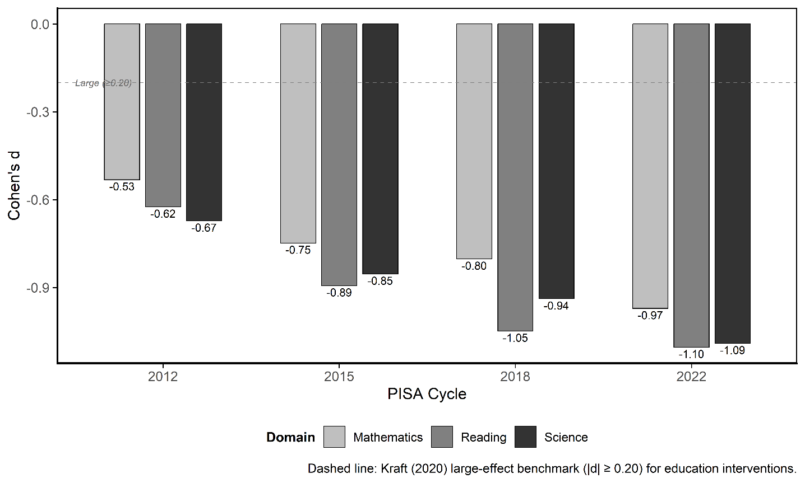
Figure S2. Effect sizes. Note that the dashed line marks Kraft’s (2020) large-effect benchmark (|d| ≥ 0.20). All 12 cycle × domain estimates far exceed this threshold; by 2022 all three domains produce |d| > 0.97, roughly five times the benchmark.
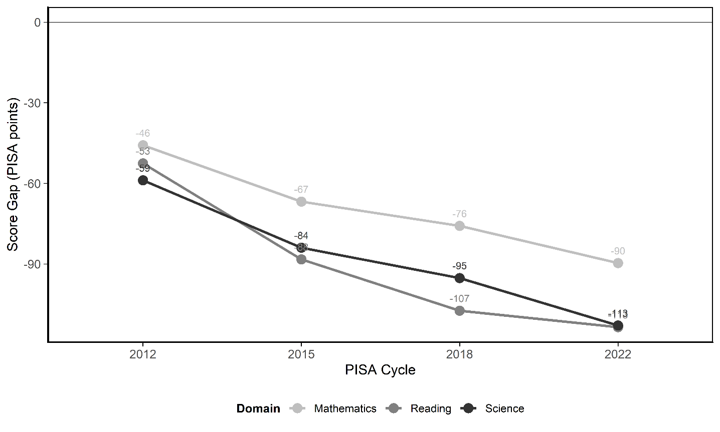
Figure S3. Score gap trends.
The raw score gap widens from approximately -50 to -60 PISA points in 2012 to -90 to -114 points in 2022. Reading is consistently the largest, widening from -53 points (2012) to -114 points (2022).

Supplement C: Teacher-rated reading comprehension
The German national extension includes a teacher-rated measure of reading comprehension (lesef), scored 1 = very poor to 5 = very good. This captures classroom-embedded functional literacy, distinct from PISA’s latent reading proficiency.
Table S5
Teacher-rated reading comprehension (1 = very poor to 5 = very good)
Cycle | 1st Gen.  M (SE) | Non-1st Gen.  M (SE) | Gap | Cohens d | n  (1st Gen.) | n  (Non-1st Gen.
2012 | 3.07 | 3.71 | -0.64 | -0.596 | 244 | 7659
2015 | 2.99 | 3.75 | -0.76 | -0.692 | 205 | 5133
2018 | 2.73 | 3.67 | -0.94 | -0.872 | 171 | 2079
2022 | 2.69 | 3.56 | -0.87 | -0.808 | 469 | 4911

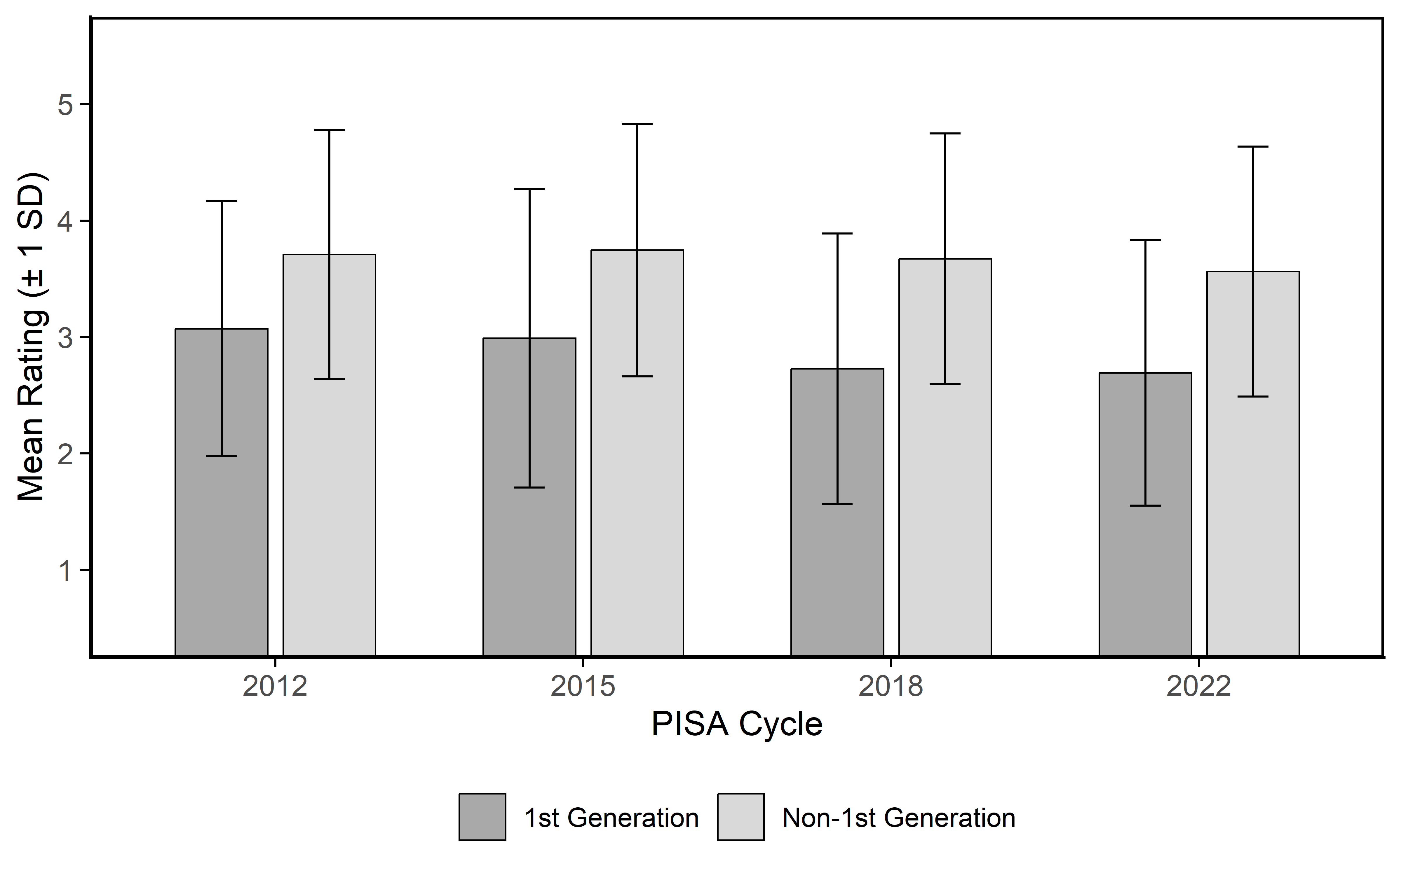
Figure S4. Teacher ratings.
Teacher ratings mirror the standardized achievement pattern. Effect sizes range from d = -0.60 (2012) to d = -0.87 (2018), with 2022 (d = −0.81) near the 2018 level. The gap widened from 2012 to 2018 and stabilized by 2022, corroborating the main article’s emphasis on teacher-perceived functional literacy as a predictor distinct from PISA’s reading PVs.
A reviewer concern is that using reading competence as a predictor of achievement is circular. Lesef is a teacher-rated indicator of functional reading comprehension in German, collected on a five-level ordinal scale as part of the German national classroom extension prior to PISA administration. It is not derived from PISA’s latent reading construct and shares neither items nor scaling with the reading plausible values. It functions as a language-integration proxy—capturing how well a student processes classroom texts in the L2—rather than as a competence outcome, analogous to using teacher-rated English proficiency to predict standardized test scores in migration research.
C.1 Validity evidence for lesef: Addressing teacher rating bias
A key concern is whether teacher ratings of reading comprehension are systematically distorted by immigrant status, making lesef a proxy for rater bias rather than functional literacy. Evidence from the German context supports this concern: Lorenz (2021) found lower teacher expectations for Turkish-origin students in the linguistic domain after controlling for measured skills, SES, and demographics; Glock and Krolak-Schwerdt (2013) showed that minority labels led to lower track recommendations for equivalent performance; and Tobisch and Dresel (2017) found positive leniency toward majority students rather than strict deflation—producing a net expectancy gap. Cross-nationally, Sahlström and Silliman (2024) estimated anti-immigrant grading penalties of 0.06 SD using Finnish register data linking teacher grades to blind-graded assessments.
Teacher-based literacy ratings in immigrant-diverse classrooms are thus not bias-free. Three implications follow. First, if lesef deflation is present, between-group comparisons overestimate the functional literacy gap. Second, the critical question for the main article is not between-group bias but within-group predictive validity: a uniform downward shift for all 1st generation immigrant students would affect means without distorting rank-order relationships, leaving regression coefficients intact (Jussim et al., 1996). Third, the more damaging scenario—bias interacting with arrival age or home language, such that late arrivers receive disproportionately deflated ratings—requires direct empirical testing. We address all three concerns below.
Three Empirical Checks
Check 1: lesef correlates with standardized reading achievement within both groups. If lesef captures functional literacy rather than stereotype, it should correlate with PISA reading PVs within groups. We compute weighted Pearson correlations between lesef and each reading PV by group and cycle, pooled via Fisher-z transform and Rubin’s (1987) rules.
Table S6
Weighted correlations between lesef and PISA reading (pooled across PVs)
 | 1st Generation Immigrant |  |  |  | Non-1st Generation Immigrant
Cycle | r | SE | n |  | r | SE | n
2012 | 0.426 | 0.054 | 244 |  | 0.457 | 0.010 | 7659
2015 | 0.531 | 0.055 | 205 |  | 0.405 | 0.014 | 5133
2018 | 0.613 | 0.050 | 171 |  | 0.411 | 0.019 | 2079
2022 | 0.421 | 0.044 | 469 |  | 0.357 | 0.014 | 4911
Note. Weighted Pearson correlations between teacher-rated reading comprehension (lesef) and standardized PISA reading scores, pooled across all plausible values via Fisher-z transform and Rubin’s (1987) combining rules, by immigration group and cycle.
Check 2: lesef tracks arrival age in the predicted direction. Second-language acquisition theory predicts that children who arrived at younger ages acquire the host-country language to higher functional levels (Flege et al., 1999; Birdsong & Molis, 2001). If lesef is a valid indicator of classroom functional literacy, it should be negatively correlated with arrival age among f1st generation students—later arrivers should receive lower ratings. A null or positive correlation would constitute evidence against validity.

Table S7
Weighted correlations between lesef and arrival age (1st generation only)
Cycle | r (lesef × arrival age) | n | r (lesef × reading PVs)
2012 | -0.182 | 223 | 0.426
2015 | -0.406 | 186 | 0.531
2018 | -0.502 | 166 | 0.613
2022 | -0.230 | 461 | 0.421
Note. Weighted Pearson correlations between lesef and arrival age (years), and between lesef and PISA reading (pooled across PVs), among 1st generation students by cycle. Negative r (lesef × arrival age) indicates that later arrivers receive lower teacher ratings, consistent with SLA theory.
Check 3: does the lesef gap exceed the standardized reading gap? If teacher ratings disproportionately deflate scores for 1st generation students beyond what their actual reading skills warrant, the standardized lesef gap should substantially exceed the standardized PISA reading gap. Conversely, if the gaps are roughly proportional—or if the lesef gap is smaller than the reading gap—this is consistent with teachers using reading performance as the primary basis for their ratings, with bias operating symmetrically with achievement level.
Table S8
Comparison of Cohen’s d: lesef vs. PISA reading
Cycle | d (PISA Reading) | d (lesef) | Ratio (lesef / Reading)
2012 | -0.625 | -0.596 | 0.95
2015 | -0.893 | -0.692 | 0.77
2018 | -1.048 | -0.872 | 0.83
2022 | -1.104 | -0.808 | 0.73
Note. Comparison of standardized group differences (Cohen’s d, 1st Generation vs. Non-1st Generation) for PISA reading plausible values and teacher-rated reading comprehension (lesef). Ratios below 1.0 indicate that the lesef gap is smaller than the reading gap–the favorable outcome arguing against disproportionate teacher deflation; a ratio above 1.0 would suggest lesef amplifies group differences beyond the achievement gap.
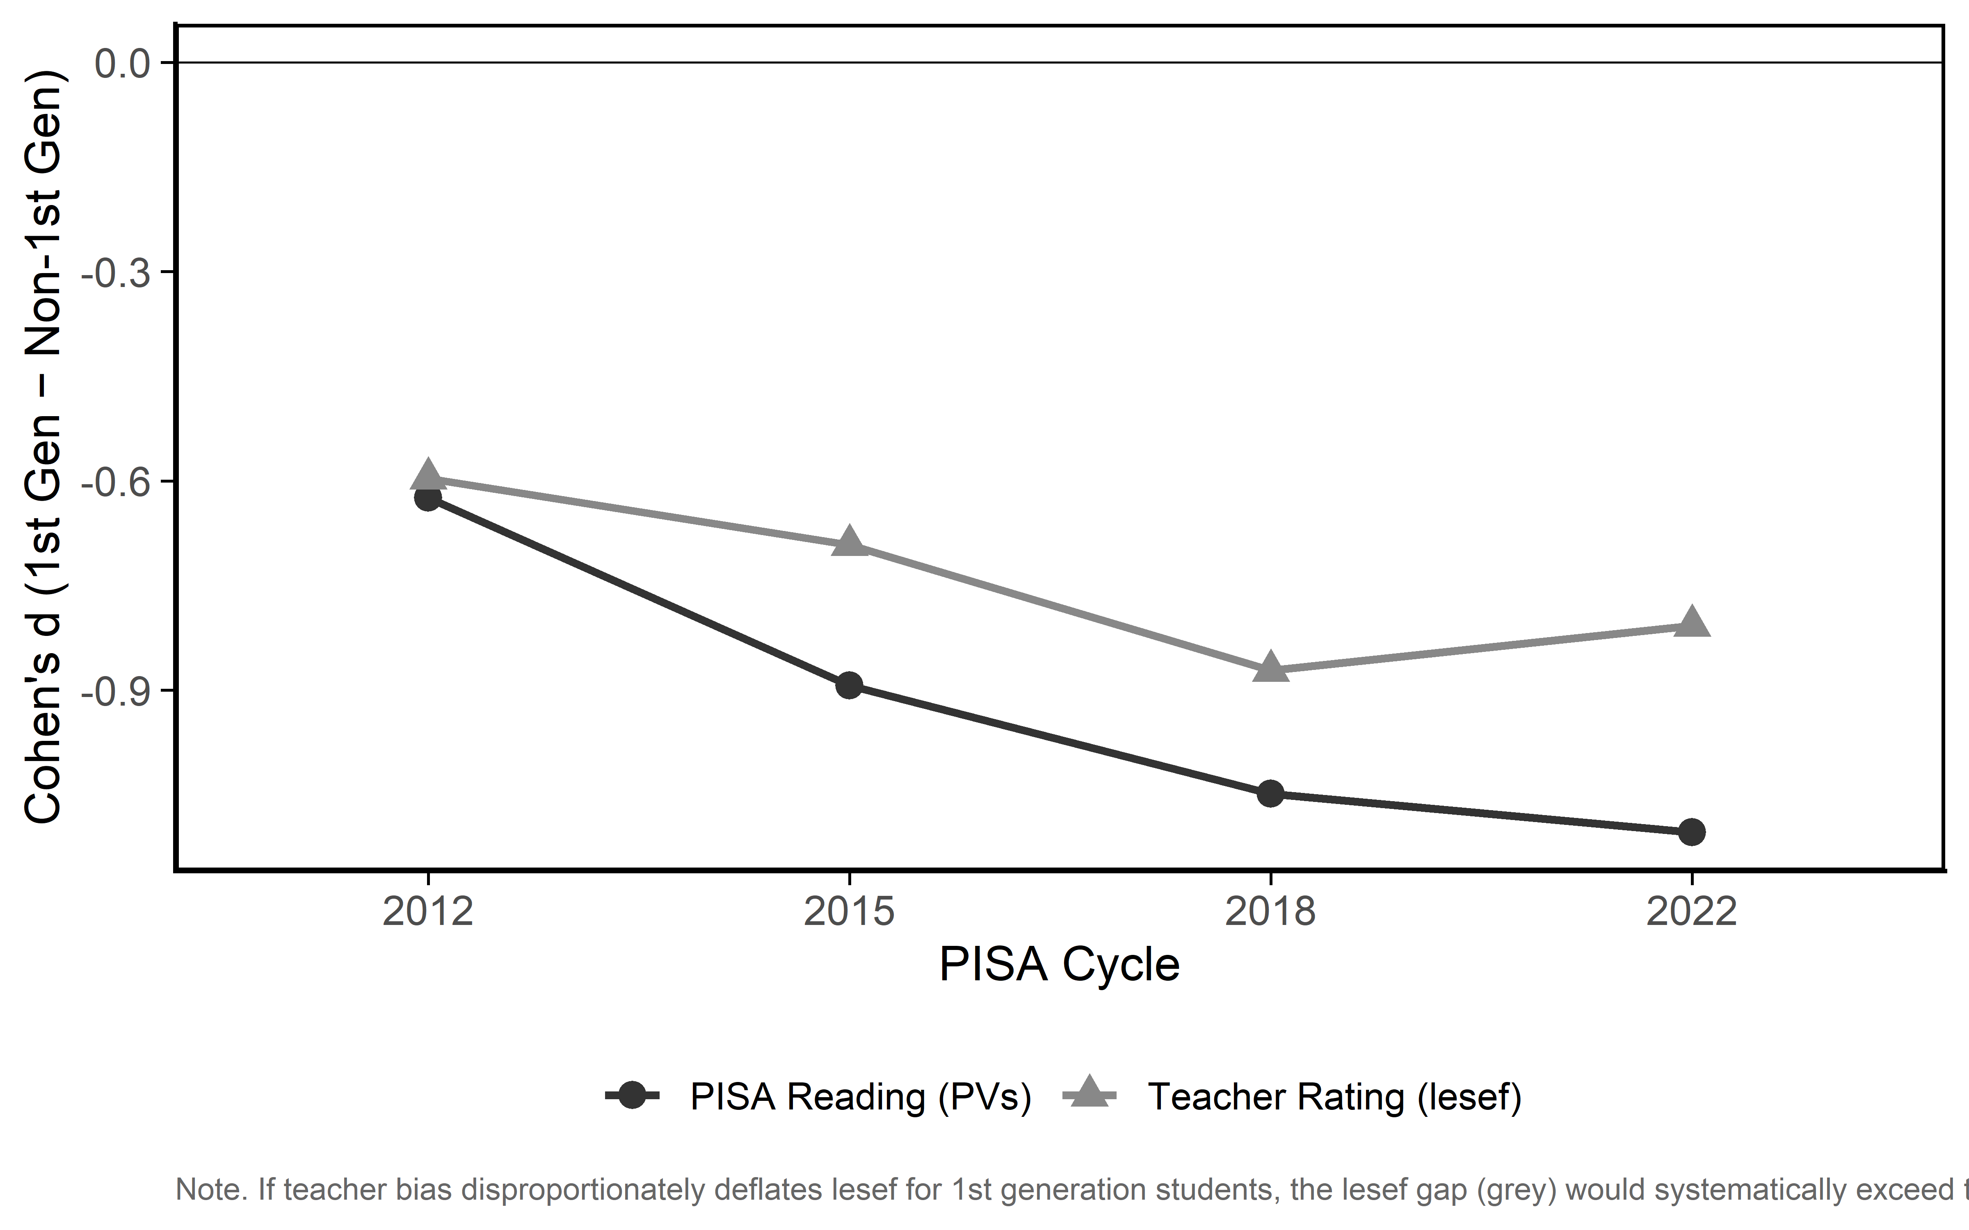
Figure S5. lesef effect size vs. PISA reading effect size by cycle. Note. If teacher bias disproportionately deflates lesef for 1st generation students, the lesef gap (grey) would systematically exceed the reading PV gap (black). The lesef gap (grey) is consistently smaller than the reading PV gap across all cycles, an observation, we use to argue against disproportionate teacher deflation.

Interpretation
Observed findings. Table S6 confirms that lesef correlates substantially with PISA reading scores within both groups across all cycles—consistent with measuring functional literacy, not stereotype. Table S7 shows lesef is negatively correlated with arrival age among 1st generation immigrant students in every cycle: later arrivers receive lower ratings, consistent with SLA theory and inconsistent with a uniform-deflation bias. Table S8 and Figure S5 show that the standardized lesef gap is consistently smaller than the PISA reading gap (ratios range from 0.73 to 0.95, all below 1.0), indicating that teachers do not amplify the gap beyond what achievement differences warrant.
What these checks do not resolve. They cannot rule out formal measurement non-equivalence—CFA across groups is precluded by lesef’s single-item nature—nor disentangle accurate rating from shared confounds (e.g., German-language exposure) or self-fulfilling prophecy effects (Gentrup et al., 2020). Since the main article uses lesef as a predictor within 1st generation immigrant students rather than a group comparison tool, the relevant bar is predictive validity conditional on group membership, not cross-group measurement equivalence. The empirical pattern is consistent with that bar being met.
Notably, Kleinkorres et al. (2025) found positive leniency toward students with migration backgrounds in Germany, suggesting that if rater bias operates at all in this context, it may run in the direction of overrating rather than deflating immigrant students’ literacy. This would imply that lesef’s predictive associations in the main analyses are, if anything, attenuated relative to what an unbiased measure would show. The methodological limitations of that study—particularly the reliance on German-language parental reports and full imputation for a population with known high item nonresponse—mean this conclusion should be held tentatively. Nevertheless, it is the most directly relevant German-context evidence available on the bias question, and it does not support the deflation scenario.

Supplement D: Socioeconomic background
Three PISA SES indicators—HISEI (occupational status), HOMEPOS (home possessions), and PARED (parental education in years)—are compared between groups. In 2015–2022, these are available as 10 nationally imputed plausible values pooled via Rubin’s (1987) rules; in 2012 only WLE point estimates exist (replicated into five draws for structural consistency), so between-imputation variance Bₘ = 0 and standard errors reflect within-imputation sampling uncertainty only.
These between-group disparities contextualize the main article’s finding that SES shows no significant within-group associations. PARED is reported by 15-year-old students and is, as stated in our main article, especially unreliable for recently arrived immigrants (Jerrim & Micklewright, 2014; Lavest et al., 2025), contributing to high missingness and inconsistent effect sizes across cycles.
Table S9
Background variables
Cycle | Variable | 1st Gen.  M (SE) | Non-1st Gen.  M (SE) | Gap | Cohens d
2012 | HISEI | 41.92 (1.23) | 50.21 (0.19) | -8.28 | -0.534
 | HOMEPOS | -0.30 (0.06) | 0.31 (0.01) | -0.60 | -0.790
 | PARED | 12.79 (0.28) | 13.52 (0.03) | -0.73 | -0.283
2015 | HISEI | 45.07 (1.59) | 51.37 (0.28) | -6.30 | -0.310
 | HOMEPOS | -0.22 (0.07) | 0.19 (0.01) | -0.41 | -0.530
 | PARED | 13.47 (0.22) | 13.60 (0.04) | -0.13 | -0.050
2018 | HISEI | 42.68 (1.36) | 52.01 (0.33) | -9.33 | -0.449
 | HOMEPOS | -0.60 (0.06) | 0.19 (0.01) | -0.79 | -0.866
 | PARED | 12.61 (0.26) | 13.63 (0.04) | -1.02 | -0.354
2022 | HISEI | 42.84 (1.10) | 52.34 (0.31) | -9.50 | -0.459
 | HOMEPOS | -0.71 (0.04) | 0.23 (0.01) | -0.94 | -1.042
 | PARED | 12.61 (0.21) | 13.33 (0.05) | -0.72 | -0.228
Note. SES comparison by group and cycle (Rubin-pooled across 10 PVs for 2015–2022; WLE single estimate for 2012).

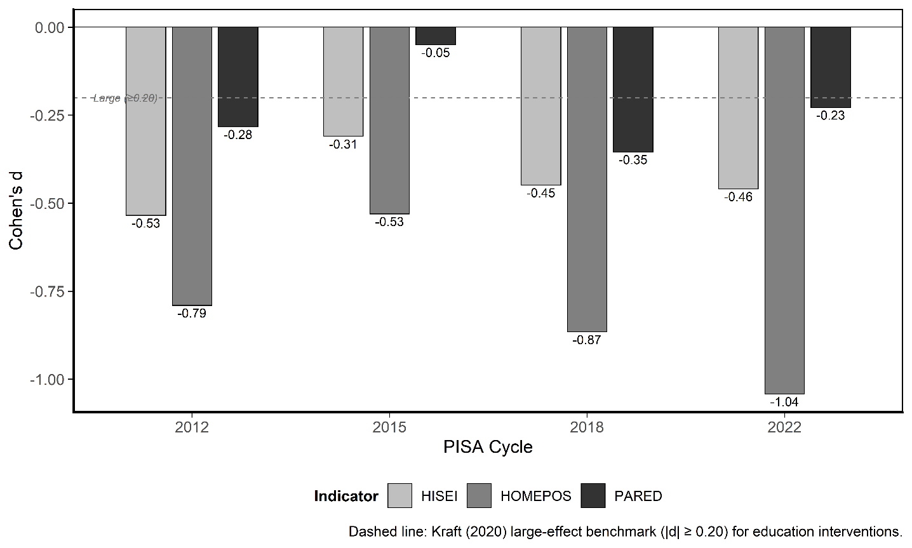
Figure S6. SES disparities.
HISEI and HOMEPOS show consistent disadvantage (d = −0.31 to −1.04), all exceeding Kraft’s (2020) large-effect benchmark (|d| ≥ 0.20) by wide margins. HOMEPOS widens from 2012 to 2022, consistent with post-2015 migration composition changes. PARED differences are smaller and inconsistent.

Supplement E: Composite score
Table S10
Composite score (mean of Math, Read, Science PVs).
Cycle | 1st Gen. | Non-1st Gen. | Gap | Cohens d
2012 | 461.2 | 513.5 | -52.4 | -0.639
2015 | 437.0 | 516.7 | -79.7 | -0.879
2018 | 419.7 | 512.5 | -92.8 | -0.981
2022 | 391.8 | 497.1 | -105.3 | -1.114
Composite d increases monotonically from -0.64 (2012) to -1.11 (2022), exceeding one pooled SD by the most recent cycle. This trend underscores the widening disparity and reinforces the motivation for investigating within-group heterogeneity.

Supplement F: Marginal effects of key predictors
F.1 Rationale
This supplement reports average marginal effects (AMEs) from stepwise multilevel models fitted to the full analytic sample (all students with non-missing lesef and LANG data; the exact N depends on domain-specific PV availability but is approximately 21,000), complementing the main article’s regression results ('Multilevel analysis of achievement predictors' section of the main article) with effect-size estimates on the PISA-point scale. In the main article, arrival age enters as a continuous predictor restricted to 1st generation immigrants. Here, we exploit the arrival-age cut-points identified by recursive partitioning (see 'Exploratory analyses: arrival-age profiles' section of the main article, 9.5 and 13.5 years) to construct a four-level categorical variable: (0) non-1st generation students (reference), (1) early-arriving 1st generation immigrants (arrived before age 10), (2) mid-arriving (ages 10–13), and (3) late-arriving (age 14 or older). Fifty-nine 1st generation students whose arrival age is missing in the PISA data are assigned to the Early (< 10) group so that the full 1st generation sample (n = 1,248) is retained—this is a conservative decision because it assigns the unknown cases to the group closest to the non-1st generation reference, biasing any Early-vs.-reference contrast toward zero rather than inflating it. This coding includes the entire sample while avoiding the interpretability problem that arises when scale() is applied to a continuous arrival-age variable in which ~95% of values are zero (non-1st generation students have no arrival age and would be set to 0): the resulting SD is inflated by the zero-spike and the per-SD AME has no meaningful real-world referent. The group-coded specification instead yields AMEs that directly quantify each arrival-age group’s achievement gap relative to non-1st generation peers—a natural, policy-relevant effect size.
F.2 Model specification
Marginal effects are estimated from stepwise multilevel models fitted separately to each plausible value draw and pooled via Rubin’s (1987) rules. The outcome is a single PISA achievement score (mathematics, reading, or science); all models include a random intercept for PISA cycle (year), matching the nesting structure of the main article. The analytic sample comprises all students with non-missing lesef, LANG, and arrival-age group data.
Arrival age enters the model as a four-level factor: Non-1st generation (reference), Early (< 10), Mid (10–13), and Late (14+). Non-1st generation students—who have no arrival-age value—serve as the reference category, so each 1st generation group’s AME is interpretable as the expected achievement difference relative to non-1st generation peers, net of the other covariates. This avoids the inflated SD that would result from standardizing a mostly-zero continuous arrival-age variable across the full sample (see F.1).
The stepwise sequence is:
- M1 (intercept only): baseline ICC
- M2: arrival-age group + LANG
- M3: M2 + lesef
- M4 (full): M3 + HISEI + HOMEPOS + PARED
Marginal effects are computed from M4. For the continuous predictor lesef, we report the AME per SD with 95% CI; for categorical predictors (arrival-age group, LANG), we report contrasts against the reference level. Following Mize (2019), lesef is also visualized as predicted values across its 1–5 range with other predictors held at their means (MEM specification).
F.3 Results: Average marginal effects
Table S11
Average marginal effects from the full multilevel model
Domain | Predictor | AME (95% CI) | SE
Mathematics | Non-German at home | -27.25 [-32.14, -22.35] | 2.50
 | 1st-gen: Early (<10 yrs) | -18.83 [-28.40, -9.26] | 4.88
 | 1st-gen: Mid (10–13 yrs) | -11.17 [-22.48, 0.15] | 5.77
 | 1st-gen: Late (>13 yrs) | -46.12 [-68.10, -24.13] | 11.22
 | lesef (per SD) | 25.52 [24.10, 26.94] | 0.72
Reading | Non-German at home | -27.70 [-33.10, -22.30] | 2.75
 | 1st-gen: Early (<10 yrs) | -30.16 [-40.70, -19.62] | 5.38
 | 1st-gen: Mid (10–13 yrs) | -43.50 [-55.14, -31.86] | 5.94
 | 1st-gen: Late (>13 yrs) | -83.58 [-105.75, -61.41] | 11.31
 | lesef (per SD) | 30.79 [29.11, 32.46] | 0.86
Science | Non-German at home | -35.82 [-40.81, -30.83] | 2.54
 | 1st-gen: Early (<10 yrs) | -24.41 [-33.67, -15.15] | 4.73
 | 1st-gen: Mid (10–13 yrs) | -29.74 [-41.44, -18.03] | 5.97
 | 1st-gen: Late (>13 yrs) | -58.78 [-80.57, -37.00] | 11.12
 | lesef (per SD) | 29.08 [27.40, 30.76] | 0.86
Note. Average marginal effects (AME), where estimates are pooled across all available plausible values via Rubin’s (1987) combining rules (M = 5 for 2012, M = 10 for 2015–2022; draws 6–10 include 2015–2022 only). Arrival-age group is a four-level factor (Non-1st -gen (reference group), Early < 10, Mid 10–13, Late >13); AMEs for group levels are contrasts vs. the non-1st generation reference. lesef is standardized; its AME is in PISA points per SD. LANG contrast is non-German vs. German at home. Survey-weighted (W_FSTUWT). Random intercept for PISA cycle. Full analytic sample. SES PVs matched to each achievement PV draw.
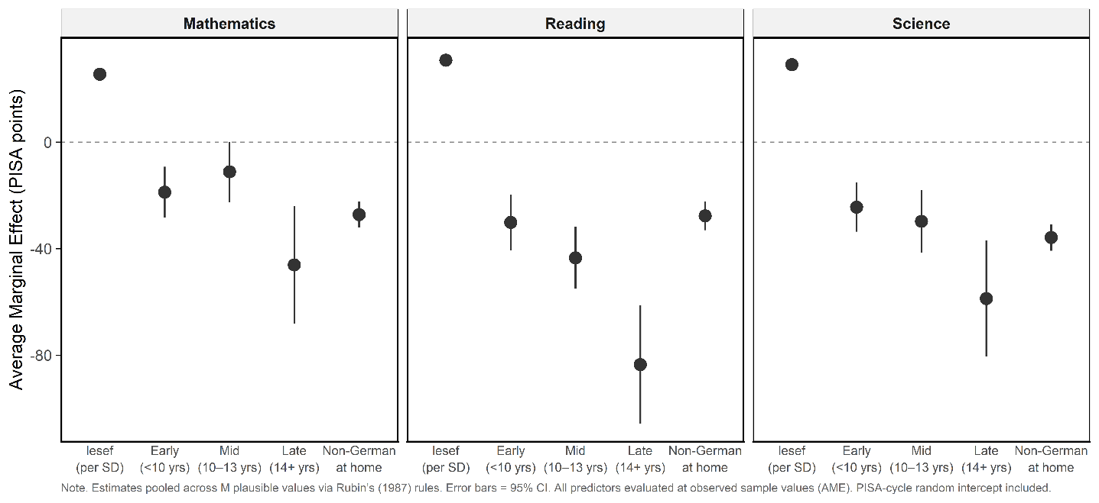
Figure S7. Full model average marginal effects based on age grouping using all students. Note. Estimates pooled across M plausible values via Rubin (1987) rules. Error bars = 95% CI. All predictors evaluated at observed sample values (AME). PISA-cycle random intercept included.
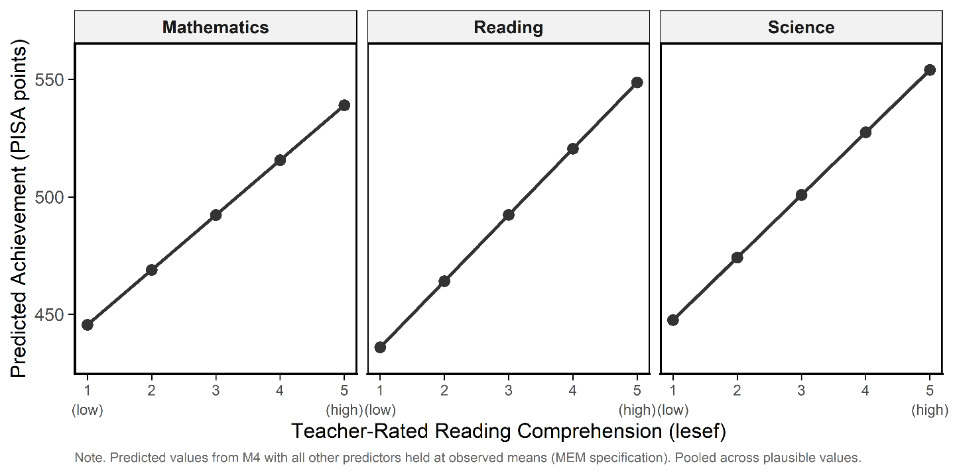
Figure S8. Full model average marginal effects based on lesef. Note. Predicted values from model M4 with all other predictors held at observed means (MEM specification). Pooled across plausible values.
Table S11 and Figure S7 present the AMEs from the full model (M4) across all three domains, now estimated on the full sample with non-1st generation students as the reference group. Four findings stand out.
First, lesef is the strongest continuous predictor: each SD increase in teacher-rated reading comprehension is associated with a gain of 25–31 PISA points (depending on domain), net of arrival-age group, home language, and SES. Note that lesef and the arrival-age group contrasts are on different scales—per-SD change versus group membership—so their magnitudes are not directly comparable. Among the group-level contrasts, late-arriving 1st generation students (>13) show the largest deficits (up to −84 points in reading), exceeding the lesef per-SD effect in absolute terms. Nevertheless, lesef is the strongest continuous predictor across all three domains; the main article’s Tables 2 and 3 show that this association holds within 1st generation immigrant students across arrival-age and home-language strata.
Second, the arrival-age group contrasts show that 1st generation students at every arrival-age level score below non-1st generation peers, and the penalty is largest for late arrivers (>13) across all three domains. In reading and science, the pattern is strictly graded: Early (< 10), Mid (10–13), Late (>13). In mathematics, Early and Mid deficits are similar in magnitude and their confidence intervals overlap, but the Late penalty remains by far the largest (−46 points)—consistent with the SLA prediction that later L2 onset limits academic-language development. Critically, even early-arriving 1st generation students score below non-1st generation peers, indicating that the achievement gap is not eliminated by early arrival alone.
Third, the LANG contrast (non-German vs. German at home) is negative and significant in all three domains, with the largest effect in science (−35 points), confirming that home-language environment carries additional explanatory weight beyond arrival timing.
Fourth, Figure S8 plots predicted achievement across the 1–5 lesef scale (other predictors at observed means). The relationship is approximately monotone, with the steepest gains between ratings 2 and 4, suggesting the middle range carries the most predictive information. All three domain panels share this shape.
In sum, functional literacy is the strongest continuous correlate of achievement; the arrival-age group variable reveals a penalty that is largest for late arrivers; and home language is independently associated with lower achievement across all domains.
F.4 Link to arrival-age grouping
The group-coded AMEs in Table S11 directly incorporate the arrival-age cut-points identified by recursive partitioning in Section 5.2 of the main article (9.5 and 13.5 years). In reading and science the three groups show strictly graded deficits (Early < Mid < Late); in mathematics Early and Mid are comparable, but Late remains sharply worse. Together, this confirms that the tree-based segmentation captures developmentally meaningful thresholds—particularly the Late cut-point at 13.5 years, which marks the steepest drop in every domain. The AMEs quantify the magnitude of these group differences on the PISA-point scale, while the tree analysis identifies where along the arrival-age continuum the steepest drops occur; the two approaches are complementary.

F.5 Stepwise model fit
Table S12
Stepwise R² statistics from survey-weighted multilevel models with random intercept for PISA cycle
Domain | Model | Marginal R² | Conditional R² | SB pseudo-R²
Mathematics | M1: Intercept only | 0.000 | 0.000 | 0.000
 | M2: Arrival-age group + LANG | 0.001 | 0.001 | 0.087
 | M3: + lesef | 0.002 | 0.002 | 0.202
 | M4: + SES | 0.004 | 0.004 | 0.296
Reading | M1: Intercept only | 0.000 | 0.000 | 0.000
 | M2: Arrival-age group + LANG | 0.001 | 0.001 | 0.102
 | M3: + lesef | 0.003 | 0.003 | 0.229
 | M4: + SES | 0.004 | 0.004 | 0.301
Science | M1: Intercept only | 0.000 | 0.000 | 0.000
 | M2: Arrival-age group + LANG | 0.001 | 0.001 | 0.108
 | M3: + lesef | 0.003 | 0.003 | 0.227
 | M4: + SES | 0.004 | 0.004 | 0.316
Note. Estimates are pooled across all available PV draws per domain (M = 5 for 2012, M = 10 for 2015–2022; draws 6–10 include 2015–2022 only). Marginal and conditional R² via Nakagawa & Schielzeth (2013) and Johnson (2014); SB pseudo-R² = Snijders & Bosker (2012) proportional reduction in total prediction-error variance relative to the null model, computed with the same Snijders–Bosker formula used in the main article’s Tables 2 and 3 (though the samples differ). M1 = intercept only; M2 = arrival-age group + LANG; M3 = + lesef; M4 = + SES. SES PVs matched to each achievement PV draw; 2012 WLE replicated into five draws for structural consistency; between-imputation variance equals zero for 2012 SES, so SEs reflect within-imputation sampling uncertainty only.
Table S12 reports three R² metrics across the four stepwise models: Nakagawa and Schielzeth’s (2013) marginal R², reflecting variance explained by fixed effects alone; their conditional R², reflecting variance explained by fixed and random effects jointly; and the Snijders and Bosker (2012) pseudo-R², which expresses the proportional reduction in total prediction-error variance—pooling Level-1 residual variance and between-cluster variance—relative to the intercept-only model. The SB pseudo-R² is the metric reported in Tables 2 and 3 of the main article and is the primary basis for interpreting model fit there; the marginal and conditional decomposition is provided here as supplementary information.
Interpreting the three metrics in this design. In the present specification—four PISA cycles as the sole Level-2 clustering unit—the random intercept absorbs very little variance, and marginal and conditional R² are virtually identical across all models when rounded to three decimal places. This is expected: with only four upper-level units, the between-cycle variance component τ² is both small relative to the residual variance and estimated with substantial imprecision (see Section 6.6). Any numerical difference between the marginal and conditional estimates should be read as at most directional evidence for cohort-level heterogeneity rather than as a meaningful partition of variance. Because the SB pseudo-R² incorporates τ² into both numerator and denominator, its trajectory across models is the most relevant indicator of how each predictor block reduces total unexplained variability in this design. We caution, however, that adding Level-1 predictors in models with very few clusters can increase the estimated τ² relative to the null, potentially inflating the SB pseudo-R² upward independently of the true fixed-effect signal; the values in Table S12 should therefore be read as approximate upper bounds on explained variance.
Benchmarking R². The stepwise models in Table S12 are estimated on the full sample—including both 1st generation and non-1st generation students—which makes the explained-variance increments more readily interpretable than the 1st generation-only specification in the main article, where range restriction on every predictor compresses all R² values toward zero. In the full-sample models, the arrival-age group variable at M2 directly captures the 1st generation versus non-1st generation gap alongside within-immigrant differences by arrival timing, meaning its R² increment jointly reflects both sources of between-student variability.
The lesef increment. Adding lesef at M3 produces a substantial further increment in SB pseudo-R² across all three domains, consistent with the main article’s finding that teacher-rated reading comprehension discriminates achievement above and beyond migration-process variables (arrival-age group, home language). This positions lesef as capturing functional school integration—something the other predictors miss—which is the central finding of the main article (section 'Reading competence, not home language, predicts achievement'), confirmed here on the PISA-point scale.
SES attenuation. Adding SES at M4 yields only a modest additional increment. Two mechanisms compound: (a) measurement unreliability, since PARED and HISEI require 15-year-olds to map parental qualifications acquired abroad onto host-country classifications (Jerrim & Micklewright, 2014; Lavest et al., 2025); and (b) range restriction, since labor migration and asylum pathways compress the SES distribution among 1st generation immigrant families relative to the general population. Both mechanisms attenuate regression coefficients toward zero and deflate R² increments beyond what would be observed without these measurement limitations.
Attenuation toward zero. Finally, it is worth noting that the conditioning model we used to generate the main article’s plausible values included only two covariates (arrival age and teacher-rated reading comprehension). Associations between those covariates and the PV-based outcome are therefore biased toward zero to the extent that the conditioning model is incomplete (seethe 'Limitations' section of the main article). Both mechanisms attenuate regression coefficients and deflate R² increments toward zero; the values in Table S12 should accordingly be read as conservative lower bounds on explained variance.

F.6 Sensitivity: Unweighted models
Table S13
Weighted vs. unweighted AMEs (SE) from multi-level models
Domain | Predictor | Weighted | Unweighted | Δ
Mathematics | Non-German at home | -27.25 (2.50) | -26.71 (2.50) | -0.54
 | 1st -gen: Early (<10 yrs) | -18.83 (4.88) | -18.13 (4.90) | -0.69
 | 1st -gen: Mid (10–13 yrs) | -11.17 (5.77) | -13.60 (5.90) | 2.43
 | 1st -gen: Late (>13 yrs) | -46.12 (11.22) | -45.92 (11.26) | -0.20
 | lesef (per SD) | 25.52 (0.72) | 25.87 (0.71) | -0.35
Reading | Non-German at home | -27.70 (2.75) | -26.85 (2.77) | -0.85
 | 1st -gen: Early (<10 yrs) | -30.16 (5.38) | -28.90 (5.38) | -1.25
 | 1st -gen: Mid (10–13 yrs) | -43.50 (5.94) | -45.54 (6.33) | 2.05
 | 1st -gen: Late (>13 yrs) | -83.58 (11.31) | -84.08 (11.17) | 0.50
 | lesef (per SD) | 30.79 (0.86) | 31.10 (0.87) | -0.31
Science | Non-German at home | -35.82 (2.54) | -35.14 (2.52) | -0.68
 | 1st -gen: Early (<10 yrs) | -24.41 (4.73) | -23.57 (4.71) | -0.84
 | 1st -gen: Mid (10–13 yrs) | -29.74 (5.97) | -32.17 (6.13) | 2.43
 | 1st -gen: Late (>13 yrs) | -58.78 (11.12) | -59.17 (11.04) | 0.39
 | lesef (per SD) | 29.08 (0.86) | 29.44 (0.86) | -0.36
Note. Δ = weighted − unweighted.
Table S13 compares AMEs from the survey-weighted (main) and unweighted M4 models. Point estimates are very similar across all predictors and domains; differences are small relative to the standard errors. This indicates that substantive conclusions are robust to the choice of weighting scheme. We retained the weighted estimates as the primary specification because they account for the PISA complex sampling design and yield population-representative inferences.

Supplement G: R code excerpt of main analyses
Model fitting (for N = 1,189)
fit_nested_domain_model <- function(item_names, full_data, domain_name) {
# Prepare item data
domain_data <- full_data %>% select(all_of(item_names))
domain_data_matrix <- as.matrix(domain_data)

# Filter items with variance > 0
item_variances <- apply(domain_data_matrix, 2, var, na.rm = TRUE)
valid_items <- names(item_variances[item_variances > 0])
domain_data_filtered <- domain_data_matrix[, valid_items, drop = FALSE]

# Prepare covariates with mean imputation (simple and can be escalated if needed–we decided not to). Note that this decision is inconsistent with the FIML strategy used elsewhere. Median imputation introduces bias into the conditioning model itself, which then propagates into all PV-based estimates. However, we fear the issue of model on model imputation and therefore opted for the simplest handling here.

covariates <- full_data %>%
select(arrival_age, lesef) %>%
mutate(across(everything(), ~ ifelse(is.na(.), mean(., na.rm = TRUE), .)))
# there might be a fancier way like early stage imputation.

# Year as factor for nesting
year_factor <- as.factor(full_data$year)

# Determines item types (2PL or PCM) based on number of categories 0,1 vs. 0,1,2
item_categories <- apply(domain_data_filtered, 2, function(x) length(unique(na.omit(x))))
twopl_items <- names(item_categories[item_categories == 2])
pcm_items <- names(item_categories[item_categories > 2])
item_type_string <- paste(
paste0(twopl_items, “(2PL);”, collapse = “ “),
paste0(pcm_items, “(PCM);”, collapse = “ “)
)

# Model specification
model_spec <- paste0( # all as a single factor model with item types
“LAVAAN MODEL:\n”,
“F =~ “, paste(valid_items, collapse = “ + “), “\n”,
“F ~~ 1*F\n”,
“ITEM TYPE:\n”,
item_type_string
)

# This is the model that is fitted to each competency separately
mod <- TAM::tamaan(
tammodel = model_spec,
resp = domain_data_filtered,
group = year_factor,
formulaY = ~ arrival_age + lesef,
dataY = covariates,
control = list(
maxiter = 500,
conv_crit = 1e-4,
snodes = 0,
progress = TRUE,
ridge = 0.05,
convD = 1e-5,
conv = 1e-5,
increment.factor = 1.05,
fac.oldxsi = 0.5
)
)
return(mod)
}

# A list of domains and their item vectors
domain_list <- list(
MATH = math_items,
READING = read_items,
SCIENCE = science_items,
COMP = c(math_items,read_items,science_items ) # or names(as.data.frame(response_data)) for all items
)

# TThis Stores models in a named list
domain_models <- list()
for (domain in names(domain_list)) {
domain_models[[domain]] <- fit_nested_domain_model(
item_names = domain_list[[domain]],
full_data = combined_items_data_recoded2,
domain_name = domain
)
}

# ==================================================================
# IMPORTANT: PVs are kept here in their ORIGINAL TAM scale (NO scaling to mean=500, SD=100, as OECD usually does)
# This preserves the original psychometric properties and avoids artificial transformations
# (As all stems from the same IRT model, we believe these are comparable)
# ==================================================================

pvMATH <- TAM::tam.pv(domain_models$MATH, normal.approx=TRUE, ntheta=2000,samp.regr=TRUE, nplausible=100 )$pv
pvREAD <- TAM::tam.pv(domain_models$READING, normal.approx=TRUE, ntheta=2000,samp.regr=TRUE, nplausible=100 )$pv
pvSCIE <- TAM::tam.pv(domain_models$SCIENCE, normal.approx=TRUE, ntheta=2000,samp.regr=TRUE, nplausible=100 )$pv
pvCOMP <- TAM::tam.pv(domain_models$COMP, normal.approx=TRUE, ntheta=2000,samp.regr=TRUE, nplausible=100 )$pv

Decision Trees
# === 1. Decision Trees for Composite PVs (1) ===
tree_model <- rpart(PV1COMP ~ arrival_age, data = combined_items_data_recoded4,
method = “anova”, control = rpart.control(minsplit = 50, cp = 0.01))
rpart.plot(tree_model,
main = “Decision Tree for Age at Arrival”,
extra = 101,
box.palette = “RdYlGn”,
shadow.col = “gray”,
nn = TRUE)
# === 2. Decision Trees for All Composite PVs (1–100) ===
all_split_points <- list()
pv_comp_cols <- grep(“^PV\\d+COMP$”, names(combined_items_data_recoded4), value = TRUE)
for (composite_var in pv_comp_cols) {
formula_tree <- as.formula(paste0(composite_var, “ ~ arrival_age”))
tree_model <- rpart(formula_tree, data = combined_items_data_recoded4,
method = “anova”, control = rpart.control(minsplit = 50, cp = 0.01))
plot_title <- paste(“Decision Tree for Age at Arrival -”, composite_var)
rpart.plot(tree_model,
main = plot_title,
extra = 101,
box.palette = “RdYlGn”,
shadow.col = “gray”,
nn = TRUE)
if (!is.null(tree_model$splits)) {
sp <- sort(unique(tree_model$splits[, “index”]))
all_split_points[[composite_var]] <- sp
} else {
all_split_points[[composite_var]] <- NA
}
}
all_split_points

Measurement models
# Baseline Model (Random Intercept Only)
mg.mod0.am <- with(big.implist.am, lme4::lmer(
COMP ~ 1 + (1 | year)))
res0 <- testEstimates(mg.mod0.am, extra.pars = TRUE)
r2_mod0 <- multilevelR2(mg.mod0.am, print = “SB”)

#Random Intercept with Level-1 Predictors (Manifest Model)
mg.mod1.am <- with(big.implist.am, lme4::lmer(
COMP ~ 1 + arrival_age + lesef.centered + LANG + (1 | year)))
testEstimates(mg.mod1.am, extra.pars = TRUE)
multilevelR2(mg.mod1.am, print=c(“SB”))

#boundary (singular) fit: see help(‘isSingular’)

mg.mod1.amx <- with(big.implist.am, lme4::lmer(
COMP ~ 1 + arrival_age + lesef.centered + LANG +
HISEI.centered + PARED.centered + HOMEPOS.centered + (1 | year)))
testEstimates(mg.mod1.amx, extra.pars = TRUE)
multilevelR2(mg.mod1.amx, print=c(“SB”))
# boundary (singular) fit: see help(‘isSingular’)

#ICC|year 0.132 13.2% to variation in year
#effect is estimated in a way that the year does not matter

# justified Random Intercept and Random Slope Model

mg.mod2.am2 <- with(big.implist.am, lme4::lmer(
COMP ~ 1 + arrival_age + lesef.centered + LANG + (1 + lesef.centered | year)))
testEstimates(mg.mod2.am2, extra.pars = TRUE)
multilevelR2(mg.mod2.am2, print=c(“SB”)) #

mg.mod2.am2x <- with(big.implist.am, lme4::lmer(
COMP ~ 1 + arrival_age + lesef.centered + LANG +
HISEI.centered + PARED.centered + HOMEPOS.centered + (1 + lesef.centered | year)))
testEstimates(mg.mod2.am2x, extra.pars = TRUE)
multilevelR2(mg.mod2.am2x, print=c(“SB”))

Descriptive statistics
##### Note that this is based on the function micombine.cor from the miceadds package (Robitzsch & Grund, 2024) we adapted it with the from the psych package (Revelle, 2025), - specifically replace cor with corFiml-

# from miceadds (micombine.cor)
# Modified function using corFiml instead of stats::cor
atest_fiml <- function (mi.res, variables = NULL, conf.level = 0.95, method = “pearson”,
nested = FALSE, partial = NULL)
{
if (inherits(mi.res, “data.frame”)) {
mi.res <- list(mi.res)
}
if (inherits(mi.res, “nested.datlist”)) {
nested <- TRUE
}
if (!nested) {
mi.list <- datlist_create(mi.res)
}
if (nested) {
mi.list <- nested.datlist_create(mi.res)
}
Nimp <- attr(mi.list, “Nimp”)
N <- attr(mi.list, “nobs_datasets”)
vars <- attr(mi.list, “variables”)
if (is.null(variables)) {
variables <- vars
}
VV <- length(variables)
N_partial <- 0
if (!is.null(partial)) {
if (!inherits(partial, “formula”)) {
partial <- as.formula(paste0(“ ~ “, paste0(partial,
collapse = “+”)))
}
}
if (is.character(variables)) {
if (!nested) {
variables <- which(vars %in% variables)
}
if (nested) {
variables <- which(vars %in% variables)
}
}
dfr <- NULL
for (i in 1:(VV - 1)) {
for (j in (i + 1):VV) {
if (i != j) {
ii <- variables[i]
jj <- variables[j]
if (i != j) {
if (!nested) {
cor.ii.jj <- unlist(lapply(mi.list, FUN = function(dat) {
dat_ii <- dat[, ii]
dat_jj <- dat[, jj]
if (!is.null(partial)) {
fm <- paste0(“dat_ii “, paste(partial,
collapse = “ “))
mod_ii <- stats::lm(as.formula(fm), data = dat)
rii <- resid(mod_ii)
mii <- as.numeric(names(mod_ii$residuals))
dat_ii <- NA * dat_ii
dat_ii[mii] <- rii
fm <- paste0(“dat_jj “, paste(partial,
collapse = “ “))
mod_jj <- stats::lm(as.formula(fm), data = dat)
rjj <- resid(mod_jj)
mjj <- as.numeric(names(mod_jj$residuals))
dat_jj <- NA * dat_jj
dat_jj[mjj] <- rjj
N_partial <- length(coef(mod_jj)) - 1
}
# Use corFiml instead of stats::cor
dat_pair <- cbind(dat_ii, dat_jj)
cor_matrix <- psych::corFiml(dat_pair, covar = FALSE, show = FALSE)
cor_matrix[1, 2] # Extract correlation between the two variables
}))
}
if (nested) {
cor.ii.jj <- lapply(mi.list, FUN = function(mm) {
lapply(mm, FUN = function(dat) {
dat_ii <- dat[, ii]
dat_jj <- dat[, jj]
if (!is.null(partial)) {
fm <- paste0(“dat_ii “, paste(partial,
collapse = “ “))
mod_ii <- stats::lm(as.formula(fm),
data = dat)
rii <- resid(mod_ii)
mii <- as.numeric(names(mod_ii$residuals))
dat_ii <- NA * dat_ii
dat_ii[mii] <- rii
fm <- paste0(“dat_jj “, paste(partial,
collapse = “ “))
mod_jj <- stats::lm(as.formula(fm),
data = dat)
rjj <- resid(mod_jj)
mjj <- as.numeric(names(mod_jj$residuals))
dat_jj <- NA * dat_jj
dat_jj[mjj] <- rjj
N_partial <- length(coef(mod_jj)) - 1
}
# Use corFiml instead of stats::cor
dat_pair <- cbind(dat_ii, dat_jj)
cor_matrix <- psych::corFiml(dat_pair, covar = FALSE, show = FALSE)
cor_matrix[1, 2] # Extract correlation between the two variables
})
})
}
res.ii.jj <- miceadds:::micombine_cor_compute(cor.list = cor.ii.jj,
N = N, conf.level = conf.level, nested = nested,
Nimp = Nimp, N_partial = N_partial)
dfr <- rbind(dfr, c(ii, jj, res.ii.jj))
}
}
}
}
dfr1 <- dfr
dfr <- rbind(dfr, dfr1[, c(2, 1, seq(3, ncol(dfr)))])
dfr <- data.frame(variable1 = vars[dfr[, 1]], variable2 = vars[dfr[,
2]], dfr[, -c(1:2)])
class(dfr) <- “data.frame”
m1 <- miceadds:::vector2matrix(index1 = dfr$variable1, index2 = dfr$variable2,
val = dfr$r, empty_val = 1)
attr(dfr, “r_matrix”) <- m1
m1 <- miceadds:::vector2matrix(index1 = dfr$variable1, index2 = dfr$variable2,
val = dfr$rse, empty_val = NA)
attr(dfr, “rse_matrix”) <- m1
return(dfr)
}

resreal<-atest_fiml(mi.res=tesssssr,variables= c(“arrival_age”,”lesef”,”LANG”,”COMP”,”MATH”,”READ”, “SCIE”,”HISEI”,”PARED”,”HOMEPOS”))
attr(resreal, “r_matrix”)
## To get the p values:
p_table <- resreal %>%
dplyr::select(variable1, variable2, p) %>%
pivot_wider(names_from = variable2, values_from = p)

# Add upper triangle and diagonal as NA for readability
vars <- unique(c(resreal$variable1, resreal$variable2))
p_matrix <- matrix(NA, nrow = length(vars), ncol = length(vars),
dimnames = list(vars, vars))

# Fill lower triangle with p-values
for(i in seq_len(nrow(resreal))) {
v1 <- resreal$variable1[i]
v2 <- resreal$variable2[i]
p_matrix[v1, v2] <- resreal$p[i]
}
p_df

order_vars <- c(“arrival_age”, “lesef”, “LANG”, “COMP”, “MATH”, “READ”, “SCIE”, “HISEI”, “PARED”, “HOMEPOS”)
#fiml R
attr(resreal, “r_matrix”)[order_vars, order_vars]

#fiml p
p_df[order_vars, order_vars]

R² statistics
#multilevelR2(x, print=c(“SB”))
# reproduce manually to know whats happening
calculate_riv_fmi <- function(implist, formula) {
m <- length(implist)
estimates <- numeric(m)
variances <- numeric(m)
for (i in seq_along(implist)) {
# Fit model on current imputation
model <- lme4::lmer(formula, data = implist[[i]])
# We extract fixed effects and covariance matrix of fixed effects
fe <- lme4::fixef(model)
vc <- vcov(model) # Use the generic vcov function here
# Store intercept estimate and its variance
estimates[i] <- fe[[“(Intercept)”]]
variances[i] <- vc[1, 1]
}

# pools using Rubin’s rules
Q_bar <- mean(estimates) # Pooled estimate
U_bar <- mean(variances) # Within-imputation variance
#B <- var(estimates) * m / (m - 1) # Between-imputation variance (correct formula)
#This overestimates B because:
# var(estimates) already uses denominator m−1m−1 (unbiased sample variance)
#Multiplying by m/(m−1)m/(m−1) double-counts the adjustment
B <- var(estimates) # Simple variance of estimates
# Total variance
T_total <- U_bar + B + (B / m)
SE_total <- sqrt(T_total)
# Relative increase in variance (RIV) and Fraction of Missing Information (FMI)
RIV <- (B + B / m) / U_bar
FMI <- (B + B / m) / T_total
list(
Estimate = Q_bar,
Std.Error = SE_total,
RIV = RIV,
FMI = FMI,
Components = list(
Within_var = U_bar,
Between_var = B,
Total_var = T_total
)
)
}

# Run this on the baseline model
results <- calculate_riv_fmi(
implist = big.implist.am,
formula = COMP ~ 1 + (1 | year)
)

Additional explorations
# Exploration of MODELS
# all Random Intercept and Random Slope Model
mg.mod2.am1 <- with(big.implist.am, lme4::lmer(
COMP ~ 1 + arrival_age + lesef.centered + LANG +
HISEI.centered + PARED.centered + HOMEPOS.centered +
(1 + arrival_age | year)))
testEstimates(mg.mod2.am1, extra.pars = TRUE)

mg.mod2.am1x <- with(big.implist.am, lme4::lmer(
COMP ~ 1 + arrival_age + lesef.centered + LANG +
HISEI.centered + PARED.centered + HOMEPOS.centered +
(1 + arrival_age | year)))
testEstimates(mg.mod2.am1x, extra.pars = TRUE)

mg.mod2.am2 <- with(big.implist.am, lme4::lmer(
COMP ~ 1 + arrival_age + lesef.centered + LANG +
(1 + lesef.centered | year)))
testEstimates(mg.mod2.am2, extra.pars = TRUE)

mg.mod2.am2x <- with(big.implist.am, lme4::lmer(
COMP ~ 1 + arrival_age + lesef.centered + LANG +
HISEI.centered + PARED.centered + HOMEPOS.centered +
(1 + lesef.centered | year)))
testEstimates(mg.mod2.am2x, extra.pars = TRUE)

mg.mod2.am3 <- with(big.implist.am, lme4::lmer(
COMP ~ 1 + arrival_age + lesef.centered + LANG +
(1 + lesef.centered + arrival_age| year)))
testEstimates(mg.mod2.am3, extra.pars = TRUE)

mg.mod2.am3x <- with(big.implist.am, lme4::lmer(
COMP ~ 1 + arrival_age + lesef.centered + LANG +
HISEI.centered + PARED.centered + HOMEPOS.centered +
(1 + lesef.centered + arrival_age| year)))
testEstimates(mg.mod2.am3x, extra.pars = TRUE)

mg.mod2.am4 <- with(big.implist.am, lme4::lmer(
COMP ~ 1 + arrival_age + lesef.centered + arrival_age:lesef.centered + LANG +
(1 + lesef.centered + arrival_age| year)))
testEstimates(mg.mod2.am4, extra.pars = TRUE)

mg.mod2.am4x <- with(big.implist.am, lme4::lmer(
COMP ~ 1 + arrival_age + lesef.centered + arrival_age:lesef.centered + LANG +
HISEI.centered + PARED.centered + HOMEPOS.centered +
(1 + lesef.centered + arrival_age| year)))
testEstimates(mg.mod2.am4x, extra.pars = TRUE)

Best exploratory model
# Simplify model if singular fits persist (Barr et al., 2013 recommendation)
final_model <- with(big.implist.am, lme4::lmer(
COMP ~ arrival_age + lesef.centered + HOMEPOS.centered +
(1 + lesef.centered | year))) # Keep only significant random slope
testEstimates(final_model, extra.pars = TRUE)
# We think this has not enough years (this might be true for all models). A muti group analyses would be interesting to see- but is not our scope

Models applied to each competency, R²
# Random Intercept with Level-1 Predictors (Manifest Model) without SES
# Function to calculate R² for lmer models (Two-level models)
extract_r_squared_lme4 <- function(model_list) {
r_squared_values <- numeric(length(model_list))

# Loop through each imputed dataset to extract R² values
for (i in 1:length(model_list)) {
model <- model_list[[i]]
# Calculate R² for the model using multilevelR2
r_squared_values[i] <- multilevelR2(model, print=c(“SB”))
}
return(r_squared_values)
}

# Fit the models for MATH, READ, and SCIE with lmer for each imputed dataset
mg_t22_mat <- with(big.implist.am, lme4::lmer(MATH ~ 1 + arrival_age + lesef.centered + LANG + (1 | year)))
mg_t22_read <- with(big.implist.am, lme4::lmer(READ ~ 1 + arrival_age + lesef.centered + LANG + (1 | year)))
mg_t22_scie <- with(big.implist.am, lme4::lmer(SCIE ~ 1 + arrival_age + lesef.centered + LANG + (1 | year)))

# WITH SES

# Fit the models for MATH, READ, and SCIE with lmer for each imputed dataset
mg_t22_matx <- with(big.implist.am, lme4::lmer(MATH ~ 1 + arrival_age + lesef.centered + LANG + HISEI.centered + PARED.centered + HOMEPOS.centered +(1 | year)))
mg_t22_readx <- with(big.implist.am, lme4::lmer(READ ~ 1 + arrival_age + lesef.centered + LANG + HISEI.centered + PARED.centered + HOMEPOS.centered+(1 | year)))
mg_t22_sciex <- with(big.implist.am, lme4::lmer(SCIE ~ 1 + arrival_age + lesef.centered + LANG + HISEI.centered + PARED.centered + HOMEPOS.centered+(1 | year)))

# Random Intercept and Random Slope Model
# No SES
# Fit the models for MATH, READ, and SCIE with lmer for each imputed dataset, adding the #new predictors
mg_t22_mat_background <- with(big.implist.am, lme4::lmer(MATH ~ 1 + arrival_age + lesef.centered + LANG + (1 + lesef.centered | year)))
mg_t22_read_background <- with(big.implist.am, lme4::lmer(READ ~ 1 + arrival_age + lesef.centered + LANG + (1 + lesef.centered | year)))
mg_t22_scie_background <- with(big.implist.am, lme4::lmer(SCIE ~ 1 + arrival_age + lesef.centered + LANG + (1 + lesef.centered | year)))

# Above with SES
# Fit the models for MATH, READ, and SCIE with lmer for each imputed dataset, adding the new predictors
mg_t22_mat_backgroundx <- with(big.implist.am, lme4::lmer(MATH ~ 1 + arrival_age + lesef.centered + LANG + HISEI.centered + PARED.centered + HOMEPOS.centered + (1 + lesef.centered | year)))
mg_t22_read_backgroundx <- with(big.implist.am, lme4::lmer(READ ~ 1 + arrival_age + lesef.centered + LANG + HISEI.centered + PARED.centered + HOMEPOS.centered + (1 + lesef.centered | year)))
mg_t22_scie_backgroundx <- with(big.implist.am, lme4::lmer(SCIE ~ 1 + arrival_age + lesef.centered + LANG + HISEI.centered + PARED.centered + HOMEPOS.centered + (1 + lesef.centered | year)))

References for supplemental material
Birdsong, D., & Molis, M. (2001). On the evidence for maturational constraints in second-language acquisition. Journal of Memory and Language, 44(2), 235–249. https://doi.org/10.1006/jmla.2000.2750
Cohen, J. (1988). Statistical Power Analysis for the Behavioral Sciences (2nd ed.). Lawrence Erlbaum.
Flege, J. E., Yeni-Komshian, G. H., & Liu, S. (1999). Age constraints on second-language acquisition. Journal of Memory and Language, 41(1), 78–104. https://doi.org/10.1006/jmla.1999.2638
Gentrup, S., Lorenz, G., Kristen, C., & Kogan, I. (2020). Self-fulfilling prophecies in the classroom: Teacher expectations, teacher feedback and student achievement. Learning and Instruction, 66, 101296. https://doi.org/10.1016/j.learninstruc.2019.101296
Glock, S., & Krolak-Schwerdt, S. (2013). Does nationality matter? The impact of stereotypical expectations on student teachers’ judgments. Social Psychology of Education, 16(1), 111–127. https://doi.org/10.1007/s11218-012-9197-z
Hedges, L. V., & Olkin, I. (1985). Statistical methods for meta-analysis. Academic Press.
Jerrim, J., & Micklewright, J. (2014). Socio-economic gradients in children’s cognitive skills: Are cross-country comparisons robust to who reports family background? European Sociological Review, 30(6), 766–781. https://doi.org/10.1093/esr/jcu072
Johnson, P. C. D. (2014). Extension of Nakagawa & Schielzeth’s R²GLMM to random slopes models. Methods in Ecology and Evolution, 5(9), 944–946. https://doi.org/10.1111/2041-210X.12225
Jussim, L., Eccles, J., & Madon, S. (1996). Social perception, social stereotypes, and teacher expectations: Accuracy and the quest for the powerful self-fulfilling prophecy. Advances in Experimental Social Psychology, 28, 281–388. https://doi.org/10.1016/S0065-2601(08)60240-3
Kleinkorres, R., Ludewig, U., & Lorenz, R. (2025). Educational processes and competence development [Bildungsprozesse und Kompetenzentwicklungen]. TU Dortmund/pedocs. https://www.pedocs.de/volltexte/2025/34167/pdf/McElvany_et_al_Bildungsprozesse_und_Kompetenzentwicklungen.pdf
Kraft, M. A. (2020). Interpreting effect sizes of education interventions. Educational Researcher, 49(4), 241–253. https://doi.org/10.3102/0013189X20912798
Lavest, C., Ferry, M., Ichou, M., & Präg, P. (2025). Who do they think you are? Inconsistencies in self- and proxy-reports of education within families. Social Science Research, 132, 103225. https://doi.org/10.1016/j.ssresearch.2025.103225
Lorenz, G. (2021). Subtle discrimination: Do stereotypes among teachers trigger bias in their expectations and widen ethnic achievement gaps? Social Psychology of Education, 24(2), 537–571. https://doi.org/10.1007/s11218-021-09615-0
Mize, T. D. (2019). Best practices for estimating, interpreting, and presenting nonlinear interaction effects. Sociological Science, 6, 81–117. https://doi.org/10.15195/v6.a4
Nakagawa, S., & Schielzeth, H. (2013). A general and simple method for obtaining R² from generalized linear mixed-effects models. Methods in Ecology and Evolution, 4(2), 133–142. https://doi.org/10.1111/j.2041-210x.2012.00261.x
OECD. (2023). PISA 2022 results (Volume II): Learning during—and from—disruption. OECD Publishing. https://doi.org/10.1787/a97db61c-en
Rubin, D. B. (1987). Multiple imputation for nonresponse in surveys. John Wiley & Sons. https://doi.org/10.1002/9780470316696
Sahlström, E., & Silliman, M. (2024). The extent and consequences of teacher biases against immigrants (IZA Discussion Paper No. 16899). Institute of Labor Economics.
Snijders, T. A. B., & Bosker, R. J. (2012). Multilevel Analysis: An Introduction to Basic & Advanced Multilevel Modeling (2nd ed.). Sage Publications.
Tobisch, A., & Dresel, M. (2017). Negatively or positively biased? Dependencies of teachers’ judgments and expectations based on students’ ethnic and social backgrounds. Social Psychology of Education, 20(4), 731–752. https://doi.org/10.1007/s11218-017-9392-z

