Cognitive skills and long-term life outcomes. Evidence from 19 years of PISA 2000 follow-up surveys in Switzerland
Online Supplement

Content

Overview of TREE1 topics 2
Tables displaying control variables 4
Scatterplots 8
Robustness check: missingness 9
Robustness check: plausible values 11
PISA mathematics and science scores as independent variables 13
Incremental validity of PISA reading scores 16
Predictive validity of PISA reading scores at age 25 and 30 17

Please note: The numbering of the models follows the same numbering as in the article to ease comparison.

Overview of TREE1 topics
Table S1: TREE1 survey topics
Survey Topic
1 Education & Training
Description of education or training
Certificates
Strains & resources within the training firm
Strains & resources at school
Skills/competencies of VET trainers
Skills/competencies of (school) teachers
Equal opportunity within the training firm
Equal opportunity within the (vocational) school
Satisfaction with regard to education/training
Learning styles
Indicators of academic performance
Social support (with regard to education/training)
Propensity to quit/change the program
Absences
Source for Financing Education
2 Traineeships/internships
Description of traineeship/internship
3 Gainful occupation
Description of (main) job
Terms of employment
Strains & ressources at the workplace
Equal opportunity of employer
Skills/competencies of superiors
Relevance of attained VET for current job
Satisfaction with work & profession
Affective commitment
Social support with regard to work
Job Retention, Absenteeism, and Security Perceptions
Job search for current job
Profile of current employment
4 Other situations and activities
5 Significant life events
6 Personal characteristics
Persistence
Self-efficacy
Coping
Ambition
Value orientation
Gender roles
Parenting styles
Growth need strength
Anomy
7 Health and well-being
Self esteem
Depression
Positive attitude towards life
Physical ailments
Affectivity
Substance use
Life domains
8 Soci(et)al integration & participation
Social support
Relationships
Soci(et)al and cultural participation
Division of domestic chores
Social & cultural communication at home
Media consumption and media use
Status(transfer)
Plans & expectations for the future
Preferred Country of Residence and Political Identity
9 Demography, housing, finances
Demography
Housing and Finances
Civil status
Children
Childcare situation
Partner
Nationality

A more detailed documentation is available as part of the data release download package.
TREE (2025). Transitions from Education to Employment, Cohort 1 (TREE1), panel waves 0-10 (2000-2019) [Dataset]. University of Bern. Distributed by FORS data service. doi.org/10.48573/fdqv-4318

Tables displaying control variables
Table S2: PISA reading scores and obtaining a tertiary degree (Table 3 in article)
 | Mode 1 | Model 2 | Model 3
PISA reading score^{a)} | 0.226** (0.017) | 0.167** (0.022) | 0.224** (0.027)
Lower-secondary school track, ref.: highest track
medium track |  | -0.188** (0.038) | -0.197 (0.230)
lowest track |  | -0.268** (0.050) | -0.295 (0.258)
lower secondary school track # PISA reading score
medium track |  |  | -0.071 (0.043)
lowest track |  |  | -0.115* (0.052)
Migration status, ref.: no
2nd generation | -0.006 (0.049) | -0.014 (0.045) | -0.007 (0.045)
1st generation | 0.028 (0.063) | 0.013 (0.064) | 0.002 (0.063)
Gender: male | 0.102** (0.035) | 0.108** (0.033) | 0.106** (0.033)
Parental HISEI | 0.005** (0.001) | 0.005** (0.001) | 0.005** (0.001)
Language region, ref.: German
French | -0.041 (0.033) | -0.111** (0.034) | -0.096** (0.035)
Italian | -0.007 (0.038) | 0.023 (0.038) | 0.024 (0.038)
Intercept | 0.387** (0.025) | 0.557** (0.037) | 0.522** (0.040)
R-squared | 0.22 | 0.25 | 0.25
Number of observations | 2887 | 2887 | 2887

Source: TREE (2025a), authors calculation.
Linear probability/ Ordinary least squares models, ** p < 0.01, * p < 0.05; standard errors in parentheses; weighted results.
^{a)} PISA scores are divided by 100 so that coefficients refer to a 100-point-increase in PISA scores. PISA scores and parental HISEI are mean-centered.

Table S3: PISA reading scores and labor market outcomes (Table 4 in manuscript)
 | (Self-)employed |  | Log hourly income |  | ISEI
 | M4 | M5 | M6 | M7 | M8 | M9
PISA reading score ^{a)} | 0.006 (0.020) | 0.004 (0.020) | 0.085** (0.033) | 0.025 (0.035) | 3.059** (0.745) | 1.581* (0.775)
Tertiary degree |  | 0.014 (0.016) |  | 0.342** (0.058) |  | 8.675** (1.277)
Migration status, ref.: no
2nd generation | -0.008 (0.050) | -0.008 (0.050) | -0.194 (0.186) | -0.195 (0.181) | 5.314** (1.589) | 5.295** (1.581)
1st generation | -0.018 (0.047) | -0.018 (0.047) | 0.114 (0.082) | 0.113 (0.071) | 1.015 (1.672) | 0.975 (1.418)
Gender: male | 0.068** (0.019) | 0.067** (0.019) | 0.320** (0.056) | 0.284** (0.054) | 6.766** (1.035) | 5.898** (0.957)
Parental HISEI | -0.000 (0.000) | -0.000 (0.000) | 0.001 (0.002) | -0.001 (0.002) | 0.163** (0.033) | 0.123** (0.033)
Language region, ref.: German
French | 0.019 (0.017) | 0.020 (0.017) | 0.013 (0.065) | 0.050 (0.066) | -3.485** (1.196) | -2.515* (1.214)
Italian | -0.014 (0.030) | -0.014 (0.030) | -0.091 (0.086) | -0.086 (0.086) | -1.003 (1.124) | -0.954 (0.993)
Lower-secondary school track, ref.: highest track
medium track | 0.023 (0.017) | 0.026 (0.017) | -0.103 (0.062) | -0.051 (0.056) | -4.447** (1.251) | -2.871* (1.152)
lowest track | -0.032 (0.037) | -0.029 (0.036) | -0.165 (0.091) | -0.081 (0.084) | -9.541** (1.672) | -7.346** (1.667)
Intercept | 0.899* (0.021) | 0.891* (0.023) | 3.526** (0.066) | 3.344** (0.068) | 51.855** (1.309) | 47.022** (1.443)
R-squared | 0.03 | 0.03 | 0.10 | 0.16 | 0.23 | 0.29
Number of observations | 2887 | 2887 | 2466 | 2466 | 2685 | 2685

Source: TREE (2025a), authors calculation.
Linear probability models / Ordinary least squares models, ** p < 0.01, * p < 0.05; standard errors in parentheses; weighted results.
^{a)} PISA scores are divided by 100 so that coefficients refer to a 100-point-increase in PISA scores. PISA scores and parental HISEI are mean-centered.

Table S4: PISA reading score and health and political interest (Table 5 in article)
 | Health |  | Political interest
 | M10 | M11 | M12 | M13
PISA reading score ^{a)} | -0.045 (0.037) | -0.027 (0.036) | 0.097** (0.029) | 0.064* (0.029)
Tertiary degree |  | -0.108 (0.085) |  | 0.172** (0.042)
(Self-)employed |  | -0.091 (0.113) |  | -0.033 (0.083)
Migration status, ref.: no
2nd generation | -0.301** (0.087) | -0.315** (0.085) | -0.077 (0.081) | -0.066 (0.079)
1st generation | 0.083 (0.110) | 0.073 (0.107) | -0.015 (0.074) | -0.004 (0.074)
Gender: male | -0.053 (0.070) | -0.035 (0.065) | 0.244** (0.039) | 0.228** (0.039)
Parental HISEI | 0.000 (0.002) | 0.001 (0.002) | 0.003* (0.001) | 0.002 (0.001)
Language region, ref.: German
French | -0.075 (0.052) | -0.080 (0.051) | -0.150** (0.046) | -0.136** (0.045)
Italian | -0.088 (0.084) | -0.069 (0.088) | -0.033 (0.052) | -0.059 (0.051)
Lower-secondary school track, ref.: highest track
medium track | -0.025 (0.073) | -0.046 (0.076) | -0.065 (0.044) | -0.028 (0.042)
lowest track | -0.035 (0.098) | -0.070 (0.112) | 0.041 (0.065) | 0.082 (0.064)
Intercept | 4.152** (0.054) | 4.296** (0.141) | 0.518** (0.048) | 0.453** (0.084)
R-squared | 0.02 | 0.03 | 0.11 | 0.13
Number of observations | 2379 | 2379 | 2352 | 2352

Source: TREE (2025a), authors calculation.
Linear probability models / Ordinary least squares models, ** p < 0.01, * p < 0.05; standard errors in parentheses; weighted results.
^{a)} PISA scores are divided by 100 so that coefficients refer to a 100-point-increase in PISA scores. PISA scores and parental HISEI are mean-centered.

Table S5: PISA reading score and wellbeing (Table 6 in article)
 | Life satisfaction |  | Positive life attitudes
 | M14 | M15 | M16 | M17
PISA reading score ^{a)} | -0.009 (0.075) | -0.019 (0.077) | -0.011 (0.030) | -0.020 (0.030)
Tertiary degree |  | 0.040 (0.102) |  | 0.050 (0.055)
(Self-)employed |  | 0.430 (0.410) |  | 0.026 (0.132)
Migration status, ref.: no
2nd generation | -0.110 (0.139) | -0.106 (0.140) | -0.170* (0.077) | -0.165* (0.077)
1st generation | -0.514 (0.285) | -0.507 (0.280) | 0.161 (0.095) | 0.165 (0.094)
Gender: male | 0.087 (0.119) | 0.053 (0.107) | -0.039 (0.047) | -0.047 (0.046)
Parental HISEI | -0.005 (0.003) | -0.005 (0.003) | -0.002 (0.002) | -0.002 (0.002)
Language region, ref.: German
French | -0.067 (0.097) | -0.070 (0.095) | -0.211** (0.056) | -0.208** (0.056)
Italian | -0.083 (0.169) | -0.078 (0.166) | -0.134 (0.071) | -0.140* (0.070)
Lower-secondary school track, ref.: highest track
medium track | -0.139 (0.106) | -0.141 (0.103) | 0.012 (0.058) | 0.022 (0.059)
lowest track | -0.132 (0.135) | -0.107 (0.143) | 0.043 (0.069) | 0.058 (0.073)
Intercept | 8.367** (0.120) | 7.959** (0.443) | 5.053** (0.050) | 5.001** (0.136)
R-squared | 0.02 | 0.03 | 0.04 | 0.04
Number of observations | 2878 | 2878 | 2385 | 2385

Source: TREE (2025a), authors calculation.
Ordinary least squares models, ** p < 0.01, * p < 0.05; standard errors in parentheses; weighted results.
^{a)} PISA scores are divided by 100 so that coefficients refer to a 100-point-increase in PISA scores. PISA scores and parental HISEI are mean-centered.

Scatterplots
Figure S1: Scatterplot PISA reading scores – hourly income
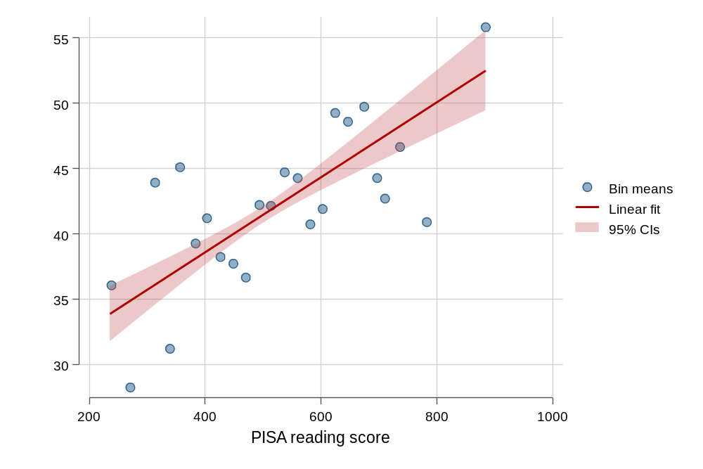
Source: TREE (2025a), authors calculation. (PISA scores divided into 30 equally spaced bins.)

Figure S2: Scatterplot PISA reading scores – occupational prestige (ISEI)
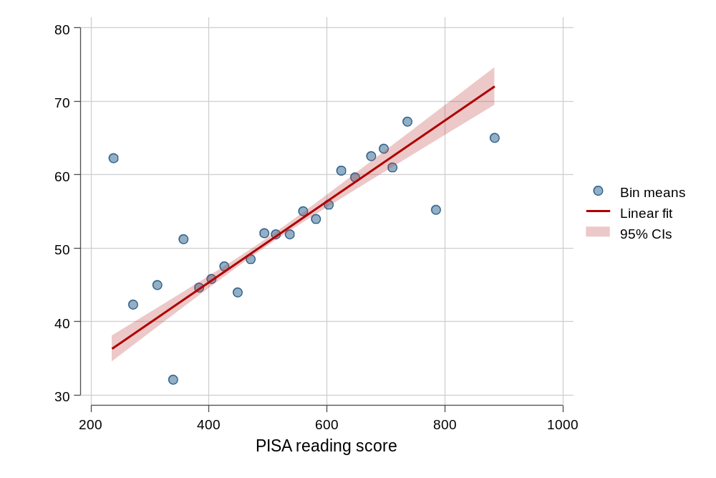
Source: TREE (2025a), authors calculation. (PISA scores divided into 30 equally spaced bins.)

Robustness check: missingness
The survey questionnaire (TREE1, wave 10) consisted of different logical modules and was administered in two parts: 1) the base questionnaire, which served the purpose of updating education and career trajectories, and 2) a complementary questionnaire collecting additional (cross-sectional) information. Around 17% of the wave 10 respondents with valid information on the base questionnaire did not respond to the complementary questionnaire. Unfortunately, the weights do not account for this source of non-response. This issue applies to the dependent variables political interest, health, and positive life attitudes. We evaluated a wide array of variables and identified the following as being significantly related to CQ-non-response: life satisfaction, being married and having children. Table S6 compares the original models predicting political interest, health and positive attitudes towards life with models including these variables. The results do not differ in any substantial way.

Table S6: Models including variables related to additional non-response
 | Health |  | Political interest |  | Positive life attitudes
 | M11 |  | M13 |  | M17
PISA reading score ^{a)} | -0.027 (0.036) | -0.008 (0.035) | 0.064* (0.029) | 0.064* (0.029) | -0.020 (0.030) | 0.012 (0.028)
Tertiary degree | -0.108 (0.085) | -0.094 (0.070) | 0.172** (0.042) | 0.178** (0.042) | 0.050 (0.055) | 0.061 (0.039)
(self-)employed) | -0.091 (0.113) | -0.122 (0.087) | -0.033 (0.083) | -0.031 (0.082) | 0.026 (0.132) | -0.027 (0.080)
Migration status, ref.: no
2nd generation | -0.315** (0.085) | -0.242** (0.077) | -0.066 (0.079) | -0.073 (0.078) | -0.165* (0.077) | -0.153 (0.068)
1st generation | 0.073 (0.107) | 0.060 (0.087) | -0.004 (0.074) | -0.000 (0.072) | 0.165 (0.094) | 0.129 (0.077)
Gender: male | -0.035 (0.065) | -0.058 (0.056) | 0.228** (0.039) | 0.224** (0.039) | -0.047 (0.046) | -0.049 (0.038)
Parental HISEI | 0.001 (0.002) | 0.003 (0.002) | 0.002 (0.001) | 0.002 (0.001) | -0.002 (0.002) | 0.002 (0.001)
Language region, ref.: German
French | -0.080 (0.051) | -0.021 (0.046) | -0.136** (0.045) | -0.142** (0.045) | -0.208** (0.056) | -0.145** (0.045)
Italian | -0.069 (0.088) | -0.101 (0.077) | -0.059 (0.051) | -0.063 (0.051) | -0.140* (0.070) | 0.024 (0.051)
Lower-secondary school track, ref.: highest track
medium track | -0.046 (0.076) | -0.024 (0.068) | -0.028 (0.042) | -0.027 (0.042) | 0.022 (0.059) | 0.060 (0.044)
lowest track | -0.070 (0.112) | -0.026 (0.108) | 0.082 (0.064) | 0.080 (0.064) | 0.058 (0.073) | 0.115* (0.056)
Life satisfaction |  | 0.272** (0.025) |  | -0.002 (0.018) |  | 0.359** (0.020)
Children |  | -0.072 (0.096) |  | 0.048 (0.048) |  | 0.065 (0.047)
Marital status, ref.: single
Married |  | -0.110 (0.099) |  | -0.062 (0.047) |  | 0.044 (0.044)
divorced |  | 0.106 (0.134) |  | -0.059 (0.094) |  | 0.104 (0.083)
Widowed |  | -0.400* (0.170) |  | -0.097 (0.206) |  | -0.086 (0.270)
Intercept | 4.296** (0.141) | 2.102** (0.216) | 0.453** (0.084) | 0.481** (0.158) | 5.001** (0.136) | 1.911 (0.163)
R-squared | 0.03 | 0.18 | 0.13 | 0.14. | 0.04 | 0.39
Number of observations | 2379 | 2375 | 2352 | 2348 | 2385 | 2381

Source: TREE (2025a), authors calculation.
Ordinary least squares models, ** p < 0.01, * p < 0.05; standard errors in parentheses; weighted results.
^{a)} PISA scores are divided by 100 so that coefficients refer to a 100-point-increase in PISA scores. PISA scores and parental HISEI are mean-centered.

Robustness check: plausible values
In the main article, we use test scores based on Warm’s Weighted Likelihood Estimator (WLE) that is provided for each domain in the PISA 2000 dataset, together with five plausible values (PV) (Adams and Wu 2002, p. 106). PISA scores are scaled to an (international) mean of 500 and a standard deviation of 100. As a robustness check, we compare the WLE results with the ones based on PVs. PVs are random numbers drawn from the distribution of scores that could be reasonably assigned to each individual and which are derived from the student’s answer to the test as well as the background questions using imputation methods. We use OECD suggested estimation methodology (running separate models for each plausible value and using Rubin’s combination method). To this end, we use the Stata package “pv” and the sampling design information and (longitudinal) weights provided by TREE. The following tables show that the results do not differ in any substantial way.

Table S7: PISA reading score and obtaining a tertiary degree – plausible values
 | Model 1 | Model 2
PISA reading score ^{a)} | 0.223** (0.022) | 0.161** (0.028)
Lower-secondary school track |  | x
Controls | x | x
Intercept | 0.385** (0.025) | 0.553** (0.040)
R-squared | 0.22 | 0.25
Number of observations | 2887 | 2887

Table S8: PISA reading score and labor market outcomes – plausible values
 | (Self-)employed |  | Log hourly income |  | ISEI
 | M4 | M5 | M6 | M7 | M8 | M9
PISA reading score ^{a)} | 0.006 (0.019) | 0.004 (0.020) | 0.076* (0.033) | 0.017 (0.034) | 3.152** (0.820) | 1.736* (0.810)
Tertiary degree |  | x |  | x |  | x
Controls | x | x | x | x | x | x
Intercept | 0.899** (0.021) | 0.891** (0.024) | 3.530** (0.060) | 3.347** (0.068) | 51.627** (1.363) | 46.844** (1.468)
R-squared | 0.03 | 0.03 | 0.10 | 0.16 | 0.23 | 0.29
Number of observations | 2887 | 2887 | 2466 | 2466 | 2685 | 2685

Table S9: PISA reading score and health and political interest – plausible values
 | Health |  | Political interest
 | M10 | M11 | M12 | M13
PISA reading score ^{a)} | -0.058 (0.047) | -0.042 (0.046) | 0.089** (0.031) | 0.058 (0.032)
Tertiary degree / (self-)employed |  | x |  | x
Controls | x | x | x | x
Intercept | 4.166** (0.063) | 4.308** (0.144) | 0.518** (0.050) | 0.452** (0.084)
R-squared | 0.02 | 0.03 | 0.11 | 0.13
Number of observations | 2379 | 2379 | 2352 | 2352

Table S10: PISA reading score and wellbeing – plausible values
 | Life satisfaction |  | Positive life attitudes
 | M14 | M15 | M16 | M17
PISA reading score ^{a)} | 0.016 (0.089) | 0.008 (0.090) | -0.024 (0.035) | -0.033 (0.036)
Tertiary degree /  (self-)employed | x | x |  | x
Controls | x | x | x | x
Intercept | 8.348** (0.130) | 7.945** (0.438) | 5.064** (0.054) | 5.011** (0.137)
R-squared | 0.02 | 0.03 | 0.04 | 0.04
Number of observations | 2878 | 2878 | 2385 | 2385

Notes apply to all tables displaying plausible values
Source: TREE (2025a), authors calculation.
Linear probability models / Ordinary least squares models, ** p < 0.01, * p < 0.05; standard errors in parentheses; weighted results.
Control variables included in all models: Gender, parental HISEI, migration background, language region, lower-secondary school track.
^{a)} PISA scores (plausible values) are divided by 100 so that coefficients refer to a 100-point-increase in PISA scores. PISA scores and parental HISEI are mean-centered.

PISA mathematics and science scores as independent variables

Table S11: PISA mathematics and science scores and obtaining a tertiary degree
 |  | Mathematics |  |  | Science
 | M1 | M2 | M3 | M1 | M2 | M3
PISA score ^{a)} | 0.181** (0.022) | 0.107** (0.027) | 0.114** (0.022) | 0.150** (0.023) | 0.104** (0.027) | 0.199** (0.031)
Lower-secondary school track, ref.: highest track
medium track |  | -0.235** (0.052) | -0.230** (0.055) |  | -0.139** (0.050) | -0.089 (0.054)
lowest track |  | -0.411** (0.061) | -0.450** (0.067) |  | -0.269** (0.071) | -0.239** (0.065)
Lower-secondary school track # PISA reading score
medium track |  |  | -0.045 (0.049) |  |  | -0.125* (0.053)
lowest track |  |  | -0.090 (0.063) |  |  | -0.120* (0.051)
Intercept | 0.466* (0.032) | 0.674** (0.039) | 0.665** (0.047) | 0.420** (0.032) | 0.561** (0.050) | 0.510** (0.087)
R-squared | 0.21 | 0.27 | 0.28 | 0.22 | 0.25 | 0.26
Number of observations | 1635 | 1635 | 1635 | 1577 | 1577 | 1577

Table S12: PISA mathematics and science scores and being (self-)employed
 | Mathematics |  | Science
 | M4 | M5 | M4 | M5
PISA score ^{a)} | 0.012 (0.024) | 0.013 (0.025) | -0.023 (0.015) | -0.027 (0.016)
Tertiary degree |  | -0.012 (0.024) |  | 0.031 (0.022)
Intercept | 0.901** (0.025) | 0.908** (0.030) | 0.899** (0.021) | 0.882** (0.029)
R-squared | 0.05 | 0.05 | 0.09 | 0.10
Number of observations | 1635 | 1635 | 1577 | 1577

Table S13: PISA mathematics and science scores and hourly income (log)
 | Mathematics |  | Science
 | M6 | M7 | M6 | M7
PISA score ^{a)} | 0.133** (0.033) | 0.097 (0.033) | 0.044 (0.033) | 0.002 (0.031)
Tertiary degree |  | 0.303** (0.067) |  | 0.363** (0.073)
Intercept | 3.553** (0.063) | 3.356** (0.082) | 3.507** (0.087) | 3.309** (0.096)
R-squared | 0.15 | 0.19 | 0.11 | 0.18
Number of observations | 1401 | 1401 | 1350 | 1350

Table S14: PISA mathematics and science scores and occupational status (ISEI)
 | Mathematics |  | Science
 | M8 | M9 | M8 | M9
PISA score ^{a)} | 2.459** (0.919) | 1.601 (0.899) | 3.037** (0.735) | 1.820* (0.744)
Tertiary degree |  | 7.101** (1.550) |  | 11.692** (1.516)
Intercept | 53.155** (1.808) | 48.414** (2.183) | 50.994** (1.451) | 44.459** (1.404)
R-squared | 0.23 | 0.27 | 0.25 | 0.36
Number of observations | 1520 | 1520 | 1458 | 1458

Table S15: PISA mathematics and science scores and health, political interest
 | Health |  | Political interest
 | Math | Science | Math | Science
 | M11 | M11 | M13 | M13
PISA score ^{a)} | -0.044 (0.054) | -0.017 (0.062) | 0.020 (0.039) | 0.037 (0.034)
Tertiary degree | -0.109 (0.096) | -0.112 (0.122) | 0.168** (0.061) | 0.273** (0.059)
(Self-)employed | -0.216 (0.160) | -0.322* (0.152) | 0.028 (0.086) | -0.089 (0.098)
Intercept | 4.431** (0.199) | 4.487** (0.205) | 0.416 (0.106) | 0.463** (0.111)
R-squared | 0.04 | 0.06 | 0.13 | 0.19
Number of observations | 1344 | 1306 | 1328 | 1290

Table S16: PISA mathematics and science scores and wellbeing
 | Life satisfaction |  | Positive life attitudes
 | Math | Science | Math | Science
 | M15 | M15 | M17 | M17
PISA score ^{a)} | 0.192 (0.159) | 0.005 (0.104) | -0.053 (0.048) | -0.046 (0.050)
Tertiary degree | -0.194 (0.168) | 0.193 (0.152) | 0.045 (0.071) | 0.084 (0.069)
(Self-)employed | 0.807 (0.665) | 0.710 (0.561) | 0.002 (0.187) | -0.073 (0.159)
Intercept | 7.587** (0.689) | 7.690** (0.565) | 5.056** (0.209) | 5.094** (0.176)
R-squared | 0.05 | 0.05 | 0.05 | 0.06
Number of observations | 1629 | 1573 | 1348 | 1306

Notes apply to all tables displaying PISA math and science scores
Source: TREE (2025a), authors calculation.
Linear probability models / Ordinary least squares models, ** p < 0.01, * p < 0.05; standard errors in parentheses; weighted results.
Control variables included in all models: Gender, parental HISEI, migration background, language region, lower-secondary school track.
^{a)} PISA scores are divided by 100 so that coefficients refer to a 100-point-increase in PISA scores. PISA scores and parental HISEI are mean-centered.

Incremental validity of PISA reading scores
We tested the incremental validity of PISA reading scores (i.e., whether they have explanatory power above other predictors) for our dependent variables by estimating a full model with and without PISA scores and comparing the goodness-of-fit of both models. PISA scores have an incremental value when predicting tertiary degree attainment. The explained variance increases significantly by 5 percentage points. Furthermore, the increase in R² is significant when predicting occupational prestige and political interest. However, this increase is very small.

Table S17: Assessment of incremental validity of PISA reading scores (nested regression models predicting life outcomes)
 | F | Block df | Design df | Pr > F | R² | Δ R²
Educational attainment
Full model | 39.09 | 8 | 434 | 0.0000 | 0.1999
+ PISA reading score | 58.24 | 1 | 434 | 0.0000 | 0.2482 | 0.0483
Employment status
Full model | 4.40 | 9 | 434 | 0.0000 | 0.0294
+ PISA reading score | 0.03 | 1 | 434 | 0.8612 | 0.0295 | 0.0001
Income
Full model | 13.91 | 9 | 423 | 0.0000 | 0.1563
+ PISA reading score | 0.51 | 1 | 423 | 0.4742 | 0.1569 | 0.0006
ISEI
Full model | 61.35 | 9 | 427 | 0.0000 | 0.2836
+ PISA reading score | 4.16 | 1 | 427 | 0.0420 | 0.2880 | 0.0043
Health
Full model | 2.34 | 10 | 415 | 0.0109 | 0.0256
+ PISA reading score | 0.53 | 1 | 415 | 0.4655 | 0.0261 | 0.0005
Political interest
Full model | 12.14 | 10 | 412 | 0.0000 | 0.1282
+ PISA reading score | 4.96 | 1 | 412 | 0.0265 | 0.1350 | 0.0067
Life satisfaction
Full model | 0.98 | 10 | 434 | 0.4615 | 0.0266
+ PISA reading score | 0.06 | 1 | 434 | 0.8070 | 0.0267 | 0.0001
Positive life attitudes
Full model | 3.99 | 10 | 415 | 0.0000 | 0.0365
+ PISA reading score | 0.43 | 1 | 415 | 0.5115 | 0.0369 | 0.0003
Source: TREE (2025a), authors calculation.
Full model: gender, parental HISEI, migration background, language region, lower-secondary school track, tertiary degree (in models predicting labor market outcomes, health, political interest, life satisfaction, positive life attitudes), employment status (in models predicting health, political interest, life satisfaction, positive life attitudes)
The second model add PISA reading scores.

Predictive validity of PISA reading scores at age 25 and 30

One important question is whether the association between PISA reading scores and the different life outcomes varies over the life course. For most outcome variables (with the exemption of life satisfaction), we have comparable measures for waves 8, 9, and 10 which cover an age range of 10 years (25 to 35). However, for labor market outcomes, earlier measurements might be problematic because quite a few respondents – especially those aiming for a tertiary degree – are still in education (28% at age 25, 8% at age 30) or at a very early stage in their careers.
Table S18 shows models across respondents’ age. Age 35 models are the same as in the main article. In the models referring to age 25 and age 30, we additionally control for whether respondents are still in education. While there are no substantial differences across models for occupational prestige, health, and positive life attitudes, we find some interesting patterns regarding the other outcomes: The association between reading literacy and tertiary degree attainment seems to increase gradually between age 25 and age 35. Reading literacy even has a negative impact on employment at age 25 which is probably caused by the fact that some respondents are still in education. The somewhat surprising positive association at age 30 might indicate that people with higher reading skills experience smoother labor market transition. The association between reading skills and income is, unsurprisingly, not observable at age 25, when many highly skilled students are still in education.
Finally, the association between reading literacy and political interest at age 35 is not observable in earlier waves. These are first explorative analyses and interpretations that should be examined in more detail in future research.

Table S18: Predictive validity of PISA reading scores at age 25 and 30
 | Models with controls |  |  | Models with controls and mediators
 | Age 25 | Age 30 | Age 35 | Age 25 | Age 30 | Age 35
Tertiary degree
PISA reading score | 0.190** (0.017) | 0.207** (0.020) | 0.226** (0.017) | 0.136** (0.020) | 0.160** (0.023) | 0.167** (0.022)
Lower sec. track |  |  |  | x | x | x
Controls | x | x | x | x | x | x
Employment status
PISA reading score | -0.054** (0.016) | 0.041* (0.016) | 0.006 (0.020) | -0.054** (0.017) | 0.034* (0.015) | 0.004 (0.020)
Tertiary degree |  |  |  | x | x | x
Controls | x | x | x | x | x | x
Hourly income
PISA reading score | 0.013 (0.000) | 0.060** (0.018) | 0.085** (0.033) | -0.008 (0.000) | 0.053** (0.018) | 0.025 (0.035)
Tertiary degree |  |  |  | x | x | x
Controls | x | x | x | x | x | x
ISEI
PISA reading score | 3.648** (0.808) | 4.167** (0.762) | 3.059** (0.745) | 2.634** (0.821) | 2.937** (0.760) | 1.581* (0.775)
Tertiary degree |  |  |  | x | x | x
Controls | x | x | x | x | x | x
Health
PISA reading score | 0.006 (0.047) | -0.008 (0.048) | -0.045 (0.037) | -0.012 (0.046) | -0.012 (0.043) | -0.027 (0.036)
Lower sec. track |  |  |  | x | x | x
Controls | x | x | x | x | x | x
Political interest
PISA reading score | 0.048 (0.028) | 0.052 (0.031) | 0.097** (0.029) | 0.020 (0.027) | 0.028 (0.031) | 0.064* (0.029)
Tertiary degree/ employment |  |  |  | x | x | x
Controls | x | x | x | x | x | x
Positive life attitudes
PISA reading score | -0.031 (0.043) | 0.039 (0.049) | -0.011 (0.030) | -0.051 (0.042) | 0.025 (0.051) | -0.020 (0.030)
Tertiary degree/ employment |  |  |  | x | x | x
Controls | x | x | x | x | x | x

Source: TREE (2025a), authors calculation.
Linear probability models / Ordinary least squares models, ** p < 0.01, * p < 0.05; standard errors in parentheses; valid cases and weights from respective wave (age 25=t8, age 30=t9, age 35=t10)
Control variables included in all models: Gender, parental HISEI, migration background, language region, lower-secondary school track. T8 and t9 models additionally include a variable on whether respondents are still in full-time education.
PISA scores are divided by 100 so that coefficients refer to a 100-point-increase in PISA scores.

Adams, R., & Wu, M. (2002). PISA 2000 technical report. Paris: OECD Publishing.

