Table S1. A slice from the real aligned Chr 22 WGS data set

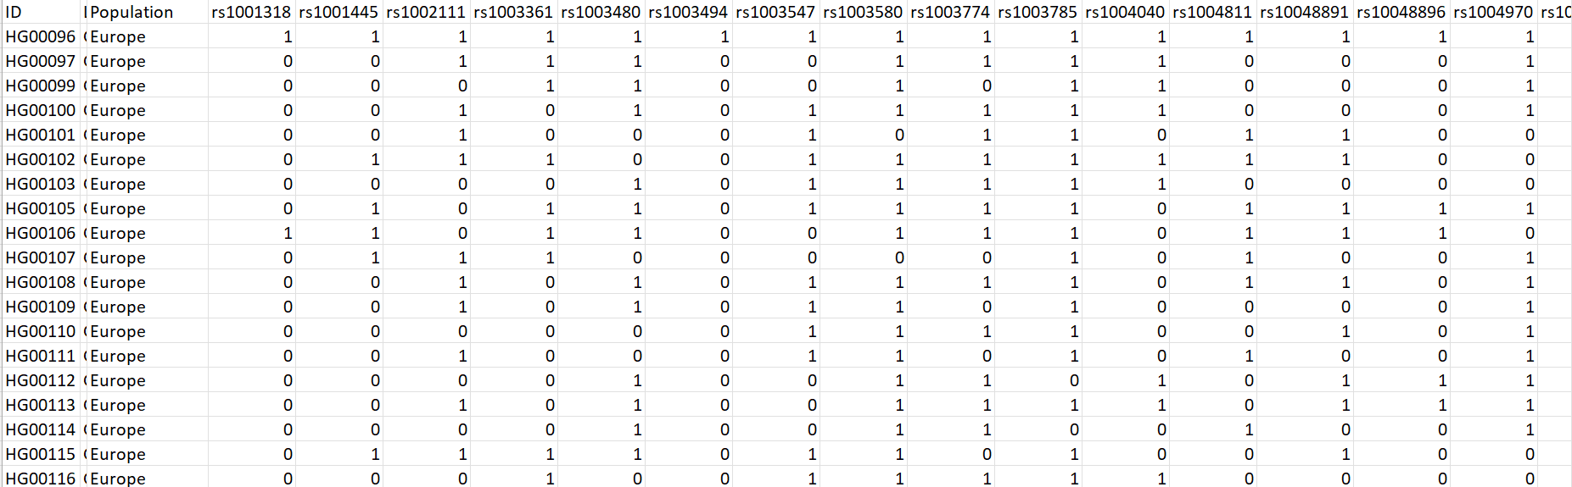

Table S2. Performance comparison of Deep Learning algorithm on ART Simulation data set
Epoch | LR=0.01-ART Simulation Data |  |  |  |  |  |  |  |  |  | LR=0.001-ART Simulation Data
Epoch |  |  | Accuracy | AUC |  | Recall | Precision |  |  | F-Score | Accuracy | AUC |  | Recall | Precision |  | F-Score
500 | Mean |  | 0.6319 | 0.6446 |  | 0.6332 | 0.6128 |  |  | 0.6184 | 0.6922 | 0.7143 |  | 0.7112 | 0.6899 |  | 0.7012
500 | Median |  | 0.6320 | 0.6440 |  | 0.6330 | 0.6130 |  |  | 0.6180 | 0.6920 | 0.7140 |  | 0.7120 | 0.6900 |  | 0.7020
500 | Std Dev |  | 0.0065 | 0.0075 |  | 0.0060 | 0.0059 |  |  | 0.0038 | 0.0168 | 0.0163 |  | 0.0084 | 0.0053 |  | 0.0066
500 | Min |  | 0.6210 | 0.6320 |  | 0.6230 | 0.6030 |  |  | 0.6120 | 0.6640 | 0.6870 |  | 0.6960 | 0.6810 |  | 0.6900
500 | Max |  | 0.6430 | 0.6580 |  | 0.6440 | 0.6230 |  |  | 0.6250 | 0.7210 | 0.7420 |  | 0.7250 | 0.6990 |  | 0.7120
1000 | Mean |  | 0.6804 | 0.6939 |  | 0.6890 | 0.6616 |  |  | 0.6786 | 0.7214 | 0.7439 |  | 0.7272 | 0.7082 |  | 0.7144
1000 | Median |  | 0.6800 | 0.6940 |  | 0.6890 | 0.6610 |  |  | 0.6790 | 0.7220 | 0.7440 |  | 0.7270 | 0.7080 |  | 0.7150
1000 | Std. Dev |  | 0.0090 | 0.0076 |  | 0.0024 | 0.0112 |  |  | 0.0118 | 0.0182 | 0.0173 |  | 0.0125 | 0.0136 |  | 0.0095
1000 | Min |  | 0.6650 | 0.6810 |  | 0.6850 | 0.6430 |  |  | 0.6590 | 0.6910 | 0.7150 |  | 0.7060 | 0.6850 |  | 0.6980
1000 | Max |  | 0.6960 | 0.7070 |  | 0.6930 | 0.6810 |  |  | 0.6990 | 0.7530 | 0.7740 |  | 0.7480 | 0.7320 |  | 0.7310
2000 | Mean |  | 0.7333 | 0.7316 |  | 0.7285 | 0.7403 |  |  | 0.7314 | 0.8014 | 0.8067 |  | 0.7846 | 0.7946 |  | 0.7866
2000 | Median |  | 0.7340 | 0.7320 |  | 0.7290 | 0.7410 |  |  | 0.7320 | 0.8020 | 0.8060 |  | 0.7840 | 0.7940 |  | 0.7860
2000 | Std Dev |  | 0.0167 | 0.0129 |  | 0.0153 | 0.0206 |  |  | 0.0170 | 0.0386 | 0.0455 |  | 0.0468 | 0.0468 |  | 0.0468
2000 | Min |  | 0.7060 | 0.7100 |  | 0.7030 | 0.7060 |  |  | 0.7030 | 0.7360 | 0.7280 |  | 0.7040 | 0.7140 |  | 0.7060
2000 | Max |  | 0.7630 | 0.7540 |  | 0.7550 | 0.7760 |  |  | 0.7610 | 0.8690 | 0.8840 |  | 0.8650 | 0.8750 |  | 0.8670

Table S3. Performance comparison of Deep Learning algorithm on Chr 22 WGS data set
Epoch | LR=0.01 Chr 22 |  |  |  |  |  | LR=0.001 Chr 22
Epoch |  | Accuracy | AUC | Recall | Precision | F-Score | Accuracy | AUC | Recall | Precision | F-Score
500 | Mean | 0.5289 | 0.5333 | 0.5299 | 0.5086 | 0.5170 | 0.5508 | 0.5553 | 0.5486 | 0.5313 | 0.5360
500 | Median | 0.5290 | 0.5330 | 0.5300 | 0.5090 | 0.5170 | 0.5510 | 0.5550 | 0.5490 | 0.5310 | 0.5360
500 | Std Dev | 0.0106 | 0.0115 | 0.0040 | 0.0033 | 0.0035 | 0.0074 | 0.0077 | 0.0104 | 0.0060 | 0.0007
500 | Min | 0.5110 | 0.5140 | 0.5230 | 0.5029 | 0.5110 | 0.5380 | 0.5420 | 0.5310 | 0.5210 | 0.5350
500 | Max | 0.5470 | 0.5540 | 0.5370 | 0.5140 | 0.5230 | 0.5640 | 0.5690 | 0.5670 | 0.5420 | 0.5370
1000 | Mean | 0.5421 | 0.5559 | 0.5437 | 0.5638 | 0.5519 | 0.5841 | 0.5731 | 0.5647 | 0.5772 | 0.5764
1000 | Median | 0.5420 | 0.5560 | 0.5440 | 0.5640 | 0.5520 | 0.5830 | 0.5730 | 0.5650 | 0.5770 | 0.5760
1000 | Std Dev | 0.0059 | 0.0077 | 0.0073 | 0.0106 | 0.0067 | 0.0079 | 0.0084 | 0.0108 | 0.0129 | 0.0137
1000 | Min | 0.5320 | 0.5430 | 0.5310 | 0.5460 | 0.5400 | 0.5710 | 0.5580 | 0.5460 | 0.5550 | 0.5530
1000 | Max | 0.5520 | 0.5690 | 0.5560 | 0.5820 | 0.5640 | 0.5980 | 0.5880 | 0.5830 | 0.5990 | 0.6000
2000 | Mean | 0.5820 | 0.5664 | 0.5668 | 0.5761 | 0.5713 | 0.6045 | 0.5979 | 0.6096 | 0.6168 | 0.6141
2000 | Median | 0.5820 | 0.5660 | 0.5680 | 0.5750 | 0.5710 | 0.6040 | 0.5980 | 0.6090 | 0.6170 | 0.6140
2000 | Std Dev | 0.0089 | 0.0091 | 0.0126 | 0.0141 | 0.0126 | 0.0044 | 0.0064 | 0.0060 | 0.0177 | 0.0104
2000 | Min | 0.5670 | 0.5510 | 0.5450 | 0.5510 | 0.5500 | 0.5970 | 0.5870 | 0.6000 | 0.5870 | 0.5970
2000 | Max | 0.5980 | 0.5820 | 0.5880 | 0.6010 | 0.5930 | 0.6120 | 0.6090 | 0.6200 | 0.6480 | 0.6320

Figure S1. Comparison of model performances of ART simulation data set

Figure S2. Comparison of model performances of Chr 22 WGS data set

