Appendixes:

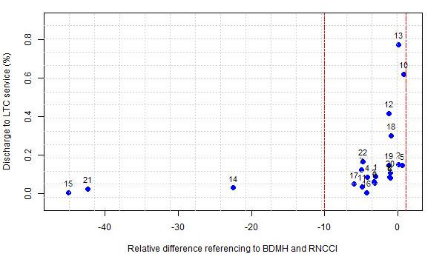
Figure 1. Scatterplot of the public hospitals mainland in Portugal comparing the relative difference of referrals registered in the Gestcare and the LTCD registered in the Hospital Morbidity Database. Hospitals 14,15 and 21 were excluded, once they were not within the cut-off area selected (relative difference of referencing to RNCCI and Hospital Morbidity Database between -10 and 1) in order to select hospitals with good data quality. Hence, the number of hospitals used in this study was 19.

Table 1. The most frequent principal diagnoses in 2012 to 2016 dataset.
Principal Diagnoses | Frequency | %
Cerebrovascular disease (430-438) | 725 | 21,0084
Pneumonia and influenza (480-488) | 369 | 10,69255
Other diseases of urinary system (590-599) | 331 | 9,591423
Acute respiratory infections (460-466) | 167 | 4,839177
Supplementary classification of factors influencing health status and contact with health services (v01-v89) | 156 | 4,520429
Fractures (800-829) | 135 | 3,91191
Other diseases of digestive system (570-579) | 87 | 2,521008
Malignant neoplasm of digestive organs and peritoneum (150-159) | 86 | 2,492031
Complications of surgical and medical care, not elsewhere classified (996-999) | 80 | 2,318169
Other forms of heart disease (420-429) | 77 | 2,231237
Pneumoconioses and other lung diseases due to external agents (500-508) | 73 | 2,115329
Other metabolic and immunity disorders (270-279) | 60 | 1,738626
Diseases of arteries, arterioles, and capillaries (440-449) | 52 | 1,50681
Chronic obstructive pulmonary disease and allied conditions (490-496) | 52 | 1,50681
Malignant neoplasm of other and unspecified sites (190-199) | 52 | 1,50681
Diseases of other endocrine glands (249-259) | 51 | 1,477833
Other diseases of respiratory system (510-519) | 48 | 1,390901
Other diagnoses with less frequency | 850 | 24,63054

Table 2. The most frequent principal diagnoses in 2017 dataset.
Principal diagnoses | Frequency | %
Cerebrovascular diseases I60-I69 | 208 | 21,31148
Influenza and pneumonia J09-J18 | 112 | 11,47541
Other diseases of the urinary system N30-N39 | 67 | 6,864754
Other bacterial diseases A30-A49 | 51 | 5,22541
Injuries to the hip and thigh S70-S79 | 48 | 4,918033
Factors influencing health status and contact with health services (Z00-Z99) | 44 | 4,508197
Other acute lower respiratory infections J20-J22 | 39 | 3,995902
Osteoarthritis M15-M19 | 21 | 2,151639
Lung diseases due to external agents J60-J70 | 19 | 1,946721
Other forms of heart disease I30-I52 | 18 | 1,844262
Injuries to the head S00-S09 | 18 | 1,844262
Chronic lower respiratory diseases J40-J47 | 17 | 1,741803
Complications of surgical and medical care, not elsewhere classified T80-T88 | 14 | 1,434426
Other diagnoses with less frequency | 300 | 30,7377

Table 3. Distribution of comorbidities for both datasets.
Dataset | 2012 to 2016 |  |  | 2017
Comorbidity | No | Yes | % of Yes | No | Yes | % of Yes
HTN | 1931 | 1520 | 44,0452 | 439 | 537 | 55,02049
Arrhythmia | 2415 | 1036 | 30,02028 | 699 | 277 | 28,38115
FluidsLytes | 2594 | 857 | 24,83338 | 696 | 280 | 28,68852
DM | 2674 | 777 | 22,51521 | 784 | 192 | 19,67213
NeuroOther | 2757 | 694 | 20,11011 | 805 | 171 | 17,52049
Paralysis | 2865 | 586 | 16,98059 | 815 | 161 | 16,4959
CHF | 2886 | 565 | 16,37207 | 813 | 163 | 16,70082
Anemia | 2909 | 542 | 15,70559 | 910 | 66 | 6,762295
Renal | 3019 | 432 | 12,51811 | 857 | 119 | 12,19262
Tumor | 3116 | 335 | 9,707331 | 942 | 34 | 3,483607
Alcohol | 3169 | 282 | 8,171544 | 873 | 103 | 10,55328
Pulmonary | 3205 | 246 | 7,128369 | 880 | 96 | 9,836066
Obesity | 3205 | 246 | 7,128369 | 908 | 68 | 6,967213
Depression | 3211 | 240 | 6,954506 | 908 | 68 | 6,967213
Mets | 3250 | 201 | 5,824399 | 945 | 31 | 3,17623
Valvular | 3241 | 210 | 6,085193 | 932 | 44 | 4,508197
Hypothyroid | 3289 | 162 | 4,694292 | 928 | 48 | 4,918033
DMcx | 3304 | 147 | 4,259635 | 895 | 81 | 8,29918
PVD | 3306 | 145 | 4,201681 | 958 | 18 | 1,844262
Liver | 3335 | 116 | 3,361345 | 931 | 45 | 4,610656
Coagulopathy | 3347 | 104 | 3,013619 | 936 | 40 | 4,098361
Psychoses | 3373 | 78 | 2,260214 | 966 | 10 | 1,02459
PHTN | 3407 | 44 | 1,274993 | 959 | 17 | 1,741803
WeightLoss | 3409 | 42 | 1,217039 | 925 | 51 | 5,22541
Rheumatic | 3411 | 40 | 1,159084 | 962 | 14 | 1,434426
PUD | 3410 | 41 | 1,188061 | 976 | 0 | 0,000000
Drugs | 3418 | 33 | 0,956245 | 968 | 8 | 0,819672
BloodLoss | 3421 | 30 | 0,869313 | 969 | 7 | 0,717213
Lymphoma | 3429 | 22 | 0,637496 | 967 | 9 | 0,922131
HIV | 3451 | 0 | 100 | 972 | 4 | 0,409836

Table 4. Distribution of the sociodemographic and clinical characteristics of all episodes between 2012 and 2017 with all destinations after discharge within the hospitals selected in this study.
2012-2017
 | N | %
Age (years)  <18  18-49  50-64  65-79  >80 | 291429  475883  322299  479037  387856 | 14.8954  24.3231  16.4732  24.4843  19.8239
Sex  Male | 892204 | 45.6
Destination after discharge (DSP)  For home  To another institution  Home service  Departure against medical opinion  Specialized aftercare  Deceased  Palliative-care  Post-Hospital Care  Long-term hospital care | 1734170  62241  3971  15184  10392  120384  2300  3716  4146 | 88.64  3.18  0.20  0.78  0.53  6.15  0.12  0.19  0.21
Mode of admission  Programmed  Urgent  Access  PECLEC*  Private Medicine  SIGIC*  PACO*  External SIGIC | 515792  1417077  6  7  2  23391  76  153 | 26.3629  72.4290  0.0003  0.0003  0.0001  1.1955  0.0039  0.0078
ICD Version  ICD-9-CM  ICD-10-CM | 1627495  329009 | 83.18  16.82
Total | 1956504 | 100
*PECLEC - Programa Especial de Recuperação das Listas de Espera (Special Program for Recovery of Waiting Lists)
*SIGIC - Sistema Integrado de Gestão de Inscritos para Cirurgia (Integrated Surgery Enrollment Management System)
*PACO - Plano de Acesso à Cirurgia Oftalmológica (Access Plan for Ophthalmologic Surgery)

Table 5. The most frequent groups of principal diagnoses in all episodes between 2012 to 2017 with all destinations after discharge.
Principal diagnoses | Frequency | %
Liveborn Infants According To Type Of Birth | 132881 | 6.79
Pneumonia And Influenza | 86354 | 4.41
Other Forms Of Heart Disease | 75925 | 3.88
Other Diseases Of Digestive System | 74644 | 3.82
Other Diseases Of Urinary System | 68763 | 3.51
Normal Delivery, And Other Indications For Care In Pregnancy, Labor, And Delivery | 67217 | 3.44
Cerebrovascular Disease | 62421 | 3.19
Ischemic Heart Disease | 49820 | 2.55
Fracture Of Lower Limb | 41807 | 2.14
Complications Mainly Related To Pregnancy | 39323 | 2.01
Other diagnoses with less frequency | 1257349 | 64.18

Table 6. Distribution of comorbidities for all episodes between 2012 to 2017 with all destinations after discharge.
Dataset | 2012 to 2017
Comorbidity | No | Yes | % of Yes
Hypertension | 15053 | 5481 | 26.6923
Arrhythmia | 16276 | 4258 | 20.7363
Pulmonary | 16883 | 3651 | 17.7802
Fluid and Electrolyte Disorders | 16929 | 3605 | 17.5562
Anemia | 16937 | 3597 | 17.5172
Obesity | 16959 | 3575 | 17.4101
Depression | 17029 | 3505 | 17.0692
Other Neurological Disorders | 17419 | 3115 | 15.1699
Alcohol | 17541 | 2993 | 14.5758
Renal Failure | 17596 | 2938 | 14.3079
Congestive Heart Failure | 17610 | 2924 | 14.2398
Hypothyroid | 17794 | 2740 | 13.3437
Diabetes Mellitus without complications | 17966 | 2568 | 12.5060
Liver | 18073 | 2461 | 11.9850
Coagulopathy | 18132 | 2402 | 11.6976
Valvular | 18152 | 2382 | 11.6002
Metabolic equivalents | 18558 | 1976 | 9.6230
Paralysis | 18569 | 1965 | 9.5694
Peripheral Vascular Disease | 18682 | 1852 | 9.0191
Psychoses | 18697 | 1837 | 8.9461
Diabetes Mellitus with complications | 18726 | 1808 | 8.8049
Rheumatic | 18741 | 1793 | 8.7318
Tumor | 18777 | 1757 | 8.5565
Drugs | 18791 | 1743 | 8.4883
Peptic Ulcer Disease | 18887 | 1647 | 8.0208
Lymphoma | 19178 | 1356 | 6.6036
Pulmonary Circulation Disorders | 19301 | 1233 | 6.0046
Blood Loss | 19405 | 1129 | 5.4981
Weight Loss | 19536 | 998 | 4.8602
HIV | 19657 | 877 | 4.2709

Table 7. Agglomerative and divisive coefficients for each method and dataset.
Dataset and method used to categorize principal diagnoses | Agglomerative coefficient |  |  |  | Divisive coefficient
Dataset and method used to categorize principal diagnoses | Average method | Single method | Complete method | Ward method | Divisive coefficient
2012-2016 – ICD9 main categories | 0.8793485 | 0.6269965 | 0.9334271 | 0.9963879 | 0.9262584
2012-2016 – ICD9 more detailed categories | 0.9751590 | 0.6298867 | 0.9857664 | 0.9993890 | 0.9846602
2012-2016 – CCS single-level | 0.9879172 | 0.6051584 | 0.9920862 | 0.9997013 | 0.9915158
2012-2016 – CCS level 2 | 0.9780681 | 0.6320581 | 0.9871715 | 0.9994120 | 0.9862014
2017 – ICD10 main categories | 0.8471768 | 0.5931157 | 0.9234376 | 0.9921535 | 0.9184817
2017 – ICD10 more detailed categories | 0.9694235 | 0.5654623 | 0.9838883 | 0.9980451 | 0.982788
2017 – CCSR | 0.9812057 | 0.5954615 | 0.9881727 | 0.9991313 | 0.9874445
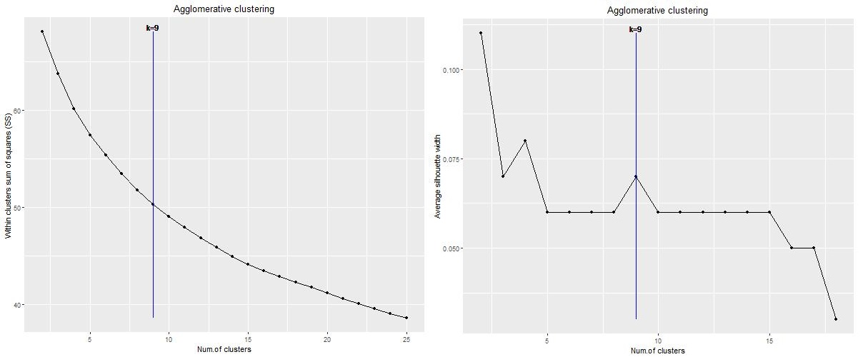
Figure 2. Elbow (on the left) and Silhouette (on the right) plots for 2012-2016 dataset with principal diagnoses categorized with ICD9 main categories and with optimal number of clusters signalled.

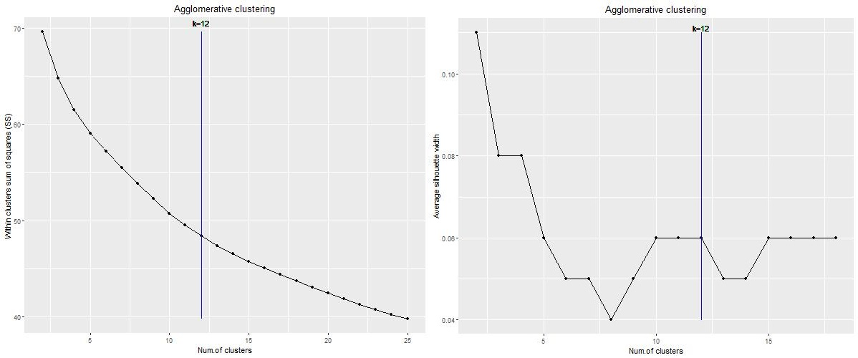
Figure 3. Elbow (on the left) and Silhouette (on the right) plots for 2012-2016 dataset with principal diagnoses categorized with ICD9 more detailed categories and with optimal number of clusters signalled.
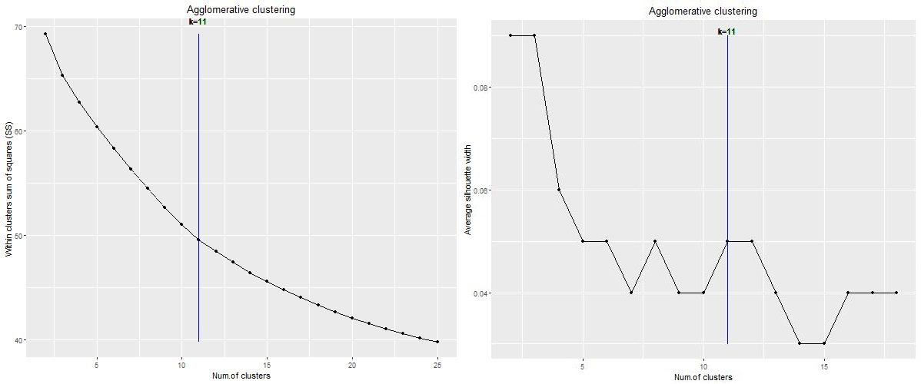
Figure 4. Elbow (on the left) and Silhouette (on the right) plots for 2012-2016 dataset with principal diagnoses categorized with CCS single level and with optimal number of clusters signalled.

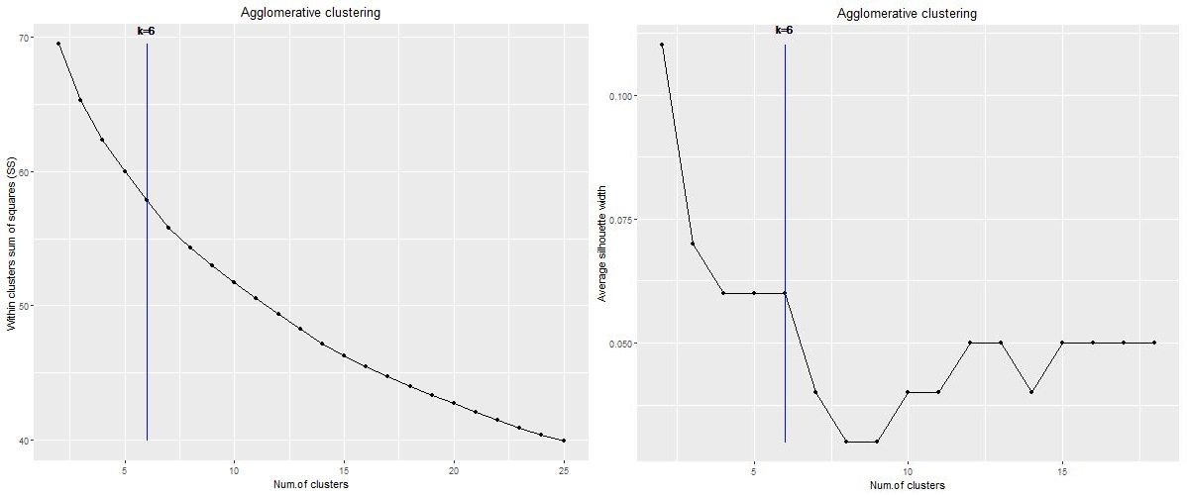
Figure 5. Elbow (on the left) and Silhouette (on the right) plots for 2012-2016 dataset with principal diagnoses categorized with CCS level 2 and with optimal number of clusters signalled.

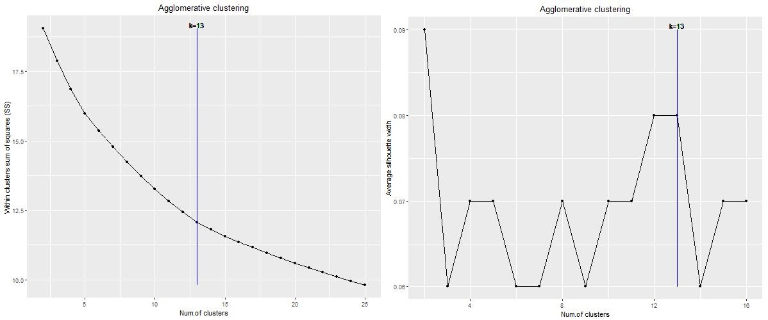
Figure 6. Elbow (on the left) and Silhouette (on the right) plots for 2017 dataset with principal diagnoses categorized with ICD10 main categories and with optimal number of clusters signalled.

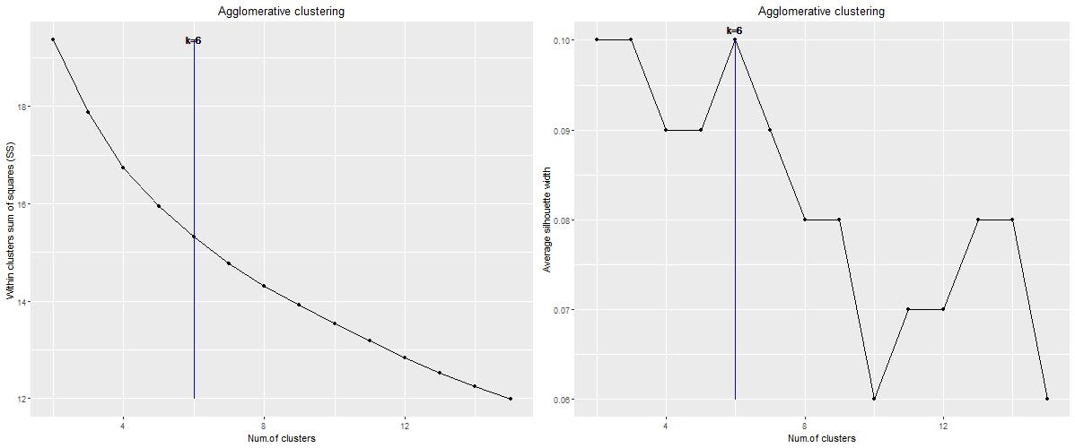
Figure 7. Elbow (on the left) and Silhouette (on the right) plots for 2017 dataset with principal diagnoses categorized with ICD10 more detailed categories and with optimal number of clusters signalled
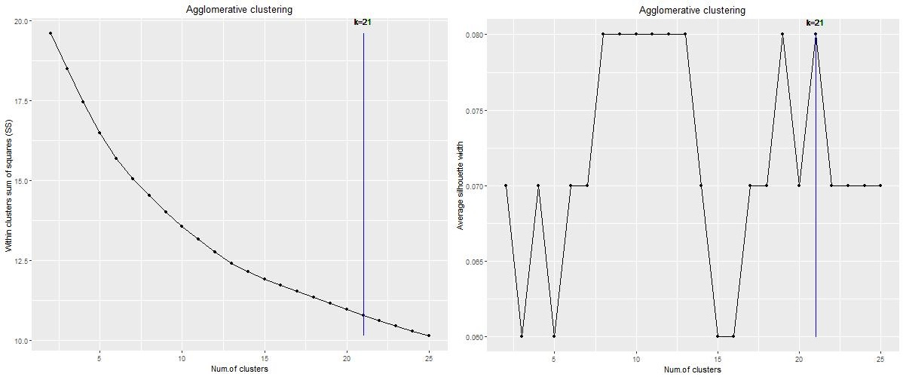
Figure 8. Elbow (on the left) and Silhouette (on the right) plots for 2012-2016 dataset with principal diagnoses categorized with CCSR and with optimal number of clusters signalled.
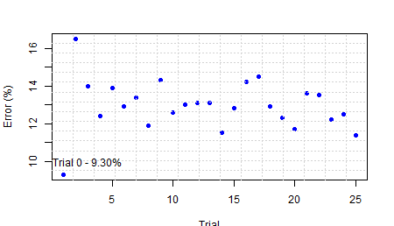
Figure 9. Errors of each trial for the 2012-16 dataset with principal diagnoses categorized with ICD9 main categories and with the trial with less error signalled.
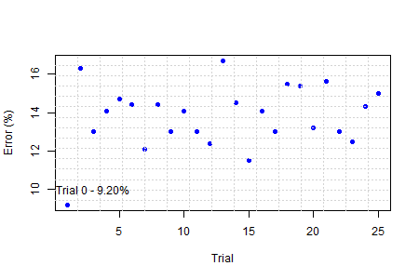
Figure 10. Errors of each trial for the 2012-16 dataset with principal diagnoses categorized with ICD9 more detailed categories and with the trial with less error signalled.
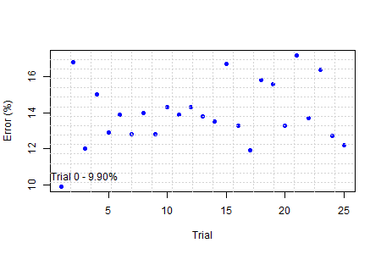
Figure 11. Errors of each trial for the 2012-16 dataset with principal diagnoses categorized with CCS single level and with the trial with less error signalled.
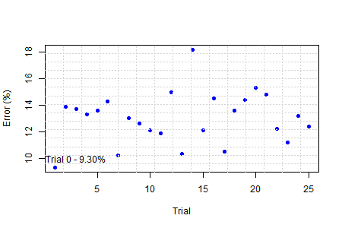
Figure 12. Errors of each trial for the 2012-16 dataset with principal diagnoses categorized with CCS level 2 and with the trial with less error signalled.
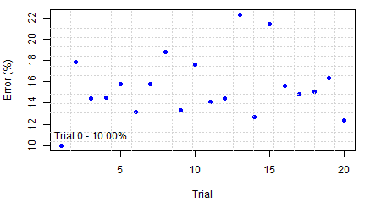
Figure 13. Errors of each trial for the 2017 dataset with principal diagnoses categorized with ICD10 main categories and with the trial with less error signalled.
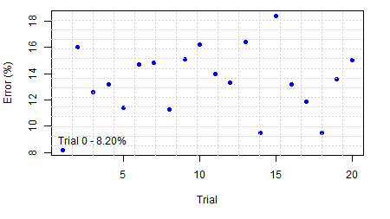
Figure 14. Errors of each trial for the 2017 dataset with principal diagnoses categorized with ICD10 more detailed categories and with the trial with less error signalled.
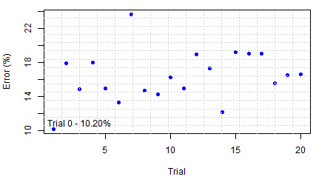
Figure 15. Errors of each trial for the 2017 dataset with principal diagnoses categorized with CCSR and with the trial with less error signalled.

Table 8. Classes for the 2012-2016 dataset with principal diagnoses categorized with ICD9 main groups.
Class | Age | Gender | Admission type | Transfer | Principal Diagnostic | Comorbidities
1 – 328 obs. | Older than 50 | Both | - | - | Diseases of the Genitourinary System; Diseases of the Respiratory System; Neoplasms; Injury and Poisoning; Diseases of the Digestive System; Symptoms signs and ill-defined conditions; Infectious and parasitic diseases | Fluid and Electrolyte Disorders, Pulmonary, Anemia
2 – 454 obs. | Older than 80 | Both | Urgent | No | Diseases of the Circulatory System; Diseases of the Digestive System; Diseases of the Genitourinary System; Diseases of the Nervous System and Sense Organs; Injury and Poisoning; Neoplasms; Injury and Poisoning; Infectious and parasitic diseases | Arrhythmia, Paralysis, Hypothyroid
3 – 139 obs. | Between 18 and 79 | Both | Urgent | - | Diseases of the Circulatory System; Injury and Poisoning; Mental Disorders | Arrhythmia, Alcohol
4 – 415 obs. | Older than 50 | Male | Urgent | - | - | Tumor, Hypothyroid, Peripheral Vascular Disease
5 – 718 obs. | Older than 50 | Both | Urgent and Programmed | Yes | Endocrine Nutritional and Metabolic Diseases and Immunity Disorders; Diseases of the Blood and Blood forming organs; Diseases of the Circulatory System; Injury and Poisoning; Supplementary Classification of Factors Influencing Health Status and Contact with Health Services; Diseases of the Digestive System; Diseases of the Genitourinary System | Renal failure, Diabetes Mellitus with complications, Obesity, Peripheral Vascular Disease
6 – 141 obs. | - | - | - | - | - | Other neurological disorders
7 – 571 obs. | Older than 18 | Female | Programmed | - | Diseases of the Circulatory System; Diseases of the Digestive System; Neoplasms; Injury and Poisoning; Neoplasms; Diseases of the Genitourinary System; Diseases of the Respiratory System; Endocrine Nutritional and Metabolic Diseases and Immunity Disorders | Obesity, Depression
8 – 251 obs. | Older than 18 | Both | - | - | Diseases of the Genitourinary System; Injury and Poisoning; Diseases of the Respiratory System; Diseases of the Nervous System and Sense Organs | Drugs; Other neurological disorders
9 – 434 obs. | Older than 18 | Both | Urgent | - | Diseases of the Circulatory System; Diseases of the Genitourinary System; Diseases of the Respiratory System; Diseases of the Blood and Blood forming organs | Depression, Congestive heart failure, Pulmonary circulation disorders, Arrhythmia

Table 9. Classes for the 2012-2016 dataset with principal diagnoses categorized with ICD9 more detailed categories.
Class | Age | Gender | Admission type | Transfer | Principal Diagnostic | Comorbidities
1 –355 obs. | Older than 18 | Both | - | - | - | Diabetes Mellitus with complications, Peptic ulcer disease, Diabetes Mellitus without complications
2 – 381 obs. | Between 65 and 79 | Female | - | - | - | Other neurological disorders, Arrhythmia, Paralysis, Tumor
3 – 211 obs. | Older than 18 | Both | - | - | Poisoning by drugs medicinal and biological substances | Peripheral vascular disease, Diabetes Mellitus with complications, Renal
4 – 519 obs. | Older than 18 | Both | Programmed and Urgent | - | Dorsopathies; fractures; Human immunodeficiency virus hiv infection; Infections of skin and subcutaneous tissue; Mental retardation; Open wounds; Other and unspecified effects of external causes; Other.diseases of intestines and peritoneum; other diseases of respiratory system; Other diseases of skin and subcutaneous tissue; Other diseases of urinary system; Other disorders of the central nervous system; Other metabolic and immunity disorders; Pneumoconioses and other lung diseases due to external agents; Supplementary classification of factors influencing health status and contact with health services | Liver, Drugs
5 – 243 obs. | - | Both | Programmed and Urgent | No | Cerebrovascular disease; Acute respiratory infections; Fractures; Ischemic heart disease; Other forms of heart disease; Pneumonia and influenza; Poliomyelitis and other non-arthropod borne viral diseases and prion diseases of central nervous system; Supplementary classification of factors influencing health status and contact with health services | Diabetes Mellitus without complications, Alcohol, Other neurological disorders
6 – 169 obs. | Between 18 and 64 and older than 80 | Both | - | - | - | Congestive heart failure, Pulmonary circulation disorders, Valvular, Hypothyroid, Fluid and Electrolyte Disorders
7 – 171 obs. | Older than 65 | Female | - | - | - | Fluid and Electrolyte Disorders, Obesity
8 – 299 obs. | Older than 18 | Both | Urgent | - | - | Tumor, Pulmonary
9 – 536 obs. | Older than 18 | Female | - | Yes | - | Obesity, Depression
10 – 177 obs. | Between 18 and 49 and older than 65 | - | - | - | - | Anemia
11 – 264 obs. | Older than 80 | Both | - | - | - | Arrhythmia, Hypertension, Congestive heart failure, Anemia, Hypothyroid
12 – 126 obs. | - | - | - | - | - | Metabolic equivalents

Table 10. Classes and characteristics for the 2012-2016 dataset with principal diagnoses categorized with CCS single level.
Class | Age | Gender | Admission type | Transfer | Principal Diagnostic | Comorbidities
1 – 501 obs. | Between 18 and 79 | Both | Programmed | - | - | Liver
2 – 315 obs. | - | Male | Urgent | - | Acute cerebrovascular disease; Aspiration pneumonitis; Back problem; Brain injury; Chronic obstructive pulmonary disease; HIV infection, Intestinal obstruction; Intracranial injury; Other aftercare; Other benign neoplasm;, Other hereditary Central Nervous System disease; Other hereditary Central Nervous System infection; Other Central Nervous System disease; Other cerebrovascular disease; Other Gastrointestinal disease; Pathological fracture; Spinal cord injury; Spontaneous abortion; Ulcer skin; Urinary Tract Infection | Paralysis, Other neurological disorders, Alcohol
3 – 252 obs. | Older than 50 | Female | Programmed and Urgent | No | Acute cerebrovascular disease; Congestive heart failure; Encephalitis; Leg fracture; Other nutrition disease; Other liver disease; Septicemia; Urinary Tract Infection | Hypertension, Other neurological disorders
4 – 312 obs. | Older than 18 | Both | - | - | - | Renal, Arrhythmia, Hypothyroid, Peripheral vascular disease, Fluid and Electrolyte Disorders, Diabetes Mellitus with complications, Valvular
5 – 229 obs. | Between 50 and 79 | Both | - | No | Bronchitis; Coronary atherosclerosis; Pneumonia; Septicemia | Other neurological disorders, Tumor
6 – 214 obs. | Older than 18 | Female | - | - | Delirium dementia amnestic other cognitive; Fracture of neck of femur (hip) | Pulmonary circulation disorders, Valvular, Congestive heart failure
7 – 300 obs. | Older than 65 | Female | Urgent | - | - | Arrhythmia, Hypertension, Paralysis, Pulmonary circulation disorders, Obseity, Tumor
8 – 425 obs. | Older than 18 | Male | - | No | - | Tumor, Depression, Arrhythmia, Pulmonary
9 – 418 obs. | - | Female | Urgent | - | - | Depression, Hypertension, Metabolic equivalents
10 – 284 obs. | Older than 18 | Both | - | Yes | - | Diabetes Mellitus without complications, Fluid and Electrolyte Disorders
11 – 201 obs. | Older than 50 | Both | - | - | Gangrene; Other aftercare; Peripheral atherosclerosis; Ulcer skin; Urinary Tract Infection | Congestive heart failure, Anemia, Hypertension

Table 11. Classes and characteristics for the 2012-2016 dataset with principal diagnoses categorized with CCS level 2.
Class | Age | Gender | Admission type | Transfer | Principal Diagnostic | Comorbidities
1 – 962 obs. | Between 18 and 79 | Both | Programmed | - | Delirium, dementia and amnestic and other cognitive disorders; Diabetes mellitus with complications; Other inflammatory condition of skin; Viral infection | Metabolic equivalents, Alcohol, Liver, Pulmonary
2 – 449 obs. | Between 65 and 79 | - | - | No | Cerebrovascular disease | Congestive heart failure, Other neurological disorders, Paralysis, Arrhythmia
3 – 868 obs. | - | Both | Urgent | Yes | Anemia; Chronic obstructive pulmonary disease and bronchiectasis; Diseases of the heart; Respiratory infections | Diabetes Mellitus without complications, Diabetes Mellitus with complications, Depression, Peripheral Vascular Disease, Pulmonary Circulation Disorders, Coagulopathy
4 – 507 obs. | Older than 18 | Both | - | No | Aspiration pneumonitis food vomitus; Cancer of bronchus lung; Cancer of lymphatic and hematopoietic tissue; Cancer other primary; Central nervous system infection; Diabetes mellitus with complications; Diseases of the heart; Hypertension; Intracranial injury; Other lower respiratory disease; Viral infection; Diseases of the urinary system | Fluid and Electrolyte Disorders, Hypothyroid, Pulmonary Circulation Disorders
5 – 263 obs. | Older than 18 | Male | - | No | Aspiration pneumonitis food vomitus; Cerebrovascular disease; Diseases of the urinary system; Epilepsy convulsions; Factors influencing health care; Lower gastrointestinal disorders; Respiratory infections; Bacterial infection; Biliary tract disease; Delirium dementia and amnestic and other cognitive disorders; Diseases of male genital organs; Fluid and electrolyte disorders; Other congenital anomalies; Poisoning; Respiratory failure insufficiency arrest adult; Symptoms signs and ill defined conditions | Other neurological disorders
6 – 402 obs. | Older than 18 | Both | - | No | - | Diabetes Mellitus without complications, Peripheral Vascular Disease

Class | Age | Gender | Admission type | Principal Diagnostic | Comorbidities
1 – 63 obs. | Older than 80 | Male | Programmed and Urgent | Diseases of the Circulatory System; Diseases of the Digestive System; Symptoms, Signs and Abnormal Clinical and Laboratory Findings not elsewhere Classified | Arrhythmia, Diabetes Mellitus, Congestive Heart Failure
2 – 138 obs. | Older than 65 | Female | Urgent | - | Hypertension, Hypothyroid, Diabetes Mellitus with complications, Renal failure
3 – 79 obs. | Older than 50 | Both | Programmed and Urgent | Diseases of the Circulatory System; Diseases of the Nervous System | Arrhythmia, Paralysis, Congestive Heart Failure, Other neurological disorders
4 – 90 obs. | Between 65 and 79 | Female | Programmed and Urgent | Diseases of the Genitourinary System | Arrhythmia, Obesity, Valvular, Hypertension
5 – 87 obs. | Between 65 and 79 | Male | Urgent | - | Diabetes Mellitus
6 – 55 obs. | Between 18 and 64 | Male | Urgent | Certain Infectious and Parasitic Diseases; Endocrine Nutritional and Metabolic Diseases | Liver, Alcohol, Fluid and Electrolyte Disorders, Coagulopathy
7 – 121 obs. | Older than 65 | Male | Urgent | - | Renal failure, Fluid and Electrolyte Disorders
8 – 38 obs. | - | Both | Urgent | - | Other neurological disorders, Fluid and Electrolyte Disorders
9 – 55 obs. | Older than 80 | Both | Urgent | Diseases of the Respiratory System | Pulmonary, Renal failure, Congestive Heart Failure, Tumor
10 – 80 obs. | Between 65 and 79 | Female | - | - | Congestive Heart Failure, Fluid and Electrolyte Disorders, Weight Loss
11 – 51 obs. | - | - | Programmed | - | -
12 – 71 obs. | Between 18 and 79 | Male | Programmed and Urgent | - | Hypertension, Diabetes Mellitus with complications, Paralysis
13 – 48 obs. | Older than 80 | Both | Urgent | - | Arrhythmia, Diabetes Mellitus, Fluid and Electrolyte Disorders, Hypertension, Renal failure, Other neurological disorders
Table 12. Classes and characteristics for the 2017 dataset with principal diagnoses categorized with ICD10 main categories.

Table 13. Classes and characteristics for the 2017 dataset with principal diagnoses categorized with ICD10 more detailed categories.
Class | Age | Gender | Admission type | Principal Diagnostic | Comorbidities
1 – 193 obs. | Older than 50 | Male | Urgent | - | Fluid and Electrolyte Disorders, Diabetes Mellitus without complications, Coagulopathy
2 – 336 obs. | Between 50 and 64 and older than 80 | Both | Programmed | Malignant neoplasms of ill-defined other secondary and unspecified sites; Influenza and pneumonia; Injuries to the thorax; Injuries to the hip and thigh | Congestive heart failure
3 – 130 obs. | - | Female | - | - | Arrhythmia, peripheral vascular disease, Paralysis
4 – 112 obs. | - | Female | Programmed | - | Pulmonary circulation disorders, Valvular
5 – 156 obs. | - | Male | - | - | Anemia, Liver, Alcohol, Drugs
6 – 49 obs. | Between 65 and 79 | Both | - | - | Diabetes Mellitus with complications, Renal, Liver, BloodLoss

Table 14. Classes and characteristics for the 2017 dataset with principal diagnoses categorized with CCSR.
Class | Age | Gender | Admission type | Principal Diagnostic | Comorbidities
1 – 45 obs. | - | Male | - | - | -
2 – 82 obs. | Older than 18 | Female | Urgent | Nutritional anemia; Other aftercare encounter; Other specified and unspecified lower respiratory disease; Pneumonia except that caused by tuberculosis | -
3 – 93 obs. | Older than 80 | Female | Urgent | - | Hypertension
4 – 72 obs. | - | Female | Urgent | Acute hemorrhagic cerebrovascular disease; Cerebral infarction | Hypertension, Other neurological disorders, Paralysis
5 – 34 obs. | Between 50 and 64 and older than 80 | Both | - | - | Arrhythmia, Hypertension, Fluid and Electrolyte Disorders, Other neurological disorders, peripheral vascular disease, Coagulopathy
6 – 73 obs. | Between 50 and 79 | Male | Urgent | - | Diabetes Mellitus without complications, Hypertension, Fluid and Electrolyte Disorders
7 – 40 obs. | Between 50 and 64 | Male | - | - | Hypertension, Alcohol
8 – 89 obs. | Between 65 and 79 | Male | Urgent | Fluid and electrolyte disorders; Gastrointestinal and biliary perforation; Heart failure; Nervous system cancers brain; Other aftercare encounter; Peripheral and visceral vascular disease; Pneumonia except that caused by tuberculosis; Pressure ulcer of skin, Sequela of cerebral infarction and other cerebrovascular disease; Spinal cord injury SCI subsequent encounter | Alcohol, Paralysis,
9 – 52 obs. | Between 18 and 79 | Female | Urgent | - | Other neurological disorders, Fluid and Electrolyte Disorders, WeightLoss
10 – 37 obs. | Older than 50 | Both | - | Cerebral infarction; Pneumonia except that caused by tuberculosis | Renal, Fluid and Electrolyte Disorders, Metabolic equivalents, WeightLoss
11 – 27 obs. | Between 65 and 79 | Female | Urgent | - | Arrhythmia, Pulmonary circulation disorders, Hypertension, Renal, Obesity, Congestive heart failure
12 – 45 obs. | - | Both | Programmed | - | Other neurological disorders, Diabetes Mellitus without complications
13 – 23 obs. | Older than 50 | Both | - | - | Anemia
14 – 55 obs. | Older than 80 | Female | Programmed and Urgent | - | Fluid and Electrolyte Disorders, Valvular
15 – 58 obs. | - | Female | Urgent | - | Arrhythmia
16 – 23 obs. | Between 65 and 79 | Both | Urgent | - | Arrhythmia, Diabetes Mellitus with complications, Congestive heart failure, Renal, Fluid and Electrolyte Disorders, Other neurological disorders
17 – 28 obs. | Between 65 and 79 | Both | Urgent | Aspiration pneumonitis; Cerebral infarction; Urinary tract infections | Arrhythmia, Paralysis, Fluid and Electrolyte Disorders
18 – 43 obs. | Older than 80 | Male | - | - | Renal, Congestive heart failure
19 – 33 obs. | Between 18 and 79 | Male | - | - | Hypertension
20 – 20 obs. | Between 18 and 49 | Male | - | - | Alcohol, Drugs, Coagulopathy
21 – 4 obs. | Between 18 and 49 | - | - | - | Arrhythmia, Pulmonary, Fluid and Electrolyte Disorders, Hypertension

