Supplementary Material for “A bibliometric analysis of the first decade of the Journal of Big Data”

This supplementary material provides extended empirical evidence supporting the findings reported in the main article. Section S1 presents detailed tables on leading authors, institutions, and countries/regions in the Journal of Big Data, including full rankings and citation-based indicators underlying the summary results in the paper. Section S2 reports the bibliographic-coupling statistics for authors, institutions, and countries/regions, offering additional insight into how contributors are interconnected through shared references. Together, these materials are intended to enhance transparency and reproducibility by making the full underlying data and rankings available to readers.
Search string in Scopus:
SRCTITLE ( journal of big data ) AND PUBYEAR < 2025 AND PUBYEAR > 2013 AND ( DOCTYPE ( ar ) OR DOCTYPE ( re ) ) AND ( LIMIT-TO ( EXACTSRCTITLE , "Journal of Big Data" ) ) AND ( LIMIT-TO ( PUBSTAGE , "final" ) )
Search string in Web of Science (WoS):
(((SO=(JOURNAL OF BIG DATA)) AND PY=(2018-2024)) AND DT=(Article OR Review)) NOT DT=(Retracted Publication)
Software used in the graphical analysis:
VOSviewer version 1.6.20 (https://www.vosviewer.com/).
Bibliometrix version 4.1 (https://www.bibliometrix.org/home/).

S1. Leading authors, institutions and countries
The authorship structure of a journal reveals not only its core intellectual contributors but also institutional collaborations and geographic concentrations of expertise. Table S1 presents the most prolific authors in the JBD, offering a detailed account of their total outputs (TP), cumulative citations (TC), h-index, average citation impact (C/P), and representation in high-impact articles (≥100 citations and Top 50 most-cited documents). This disaggregated view highlights the presence of concentrated authorial leadership alongside emerging contributors across multiple regions.

Table S1. Most productive and influential authors in the JBD (2014–2024).
R | Author Name | University | C/R | TP | TC | H | C/P | ≥100 | ≥10 | T50
1 | Khoshgoftaar, T.M. | Florida Atlantic U | USA | 53 | 23,729 | 33 | 447.7 | 18 | 51 | 15
2 | Leevy, J.L. | Florida Atlantic U | USA | 16 | 1,216 | 13 | 76 | 2 | 15 | 1
3 | Hancock, J. | Florida Atlantic U | USA | 14 | 1,687 | 12 | 120.5 | 2 | 13 | 2
4 | Zhan, J. | U Nevada | USA | 11 | 837 | 11 | 76.1 | 1 | 11 | 1
5 | Aslam, M. | King Abdulaziz U | SAU | 10 | 51 | 5 | 5.1 | 0 | 1 | 0
6 | Furht, B. | Florida Atlantic U | USA | 10 | 877 | 9 | 87.7 | 2 | 9 | 2
7 | Douzi, S. | U Hassan II | MAR | 8 | 605 | 7 | 75.6 | 2 | 7 | 0
8 | Villanustre, F. | LexisNexis Bus Inform Solut | USA | 8 | 2,153 | 8 | 269.1 | 1 | 8 | 1
9 | Bauder, R.A. | Florida Atlantic U | USA | 7 | 921 | 7 | 131.6 | 2 | 7 | 1
10 | Chowanda, A. | Bina Nusantara U | IDN | 7 | 225 | 5 | 32.1 | 0 | 4 | 0
11 | Khare, N. | Maulana Azad Natl Inst Tech | IND | 7 | 430 | 6 | 61.4 | 1 | 4 | 1
12 | Kumar, S. | South Ural State U | RUS | 7 | 1,270 | 7 | 181.4 | 2 | 7 | 1
13 | Douzi, K. | U Hassan II | MAR | 6 | 461 | 6 | 76.8 | 2 | 5 | 0
14 | Budiharto, W. | Bina Nusantara U | IDN | 6 | 374 | 5 | 62.3 | 1 | 5 | 0
15 | Wibisono, A. | U Indonesia | IDN | 6 | 77 | 4 | 12.8 | 0 | 3 | 0
16 | Seliya, N. | U Wisconsin-Eau Claire | USA | 5 | 2,759 | 5 | 551.8 | 3 | 5 | 2
17 | Sarker, I.H. | Swinburne U Technology | AUS | 5 | 870 | 5 | 174 | 2 | 5 | 2
18 | Hssina, B. | U Hassan II | MAR | 5 | 427 | 5 | 85.4 | 2 | 4 | 0
19 | Zuech, R. | Florida Atlantic U | USA | 5 | 383 | 4 | 76.6 | 1 | 4 | 1
20 | Nikolov, N.S. | U Limerick | IRL | 5 | 174 | 4 | 34.8 | 1 | 4 | 0
21 | Surendro, K. | Institut Teknologi Bandung | IDN | 5 | 145 | 5 | 29 | 0 | 4 | 0
22 | Suhartono, D. | Bina Nusantara U | IDN | 5 | 135 | 4 | 27 | 0 | 4 | 0
23 | Agarwal, A. | Florida Atlantic U | USA | 5 | 65 | 4 | 13 | 0 | 2 | 0
24 | Asemi, A. | U Malaya | MYS | 5 | 50 | 4 | 10 | 0 | 2 | 0
25 | Ko, A. | Corvinus U Budapest | HUN | 5 | 50 | 4 | 10 | 0 | 2 | 0
26 | Mursanto, P. | U Indonesia | IDN | 5 | 46 | 3 | 9.2 | 0 | 2 | 0
- | 26 authors | - | - | 4 | - | - | - | - | - | -
- | 75 authors | - | - | 3 | - | - | - | - | - | -
Abbreviations: R = Rank; C/R = Country/Region; TP = Total papers; TC = Total citations; H = h-index; C/P = Cites per paper; ≥100, ≥10 = Number of papers with equal or more than 100 and 10 citations; T50 = Number of documents in the Top 50 of Table 3.

At the apex stands Taghi M. Khoshgoftaar of Florida Atlantic University, with a remarkable 53 publications, 23,729 citations, an h-index of 33, and 18 articles exceeding 100 citations, including 15 entries in the Top 50 most cited documents. He leads not only in output but also in high-impact publications. He has a foundational position in JBD’s citation landscape. Five other Florida Atlantic University affiliates create a strong institutional cluster: Leevy, Hancock, Furht, Bauder, and Zuech—appear within the top 20. This signals the emergence of a highly productive research hub with sustained internal collaboration in areas spanning algorithmic fairness, healthcare data, and machine learning pipelines.
Outside the USA, Kumar (South Ural State University, Russia), Sarker (Swinburne University, Australia), and several Indonesian and Moroccan scholars (e.g., Budiharto, Douzi, Hssina) contribute strong regional representation, especially within applied AI and predictive analytics. However, disparities in average impact are evident. For example, Seliya (University of Wisconsin–Eau Claire) has produced only five articles but accumulated 2,759 citations, averaging 551.8 cites per paper, while authors like Aslam and Ko, show lower citation footprints despite comparable productivity. The presence of institutional clusters (e.g., Bina Nusantara University and Hassan II University of Casablanca) points to locally embedded research ecosystems driving domain-specific contributions. Moreover, high C/P values among certain authors suggest the journal’s capacity to attract breakthrough research with global relevance, even when originating from mid-size or non-Western institutions.
Beyond individual contributions, the institutional dimension of scientific productivity reveals the centers of gravity that support, sustain, and amplify scholarly impact. Table S2 presents the most active institutions contributing to the JBD, encompassing TP, TC, h-index, C/P, and high-impact papers. The dataset underscores institutional clustering in certain regions, with a few universities serving as epicenters of both quantity and quality. Florida Atlantic University (USA) is the unequivocal leader, with 67 articles, a cumulative 24,032 citations, h-index of 34, and 18 papers surpassing 100 citations, including 15 within the Top 50 most-cited list. This consolidated performance confirms its role as the journal’s most prominent institutional contributor, aligned with the dominance of its faculty in Table S1. Its average of 358.7 citations per paper places it well ahead of all peers.
A secondary group of productive institutions includes Bina Nusantara University (Indonesia), Hassan II University Casablanca (Morocco), and University of Indonesia, which each published over 15 papers. While these institutions maintain steady productivity, their citation impacts vary widely. For example, Bina Nusantara’s 22 papers received 660 citations (C/P = 30), whereas Hassan II’s 20 papers attracted 805 citations (C/P = 40.2), supported by stronger h-index values. Certain institutions with fewer publications achieved disproportionate impact. Queensland University of Technology (Australia), with only 8 papers, amassed 5,572 citations (C/P = 696.5), driven by a few landmark contributions. Similarly, LexisNexis Business Information Solutions (USA) and South Ural State University (Russia) registered high average citations per paper, 347.3 and 196.8, respectively, suggesting their limited outputs are high-value, possibly representing specialized or collaborative big-data innovations.
Regional patterns also emerge. Moroccan and Indonesian institutions are notably well-represented, pointing to strong national research clusters. Iranian institutions (e.g., Sharif University of Technology, Islamic Azad University branches) also appear frequently, albeit with lower citation averages. This disparity indicates differences in research visibility and impact, despite comparable publication efforts. Institutions from Africa (e.g., Cairo University, Bahir Dar University), the Middle East (e.g., Zayed University, Khalifa University), and Eastern Europe (e.g., University of Belgrade, University of Kragujevac) contribute to the geographic diversity of JBD, although their presence is mostly centered on quantity rather than high-citation influence.

Table S2. Most active institutions publishing in the JBD (2014–2024).
R | Institution | C/R | TP | TC | H | C/P | ≥100 | ≥10 | T50
1 | Florida Atlantic U | USA | 67 | 24,032 | 34 | 358.7 | 18 | 61 | 15
2 | Bina Nusantara U | IDN | 22 | 660 | 11 | 30 | 1 | 13 | 0
3 | Hassan II U Casablanca | MAR | 20 | 805 | 14 | 40.2 | 2 | 16 | 0
4 | U Indonesia | IDN | 17 | 392 | 11 | 23.1 | 0 | 13 | 0
5 | U Belgrade | SRB | 14 | 121 | 8 | 8.6 | 0 | 7 | 0
6 | Higher Inst Appl Sci Tech Syria | SYR | 13 | 1,030 | 11 | 79.2 | 3 | 11 | 1
7 | U Sidi Mohamed Ben Abdellah | MAR | 13 | 512 | 10 | 42.7 | 1 | 10 | 0
8 | King Abdulaziz U | SAU | 13 | 112 | 6 | 8.6 | 0 | 3 | 0
9 | Mohammed V U in Rabat | MAR | 11 | 648 | 8 | 46.3 | 2 | 8 | 0
10 | U Nevada, Las Vegas | USA | 10 | 728 | 11 | 66.2 | 1 | 11 | 1
11 | Sharif U Tech | IRN | 10 | 211 | 6 | 21.1 | 0 | 6 | 0
12 | Islamic Azad U | IRN | 10 | 99 | 6 | 14.1 | 0 | 3 | 0
13 | Zayed U | UAE | 9 | 239 | 7 | 26.6 | 0 | 7 | 0
14 | Islamic Azad U, Mashhad Branch | IRN | 9 | 219 | 6 | 24.3 | 0 | 5 | 0
15 | Koneru Lakshmaiah (Deemed U) | IND | 9 | 146 | 7 | 20.9 | 0 | 5 | 0
16 | Chinese Academy of Sciences | CHN | 9 | 85 | 4 | 10.6 | 0 | 2 | 0
17 | Queensland U Tech | AUS | 8 | 5,572 | 6 | 696.5 | 3 | 5 | 2
18 | King Saud U | SAU | 8 | 199 | 6 | 24.9 | 0 | 5 | 0
19 | Bahir Dar U | ETH | 8 | 197 | 5 | 24.6 | 1 | 4 | 0
20 | U Manchester | ENG | 8 | 88 | 7 | 11 | 0 | 4 | 0
21 | Central South U | CHN | 8 | 69 | 2 | 11.5 | 0 | 1 | 0
22 | Swinburne U Tech | AUS | 7 | 1,196 | 7 | 170.9 | 3 | 7 | 3
23 | Inst Tech Bandung | IDN | 7 | 338 | 9 | 24.1 | 0 | 8 | 0
24 | Islamic Azad U, Sci Res Branch | IRN | 7 | 154 | 6 | 22 | 0 | 4 | 0
25 | Xiangya Hospital Central South U | CHN | 7 | 106 | 4 | 15.1 | 0 | 2 | 0
26 | Cairo U | EGY | 7 | 76 | 4 | 10.9 | 0 | 3 | 0
27 | Maulana Azad Natl Inst Tech | IND | 7 | 31 | 4 | 7.8 | 0 | 1 | 0
28 | LexisNexis Bus Inform Solut | USA | 6 | 2,084 | 6 | 347.3 | 1 | 6 | 1
29 | South Ural State U | RUS | 6 | 1,181 | 6 | 196.8 | 2 | 6 | 1
30 | Norwegian U Sci Tech | NOR | 6 | 453 | 5 | 75.5 | 3 | 4 | 1
31 | Khalifa U Sci Tech | UAE | 6 | 352 | 6 | 50.3 | 1 | 4 | 1
32 | Qatar U | QAT | 6 | 209 | 6 | 34.8 | 1 | 5 | 0
33 | Minia U | EGY | 6 | 184 | 5 | 30.7 | 0 | 5 | 0
34 | Inst Tech Sepuluh Nopember | IDN | 6 | 175 | 5 | 29.2 | 0 | 4 | 0
35 | U Malaya | MYS | 6 | 162 | 4 | 27 | 1 | 2 | 0
36 | Kafrelsheikh U | EGY | 6 | 113 | 4 | 22.6 | 0 | 3 | 0
37 | U California, Irvine | USA | 6 | 97 | 5 | 16.2 | 0 | 4 | 0
38 | U Kragujevac | SRB | 6 | 36 | 3 | 6 | 0 | 2 | 0
- | 20 institutions | - | 5 | - | - | - | - | - | -
- | 38 institutions | - | 4 | - | - | - | - | - | -
Abbreviations are available in Table S1.

While institutions form the structural backbone of scientific productivity, the broader national context provides insights into geopolitical knowledge production and diffusion. Table S3 presents the top 40 countries contributing to the JBD from 2014 to 2024, examining productivity, cumulative citations, h-index, impact indicators, high-impact papers, and normalized metrics per population. The United States holds a dominant position with 196 publications, 35,005 citations, an h-index of 45, and 31 papers with over 100 citations, including 23 articles among the Top 50 most cited. Its normalized output of 0.56 papers per million inhabitants (P/Po) and 100.8 citations per million (C/Po) reflects not only a high volume but sustained impact. China, while second in total output (108 papers), has a significantly lower average citation impact (17.3 C/P) and C/Po (1.3), underscoring a volume-centric contribution strategy.
Several Global South nations demonstrate rising scientific presence, albeit with varying impact. India (91 papers) and Indonesia (66 papers) are among the top five contributors, with India achieving 5,088 citations and a respectable h-index of 33. Morocco and Iran also exhibit strong activity, though with citation-per-paper values (50 and 25, respectively) that indicate room for growth in influence per publication. Striking disparities emerge when productivity is normalized. Australia ranks seventh by volume but is second in citations per paper (154.7) and leads in C/Po (286.4). Spain (C/P = 271.9), Portugal (C/P = 117.4), and Ireland (C/P = 67.8) also rank highly despite moderate output volumes, suggesting the presence of a few highly influential papers. In contrast, populous countries like Pakistan, Thailand, and Turkey, show low productivity and impact both in absolute and normalized terms.
Qatar, Norway, and New Zealand exhibit high normalized productivity and citation impact, with Qatar’s P/Po of 3.23 and C/Po of 60.4 being particularly notable given its small population. Other countries with high citation-to-publication ratios (e.g., Switzerland, South Africa, and Finland) reinforce the global dispersion of impactful big data research beyond traditional scientific superpowers. These findings confirm the dominance of Western and BRICS nations in publication volume, while also highlighting smaller, high-efficiency contributors whose limited outputs yield strong citation returns. The distribution also suggests opportunities for research collaborations between high-volume and high-impact countries to balance reach and influence in future JBD contributions.

Table S3. The most productive and influential country/region in JBD.
R | Country/Region | TP | TC | H | C/P | ≥100 | ≥10 | T50 | P/Po | C/Po
1 | United States | 196 | 35,005 | 45 | 178.6 | 31 | 128 | 23 | 0.56 | 100.8
2 | China | 108 | 1,885 | 18 | 17.3 | 3 | 27 | 1 | 0.08 | 1.3
3 | India | 91 | 5,088 | 33 | 53 | 11 | 62 | 6 | 0.07 | 3.5
4 | Indonesia | 66 | 2,526 | 26 | 38.3 | 3 | 46 | 1 | 0.23 | 8.8
5 | Morocco | 56 | 2,800 | 25 | 50 | 8 | 42 | 2 | 1.46 | 72.9
6 | Iran | 56 | 1,523 | 20 | 25 | 2 | 35 | 1 | 0.66 | 16.5
7 | Australia | 50 | 7,733 | 25 | 154.7 | 8 | 36 | 5 | 1.85 | 286.4
8 | United Kingdom | 45 | 5,955 | 16 | 132.3 | 3 | 23 | 2 | 0.65 | 100.8
9 | Italy | 45 | 1,801 | 18 | 40 | 2 | 26 | 1 | 0.76 | 25.9
10 | Saudi Arabia | 44 | 932 | 18 | 21.2 | 0 | 23 | 0 | 1.27 | 26.9
11 | Malaysia | 35 | 1,595 | 16 | 45.6 | 4 | 19 | 2 | 0.97 | 13.5
12 | Egypt | 35 | 807 | 15 | 23.1 | 0 | 21 | 0 | 0.3 | 22.4
13 | South Korea | 35 | 515 | 12 | 14.7 | 1 | 13 | 0 | 0.68 | 10
14 | Ethiopia | 28 | 858 | 15 | 30.6 | 4 | 16 | 0 | 0.21 | 6.3
15 | Canada | 25 | 1,039 | 14 | 41.6 | 3 | 15 | 2 | 0.6 | 25
16 | United Arab Emirates | 25 | 645 | 12 | 25.8 | 1 | 15 | 1 | 2.19 | 56.6
17 | Germany | 23 | 448 | 7 | 19.5 | 1 | 5 | 1 | 0.27 | 5.3
18 | Spain | 21 | 5,709 | 10 | 271.9 | 3 | 11 | 2 | 0.44 | 119.2
19 | Russian Federation | 18 | 1,466 | 10 | 81.4 | 3 | 12 | 1 | 0.13 | 10.2
20 | Serbia | 18 | 126 | 8 | 7 | 0 | 7 | 0 | 2.73 | 19.1
21 | Nigeria | 17 | 443 | 9 | 26.1 | 1 | 9 | 0 | 0.08 | 2
22 | Poland | 16 | 1,817 | 9 | 113.6 | 3 | 9 | 2 | 0.43 | 48.5
23 | Syrian Arab Republic | 16 | 1,132 | 13 | 70.8 | 3 | 13 | 1 | 0.71 | 50.5
24 | Bangladesh | 15 | 1,496 | 10 | 99.7 | 4 | 10 | 3 | 0.09 | 8.8
25 | Japan | 15 | 159 | 6 | 10.6 | 0 | 6 | 0 | 0.12 | 1.3
26 | France | 14 | 319 | 10 | 22.8 | 1 | 10 | 0 | 0.21 | 4.7
27 | Portugal | 13 | 1,526 | 9 | 117.4 | 2 | 9 | 1 | 1.27 | 272.5
28 | Finland | 13 | 538 | 9 | 41.4 | 2 | 9 | 1 | 2.32 | 52.7
29 | South Africa | 11 | 958 | 8 | 87.1 | 3 | 8 | 1 | 0.18 | 15.5
30 | Switzerland | 11 | 282 | 8 | 25.6 | 1 | 7 | 0 | 1.25 | 32
31 | Turkey | 11 | 195 | 7 | 17.7 | 0 | 7 | 0 | 0.12 | 2.2
32 | Ireland | 10 | 678 | 9 | 67.8 | 3 | 9 | 1 | 1.96 | 132.9
33 | Norway | 10 | 594 | 7 | 59.4 | 3 | 7 | 1 | 1.79 | 33.4
34 | Qatar | 10 | 338 | 9 | 33.8 | 1 | 8 | 0 | 3.23 | 60.4
35 | Pakistan | 10 | 223 | 6 | 22.3 | 0 | 6 | 0 | 0.04 | 0.9
36 | Netherlands | 10 | 132 | 6 | 13.2 | 0 | 5 | 0 | 0.56 | 42.6
37 | Thailand | 9 | 141 | 5 | 15.7 | 0 | 4 | 0 | 0.13 | 23.9
38 | Singapore | 9 | 85 | 5 | 9.4 | 0 | 4 | 0 | 1.53 | 1.2
39 | New Zealand | 8 | 601 | 8 | 75.1 | 2 | 8 | 1 | 1.51 | 58.3
40 | Greece | 8 | 229 | 6 | 28.6 | 0 | 5 | 0 | 0.78 | 43.2
Abbreviations are available in Table S1 except for: P/Po and C/Po = Papers and cites per million inhabitants.

Table S4 presents the annual distribution of JBD publications by country from 2014 to 2024, capturing not only longitudinal productivity but also the emergence of national-level contributors. The United States consistently outperformed all countries across the entire timeline, with a notable productivity surge in 2019 (n=30) and sustained output thereafter, reaching 27 papers in 2024. China’s growth is exceptionally sharp and recent: although its output remained marginal until 2021, the country published 36 and 50 articles in 2023 and 2024, respectively, positioning it as a major late-stage contributor. Similarly, India has shown a stable and progressive increase since 2015, reaching 17 papers in 2024, highlighting a compound trajectory of engagement.
Several emerging contributors reveal distinct surges rather than steady growth. Indonesia, for example, had no output until 2018 but peaked in 2021 with 21 papers and has maintained moderate activity since. Morocco exhibited a comparable trend, with 20 publications in 2021 following a modest lead-up, reflecting concentrated efforts likely driven by institutional or policy-level initiatives. In contrast, countries like Saudi Arabia and South Korea display steep growth in the last two years, indicating recent but aggressive integration into the JBD discourse. While some countries (e.g., Canada, Germany, Spain) exhibit relatively stable or fluctuating outputs, others like Ethiopia and the UAE have gradually increased their contributions in the latter half of the decade. Notably, several traditionally high-output nations in global science, such as the UK and Italy, have remained moderately productive but without major surges, suggesting different engagement dynamics with the journal’s scope or open-access nature.

Table S4. Annual publication trends of leading countries contributing to JBD (2014–2024).
R | Country/Region | Total | 14 | 15 | 16 | 17 | 18 | 19 | 20 | 21 | 22 | 23 | 24
1 | USA | 196 | 3 | 11 | 7 | 15 | 12 | 30 | 18 | 26 | 15 | 32 | 27
2 | China | 108 | 2 | 2 | 0 | 1 | 1 | 5 | 1 | 2 | 9 | 36 | 50
3 | India | 91 | 0 | 3 | 6 | 9 | 7 | 9 | 10 | 11 | 9 | 15 | 17
4 | Indonesia | 66 | 0 | 0 | 0 | 0 | 2 | 6 | 13 | 21 | 15 | 4 | 5
5 | Iran | 56 | 0 | 0 | 2 | 1 | 6 | 9 | 9 | 18 | 5 | 6 | 5
6 | Morocco | 56 | 0 | 0 | 0 | 5 | 7 | 7 | 4 | 20 | 5 | 6 | 2
7 | Australia | 50 | 0 | 2 | 1 | 1 | 2 | 5 | 8 | 7 | 4 | 9 | 11
8 | Italy | 45 | 0 | 0 | 1 | 4 | 2 | 7 | 4 | 7 | 5 | 6 | 9
9 | UK | 45 | 0 | 0 | 2 | 1 | 4 | 7 | 4 | 6 | 3 | 12 | 6
10 | Saudi Arabia | 44 | 0 | 0 | 0 | 0 | 1 | 1 | 4 | 7 | 3 | 14 | 14
11 | Egypt | 35 | 0 | 0 | 0 | 2 | 0 | 1 | 0 | 2 | 3 | 9 | 18
12 | Malaysia | 35 | 0 | 0 | 1 | 2 | 1 | 1 | 2 | 10 | 3 | 8 | 7
13 | South Korea | 35 | 0 | 0 | 0 | 0 | 2 | 1 | 0 | 1 | 2 | 14 | 15
14 | Ethiopia | 28 | 0 | 0 | 0 | 2 | 2 | 1 | 3 | 6 | 7 | 2 | 5
15 | Canada | 25 | 0 | 2 | 0 | 2 | 1 | 2 | 4 | 7 | 2 | 2 | 3
16 | UAE | 25 | 1 | 0 | 0 | 0 | 0 | 1 | 2 | 3 | 5 | 6 | 7
17 | Germany | 23 | 0 | 1 | 1 | 0 | 1 | 2 | 3 | 1 | 4 | 6 | 4
18 | Spain | 21 | 0 | 0 | 0 | 0 | 2 | 0 | 1 | 2 | 1 | 7 | 8
19 | Russia | 18 | 1 | 0 | 0 | 1 | 1 | 5 | 4 | 1 | 0 | 3 | 2
20 | Serbia | 18 | 0 | 1 | 1 | 0 | 0 | 0 | 0 | 0 | 0 | 9 | 7
Abbreviations: R = Rank; 14-24 = Annual number of documents published between 2014-2024.

Figure S1 illustrates the global structure of cross-national collaborations in JBD (minimum of two co-authored papers), revealing both central hubs and transcontinental linkages. The United States emerges as the dominant node in the international co-authorship network, exhibiting high-degree centrality with connections to nearly all contributing regions, including Western Europe, East and Southeast Asia, North Africa, and Oceania. This centrality reinforces the U.S. role as both a prolific contributor and an integrator of global research efforts. Western European countries—especially the United Kingdom, Germany, France, and Spain—form dense intra-regional clusters while maintaining frequent collaborations with both the U.S. and emerging research economies such as India, China, and Morocco. China displays extensive connections particularly with Australia, South Korea, the U.S., and Southeast Asia, despite its relatively recent surge in publication output, suggesting that its rise is accompanied by a parallel investment in international research ties.
Australia demonstrates significant collaborative activity with both Asian and Western countries, reflecting its strategic bridging role in global data science. Notably, several developing regions including North Africa (notably Morocco, Egypt and Ethiopia), the Middle East, and parts of Southeast Asia (notably Indonesia and Malaysia) are also involved in multinational research, often via collaboration with institutions from the U.S. or Europe. The map indicates that JBD’s collaborative landscape is both diverse and increasingly multipolar, with a growing presence of Global South countries in high-collaboration partnerships. This spatial expansion of cooperation highlights the journal’s integrative scope and its appeal across varied geopolitical and disciplinary boundaries.
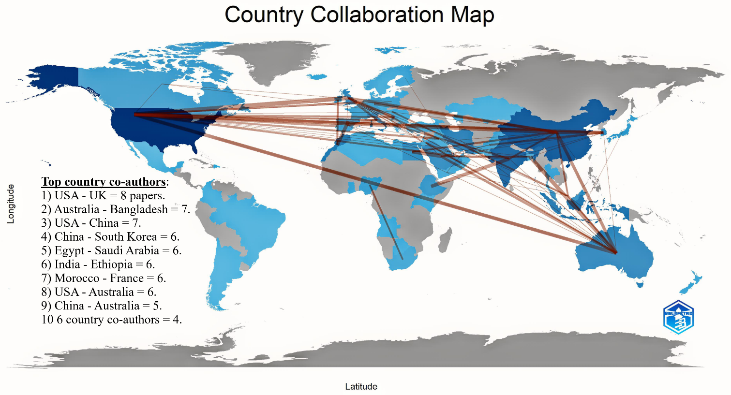
Figure S1. Geographic structure of international research collaborations in JBD.

Table S5 presents the supranational distribution of publications in JBD, offering a macroscopic view of regional productivity, influence, and per capita contribution. North America, driven almost exclusively by the United States, ranks second in publication volume (TP = 225) but dominates all other indicators, with the highest total citations (TC = 36,416), h-index (H = 49), average citations per paper (C/P = 161.8), and the greatest number of highly cited articles (≥100 = 35, T50 = 26). It also leads in citations per million inhabitants (C/Pop = 59.41), underscoring not only its productivity but its disproportionate global impact. Europe, the most prolific region in terms of output (TP = 263), also demonstrates strong performance with 14,881 citations and an h-index of 42. While its C/P (56.6) trails that of North America and Oceania, Europe leads in the number of authors with ≥10 citations (n = 139), suggesting consistent mid-tier impact and a widely distributed contribution base.
Africa exhibits unexpectedly high productivity (TP = 159), outperforming Asia despite the latter’s population and scientific growth. Africa’s relatively high h-index (H = 39) and strong citation profile (C/P = 44.8) signal concentrated, high-impact contributions from countries like Morocco and Egypt, often through collaborative publications. Oceania, although producing fewer papers (TP = 57), yields a citation-per-paper ratio (C/P = 143) rivaled only by North America, and the highest citation-per-population ratio (C/Pop = 177.17), driven predominantly by Australia. In contrast, Asia and Latin America show modest influence relative to their size. Asia, despite being home to several emerging contributors like China and India, shows the lowest C/P (17.3) and minimal elite citation impact (≥100 = 3, T50 = 15), suggesting its growing presence is not yet matched by corresponding impact. Latin America remains marginal in all metrics. These figures suggest that while Europe and North America remain dominant centers of production and influence, Oceania and parts of Africa have emerged as high-impact players. Asia’s trajectory appears to reflect a phase of rapid publication expansion with as-yet unrealized citation impact, while Latin America continues to be underrepresented.

Table S5. Regional contributions and impact distribution in JBD by supranational blocs.
R | Region | TP | TC | H | C/P | ≥100 | ≥10 | T50 | P/Pop | C/Pop
1 | Europe | 263 | 14,881 | 42 | 56.6 | 24 | 139 | 11 | 0.35 | 19.97
2 | North America | 225 | 36,416 | 49 | 161.8 | 35 | 146 | 26 | 0.36 | 59.41
3 | Africa | 159 | 7,127 | 39 | 44.8 | 18 | 105 | 6 | 0.11 | 4.7
4 | Asia | 109 | 1,885 | 18 | 17.3 | 3 | 27 | 15 | 0.02 | 0.39
5 | Oceania | 57 | 8,150 | 27 | 143 | 9 | 43 | 6 | 1.24 | 177.17
6 | Latin America | 13 | 280 | 9 | 21.5 | 1 | 9 | 0 | 0.02 | 0.42
Abbreviations are available in Tables 7 and 9.

S2. Bibliographic coupling of authors, institutions and countries
Figure S2 visualizes the co-authorship network of scholars contributing to JBD between 2018 and 2024. Each node represents an author, with edge thickness reflecting the strength of collaboration, and node color indicating the average year of publication based on the color scale (blue: earlier, yellow: recent, red: most recent). The central position is occupied by Taghi M. Khoshgoftaar, whose dense connectivity and central turquoise coloring suggest sustained, collaborative output primarily during the 2020–2022 period. His strong links to John Hancock, Jeffrey Leevy, Richard Zuech, and Flavio Villanustre form the core cluster, highlighting a prolific and coherent research team in the domain. On the periphery, distinct author groups emerge. The yellow-orange colored dyad of Domenico Talia and Riccardo Cantini signals recent but more isolated collaboration. A similarly recent node is visible around Sreemoyee Biswas, Nilay Khare, and Manasi Gyanchandani, working in a tightly bound yet externally disconnected cluster.
The violet cluster anchored by Justin Zhan and Bilal Abu-Salih bridges older and newer contributors, with links to scholars like Borko Furht, Azzeddine Zahi, and Tawfiq Hasanain. This indicates a transitional role in maintaining intellectual continuity across publication years. The network exhibits a modular and collaborative structure with identifiable research nuclei, cross-linking contributors, and geographically or topically isolated research groups. The diversity in coloring reveals evolving collaboration dynamics and emerging scholarly voices in the journal’s recent history.
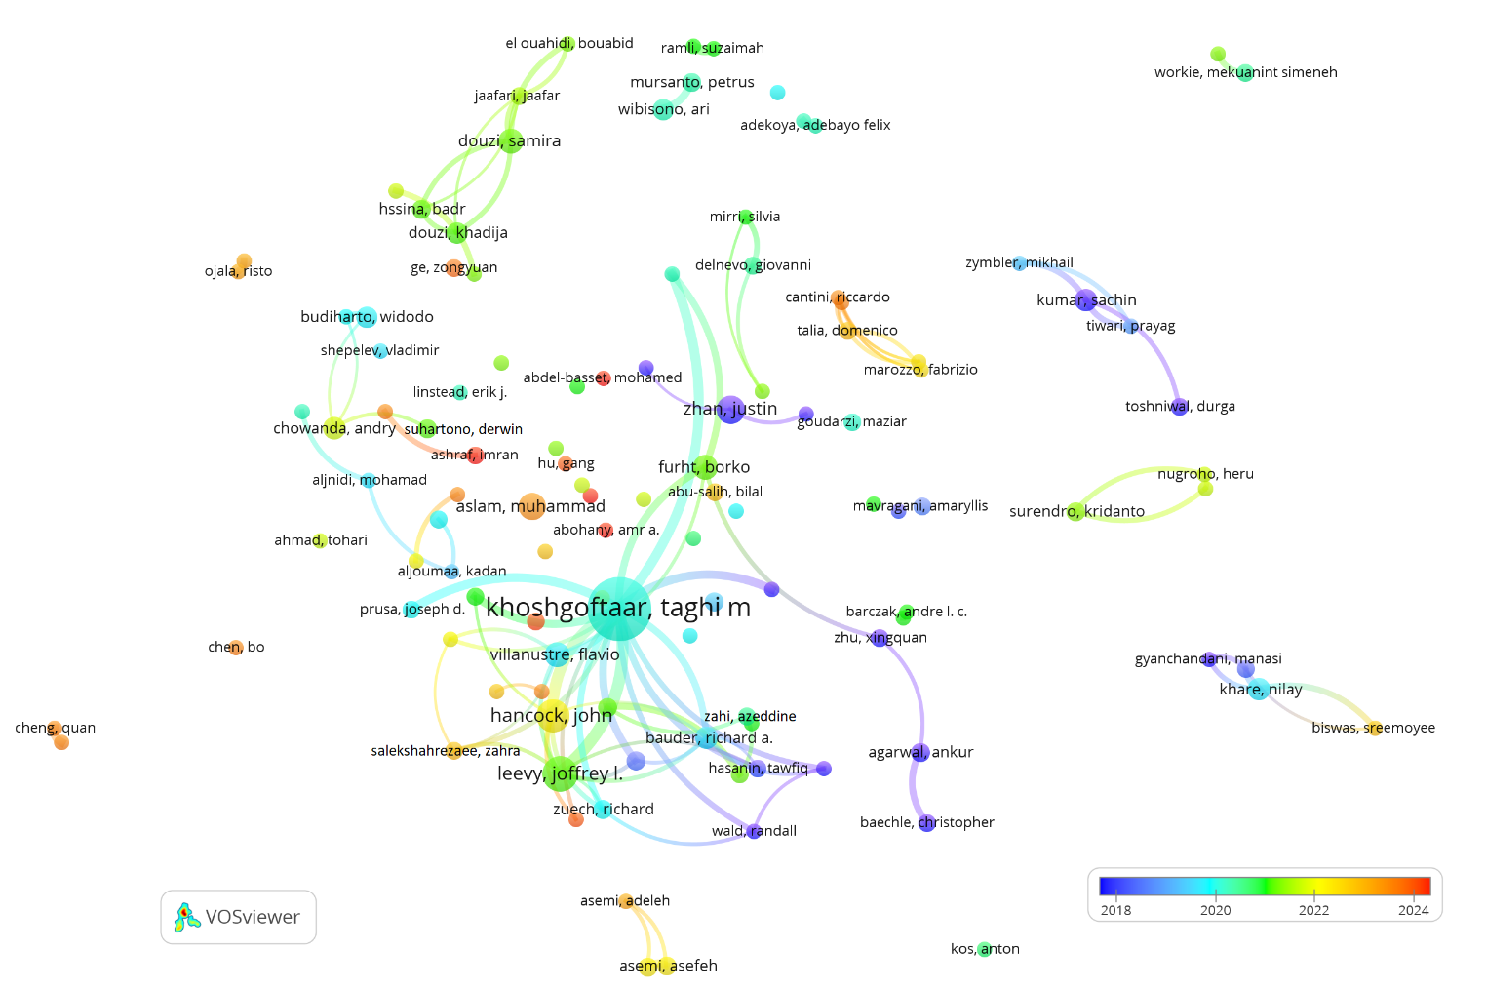Figure S2. Bibliographic coupling of authors publishing in JBD: minimum publication threshold of 5 documents and 100 links.

Figure S3 illustrates the bibliographic coupling network of institutions contributing to JBD between 2018 and 2024, based on a threshold of at least three publications and 100 citation links. Nodes represent institutions, with edge thickness corresponding to the extent of shared references. The color gradient (blue to red) indicates the average year of publication activity, from earlier (2020) to more recent (2024). At the center of the network is Florida Atlantic University, a dominant node in terms of both connectivity and citation overlap, indicative of its pivotal role in shaping thematic and methodological coherence across JBD’s institutional contributors. It forms tight bibliographic ties with institutions such as Islamic Azad University, University of Indonesia, Bina Nusantara University, and Sidi Mohamed Ben Abdellah University, forming the core of a broad, diverse, and temporally stable citation structure (primarily in cyan and green, reflecting 2021–2022).
Peripheral clusters suggest more recent but thematically concentrated scholarly activity. For instance, the orange-red cluster comprising Zagazig University, Minia University, and Princess Nourah Bint Abdulrahman University indicates intensified publishing activity in 2023–2024 with shared thematic grounding but limited linkage to older or global institutions. A similar recent cluster is formed around Huazhong University of Science and Technology, Southern Medical University, and Central South University. Another visible collaboration chain includes MIT, Sun Yat-sen University, and University of Hong Kong, situated on the left with a medium-level citation density and publication years spanning 2022–2023. This network reflects a geographically diverse and temporally evolving landscape of institutional knowledge production, anchored by a few central players and enriched by regionally emerging contributors.
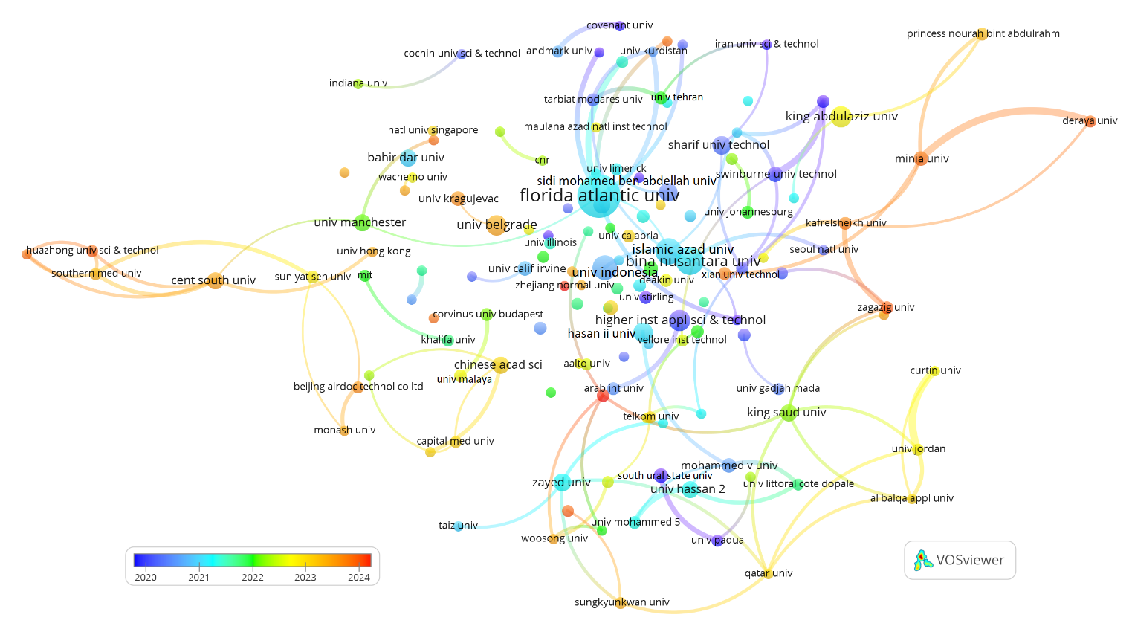Figure S3. Bibliographic coupling of institutions publishing in JBD: minimum publication threshold of 3 documents and 100 links (WoS 2018-2024).
Figure S4 presents the bibliographic coupling network of countries that have published at least five documents in the JBD during 2018–2024, with a minimum threshold of 100 citation links. Nodes represent countries, and link thickness denotes the extent of shared bibliographic references. Node color reflects the average year of publication activity, ranging from earlier (blue, ~2020) to more recent (orange-red, ~2023). The United States is the central and most influential node in the network, forming extensive bibliographic links with a broad array of countries, particularly China, India, United Kingdom, Australia, and Italy. These core countries represent the global backbone of JBD’s knowledge production, distinguished by deep interconnectedness and citation overlap. The United States and China, while both central, differ in temporal emphasis; the U.S. leans slightly earlier in activity (blue), while China’s dominant publication phase peaks closer to 2023 (orange).
Surrounding the core are emerging contributors such as Iran, Malaysia, Indonesia, and Saudi Arabia, reflecting growing regional investment in big data research. These countries are shaded in green to yellow, indicating a steady rise in publication activity since 2021. Notably, Ethiopia, Bangladesh, Nigeria, and Iraq appear more peripherally positioned but yet maintain clear bibliographic coupling, often through regional research alliances with countries like India and Malaysia. The map also identifies countries with distinctive and often more recent trajectories, such as Egypt, Turkey, and Pakistan, which show strong intra-regional linkages (e.g., with Jordan, Saudi Arabia, and Qatar) and are predominantly colored in orange, reflecting more recent publication surges post-2022. This visualization highlights JBD’s expanding internationalization, with an anchor in Western and Asian publishing hubs and accelerating contributions from the Global South. The coupling strength emphasizes thematic coherence and shared methodological frameworks, especially among digitally active nations engaged in applied AI, IoT, and data analytics research.
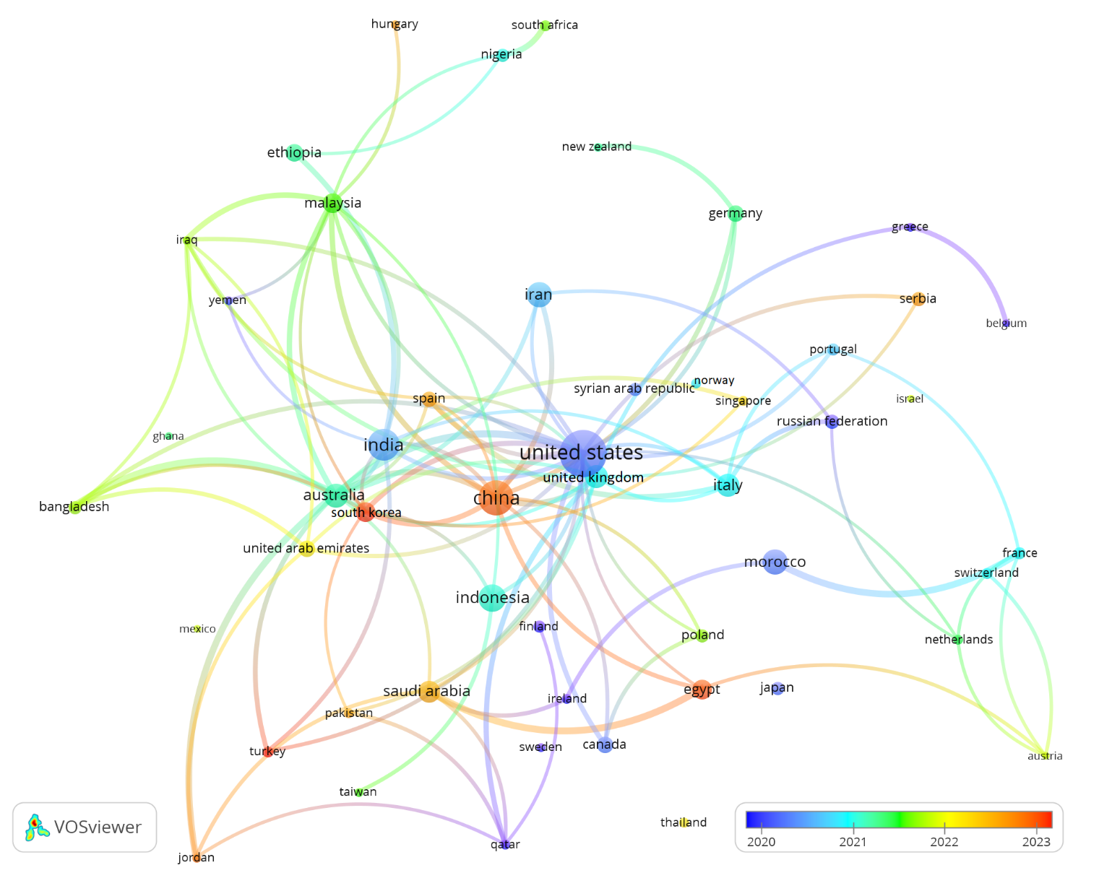Figure S4. Bibliographic coupling of countries publishing in JBD: minimum publication threshold of 5 documents and 100 links.

