Additional Information

Xylella fastidiosa and Olive quick decline syndrome (CoDiRO) in Salento (southern Italy): a chemometric ¹H NMR-based preliminary study on Ogliarola Salentina and Cellina di Nardò cultivars
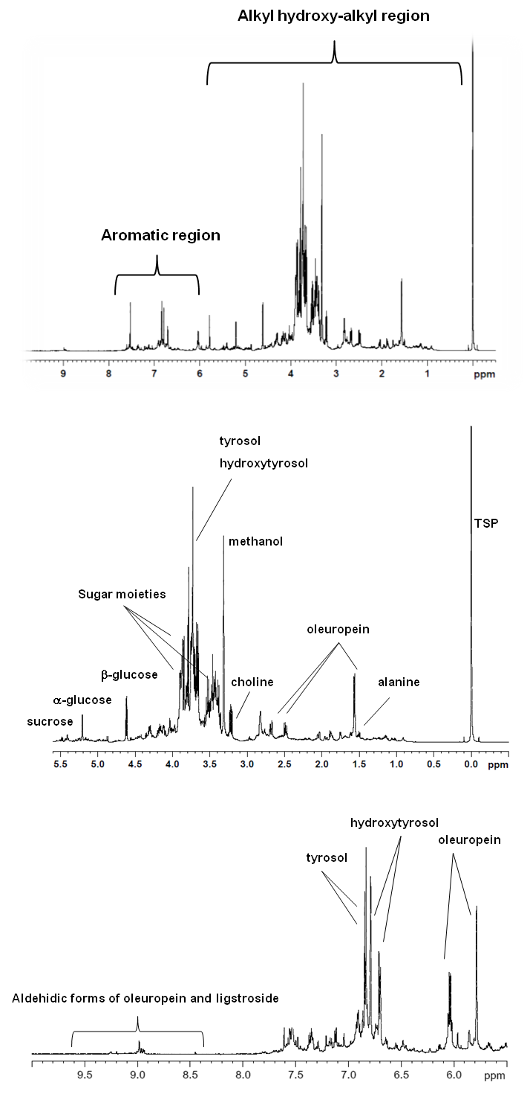
Figure S1. Typical 600MHz ¹H NMR spectrum of olive leaf extracts. Diagnostic peaks of some metabolites are indicated in the two expansions of the spectrum
Figure S2. PCA (a) t[1]/t[2] and b) t[2]/t[4] score plots for cv. Cellina di Nardò cultivars, considering the DENTAMET® treated and the untreated samples (six components, R2X(cum)=0.935, Q²(cum)=0.816).

Figure S3. PCA (a) t[1]/t[2] and b) t[2]/t[4] score plots for cv. Ogliarola Salentina cultivars, considering the DENTAMET® treated and the untreated samples (six components, R2X(cum)=0.964, Q²(cum)=0.815).

