HYDROCHAR FROM SUGARCANE INDUSTRY BY-PRODUCTS: ASSESSMENT OF ITS POTENTIAL USE AS A SOIL CONDITIONER BY GERMINATION AND GROWTH OF MAIZE

Laís G. Fregolente ^{a,b}, João Vitor dos Santos ª, Felipe S. Mazzati ª, Thaiz B. A. R. Miguel ^{c} , Emílio de C. Miguel ^{d,e}, Altair B. Moreira ª, Odair P. Ferreira ^{b}, Marcia C. Bisinoti ª*.

ª Laboratory for Environment Science Studies, Institute of Bioscience, Languages and Exact Sciences, Universidade Estadual Paulista “Júlio de Mesquita Filho”, São José do Rio Preto, São Paulo State, Brazil, postcode 15054-000.
^{b} Advanced Functional Materials Laboratory (LaMFA), Department of Physics, Universidade Federal do Ceará, Fortaleza, Ceará State, Brazil, P.O. Box 6030, postcode 60455-900.
^{c} Laboratory of Biotechnology, Universidade Federal do Ceará, Fortaleza, Ceará State, Brazil, postcode 60020-181.
^{d} Laboratory of Biomaterials, Universidade Federal do Ceará, Fortaleza, Ceará State, Brazil, postcode 60440-554.
^{e} Analytical Center, Universidade Federal do Ceará, Fortaleza, Ceará State, Brazil, P.O. Box 6030, postcode 60455-900.

maize seeds | tomato seeds
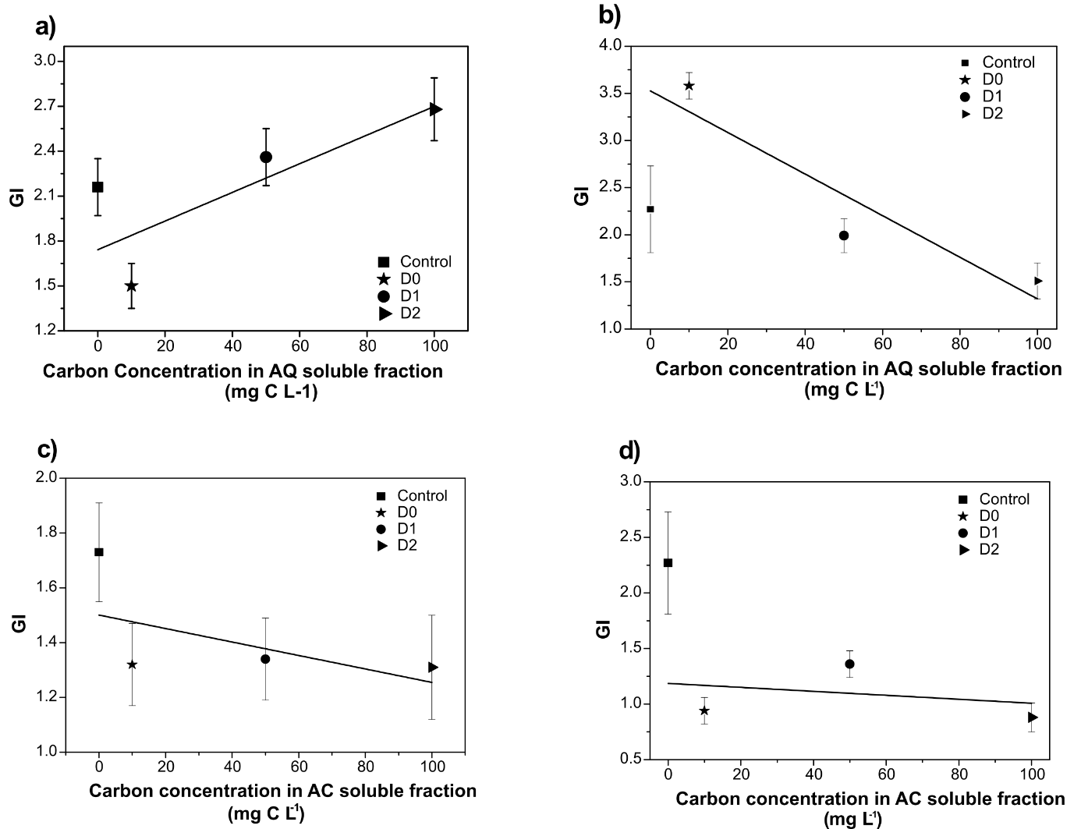
Figure S1. Germination Index (GI) maize and tomato seed germinated in acid (AC) and aqueous (AQ) hydrochar soluble fractions.
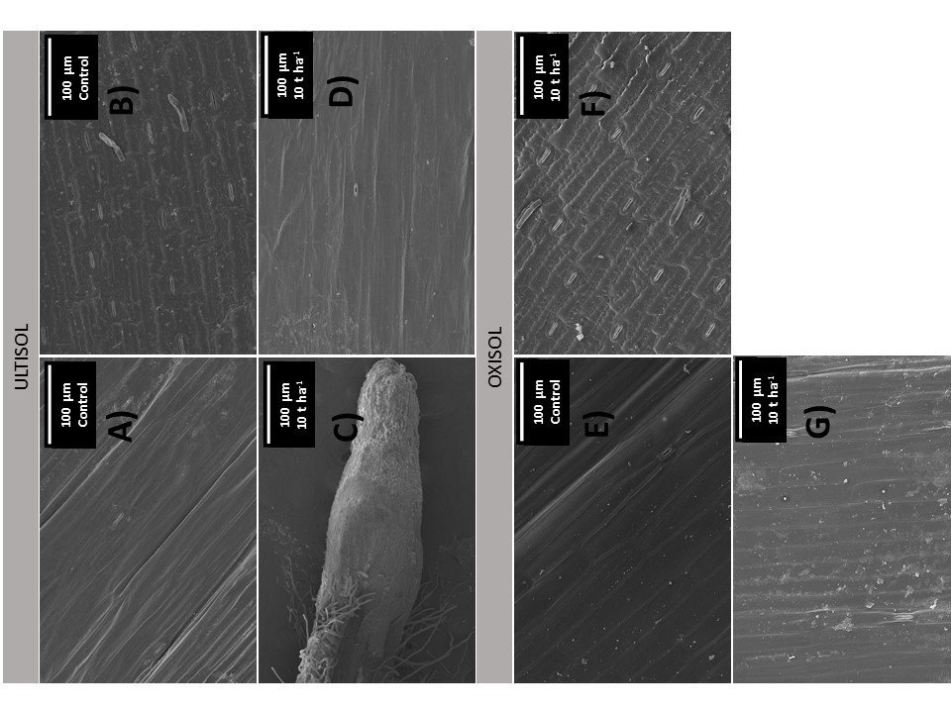
Figure S2. SEM images of a) sheath, b) leaf, c) root and d) sheath of maize from ultisol; e) sheath, f) leaf and g) sheath of maize from oxisol.

Table S1. Seedling length and number of leaves on thinning day, and number of leaves at the end of the maize growth experiment.
Seedling length on thinning day
 | Ultisol | Oxisol | Terra Mulata
Control | 19.29±3.06 | 22.00±3.61 | 20.32±6.05
10 t ha⁻¹ | 21.41±2.97a | 21.75±3.00
20 t ha⁻¹ | 17.44±2.44 | 25.43±5.72aA
Number of leaves on thinning day
 | Ultisol | Oxisol | Terra Mulata
Control | 3.00±0.41 | 3.08±0.41 | 3.18±0.40
10 t ha⁻¹ | 3.16±0.37 | 3.16±0.37
20 t ha⁻¹ | 2.90±0.30 | 2.90±0.31
Number of leaves at the end of plant growth experiment
 | Ultisol | Oxisol | Terra Mulata
Control | 7.60±0.55 | 8.20±0.45 | 8.33±0.58
10 t ha⁻¹ | 7.00±0.0 | 8.20±0.45
20 t ha⁻¹ | 7.40±0.55 | 7.80±0.45
a Indicates a positive statistical difference in relation to the control; A Indicates a positive statistical difference in relation to all application rates and kinds of soil.

DESCRIPTION OF SOIL TEXTURE CHARACTERIZATION
The characterization of soil samples regarding its composition of silt and clay was provided by a certificated laboratory specialized in soil characterization. The soil particle distribution is described in Table S2.
Table S2. Soil particle characterization of Oxisol and Ultisol samples and their soil class.
Sample | Total Sand | Clay | Silt | Classification
Sample | g/kg |  |  | Classification
Oxisol | 372 | 511 | 117 | Loamy soil
Ultisol | 876 | 74 | 50 | Sandy soil
Terra Mulata | 388 | 494 | 118 | Loamy soil

