Evaluation of metal nano-particles as growth promoters and
fungi inhibitors for cereal crops
Son A. Hoang^{1,4 *}, Hanh H. Cong¹, Shukanov V. P.^{2*}, Karytsko L. A.², Poljanskaja S. N.², Melnikava E. V.², Mashkin I. A.², Huyen T. Nguyen³, Khanh D. Pham¹ and Chi M. Phan⁵

¹ Institute of Materials Science, Vietnam Academy of Science and Technology, Vietnam
²V.F. Kuprevich Institute of Experimental Botany, National Academy of Science, Belarus
³Viet Tri University of Industry, Vietnam
⁴ Graduate University of Science and Technology, Vietnam Academy of Science and Technology, Vietnam
⁵Curtin University, Australia
*Corresponding authors
Son A. Hoang (email sonha@ims.vast.ac.vn) and Shukanov. V.P (email patphysio@mail.ru)
Supplementary information

CharacteriZations of nano-particles
The surface morphology of zero-valent Cu⁰ nano-particle was revealed by SEM (Hitachi S-4800) and showed in Figure 1a. The size of the copper nano-particle was about 50-70 nm. It can be seen that the diffraction diagrams are consistent with the XRD pattern (XRD 3100 diffract meter at 45 kV, and 30 mA). The broad peak at 43.38, 50.48 and 74.18 revealed the existence of copper element (Figure S1b).
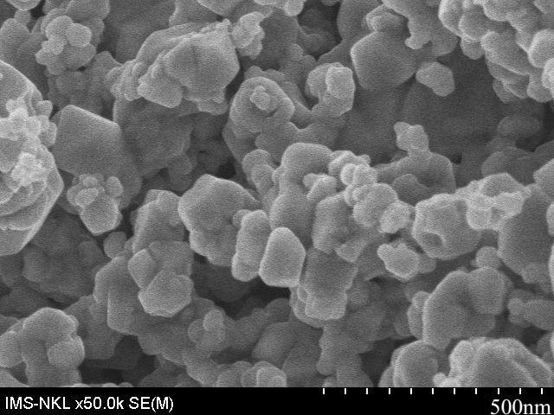
(a)
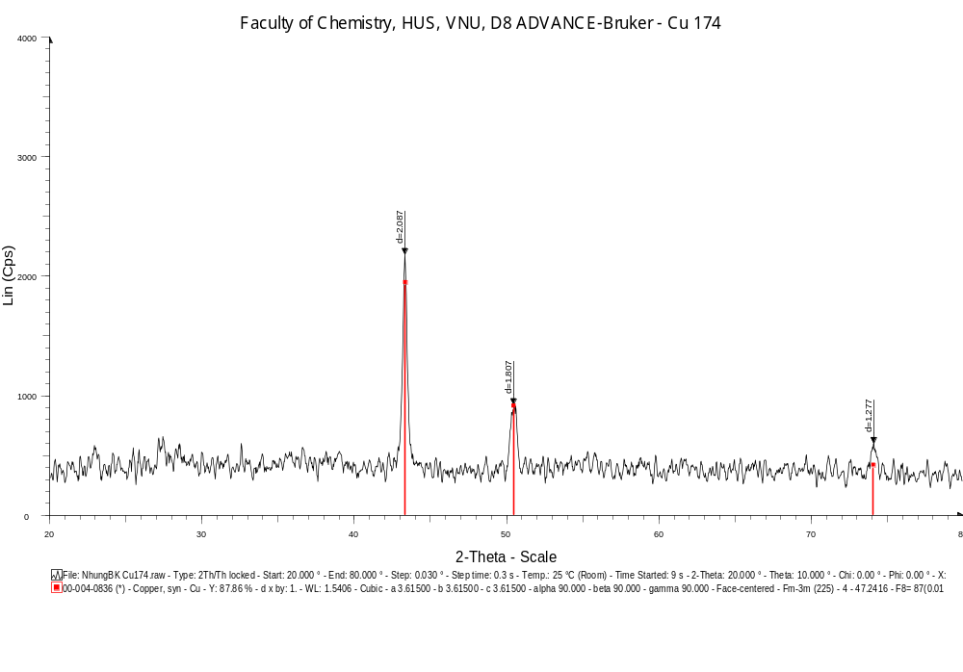(b)
Figure S1. SEM image (a) and XRD pattern (b) of Cu⁰ nanoparticles synthesized at 400°C

As shown in Figure S2b, in the product of the iron reduction process with three distinct diffraction peaks located at 44.5, 65 and 82º the samples were determined as single-phase α-Fe. By applying Debye–Scherrer equation to the obtained XRD pattern of the nZVI reduced for 90 minutes d = kλ/βcosθ; where d is the mean size of crystallites (nm), K is crystallite shape factor (0.89), λ is X-ray wavelength (0.1542 nm), β is full width at half the maximum in radians of the X-ray diffraction peak (β = 0.252º), and θ is the Bragg angle (44.5º), the average nano-particle size was found to be 43.8 nm. This result was consistent with the data from size distribution and SEM image (Figure 2a).
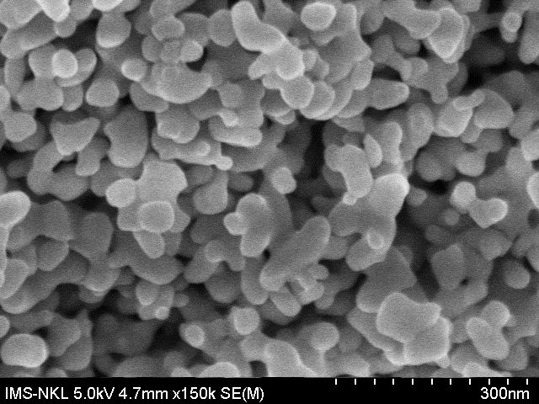
(a)
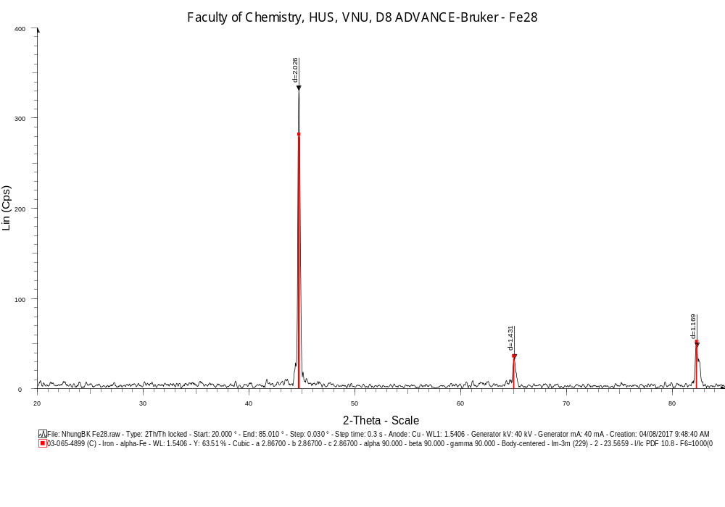(b)
Figure S2. SEM image (a) and XRD pattern (b) of Fe⁰ nanoparticles synthesized at 400°C

Similar results were obtained for cobalt particles (Figure S3).
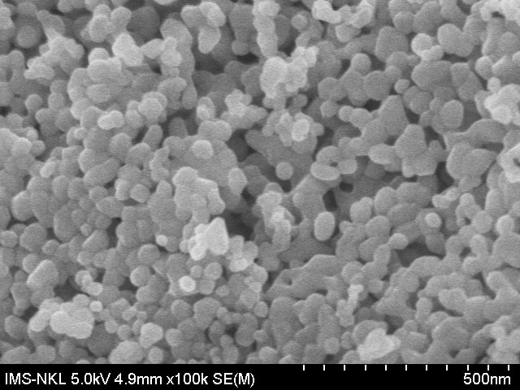
(a)
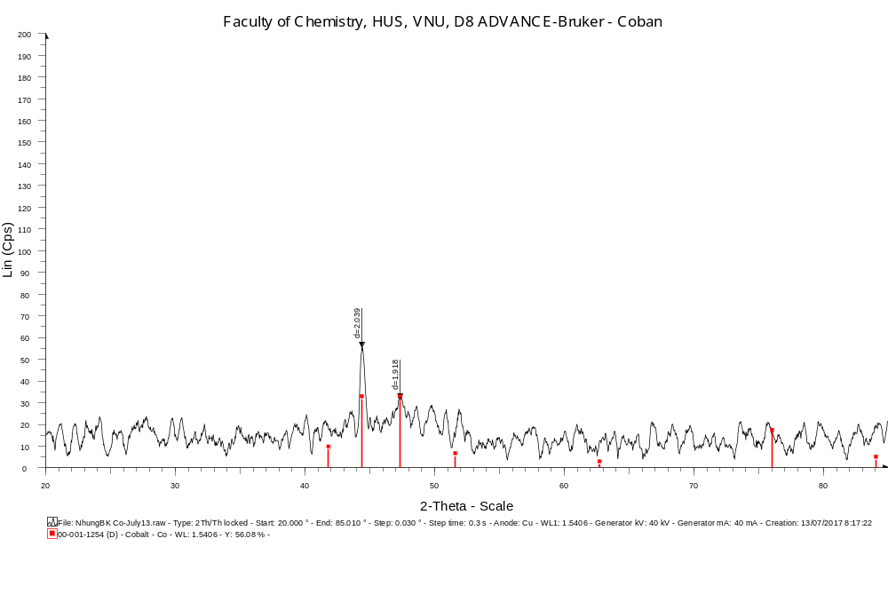
(b)
Figure S3. SEM image of Co° nanoparticles with average size of 50 nm (a) and XRD pattern (b) of Co⁰ nanoparticles synthesized at 300°C

Morphological characteristics and zeta potential of chitosan-stabilized Ag were characterized by SEM and Uv-Vis. The sample was prepared with AgNO₃ 500 ppm and chitosan 120 ppm. Figure S4 showed the morphology and particle size of sample A500-C120 had a spherical form, uniform in size from 20 to 30 nm through FE-SEM analysis (Figure S4a). The majority of chitosan-Ag particles were separated, while a small number of particles tended to accumulate due to the effect of chitosan, which was a highly viscous polymer.
- (b)
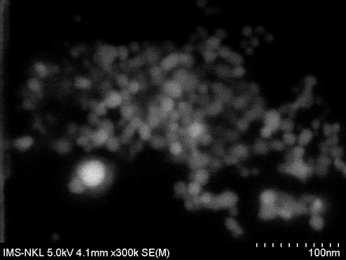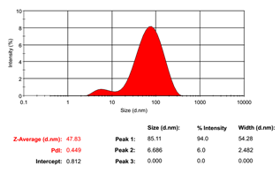
Figure S4. FE-SEM image (a) and size distribution (b) of Ag nano-particles
The average particle size distribution of the chitosan-stabilized Ag around 47.83 nm (zeta potential analysis, Figure S4b), due to the combination of chitosan-bound particles around Ag, so the particle size was larger than the FE-SEM result. The zeta potential was quite high, reaching 30.8mV and relatively concentrated. The data confirmed that chitosan-stabilized Ag nano-particles were highly stable. The nanosystem Ag-chitosan was left to stand for months, and no precipitation was observed.

Figure S5. UV-Vis spectra of sample A500-C120 (AgNO3 500 ppm and chitosan 120 ppm)

UV-Vis spectra of the sample showed that the solution of chitosan-Ag particles mainly was absorbed waves with a wavelength in the range of 350-450 nm and had a peak at 400 nm (Figure S5). This value was specific to the plasmon absorption of silver nano-particles. The results also showed that the peak of the absorption was sharp and balanced with a narrow peak width at half-height, which demonstrated a uniform size.

Fungi Inhibition and CROp productivity

Table S1. The effect of metal nanoparticles on the development of mycelium of phytopathogenic fungi (10th day).
Processing option | The diameter of the fungus colony, cm
Processing option | Fusarium sp. | Alternaria sp. | Helmintosporium teres
Control | 6.00±0.22 | 4.50±0.13 | 3.75±0.15
Fe (0.3 mg/kg) | 6.50±0.15 | 4.55±0.17 | 3.50±0.10
Fe (0.4 mg/kg) | 6.25±0.17 | 4.50±0.13 | 3.00±0.11*
Fe (0.5 mg/kg) | 6.25±0.15 | 4.55±0.19 | 3.00±0.12*
Cu (0.3 mg/kg) | 5.75±0.20 | 4.75±0.15 | 2.75±0.10**
Cu (0.4 mg/kg) | 5.75±0.20 | 4.25±0.13 | 2.75±0.11**
Cu (0.5 mg/kg) | 6.00±0.21 | 3.75±0.12* | 2.50±0.11**
Co (0.3 mg/kg) | 5.75±0.16 | 4.25±0.18 | 2.75±0.10**
Co (0.4 mg/kg) | 5.70±0.17 | 3.00±0.19** | 2.50±0.13**
Co (0.5 mg/kg) | 5.60±0.14 | 3.00±0.15** | 1.75±0.09**
ZnO (0.3 mg/kg) | 5.75±0.20 | 4.25±0.13 | 2.75±0.11*
ZnO (0.4 mg/kg) | 5.75±0.17 | 4.10±0.11 | 2.60±0.11**
ZnO (0.5 mg/kg) | 5.70±0.16 | 3.75±0.12* | 2.60±0.12**
Ag (15 mg/kg) | 6.00±0.21 | 4.00±0.13 | 2.25±0.10**
Ag (30 mg/kg) | 5.75±0.11 | 3.25±0.16** | 1.75±0.11**
Ag (60 mg/kg) | 5.70±0.14 | 3.00±0.16** | 1.75±0.10**
* the difference between the treated and control samples is statistically significant at the 0.05 level
** the difference between the treated and control samples is statistically significant at the 0.01 level

Table S2. Effects of metal nanoparticles on barley plant cell membranes.
Sample | Water-soluble substances  ppm/g fresh mass |  | Lipid peroxidation products.  μM/g fresh mass
Sample | Healthy plants | Infected plants | Healthy plants | Infected plants
Control | 20.93±0.03 | 23.20±0.06 | 11.11±0.30 | 12.43±0.27
Fe (0.25 mg/kg) | 16.53±0.03 | 20.53±0.03 | 7.59±0.32 | 12.39±0.29
Fe (0.50 mg/kg) | 17.33±0.03 | 18.20±0.06 | 8.48±0.24 | 9.88±0.25
Cu (0.25 mg/kg) | 12.73±0.03 | 15.53±0.03 | 8.14±0.25 | 10.82±0.26
Cu (0.50 mg/kg) | 17.00±0.03 | 14.87±0.03 | 10.79±0.27 | 8.86±0.16
Co (0.25mg/kg) | 14.13±0.03 | 15.40±0.06 | 8.13±0.29 | 10.44±0.27
Co (0.50 mg/kg) | 19.20±0.06 | 13.27±0.03 | 10.17±0.28 | 9.76±0.20
ZnO (0.25 mg/kg) | 17.53±0.03 | 12.07±0.03 | 7.31±0.28 | 9.44±0.27
ZnO (0.50 mg/kg) | 16.73±0.03 | 11.73±0.03 | 9.59±0.30 | 7.29±0.27
Ag (15 mg/kg) | 10.93±0.03 | 16.47±0.03 | 7.37±0.23 | 9.52±0.28
Ag (30 mg/kg) | 11.73±0.03 | 12.53±0.03 | 7.68±0.17 | 10.21±0.15

Table S3. Effect of metal nanoparticles on photosynthetic pigments in barley seedlings.
Sample | The sum of chlorophylls a + b.  µg/g fresh mass |  | Carotenoids.  mg/g fresh mass
Sample | Healthy plants | Infected plants | Healthy plants | Infected plants
Control | 1.00±0.03 | 0.77±0.02 | 0.49±0.02 | 0.40±0.01
Fe (0.25mg/kg) | 1.24±0.06 | 1.11±0.01 | 0.62±0.02 | 0.56±0.01
Fe (0.50mg/kg) | 0.95±0.01 | 0.93±0.01 | 0.48±0.01 | 0.47±0.01
Cu (0.25mg/kg) | 1.18±0.01 | 0.89±0.01 | 0.59±0.01 | 0.46±0.01
Cu (0.50mg/kg) | 0.97±0.01 | 0.94±0.01 | 0.42±0.01 | 0.50±0.01
Co (0.25mg/kg) | 1.01±0.01 | 0.87±0.01 | 0.51±0.01 | 0.45±0.01
Co (0.50mg/kg) | 1.03±0.01 | 0.87±0.01 | 0.50±0.01 | 0.45±0.01
ZnO (0.25mg/kg) | 1.02±0.01 | 0.80±0.01 | 0.51±0.02 | 0.41±0.02
ZnO (0.50 mg/kg) | 1.04±0.04 | 1.03±0.01 | 0.52±0.02 | 0.53±0.01
Ag (15 mg/kg) | 0.99±0.01 | 0.77±0.01 | 0.49±0.01 | 0.39±0.01
Ag (30 mg/kg) | 1.15±0.02 | 0.97±0.01 | 0.56±0.01 | 0.51±0.01

Table S4. Influence of pre-treatment of spring wheat seeds on the productivity indicators
Processing option | Stem length, cm | Number of stems on the plant, pcs. |  | Mass of straw (10 plants), g
Processing option | Stem length, cm | productive | unproductive | Mass of straw (10 plants), g
Control | 76.60±1.15 | 2.20±0.14 | 0.20±0.08 | 28.24
Fe (0.25 mg/kg) | 76.80±0.99 | 2.80±0.20* | 0.20±0.14 | 39.54*
Fe (0.50 mg/kg) | 81.82±1.14* | 2.82±0.24* | 0.20±0.10 | 45.18*
Cu (0.25 mg/kg) | 78.70±1.21 | 2.40±0.31 | 0.60±0.17* | 34.64*
Cu (0.50 mg/kg) | 75.50±1.22 | 2.40±0.31 | 0.40±0.05* | 33.72*
Co (0.25 mg/kg) | 76.60±1.15 | 2.30±0.22 | 0.40±0.04* | 35.95*
Co (0.50 mg/kg) | 78.00±1.09 | 2.70±0.22 | 0.40±0.04* | 40.10*
* the difference between the treated and control samples is statistically significant at the 0.05 level

Table S5. Influence of pre-treatment of barley seeds on the productivity indicators
Processing option | Stem length, cm | Number of stems on the plant, pcs. |  | Mass of straw (10 plants), g
Processing option | Stem length, cm | productive | unproductive | Mass of straw (10 plants), g
Control | 44.30±1.36 | 3.30±0.06 | 0.50±0.03 | 16.98
Fe (0.25 mg/kg) | 45.40±1.21 | 3.60±0.09* | 0.50±0.03 | 22.73*
Fe (0.50 mg/kg) | 43.00±1.55 | 3.80±0.13* | 0.40±0.05 | 25.54*
Cu (0.25 mg/kg) | 45.20±1.21 | 3.10±0.12 | 0.70±0.06* | 18.02
Cu (0.50 mg/kg) | 42.80±1.53 | 3.10±0.08 | 0.80±0.10* | 19.60
Co (0.25 mg/kg) | 43.20±1.57 | 3.00±0.09* | 1.10±0.16* | 22.82*
Co (0.50 mg/kg) | 45.70±0.64 | 2.70±0.10* | 0.80±0.10* | 20.32*
* the difference between the treated and control samples is statistically significant at the 0.05 level

