Effect of biodegradable poly-3-hydroxybutyrate amendment on the soil biochemical properties and fertility under varying sand loads

Brtnicky M. ^{1,2}, Pecina V. ^{1,2}, Holatko J. ^{2,3}, Hammerschmiedt T. ², Mustafa A. ^{1,2,4}, Kintl A.^{2,5}, Fojt J. ¹, Baltazar T. ², Kucerik J. ¹

¹ Faculty of Chemistry, Institute of Chemistry and Technology of Environmental Protection, Brno University of Technology, Purkynova 118, 612 00 Brno, Czech Republic; martin.brtnicky@seznam.cz, xcpecina@fch.vut.cz, xcfojt@fch.vut.cz, kucerik@fch.vut.cz
² Department of Agrochemistry, Soil Science, Microbiology and Plant Nutrition, Faculty of AgriSciences, Mendel University in Brno, Zemedelska 1, 613 00 Brno, Czech Republic; jiri.holatko@mendelu.cz, tereza.hammerschmiedt@mendelu.cz, adnanmustafa780@gmail.com, tivadar.baltazar@mendelu.cz
³ Agrovyzkum Rapotin, Ltd., Vyzkumniku 267, 788 13 Rapotin, Czech Republic
⁴ Faculty of Science, Institute for Environmental Studies, Charles University in Prague, Benatska 2,128 00 Prague, Czech Republic;
⁵ Agricultural Research, Ltd., Zahradni 1, 664 41 Troubsko, Czech Republic; kintl@vupt.cz

Supplementary material

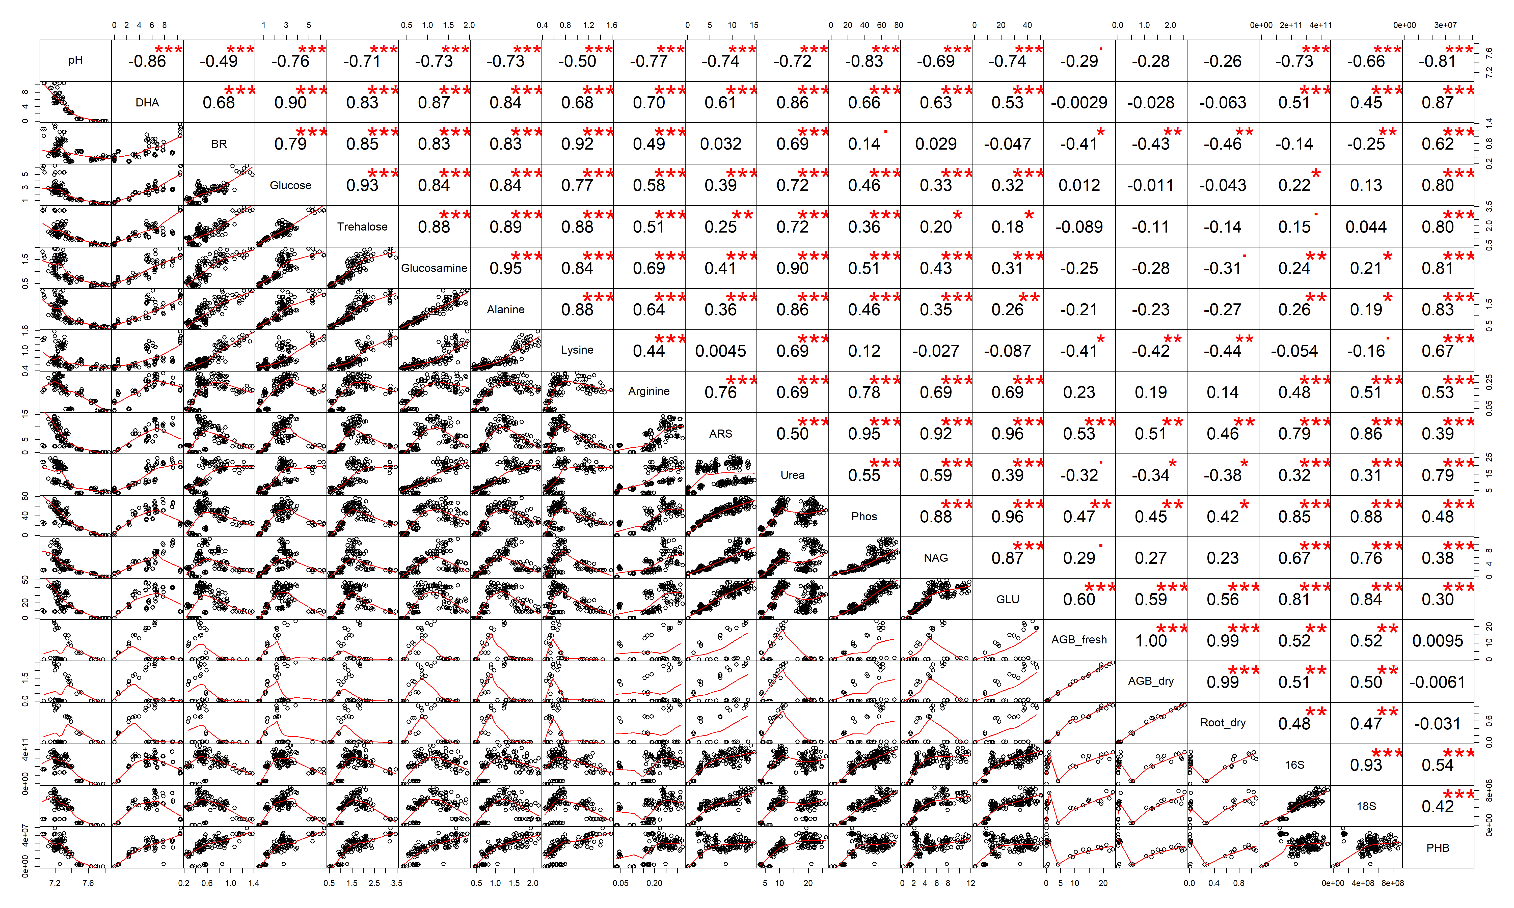Fig. S1 Correlation matrix of soil properties; numbers indicate the Pearson’s correlation coefficient r.

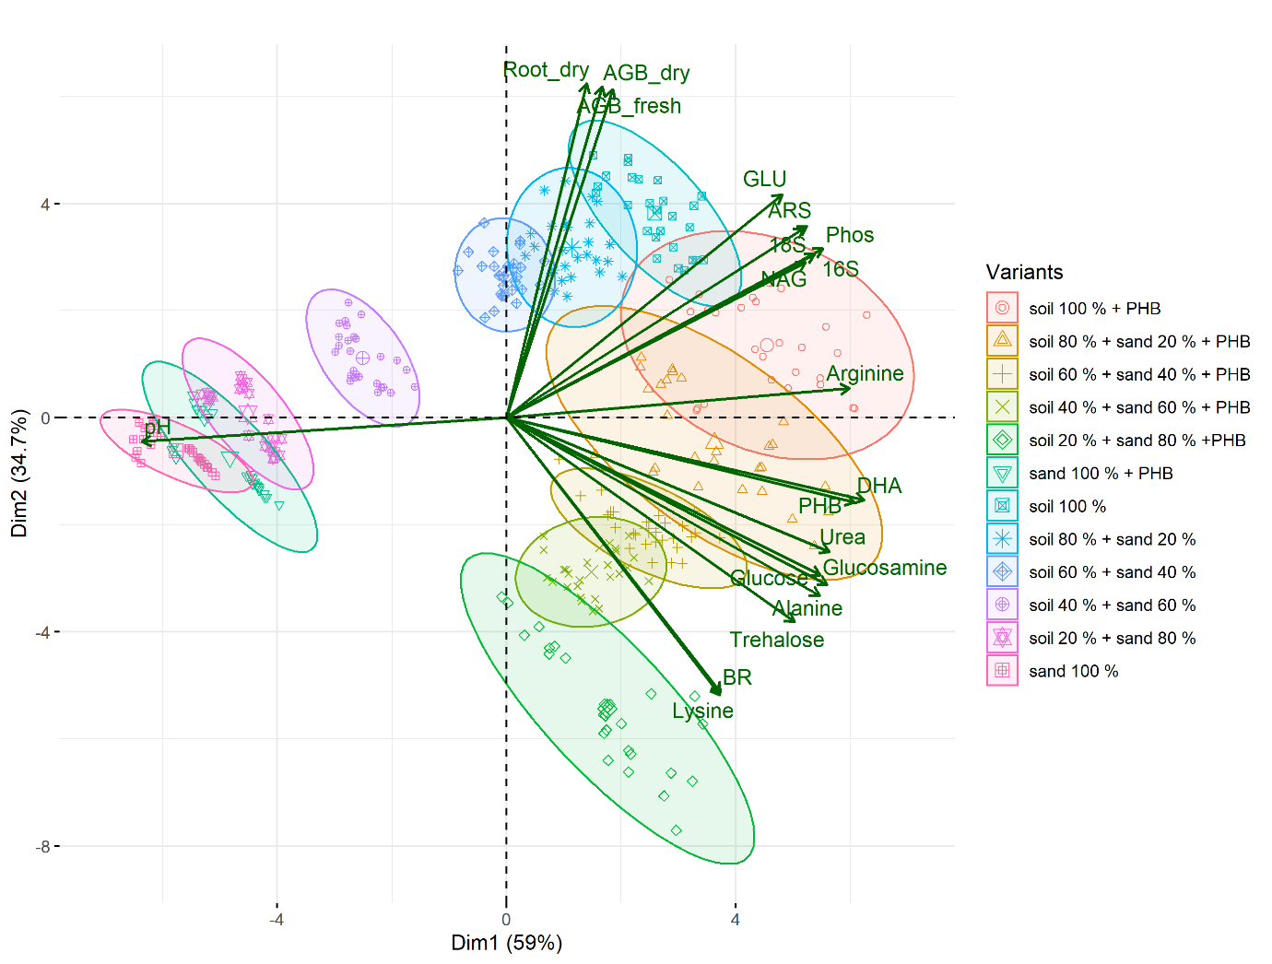Fig. S2 Rohlf PCA biplot of individuals and variables.

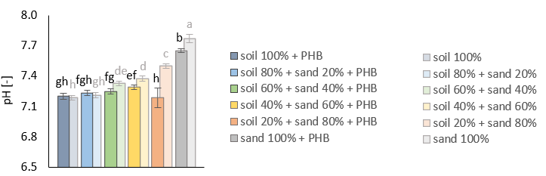
Fig. S3 pH in the substrates; the lowercase letters indicate significant differences at p ≤ 0.05.

