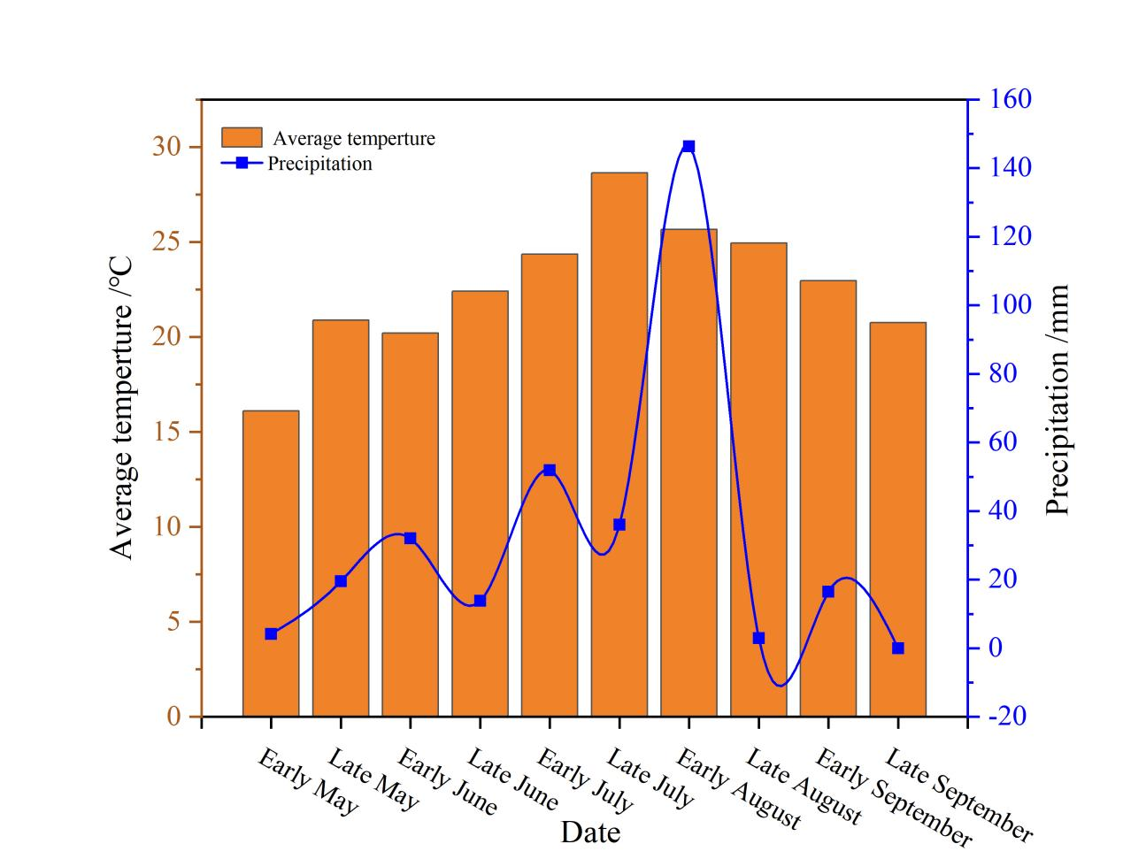
Fig. S1 Mean temperature and precipitation every half-month during the field experiment in 2019.
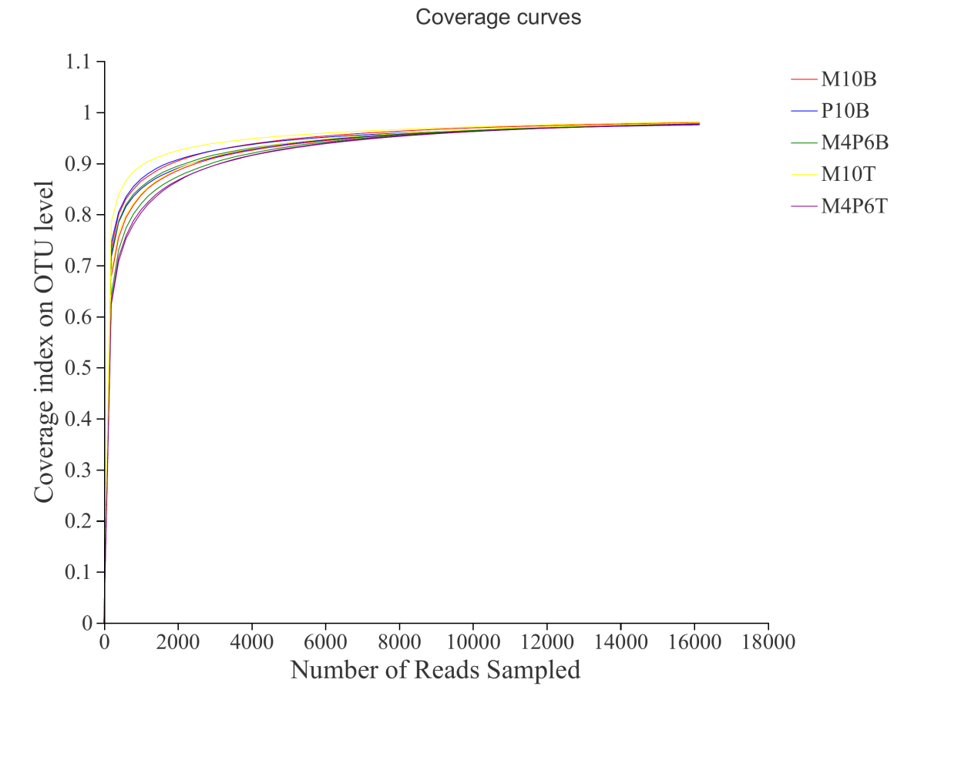
Fig.S2 Rarefaction curve

