Induced secondary metabolites of the beneficial fungus Trichoderma harzianum M10 through OSMAC approach

Alessia Staropoli^{1,2}, Giuseppina Iacomino¹, Paola De Cicco³, Sheridan L. Woo^{3,5}, Luigi Di Costanzo¹, Francesco Vinale^{2,4,5*}

¹Department of Agricultural Sciences, University of Naples Federico II, 80055 Portici, Italy; alessia.staropoli@unina.it (A.S.); giuseppina.iacomino@unina.it (G.I.);luigi.dicostanzo4@unina.it (L.D.C.).
²Institute for Sustainable Plant Protection, National Research Council, 80055 Portici, Italy;
³Department of Pharmacy, University of Naples Federico II, 80100 Naples, Italy; woo@unina.it (S.L.W.); paola.decicco@unina.it (P.D.C.).
⁴Department of Veterinary Medicine and Animal Production, University of Naples Federico II, 80137 Naples, Italy.
⁵BAT Center—Interuniversity Center for Studies on Bioinspired Agro-Environmental Technology, University of Naples Federico II, 80055 Portici, Italy
*Author to whom correspondence should be addressed; E-Mail: frvinale@unina.it Tel.: +39-081-2539338.
Additional file Information

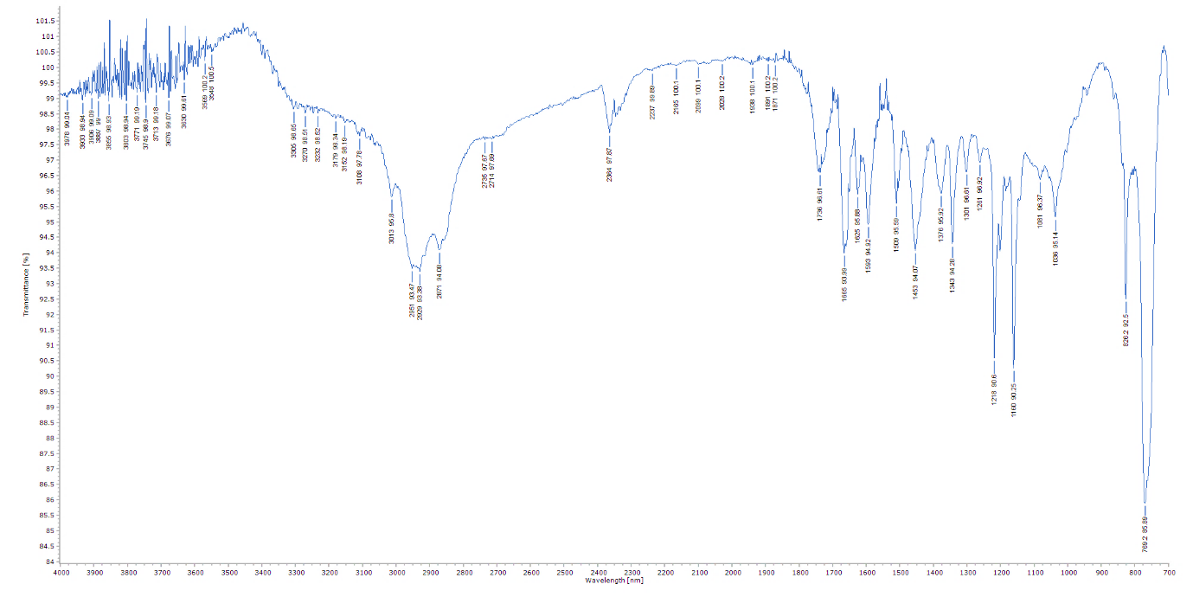
Additional Fig. S1. IR spectrum of 5-hydroxy-2,3-dimethyl-7-methoxychromone.

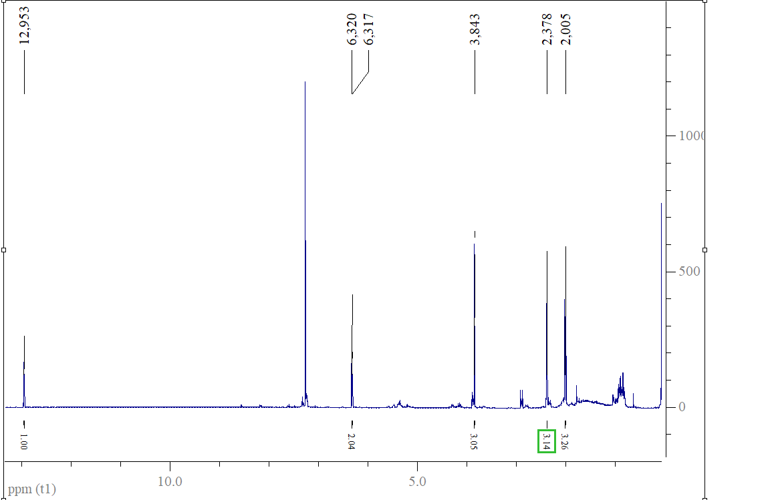
Additional Fig. S2. ¹H-NMR spectrum of 5-hydroxy-2,3-dimethyl-7-methoxychromone.
Additional Table S1. ¹H-NMR Spectral Data of 5-hydroxy-2,3-dimethyl-7-methoxychromone, measured in CDCl₃.
C | δ_{H}
6 | 6.320 | d (1.7)
8 | 6.317 | d (1.7)
9 | 2.378 | s
10 | 2.005 | s
5-OH | 12.953 | br s
7-OMe | 3.843 | s
Values in parentheses are coupling constants in Hz.

