Table S1. Compounds present in CAF8 identified through GCMS
 | RT | Compound |  |  | Peak area (%) | Molecular formula |  | Molecular weight |  | Bioactivity |  |  | References
Fatty acids
1 | 25.323 | 17-Pentatriacontene |  |  | 1.951 | C₃₅H₇₀ |  | 490 |  | Antibacterial, antiviral |  |  | Paramanantham and Murugesan (2014)
2 | 28.279 |  |  |  | 0.761
3 | 23.312 | 9,12,15-Octadecatrienoic acid, (Z,Z,Z)- |  |  | 10.837 | C₁₈H₃₀O₂ |  | 278 |  | Hypocholesterolemic, Nematicide, Anti androgenic Hypocholesterolemic Nematicide 5-Alpha reductase inhibitor Antihistaminic Anticoronary Insectifuge Antieczemic Antiacne |  |  | Duke and Bogenschutz, 1994
4 | 23.497 | 9,12-Octadecadienoic acid (Z,Z)- |  |  | 1.169 | C₁₈H₃₂O₂ |  | 280 |  | Hypocholesterolemic Nematicide Antiarthritic Hepatoprotective Anti androgenic Hypocholesterolemic Nematicide 5-Alpha reductase inhibitor Antihistaminic Anticoronary Insectifuge Antieczemic Antiacne |  |  | Duke and Bogenschutz, 1994
5 | 29.719 | Docosanoic acid, methyl ester |  |  | 0.684 | C₂₃H₄₆O₂ |  | 354 |  | Antibacterial activity |  |  | Igwe and Okwu 2013
6 | 25.723 | Dodecane, 5,8-diethyl- |  |  | 1.604 | C₁₆H₃₄ |  | 226 |  | Antifungal activity |  |  | Devi et al. 2015
7 | 29.354 | Hexadecanoic acid, 2-hydroxy-1-  (hydroxymethyl)ethyl ester |  |  | 1.146 | C₁₉H₃₈O₄ |  | 330.5 |  | Hemolytic, pesticide, flavor, antioxidant |  |  | Gnanavel and Saral, 2013
8 | 19.335 | Hexadecanoic acid, methyl ester |  |  | 1.474 | C₁₈H₃₆O₂ |  | 284 |  | Antioxidant Hypocholesterolemic Nematicide Pesticide Anti androgenic Flavor Hemolytic 5-Alpha reductase inhibitor |  |  | Duke and Bogenschutz, 1994
9 | 21.916 | Hexadecanol, 2-methyl- |  |  | 0.789 | C₁₇H₃₆O |  | 256.4 |  | antimicrobial properties |  |  | Narayanamoorthi et al. 2015
10 | 17.554 | Hexadecyne |  |  | 1.355 | C₁₆H₃₀ |  | 221 |  | antimicrobial properties |  |  | Balamurugan et al. 2017
11 | 27.003 | Linolenic acid, 2-hydroxy-1-(hydroxymethyl)ethyl  ester (Z,Z,Z)- Linolenic acid, ethyl ester |  |  | 4.049 | C₂₀H₃₄O₂ |  | 306 |  | Hypocholesterolemic, Nematicide, Antiarthritic,  Hepatoprotective Antiandrogenic,  Hypocholesterolemic, 5-Alpha reductase inhibitor, Antihistaminic, Anticoronary, Insectifuge, Antieczemic, Antiacne |  |  | Tyagi and Agarwal, 2017
12 | 20.151 | n-Hexadecanoic acid |  |  | 13.317 | C₁₆H₃₂O₂ |  | 256 |  | Antioxidant  Antimicrobial |  |  | Duke and Bogenschutz, 1994
13 | 23.757 | Octadecanoic acid |  |  | 1.785 | C₁₈H₃₆O₂ |  | 284.4 |  | Antioxidant, anti-inflammatory |  |  | Duke and Bogenschutz, 1994
14 | 28.019 | Octadecanoic acid, 2,3-dihydroxypropyl ester |  |  | 2.224 | C₂₁H₄₅BO₇ |  | 420.39 |  | antioxidant, hepatoprotective, antihistaminic,  hypocholesterolemic and antieczemic activities |  |  | Duke and Bogenschutz, 1994
15 | 19.64 | Palmitoleic acid |  |  | 0.742 | C₁₆H₃₀O₂ |  | 254.41 |  | Antiinflammatory |  |  | Duke and Bogenschutz, 1994
16 | 29.139 | tert-Hexadecanethiol |  |  | 0.618 | C₁₆H₃₄S |  | 258 |  | Enzyme activators |  |  | Krishnamoorthy and Subramaniam, 2014
17 | 23.407 | trans-13-Octadecenoic acid |  |  | 2.099 | C₁₉H₃₆O₂ |  | 296 |  | Anti-inflammatory,  antiandrogenic, cancer  preventive, dermatitigenic,  irritant, antileukotriene—D4,  hypocholesterolemic, 5-alpha  reductase inhibitor,  anemiagenic, insectifuge,  flavor |  |  | Krishnamoorthy and Subramaniam, 2014
18 | 24.777 | Z-5-Methyl-6-heneicosen-11-one |  |  | 0.541 | C₂₂H₄₂O |  | 322.5 |  | antiinflammatory,  antibacterial, antifungal, antiulcerative and  antitumoral activities
19 | 16.014 | Tetradecanoic acid |  |  | 0.524 | C₁₄H₂₈O₂ |  | 256 |  | Cosmetic  Nematicide  Hypercholesterolemic  Lubricant |  |  |  | Paulpriya et al. 2014
Alkanes
20 | 22.351 | Hentriacontane |  |  | 1.259 | C₃₁H₆₄ |  | 436.84 |  | Antifungal against fungal spores germination, Antioxidant,  Antitumour, Antibacterial |  |  |  | Dandekar et al. 2015
21 | 27.824 |  |  |  | 6.664
22 | 22.532 | Heptacosane |  |  | 3.827 | C₂₇H₅₆ |  | 380 |  | antibacterial |  |  |  | Konovalova et al. 2013
23 | 29.574 |  |  |  | 1.317
24 | 25.923 | Heptadecane, 9-hexyl- |  |  | 0.674 | C₂₃H₄₈ |  | 324.637 |  | Anitmicrobial, antioxidant, anticancer |  |  |  | Adeyemi et al. 2017
25 | 22.251 | Tetratetracontane |  |  | 0.881 | C₄₄H₉₀ |  | 618 |  | anti-inflammatory, hypocholesterolemic, Anticancer, hepatoprotective, antioxidant, and hypocholesterolemic |  |  |  | Hamidi et al. 2016
26 | 28.629 |  |  |  | 1.119
Terpenoids
27 | 17.649 | 2-Pentadecanone, 6,10,14-trimethyl- |  |  | 0.597 | C₁₈H₃₆O |  | 268 |  | Allelopathic, Antibacterial |  |  |  | Arora et al. 2017
28 | 28.739 | Cyclohexane, 1,4-dimethyl-2-octadecyl- |  |  | 0.685 | C₂₆H₅₄ |  | 378 |  | Anticancer |  |  |  | Viswanathan, 2014
29 | 18.23 | Neophytadiene |  |  | 1.187 | C₂₀H₃₈ |  | 278.524 |  | analgesic, antipyretic, anti-inflammatory, antimicrobial, and antioxidant compound |  |  |  | Swamy et al. 2017
30 | 17.289 | Phytol |  |  | 4.619 | C₂₀H₄0O |  | 296 |  | Cancer preventive Diuretic Antimicrobial Anti-inflammatory |  |  |  | Duke and Bogenschutz, 1994
31 | 22.752 |  |  |  | 3.877
32 | 18.4 |  |  |  | 0.759
Sterols
33 | 24.918 | ä- Sitosterol |  |  | 0.633 | C₂₉H₅₀O |  | 414 |  | Antimicrobial |  |  |  | Bhardwaj et al. 2014
34 | 25.383 | Campesterol |  |  | 1.409 | C₂₈H₄₈O |  | 400.68 |  | antiinflammatory,  antibacterial, antifungal, antiulcerative and  antitumoral activities |  |  |  | dos Santos et al 2014
35 | 28.479 | Stigmasta-5,24(28)-dien-3-ol, (3á,24Z)- |  |  | 1.282 | C₂₉H₄₈O |  | 412.69 |  | Anticancer |  |  |  | Sureshkumar et al. 2012
Alcohol
36 | 26.668 | E,E,Z-1,3,12-Nonadecatriene-5,14-diol |  |  | 1.223 | C₁₈H₃₄O₂ |  | 294 |  | Antimicrobial activity |  |  |  | Hadi et al. 2016
37 | 28.819 |  |  |  | 0.813
38 | 19.17 | 1-Dodecanol, 3,7,11-trimethyl- |  |  | 0.576 | C₁₄H₂₈O |  | 212 |  | Antimicrobial activity |  |  |  | Wijekoon et al. 2013
38 | 24.322 | Eicosyl octyl ether |  |  | 0.571 | C₂₈H₅₈O |  | 410.771
39 | 28.334 | Tetrapentacontane, 1,54-dibromo- |  |  | 0.647 | C₅₄H₁₀₈Br₂ |  | 914.68

Figure S1.
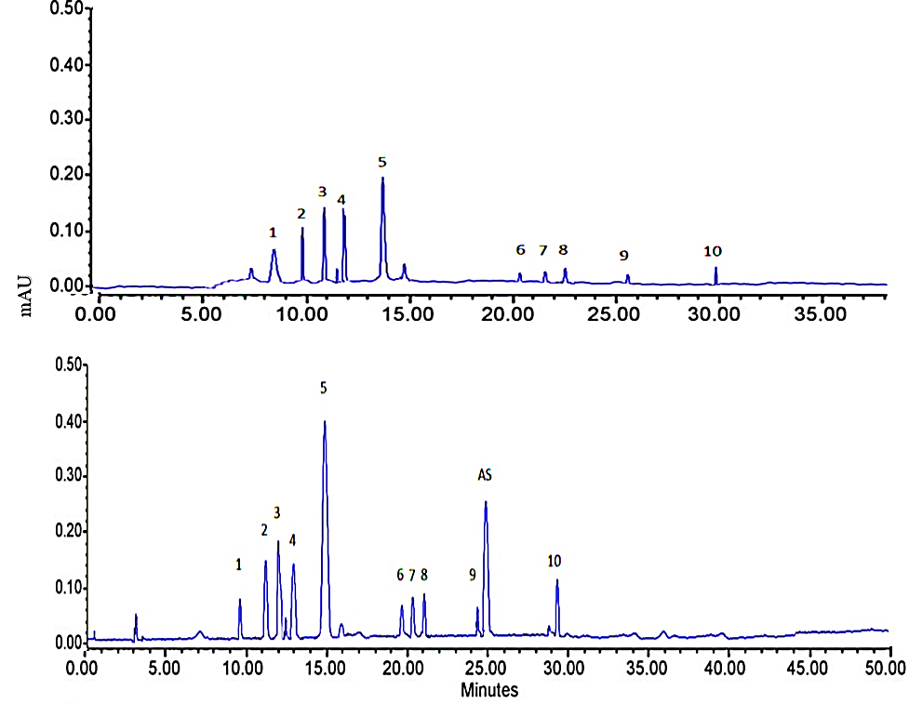
HPLC chromatogram of plants A) Control B) CA-F8 treated (Hydroxycinnamic derivatives (1, 2, 3, 4, 5, and 9), flavonoids (6, 8), hydroxybenzoic acids (7, 10) and AS (acetylsalicylic acid).

