Supplementary Information
Biodynamic, organic and integrated agriculture effects on cv. Italia table grapes juice, over a 3-year period experiment: a ¹H NMR spectroscopy-based metabolomics study
Chiara Stella Colì¹, Chiara Roberta Girelli¹, Gianluigi Cesari², Mudassar Hussain¹, Francesco Paolo Fanizzi^{1*}
*Correspondence: fp.fanizzi@unisalento.it
¹ Di.S.Te.B.A., Department of Biological and Environmental Sciences and Technologies, University of Salento, 73100 - Lecce (Italy)
²C.I.H.E.A.M Istituto Agronomico Mediterraneo di Bari, Via Ceglie 9, 70010 - Valenzano (Bari), Italy.

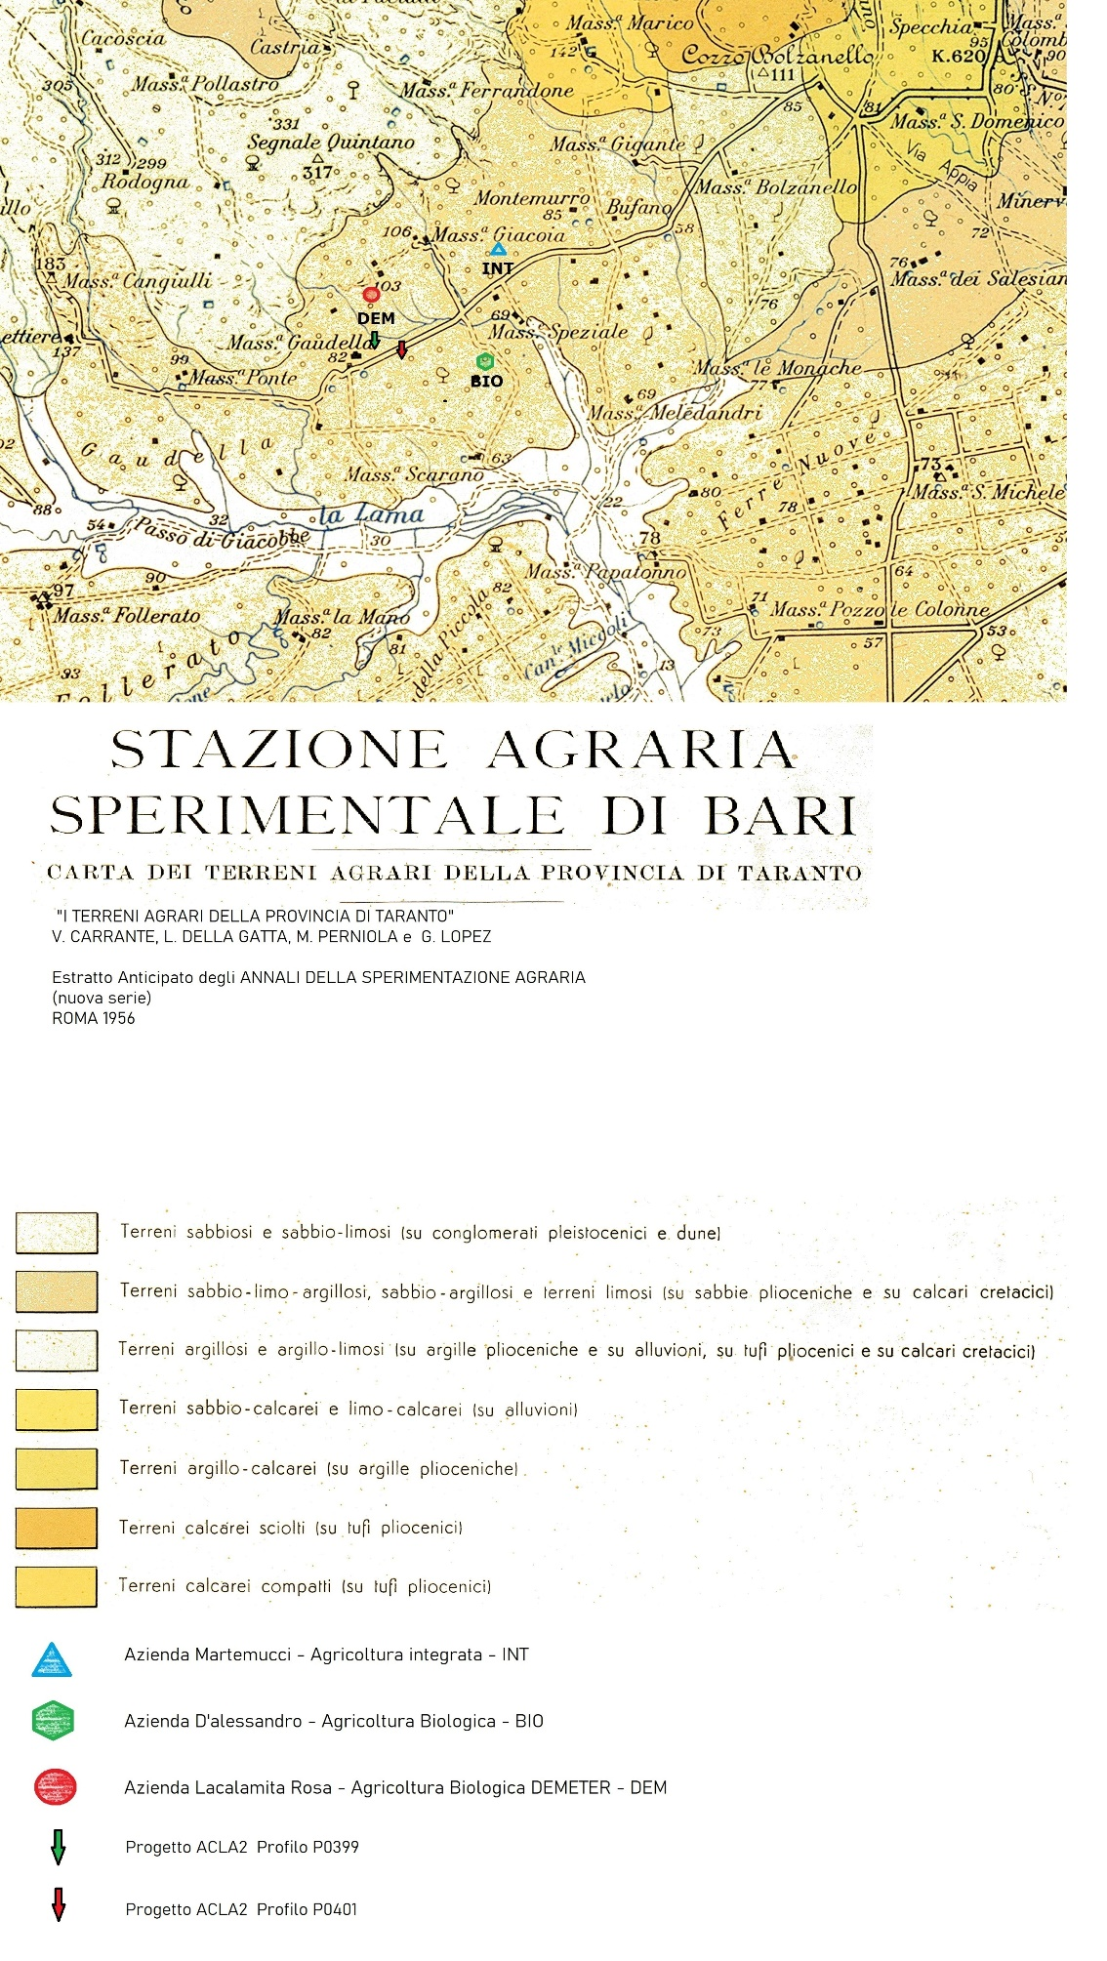
Figure S1. Local pedological map according to ref. 48 and closest confirming samples ACLA2 project ref. 49 (references are reported in the paper).
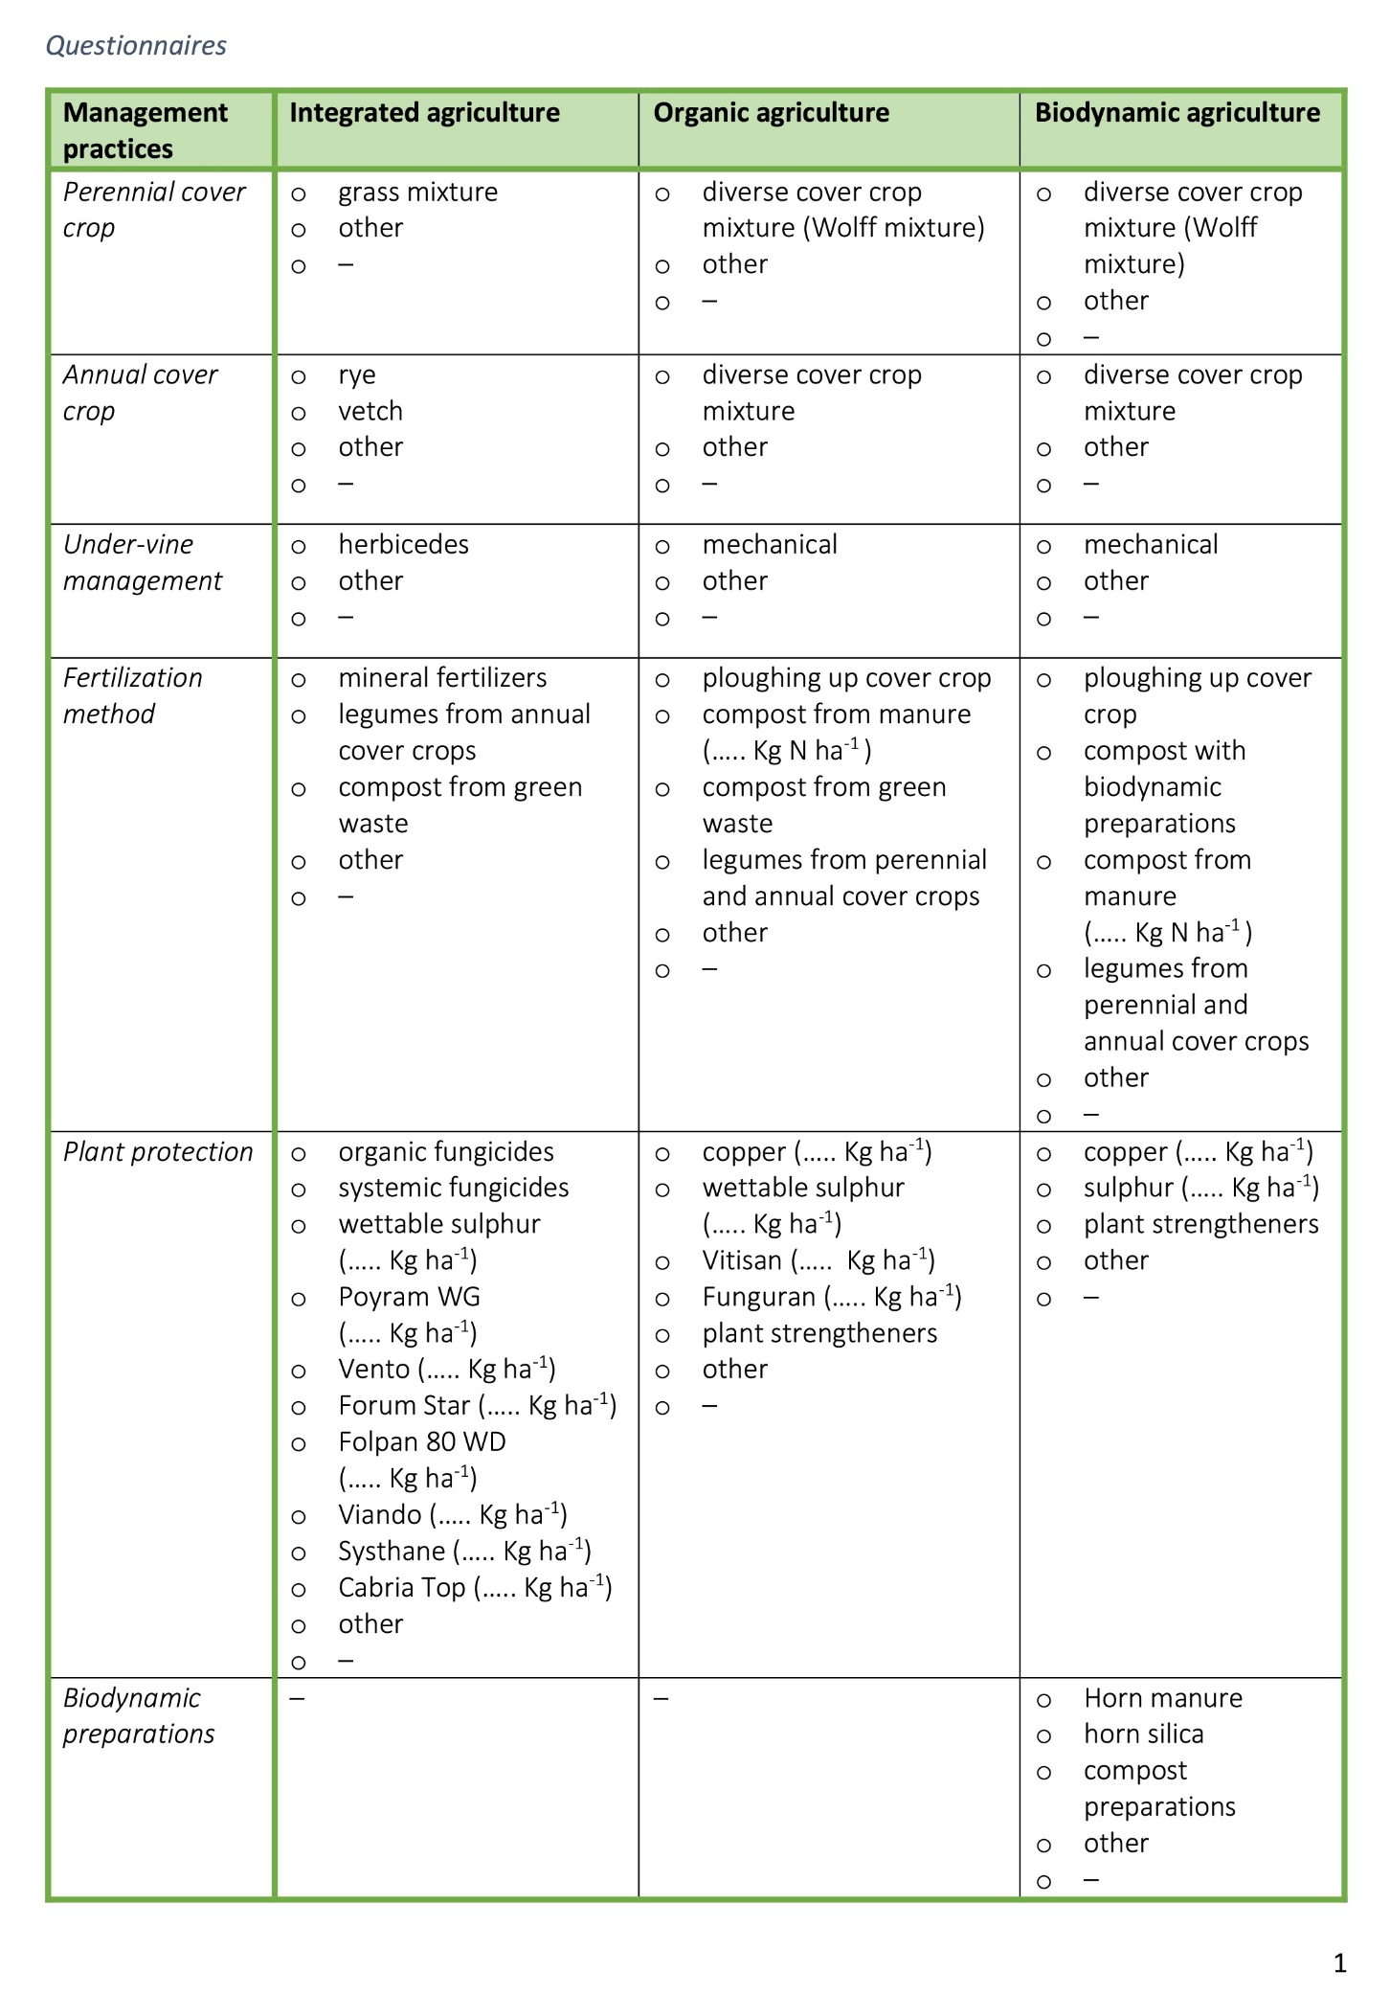



Figure S2. Questionnaires, consisting on open/close-ended questions, supplied to farms in order to know detailed information about their viticultural practices.
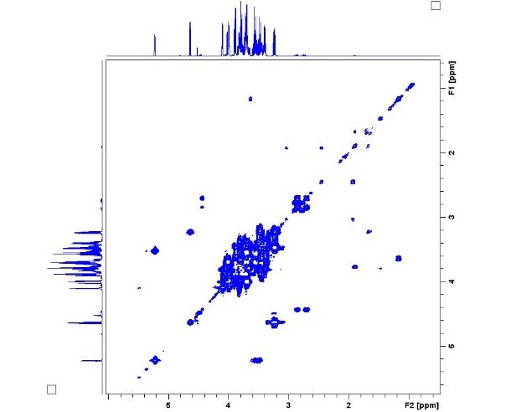
Figure S3. [¹H,¹H]-cosy spectrum expansion for a representative grape juice sample.

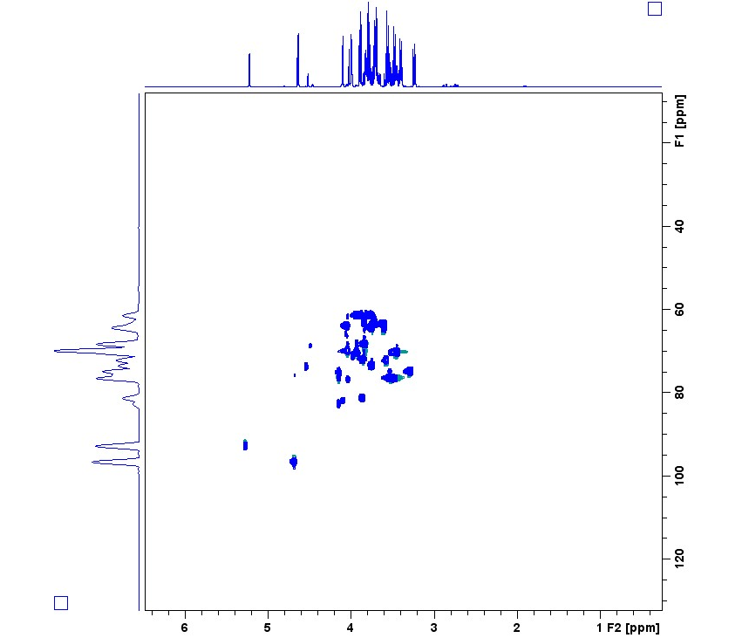
Figure S4. [¹H,¹³C]-HSQC spectrum expansion for a representative grape juice sample.

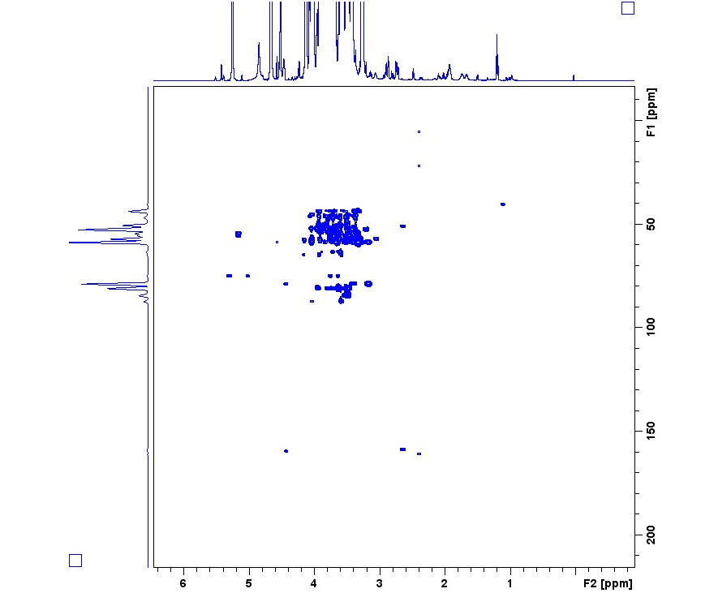
Figure S5. [¹H,¹³C]-HMBC spectrum expansion for a representative grape juice sample.
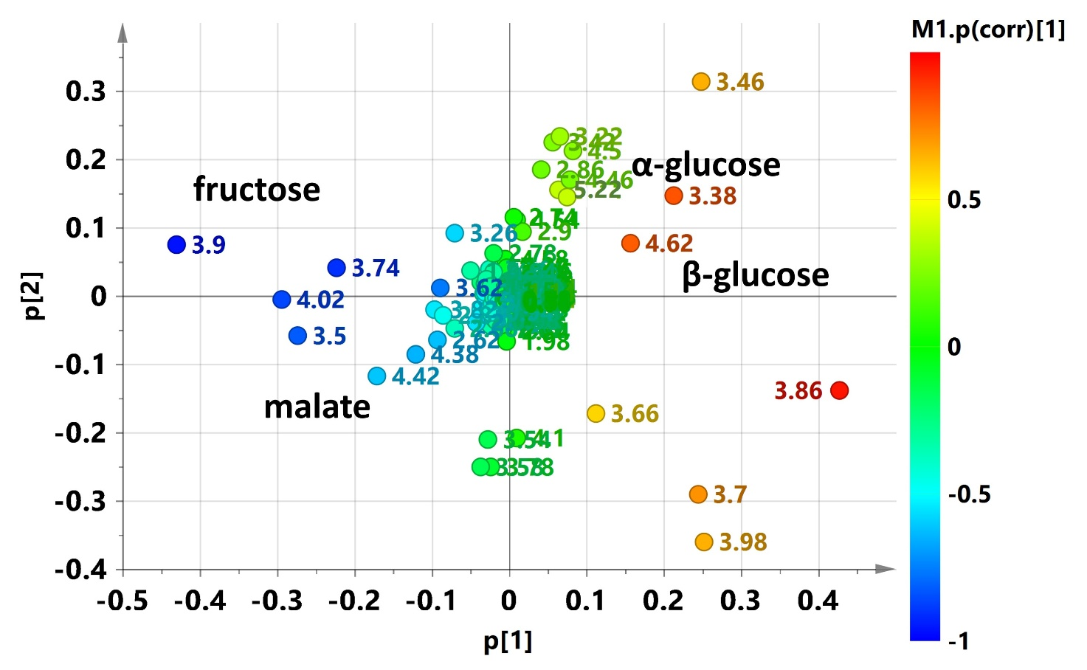
Figure S6. Loading scatter plot for the PCA model colored according to the correlation coefficient p(corr). The colour bar associated to the plot indicates the correlation of the metabolites in segregating among groups.
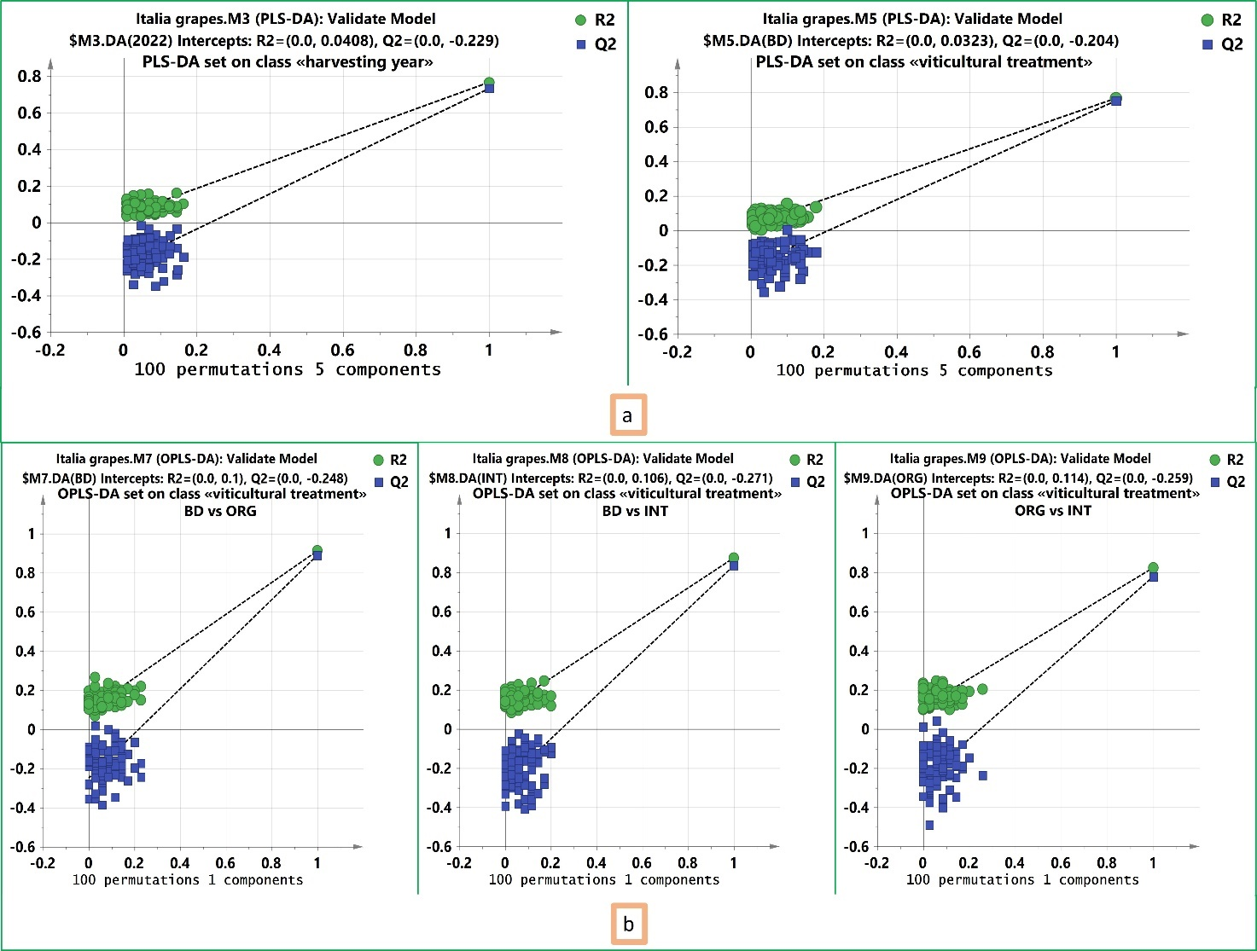
Figure S7. Examples of validity tests for PLS-DA and OPLS-DA models. a) Permutation analyses plotting R² and Q² from 100 permutation tests in the PLS-DA model set on class “harvesting year” (on the left) and in the PLS-DA model set on class “viticultural treatment” (on the right). The y-variables selected to make the calculations for the shown permutation tests were, respectively, “vintage 2022” and “BD treatment”. b) Permutation analyses plotting R² and Q² from 100 permutation tests in the OPLS-DA models set on class “viticultural treatment” related to pairwise comparisons BD vs ORG (on the left), BD vs INT (on the center) and ORG vs INT (on the right). The y-variables selected to make the calculations for the shown permutation tests were, respectively, “BD treatment” “INT treatment” and “ORG treatment”. The y-axis shows R² and Q², whereas the x-axis shows the correlation coefficient of permuted and observed data. The two dots on the right represent the observed R² and Q². Groups of dots on the left represents 100 permuted R²s and Q²s. Green and blue dots represent R² and Q² values, respectively. Dashed lines depict corresponding fitted regression lines for observed and permutated R² and Q².

Metabolite | Var ID (Primary) | M7.p(corr)[1] | M7.VIP[1+4+0]
arginine (broad signal) | 7.22 | 0.873259 | 1.43721
arginine (broad signal) | 6.66 | 0.840801 | 1.11892
α-glucose | 5.22 | 0.0828527 | 1.17071
β-glucose | 4.66 | -0.59327 | 2.09844
tartaric acid | 4.5 | 0.31258 | 2.75463
malate | 4.42 | -0.594531 | 3.40165
sugars (overlapping signals) | 3.86* | 0.0836191 | 3.33523
sugars (overlapping signals) | 3.5* | -0.565188 | 4.39074
sugars (overlapping signals) | 3.46* | 0.615119 | 5.1025
citrate | 2.86 | 0.0611779 | 1.46225
malate | 2.82 | -0.799928 | 2.88226
citrate | 2.74 | 0.168458 | 1.38458
malate | 2.66 | -0.694628 | 2.51766
arginine | 1.9 | 0.805384 | 2.48059
arginine | 1.7 | 0.823072 | 1.65272
ethanol | 1.18 | -0.641664 | 1.17389

Table S1. List of discriminating chemical descriptors (variables) with corresponding correlation coefficient p(corr) and variable importance in the projection (VIP) for BD vs ORG samples comparison in the related OPLS-DA model. The discriminant metabolites with high statistical reliability |p(corr)| ≥ 0.5 and strong discrimination power (VIP≥1) are highlighted and taken into account for the relative quantifications (Log₂ Fold Change calculation). * Only the signals of the sugar anomeric protons were considered for statistical analysis.

Metabolite | Var ID (Primary) | M8.p(corr)[1] | M8.VIP[1+4+0]
arginine (broad signal) | 7.22 | -0.937348 | 2.05831
arginine (broad signal) | 6.66 | -0.918983 | 1.89495
α-glucose | 5.22 | 0.416056 | 2.34009
β-glucose | 4.66 | 0.534105 | 2.3702
tartaric acid | 4.5 | 0.176476 | 1.70094
malate | 4.42 | -0.0136583 | 1.72034
fructose | 4.02 | -0.101826 | 2.73097
sugars (overlapping signals) | 3.86* | 0.0614949 | 3.51721
sugars (overlapping signals) | 3.46* | 0.144823 | 2.7099
citrate | 2.86 | 0.04933 | 1.29495
malate | 2.82 | -0.0161564 | 1.05791
citrate | 2.74 | 0.0921828 | 0.621231
malate | 2.66 | -0.346855 | 1.85841
glutamine | 2.42 | -0.513413 | 1.06441
glutamine | 2.14 | -0.692843 | 1.28468
arginine | 1.9 | -0.899908 | 4.15259
arginine | 1.7 | -0.910379 | 2.7873
ethanol | 1.18 | 0.564091 | 1.45689
leucine | 0.94 | -0.650922 | 1.16956
Table S2. List of discriminating chemical descriptors (variables) with corresponding correlation coefficient p(corr) and variable importance in the projection (VIP) for BD vs INT samples comparison in the related OPLS-DA model. The discriminant metabolites with high statistical reliability |p(corr)| ≥ 0.5 and strong discrimination power (VIP≥1) are highlighted and taken into account for the relative quantifications (Log₂ Fold Change calculation). * Only the signals of the sugar anomeric protons were considered for statistical analysis.

Metabolite | Var ID (Primary) | M9.p(corr)[1] | M9.VIP[1+4+0]
α-glucose | 5.22 | 0.53188 | 1.9931
β-glucose | 4.62 | 0.406224 | 1.98494
tartaric acid | 4.5 | 0.312525 | 2.05901
malate | 4.42 | -0.560415 | 3.46118
fructose | 3.98 | -0.152469 | 3.11676
sugars (overlapping signals) | 3.5* | -0.638019 | 4.43372
sugars (overlapping signals) | 3.46* | 0.739854 | 5.81186
citrate | 2.86 | 0.219695 | 1.48792
malate | 2.82 | -0.787983 | 2.93658
citrate | 2.74 | 0.301429 | 1.49485
malate | 2.66 | -0.858382 | 3.30674
glutamine | 2.42 | -0.726502 | 1.15866
glutamine | 2.14 | -0.370417 | 0.56911
Table S3. List of discriminating chemical descriptors (variables) with corresponding correlation coefficient p(corr) and variable importance in the projection (VIP) for ORG vs INT samples comparison in the related OPLS-DA model. The discriminant metabolites with high statistical reliability |p(corr)| ≥ 0.5 and strong discrimination power (VIP≥1) are highlighted and taken into account for the relative quantifications (Log₂ Fold Change calculation). * Only the signals of the sugar anomeric protons were considered for statistical analysis.

