Additional file 1
Title: Comparative analysis on root exudate and rhizosphere soil bacterial assembly between tomatoes and peppers infected by Ralstonia
Name of Authors: Mengyuan Yan^{1,2}, Meng Wu^{1,2}, Ming Liu^{1,2}, Guilong Li³, Kai Liu^{1,2}, Cunpu Qiu⁴, Ying Bao^{1,2}, Zhongpei Li^{1,2}*
Affiliations of authors:
¹State Key Laboratory of Soil and Sustainable Agriculture, Institute of Soil Science, Chinese Academy of Sciences, Nanjing 210008, China.
²University of Chinese Academy of Sciences, Beijing 100049, China.
³Soil and Fertilizer & Resources and Environment Institute, Jiangxi Academy of Agricultural Sciences, Nanchang 330200, China.
⁴Zhenjiang College, Zhanjiang 212028, China.
*Corresponding authors: Zhongpei Li
E-mail address: zhpli@issas.ac.cn
Telephone number: +86-25-86881323
Present address: Institute of Soil Science, Chinese Academy of Sciences, NO.71 East Beijing Road, Nanjing 210008, China.

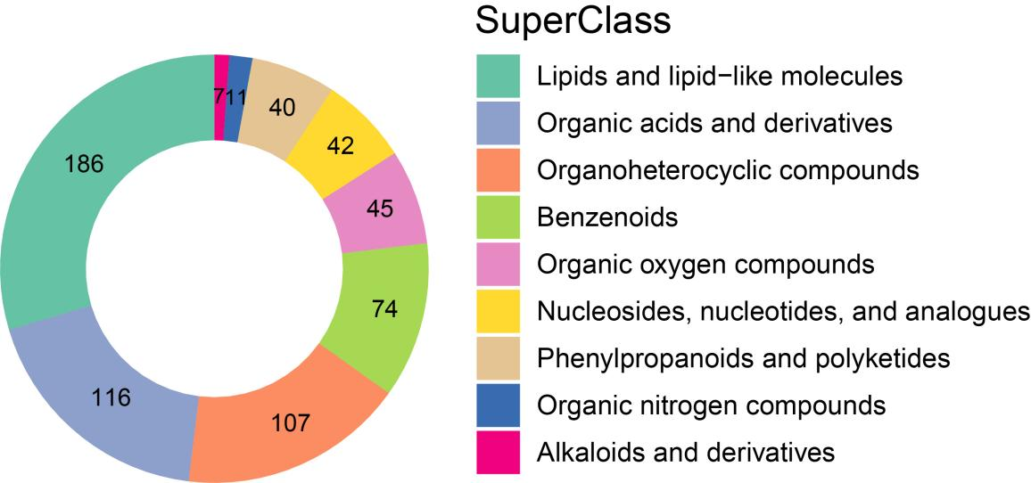
Figure S1. Number of compounds in root exudate at the Superclass level.

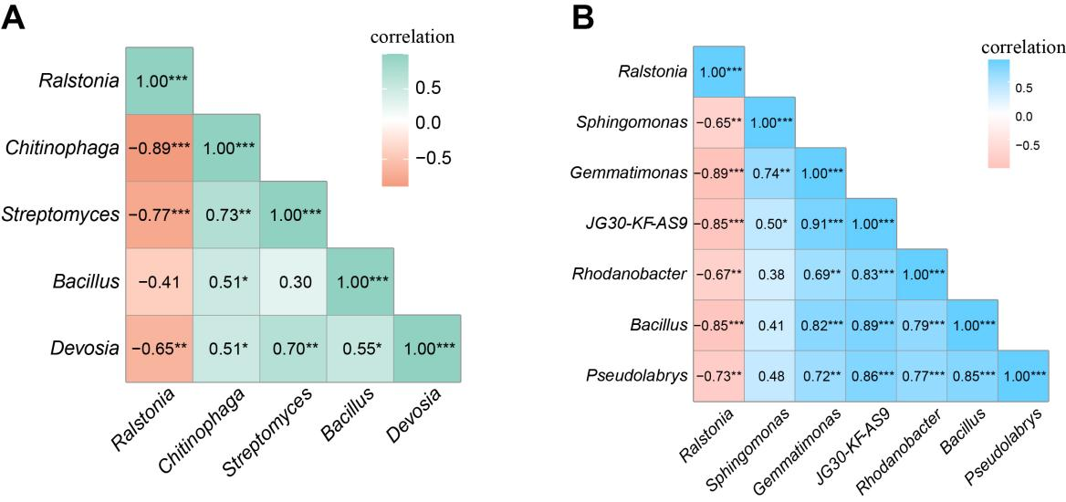
Figure S2. Shows the correlation between the relative abundance of differential bacterial genera. A The spearman correlation of bacterial genera that have significant differences in THR and TDR. B The spearman correlation of bacterial genera that have significant differences in PHR and PDR. * P < 0.05; ** P < 0.01; *** P < 0.001.

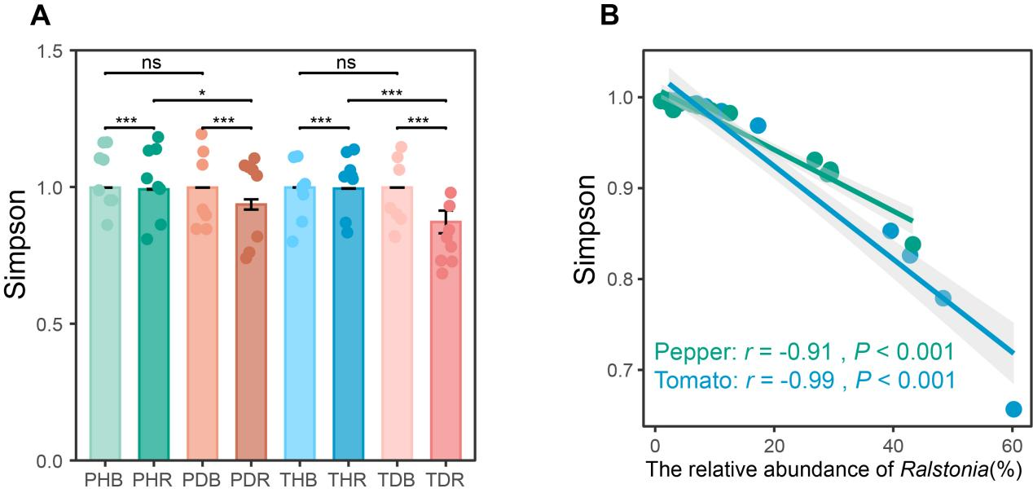
Figure S3. The Simpson index of rhizosphere bacteria. A The alpha diversity of bacterial community in different treatments. “ns” represents no significant difference in alpha diversity between treatments, * P < 0.05; ** P < 0.01; *** P < 0.001. B The spearman correlation between the relative abundance of Ralstonia and alpha diversity index. PHB, bulk of healthy pepper; PHR, rhizosphere of healthy pepper; PDB, bulk of diseased pepper; PDR, rhizosphere of diseased pepper; THB, bulk of healthy tomato; THR, rhizosphere of healthy tomato; TDB, bulk of diseased tomato; TDR, rhizosphere of diseased tomato.

Table S1. Pairwise differences in root exudates composition between treatments were assessed using the pairwise. Adonis function, and the P-value was corrected using FDR. * P < 0.05; ** P < 0.01; *** P < 0.001.
Pair | F | R² | P-value | Significance
PHR_PDR | 19.57 | 0.58 | 0.0036 | **
THR_TDR | 3.37 | 0.19 | 0.024 | *
THR_ PHR | 9.90 | 0.41 | 0.0015 | **
TDR_PDR | 13.30 | 0.49 | 0.0015 | **

Table S2. The relative abundance of the top 10 bacterial phyla in different treatments of tomato and pepper. Capital letters denote significant differences in the relative abundance of phyla between pepper treatments, and lowercase letters denote significant differences in the relative abundance of phyla between tomato treatments (P < 0.05).
 | PHB | PHR | PSB | PSR
Proteobacteria | 28.17±2.10C | 39.85±5.05B | 31.84±2.06C | 54.38±9.80A
Actinobacteria | 18.84±2.61A | 19.38±2.48A | 16.74±1.94A | 16.30±4.00A
Chloroflexi | 9.70±0.98A | 6.21±1.38B | 9.54±1.40A | 5.51±1.17B
Bacteroidetes | 6.33±2.48B | 16.99±4.55A | 6.97±2.62B | 8.84±2.38B
Acidobacteria | 6.96±1.38A | 3.10±1.07B | 8.39±0.98A | 2.93±0.75B
Firmicutes | 11.70±4.52A | 3.24±1.01B | 8.63±2.32A | 2.06±0.69B
Gemmatimonadetes | 7.47±1.59A | 2.64±0.32B | 6.56±1.18A | 2.20±0.49B
Myxococcota | 2.53±0.55A | 2.40±0.81A | 2.79±0.34A | 2.33±0.62A
Planctomycetes | 2.50±0.27A | 3.05±1.01A | 2.32±0.32A | 2.78±1.27A
Verrucomicrobia | 1.82±0.34AB | 1.58±0.31AB | 2.15±0.57A | 1.32±0.57B
 | THB | THR | TSB | TSR
Proteobacteria | 24.00±2.85c | 44.93±4.08b | 24.49±3.97c | 63.40±10.71a
Actinobacteria | 23.94±3.08a | 17.87±5.86b | 23.43±5.99a | 14.08±5.42b
Chloroflexi | 17.07±3.13a | 6.67±1.24b | 15.87±2.74a | 3.98±1.18b
Bacteroidetes | 2.53±0.88b | 7.89±0.94a | 2.49±0.68b | 5.96±2.45a
Acidobacteria | 8.70±1.70a | 5.96±1.44b | 9.52±2.37a | 3.54±1.18c
Firmicutes | 7.00±1.39a | 4.17±1.19b | 6.17±1.32a | 2.13±0.58c
Gemmatimonadetes | 3.59±0.62a | 3.28±0.44b | 4.36±0.92a | 1.97±0.63c
Myxococcota | 2.53±0.33a | 2.72±0.62a | 2.85±0.45a | 1.64±0.49b
Planctomycetes | 1.99±0.46a | 2.05±0.37a | 1.69±0.26a | 1.13±0.47b
Verrucomicrobia | 2.61±0.36a | 2.51±1.01a | 2.33±0.50a | 1.19±0.31b

Table S3. Pairwise differences in bacterial community composition between treatments were assessed using the pairwise. Adonis function, and the P-value was corrected using FDR. “ns” represents no significant difference in community composition between treatments, * P < 0.05; ** P < 0.05; *** P < 0.001.
Pair | F | R² | P-value | Significance
THR_THB | 9.87 | 0.41 | 0.0014 | **
TDR_TDB | 13.90 | 0.50 | 0.0014 | **
THR_TDR | 4.85 | 0.26 | 0.0022 | **
THB_TDB | 1.03 | 0.07 | 0.383 | ns
PHR_PHB | 7.15 | 0.34 | 0.0014 | **
PDR_PDB | 9.47 | 0.40 | 0.0014 | **
PHR_PDR | 3.57 | 0.20 | 0.0022 | **
PHB_PDB | 1.29 | 0.08 | 0.0519 | ns
THR_PHR | 9.52 | 0.40 | 0.0014 | **
THB_PHB | 6.96 | 0.33 | 0.0014 | **
TDR_PDR | 4.94 | 0.26 | 0.0014 | **
TDB_PDB | 6.32 | 0.31 | 0.0014 | **

Table S4. Pairwise differences in KO functional categories between treatments were assessed using the pairwise. Adonis function, and the P-value was corrected using FDR. “ns” represents no significant difference in community composition between treatments, * P < 0.05; ** P < 0.05; *** P < 0.001.
Pair | F | R² | P-value | Significance
THR_THB | 3.34 | 0.19 | 0.0811 | ns
TDR_TDB | 22.42 | 0.62 | 0.0047 | **
THR_TDR | 10.11 | 0.42 | 0.01 | **
THB_TDB | 1.19 | 0.08 | 0.3114 | ns
PHR_PHB | 5.12 | 0.27 | 0.0263 | *
PDR_PDB | 32.55 | 0.70 | 0.0047 | **
PHR_PDR | 11.14 | 0.44 | 0.0076 | **
PHB_PDB | 2.49 | 0.15 | 0.1642 | ns
THR_PHR | 1.62 | 0.10 | 0.2298 | ns
THB_PHB | 1.13 | 0.03 | 0.523 | ns
TDR_PDR | 0.48 | 0.07 | 0.3338 | ns
TDB_PDB | 0.97 | 0.06 | 0.3464 | ns

