Supporting Information for the research paper

“MRI and HR-MAS NMR spectroscopy to correlate structural characteristics and the metabolome of Fiano and Pallagrello grapes with the action of field spray preparation 500 and the soil spatial microvariability”

For the collection “The scientific bases of biodynamic agriculture”

Pierluigi Mazzei*^{,1}, Andrea Sica¹, Claudio Migliaro¹, Gessica Altieri¹, Nicola Funicello², Salvatore De Pasquale², Alessandro Piccolo³ & Giuseppe Celano¹

*Correspondence: pmazzei@unisa.it

¹ University of Salerno, Department of Pharmacy, Via Giovanni Paolo II, 132, Fisciano, Italy
² University of Salerno, Department of Physics, Via Giovanni Paolo II, 132, Fisciano, Italy
³ University of Naples “Federico II”, Department of Agriculture, Via Università 100, Portici, Italy

Supporting Figure: 4
Supporting Tables: 3
Supporting Videos: 2

Supporting Figures
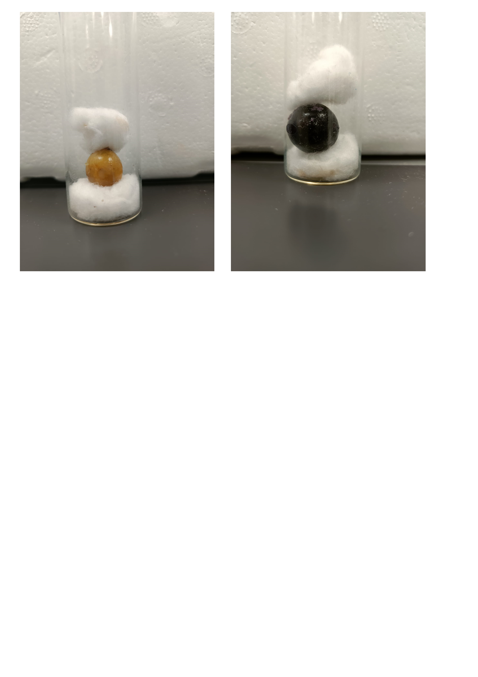
Supporting Fig. S1 Representative Fiano (on the left) and Pallagrello Rosso (on the right) berries, loaded into a sterilized 25 mm MRI tube sample, supported and stabilized by inert material on the bottom and the top.

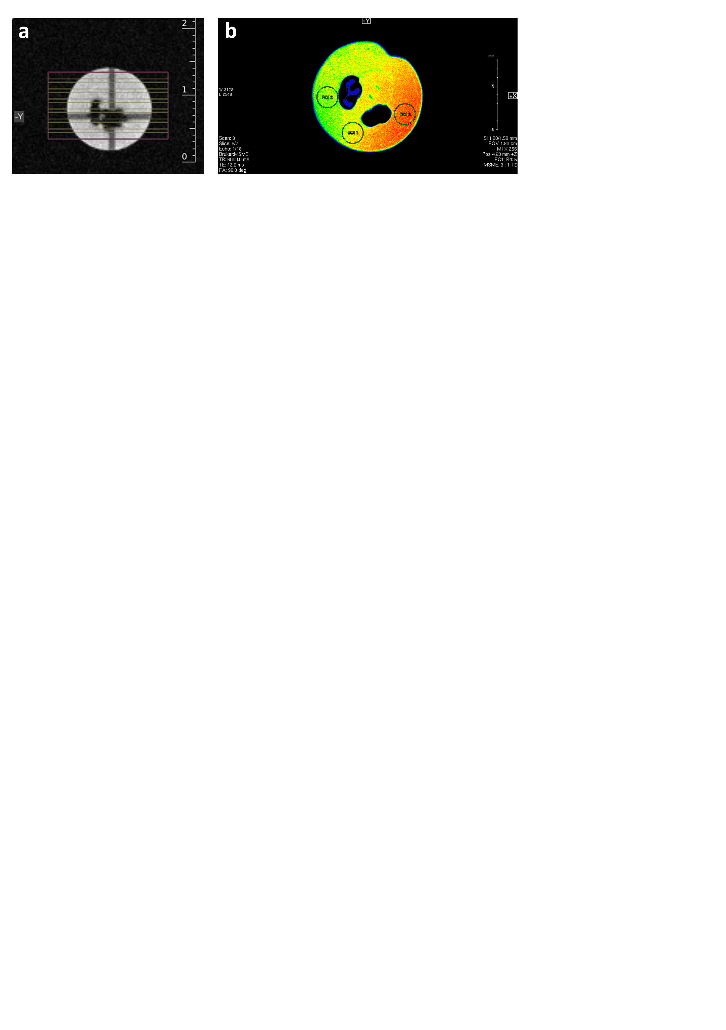
Supporting Fig. S2 (a) Axial geometry scheme applied to a representative grape berry and composed by slices with a thickness of 1 mm and a visual window of 18 x 18 mm². (b) Axial image of a grape berry in which they are shown circular ROIs, each of 0.4 mm².

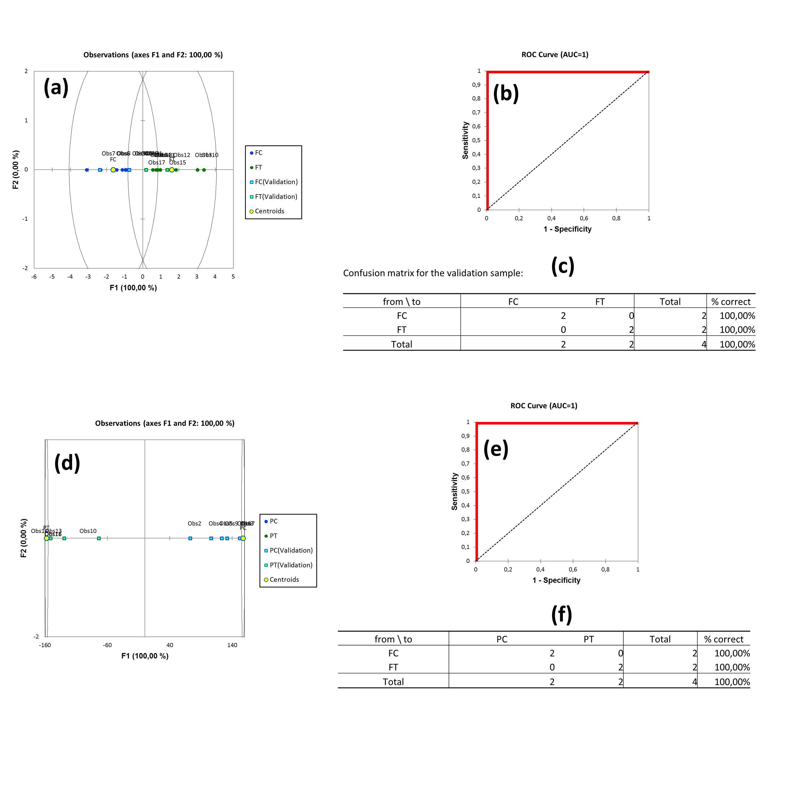Supporting Fig. S3. Discriminant Analysis of Pallagrello (P) and Fiano (F) grapes treated (T) and untreated (C) with p500: (a and d) PLS-DA Cross-validation score-plots, with full (training-set) and holed (test-set) circles corresponding to C and T samples, respectively; (b and e) PLS-DA Receiver Operator Characteristics (ROC) curve (red segments), including the value of the Area Under the Curve (AUC); (c and f) PLS-DA cross-validation results.

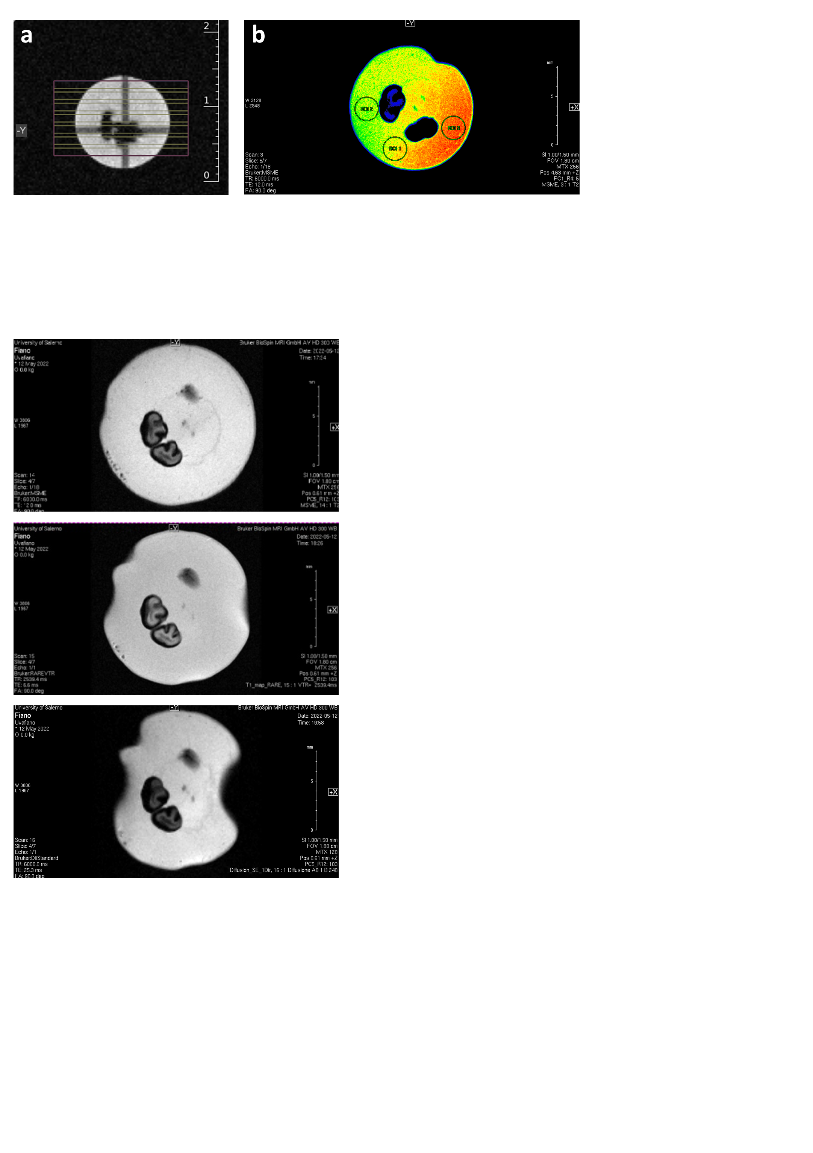
Supporting Fig. S4 Central slice of a representative Pallagrello berry sample after the progressive conclusion of T2, T1 and DIFF experiments (from top to the bottom, respectively).The progressive collapse of the fruit is proved by the increasingly pronounced loss of a spherical shape.

Supporting Tables

Supporting Tab. S1: Types of grape variety, sample lables referring to the map in Fig. 1, p500 treatment, Type of ECa response (H, high; L, Low).
Grape variety | Sample identification | p500 treatment | ECa response | Sample label
Pallagrello Nero | PT1 | Yes | L | PT_L
Pallagrello Nero | PT2 | Yes | H | PT_H
Pallagrello Nero | PC3 | No | H | PC_H
Pallagrello Nero | PC5 | No | L | PC_L
Fiano | FT1 | Yes | H | FT_H
Fiano | FT5 | Yes | L | FT_L
Fiano | FC1 | No | H | FC_H
Fiano | FC3 | No | L | FC_L

Supporting Tab. S2: Average values and standard deviations of relaxation times (T1 and T2) and diffusion coefficients (DIFF) of Fiano grapes (control, FC, and treated, FT), collected at points with low (L) and high (H) apparent soil electrical conductivity.
 | FC_H | FT_H | FC_L | FT_L
T₂  (ms) | 43,36  ±  0,15 | 53,22  ±  1,93 | 48,79  ±  1,58 | 39,56  ±  0,10
T₁  (ms) | 1489,49  ±  20,77 | 1430,74  ±  12,79 | 1220,36  ±  14,13 | 1419,43  ±  42,54
Diffusion Coefficients  (mm²/s *10⁻³) | 1,213  ±  0,007 | 1,413  ±  0,020 | 1,305  ±  0,008 | 1,292  ±  0,008

Supporting Tab. S3: Results (averages)of ANOVA test (Fisher and Tukey, 0.05 level of significance) by comparing relaxation times (T₁ and T₂) and diffusion coefficients (DIFF) of Fiano grapes (control, FC, and treated, FT), collected at points with low (L) and high (H) apparent soil electrical conductivity.
 | T₂  (ms) | Significantly different groups
FT H | 53,223 | A
FC L | 48,789 |  | B
FC H | 43,364 |  |  | C
FT L | 39,560 |  |  |  | D
 | T₁  (ms) | Significantly different groups
FC H | 1489,491 | A
FT H | 1430,741 | A | B
FT L | 1419,428 |  | B
FC L | 1220,361 |  |  | C
 | Diffusion coefficients  (mm²/s *10⁻³) | Significantly different groups
FT H | 1,413 | A
FC L | 1,306 |  | B
FT L | 1,292 |  | B
FC H | 1,213 |  |  | C

Supporting Video

Video clip 1. 3D projection of an intact Fiano grape berry rotating around the z axis and obtained by setting a rare 3D pulse sequence with a rare factor of 3. (the file has been uploaed as figure)

Video clip 2. Bottom-up sequence of axial slices of an intact Fiano grape berry (the file has been uploaed as figure)

