Table S1. Dynamics of basal respiration in soil-polymer mixtures with the application of PE-formulations
 |  | 1* | 2 | 3 | 4
A | Basal respiration, µg C-CO₂∙g⁻¹∙day⁻¹ | 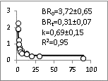 | 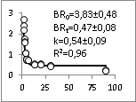 | 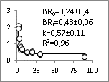 | 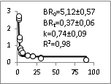
B | Basal respiration, µg C-CO₂∙g⁻¹∙day⁻¹ | 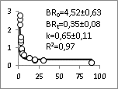 | 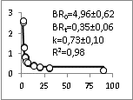 | 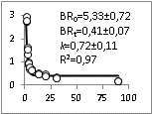 | 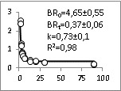
C | Basal respiration, µg C-CO₂∙g⁻¹∙day⁻¹ | 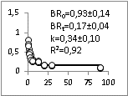 | 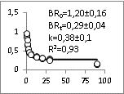 | 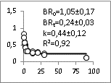 | 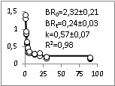
D | Basal respiration, µg C-CO₂∙g⁻¹∙day⁻¹ | 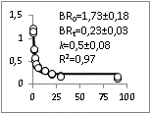 | 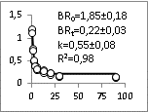 | 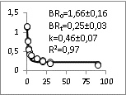 | 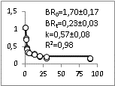
Time, day
Sample designations: A1-B4 are treatments without HM: Control (A1), LH (A2), SH (A3), HYPAN (A4), HYPAN/LH 1/1 (B1), HYPAN/SH 1/1 (B2), HYPAN/LH 1/2 (B3), and HYPAN/SH 1/2 (B4). C1-D4 are HM-spiked treatments: Control+HM (C1), LH+HM (C2), SH+HM (C3), HYPAN+HM (C4), HYPAN/LH 1/1 +HM (D1), HYPAN/SH 1/1+HM (D2), HYPAN/LH 1/2+HM (D3) +HM, and HYPAN/SH 1/2 +HM (D4).

