Supplementary Materials

Sustainable production of a highly pure (R,R)-2,3-butanediol from crude glycerol using metabolically engineered Klebsiella pneumoniae GEM167 strain

Min-Ho Jo ^{1, 2}, Jung-Hyun Ju ¹, Sun-Yeon Heo ¹, Ki Jun Jeong ² and Baek-Rock Oh ^{1, *}

¹ Microbial Biotechnology Research Center, Jeonbuk Branch Institute, Korea Research Institute of Bioscience and Biotechnology, Jeongeup, Jeonbuk 56212, Republic of Korea.
² Department of Chemical and Biomolecular Engineering and Institute for the BioCentury, KAIST, Daejeon 34141, Republic of Korea

* Correspondence:
Baek-Rock Oh, Microbial Biotechnology Research Center, Jeonbuk Branch Institute, Korea Research Institute of Bioscience and Biotechnology (KRIBB), Jeongeup, Jeonbuk 56212, Republic of Korea. Tel: +82 63 570 5117; Fax: +82 63 570 5160; E-mail: baekrock.oh@kribb.re.kr (B. R. Oh)
Supplementary Figures
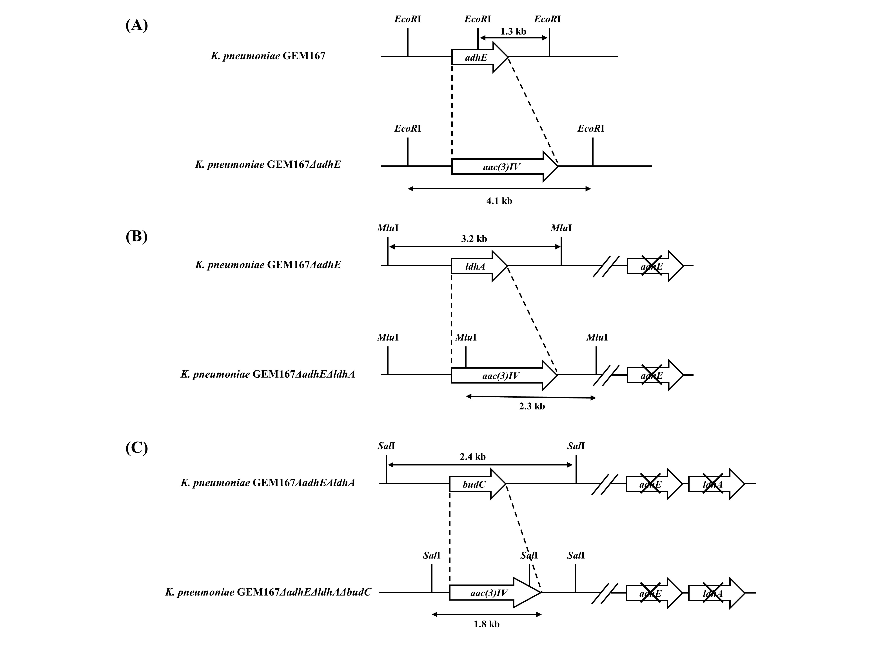
Fig. S1. Construction of specific gene-deficient K. pneumoniae GEM167 mutant strain by substitution of genes with an apramycin-resistance gene [aac(3)IV] via homologous recombination. (A) aldehyde dehydrogenase (adhE); (B) lactate dehydrogenase ldhA; (C) acetoin reductase budC.
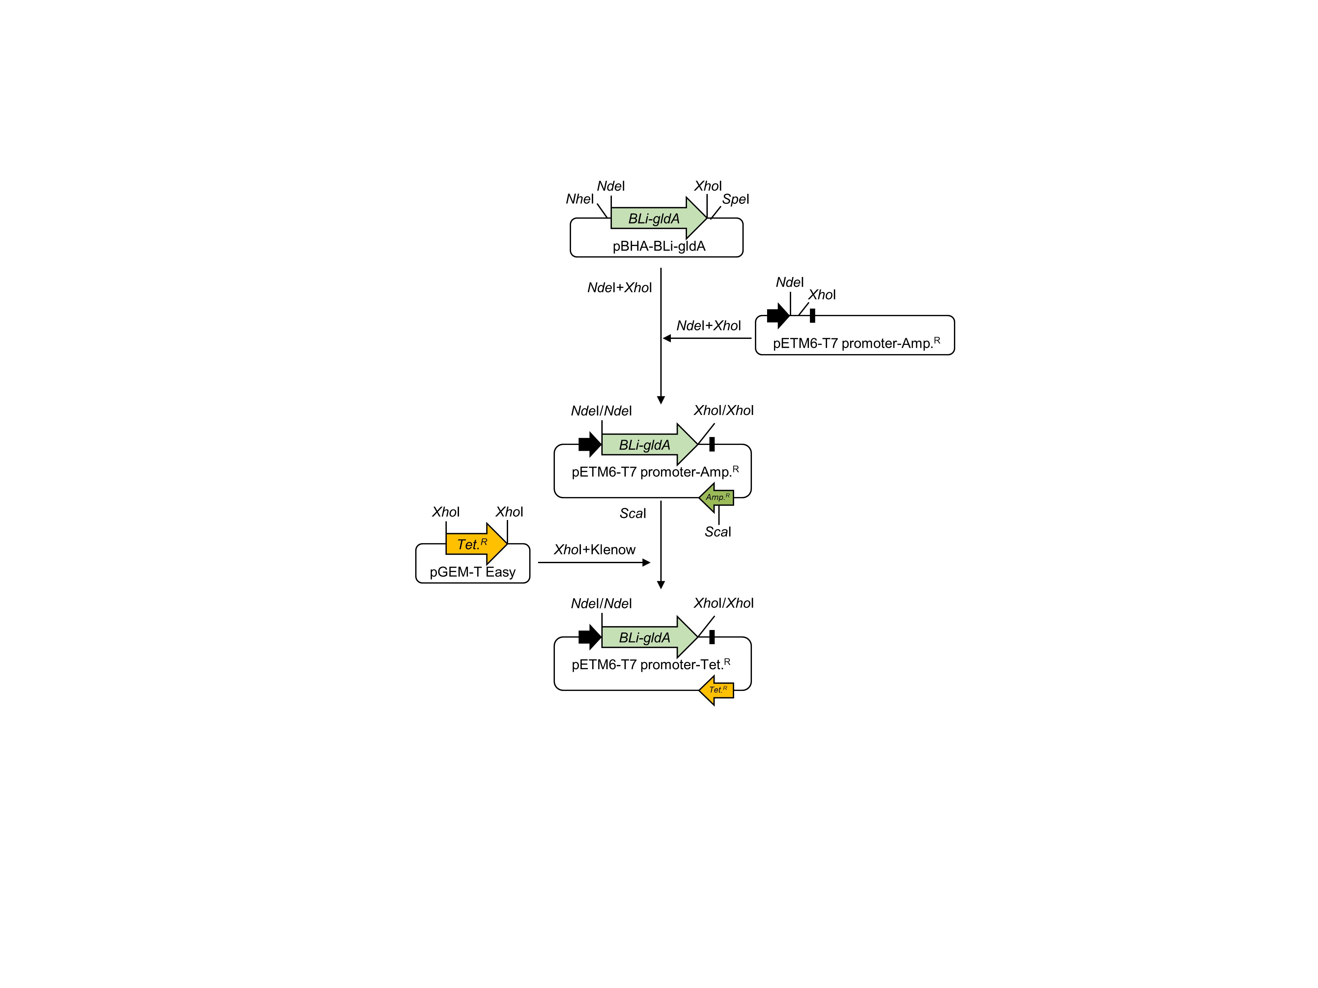
Fig. S2. Schematic representation of plasmid construction for expression of gldA gene from Bacillus licheniformis.

Table S1. Oligonucleotides used in this study
Gene | Region | Primer | Sequence (5’-3’)
adhE | Upstream | P1 | TCCGCAGCATCATCAAAATTGGCG
adhE | Upstream | P2 | ACCGGAGCAACTTCGGCTTTCGATATCATTCGAGCATCTGCAGCGGC
adhE | Upstream | P5 | TCGAACAGTGATTGAGTCAC
adhE | Downstream | P3 | GCCGCTGCAGATGCTCGAATGATATCGAAAGCCGAAGTTGCTCCGGT
adhE | Downstream | P4 | TGTATAATCCACAGACCTCGTTA
adhE | Downstream | P6 | AAGTCAGTTCGCGTATCGG
ldhA | Upstream | P1 | CAGCCAGACGGGAATAGCTT
ldhA | Upstream | P2 | CGCCAATTTTCTGGTGCTTCAGATATCGCCTCAAGGTCGACGTTGTTAA
ldhA | Upstream | P5 | CGACGTTCGGCCATTATCAT
ldhA | Downstream | P3 | TTAACAACGTCGACCTTGAGGCGATATCTGAAGCACCAGAAAATTGGCG
ldhA | Downstream | P4 | AGCTCGATGGTTCGGCGATT
ldhA | Downstream | P6 | AACTGCGCCATGATAGGCG
budC | Upstream | P1 | ATCACAATAAGGAAAGGAAA
budC | Upstream | P2 | CGGTCATATAATCAGAATCCGGTTAACCCTTTAACGTTGATGTTG
budC | Upstream | P5 | CCGGATGTCGAGCTGGTG
budC | Downstream | P3 | CAACATCAACGTTAAAGGGTTAACCGGATTCTGATTATATGACCG
budC | Downstream | P4 | ATTTGGTTCCTCAATTTTATAG
budC | Downstream | P6 | TATCCAATGGAATTTATGAGGG
Italicized letters indicate restriction enzyme sites (GATATC, EcoRV; GTTAAC, HpaI)

