Supplementary information
Study on application of green sythesized ZnO and Si nanoparticles in enhancing aquaculture sediment quality
Yaoqiang Zhu^{1,2#}, Weidong Li^{1,2#}, Waqas Ahmed^{1,2}, Mohsin Mahmood^{1,2}, Hayssam M. Ali³, Muhammad Rizwan⁴, Jochen Bundschuh⁵, Muhammad Akmal⁶, Sajid Mehmood^{1,2*}
¹College of Ecology, Hainan University, Haikou City, 570100, P.R China
² Center for Eco-Environment Restoration Engineering of Hainan Province, Hainan University, Haikou, 570228, China.
³Department of Botany and Microbiology, College of Science, King Saud University, 11451-Riyadh, Saudi Arabia
⁴Agricultural Research Station, Office of VP for Research & Graduate Studies, Qatar University, 2713 - Doha, Qatar
⁵Faculty of Health, Engineering and Sciences, University of Southern Queensland, Toowoomba, 4350 QLD, Australia
⁶Institute of Soil and Environmental Sciences, PMAS- Arid Agriculture University Rawalpindi 46300, Pakistan
#These authors contributed equally to this paper
*Corresponding author
Dr. Sajid Mehmood: E-mail: drsajid@hainanu.edu.cn
Section S1. Preparation of plant extract
Briefly, Azola Pinnata and horsetail plants, upon collection, underwent multiple washes with ultra-pure deionized water to eliminate dust particles. Subsequently, the plants were air-dried at room temperature (25 °C) for six days until a stable weight was achieved. The dried plants were finely powdered using a Worbush grinder (Dongguan Huatai Electric Appliances Co. Ltd., China) for a duration of four minutes. Following this, finely powdered plants material was subjected to heating in 100 mL of deionized water for 45 minutes at 55 °C. The heated leaves were then filtered and employed for the green synthesis of zinc oxide nanoparticles (GSZnONPs) and silica nanoparticles (GSSiNPs).
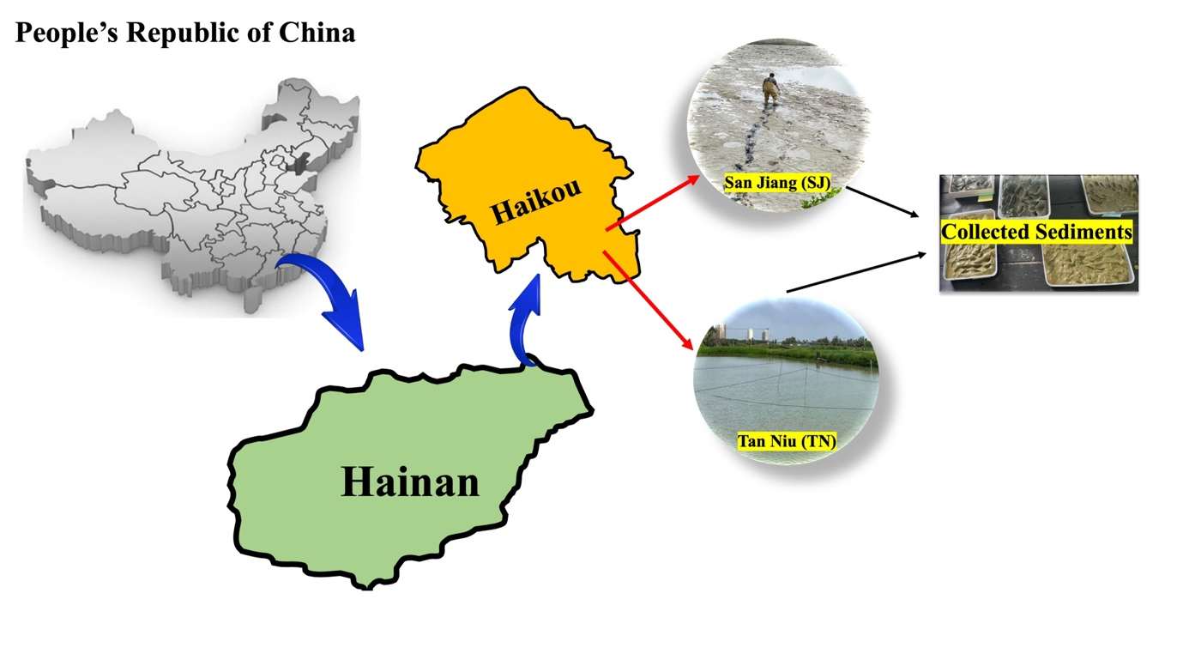
Figure S1. Fish pond sediments sites in San Jiang and Tan Niu in eastern Hainan Province, China.

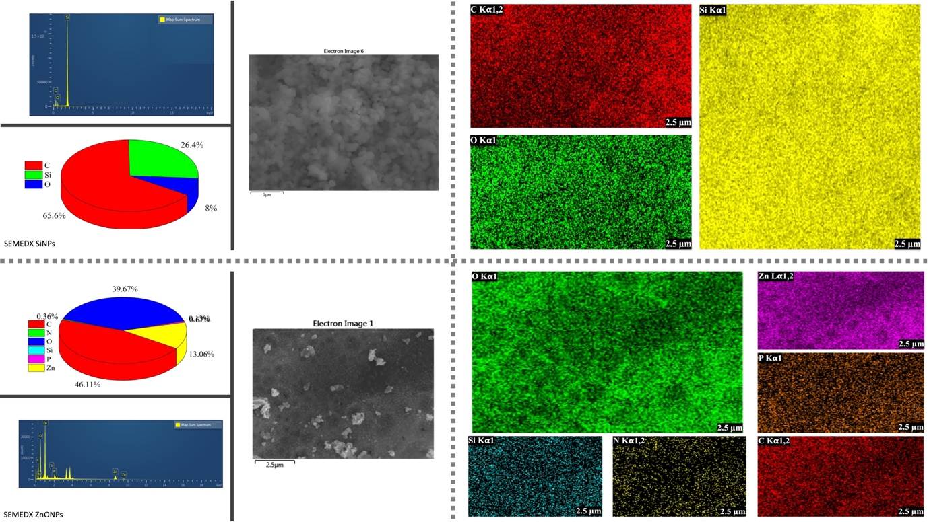
Figure S2: Elemental mapping of Green synthesised silicon nanoparticles (GSSiNPs) and green synthesised zinc oxide nanoparticles (GSZnONPs).

Table S1. Basic attributes of green sythesised nanoparticles, Azzola pinnata (AP) and horsetail plant (HP).

Item | Unit | GSZnONPs | GSSiNPS | AZ | HP
pH | —— | 8.550 | 8.910 | 5.400 | 6.420
EC | mS/cm | 31.000 | 60.000 | 0.212 | 0.432
C | Atomic % | 46.100 | 65.300 | 72.700 | 19.68
N | Atomic % | 0.360 | 0.100 | 2.300 | 1.44
O | Atomic % | 39.660 | 8.000 | 17.800 | 63.57
Si | Atomic % | 0.130 | 26.100 | 0.200 | 15.22
P | Atomic % | 0.670 | 0.500 | 1.000 | 0.09
Cd | mg/kg | nd | nd | nd | nd
Cu | mg/kg | nd | nd | nd | nd
Hg | mg/kg | nd | nd | nd | nd
Zn | mg/kg | 41.210 | nd | nd | nd
Cr | mg/kg | nd | nd | nd | nd
BET Surface Area | m²/g | 18.9884 | 13.7071 | 0.1348 | 0.0066
t-Plot External Surface Area | m²/g | 16.7158 | 13.7141 | -0.653 | -0.0933
Single point surface area at P/Po | m²/g | 18.7299 | 13.2486 | 0.1287 | 0.0059

GSZnONPs (green synthesized zinc oxide nanoparticles); GSSiNPS (green synthesized silicon nanoparticles).
Table S2: The BCR sequential extraction procedure ª (Rauret et al., 1999)

Step No. | Fraction | Reagent | Experimental conditions
1 | Acid soluble fraction (F1) | 20 mL of 0.11 mol L⁻¹ acetic acid solution | Room temp.16 h, constant shaking
2 | Reducible fraction (F2) | 20 mL of 0.5 mol L⁻¹ hydroxyl amine hydrochloride solution at pH 1.5 (with nitric acid) | Room temp.16 h, constant shaking
3 | Oxidizable fraction (F3) | 5 mL of 30%, w/v, H₂O₂  5 mL of 30%, w/v, H₂O₂  15 mL of 1mol L⁻¹ ammonium acetate at pH 2 | Room temp. 1 h, occasional agitation + 85 ◦C, 1h  85 ◦C, 1 h, Reduce the volume to a few mL  Room temperature, 16 h, constant shaking
4 | Residual Fraction (F4) | Soil residues were digested with HCl: HNO₃:HClO₄ acids | Wet oxidation digestion (25 ml)
ª For 0.5-g sample. [1]

Table S3. Basic attributes of sediments from San Jiang (SJ) and Tan Niu (TN) before and after addition of green synthesized (GS) zinc oxide (ZnO) and silicon (Si) nanoparticles.

Item |  | Unit | SJ | GSZnONPs | GSSiNPs | TN | GSZnONPs | GSSiNPs
H |  | % | 0.837 | 0.910 | 0.806 | 0.672 | 0.865 | 0.795
pH |  | —— | 8.610 | 9.360 | 8.660 | 6.590 | 7.160 | 6.790
OC |  | g/kg | 21.000 | 22.843 | 20.832 | 11.800 | 15.187 | 13.962
TN |  | g/kg | 2.110 | 2.295 | 2.073 | 1.590 | 2.046 | 1.881
Na |  | g/kg | 5.900 | 6.245 | 5.382 | 1.300 | 1.542 | 1.457
Ca |  | g/kg | 11.400 | 12.150 | 11.650 | 1.600 | 1.937 | 1.818
Mg |  | g/kg | 4.100 | 4.325 | 4.235 | 2.100 | 2.465 | 2.337
A.Phosp |  | mg/kg | 48.800 | 50.941 | 49.411 | 200.000 | 227.497 | 217.935
a.Sulpher |  | mg/kg | 180.000 | 191.487 | 184.308 | 149.000 | 179.386 | 168.625
EC |  | mS/m | 121.000 | 126.792 | 125.826 | 13.390 | 15.760 | 15.921
Exch. Potasium |  | mg/kg | 1.540 | 1.685 | 1.557 | 0.280 | 0.330 | 0.331
Particle composition | 2.0~1.0mm | g/kg | 1.100 |  |  | 1.700
 | 1.0~0.5mm | g/kg | 1.400 |  |  | 2.200
 | 0.5~0.25mm | g/kg | 2.600 |  |  | 8.300
 | 0.05~0.02mm | g/kg | 116.700 |  |  | 90.900
 | 0.02~0.002mm | g/kg | 321.900 |  |  | 288.800
 | <0.002mm | g/kg | 89.300 |  |  | 236.300
 | 0.25~0.05mm | g/kg | 467.000 |  |  | 371.800
 | 2.0~0.05mm | g/kg | 472.100 |  |  | 384.000
 | 0.05~0.002mm | g/kg | 438.600 |  |  | 379.700
Texture |  |  | Loam |  |  | Loam
Carbon |  | % | 2.340 | 2.545 | 2.362 | 1.320 | 1.699 | 1.562
Cu |  | mg/kg | 9.000 | 7.382 | 8.282 | 18.000 | 14.027 | 15.243
Zn |  | mg/kg | 40.000 | 29.703 | 36.490 | 28.000 | 21.257 | 23.302
Cr |  | mg/kg | 53.000 | 37.384 | 48.349 | 38.000 | 28.849 | 31.624

Reference:
1. Rauret, G. et al. (1999) Improvement of the BCR three step sequential extraction procedure prior to the certification of new sediment and soil reference materials. J. Environ. Monit. 1, 57–61

