Genome-wide analysis of DnaJA proteins in Nicotiana tabacum reveals that NtDnaJA3 responses to drought stress
Qiao Wang^{1,2}, Lijun Meng², Zechao Qu², Huan Su^{1,2}, Jiemeng Tao^{1,2}, Peng Lu^{1,2}, Chenfeng Hua¹, Jinbang Wang³, Jianfeng Zhang^{1,2}, Peijian Cao^{1,2,3*}, Jingjing Jin^{1,2*}
¹Beijing Life Science Academy, Beijing 102200, China
²China Tobacco Gene Research Center, Zhengzhou Tobacco Research Institute of CNTC, Zhengzhou 450001, China
³China Tobacco Science and Technology Information Center, Zhengzhou Tobacco Research Institute of CNTC, Zhengzhou, 450001, China
⁴School of Agricultural Sciences, Zhengzhou University, Zhengzhou 450001, China
*Correspondence: jinjingjing1218@126.com; peijiancao@163.com

Figure S1 The number of DnaJA genes identified in tobacco based on conserved domains and homolog analysis.

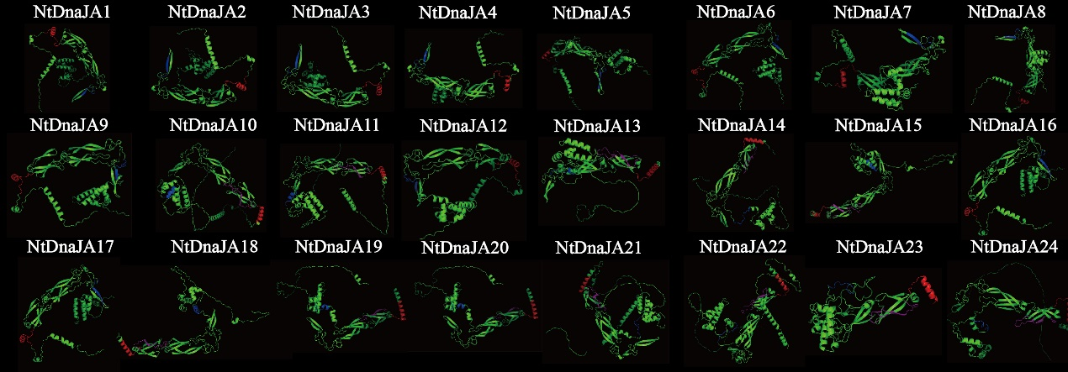
Figure S2 The predicted three-dimensional structure of NtDnaJA genes.
Note: Motif 10 is shown in red; motif 11 is represented in purple; and motif 12 is depicted in blue.

Figure S3 The chromosomal localization of NtDnaJA genes in tobacco.
Figure S4 The number of miRNAs and transcription factors (TFs) predicted to target the NtDnaJA genes in tobacco.
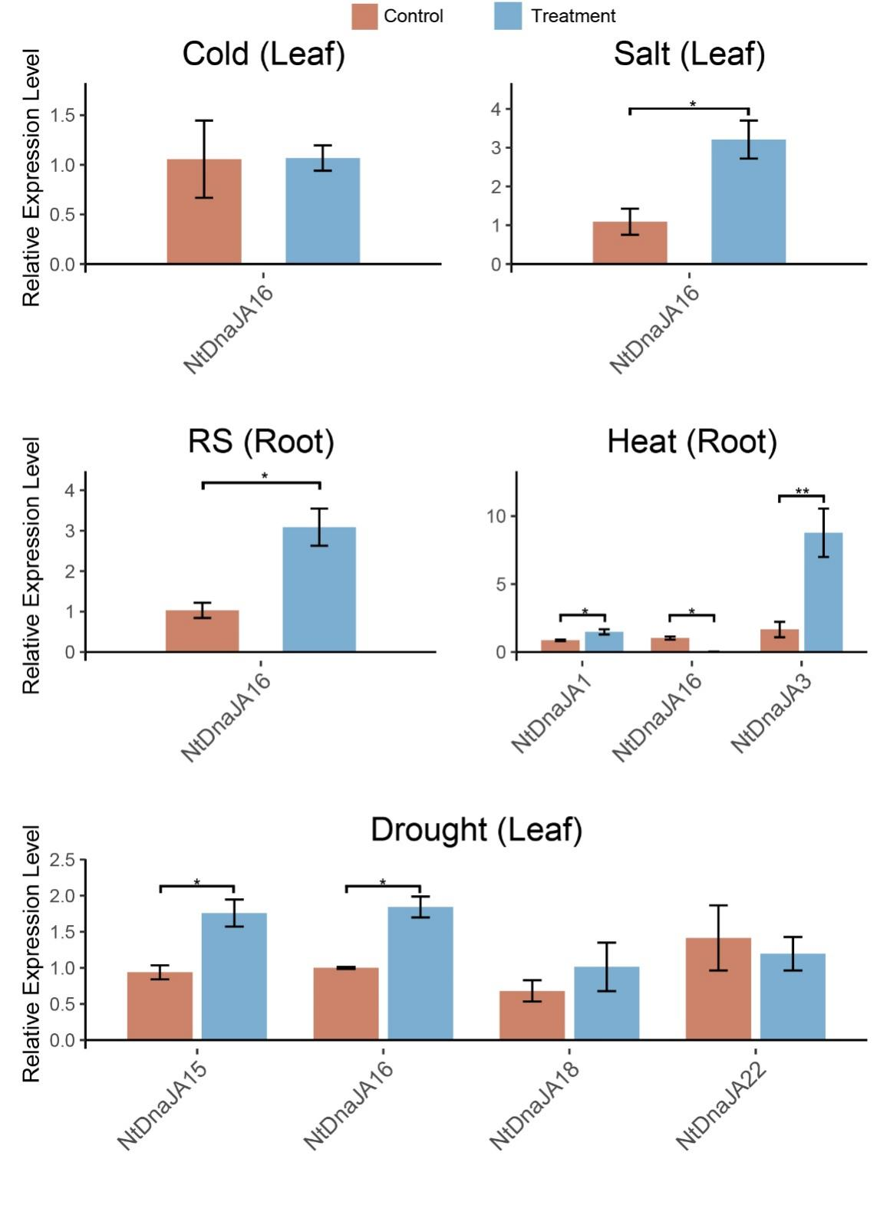
Figure S5 qRT-PCR analysis of six NtDnaJA genes under cold, Salt, RS, Heat, Drought treatment. Data are presented as mean ± SEM from three independent biological replicates (N=3). Statistical significance is indicated by asterisks: * for p < 0.05, ** for p < 0.01, and *** for p < 0.001.

