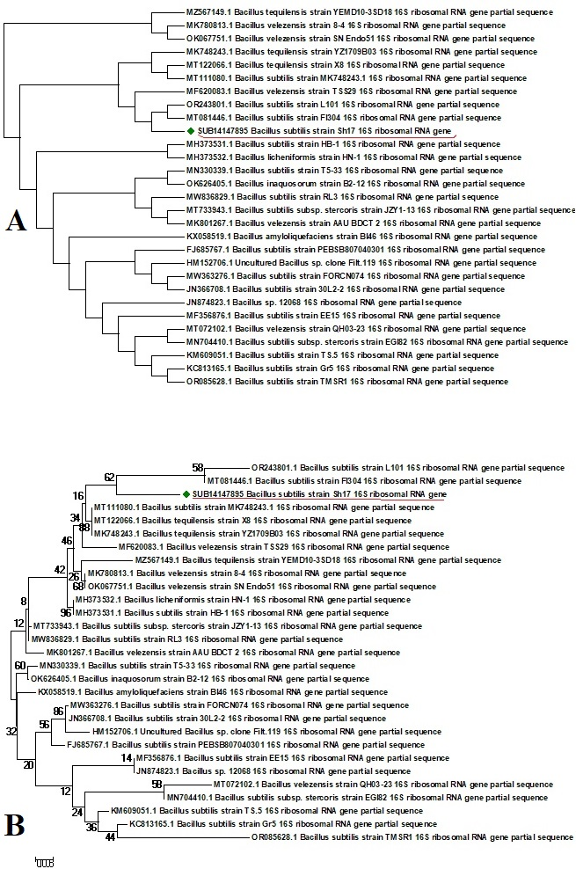

Supplementary Figure S1: Maximum likelihood consensus phylogenetic tree of the tested bacteria from highly conserved sequences obtained from blast for the strains Sh-17. The numbers on the nodes are bootstrap values inferred from 1,000 replicates. (A) bootstrapped tree. (B) The normal tree was obtained without bootstrap values generated through Mega-10 software.

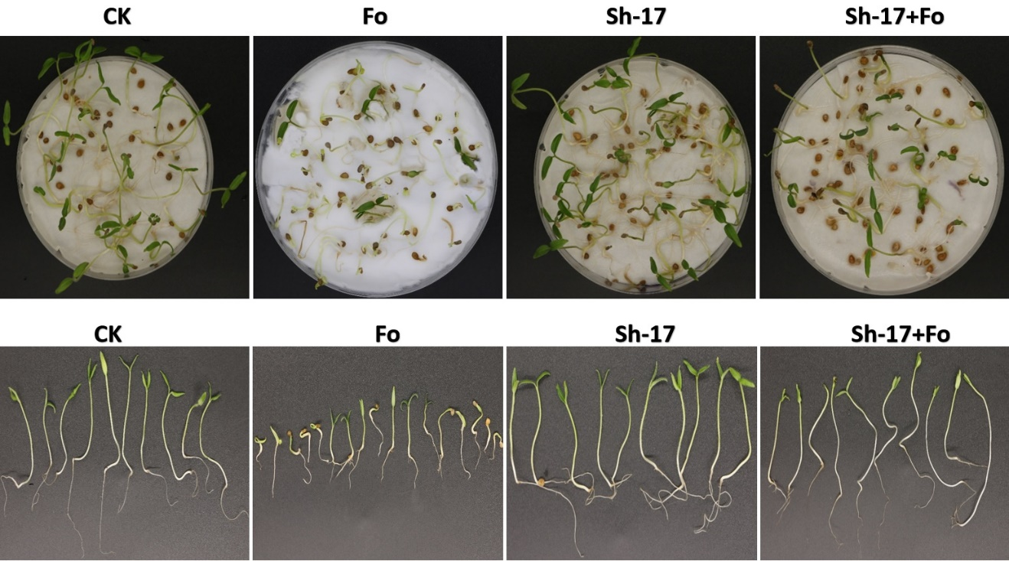
Supplementary Figure S2: Effect of B. subtilis Sh-17 on the germination of tomato seedlings grown on petri plates. (A) petri dishes representing treatments groups. CK; Maximum seedlings germinated showed normal and healthy growth. FOL; Pathogen treated seeds germination is lowest with stunted growth and diseased seedlings. Sh-17; Seeds treated with biocontrol agent displayed maximum germination rate with good growth and healthy plants. Sh17+Fo; Seedlings treated with both FOL and Sh-17 showing a comparatively low germination rate as compared to control group. (B) Individual plants representing their growth.

Supplementary Figure S3: PCR detection of antifungal LPs biosynthetic genes in B. siamensis Sh-17. (A) From left to right (2000 DNA Marker), Srf (Surfactin); (B) ItuA (Iturin); (C) bacA (Bacilysin); (D) dfnA (difficidin).
Supplementary Figure S4: The chemical structures of lipopeptides detected through LC-MS and PCR using primers from previous literature. The LPs are fengycin, Iturin, surfactin, bacilysin, bacillomycin D, fengycin, iturin, bacillomycin D and difficidin.

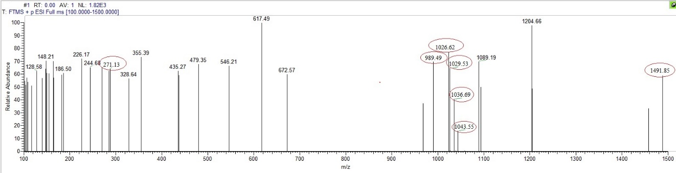
Supplementary Figure S5: LC-MS analysis of B. subtilis Sh-17 showing the encircled antifungal lipopeptides Bacilysin with m/z (271.13), Bacillomycin D (989.49 m/z), Surfactin (1026.62 m/z), Iturin A (1029.53 m/z), Surfactin (1036.692 m/z), Iturin D (1043.55 m/z) and Fengycin B (1491.85 m/z).

Supplementary Table T1: Lipopeptide screening using specific Primers used in this study to detect the LP’s biosynthetic genes through PCR
Lipopeptides | LP’S Homologs | Fragment Size (bp) | Primers | Reference
Surfactin | Srf | 1298 | srf-F  CGGTGATCTTGCGAAGCTTTAT  Srf-R  CGCTTTCGTTCTGCCATTCT | (Ahmad et al., 2023)
Iturin | ItuA | 1047 | ItuA-F  ATGTATACCAGTCAATTCC  ItuA-R  GATCCGAAGCTGACAATAG | (张学雯 et al., 2019)
Difficidin | dfnA | 900 | dfnA-F  CAGGCGGAATAGGAGAAGTATGCG  dfnA-R  CGGCAGCCGATTGAAATAAC | (Hazarika et al., 2019)
Bacilysin | bacA | 990 | bacA-F  AGACTCCACCAAGGCAAATC  bacA-R  CAGCGGCTTCATGTCATACT | (Hazarika et al., 2019)

References

Ahmad, T., Xing, F., Nie, C., Cao, C., Xiao, Y., Yu, X., Moosa, A., & Liu, Y. (2023). Biocontrol potential of lipopeptides produced by the novel Bacillus subtilis strain Y17B against postharvest Alternaria fruit rot of cherry. Frontiers in microbiology, 14, 1150217.
Hazarika, D. J., Goswami, G., Gautom, T., Parveen, A., Das, P., Barooah, M., & Boro, R. C. (2019). Lipopeptide mediated biocontrol activity of endophytic Bacillus subtilis against fungal phytopathogens. BMC microbiology, 19, 1-13.
张学雯, 张学彬, 李红亚, 王树香, 王全, & 李术娜. (2019). 黄曲霉拮抗菌 Bacillus amyloliquefaciens B10-6-1 产生的脂肽 类抗生素的分离和鉴别. Mycosystema, 38(4).

