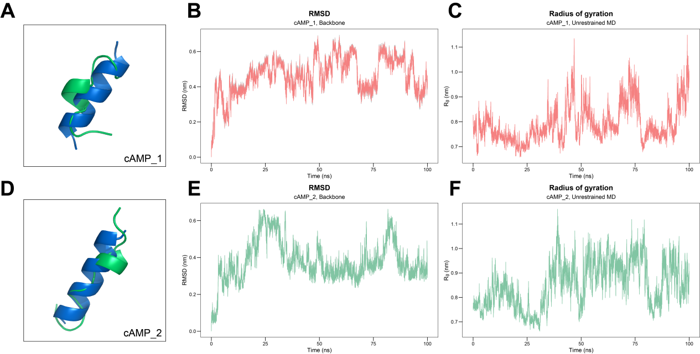
Figure S2. Molecular dynamics simulations of cAMP_1 and cAMP_2 over 100 ns. The differences in the 3D structures of cAMP_1 (A) and cAMP_2 (D) between before (blue) and after (green) molecular dynamics simulations. The root mean square deviation (RMSD) of cAMP_1 (B) and cAMP_2 (E) over time (0-100 ns). The radius of gyration (Rg) of the protein of cAMP_1 (C) and cAMP_2 (F) over time (0-100 ns) (C).

