Types of paper: Research paper
Title:Molecular Mechanism Study on the Contribution of Open-Fire Flue-curing Technology to Tobacco Leaf Aroma
Author names and affiliations: Kaiyuan Gu^{1,2}, Jialiang Li¹, Zhao Lu¹, Jiaen Su¹, Ming Liu², Xianglu Liu², Binbin Hu¹, Yonglei Jiang¹, Yi Chen^{1,⁎}
1 Yunnan Academy of Tobacco Agricultural Sciences, Kunming, Yunnan 650021, China
2 College of Agronomy and Biotechnology, Southwest University / Engineering Research Center of South Upland Agriculture, Ministry of Education, Chongqing, 400715, China

⁎Corresponding authors:
⁎Corresponding authors: Yi Chen (cytobacco007@sina.com)
Supplementary
Table S1 Chemical properties of freshly cured tobacco leaves
Figure S1 Bulk curing barn model
Figure S2 Open fire curing barn model
Figure S3 Open-fire flue-curing process
Figure S4 Phenotypic and physiological characteristics of open-fire flue-curing and conventional curing

Table S1 Chemical properties of freshly cured tobacco leaves
 | Treatments | Reducmg sugar% | Total sugars% | Total N% | Nicotine% | Total K% | Chloride ions% | Starch % | Protein%
Fresh leaves | CK-Fresh | 29.27±0.42a | 14.64±1.82a | 2.09±0.48a | 3.5±1.04a | 2.06±0.44a | 0.17±0.11a | 19.84±6.48a | 8.73±1.57a
Fresh leaves | X-Fresh | 28.27±0.97a | 13.71±0.48a | 2.2±0.30a | 3.45±0.31a | 2.36±0.71a | 0.18±0.05a | 22.14±1.08a | 9.77±1.29a
Bake to 38 degrees | CK-38 | 38.52±2.55a | 28.58±1.04a | 1.77±0.24a | 2.86±0.51a | 2.27±0.59a | 0.76±0.35a | 9.57±5.18a | 6.27±0.26a
Bake to 38 degrees | X-38 | 38.71±0.96b | 25.2±1.28b | 1.55±0.5b | 2.56±0.29a | 1.96±0.62a | 0.6±0.38a | 11.41±5.83a | 4.79±2.14b
Bake to 42 degrees | CK-42 | 33.19±1.39a | 24.95±1.17a | 1.24±0.18a | 2.27±0.37a | 1.8±0.19a | 0.64±0.08a | 21.1±5.79a | 4.44±0.77a
Bake to 42 degrees | X-42 | 38.15±1.08b | 29.92±1.00b | 1.75±0.16b | 3.48±0.77a | 2.09±0.29a | 0.76±0.33a | 6.68±2.03b | 4.48±0.82a
At the end of baking | CK-After | 32.49±5.46a | 22.68±1.69a | 2.23±0.16a | 3.45±0.17a | 2.41±0.17a | 1.02±0.64a | 1.59±0.54a | 7.55±0.68a
At the end of baking | X-After | 33.44±3.11a | 29.57±2.15b | 1.52±0.16b | 2.71±0.31b | 1.76±0.13b | 0.75±0.35a | 11.46±1.77b | 5.19±0.38b
These data were subjected to Duncan's multi-range test. Different lower-case letters indicate significant differences between the two sets of data at the (P ≤ 0.05 level. Data represent mean ± standard error (n = 3)


Fig.S1 Bulk curing barn model

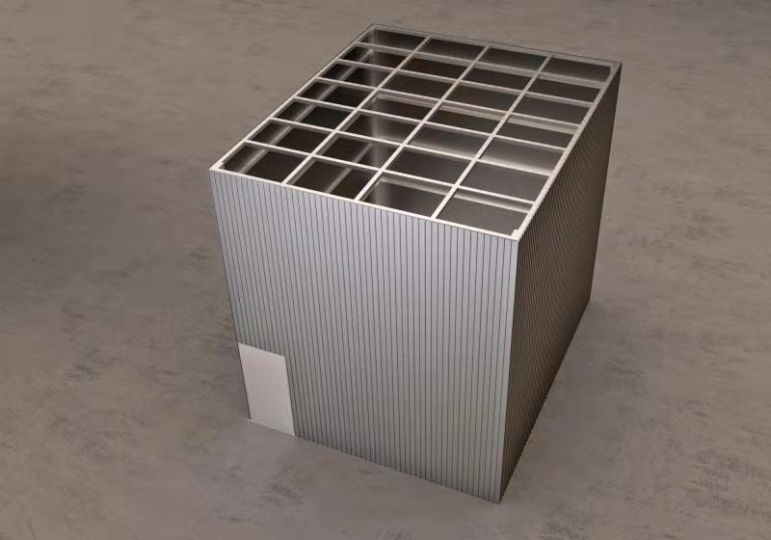
Fig.S2 Open fire curing barn model

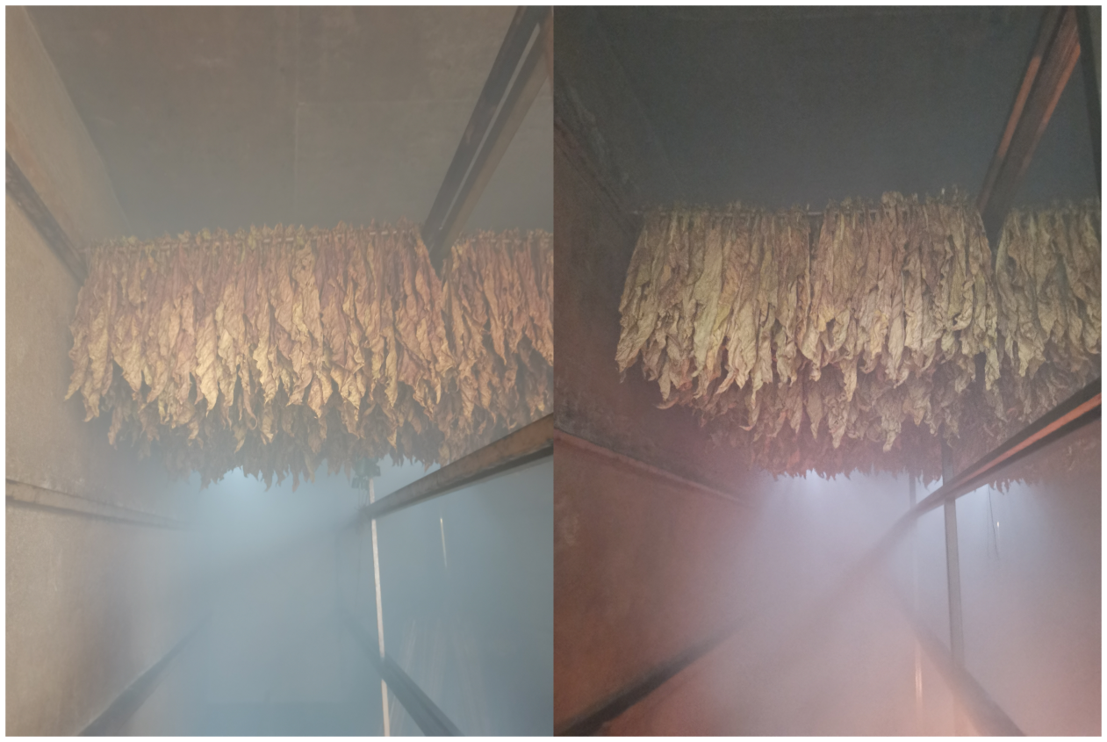
Fig.S3 Open-fire flue-curing process

Fig.S4 Phenotypic and physiological characteristics of open-fire flue-curing and conventional curing
Fresh: Fresh tobacco leaf; After:Post-curing tobacco leaves
The data were tested by Duncan's multiple range test. "**" indicates a significant difference at the α=0.01 level between the two groups of data. Data represent means ± standard error (n = 3).

