Target gene screening and validation for RNAi-based suppression of the microsporidian parasite Vairimorpha (=Nosema) ceranae in honeybees

Sooho Lim^{1,2,†,*}, Hyeonha Yoo^{1,†}, Giyoun Han¹, Woojin Kim¹ and Minlee Kim^{1,*}

¹ R&D Center, Genolution Inc., Seoul 07793, Republic of Korea
² Department of Agricultural Biotechnology, Seoul National University, Seoul 08826, Republic of Korea

† These authors contributed equally to this work.

* Corresponding author at: R&D Center, Genolution Inc., 63, Magokjungang 8-ro 3-gil, Gangseo-gu, Seoul, Republic of Korea 07793

E-mail: Sooho Lim(sh.lim@genolution1.com), Minlee Kim(minlee.kim@genolution1.com)

Supplementary Figure Legends
Figure S1. Agarose gel electrophoresis validation of synthesized dsRNAs targeting V. ceranae and controls.
A 100bp DNA Ladder (BioFACT, Daejeon, Korea) was used as the molecular size marker. Due to the slower migration of dsRNA compared dsDNA, apparent sizes appear slightly larger than sizes indicated by the DNA ladder.

Figure S2. Individual inoculation setup for V. ceranae infection assay.
Image of honeybees individually housed in a 24-well plate, with a schematic illustration of spore feeding through a lid.

Figure S3. Construction of the standard curve for absolute quantification of Vc16S rRNA by qPCR.
(a) Partial sequence of the Vc16S rRNA (250 bp) inserted into the pGEM-T easy vector, verified by Sanger sequencing. (b) Threshold cycle (Ct) values were plotted against log₁₀-scaled copy number of plasmid DNA. The regression equation, coefficient of determination (R²), PCR efficiency, and limit of detection (LOD) Ct are indicated.

Figure S4. Assessment of non-target control (dsRNA-gfp) effects in group and individual inoculation assays.
Relative Vc16S rRNA copies showed no significant difference between NFW and gfp treatments (Student’s t-test, ns = not significant)

Figure S5. Fluorescence-based visualization of V. ceranae infection in honeybee midguts.
(a) Midgut from non-infected bee, (b) Midgut from infected bee.

Figure S6 MNase control for fluorescence localization in dsRNA uptake assay.
No fluorescence signal was detected in spores treated with Cy3-labeled dsRNA-swp25 after MNase treatment at 1 hpt (a) and 2 hpt (b), indicating surface-bound localization. (Scale bar = 20 μm)

Figure S7. Control validation for fluorescence specificity in dsRNA uptake assay.
No fluorescence signal was detected in spores treated with non-labeled dsRNA-swp25 (a) and dsRNA-gfp (b).

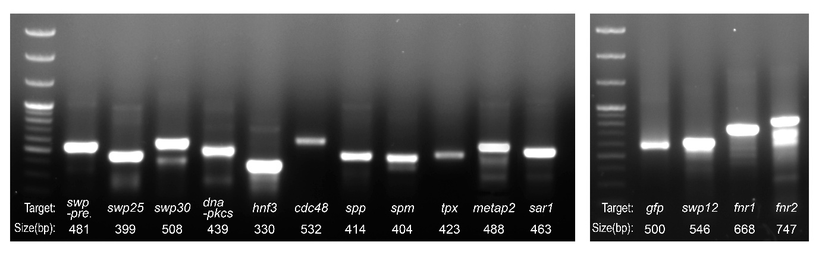

Figure S1

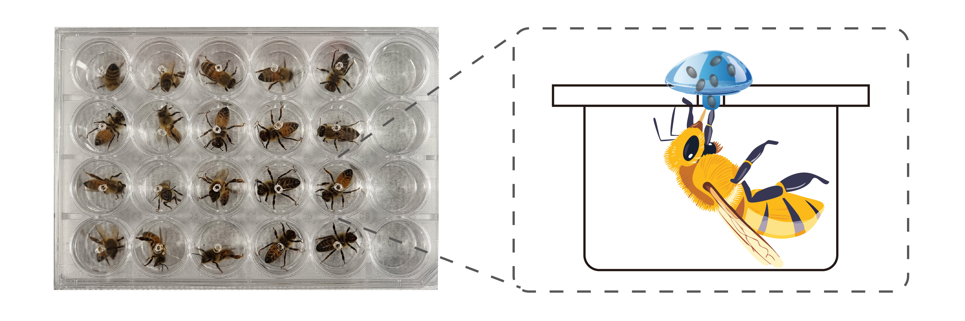

Figure S2

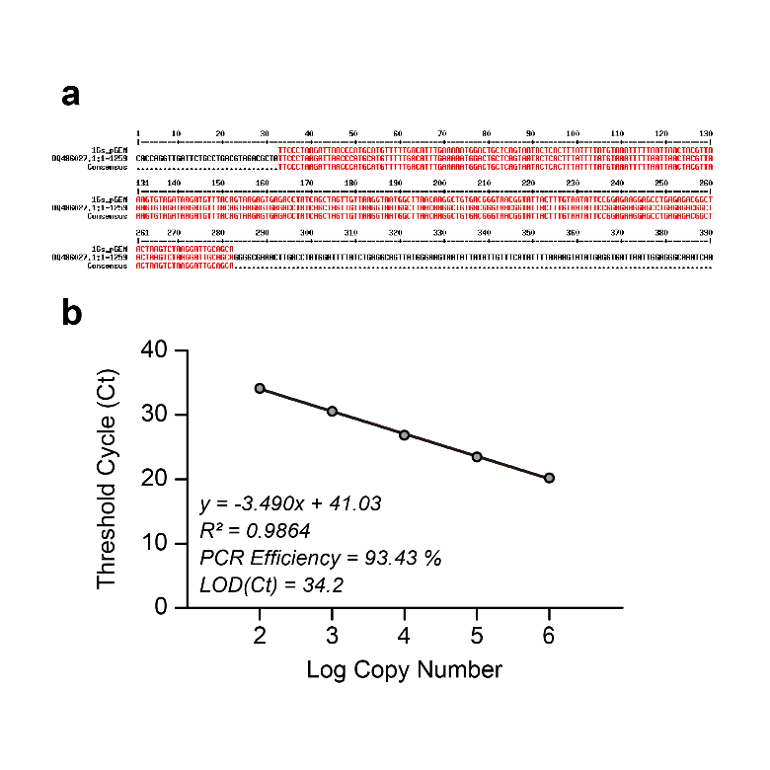

Figure S3

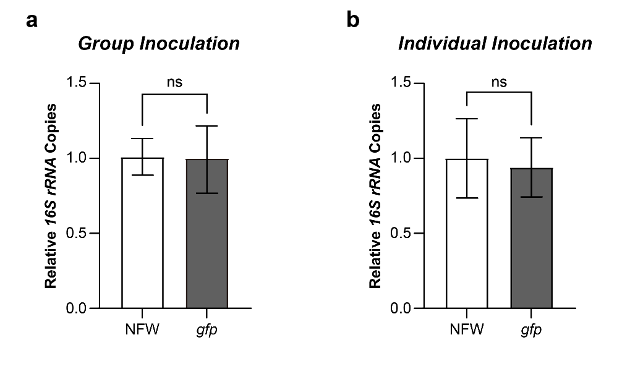

Figure S4

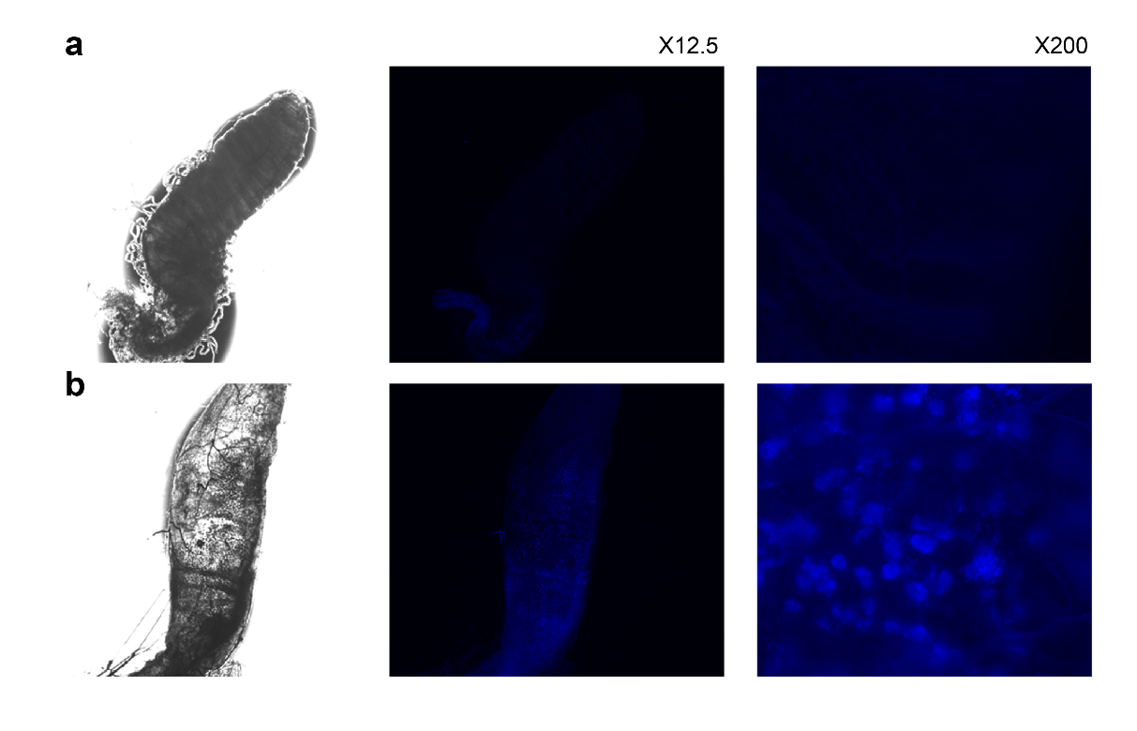

Figure S5

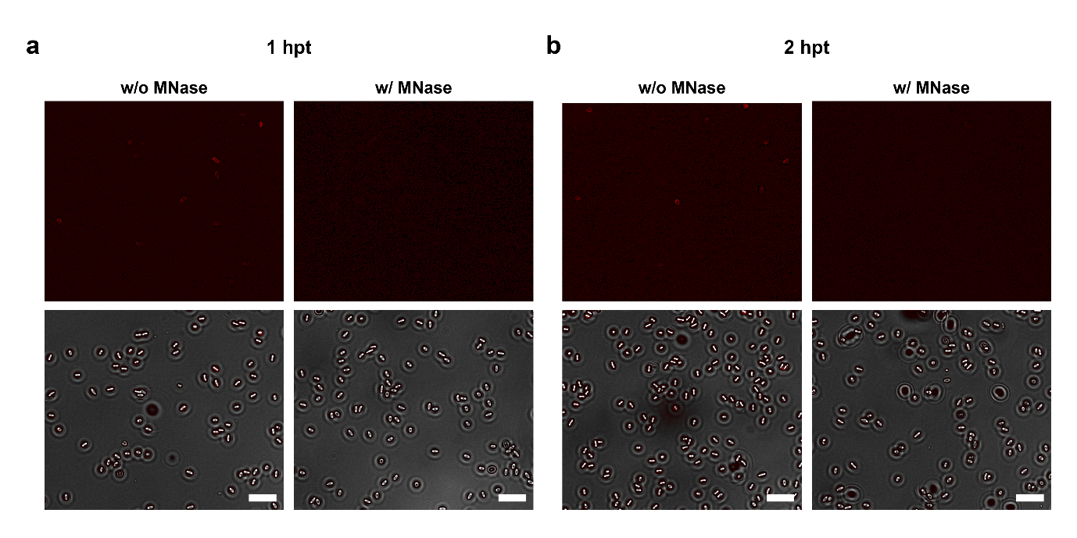

Figure S6

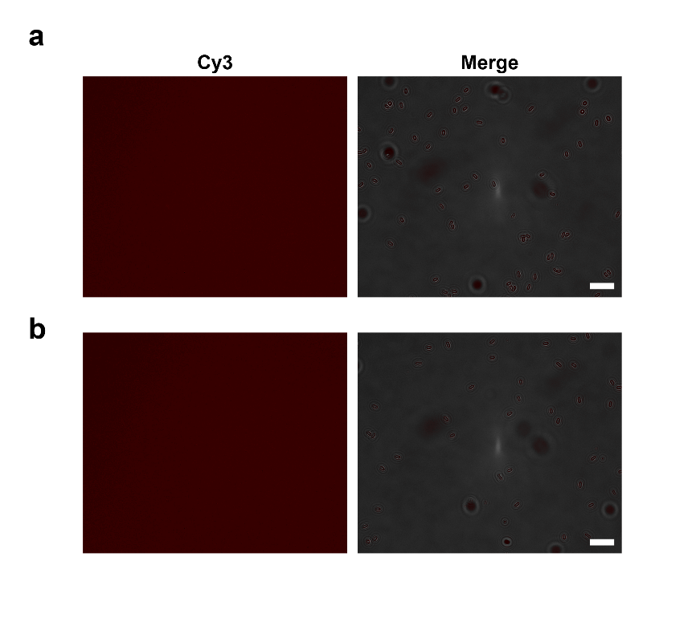

Figure S7

