Supplementary data

Table S1: Detailed description of all parameters used for GC-MS and UPLC-MS methods.
Parameter | GC-MS | UPLC-MS
Instrument | Varian CP-3800 GC + Bruker 300-MS triple quadrupole MS | Waters Xevo® triple quadrupole MS
Column | Restek stabilwax-DA (30 m × 0.25 mm × 50.5 µm) | Aquity BEH C18 + Aquity HSS PFP (2.1 × 100 mm × 1.7 µm)
Injection volume | 0.4 µL (split mode, 20:1) | 10 µL
Carrier gas | Helium at 1.3 mL min⁻¹ | Mobile phase flow 0.2 mL min⁻¹
Injector temperature | 240 °C | —
Column oven program | Start at 85 °C (0.5 min), ramp to 200 °C at 6 °C min⁻¹, hold 10.34 min | Gradient: 100% Solvent A → 30% B in 4 min, hold 4 min, return
Transfer line temperature | 280 °C | Column temperature: 45 °C
Detection mode | Full Scan (m/z 40–450) | MRM (multiple reaction monitoring), negative ESI
Sample preparation | pH adjusted to 2.0 (H₃PO₄), benzoic acid internal standard | Diluted 10× with solvent A (1% acetic acid)
Standards | Supelco VFA CRM46975, 5 levels | 7 external standards (0.1–10 mg L⁻¹)
Analytes | Acetic, formic, propionic, isobutyric, butyric, isovaleric, etc. | Lactic, citric, succinic, gluconic, tartaric, malic, etc.
Desolvation temperature | — | 450 °C
Nebulizer gas flow | — | Nitrogen, 950 L h⁻¹
Cone gas flow | — | Nitrogen, 50 L h⁻¹
Capillary voltage | — | 2.7 kV
Dwell Time (MRM) | — | 0.036 s

Table S2: The recipe of phosphorus-deficient Hoagland solution.
Chemical | Concentrations
Calcium nitrate (Ca(NO₃)₂4H₂O) | 4.0 mM
Potassium nitrate (KNO₃) | 4.0 mM
Magnesium sulfate (MgSO₄7H₂O) | 2.0 mM
Potassium chloride (KCl) | 1.0 mM
Micronutrients | 1 mL L⁻¹ of stock solution of H₃BO₃ (2.86 mg L⁻¹), MnCl₂4H₂O (1.81 mg L⁻¹), ZnSO₄7H₂O (0.22 mg L⁻¹), CuSO₄5H₂O (0.08 mg L⁻¹), H₂MoO₄H₂O (0.02 mg L⁻¹)
Fe-EDTA | 1 mL L⁻¹ of 10 mM Fe-EDTA stock solution
KCl was added in place of KH₂PO₄ to make solution phosphorus-deficient.

Table S3: Identification of selected rhizobacterial strains through 16S rRNA partial gene sequencing showing their closet matching type strains, orthologous average nucleotide identity (ANI), and similarity index.
Strains | Accession No. | Size (bp) | Closet matching type strains | ANI (%) | Aligned bp | Similarity (%) | IAA (µg mL⁻¹)
SAM1 | PP732276 | 1478 | Bacillus altitudinis 41KF2b^{T} (ASJC01000029) | 99.8 | 1008 | 100 | 16.30 ± 0.36
SAM7 | PP732277 | 1461 | LJIY_s FJAT-21963^{T} (LJIY01000004) | 99.7 | 997 | 100 | 14.36 ± 0.41
SAM9 | PP732278 | 827 | Bacillus cereus ATCC 14579^{T} (AE016877) | 99.8 | 810 | 100 | 18.91 ± 0.53
SAM13 | PP732279 | 1429 | LJIY_s FJAT-21963^{T} (LJIY01000004) | 99.9 | 1002 | 100 | 14.20 ± 0.30
SAM15 | PP732280 | 1482 | Bacillus altitudinis 41KF2b^{T} (ASJC01000029) | 99.9 | 1011 | 100 | 14.97 ± 0.37

Morphological characteristics and microscopic observation
Methodology: The colony morphology of rhizobacterial strains was determined using the method described by Breakwell et al. (2007). Various morphological features, including size, color, form, elevation, margin, and texture, were recorded. A Gram stain was performed for microscopic observation, and the gram reaction, color, and bacterial shape were recorded.
Results: The colony morphology and microscopic results of tested rhizobacterial strains are given in Table S3. Most of the tested rhizobacterial strains were Gram-positive, except for SAM3. The colony colors of SAM1 and SAM13 were white, and SAM9 had a pale white colony color. The yellow colony was observed from strains SAM3, SAM7, SAM11, and SAM15. The colony form of circular was observed from SAM1, SAM7, and SAM9, while SAM3, SAM11, and SAM15 had irregular colony forms. Only strain SAM13 had filamentous colony form. Most of the colony margin was entire and appeared smooth and shiny. We observed raised elevation from four strains and flat elevation from two strains, while SAM13 had umbonate colony elevation.
References: Breakwell, D., MacDonald, B., Woolverton, C., Smith, K. and Robison, R., 2007. Colony morphology protocol. American Society for Microbiology, pp.1-7.
Table S3: Morphological characterization of rhizobacterial strain from wheat rhizosphere.
Strains | SAM1 | SAM3 | SAM7 | SAM9 | SAM11 | SAM13 | SAM15
Gram staining | Gram +ve | Gram -ve | Gram +ve | Gram +ve | Gram +ve | Gram +ve | Gram +ve
Color | White | Yellow | Yellow | pale white | Light yellow | White | Yellow
Form | Circular | Irregular | Circular | Circular | Irregular | Filamentous | Irregular
Elevation | Raised | Flat | Raised | Flat | Raised | Umbonate | Raised
Margin | Entire | Entire | Entire | Entire | Entire | Filamentous | Entire
Appearance | Smooth shiny | Smooth | Smooth shiny | Rough | Smooth | Smooth | Smooth

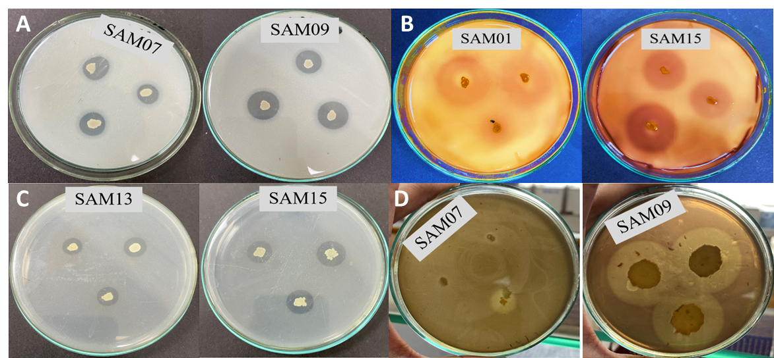
Fig. S1: Dissolution of minerals including tricalcium phosphate (A), mica (B), zinc oxide (C), and manganese oxide (D) by rhizobacterial strains.

Fig. S2: The correlation matrices between wheat growth and grain traits, nutrient availability, and soil properties under pot conditions.

