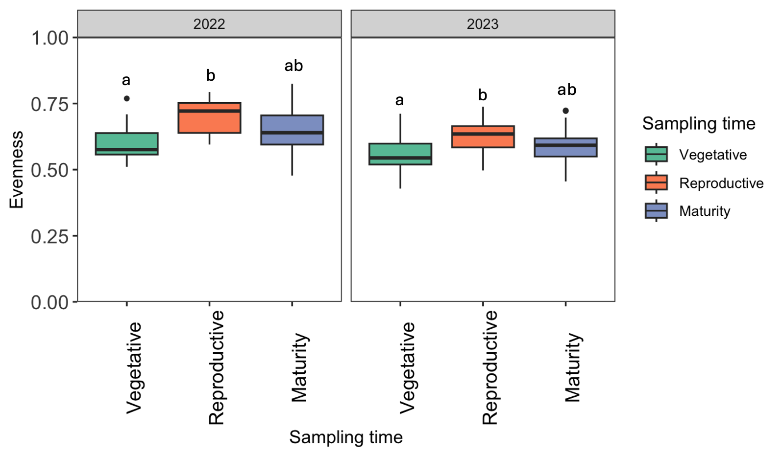
Fig. S1 AMF community evenness (Pielou’s J) across sampling time and year. Points/boxes show sample-level evenness values; model results are reported in Table S7. Differences among treatment combinations were assessed using a generalized linear model (GLM) followed by Tukey-adjusted pairwise comparisons (α = 0.05). Different letters indicate significant differences at α = 0.05. Sample size: n = 18 per sampling time x year (3 inoculation treatments × 2 cover crop treatments x 3 replicates), total n = 54 per year and n = 108 overall.

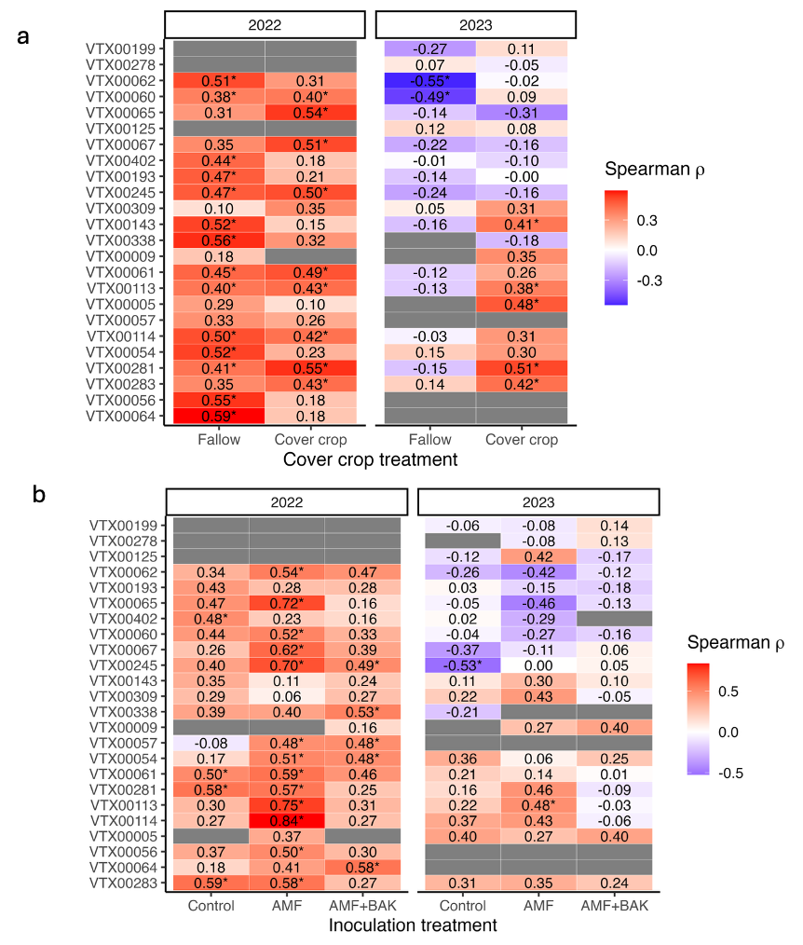
Fig. S2 Correlation between AMF colonization intensity and VTX abundance across treatments and years. Values in the heatmaps indicate Spearman correlation coefficients (ρ) for the relationship of colonization intensity and the abundance of virtual taxa (VTX) in maize roots under a) cover crop and fallow treatments, and b) inoculation treatments (Control, AMF, AMF+BAK) in 2022 (left) and 2023 (right). Red colors indicate positive correlations; blue colors indicate negative correlations. Statistically significant correlations (p < 0.05) are marked with an asterisk (*). Sample sizes: (a) n = 27 per cover crop treatment and year (3 sampling stages × 3 inoculation treatments × 3 replicates), (b) n = 18 per inoculation treatment and year (3 sampling stages × 2 cover crop treatments × 3 replicates).

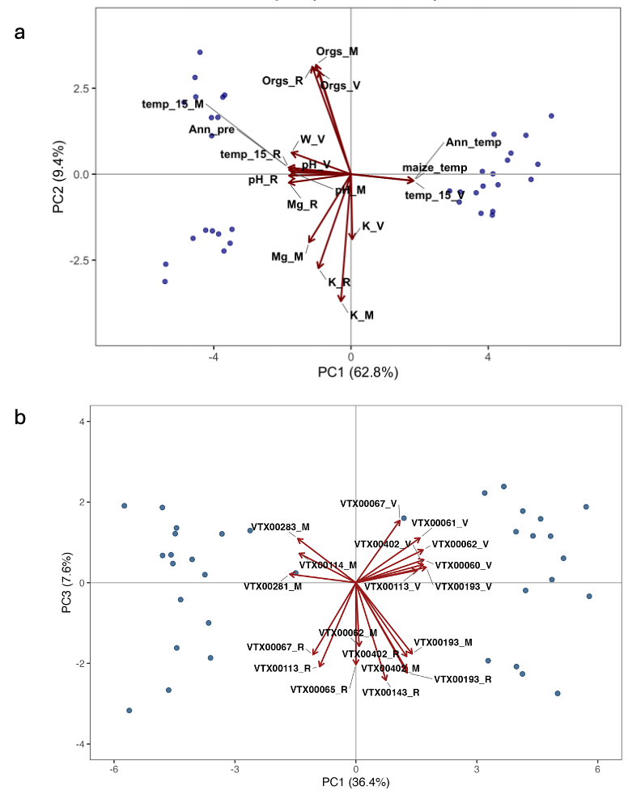
Fig. S3 Principal component analysis (PCA) of (a) environmental variables and (b) root-associated VTXs during maize growth across two years (2022, 2023). Soil PCA was based on standardized soil chemical properties; the PCA of VTX abundances was based on Hellinger-transformed data after removing rare taxa (<0.01% of total abundance). For each PCA, the top eighteen variables with the highest loadings on PC1/PC2 in panel (a) and PC1/PC3 in panel (b) are shown as red vectors, with direction and length indicating the strength and sign of correlations with the ordination axes. Points represent individual samples in year (blue).

