Supporting information for
Optimization of geographical traceability models for tobacco: an investigation into the effects of region, harvest year, and variety on stable isotope and multi-elemental profiling

Lili Cui,ª Shulei Han,ª Yongxiu Wang,ª Yaning Fu,^{b} Hongjuan Wang,ª Yushan Tian,ª Xiao Li,ª Zheng Song,ª Huan Chen,^{*a,b} Yuwei Yuan,^{*c} and Hongwei Hou^{*a,b}
a China National Tobacco Quality Supervision and Test Center, key Laboratory of Tobacco Biological Effects, Zhengzhou 450001, China
b Beijing Life Science Academy, Beijing 102209, China
^{c} Institute of Agro-product Safety and Nutrition, Zhejiang Academy of Agricultural Sciences; Key Laboratory of Information Traceability for Agricultural Products, Ministry of Agriculture and Rural Affairs of China, Hangzhou 310021, China

* a,b Huan Chen, E-mail: hunny_ch@163.com; Tel: +86-0371-67672597
^{* c} Yuwei Yuan, E-mail: ywytea@163.com; Tel: +86-0571-86414668
* a,b Hongwei Hou, E-mail: qsfctc@163.com; Tel: +86-0371-67672727

Table S1. Tobacco leaves sampling site and geographical information.
Sample No. | Sampling Site |  |  | Geographical information
Sample No. | Province-year | City | Longitude (E) |  | Latitude (N)
1 | HN-2020 | Pingdingshan | 113.16 |  | 33.92
2 | HN-2020 | Pingdingshan | 113.12 |  | 33.94
3 | HN-2020 | Pingdingshan | 113.19 |  | 33.88
4 | HN-2020 | Pingdingshan | 113.08 |  | 33.97
5 | HN-2020 | Pingdingshan | 113.31 |  | 33.50
6 | HN-2020 | Pingdingshan | 113.31 |  | 33.50
7 | HN-2020 | Pingdingshan | 113.31 |  | 33.50
8 | HN-2020 | Pingdingshan | 113.43 |  | 33.49
9 | HN-2020 | Pingdingshan | 113.52 |  | 33.73
10 | HN-2020 | Pingdingshan | 112.74 |  | 34.27
11 | HN-2020 | Pingdingshan | 112.90 |  | 34.07
12 | HN-2020 | Pingdingshan | 113.01 |  | 34.13
13 | HN-2020 | Pingdingshan | 112.94 |  | 34.18
14 | HN-2020 | Pingdingshan | 112.81 |  | 34.12
15 | HN-2020 | Pingdingshan | 112.83 |  | 34.15
16 | HN-2020 | Pingdingshan | 113.52 |  | 33.31
17 | HN-2020 | Pingdingshan | 113.06 |  | 34.08
18 | HN-2020 | Pingdingshan | 113.03 |  | 34.09
19 | HN-2020 | Pingdingshan | 113.16 |  | 34.06
20 | HN-2020 | Pingdingshan | 113.06 |  | 34.06
21 | HN-2020 | Pingdingshan | 113.16 |  | 33.99
22 | HN-2020 | Pingdingshan | 113.25 |  | 34.00
23 | HN-2020 | Pingdingshan | 113.27 |  | 34.04
24 | HN-2020 | Xuchang | 113.54 |  | 33.97
25 | HN-2020 | Xuchang | 113.72 |  | 33.74
26 | HN-2020 | Xuchang | 113.55 |  | 33.97
27 | HN-2020 | Xuchang | 113.48 |  | 33.96
28 | HN-2020 | Xuchang | 113.46 |  | 33.99
29 | HN-2020 | Xuchang | 113.62 |  | 33.95
30 | HN-2020 | Xuchang | 113.62 |  | 33.95
31 | HN-2020 | Xuchang | 113.67 |  | 33.94
32 | HN-2020 | Xuchang | 113.40 |  | 33.91
33 | HN-2020 | Xuchang | 113.39 |  | 33.80
34 | HN-2020 | Xuchang | 113.40 |  | 33.91
35 | HN-2020 | Xuchang | 113.64 |  | 33.91
36 | HN-2020 | Xuchang | 113.64 |  | 33.91
37 | HN-2020 | Xuchang | 113.56 |  | 33.90
38 | HN-2020 | Xuchang | 113.54 |  | 34.07
39 | HN-2020 | Xuchang | 113.59 |  | 34.03
40 | HN-2020 | Xuchang | 113.54 |  | 34.07
41 | HN-2020 | Xuchang | 113.48 |  | 34.05
42 | HN-2020 | Xuchang | 113.42 |  | 34.01
43 | HN-2020 | Xuchang | 113.49 |  | 34.14
44 | HN-2020 | Xuchang | 113.49 |  | 34.14
45 | HN-2020 | Xuchang | 113.71 |  | 33.99
46 | HN-2020 | Xuchang | 113.63 |  | 34.04
47 | HN-2020 | Xuchang | 113.70 |  | 34.11
48 | HN-2020 | Xuchang | 113.74 |  | 33.92
49 | HN-2020 | Luohe | 114.20 |  | 33.65
50 | HN-2020 | Luohe | 113.81 |  | 33.79
51 | HN-2020 | Luohe | 113.81 |  | 33.88
52 | HN-2020 | Luohe | 113.92 |  | 33.77
53 | HN-2020 | Luohe | 114.07 |  | 33.75
54 | HN-2020 | Luohe | 113.96 |  | 33.86
55 | HN-2020 | Luohe | 114.05 |  | 33.84
56 | HN-2020 | Luohe | 114.12 |  | 33.80
57 | HN-2020 | Luohe | 113.96 |  | 33.93
58 | HN-2020 | Luohe | 114.04 |  | 33.93
59 | HN-2021 | Luoyang | 111.66 |  | 34.31
60 | HN-2021 | Luoyang | 111.55 |  | 34.37
61 | HN-2021 | Luoyang | 111.51 |  | 34.33
62 | HN-2021 | Luoyang | 112.00 |  | 34.67
63 | HN-2021 | Luoyang | 112.18 |  | 34.54
64 | HN-2021 | Luoyang | 112.11 |  | 34.62
65 | HN-2021 | Luoyang | 112.27 |  | 34.45
66 | HN-2021 | Luoyang | 112.05 |  | 34.52
67 | HN-2021 | Luoyang | 111.86 |  | 34.03
68 | HN-2021 | Luoyang | 111.93 |  | 34.14
69 | HN-2021 | Luoyang | 112.08 |  | 33.88
70 | HN-2021 | Luoyang | 112.10 |  | 34.24
71 | HN-2021 | Luoyang | 112.29 |  | 34.22
72 | HN-2021 | Luoyang | 112.37 |  | 34.32
73 | HN-2021 | Luoyang | 112.30 |  | 34.32
74 | HN-2021 | Luoyang | 112.49 |  | 34.42
75 | HN-2021 | Luoyang | 112.14 |  | 34.68
76 | HN-2021 | Nanyang | 111.66 |  | 33.22
77 | HN-2021 | Nanyang | 112.92 |  | 33.26
78 | HN-2021 | Nanyang | 113.15 |  | 33.25
79 | HN-2021 | Pingdingshan | 113.07 |  | 34.09
80 | HN-2021 | Pingdingshan | 113.04 |  | 34.09
81 | HN-2021 | Pingdingshan | 113.10 |  | 34.01
82 | HN-2021 | Pingdingshan | 113.17 |  | 34.07
83 | HN-2021 | Pingdingshan | 113.42 |  | 33.98
84 | HN-2021 | Pingdingshan | 113.36 |  | 33.99
85 | HN-2021 | Pingdingshan | 113.35 |  | 33.99
86 | HN-2021 | Pingdingshan | 113.02 |  | 34.14
87 | HN-2021 | Pingdingshan | 112.95 |  | 34.18
88 | HN-2021 | Pingdingshan | 112.75 |  | 34.27
89 | HN-2021 | Pingdingshan | 112.81 |  | 34.13
90 | HN-2021 | Pingdingshan | 112.71 |  | 34.23
91 | HN-2021 | Pingdingshan | 112.79 |  | 34.27
92 | HN-2021 | Pingdingshan | 113.44 |  | 33.49
93 | HN-2021 | Zhumadian | 113.14 |  | 32.98
94 | HN-2021 | Zhumadian | 113.62 |  | 32.81
95 | HN-2021 | Zhumadian | 113.32 |  | 32.68
96 | HN-2021 | Zhumadian | 113.25 |  | 32.64
97 | HN-2021 | Zhumadian | 113.25 |  | 32.76
98 | HN-2021 | Zhumadian | 113.57 |  | 32.78
99 | HN-2021 | Zhumadian | 113.45 |  | 32.81
100 | HN-2021 | Zhumadian | 113.70 |  | 32.79
101 | HN-2021 | Zhumadian | 113.79 |  | 32.76
102 | HN-2021 | Zhumadian | 113.84 |  | 32.79
103 | HN-2021 | Luohe | 113.82 |  | 33.88
104 | HN-2021 | Luohe | 113.97 |  | 33.86
105 | HN-2021 | Luohe | 113.97 |  | 33.94
106 | HN-2021 | Luohe | 114.05 |  | 33.96
107 | HN-2021 | Luohe | 114.08 |  | 33.87
108 | HN-2021 | Luohe | 114.00 |  | 33.77
109 | HN-2021 | Luohe | 113.54 |  | 33.46
110 | HN-2021 | Luohe | 113.77 |  | 33.45
111 | HN-2021 | Luohe | 113.77 |  | 33.45
112 | HN-2021 | Luohe | 114.04 |  | 33.70
113 | HN-2021 | Luohe | 113.78 |  | 33.68
114 | HN-2021 | Luohe | 114.21 |  | 33.65
115 | HN-2021 | Luohe | 113.84 |  | 33.48
116 | HN-2022 | Xuchang | 113.54 |  | 33.98
117 | HN-2022 | Xuchang | 113.56 |  | 34.01
118 | HN-2022 | Xuchang | 113.46 |  | 33.99
119 | HN-2022 | Xuchang | 113.62 |  | 33.95
120 | HN-2022 | Xuchang | 113.41 |  | 33.92
121 | HN-2022 | Xuchang | 113.45 |  | 33.91
122 | HN-2022 | Pingdingshan | 113.36 |  | 33.95
123 | HN-2022 | Pingdingshan | 113.29 |  | 33.97
124 | HN-2022 | Pingdingshan | 113.42 |  | 33.98
125 | HN-2022 | Pingdingshan | 113.36 |  | 33.99
126 | HN-2022 | Pingdingshan | 113.35 |  | 33.99
127 | HN-2022 | Pingdingshan | 113.02 |  | 34.14
128 | HN-2022 | Pingdingshan | 112.95 |  | 34.18
129 | HN-2022 | Pingdingshan | 112.75 |  | 34.27
130 | HN-2022 | Pingdingshan | 112.81 |  | 34.13
131 | HN-2022 | Pingdingshan | 112.71 |  | 34.23
132 | HN-2022 | Pingdingshan | 112.79 |  | 34.27
133 | HN-2022 | Pingdingshan | 113.44 |  | 33.49
134 | HN-2022 | Pingdingshan | 113.32 |  | 33.51
135 | HN-2022 | Pingdingshan | 113.25 |  | 33.39
136 | HN-2022 | Pingdingshan | 113.23 |  | 33.55
137 | HN-2022 | Pingdingshan | 113.51 |  | 33.68
138 | HN-2022 | Pingdingshan | 113.50 |  | 33.74
139 | HN-2022 | Pingdingshan | 113.17 |  | 33.92
140 | HN-2022 | Pingdingshan | 113.23 |  | 33.86
141 | HN-2022 | Pingdingshan | 113.08 |  | 33.92
142 | HN-2022 | Pingdingshan | 113.05 |  | 33.99
143 | HN-2022 | Luohe | 113.82 |  | 33.88
144 | HN-2022 | Luohe | 113.97 |  | 33.86
145 | HN-2022 | Luohe | 113.97 |  | 33.94
146 | HN-2022 | Luohe | 114.05 |  | 33.96
147 | HN-2022 | Luohe | 114.08 |  | 33.87
148 | HN-2022 | Luohe | 114.00 |  | 33.77
149 | HN-2022 | Luohe | 113.95 |  | 33.87
150 | GZ-2020 | Anshun | 106.01 |  | 26.27
151 | GZ-2020 | Anshun | 106.17 |  | 26.19
152 | GZ-2020 | Anshun | 106.17 |  | 26.36
153 | GZ-2020 | Anshun | 105.75 |  | 26.31
154 | GZ-2020 | Guiyang | 107.01 |  | 27.18
155 | GZ-2020 | Guiyang | 107.14 |  | 27.30
156 | GZ-2020 | Guiyang | 107.16 |  | 27.16
157 | GZ-2020 | Guiyang | 106.18 |  | 26.86
158 | GZ-2020 | Guiyang | 106.23 |  | 26.67
159 | GZ-2020 | Guiyang | 106.54 |  | 26.94
160 | GZ-2020 | Guiyang | 106.59 |  | 27.05
161 | GZ-2020 | Bijie | 104.41 |  | 27.24
162 | GZ-2020 | Bijie | 104.73 |  | 27.24
163 | GZ-2020 | Zunyi | 107.14 |  | 27.47
164 | GZ-2020 | Zunyi | 106.75 |  | 27.52
165 | GZ-2020 | Zunyi | 106.98 |  | 27.38
166 | GZ-2020 | Zunyi | 106.82 |  | 27.87
167 | GZ-2020 | Zunyi | 106.92 |  | 27.98
168 | GZ-2020 | Zunyi | 105.69 |  | 28.54
169 | GZ-2020 | Zunyi | 106.72 |  | 27.73
170 | GZ-2020 | Zunyi | 107.10 |  | 28.41
171 | GZ-2020 | Zunyi | 107.28 |  | 28.12
172 | GZ-2020 | Zunyi | 106.92 |  | 28.11
173 | GZ-2020 | Zunyi | 106.78 |  | 28.20
174 | GZ-2020 | Zunyi | 106.84 |  | 28.11
175 | GZ-2020 | Zunyi | 106.87 |  | 28.39
176 | GZ-2020 | Zunyi | 107.13 |  | 28.84
177 | GZ-2020 | Zunyi | 107.42 |  | 27.43
178 | GZ-2020 | Zunyi | 107.40 |  | 27.50
179 | GZ-2020 | Zunyi | 107.52 |  | 27.96
180 | GZ-2020 | Zunyi | 107.82 |  | 27.76
181 | GZ-2020 | Zunyi | 107.83 |  | 27.89
182 | GZ-2020 | Zunyi | 107.69 |  | 27.80
183 | GZ-2020 | Zunyi | 107.69 |  | 27.80
184 | GZ-2020 | Zunyi | 107.59 |  | 28.12
185 | GZ-2020 | Zunyi | 107.63 |  | 27.61
186 | GZ-2020 | Zunyi | 107.62 |  | 27.53
187 | GZ-2020 | Zunyi | 107.65 |  | 27.37
188 | GZ-2020 | Zunyi | 108.10 |  | 28.95
189 | GZ-2020 | Zunyi | 107.90 |  | 28.53
190 | GZ-2020 | Zunyi | 107.88 |  | 28.70
191 | GZ-2020 | Zunyi | 107.91 |  | 28.92
192 | GZ-2020 | Zunyi | 107.18 |  | 28.56
193 | GZ-2020 | Zunyi | 107.63 |  | 28.58
194 | GZ-2020 | Zunyi | 107.58 |  | 28.22
195 | GZ-2020 | Zunyi | 107.72 |  | 29.07
196 | GZ-2020 | Zunyi | 107.59 |  | 29.08
197 | GZ-2020 | Zunyi | 107.69 |  | 28.74
198 | GZ-2020 | Zunyi | 106.44 |  | 27.67
199 | GZ-2020 | Zunyi | 106.22 |  | 27.61
200 | GZ-2021 | Qiannan | 107.34 |  | 27.43
201 | GZ-2021 | Qiannan | 107.29 |  | 27.17
202 | GZ-2021 | Qiannan | 107.45 |  | 27.27
203 | GZ-2021 | Qiannan | 107.65 |  | 26.76
204 | GZ-2021 | Qiannan | 107.46 |  | 26.89
205 | GZ-2021 | Qiannan | 107.25 |  | 26.64
206 | GZ-2021 | Qiannan | 107.73 |  | 26.25
207 | GZ-2021 | Qiannan | 106.39 |  | 26.19
208 | GZ-2021 | Qiannan | 106.83 |  | 26.10
209 | GZ-2021 | Qiannan | 106.97 |  | 26.19
210 | GZ-2021 | Qiannan | 107.18 |  | 25.85
211 | GZ-2021 | Anshun | 106.18 |  | 26.37
212 | GZ-2021 | Anshun | 106.19 |  | 26.17
213 | GZ-2021 | Anshun | 106.25 |  | 26.21
214 | GZ-2021 | Anshun | 105.75 |  | 26.32
215 | GZ-2021 | Anshun | 106.10 |  | 25.96
216 | GZ-2021 | Bijie | 104.38 |  | 27.24
217 | GZ-2021 | Bijie | 106.27 |  | 26.96
218 | GZ-2021 | Bijie | 104.03 |  | 26.75
219 | GZ-2021 | Bijie | 105.58 |  | 26.80
220 | GZ-2021 | Bijie | 105.67 |  | 27.39
221 | GZ-2021 | Bijie | 105.88 |  | 27.21
222 | GZ-2021 | Bijie | 104.47 |  | 27.07
223 | GZ-2021 | Bijie | 104.73 |  | 27.24
224 | GZ-2021 | Bijie | 105.33 |  | 27.36
225 | GZ-2021 | Bijie | 104.12 |  | 27.06
226 | GZ-2021 | Bijie | 103.83 |  | 27.09
227 | GZ-2021 | Bijie | 105.87 |  | 27.05
228 | GZ-2021 | Bijie | 105.75 |  | 27.09
229 | GZ-2021 | Bijie | 105.49 |  | 26.93
230 | GZ-2021 | Bijie | 105.05 |  | 27.35
231 | GZ-2021 | Bijie | 106.02 |  | 27.29
232 | GZ-2021 | Guiyang | 106.57 |  | 26.69
233 | GZ-2021 | Guiyang | 106.54 |  | 26.94
234 | GZ-2021 | Guiyang | 107.06 |  | 27.15
235 | GZ-2021 | Guiyang | 107.14 |  | 27.30
236 | GZ-2021 | Guiyang | 107.15 |  | 27.15
237 | GZ-2021 | Guiyang | 106.23 |  | 26.68
238 | GZ-2021 | Guiyang | 106.23 |  | 26.83
239 | GZ-2021 | Liupanshui | 104.96 |  | 26.85
240 | GZ-2021 | Liupanshui | 105.00 |  | 26.46
241 | GZ-2021 | Liupanshui | 104.73 |  | 25.41
242 | GZ-2021 | Liupanshui | 104.84 |  | 25.62
243 | GZ-2021 | Liupanshui | 104.67 |  | 25.54
244 | GZ-2021 | Qiandongnan | 108.63 |  | 27.46
245 | GZ-2021 | Qiandongnan | 108.73 |  | 27.37
246 | GZ-2021 | Qiandongnan | 108.41 |  | 27.06
247 | GZ-2021 | Qiandongnan | 107.46 |  | 26.49
248 | GZ-2021 | Qiandongnan | 108.25 |  | 27.24
249 | GZ-2021 | Qiandongnan | 107.79 |  | 26.66
250 | GZ-2021 | Qiandongnan | 108.17 |  | 27.09
251 | GZ-2021 | Qiandongnan | 107.82 |  | 26.32
252 | GZ-2021 | Qiandongnan | 108.37 |  | 27.12
253 | GZ-2021 | Qiandongnan | 108.04 |  | 27.22
254 | GZ-2021 | Qiandongnan | 108.23 |  | 26.88
255 | GZ-2021 | Qianxinan | 105.11 |  | 25.36
256 | GZ-2021 | Qianxinan | 105.05 |  | 25.34
257 | GZ-2021 | Qianxinan | 105.22 |  | 25.53
258 | GZ-2021 | Qianxinan | 105.11 |  | 25.50
259 | GZ-2021 | Qianxinan | 105.37 |  | 25.49
260 | GZ-2021 | Qianxinan | 105.32 |  | 25.86
261 | GZ-2021 | Qianxinan | 105.10 |  | 26.01
262 | GZ-2021 | Qianxinan | 105.18 |  | 25.68
263 | GZ-2021 | Qianxinan | 105.01 |  | 25.51
264 | GZ-2021 | Qianxinan | 104.95 |  | 25.56
265 | GZ-2021 | Qianxinan | 105.01 |  | 25.58
266 | GZ-2021 | Qianxinan | 104.94 |  | 25.63
267 | GZ-2021 | Qianxinan | 105.09 |  | 25.85
268 | GZ-2021 | Qianxinan | 104.97 |  | 25.79
269 | GZ-2021 | Qianxinan | 105.47 |  | 25.20
270 | GZ-2021 | Qianxinan | 105.14 |  | 25.03
271 | GZ-2021 | Qianxinan | 105.42 |  | 25.24
272 | GZ-2021 | Qianxinan | 105.48 |  | 25.12
273 | GZ-2021 | Qianxinan | 105.27 |  | 25.12
274 | GZ-2021 | Qianxinan | 105.07 |  | 25.23
275 | GZ-2021 | Qianxinan | 104.74 |  | 24.86
276 | GZ-2021 | Qianxinan | 104.76 |  | 25.02
277 | GZ-2021 | Qianxinan | 104.62 |  | 24.84
278 | GZ-2021 | Qianxinan | 104.68 |  | 24.84
279 | GZ-2021 | Tongren | 108.62 |  | 28.08
280 | GZ-2021 | Tongren | 108.49 |  | 28.23
281 | GZ-2021 | Tongren | 108.45 |  | 27.57
282 | GZ-2021 | Tongren | 107.93 |  | 27.55
283 | GZ-2021 | Tongren | 108.04 |  | 27.49
284 | GZ-2021 | Tongren | 108.00 |  | 28.32
285 | GZ-2021 | Tongren | 107.86 |  | 28.16
286 | GZ-2021 | Tongren | 108.17 |  | 28.48
287 | GZ-2021 | Tongren | 109.29 |  | 28.11
288 | GZ-2021 | Tongren | 108.71 |  | 28.43
289 | GZ-2021 | Tongren | 108.81 |  | 28.09
290 | GZ-2021 | Tongren | 108.01 |  | 27.63
291 | GZ-2021 | Tongren | 108.35 |  | 27.74
292 | GZ-2021 | Tongren | 108.11 |  | 27.90
293 | GZ-2021 | Tongren | 108.12 |  | 27.99
294 | GZ-2021 | Tongren | 108.81 |  | 27.64
295 | GZ-2021 | Tongren | 108.70 |  | 27.66
296 | GZ-2021 | Tongren | 108.14 |  | 29.06
297 | GZ-2021 | Tongren | 107.94 |  | 28.14
298 | GZ-2021 | Tongren | 108.31 |  | 28.88
299 | GZ-2021 | Tongren | 108.42 |  | 28.47
300 | GZ-2021 | Zunyi | 107.41 |  | 27.46
301 | GZ-2021 | Zunyi | 107.54 |  | 28.18
302 | GZ-2021 | Zunyi | 107.52 |  | 27.96
303 | GZ-2021 | Zunyi | 107.72 |  | 29.07
304 | GZ-2021 | Zunyi | 107.60 |  | 29.09
305 | GZ-2021 | Zunyi | 107.69 |  | 28.74
306 | GZ-2021 | Zunyi | 106.22 |  | 28.19
307 | GZ-2021 | Zunyi | 106.33 |  | 28.08
308 | GZ-2021 | Zunyi | 106.44 |  | 27.67
309 | GZ-2021 | Zunyi | 107.82 |  | 27.76
310 | GZ-2021 | Zunyi | 107.75 |  | 28.12
311 | GZ-2021 | Zunyi | 107.60 |  | 28.12
312 | GZ-2021 | Zunyi | 107.69 |  | 27.80
313 | GZ-2021 | Zunyi | 107.83 |  | 27.89
314 | GZ-2021 | Zunyi | 106.82 |  | 27.87
315 | GZ-2021 | Zunyi | 106.92 |  | 27.98
316 | GZ-2021 | Zunyi | 106.70 |  | 27.80
317 | GZ-2021 | Zunyi | 106.72 |  | 27.73
318 | GZ-2021 | Zunyi | 107.10 |  | 28.41
319 | GZ-2021 | Zunyi | 107.26 |  | 28.23
320 | GZ-2021 | Zunyi | 106.92 |  | 28.11
321 | GZ-2021 | Zunyi | 106.78 |  | 28.20
322 | GZ-2021 | Zunyi | 106.85 |  | 28.16
323 | GZ-2021 | Zunyi | 106.86 |  | 28.33
324 | GZ-2021 | Zunyi | 108.10 |  | 28.95
325 | GZ-2021 | Zunyi | 107.90 |  | 28.53
326 | GZ-2021 | Zunyi | 107.90 |  | 28.64
327 | GZ-2021 | Zunyi | 107.91 |  | 28.92
328 | GZ-2021 | Zunyi | 107.18 |  | 28.56
329 | GZ-2021 | Zunyi | 107.63 |  | 28.58
330 | GZ-2021 | Zunyi | 107.58 |  | 28.22
331 | GZ-2021 | Zunyi | 107.63 |  | 27.61
332 | GZ-2021 | Zunyi | 107.62 |  | 27.53
333 | GZ-2021 | Zunyi | 107.58 |  | 27.33
334 | GZ-2021 | Zunyi | 107.14 |  | 27.47
335 | GZ-2021 | Zunyi | 106.68 |  | 27.59
336 | GZ-2021 | Zunyi | 106.98 |  | 27.38
337 | GZ-2022 | Anshun | 106.25 |  | 26.21
338 | GZ-2022 | Anshun | 106.19 |  | 26.17
339 | GZ-2022 | Anshun | 106.10 |  | 25.96
340 | GZ-2022 | Anshun | 106.13 |  | 26.39
341 | GZ-2022 | Anshun | 105.75 |  | 26.31
342 | GZ-2022 | Guiyang | 106.54 |  | 26.94
343 | GZ-2022 | Guiyang | 106.57 |  | 26.69
344 | GZ-2022 | Guiyang | 106.23 |  | 26.83
345 | GZ-2022 | Guiyang | 106.23 |  | 26.68
346 | GZ-2022 | Guiyang | 107.14 |  | 27.30
347 | GZ-2022 | Guiyang | 107.06 |  | 27.15
348 | GZ-2022 | Guiyang | 107.15 |  | 27.15
349 | GZ-2022 | Zunyi | 107.10 |  | 28.41
350 | GZ-2022 | Zunyi | 107.26 |  | 28.23
351 | GZ-2022 | Zunyi | 107.03 |  | 27.72
352 | GZ-2022 | Zunyi | 107.54 |  | 28.18
353 | GZ-2022 | Zunyi | 107.52 |  | 27.96
354 | GZ-2022 | Zunyi | 107.82 |  | 27.76
355 | GZ-2022 | Zunyi | 107.83 |  | 27.89
356 | GZ-2022 | Zunyi | 107.69 |  | 27.80
357 | GZ-2022 | Zunyi | 107.75 |  | 28.12
358 | GZ-2022 | Zunyi | 107.60 |  | 28.12
359 | GZ-2022 | Zunyi | 106.98 |  | 27.38
360 | GZ-2022 | Zunyi | 107.14 |  | 27.47
361 | GZ-2022 | Zunyi | 106.68 |  | 27.59
362 | GZ-2022 | Zunyi | 107.63 |  | 28.58
363 | GZ-2022 | Zunyi | 107.58 |  | 28.22
364 | GZ-2022 | Zunyi | 108.10 |  | 28.95
365 | GZ-2022 | Zunyi | 107.18 |  | 28.56
366 | GZ-2022 | Zunyi | 107.91 |  | 28.92
367 | GZ-2022 | Zunyi | 107.62 |  | 27.53
368 | GZ-2022 | Zunyi | 107.63 |  | 27.61
369 | GZ-2022 | Zunyi | 107.58 |  | 27.33
370 | GZ-2022 | Zunyi | 107.78 |  | 29.10
371 | GZ-2022 | Zunyi | 107.59 |  | 29.08
372 | GZ-2022 | Zunyi | 107.69 |  | 28.74
373 | GZ-2022 | Zunyi | 106.92 |  | 28.11
374 | GZ-2022 | Zunyi | 106.78 |  | 28.20
375 | YN-2020 | Puer | 101.20 |  | 23.43
376 | YN-2020 | Puer | 100.89 |  | 23.01
377 | YN-2020 | Qujing | 104.30 |  | 24.96
378 | YN-2020 | Qujing | 104.54 |  | 24.86
379 | YN-2020 | Qujing | 104.32 |  | 24.88
380 | YN-2020 | Qujing | 104.37 |  | 25.19
381 | YN-2020 | Qujing | 104.31 |  | 24.89
382 | YN-2020 | Qujing | 104.24 |  | 25.15
383 | YN-2020 | Qujing | 104.63 |  | 24.98
384 | YN-2020 | Qujing | 104.31 |  | 25.55
385 | YN-2020 | Qujing | 104.47 |  | 25.38
386 | YN-2020 | Qujing | 104.30 |  | 25.81
387 | YN-2020 | Qujing | 104.72 |  | 25.28
388 | YN-2020 | Qujing | 104.53 |  | 25.23
389 | YN-2020 | Qujing | 104.16 |  | 25.38
390 | YN-2020 | Qujing | 104.27 |  | 25.67
391 | YN-2020 | Qujing | 104.58 |  | 25.14
392 | YN-2020 | Qujing | 104.33 |  | 25.48
393 | YN-2020 | Qujing | 104.26 |  | 25.67
394 | YN-2020 | Qujing | 104.31 |  | 25.41
395 | YN-2020 | Qujing | 103.31 |  | 26.42
396 | YN-2020 | Qujing | 103.83 |  | 26.48
397 | YN-2020 | Qujing | 103.66 |  | 26.83
398 | YN-2020 | Qujing | 103.55 |  | 26.72
399 | YN-2020 | Yuxi | 102.16 |  | 23.93
400 | YN-2020 | Yuxi | 101.37 |  | 24.32
401 | YN-2020 | Yuxi | 101.58 |  | 24.05
402 | YN-2020 | Yuxi | 102.01 |  | 23.70
403 | YN-2020 | Yuxi | 102.18 |  | 23.66
404 | YN-2020 | Yuxi | 101.89 |  | 23.66
405 | YN-2020 | Yuxi | 102.12 |  | 23.39
406 | YN-2020 | Yuxi | 102.29 |  | 23.55
407 | YN-2020 | Yuxi | 102.06 |  | 23.44
408 | YN-2020 | Yuxi | 101.86 |  | 23.41
409 | YN-2020 | Wenshan | 104.69 |  | 23.44
410 | YN-2020 | Wenshan | 104.51 |  | 23.18
411 | YN-2020 | Wenshan | 104.60 |  | 23.25
412 | YN-2020 | Wenshan | 104.60 |  | 23.11
413 | YN-2020 | Wenshan | 105.17 |  | 23.37
414 | YN-2020 | Wenshan | 104.72 |  | 23.14
415 | YN-2020 | Wenshan | 104.07 |  | 23.01
416 | YN-2020 | Wenshan | 104.41 |  | 22.90
417 | YN-2020 | Wenshan | 104.40 |  | 23.02
418 | YN-2020 | Wenshan | 104.05 |  | 24.30
419 | YN-2020 | Wenshan | 103.86 |  | 24.05
420 | YN-2020 | Wenshan | 104.11 |  | 23.89
421 | YN-2020 | Wenshan | 104.21 |  | 24.20
422 | YN-2020 | Wenshan | 104.31 |  | 23.95
423 | YN-2020 | Chuxiong | 101.84 |  | 24.74
424 | YN-2020 | Chuxiong | 101.47 |  | 24.56
425 | YN-2020 | Chuxiong | 101.86 |  | 24.61
426 | YN-2020 | Chuxiong | 101.65 |  | 24.69
427 | YN-2020 | Chuxiong | 101.47 |  | 25.26
428 | YN-2020 | Chuxiong | 101.55 |  | 25.31
429 | YN-2020 | Chuxiong | 101.63 |  | 25.27
430 | YN-2020 | Chuxiong | 101.60 |  | 25.37
431 | YN-2020 | Chuxiong | 101.28 |  | 25.20
432 | YN-2020 | Chuxiong | 100.77 |  | 25.12
433 | YN-2020 | Chuxiong | 100.86 |  | 24.89
434 | YN-2020 | Chuxiong | 101.15 |  | 25.24
435 | YN-2020 | Chuxiong | 100.81 |  | 24.98
436 | YN-2020 | Chuxiong | 101.02 |  | 25.17
437 | YN-2020 | Chuxiong | 100.90 |  | 25.16
438 | YN-2020 | Chuxiong | 101.29 |  | 25.10
439 | YN-2021 | Honghe | 102.81 |  | 23.63
440 | YN-2021 | Honghe | 103.04 |  | 23.51
441 | YN-2021 | Honghe | 102.76 |  | 23.56
442 | YN-2021 | Honghe | 103.39 |  | 23.21
443 | YN-2021 | Honghe | 102.73 |  | 23.41
444 | YN-2021 | Honghe | 102.42 |  | 23.76
445 | YN-2021 | Honghe | 103.75 |  | 24.64
446 | YN-2021 | Yuxi | 102.14 |  | 24.86
447 | YN-2021 | Yuxi | 102.14 |  | 24.86
448 | YN-2021 | Yuxi | 102.41 |  | 24.18
449 | YN-2021 | Yuxi | 102.25 |  | 24.29
450 | YN-2021 | Yuxi | 101.69 |  | 24.17
451 | YN-2021 | Yuxi | 101.86 |  | 24.11
452 | YN-2021 | Chuxiong | 101.96 |  | 24.42
453 | YN-2021 | Chuxiong | 101.01 |  | 25.89
454 | YN-2021 | Chuxiong | 101.11 |  | 25.85
455 | YN-2021 | Chuxiong | 101.26 |  | 25.81
456 | YN-2021 | Chuxiong | 101.50 |  | 25.82
457 | YN-2021 | Chuxiong | 101.89 |  | 25.96
458 | YN-2021 | Chuxiong | 101.90 |  | 25.63
459 | YN-2021 | Chuxiong | 101.68 |  | 25.72
460 | YN-2021 | Chuxiong | 101.94 |  | 25.51
461 | YN-2021 | Chuxiong | 102.16 |  | 25.53
462 | YN-2021 | Qujing | 103.92 |  | 25.36
463 | YN-2021 | Qujing | 104.07 |  | 25.26
464 | YN-2021 | Qujing | 103.73 |  | 25.51
465 | YN-2021 | Qujing | 103.84 |  | 25.43
466 | YN-2021 | Qujing | 103.89 |  | 25.52
467 | YN-2021 | Qujing | 103.81 |  | 25.49
468 | YN-2021 | Qujing | 103.58 |  | 25.44
469 | YN-2021 | Qujing | 103.60 |  | 25.49
470 | YN-2021 | Qujing | 104.31 |  | 24.89
471 | YN-2021 | Qujing | 104.24 |  | 25.15
472 | YN-2021 | Qujing | 104.63 |  | 24.98
473 | YN-2021 | Qujing | 104.31 |  | 25.55
474 | YN-2021 | Qujing | 104.47 |  | 25.38
475 | YN-2021 | Qujing | 104.72 |  | 25.28
476 | YN-2021 | Qujing | 104.27 |  | 25.67
477 | YN-2021 | Qujing | 104.58 |  | 25.14
478 | YN-2021 | Qujing | 104.33 |  | 25.48
479 | YN-2021 | Qujing | 104.26 |  | 25.67
480 | YN-2021 | Qujing | 104.31 |  | 25.41
481 | YN-2021 | Qujing | 103.31 |  | 26.42
482 | YN-2021 | Qujing | 103.83 |  | 26.48
483 | YN-2021 | Qujing | 103.55 |  | 26.72
484 | YN-2021 | Qujing | 103.63 |  | 26.26
485 | YN-2021 | Qujing | 103.58 |  | 26.13
486 | YN-2021 | Qujing | 103.52 |  | 25.97
487 | YN-2021 | Qujing | 103.59 |  | 26.37
488 | YN-2021 | Qujing | 103.63 |  | 26.56
489 | YN-2021 | Qujing | 103.52 |  | 26.82
490 | YN-2021 | Qujing | 104.02 |  | 25.66
491 | YN-2021 | Qujing | 104.13 |  | 25.83
492 | YN-2021 | Qujing | 103.67 |  | 25.68
493 | YN-2021 | Qujing | 103.61 |  | 26.00
494 | YN-2022 | Yuxi | 102.23 |  | 24.41
495 | YN-2022 | Yuxi | 101.99 |  | 24.08
496 | YN-2022 | Yuxi | 101.69 |  | 24.17
497 | YN-2022 | Yuxi | 101.98 |  | 24.07
498 | YN-2022 | Yuxi | 101.86 |  | 24.11
499 | YN-2022 | Yuxi | 102.16 |  | 23.93
500 | YN-2022 | Yuxi | 101.58 |  | 24.05
501 | YN-2022 | Yuxi | 101.89 |  | 23.66
502 | YN-2022 | Yuxi | 102.29 |  | 23.55
503 | YN-2022 | Yuxi | 102.06 |  | 23.44
504 | YN-2022 | Yuxi | 101.86 |  | 23.51
505 | YN-2022 | Qujing | 104.37 |  | 25.19
506 | YN-2022 | Qujing | 104.31 |  | 24.89
507 | YN-2022 | Qujing | 104.24 |  | 25.15
508 | YN-2022 | Qujing | 104.63 |  | 24.98
509 | YN-2022 | Qujing | 104.31 |  | 25.55
510 | YN-2022 | Qujing | 104.47 |  | 25.38
511 | YN-2022 | Qujing | 104.72 |  | 25.28
512 | YN-2022 | Qujing | 104.53 |  | 25.23
513 | YN-2022 | Qujing | 104.16 |  | 25.38
514 | YN-2022 | Qujing | 104.27 |  | 25.67
515 | YN-2022 | Qujing | 104.58 |  | 25.14
516 | YN-2022 | Qujing | 104.33 |  | 25.48
517 | YN-2022 | Qujing | 104.26 |  | 25.67
518 | YN-2022 | Qujing | 104.31 |  | 25.41
519 | YN-2022 | Wenshan | 104.07 |  | 23.01
520 | YN-2022 | Wenshan | 104.19 |  | 23.08
521 | YN-2022 | Wenshan | 104.40 |  | 23.02
522 | YN-2022 | Wenshan | 104.05 |  | 24.30
523 | YN-2022 | Wenshan | 104.11 |  | 23.89
524 | YN-2022 | Wenshan | 104.21 |  | 24.20
525 | YN-2022 | Wenshan | 104.31 |  | 23.95

Table S2 Summary statistics of constructed OPLS-DA models for tobacco samples
Model | R²X_{cum} | R²Y_{cum} | Q²_{cum}
1 | 0.934 | 0.887 | 0.873
2 | 0.909 | 0.823 | 0.810
3 | 0.901 | 0.826 | 0.814

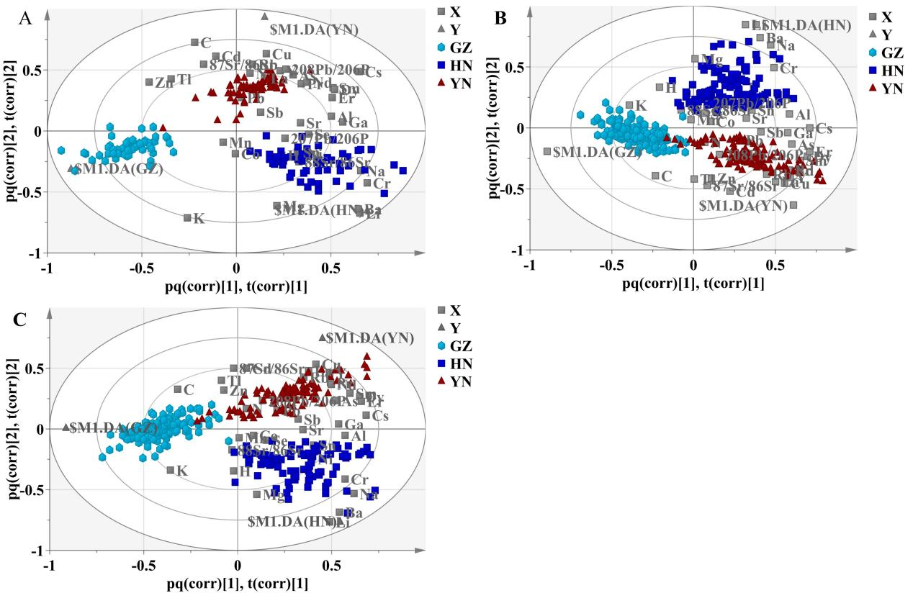
Figure S1 The biplot of the stable isotope and multi-element for training and testing sets of tobacco samples (A: training set samples from 2020; B: training set samples from 2021 and 2022; C: training set samples from two-thirds of the samples from 2020 to 2022).
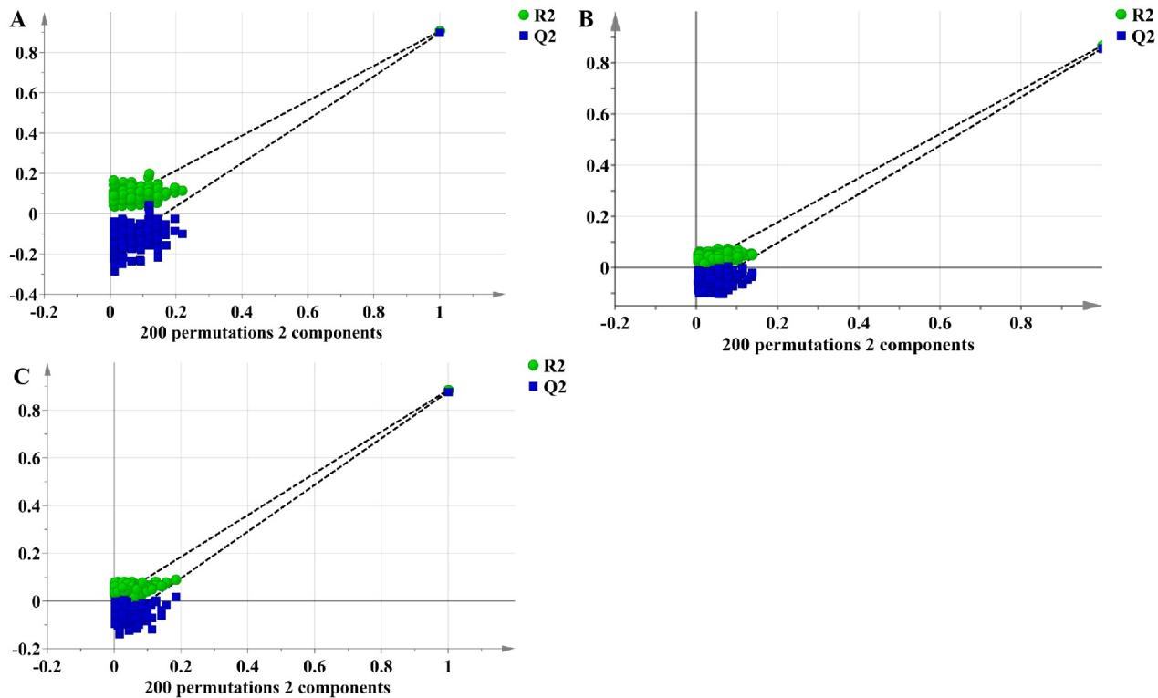
Figure S2 Permutation test for training and testing sets of tobacco samples (A: training set samples from 2020; B: training set samples from 2021 and 2022; C: training set samples from two-thirds of the samples from 2020 to 2022).
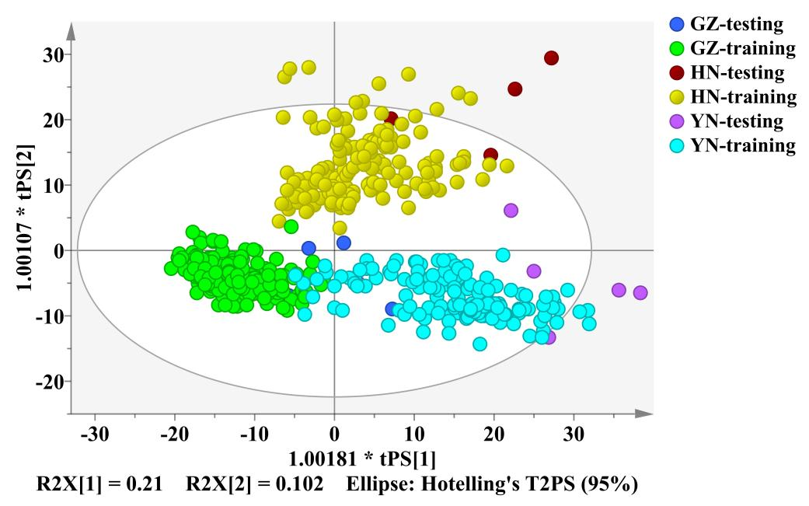
Figure S3 External dataset validation of tobacco samples ( training set samples from all the data of this model; test set samples from external;)
Table. S3. Discrimination accuracy of external dataset validation for tobacco samples (training set samples from all the data of this model; test set samples from external)

Type | Class Label | Henan | Guizhou | Yunnan | Discrimination Accuracy | Total Discrimination Accuracy
Training set | Henan (149) | 148 | 1 | 0 | 99.33 % | 97.52 %
Training set | Guizhou (223) | 0 | 223 | 0 | 100.00 % | 97.52 %
Training set | Yunnan (151) | 0 | 12 | 139 | 92.05 % | 97.52 %
Testing set | Henan (4) | 4 | 0 | 0 | 100.00 % | 92.86 %
Testing set | Guizhou (4) | 0 | 3 | 1 | 75.00 % | 92.86 %
Testing set | Yunnan (6) | 0 | 0 | 6 | 100.00 % | 92.86 %

