Supplementary Data 1: Content of GA, Zeatin, ABA, Total Carotenoid, B carotene in the leaves of graft varieties (V1, V2, V3, V4, V5) subjected to three levels of irrigation treatment (100, 75 and 50% FC). Values are presented as means ± SE (n = 5) corresponding to the figures.
IRRIGATION LEVELS  *  VARIETIES | 100% FC |  |  |  |  | 75% FC |  |  |  |  | 50% FC
IRRIGATION LEVELS  *  VARIETIES | V1 | V2 | V3 | V4 | V5 | V1 | V2 | V3 | V4 | V5 | V1 | V2 | V3 | V4 | V5
GA | 599.5±37.5E | 794±47DE | 1228.2±58BC | 1402±112AB | 1260.1±35.6BC | 595.9±33.3E | 898.7±20.6D | 1249.6±72.1BC | 1612.3±51.8A | 1399.9±91.7AB | 761.1±14.8DE | 1010.8±28.7CD | 931.69±8.33D | 1369.4±46.7AB | 1262.8±34.8BC
Zeatin | 439.132±0.916BC | 445.999±2.09ABC | 446.315±0.916ABC | 438.565±0.721BC | 456.05±0.754A | 440.194±0.898BC | 439.369±0.75BC | 444.611±4.73ABC | 435.69±1.81C | 457.36±1.99A | 445.032±1.41ABC | 445.084±1.86ABC | 0±0D | 444.751±1.09ABC | 450.297±7.52AB
ABA | 96.54±1.31E | 92.16±0.439FG | 152.72±1.26C | 95.5±0.931EF | 97.5±0.586E | 97.52±0.585E | 89.34±0.671GHI | 159.78±0.383B | 110.18±0.645D | 86.84±1.08HI | 97.2±0.99E | 91.5±0.93FG | 180.22±0.72A | 90.2±0.3GH | 85.24±1.19I
Zeaxanthin | 0.140961±0.00874GH | 0.086667±0.0116H | 0.765431±0.012B | 0.13±0.00859GH | 0.454989±0.00333D | 0.210696±0.00548F | 0.346667±0.0145E | 0.887865±0.0299A | 0.45842±0.0187D | 0.347064±0.0146E | 0.113848±0.00874GH | 0.459931±0.0116D | 0.173333±0.012FG | 0.533964±0.00859C | 0.303333±0.00333E
Total Carotenoids | 2.45141±0.159EFG | 4.36616±0.0977B | 2.78175±0.0597CDE | 1.91574±0.0391GH | 3.27519±0.14CD | 4.37603±0.0971B | 4.23433±0.0367B | 2.67129±0.18DEF | 2.01784±0.046FGH | 2.65876±0.254DEF | 4.29096±0.148B | 3.45±0.178C | 1.47464±0.201H | 3.44333±0.169C | 5.28456±0.109A
B Carotene | 4.31018±0.201EFG | 2.73605±0.0275H | 7.91209±0.0289A | 2.42479±0.0491 | 4.81767±0.0536DE | 3.30667±0.11H | 4.63853±0.0205DEF | 6.51667±0.144B | 6.63406±0.131B | 4.98111±0.0638D | 2.58347±0.192 | 4.06±0.0702FG | 3.96035±0.0989G | 5.65333±0.201C | 2.97586±0.0655H

Different letters denote significant differences between means according to Tukey HSD post hoc.

Supplementary Data 2:
Supplementary tables and figures provide detailed statistical validation of the data presented in the main manuscript, including full ANOVA outputs, Tukey’s post-hoc comparisons, and assumption checks for normality and homogeneity of variance.
All analyses were performed in Minitab v21. Residual plots and Levene’s tests confirm that the data meet ANOVA assumptions for all phytohormones (ABA, GA₃, and Zeatin).

- Zeatin
1.1 Two-way ANOVA summary (Genotype × Irrigation) for Zeatin.
Analysis of Variance
Source | DF | Seq SS | Contribution | Adj SS | Adj MS | F-Value | P-Value
Irrigation level | 2 | 127048 | 13.69% | 127048 | 63524.0 | 1882.26 | 0.000
Varity | 4 | 264223 | 28.46% | 264223 | 66055.8 | 1957.28 | 0.000
Irrigation level*Varity | 8 | 535000 | 57.63% | 535000 | 66875.0 | 1981.55 | 0.000
Error | 60 | 2025 | 0.22% | 2025 | 33.7
Total | 74 | 928297 | 100.00%

  - Residual plots
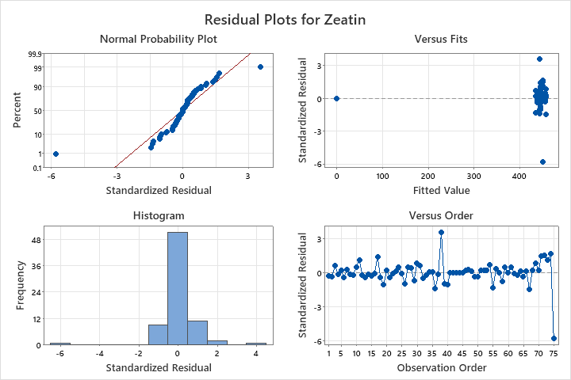

NOTE: The “Residuals vs Fitted Values” plot for zeatin shows a compressed x-axis range because the fitted means across treatments were similar, resulting in a narrow spread of predicted values. Nevertheless, residuals were symmetrically distributed around zero with no visible pattern, confirming homoscedasticity. Also, Levene’s test confirms uniform variance.

1.3 Tukey’s HSD pairwise comparison of means for Zeatin.
Tukey Pairwise Comparisons: Irrigation level*Varity
Grouping Information Using the Tukey Method and 95% Confidence
Irrigation  level*Varity | N | Mean | Grouping
75 5 | 5 | 457.360 | A
100 5 | 5 | 456.050 | A
50 5 | 5 | 450.297 | A | B
100 3 | 5 | 446.315 | A | B | C
100 2 | 5 | 445.999 | A | B | C
50 2 | 5 | 445.084 | A | B | C
50 1 | 5 | 445.032 | A | B | C
50 4 | 5 | 444.751 | A | B | C
75 3 | 5 | 444.611 | A | B | C
75 1 | 5 | 440.194 |  | B | C
75 2 | 5 | 439.369 |  | B | C
100 1 | 5 | 439.132 |  | B | C
100 4 | 5 | 438.565 |  | B | C
75 4 | 5 | 435.690 |  |  | C
50 3 | 5 | 0.000 |  |  |  | D
Means that do not share a letter are significantly different.

1.4 Levene’s test plots for equality of variances across treatments.
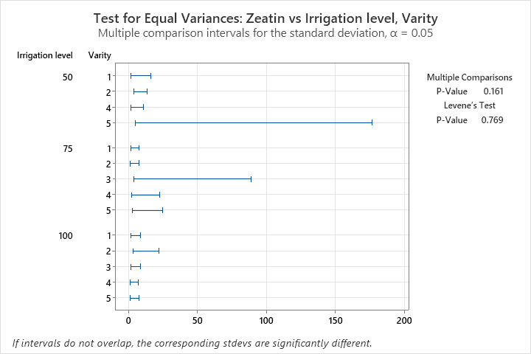

- Gibberellic Acid

  - Two-way ANOVA summary (Genotype × Irrigation) for Gibberellic Acid.
Analysis of Variance
Source | DF | Seq SS | Contribution | Adj SS | Adj MS | F-Value | P-Value
Irrigation level | 2 | 134148 | 1.71% | 134148 | 67074 | 4.66 | 0.013
Varity | 4 | 6221163 | 79.31% | 6221163 | 1555291 | 108.14 | 0.000
Irrigation level*Varity | 8 | 625529 | 7.97% | 625529 | 78191 | 5.44 | 0.000
Error | 60 | 862928 | 11.00% | 862928 | 14382
Total | 74 | 7843769 | 100.00%

  - Residual Plot
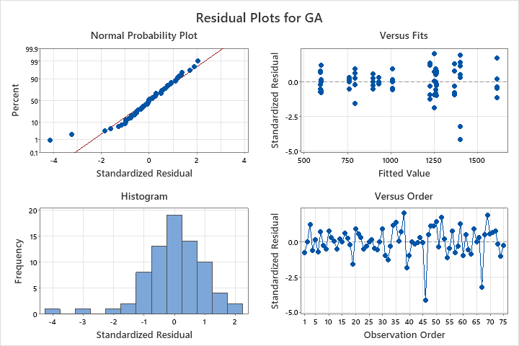
  - Tukey’s HSD pairwise comparison of means for Gibberellic Acid
Tukey Pairwise Comparisons: Irrigation level*Varity
Grouping Information Using the Tukey Method and 95% Confidence
Irrigation  level*Varity | N | Mean | Grouping
75 4 | 5 | 1612.25 | A
100 4 | 5 | 1402.43 | A | B
75 5 | 5 | 1399.91 | A | B
50 4 | 5 | 1369.36 | A | B
50 5 | 5 | 1262.81 |  | B | C
100 5 | 5 | 1260.13 |  | B | C
75 3 | 5 | 1249.58 |  | B | C
100 3 | 5 | 1228.22 |  | B | C
50 2 | 5 | 1010.77 |  |  | C | D
50 3 | 5 | 931.69 |  |  |  | D
75 2 | 5 | 898.71 |  |  |  | D
100 2 | 5 | 793.98 |  |  |  | D | E
50 1 | 5 | 761.09 |  |  |  | D | E
100 1 | 5 | 599.55 |  |  |  |  | E
75 1 | 5 | 595.92 |  |  |  |  | E
Means that do not share a letter are significantly different.

  - Levene’s test plots for equality of variances across treatments.
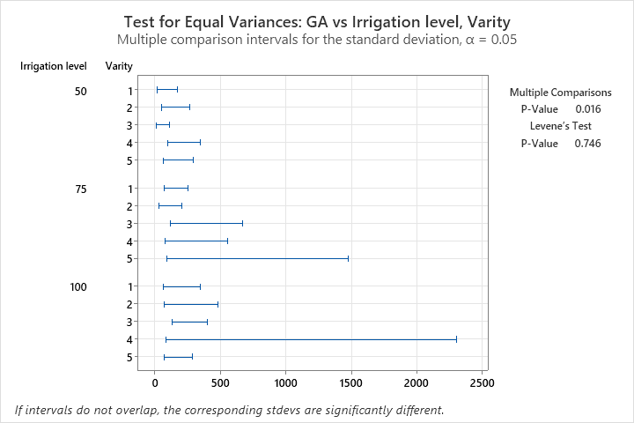

- ABA

  - Two-way ANOVA summary (Genotype × Irrigation) for ABA.
Analysis of Variance
Source | DF | Seq SS | Contribution | Adj SS | Adj MS | F-Value | P-Value
Irrigation level | 2 | 61.6 | 0.10% | 61.6 | 30.8 | 8.32 | 0.001
Varity | 4 | 59817.4 | 94.02% | 59817.4 | 14954.3 | 4043.17 | 0.000
Irrigation level*Varity | 8 | 3518.0 | 5.53% | 3518.0 | 439.8 | 118.89 | 0.000
Error | 60 | 221.9 | 0.35% | 221.9 | 3.7
Total | 74 | 63618.9 | 100.00%

3.2 Residual plots
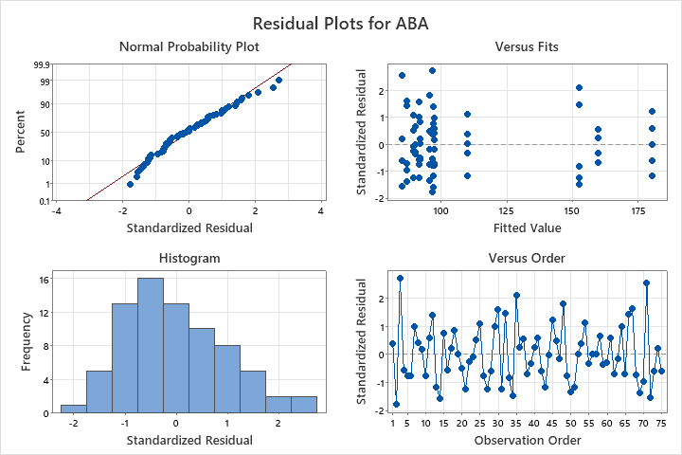

3.3. Tukey’s HSD pairwise comparison of means for ABA.
Tukey Pairwise Comparisons: Irrigation level*Varity
Grouping Information Using the Tukey Method and 95% Confidence
Irrigation  level*Varity | N | Mean | Grouping
50 3 | 5 | 180.22 | A
75 3 | 5 | 159.78 |  | B
100 3 | 5 | 152.72 |  |  | C
75 4 | 5 | 110.18 |  |  |  | D
75 1 | 5 | 97.52 |  |  |  |  | E
100 5 | 5 | 97.50 |  |  |  |  | E
50 1 | 5 | 97.20 |  |  |  |  | E
100 1 | 5 | 96.54 |  |  |  |  | E
100 4 | 5 | 95.50 |  |  |  |  | E | F
100 2 | 5 | 92.16 |  |  |  |  |  | F | G
50 2 | 5 | 91.50 |  |  |  |  |  | F | G
50 4 | 5 | 90.20 |  |  |  |  |  |  | G | H
75 2 | 5 | 89.34 |  |  |  |  |  |  | G | H | I
75 5 | 5 | 86.84 |  |  |  |  |  |  |  | H | I
50 5 | 5 | 85.24 |  |  |  |  |  |  |  |  | I
Means that do not share a letter are significantly different.

3.4. Levene’s test plots for equality of variances across treatments.
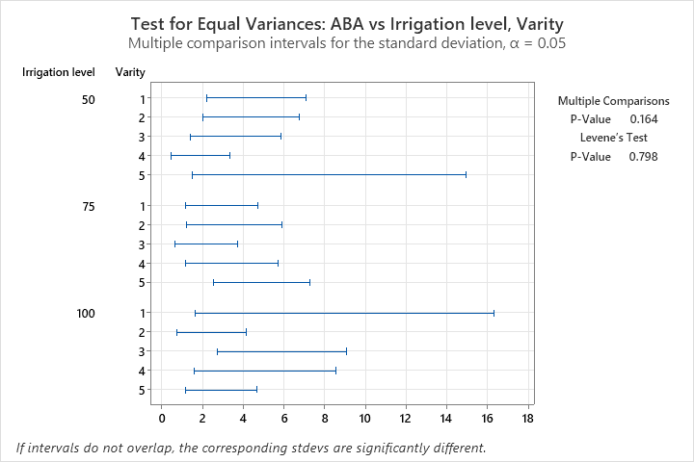

- Zeaxanthin.

  - Two-way ANOVA summary (Genotype × Irrigation) for Zeaxanthin.
Analysis of Variance
Source | DF | Seq SS | Contribution | Adj SS | Adj MS | F-Value | P-Value
Irrigation level | 2 | 0.17929 | 7.43% | 0.17929 | 0.089647 | 169.76 | 0.000
Varity | 4 | 0.97233 | 40.31% | 0.97233 | 0.243084 | 460.31 | 0.000
Irrigation level*Varity | 8 | 1.24487 | 51.60% | 1.24487 | 0.155609 | 294.67 | 0.000
Error | 30 | 0.01584 | 0.66% | 0.01584 | 0.000528
Total | 44 | 2.41235 | 100.00%

4.2 Tukey’s HSD pairwise comparison of means for Zeaxanthin.
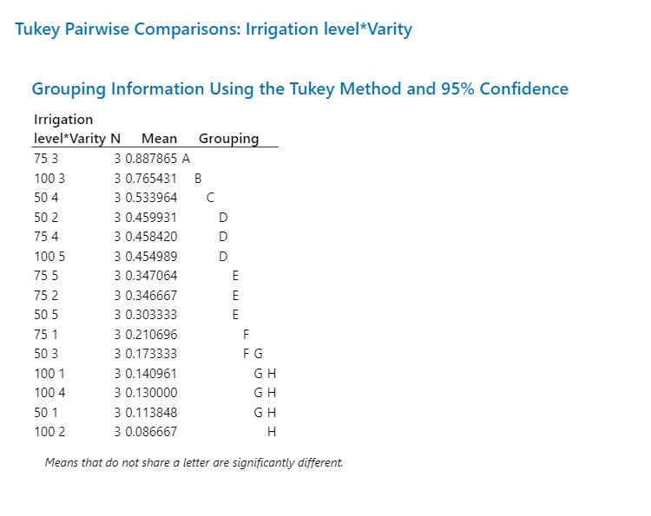

4.3 Residual plot

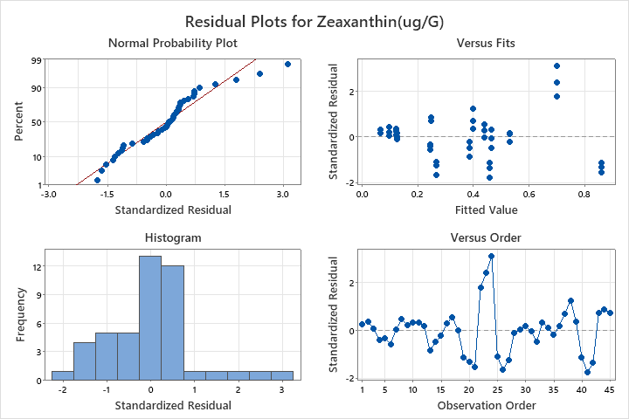

4.4. Levens Test

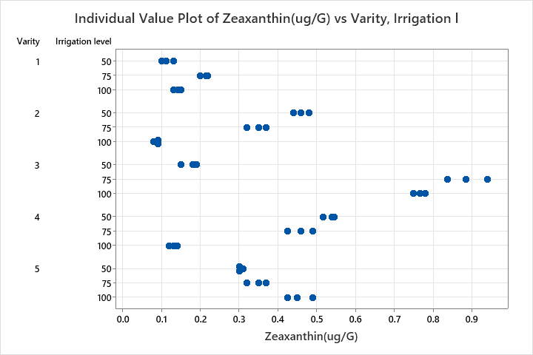

Method | Test  Statistic | P-Value
Multiple comparisons | — | 0.362
Levene | 1.04 | 0.440

5 Total Carotenoids

5.1 Two-way ANOVA summary (Genotype × Irrigation) for Total Carotenoids.

Analysis of Variance
Source | DF | Seq SS | Contribution | Adj SS | Adj MS | F-Value | P-Value
Varity | 4 | 22.918 | 43.95% | 22.918 | 5.72941 | 94.29 | 0.000
Irrigation level | 2 | 3.050 | 5.85% | 3.050 | 1.52485 | 25.10 | 0.000
Irrigation level*Varity | 8 | 24.359 | 46.71% | 24.359 | 3.04482 | 50.11 | 0.000
Error | 30 | 1.823 | 3.50% | 1.823 | 0.06076
Total | 44 | 52.149 | 100.00%

  - Tukey’s HSD pairwise comparison of means for Total Carotenoids.

Tukey Pairwise Comparisons: Irrigation level*Varity
Grouping Information Using the Tukey Method and 95% Confidence
Irrigation  level*Varity | N | Mean | Grouping
50 5 | 3 | 5.28456 | A
75 1 | 3 | 4.37603 |  | B
100 2 | 3 | 4.36616 |  | B
50 1 | 3 | 4.29096 |  | B
75 2 | 3 | 4.23433 |  | B
50 2 | 3 | 3.45000 |  |  | C
50 4 | 3 | 3.44333 |  |  | C
100 5 | 3 | 3.27519 |  |  | C | D
100 3 | 3 | 2.78175 |  |  | C | D | E
75 3 | 3 | 2.67129 |  |  |  | D | E | F
75 5 | 3 | 2.65876 |  |  |  | D | E | F
100 1 | 3 | 2.45141 |  |  |  |  | E | F | G
75 4 | 3 | 2.01784 |  |  |  |  |  | F | G | H
100 4 | 3 | 1.91574 |  |  |  |  |  |  | G | H
50 3 | 3 | 1.47464 |  |  |  |  |  |  |  | H
Means that do not share a letter are significantly different.

  - Residual Plot.

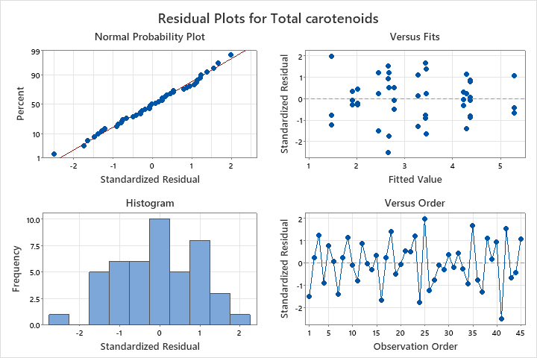

5.4 Levens test
Method | Test  Statistic | P-Value
Multiple comparisons | — | 0.512
Levene | 0.42 | 0.956

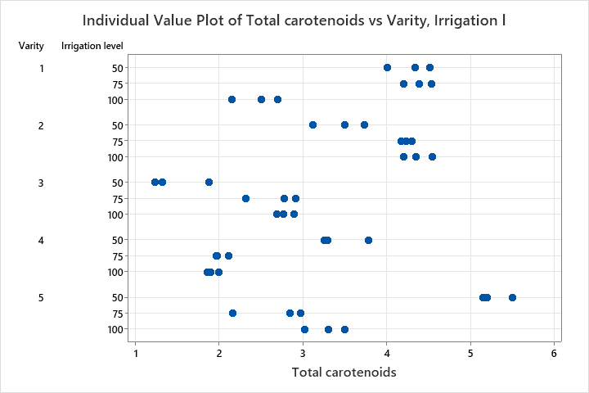

6.B carotene
6.1 Two-way ANOVA summary (Genotype × Irrigation) for B carotene

Analysis of Variance
Source | DF | Seq SS | Contribution | Adj SS | Adj MS | F-Value | P-Value
Irrigation level | 2 | 14.135 | 12.50% | 14.135 | 7.0674 | 178.48 | 0.000
Varity | 4 | 41.053 | 36.30% | 41.053 | 10.2632 | 259.19 | 0.000
Irrigation level*Varity | 8 | 56.725 | 50.15% | 56.725 | 7.0907 | 179.07 | 0.000
Error | 30 | 1.188 | 1.05% | 1.188 | 0.0396
Total | 44 | 113.101 | 100.00%

6.2 Levene’s test
Method | Test  Statistic | P-Value
Multiple comparisons | — | 0.250
Levene | 0.73 | 0.729
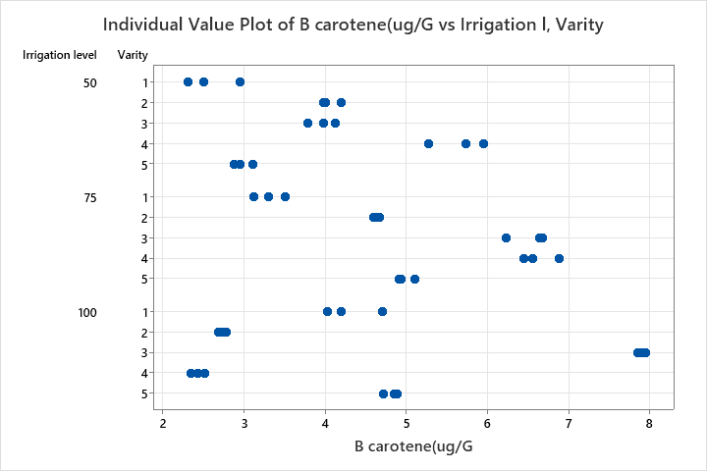

6.3 Tukey’s HSD pairwise comparison of means for B carotene
Tukey Pairwise Comparisons: Irrigation level*Varity
Grouping Information Using the Tukey Method and 95% Confidence
Irrigation  level*Varity | N | Mean | Grouping
100 3 | 3 | 7.91209 | A
75 4 | 3 | 6.63406 |  | B
75 3 | 3 | 6.51667 |  | B
50 4 | 3 | 5.65333 |  |  | C
75 5 | 3 | 4.98111 |  |  |  | D
100 5 | 3 | 4.81767 |  |  |  | D | E
75 2 | 3 | 4.63853 |  |  |  | D | E | F
100 1 | 3 | 4.31018 |  |  |  |  | E | F | G
50 2 | 3 | 4.06000 |  |  |  |  |  | F | G
50 3 | 3 | 3.96035 |  |  |  |  |  |  | G
75 1 | 3 | 3.30667 |  |  |  |  |  |  |  | H
50 5 | 3 | 2.97586 |  |  |  |  |  |  |  | H | I
100 2 | 3 | 2.73605 |  |  |  |  |  |  |  | H | I
50 1 | 3 | 2.58347 |  |  |  |  |  |  |  |  | I
100 4 | 3 | 2.42479 |  |  |  |  |  |  |  |  | I
Means that do not share a letter are significantly different.

