Supplementary Data
Table 1 The primer used in qRT-PCR
Name | Sequence
Actin | F:5’CAAAAGATGGCAGATGCTGAGGAT3’  R:5’CATGACACCAGTATGACGAGGTCG3’
TRINITY_DN7173_c0_g1 | F:5’TGGTGCAACTGCGTCTGATTCG3’  R:5’GCGGGTGGTGCTGAATGGAAG3’
TRINITY_DN3204_c1_g1 | F:5’CCGCTTGTGGTGTGAGAATAGGC3’  R:5’TGGCTACGTCTACCGCAGGATC3’
TRINITY_DN28106_c0_g1 | F:5’TGGTGTTGTGCCTGAGAGTTTGG3’  R:5’GGGAACCTGAAGCTGCTGAGAAG3’
TRINITY_DN8716_c0_g1 | F:5’AGTCCTGCCTGAAATGCACAACC3’  R:5’TTGGGAGCACTACCTCGTCTTCC3’
TRINITY_DN3527_c0_g1 | F:5’TCCATTAACGCCGCCATCAACC3’  R:5’TCCTCCTCCTCACCGAATCAAGC3’
TRINITY_DN36785_c0_g1 | F:5’AACAACCACCACCACTACCAACC3’  R:5’TTCCTTGCTTCAAAGGGGTGTGG3’

Supplementary Figure 1 The number of DEGs

Supplementary Table 2. The FPKM of DEGs
ID | nr_Symbol | RC  0h | RC  12h | RC  24h | RC  48h | RC  72h | SC  0h | SC  12h | SC  24h | SC  48h | SC  72h
TRINITY_DN  0_c1_g1 | LOC  114402295 | 19.43 | 37.12 | 31.39 | 13.49 | 26.42 | 62.28 | 31.99 | 53.36 | 37.80 | 43.24
TRINITY_DN  36844_c0_g1 | LOC  113851093 | 1.23 | 1.41 | 6.11 | 4.64 | 1.84 | 2.43 | 1.64 | 1.38 | 0.70 | 4.57
TRINITY_DN  7222_c1_g2 | LOC  113863785 | 8.73 | 10.66 | 11.08 | 27.78 | 20.49 | 9.53 | 16.07 | 13.31 | 9.77 | 20.47
TRINITY_DN  1050_c0_g1 | LOC  11438219 | 73.58 | 666.35 | 1938.27 | 4666.13 | 2204.03 | 118.23 | 1585.93 | 1948.39 | 2892.47 | 2273.15
TRINITY_DN  17633_c0_g1 | LOC  113871284 | 42.58 | 15.08 | 6.19 | 6.95 | 7.38 | 43.95 | 24.24 | 9.94 | 15.83 | 12.12
TRINITY_DN  2753_c0_g1 | LOC  109351922 | 482.03 | 256.70 | 189.44 | 83.74 | 150.05 | 383.07 | 203.69 | 211.07 | 238.83 | 191.92
Supplementary Figure 2 The GO of DEGs at differenttime
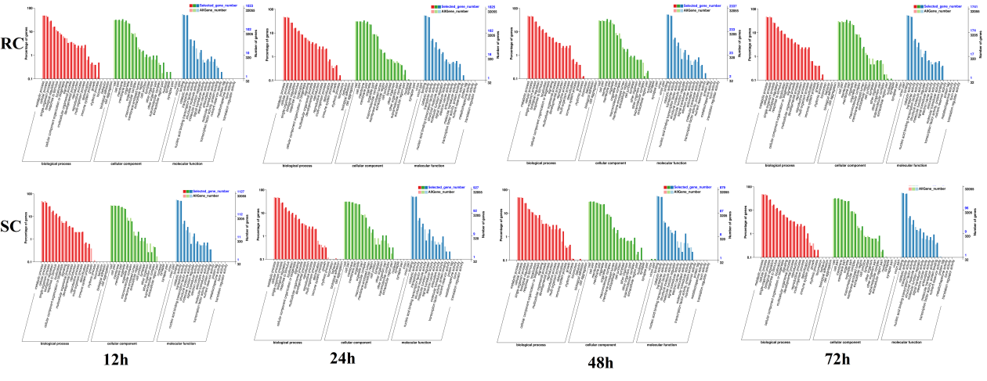
Supplementary Figure 3. The KEGG of the DGEs at differenttime.
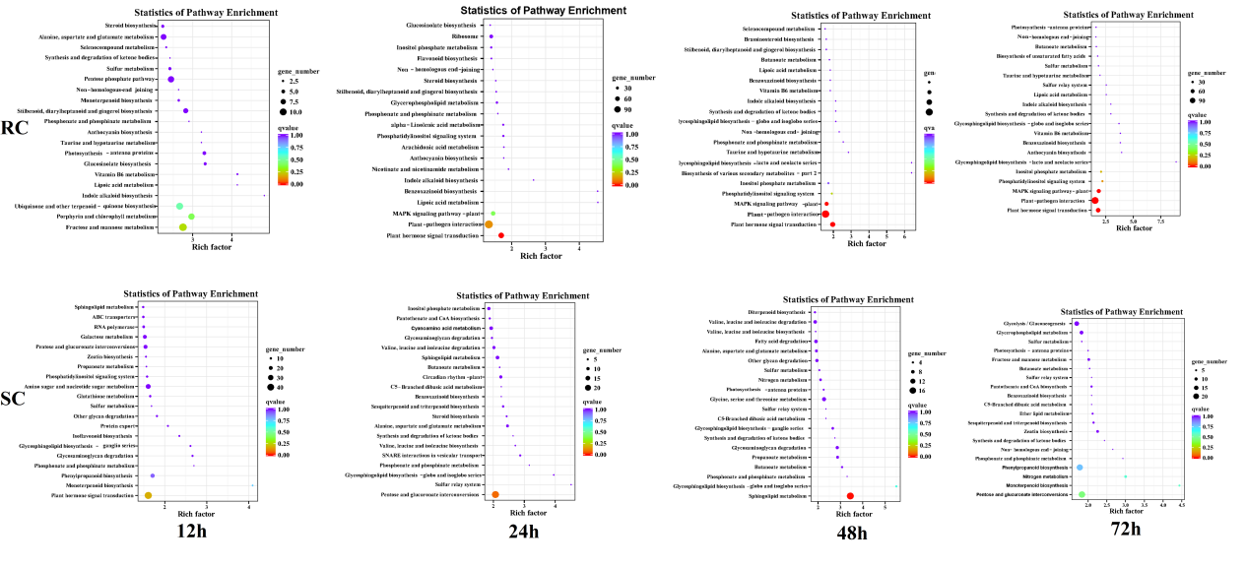
Supplementary Table 3. Differentially expressed genes ranked in the top 50 by KME value within each module

