Title: Augmenting the elemental sulphur–based formulation with strain 43UP1–Pseudomonas veronii: a haloalkaliphilic heterotroph for improved sodic soil reclamation and crop performance

Supplementary Table 1. Details of the antibiotic used in the study
Himedia Hexa Universal – 1 | Penicillin G (P), Polymyxin B (PB), Gentamicin (GEN), Neomycin (N), Bacitracin (B), Chloramphenicol (C)
HexaG – minus 2 | Ciprofloxacin (CIP), Amikacin (AK), Nitrofurantoin (NIT), Netillin (NET), Nalidixic acid (NA), Ceftazidime (CAZ)
Hexa G–minus 1 | Gentamicin (GEN), Amoxyclav (AMC), Tobramycin (TOB), Co–Trimoxazole (COT), Cefotaxime (CTX), Ampicillin (AMP)

Supplementary Table 2. PCR profiles for amplification of 16S rRNA and sox genes

Genes | Primer sequences | PCR profile
16S rRNA | 27F–1492R  27F 5’-AGAGTTTGATCMTGGCTCAG-3’ 1492R 5’-TACCTTGTTACGACTT-3’ | Initial denaturation at 95 ◦C for 5 min, followed by 35 cycles of denaturation at 95 ◦C for 1 min, primer annealing at 54 ◦C for 1 min and primer extension at 72 ◦C for 2 min, followed by a final extension at 72 ◦C for 10 min
soxA | F 5’-TGG GAG AAG GGC AAG GAG CT-3’  R 5’- TGG GAG AAG GGC AAG GAG CT -3’ | Initial denaturation at 94 °C for 5 min, followed by 35 amplification cycles of denaturation at 94 °C for 30 seconds, annealing at 55 °C for 50 seconds, primer extension at 72 °C for 25 seconds and a final extension at 72 °C for 7 min.
soxB | F 5’-ATC GGY CAG GCY TTY CCS TA -3’  R 5’-MAV GTG CCG TTG AAR TTG C -3’ | Initial denaturation at 94 °C for 5 min, followed by 25 amplification cycles of denaturation at 94 °C for 40 seconds, annealing at 62 °C for 40 seconds, primer extension at 72 °C for 1 min and a final extension at 72 °C for 6min.
soxY | F 5’- ATC GAT GAC AAC CCC GTG CC -3’  R 5’- AGC TGG TCC ATC TGC ATG CCG-3’ | Initial denaturation at 94 °C for 2 min, followed by 30 amplification cycles of denaturation at 94 °C for 30 seconds, annealing at 51 °C for 30 seconds, primer extension at 71 °C for 20 seconds and a final extension at 72 °C for 7 min.

Supplementary Table 3. Physicochemical properties of soil used in study; with code; GR: gypsum requirement

Location | Shivri farm, Lucknow, Uttar Pradesh  (UP) | Barwah farm, Indore, Madhya Pradesh  (MP) | Dharamgarh, Panipat, Haryana  (MD) | Haibatpur, Karnal,  Haryana  (MH) | Saraswati forest, Kaithal, Haryana  (MS)
Latitude and Longitude | 26°47.967’N, 80°46.302’E | 22°14.808΄N, 76°00.440΄E | 29°27.431N, 76°48.07’ E | 29°50.421N, 76°45.859’ E | 30°00’04.5” N, 76°25’27.3” E
pH_{s} | 10.53 | 9.25 | 9.20 | 9.10 | 10.16
pH_{1:2} | 10.91 | 9.84 | 10.20 | 10.11 | 10.71
EC_{1:2} (dS m^{–1}) | 6.77 | 0.53 | 0.96 | 0.47 | 3.09
pH_{e} | 10.43 | 8.53 | 8.91 | 8.88 | 0.00
EC_{e} (dS m^{–1}) | 18.70 | 4.01 | 2.26 | 1.18 | 12.15
WBOC (%) | 0.25 | 0.31 | 0.15 | 0.13 | 0.14
CaCO₃ (%) | 1.72 | 3.47 | 1.04 | 1.87 | 1.45
Gypsum requirement (Mg ha^{–1}) | 40.3 | 43.5 | 20.2 | 16.7 | 22.7
ESP (%) | 96.7 | 62.5 | 98.2 | 95.8 | 77.5
Sand (%) | 58.2 | 47.1 | 50.8 | 50.7 | 59.3
Silt (%) | 26.1 | 35.3 | 29.5 | 31.4 | 17.4
Clay (%) | 15.7 | 17.6 | 19.9 | 17.9 | 23.3
Soil solution composition
Na⁺ (me L^{–1}) | 253.52 | 33.09 | 77.72 | 31.72 | 14.81
K⁺ (me L^{–1}) | 0.74 | 0.04 | 0.22 | 0.12 | 0.06
Ca²⁺ (me L^{–1}) | 0.00 | 0.30 | 0.50 | 0.10 | 0.45
Mg²⁺ (me L^{–1}) | 0.70 | 0.50 | 0.40 | 0.30 | 0.80
CO₃^{2–} (me L^{–1}) | 115.00 | 0.60 | 1.10 | 0.80 | 0.00
HCO₃– (me L^{–1}) | 22.50 | 5.20 | 12.60 | 7.60 | 3.90
Cl– (me L^{–1}) | 5.00 | 13.90 | 7.00 | 1.40 | 2.40

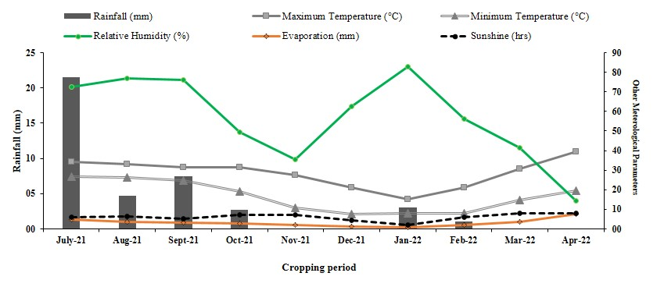Supplementary Figure 2 1. Meteorological information of the experimental site during the cropping season (July 2021 to April 2022).

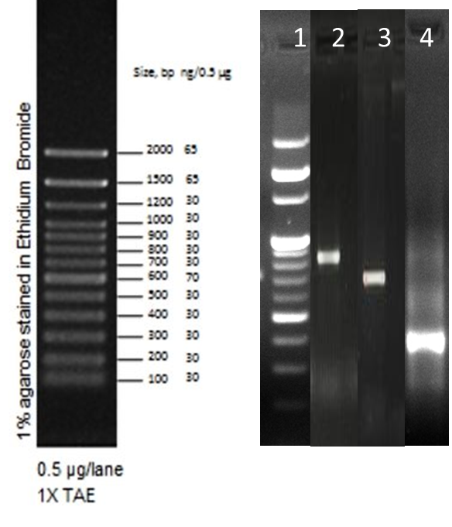

Supplementary Figure 2. Presence of soxA, soxB, and soxY genes systems. PCR amplification of SoxA, SoxB and SoxY genes. Lane 1 represents Ladder, Lane 2- SoxA (720 bp) , Lane 3–SoxB (590 bp) and Lane 3–SoxY (329 bp).

Supplementary Table 4. Antibiotic sensitivity OF Pseudomonas veronii strain 43UP1
Name of antibiotics | Resistant/Sensitive
Penicillin (P) | S | 1.5 cm
Polymyxin B (PB) | S | 1.3 cm
Gentamicin (GEN) | S | 1.4 cm
Neomycin (N) | S | 1.2 cm
Bacitracin (B) | R | --
Chloramphenicol (C) | S | 1.6 cm
Ciprofloxacin (CIP) | S | 1.2 cm
Amikacin (AK) | R | --
Nitrofurantoin (NIT) | S | 1.2 cm
Netilmicin (NET) | S | 0.6 cm
Nalidixic Acid (NA) | R | --
Ceftazidime (CAZ) | S | 1.6 cm
Amoxicillin-Clavulanic Acid (AMC) | S | 1.6 cm
Tobramycin (TOB) | S | 1.2 cm
Cotrimoxazole (COT), | R | --
Cefotaxime (CTX) | S | 1.2 cm
Ampicillin (AMP) | R | --

