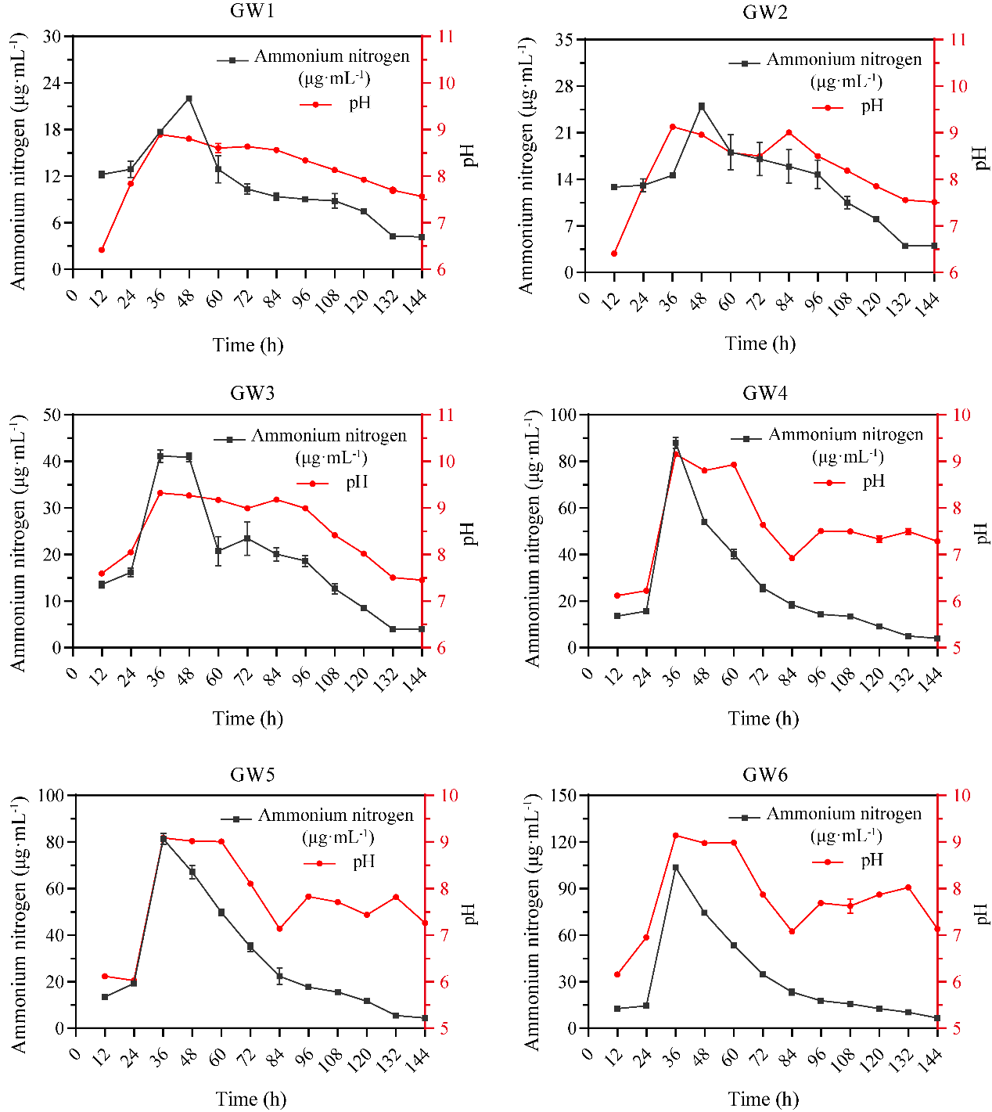
Figure S1. Ammonium nitrogen and pH dynamics during 0-2.4% urea-mediated moderate-temperature incubation

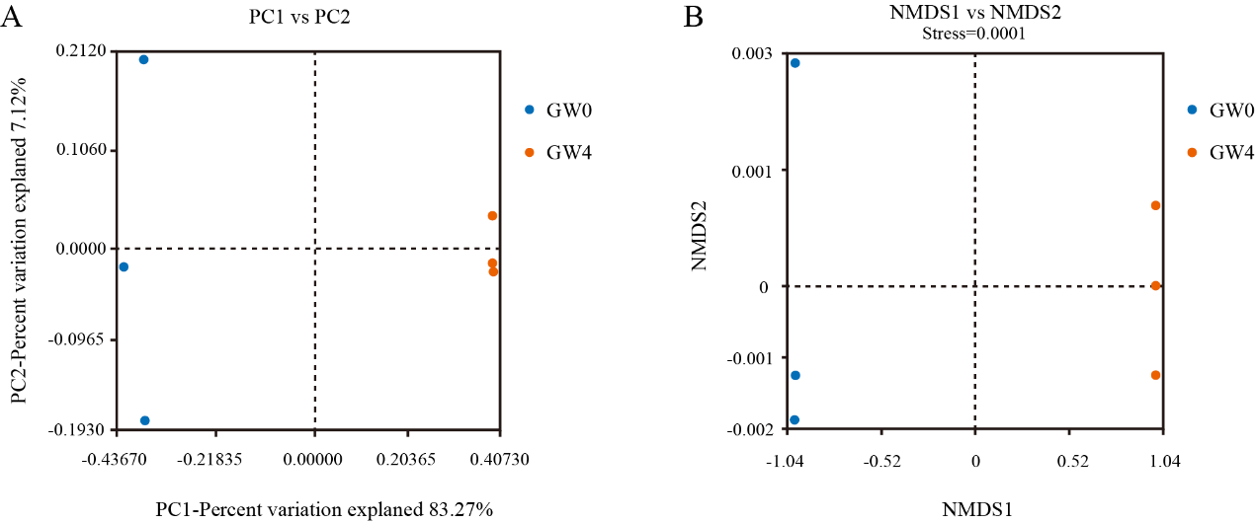
Figure S2. Results of β-Diversity Analysis. (A)PCoA Results. (B) NMDS Results.

Table S1. Alpha Diversity Index
 | Shannon | Simpson | Ace | Chao1
GW0 | 4.34 ± 0.18 | 0.97 ± 0.01 | 189.25 ± 6.40 | 189.47 ± 7.21
GW4 | 5.13 ± 0.07 | 0.98 ± 0.00 | 432.32 ± 13.20 | 431.56 ± 19.18

