Supporting Information
Biocontrol potential of Bacillus spp.: Antimicrobial metabolites identification and comparative genomics
Qingyu Li^{a,b,c#}, Jiantao Liu^{a,c#}, Jun Wan^{d}, Depeng Chu^{a,c}, Jiale Ma^{e}, Qingxian Kong^{a,c}, Jing Liu^{d*}, Johannes H. Bitter^{b}, Elinor L. Scott^{b}, Xiangwei You^{a,c}, Yiqiang Li^{a,c*}, Yuan Yuan^{a,c*}
ª Marine Agriculture Research Center, Tobacco Research Institute, Chinese Academy of Agricultural Sciences, Qingdao 266101, China
^{b} Biobased Chemistry and Technology, Wageningen University and Research, Wageningen 6708WG, The Netherlands
^{c} Qingdao Engineering Research Center for Marine and Terrestrial Waste Resource Valorization, Qingdao 266101, China
^{d} Zunyi Branch of Guizhou Tobacco Company, Zunyi 563000, China
^{e} Zunyi Maxing Organic Fertilizer Co., Ltd., Zunyi 563000, China

# Qingyu Li and Jiantao Liu contributed equally to this paper.

*Corresponding authors:
Jing Liu: liujingcre@163.com
Yiqiang Li: liyiqiang@caas.cn
Yuan Yuan: yuanyuan03@caas.cn

Captions
Figure S1 Phylogenetic tree of strain AQ171 based on multilocus sequence analysis (MLSA) of 31 housekeeping genes
Figure S2 Phylogenetic tree of strain cmc7 based on multilocus sequence analysis (MLSA) of 31 housekeeping genes
Figure S3 Phylogenetic tree of strain HTDT4 based on multilocus sequence analysis (MLSA) of 31 housekeeping gene
Figure S4 Phylogenetic tree of strain WL51 based on multilocus sequence analysis (MLSA) of 31 housekeeping gene
Figure S5 Whole genome analysis of cmc7 (A) Circular genome map of strain cmc7. (B) KEGG annotation classification. (C) COG annotation classification.
Figure S6 Whole genome analysis of HTDT4 (A) Circular genome map of strain cmc7; (B) KEGG annotation classification; (C) COG annotation classification.
Figure S7 Whole genome analysis of WL51 (A) Circular genome map of strain cmc7; (B) KEGG annotation classification; (C) COG annotation classification.

Table S1 Sequencing and genome assembly statistics of the four bacterial strains
Table S2 Average nucleotide identity (ANI) values among the four Bacillus strains
Table S3 Secondary metabolite biosynthetic gene clusters predicted in cmc7 genome
Table S4 Secondary metabolite biosynthetic gene clusters predicted in HTDT4 genome
Table S5 Secondary metabolite biosynthetic gene clusters predicted in WL51 genome
Figure S1. Phylogenetic tree of strain AQ171 based on multilocus sequence analysis (MLSA) of 31 housekeeping genes

Figure S2. Phylogenetic tree of strain cmc7 based on multilocus sequence analysis (MLSA) of 31 housekeeping genes

Figure S3. Phylogenetic tree of strain HTDT4 based on multilocus sequence analysis (MLSA) of 31 housekeeping gene

Figure S4. Phylogenetic tree of strain WL51 based on multilocus sequence analysis (MLSA) of 31 housekeeping gene

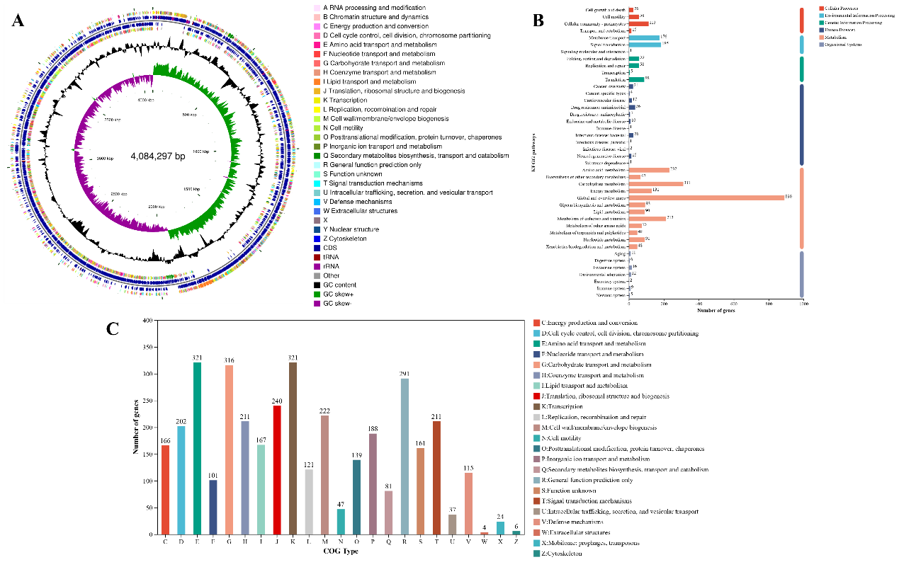
Figure S5. Whole genome analysis of cmc7 (A) Circular genome map of strain cmc7. Circular genome map from outside to inside: rings 1 and 4 show CDS on forward and reverse strands with colors representing COG functional categories; rings 2 and 3 show CDS, tRNA, and rRNA on forward and reverse strands; ring 5 shows GC content (outward peaks indicate above-average GC content, inward peaks indicate below-average); ring 6 shows GC-Skew values for identifying leading and lagging strands; innermost ring shows genome size scale. (B) KEGG annotation classification. The y-axis represents the level 2 classification of KEGG pathways, and the x-axis represents the number of genes annotated to each classification. Different bar colors represent the level 1 classification of KEGG pathways. (C) COG annotation classification. The x-axis represents different COG categories, and the y-axis represents the number of genes.

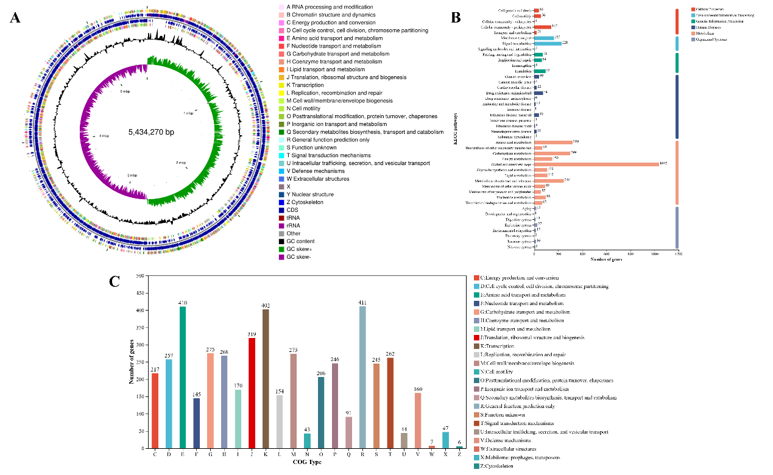
Figure S6. Whole genome analysis of HTDT4 (A) Circular genome map of strain cmc7; (B) KEGG annotation classification; (C) COG annotation classification.

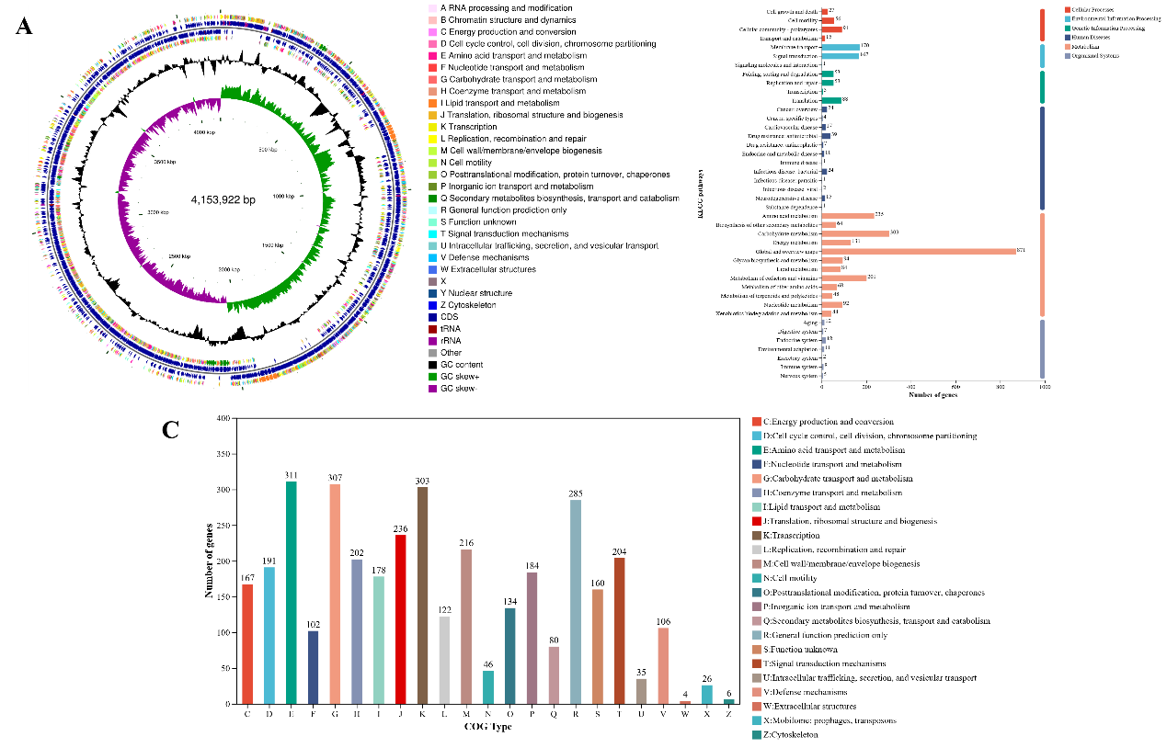
Figure S7. Whole genome analysis of WL51 (A) Circular genome map of strain cmc7; (B) KEGG annotation classification; (C) COG annotation classification.

Table S1. Sequencing and genome assembly statistics of the four bacterial strains
Strain | Illumina clean  paired reads | Illumina clean  bases (bp) | Q30 (%) | PacBio  reads | PacBio bases  (bp) | PacBio depth  (×) | Final assembled  sequences | Assembly structure | Assembly N50  (bp) | L50 | BUSCO  completeness (%) | CheckM  completeness (%) | Contamination  (%)
AQ171 | 8,595,002 | 1,295,280,322 | 95.48 | 31,423 | 279,672,265 | 71.24 | 1 | 1 circular chromosome | 3,925,746 | 1 | 100 | 99.63 | 0.02
HTDT4 | 7,172,108 | 1,077,011,986 | 95.00 | 42,100 | 368,901,058 | 67.58 | 3 | 1 circular chromosome + 2 circular plasmids | 5,434,270 | 1 | 100 | 99.23 | 0.30
cmc7 | 9,122,028 | 1,374,458,905 | 95.54 | 15,643 | 124,715,297 | 30.43 | 2 | 1 circular chromosome + 1 circular plasmid | 4,084,297 | 1 | 100 | 99.81 | 0.35
WL51 | 7,122,438 | 1,071,629,181 | 95.02 | 31,122 | 285,732,918 | 68.79 | 1 | 1 circular chromosome | 4,153,922 | 1 | 100 | 99.81 | 0.99
Note: PacBio sequencing depth was calculated as the total number of PacBio raw bases divided by the final genome size. Assembly N50 and L50 were calculated from the final assembled chromosome and plasmid sequences. Illumina and PacBio read-mapping coverage of the final assemblies reached 100% for all four strains.

Table S2. Average nucleotide identity (ANI) values among the four Bacillus strains
Strain | AQ171 | cmc7 | HTDT4 | WL51
AQ171 | 100.00 | 77.06 | 68.27 | 77.52
cmc7 | - | 100.00 | 69.01 | 87.38
HTDT4 | - | - | 100.00 | 68.57
WL51 | - | - | - | 100.00
Note: Values represent OrthoANIu percentages calculated using EzBioCloud. Values below the 95% threshold indicate distinct species boundaries.

Table S3. Secondary metabolite biosynthetic gene clusters predicted in cmc7 genome
Cluster ID | Type | Start | End | Similar Cluster | Similarity(%)
cluster1 | NRPS | 349860 | 413300 | surfactin | 82
cluster2 | terpene | 1110389 | 1130903 | - | -
cluster3 | lanthipeptide-class-i | 1686094 | 1712194 | - | -
cluster4 | transAT-PKS | 1734460 | 1839721 | bacillaene | 100
cluster5 | NRPS | 1912282 | 1989222 | fengycin | 100
cluster6 | terpene | 2059873 | 2081772 | - | -
cluster7 | T3PKS | 2129507 | 2170605 | - | -
cluster8 | NRPS | 3111278 | 3158415 | bacillibactin | 100
cluster9 | lanthipeptide-class-i | 3309286 | 3335512 | subtilin | 100
cluster10 | CDPS | 3454339 | 3475086 | - | -
cluster11 | sactipeptide | 3699564 | 3721176 | subtilosin A | 100
cluster12 | other | 3728266 | 3769685 | bacilysin | 100
cluster13 | RiPP-like | 3968534 | 3981266 | - | -
cluster14 | epipeptide | 3996511 | 4018210 | thailanstatin A | 10

Table S4. Secondary metabolite biosynthetic gene clusters predicted in HTDT4 genome
Cluster ID | Type | Start | End | Similar Cluster | Similarity(%)
cluster1 | NRPS-like | 406608 | 449561 | - | -
cluster2 | LAP | 1251850 | 1275357 | - | -
cluster3 | siderophore | 1920519 | 1934227 | petrobactin | 100
cluster4 | NRPS | 2290255 | 2335425 | bacillibactin | 46
cluster5 | NRPS | 2453613 | 2518084 | - | -
cluster6 | betalactone | 2522265 | 2547504 | fengycin | 40
cluster7 | RiPP-like | 2599304 | 2609203 | - | -
cluster8 | RiPP-like | 2704986 | 2715253 | - | -
cluster9 | NRPS | 2727628 | 2774639 | - | -
cluster10 | terpene | 3578797 | 3600651 | molybdenum cofactor | 17
cluster11 | RiPP-like | 223 | 10448 | bacillicn CER074 | 15

Table S5. Secondary metabolite biosynthetic gene clusters predicted in WL51 genome
Cluster ID | Type | Start | End | Similar Cluster | Similarity(%)
cluster1 | ranthipeptide | 202255 | 224825 | sporulation killing factor | 100
cluster2 | NRPS | 358789 | 422652 | surfactin | 86
cluster3 | PKS-like | 730048 | 842657 | aurantinin B / C / D | 21
cluster4 | terpene | 1228761 | 1249147 | - | -
cluster5 | transAT-PKS | 1843429 | 1949344 | bacillaene | 100
cluster6 | NRPS | 2023098 | 2152576 | fengycin | 100
cluster7 | terpene | 2223946 | 2245845 | - | -
cluster8 | T3PKS | 2296674 | 2337772 | - | -
cluster9 | NRPS | 3186046 | 3233186 | bacillibactin | 100
cluster10 | sactipeptide | 3757936 | 3779549 | subtilosin A | 100
cluster11 | other | 3781457 | 3822876 | bacilysin | 100

