Supplementary Information
Valorization of Ginseng Extraction Residue for Producing Rare Ginsenoside-Enriched Eggs
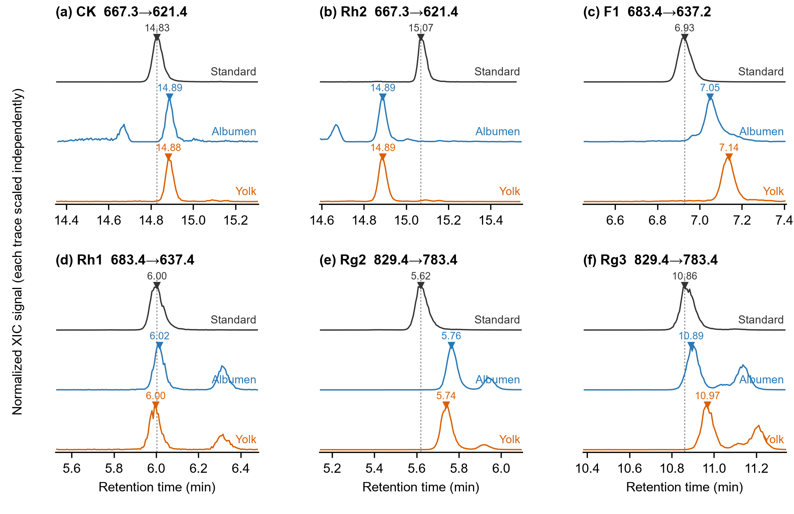
Figure S1. XIC traces of reference standards and boiled egg albumen and yolk samples.
(a) CK; (b) Rh2; (c) F1; (d) Rh1; (e) Rg2; (f) Rg3. Black, blue, and orange denote standard, albumen, and yolk. Traces were baseline-adjusted, normalized separately, and offset. Transitions are labelled in each panel; dashed lines indicate standard retention times. Numbers mark local maxima.

Table S1. Summary of recorded QC concentrations at a nominal 1 ng/mL.
Ginsenoside | n | Mean calculated concentration (ng/mL) | Accuracy (%) | Concentration RSD (%)
CK | 6 | 1.06784 | 106.78 | 0.0315
Rh2 | 6 | 1.11104 | 111.10 | 0.0664
F1 | 6 | 1.06784 | 106.78 | 0.0315
Rh1 | 6 | 0.97035 | 97.03 | 0.0646
Rg2 | 6 | 1.15790 | 115.79 | 0.0826
Rg3 | 6 | 1.05605 | 105.60 | 0.0521
n = 6. Accuracy is the mean recorded concentration divided by the nominal concentration, expressed as a percentage. RSD was calculated from the six recorded concentrations.

