Supporting Information

Supplemented experimental section
Preparation of the dark silver nanoclusters (AgNCs): The dark AgNCs are prepared via the reduction of AgNO3 by NaBH4. Briefly, 3.6 μL 1.25 mmol/L AgNO3, 5 μL 100 μmol/L ssDNA probe, 5 μL 10×PB (pH 6.6) and 32.8 μL double distilled water are mixed and incubated for 20 min at 25 ℃. Then, 3.6 μL 1.25 mmol/L freshly prepared NaBH4 is added with a total volume of 50 μL. The mixture is kept at 25 ℃ for 2 h to reduce Ag ions to Ag atom. The concentration of dark AgNCs is calculated by the concentration of ssDNA probe. 10 μmol/L dark AgNCs are obtained.

Table S1. Details of the nucleic acids used in this research
Title | Sequences (5’-3’)
H1 probe | TCAA CAT CAG TCT GAT AAG CTA TTT TAT TCA TGT CTG ATG TTG
H2 probe | TAG CTT ATC AGA CTG GGC TGG GGT GGG TGG GTG GGG TCA ACA TCA GTC TGA TAA GCT A GAA CAT CAG ACA TGA ATA AAA
DNA template | CCC TTA ATC CCC CAG CCT ACT ACC TCA
miRNA-21 | UAG CUU AUC AGA CUG AUG UUG A
Let-7a | UGA GGU AGU AGG UUG UAU AGU U
miRNA-211 | AGC UAC AUU GUC UGC UGG GUU UC
miRNA-143 | AGA AUC UUG AUG AUG CUG CAU
miRNA-155 | UUC CAC AGC UUU CUU GAA CUG

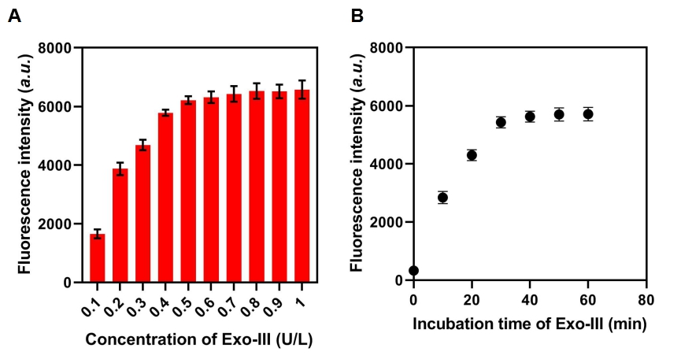
Fig S1. Optimization of incubation time. (A) Fluorescence signal of the approach with different concentrations of Exo-III enzyme. (B) Fluorescence intensity of the approach with different incubation time of Exo-III enzyme.

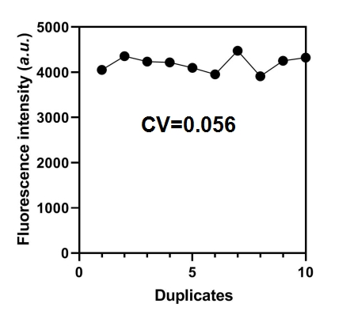
Fig S2. Fluorescence intensity of the approach when detecting 10 technical duplicates.

