Supporting information

Terminalia chebula: A novel natural product colorimetric sensor for Fe²⁺ and Fe³⁺ ions

Supporting figures………………………….………… 2-4

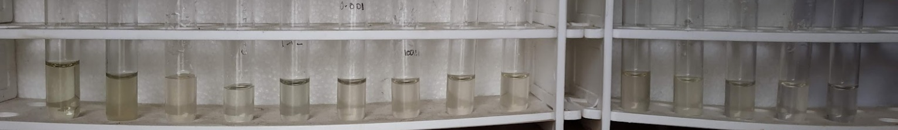
Extract
Fe²⁺ - - - - - - - - - - - -
Co²⁺ Ni²⁺ Cr³⁺ Hg²⁺ Mg²⁺ Na⁺ K⁺ Ca²⁺ Al³⁺ Mn²⁺ La³⁺ Cd²⁺

(a)

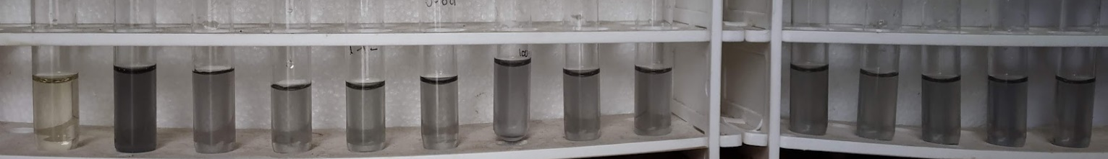
Fe²⁺ - - - - - - - - - - - -
Co²⁺ Ni²⁺ Cr³⁺ Hg²⁺ Mg²⁺ Na⁺ K⁺ Ca²⁺ Al³⁺ Mn²⁺ La³⁺ Cd²⁺
Extract

(b)

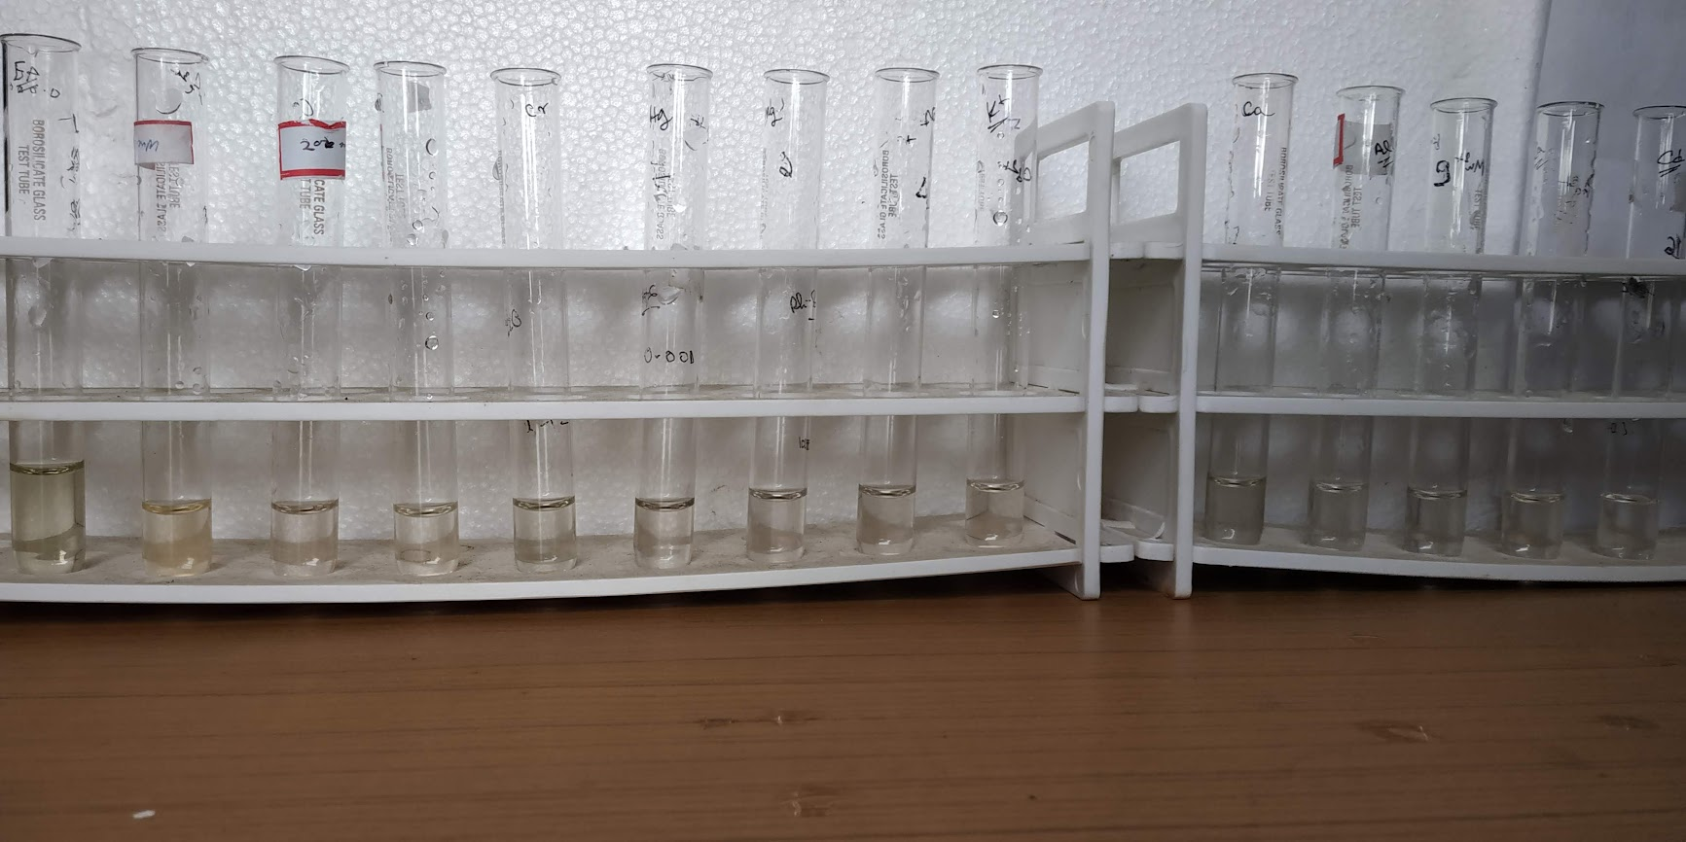
Extract
Fe³⁺ - - - - - - - - - - - -
Co²⁺ Ni²⁺ Cr³⁺ Hg²⁺ Mg²⁺ Na⁺ K⁺ Ca²⁺ Al³⁺ Mn²⁺ La³⁺ Cd²⁺

(c)

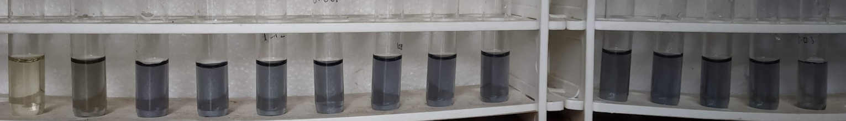
Extract
Fe³⁺ - - - - - - - - - - - -
Co²⁺ Ni²⁺ Cr³⁺ Hg²⁺ Mg²⁺ Na⁺ K⁺ Ca²⁺ Al³⁺ Mn²⁺ La³⁺ Cd²⁺

(d)

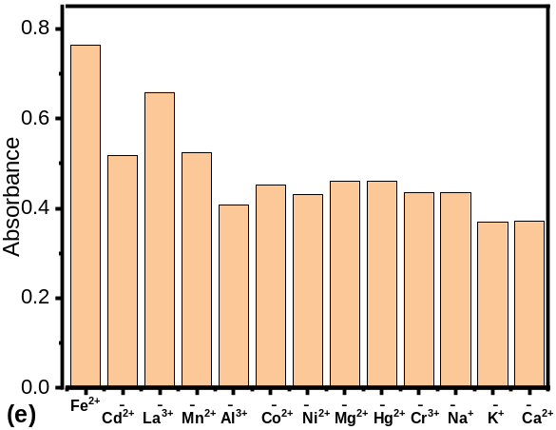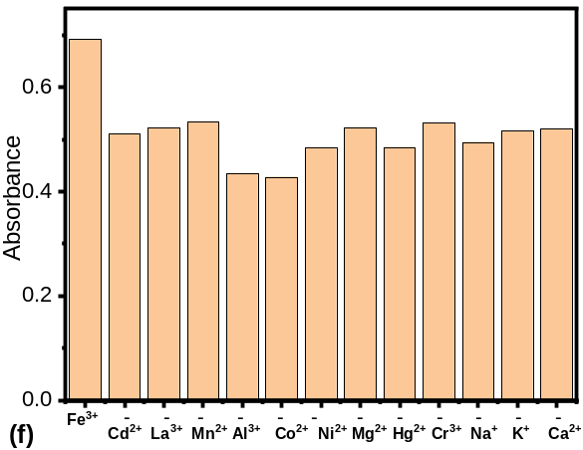
Fig. S1: The colour changes Fe²⁺ in presence of different metal ions in the (a) absence and (b) presence of T. chebula extract; The colour changes Fe³⁺ in presence of different metal ions in the (c) absence and (d) presence of T. chebula extract; Bar graph showing the absorbance of T. chebula extract with (e) Fe²⁺ and (f) Fe³⁺ in presence of various metal ions.

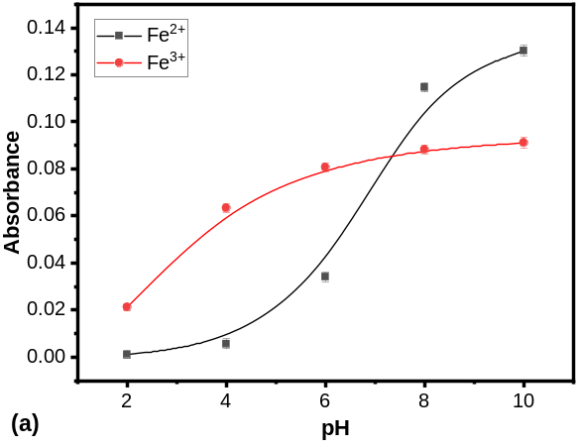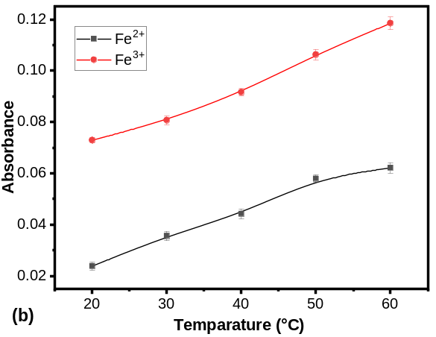
Fig. S2: Absorbance of T. chebula extract with Fe^{2+.}and Fe³⁺ at different (a) pH (b) temperature.
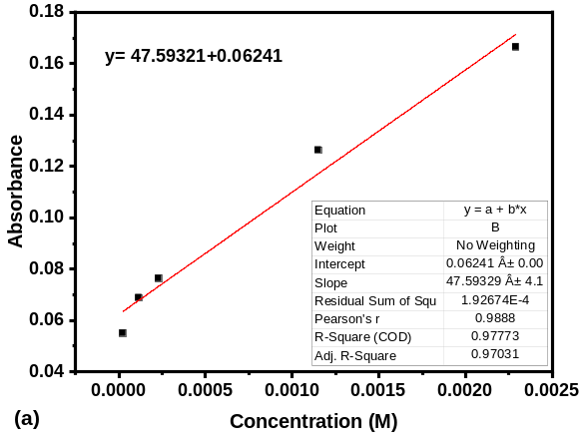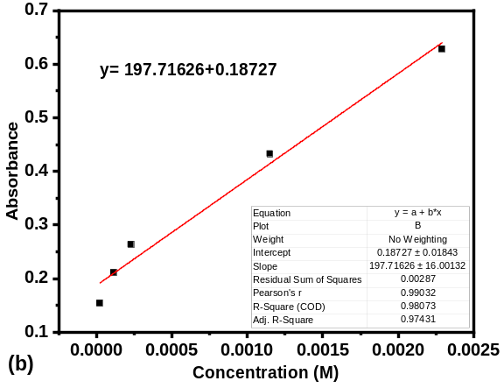
Fig. S3: The calibration curve (at 576 nm) of T. chebula extract upon the addition of (a) Fe^{2+.}and (b) Fe³⁺. [Fe²⁺] and [Fe³⁺] = 2.29×10⁻⁵ – 2.29×10⁻³ M

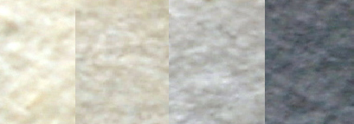
Blank 50 ppm 100 ppm 1000 ppm
Fig.S4: Colorimetric response of Fe³⁺ in paper.

